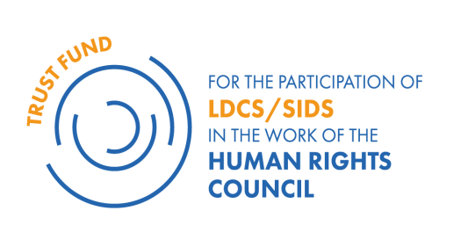

VISA INFORMATION FORM

NAME OF THE APPLICANT:
COUNTRY:
Functional Title:
Ministry /Government Office:

The APPLICANT will need a Swiss/Schengen visa to participate in the programme: Yes / No (please circle the appropriate response)

If No, please explain and provide a legible copy of the visa in your passport

If Yes, please provide clarification below:

Contact details of the applicant:
Email address (official):
Email address (private):
Mobile number: (+ country code)

Passport:
Diplomatic / Regular (please circle the appropriate response)
Passport number:
Date and place of issue:
Date of expiration (the passport must be valid for at least 6 months after the end of the delegates programme and return to the home country or official duty station):

Contact details of the nearest Embassy/Consulate that can deliver a Schengen Visa:

Country of the Embassy/Consulate:
Location: city/country:
Email address of the Embassy/Consulate:

IMPORTANT: It is the responsibility of the applicant to undertake all the necessary arrangements to secure his/her visa. The submission of this form is mandatory and should be included in the application package.

[Date] [Signature of applicant]

