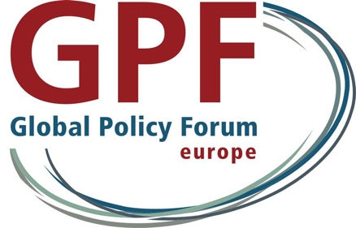



**Joint side-event at the 2024 HRC Social Forum**

**Center for Economic and Social Rights (CESR), Friedrich-Ebert-Stiftung (FES), Global Policy Forum Europe (GPF), Public Services International (PSI) and the UN Research Institute for Social Development (UNRISD)**

**Perspectives on international financial architecture reform**

**What do we want the FfD4 Conference to achieve?**

**31 October 2024; 1pm-2pm, room XXII**

**Facebook Livestream:** [**https://fb.me/e/i2gNhj2Lv**](https://fb.me/e/i2gNhj2Lv)

Reform of the international financial architecture is currently one of the most prominent items on the international political agenda. Many parties share the UN Secretary-General's view that the current architecture is "outdated, dysfunctional and inequitable". Modernising the architecture - making it fit for the challenges facing humanity now and in the future - is one of the key tasks and challenges facing the international community. The FfD4 conference in Sevilla in the summer of 2025 offers an important opportunity to move this agenda forward. For the first time in a decade, the UN is convening an international financing conference to agree a new global deal on development finance and the institutions that govern it.

In preparation for FfD4, independent researchers and civil society policy experts have drafted the report “Building new foundations. Reimagining the International Financial Architecture”. The report identifies key reform areas, develops innovative policy proposals and examines how they can be realized in the international policy-making process. It will be launched at the event. The side event will discuss how we can implement reform proposals in practice and what role FfD4 can play in this. How can we ensure fundamental reform of the tax and debt architecture and of international financial institutions such as the International Monetary Fund and the World Bank? How can we reduce borrowing costs and create fiscal space to deliver public services for all? What form should these reforms take so that the institutions of the international financial architecture can better contribute to the realisation of human rights?

A light lunch will be served.

Moderator:

Katja Hujo (Head of Bonn Office, UNRISD)

Expert Inputs:

* María Ron Balsera, Executive Director, Center for Economic and Social Rights
* Juan Pablo Bohoslavsky, Researcher at Argentina’s National Scientific and Technical Research Council (CONICET)
* David Boys, Deputy General Secretary, Public Services International
* Bodo Ellmers, Program Director Financing for Development, Global Policy Forum Europe

Respondents by UN Member States