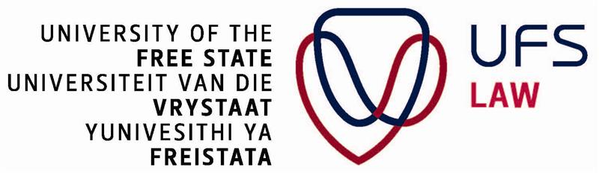

**2024 Human Rights Council Social Forum – Side Event**

**ILLICIT FINANCIAL FLOWS FROM AFRICA AND THE FINANCING OF DEVELOPMENT**

Organized by the Office of the United Nations High Commissioner for Human Rights (OHCHR) and the University of the Free State

**Friday 1 November 2024**

**1400 – 1500 hours CET**

**ROOM XXI, Palais des Nations, Geneva, Switzerland**

**Background**

Illicit financial flows (IFFs) represent a major obstacle to Africa's sustainable development. The economic performance of the African continent for the past few years features among the most competitive economies in the world. One would have expected this performance to bring about social-economic change, allowing people to achieve their human potential linked to the idea of development but this has not been the case. The gap between recent economic achievements of the continent and its state of generalised underdevelopment coupled with rampant poverty, corruption, prolonged economic crisis and political instabilities signals an issue with resource allocations and inequities in distribution. How to understand that despite such economic performance, Africa remains one of the poorest continents in the world, with one-third of its population undernourished and millions with no access to clean water, electricity, education, healthcare and infrastructure? The proliferation of IFFs plays a key role in this situation.

Africa loses an estimated $88.6 billion annually to IFFs, which represents 3.7% of its GDP. This amount far exceeds the $48 billion in official development assistance and $54 billion in foreign direct investment the continent receives each year. IFFs drain resources that could be used for essential social services. They undermine domestic resource mobilisation, reduce foreign exchange reserves, and limit the benefits of foreign investment. IFFs result in unsustainable debt that is constitutive of a major drain on development financing. Many countries have engaged in resource-backed financing, often with Chinese institutions. This has led to significant debt burdens, with countries like Ethiopia, Ghana, and Zambia facing defaults. IFFs and unsustainable debt represent major barriers to financing sustainable development in Africa. Effectively addressing these interrelated issues requires comprehensive strategies at national, regional, and global levels.

Curbing IFFs could almost halve Africa's $200 billion annual financing gap needed to achieve the SDGs. The African Union has made tackling IFFs a priority to finance Agenda 2063 and achieve sustainable development. Estimates suggest that effectively curbing IFFs could secure an additional $90 billion per year for Africa's development.

The purpose of the presentation is to explore recent developments in the IFFs environment, their impact on development financing, and the need for comprehensive strategies to address this challenge.

**Objectives**

* **Raise Awareness of Illicit Financial Flows (IFFs)**
  + Highlight the scale and impact of IFFs on African economies and development efforts.
  + Discuss the mechanisms through which IFFs occur, including tax evasion, corruption, and money laundering.
* **Understand the Impact on Development Financing**
  + Analyze how IFFs divert resources away from realizing basic human rights and essential public services such as healthcare, education, and infrastructure.
  + Explore the relationship between IFFs and the financing gaps in achieving the Sustainable Development Goals (SDGs).
* **Promote Policy Solutions**
  + Explore Innovative Financing Mechanisms
  + Create a platform for dialogue on policy solutions among government officials, civil society organizations, private sector representatives, and international organizations.

**Format**

This side event will be moderated, with interventions from thematic experts and other participants on issues which cut across Domestic Resource mobilization, investment, taxation and illicit financial flows. The discussion will present findings of a planned study on Illicit Financial Flows from Africa and the Financing of Development and invite participants to engage in a constructive dialogue with a view to sharing experiences, lessons learned and good practices in this intersecting area, having in mind that the overarching goal of Domestic Resource Mobilization is to empower countries to utilize their own financial resources effectively, leading to sustainable economic growth, the realization of human rights, and improved public welfare while reducing dependency on external aid sources.

**Moderator:** **Mr. Serges Kamga**, Dean, Faculty of Law, University of the Free State, South Africa

**Presentation of the study**

**Mr. Gerard Kamga,** Senior Lecturer, Faculty of Law, University of the Free State, South Africa, *Illicit Financial Flows from Africa and the Financing of Development*

**Discussants**

**Ms. Chenai Mukumba**, Executive Director, Tax Justice Network Africa, *Tax Justice*

**Mr. Abdul Muheet Chowdhary** / Tax Initiative, South Centre, Geneva, *Lessons Learned and Good Practices – In the Experience of the South Centre Tax Initiative*