International Solidarity and Cooperation, Partnership and Capacity-Building: Youth Empowerment Initiative for Sustainable Development guided by youth-led Start-ups: ‘Dreaming and Enabling’ for present and future generations

1. Background
Today's youth are not merely prospective leaders of tomorrow; increasingly, they are assuming leadership roles today. They exhibit exceptional passion and dedication in addressing urgent societal challenges at the grassroots level. Their solutions are birthed from genuine understanding, empathy, and real-life experiences, rendering their approach unique and pragmatic. However, many grapple with substantial obstacles that hinder their ambitions to extend their impact across the wider community.

Rather than prescribing conventional problem-solving approaches, which often yield varied levels of progress, it is crucial to listen to and learn from youths who are already effecting change at the grassroots level. By establishing direct communication and empowering them with the necessary skills and resources, we can enable them to scale their efforts and broaden their impact to reach a larger community.

2. The UNHRC Social Forum – Partnership-building Session (Talk Social, Make Social Happen)
Aims:
- Connection: Bringing together youth champions who are creating tangible impacts in their communities.
- Insight: Understanding the challenges these youth are facing and the skill sets they require to overcome them.
- Collaboration: Engaging with committed stakeholders to co-design/develop a virtual/digital enabling ecosystem to further empower these efforts.

Facilitated by Mr. Shivam Pandya, a product manager at Evercomm and also an environmental technologist deeply committed to harnessing the potential of technology to drive positive change in the battle against climate change, and Ms. Ivy Wu, Co-founder and CMO, Formfty with the Participation of Youth Worldwide.

Part I: Interactive Discussions: During the partnership-building session at the Social Forum, young participants will be able to engage in open discussions about the social challenges they are actively tackling. Some youth champions will share inspiring success stories, shed light on areas where they encounter challenges, and collectively prioritize the areas where they would appreciate additional support. Moreover, they will have a platform to cast their votes on the specific areas they identify as needing assistance.

With the participation of Ms. Maya Kumar, cofounder of HerMind.org, an organization that educates, mentors and empowers disadvantaged young female students; Mr. Tze Hean, cofounder of Budding Minds, a non-profit organization that is dedicated to supporting youth development in academic areas with free 1-to-1 tutoring for students of less fortunate backgrounds; Ms. Elizabeth Nyamawnge, Young IT Developer, researcher, and gender-equality activist, and inventor of Etana blockchain technology; Ms. Racheal Nestor, Young Environmental Rights Defender and Caribbean Institute for Meteorology and Hydrology, St. Lucia; and Mr. Sricharan Balasubramanian, co-founder of Comm.UnitySG, a ground-up youth initiative to serve the homeless and displaced during the pandemic.

Part II: Open Engagement: This segment actively facilitates both in-person and digital interactions, inviting stakeholders to engage in a dynamic exchange of ideas. Participants are encouraged to share their experiences, provide feedback on the insights shared by the youth, or discuss collaboration ideas.

Conduct brainstorming sessions with other funders, governments, business actors, mentors, educational institutions, intergovernmental and non-governmental organizations to design and pilot implementation strategies.

3. Outcomes
- Curriculum Development: Utilize insights from the needs assessment to collaborate with universities and global agencies in designing a specialized curriculum focused on social entrepreneurship, catering to the capacity-building needs of the youth.
- Mentorship Initiatives: Enlist professionals, academics, and seasoned social workers to offer invaluable guidance and mentorship to nurture and guide these young leaders in their endeavors.
- Effective Curriculum Delivery & Resource Allocation: Identify optimal avenues for curriculum dissemination and pair these with potential funding sources, technology integration, and other resource allocation strategies to support and fortify a wider array of grassroots initiatives.

4. Conclusion
By harnessing the potential of youth and providing them with the necessary tools, knowledge, and resources, we can amplify their efforts and create more sustainable and effective solutions to pressing social issues. The United Nations Social Forum provides a platform for this transformative journey, enabling passionate young leaders to receive the support they deserve.

Speakers List

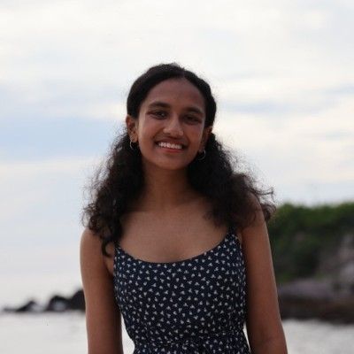
Ms. Maya Kumar, cofounder of HerMind.org, an organization that educates, mentors and empowers disadvantaged young female students;

Mr. Tze Hean, cofounder of Budding Minds, a non-profit organization that is dedicated to supporting youth development in academic areas with free 1-to-1 tutoring for students of less fortunate backgrounds;

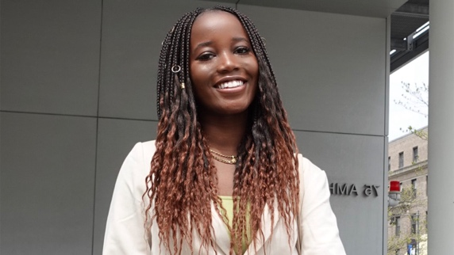
Ms. Elizabeth Nyamawnge, Young IT Developer, researcher, and gender-equality activist, and inventor of Etana blockchain technology;

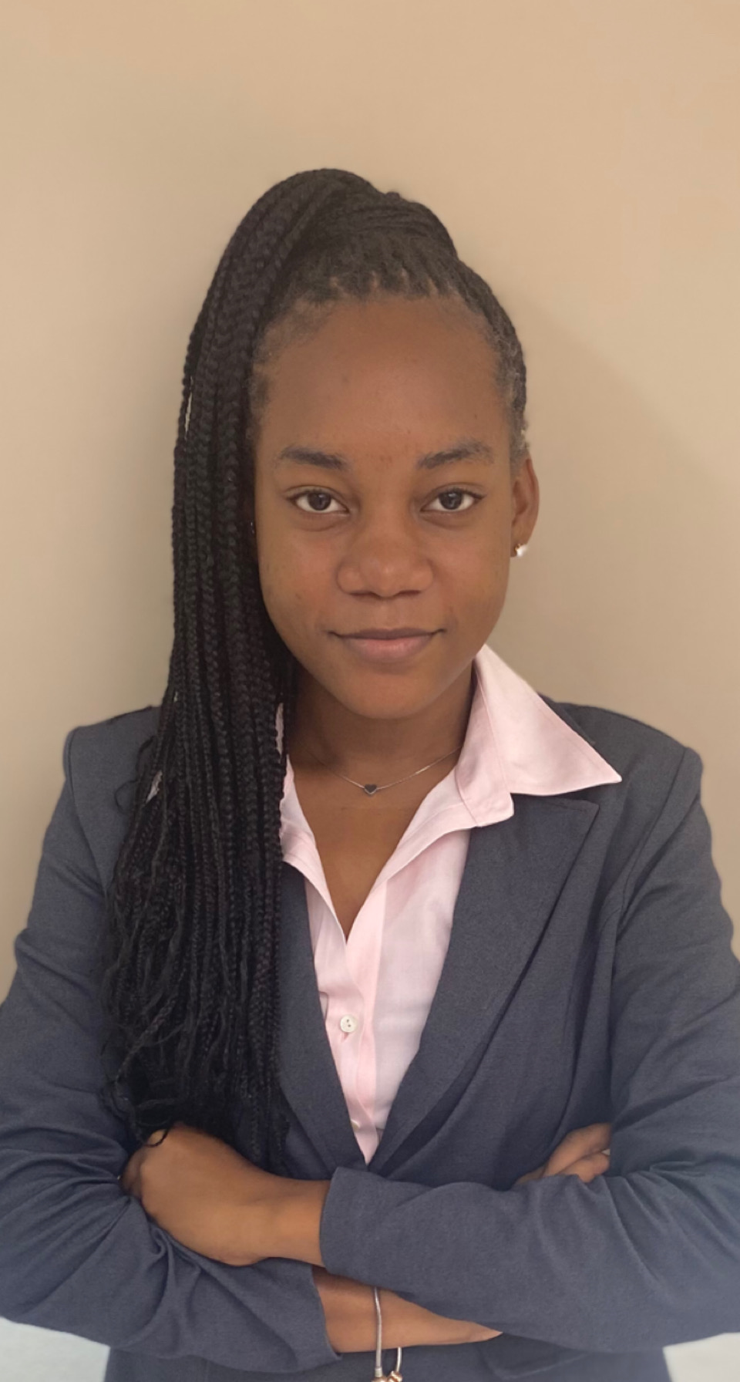
Ms. Racheal Nestor, Young Environmental Rights Defender and Caribbean Institute for Meteorology and Hydrology, St. Lucia;

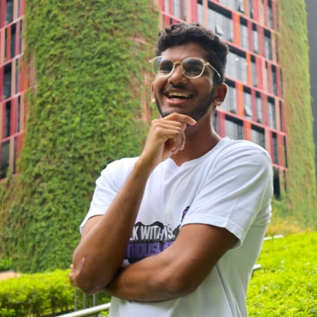
Mr. Sricharan Balasubramanian, co-founder of Comm.UnitySG, a ground-up youth initiative to serve the homeless and displaced during the pandemic.

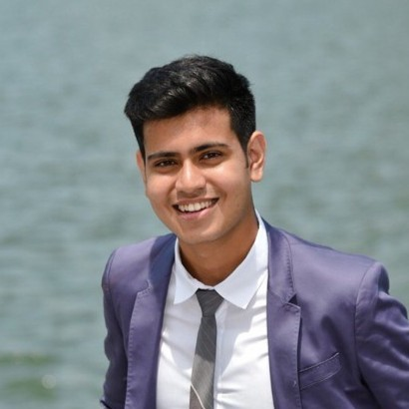
Mr. Shivam Pandya, a product manager at Evercomm, is an environmental technologist deeply committed to harnessing the potential of technology to drive positive change in the battle against climate change.

Ivy is the co-founder and CMO at Formfty, a 3D printing service-oriented company that supports the design and manufacturing of next-generation consumer electronics and medical products. She is a successful entrepreneur with a passion for innovation in consumer electronics.

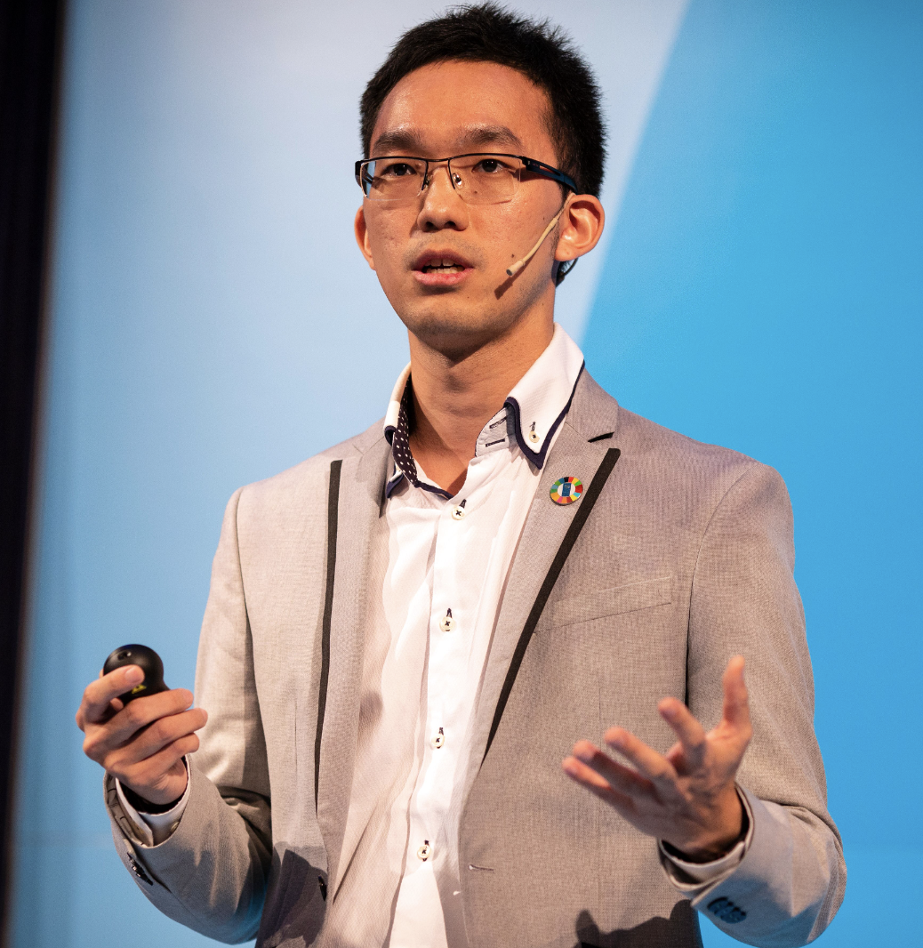
Ted is the Co-founder and CEO of Evercomm Singapore – “one of Asia Pacific’s fastest growing Sustainability AI companies in the cleantech sector.” Ted is also the youngest to receive the prestigious Singapore Energy Award and recognized as one of the digital pioneers by the Singapore Committee on the Future Economy (CFE).

