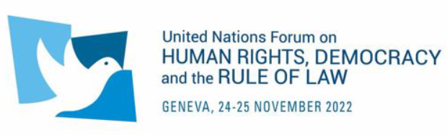

IOE HYBRID SIDE EVENT

IV United Nations Forum on Human Rights, Democracy and the Rule of Law

Friday 25 November 2022, 13:30 – 14:30 (CET)
Palais des Nations, Room XXIII & online

JOIN NOW

The International Organisation of Employers (IOE) is pleased to invite to a side event on “Human Rights and Good Governance” as part of the Fourth session of the United Nations Forum on Human Rights, Democracy and the Rule of Law.

Friday 25 November 2022
13:30 – 14:30 (CET), Room XXIII at the Palais des Nations, Geneva and online

REGISTER HERE

CONCEPT NOTE

Democracy, effective rule of law as well as strong governance and institutions by States are key prerequisites for ensuring the protection, respect and fulfilment of human rights. These elements are essential for a society to be able to enjoy the basic fundamental human rights everyone is entitled to as well as to promote economic growth, productivity, open trade and development, job creation, the rise of standards of living and decent work for all. Strong institutions and governance also allow both public and private sectors to enjoy policy and legal certainty which provides them with the necessary sustainable environment to grow and thrive, ultimately serving and benefiting society as a whole.

Yet, although the benefits of democracy, effective rule of law and good governance are no longer in doubt, little is known about the positive effects of these on social and labour issues and about the most effective means of improving labour conditions around the world.

Against this backdrop, IOE wishes to provide the key takeaways from the IOE report prepared by the Texas University which explore what is known about the most effective means of improving labour conditions around the world, and to identify gaps warranting further research. Notably, a special focus will be given to five commonly cited agents of labour conditions improvement: National Government action; Foreign/IGO Assistance; Trade Agreements (Social Clauses); Private Sector initiatives and Trade Unions.

FORMAT AND REGISTRATION

This side event will be structured around the following format:

- A first part dedicated to the presentation of the key takeaways of the report;
- A multistakeholder panel discussion on current initiatives and good practices to foster human rights and labour conditions as well as challenges faced.
The format of this event will be hybrid. Online via Webex and in-person in Room XXIII at Palais des Nations in Geneva. Kindly note that no interpretation will be provided.

To register, please follow all steps below:

- For all participants, please register via both:

- The IOE google form

- The UN Indico platform here. Kindly note that in order to enter the UN premises, due to “Pregny gate” renovations, the location to pick up your badge has changed. More information here.

- For online participants, you will receive the Webex link at a later stage.

AGENDA

13:30 - 13:35 | Introduction  - Mr Matthias Thorns, IOE Deputy Secretary-General
13:35 - 13:45 | Presentation of the IOE Report “Human Rights and Good Governance”  - Mr Raymond Robertson, Director of the Mosbacher Institute for Trade, Economics, Texas A&M University (online)
13:45 - 14:15  (6 min. each) | Panel discussion on current initiatives and good practices to foster human rights and labour conditions as well as challenges faced  - Ambassador Claudia Fuentes Julio, Permanent Representative of Chile to the UN and other international organizations in Geneva and Chair of the ILO Governing Body  - Ms Renate Hornung-Draus, BDA Managing Director, Economic and International Affairs & IOE Vice-President to the ILO  - Ms Ronnie Goldberg, Senior Counsel, United States Council for International Business (USCIB) (online)  - Mr Damilola S. Olawuyi, UNWG Member on BHR from African States (online)  - Mr Kris De Meester, First Adviser and Manager, Federation of Enterprises in Belgium (VBO-FEB)  Moderated by Jason Pegat-Toquet, IOE Advisor
14:15 - 14:25 | Q&A Session
14:25 - 14:30 | Closing remarks by Matthias Thorns, IOE Deputy Secretary-General

