IOE SIDE EVENT “HUMAN RIGHTS AND GOOD GOVERNANCE”

Friday 25 November 2022

13:30 – 14:30 (CET), Room XXIII at the Palais des Nations, Geneva and online

**BIOGRAPHIES OF SPEAKERS**

**Introduction and Master of Ceremony -** Mr Matthias Thorns, IOE Deputy Secretary-General

Matthias Thorns is the Deputy Secretary-General of IOE, the International Organisation of Employers. He has a part in the overall responsibility for the management of the IOE Secretariat in its work to support the global business community in its representation vis-a-vis the UN institutions, as well as G20, G7 and other international initiatives. Matthias has extensive international corporate experience and expertise as he supervises the IOE’s work related to G20 and G7, human rights, agenda 2030, migration and programmes under an EU framework agreement, and is responsible for the IOE company networks: the Global Industrial Relations Network (GIRN), the Global Occupational Safety and Health Network (GOSH) as well as the Corporate Partner Initiative.

**Presentation of the IOE Report “Human Rights and Good Governance”-** Mr Raymond Robertson, Director of the Mosbacher Institute for Trade, Economics, Texas A&M University (online)

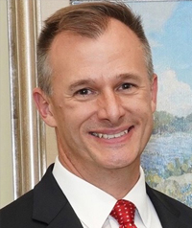

Dr. Raymond Robertson is Professor and holder of the Helen and Roy Ryu Chair in Economics and Government in the [Departments of International Affairs](https://bush.tamu.edu/inta/)at the Bush School of Government and Public Service and the Director of the [Mosbacher Institute for Trade, Economics, and Public Policy](https://bush.tamu.edu/mosbacher/). He is a research fellow at the Institute for the Study of Labor in Bonn, Germany, and a senior research fellow at the Mission Foods Texas-Mexico Center. He was named a 2018 Presidential Impact Fellow by Texas A&M University.

**Panel discussion on current initiatives and good practices to foster human rights and labour conditions as well as challenges faced**

**Ambassador Claudia Fuentes Julio, Permanent Representative of Chile to the UN and other international organizations in Geneva and Chair of the ILO Governing Body**

Ambassador Claudia Fuentes Julio is the Permanent Representative of Chile to the United Nations and other international organizations in Geneva since 7 June 2022. Ambassador Fuentes-Julio brings a wealth of knowledge and experience deeply rooted in a life-long and unwavering commitment to promoting human rights and human security. A renowned researcher and academic, she has lectured in universities in Latin America and the United States, and has written extensively on foreign policy, human rights, and conflict A person smiling in front of a flag
resolution. On the multilateral front, Ambassador Fuentes-Julio has collaborated closely with several United Nations entities on various projects. These covered a wide spectrum, ranging from projects on conflict prevention and recovery, gender and disarmament in Latin America, to developing strategies on human security and multilateral institutions in Latin America and the Caribbean, as well as methodological guides for their design and implementation.

**Ms Renate Hornung-Draus, BDA Managing Director, Economic and International Affairs & IOE Vice-President to the ILO**

Ms Hornung-Draus is Managing Director for Economic and International Affairs of the Confederation of German Employers' Associations (BDA), the top business organization representing the interests of private employers in the fields of employment, labour and social affairs. She directs BDA’s activities in the economic and international fields. This includes on the one hand representing the employers’ views vis-à-vis the relevant national, European and. international institutions, as well as within international organizations and fora (ILO, OECD, OHCHR, G7/B7, G20/B20), and on the other hand providing advice and services to member organizations and companies on economic and international issues in the fields of employment, integrity and sustainability. Renate Hornung-Draus has published extensively on economic and international topics, inter alia on European Policy, Industrial Relations, International Social Policy and Labour Standards. She holds many honorary functions in international, academic and business organizations, among others as Vice-President for ILO matters of the International Organisation of Employers (IOE) and Chair of Business at OECD - BIAC's Employment, Labour and Social Affairs Committee, Chair of BusinessEurope's CSR Working Party, Board member of the German-Arab Friendship Association (DAFG), and Advisory Board member of the Birmingham Business School and Trier University Institute for Employment Relations in the EU. Furthermore, she serves among others as Vice-Chairperson of the Governing Body of the International Labour Organization and as Co-Chair of the B20 Future of Work and Education Task Force.

**Ms Ronnie Goldberg, Senior Counsel, United States Council for International Business (USCIB) (online)**

Ronnie Goldberg advises USCIB’s president and CEO on strategic matters and represents American business at several high-level forums. She has served as the U.S. employer representative on the International Labor Organization’s Governing Body, and chaired the BIAC Employment, Labor, and Social Affairs (ELSA) Committee.

Goldberg served as USCIB’s top policy executive for over 25 years, most recently as executive vice president and chief policy officer, overseeing the organization’s wide-ranging activities on international trade, investment, economic and regulatory matters, and supervising a staff of policy professionals with expertise on a host of issues affecting American companies engaged in business abroad. In her earlier role, she also coordinated USCIB policies in relation to those of our international affiliates – the International Chamber of Commerce (ICC), the Business and Industry Advisory Committee, (BIAC) and the International Organization of Employers (IOE) – and various other groups.

**Mr Damilola S. Olawuyi, UNWG Member on BHR from African States**

**Damilola S. Olawuyi** is a Professor and UNESCO Chair on Environmental Law and Sustainable Development at the Hamad Bin Khalifa University in Qatar. He is also the director of the Institute for Oil, Gas, Energy, Environment and Sustainable Development at the Afe Babalola University, Nigeria. He researches and teaches in the fields of natural resources, energy, environment, and business and human rights law, with a focus on Africa and the Middle East. He has published and practiced extensively in these areas, and has advised the World Bank, UN agencies, governments, multinational corporations, and civil society organisations on issues related to business and human rights. From 2020-2022, he served as an Independent Expert of the Working Group on Extractive Industries, Environment and Human Rights Violations in Africa (WGEI) of the African Commission on Human and Peoples' Rights. A Senior Advocate of Nigeria, Olawuyi has served as Co-Chairman of the Legal Education Committee of the Nigerian Bar Association, and member of the governing board of the Nigeria Extractive Industries Transparency Initiative (NEITI).

**Mr Kris De Meester, First Adviser and Manager, Federation of Enterprises in Belgium (VBO-FEB)**

Kris De Meester is first adviser and manager at the Federation of Enterprises in Belgium covering the field of health and safety at work as well as international social affairs. Kris is the employer’s group spokesperson in the European Commission’s Advisory Committee on Safety and Health at Work.

He is the chairman of the Health and Safety working group of BusinessEurope, the Union of Industrial and Employers Confederations of Europe. He is also co-chairing the IOE (International Organization of Employers) Taskforce on the Future of Work.

Kris is also a member of the governing board and the bureau of the European Agency for Safety and Health at Work (EU-OSHA Bilbao), the governing board of the European Foundation for the Improvement of Living and Working Conditions (Dublin), the Governing Body of the International Labour Organization (ILO Geneva), the Governing Body of the International Training Centre of the ILO in Turin, the GOSH (Global OSH network of the International Organisation of Employers), the National Council for Prevention and Protection at Work in Belgium and the National Council the Protection against Fire and Explosion in Belgium.

He is also CEO of the organization Contractor Safety Management that operates B2B contractor safety management schemes in Belgium (BeSaCC: Belgian Safety Criteria for Contractors and VCA-SCC: Safety health and environment Checklist Contractors) with approximately 3000 certified companies and 100.000 workers and supervisors trained on a yearly base.

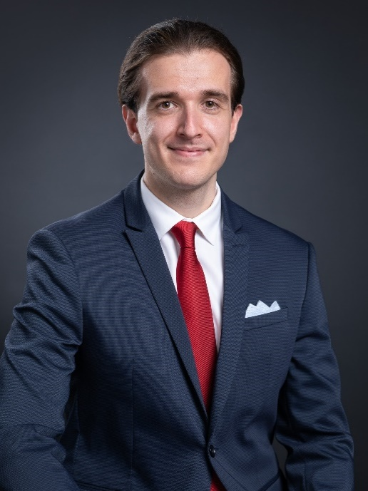**Moderated by Jason Pegat-Toquet, IOE Advisor**