Opinions

We need better laws to prosecute atrocities in Syria
Some states continue to put barriers to universal jurisdiction which prevent the prosecution of Syrian war criminals.
Catherine Marchi-Uhel
Head, UN International, Impartial and Independent Mechanism - Syria
Paulo Pinheiro
Chair, UN Commission of Inquiry - Syria
Hanny Megally
Commissioner, UN Commission of Inquiry - Syria
Lynn Welchman
Commissioner, UN Commission of Inquiry – Syria
Published On 13 Jan 202213 Jan 2022
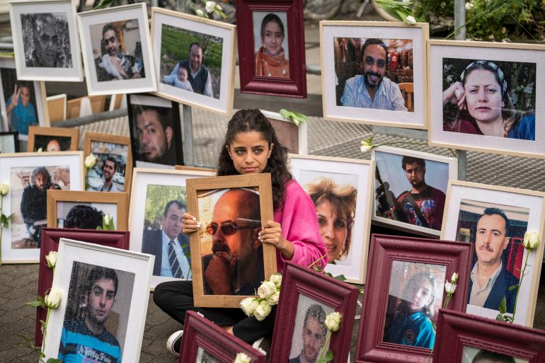
In this file photo taken on June 4, 2020, Syrian campaigner Wafa Mustafa sits between pictures of victims of the Syrian regime as she holds a picture of her father, outside the trial against two Syrian former intelligence officers accused of crimes against humanity, in Koblenz, western Germany [File: Thomas Lohnes/AFP]
Syrian civilians have paid a heavy price for a decade of war in which their government and parties to the conflict, such as ISIL (ISIS), have violated nearly every core human right and committed almost every atrocity.
From summary executions, torture and the forcible disappearance of tens of thousands of people, to chemical weapons use, genocide against the Yazidis, and the deliberate targeting of hospitals and health workers, to the bombardment of civilians under the guise of waging a war on “terrorists”, the list of despicable crimes is seemingly endless. As a result of the violence, half of Syria’s prewar population has been displaced, many repeatedly.
At present, all avenues to justice are blocked in Syria and victims can only turn up outside courts in other states. Recent developments have given rise to hope, as states have advanced prosecutions and several court cases against Syrian nationals accused of committing atrocities have ended with guilty verdicts. However, in some countries, there are still a number of legal barriers that need to be lifted to enable the prosecution of international crimes.
In principle, the Syrian government should hold accountable all perpetrators of atrocities committed on its territory by bringing those responsible before independent courts.
In practice, arbitrary actions by the Syrian security apparatus and unfair proceedings by counterterrorism and field military courts are facilitating further violations and crimes.
In principle, when a state like Syria is unwilling or unable to investigate and prosecute such crimes, the international community and the guardian of international peace and security, the United Nations Security Council, should ensure that the situation is referred to the International Criminal Court (ICC).
In practice, the Security Council is paralysed by vetoes.
Domestic courts, predominantly in Europe, have laudably taken on the challenge in the interim. Usually, a state has jurisdiction only if crimes happen on its soil, are committed by its nationals or against its people. This jurisdictional limitation was challenged after World War II, as some crimes were considered so grave that they could be prosecuted under the principle of universal jurisdiction, regardless of where the perpetrators would be tried.
Germany is one of the states that has embraced this paradigm shift and it has borne fruit. German courts have secured 20 convictions of former fighters in Syria, such as returning members of ISIL, for various international crimes, including gender and religion-based persecution.
On January 13, the Koblenz Higher Regional Court, in a landmark ruling, sentenced the former high-ranking Syrian intelligence officer Anwar Raslan to life in prison for crimes against humanity at a jail near Damascus a decade ago where he had overseen the torture of more than 4,000 prisoners, resulting in the deaths of at least 58 people.

Also, in early 2021, a former low-ranking Syrian intelligence official was found guilty in a court in Koblenz for complicity in crimes against humanity in connection with the arrest of protesters, who were detained, tortured and killed in one of the many branches of Syrian intelligence services. It was the first time that a court of law classified actions by the Syrian government as a systematic attack against its civilian population.
But not every state has opted for such a broad jurisdictional framework. Many require specific conditions to be met, including the presence of the suspect on their territory. In 2010, French legislators added a requirement for double incrimination of the act – under French law and in the state where they took place.
On this basis, the highest court in France, la Cour de Cassation, recently concluded that France cannot prosecute crimes against humanity committed in Syria because Syrian law does not define all elements of the crime in question. This ruling was a massive blow to ongoing efforts by French prosecutors and judges to bring justice to victims of crimes against humanity in Syria. How other international crimes will be affected in France remains to be seen. Hopefully, ongoing proceedings on the Yazidi genocide will be allowed to move ahead.
Fortunately, efforts to try Syrians who have committed crimes during the war continue in other states, including Austria, Belgium, Norway, Sweden, Switzerland, the United States and elsewhere – despite judicial and budget hurdles their national war crimes prosecution units and courts face.
In a context where fair and independent justice is unobtainable in Syria and the Security Council remains deadlocked, domestic courts, even if limited, offer victims a narrow path to justice.
However, to make full use of domestic justice avenues, states must ensure that their own legislation, budgets and policies can fully address the challenge.
We need to improve legislation, avoid loopholes through which perpetrators can escape justice, and ensure that universal jurisdiction faces no additional restrictions under domestic law, including in France, given the recent decision.
We need more resources and cooperation between states to ensure that those within reach can be held to account.
We need to tackle questions of immunity of senior Syrian officials to make sure that nobody stands above the law.
We need Syrian refugees and asylum seekers, who are the primary victims and witnesses in such trials, to feel welcomed, supported and encouraged to come forward with their testimonies.
As long as independent and fair justice is unavailable in Syria, states regarding themselves as human rights champions can do a better job to offer a legal remedy to those seeking justice.
The views expressed in this article are the authors’ own and do not necessarily reflect Al Jazeera’s editorial stance.

Catherine Marchi-Uhel
Head, UN International, Impartial and Independent Mechanism - Syria
Paulo Pinheiro
Chair, UN Commission of Inquiry - Syria
Paulo Sérgio Pinheiro is a Brazilian academic and political science scholar. Within the United Nations System, he served as the Special Rapporteur on the situation of human rights in Myanmar (2000-2008). Since 2011, he has served as Chairman of the Independent International Commission of Inquiry for Syria.
Hanny Megally
Commissioner, UN Commission of Inquiry - Syria
Hany Megally is Commissioner of the UN Commission of Inquiry on Syria. He is currently a senior fellow at the New York University Centre on International Cooperation leading a program on dealing with the root causes of violent extremism.
Lynn Welchman
Commissioner, UN Commission of Inquiry – Syria
Lynn Welchman is a Commissioner of the UN Commission of Inquiry on Syria. She is a Professor of Law at SOAS University of London, where she teaches Islamic law, Gender, Law and Society in the Middle East and North Africa, and Human Rights and Islamic Law.

