Opinions

The case for an international mechanism for Syria’s disappeared
Member states must back Secretary-General António Guterres’ proposal to set up a body on Syria’s disappeared.
Paulo Pinheiro
Chair, UN Commission of Inquiry - Syria
Lynn Welchman
Commissioner, UN Commission of Inquiry – Syria
Hanny Megally
Commissioner, UN Commission of Inquiry - Syria
Published On 8 Oct 20228 Oct 2022
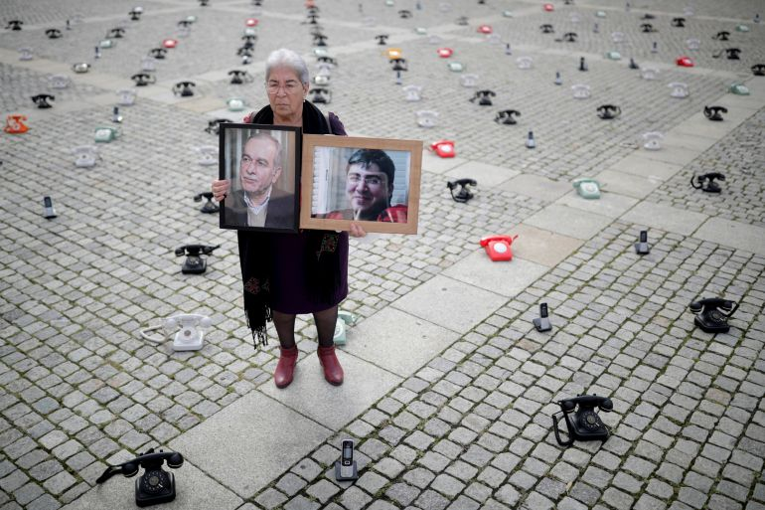
Fadwa Mahmoud holds portraits of her son and husband, who disappeared in 2012, as about 300 landline telephones placed by Syrian families stand at the Bebelplatz as a call to governments to do more to seek information about detained people in Syria, in Berlin, Germany on August 28, 2021 [File: Hannibal Hanschke/Reuters]
One of the many tragedies of the Syrian War is the unresolved fate of the missing and disappeared. Since the start of the war in 2011, tens of thousands of Syrians have gone missing or have been forcibly disappeared by the Syrian government and in some cases, by other parties to the conflict.
Families’ searches for detained relatives are fraught with the danger of being arrested, extorted and abused. The Syrian government and other parties have deliberately prolonged the suffering of hundreds of thousands of family members by withholding information on the fate and whereabouts of those missing or disappeared.
A much-awaited step has now been taken, providing the international community with a pathway to address the practical concerns and real-life implications of this terrible phenomenon.
In August, the UN Secretary-General António Guterres released his landmark report on how to bolster efforts to clarify the fate and whereabouts of missing persons in the Syrian Arab Republic and provide support to their families, as requested by the United Nations General Assembly in Resolution 76/228.
The report unequivocally recommends that member states establish a new entity to help coordinate and build on existing efforts to address this situation.
We warmly welcome the secretary-general’s recommendation as it is consistent with the forceful advocacy led by Syrian associations of families of the missing. For years, the UN Syria Commission of Inquiry has flagged the need for such a body to consolidate claims filed with a wide variety of non-governmental and humanitarian organisations, to efficiently and effectively track and identify those missing and disappeared, and to assist their families who are taking many risks and facing hardships in their continuing search. We have always stressed that family, victim and survivor participation must be central to its functioning.
With the release of the secretary-general’s report, there should no longer be a debate about the need for such an international entity. His message is very clear: any progress towards addressing the continuing tragedy of missing persons in Syria requires a coherent and holistic approach going beyond current efforts. The UN General Assembly should move swiftly, passing a resolution establishing this new entity, setting out its mandate and framing its priorities.
Experience globally shows that the longer it takes to establish such a mechanism, the more difficult it will be to ever clarify the fate and whereabouts of the missing and those forcibly disappeared.
The secretary-general’s report described the gaps in current efforts that a new mechanism can fill: It can provide a one-stop shop to support families searching for missing loved ones. It can coordinate and consolidate their claims to learn how many are missing. And it can advocate for access to all places of detention and other relevant locations controlled by all actors in the conflict.
This mechanism would not only focus on those who have disappeared in detention, but also on all the Syrians who have gone missing as a direct result of more than a decade of fighting. The war rages on, still forcing civilians to flee, while conditions for Syrian refugees in neighbouring countries grow increasingly difficult and uncertain as refugee-hosting countries grapple with complex economic, social and political challenges.

With welcomes wearing thin and the looming threat of being forced back to Syria, refugees often choose to risk their lives during perilous sea journeys or to go on dangerous overland treks to reach the borders of Europe. The recent disaster off the Syrian coast with more than 100 desperate refugees drowning in the sea, and so many tragedies before, show the transnational complexities of the issue of the missing and disappeared stemming from the conflict in Syria.
We have had the privilege of meeting on many occasions with the families, mothers, husbands, wives, children, friends and colleagues of the disappeared over the past decade. We and our team have listened to them, and while individual circumstances may differ, their message is consistent and clear – they will not stop until they find their missing relatives or uncover the truth about their fate. Families have the right to know the fate of their loved ones.
The considerable wealth of information that our Commission has collected over 11 years will be made available to the new mechanism in line with the consent provided by our sources. The Commission has already begun preparing for the transmission of the data entrusted to it by our sources, in line with their consent, and we hope other organisations dealing with missing people in Syria are doing the same.
Families have waited far too long for action at the international level. The time to act is now. Member states from the different regions of the globe have a rare opportunity to put their weight behind this meaningful humanitarian effort that will help address the suffering caused by the scourge of missing and disappeared Syrians.
Last, we should not forget that the Syrian government and the armed groups hold primary responsibility for this tragedy and can act swiftly to resolve it. They can begin by allowing immediate access by international humanitarian organisations such as the International Committee of the Red Cross to all places of detention. They can permit visits by the families. Knowing who is alive and their whereabouts would be a major step forward in breaking the wall of silence around the fate of the missing and the disappeared.
The views expressed in this article are the authors’ own and do not necessarily reflect Al Jazeera’s editorial stance.

Paulo Pinheiro
Chair, UN Commission of Inquiry - Syria
Paulo Sérgio Pinheiro is a Brazilian academic and political science scholar. Within the United Nations System, he served as the Special Rapporteur on the situation of human rights in Myanmar (2000-2008). Since 2011, he has served as Chairman of the Independent International Commission of Inquiry for Syria.
Lynn Welchman
Commissioner, UN Commission of Inquiry – Syria
Lynn Welchman is a Commissioner of the UN Commission of Inquiry on Syria. She is a Professor of Law at SOAS University of London, where she teaches Islamic law, Gender, Law and Society in the Middle East and North Africa, and Human Rights and Islamic Law.
Hanny Megally
Commissioner, UN Commission of Inquiry - Syria
Hany Megally is Commissioner of the UN Commission of Inquiry on Syria. He is currently a senior fellow at the New York University Centre on International Cooperation leading a program on dealing with the root causes of violent extremism.

