Check against delivery
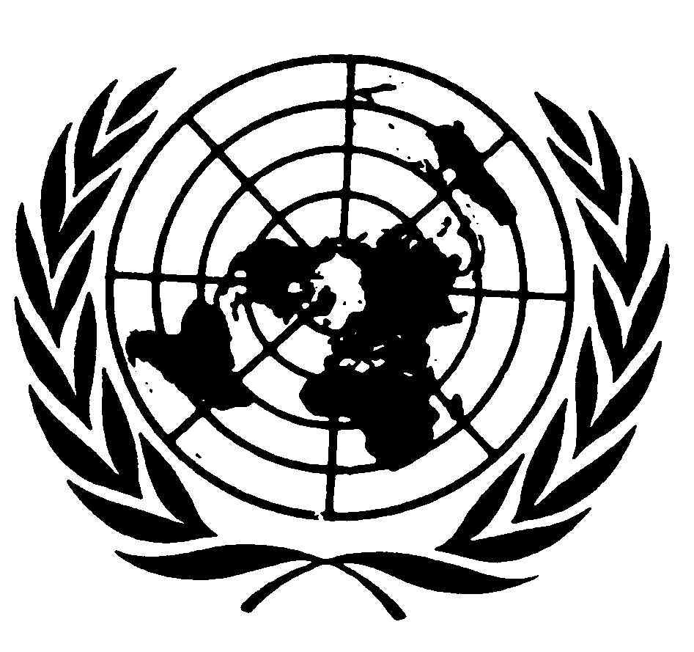

Statement by MIKIKO OTANI
CHAIR OF THE COMMITTEE ON THE RIGHTS OF THE CHILD

Seventy-seventh session of the General Assembly
Item 65 (a)

NEW YORK
7 October 2022

Mister Chair, Excellencies, distinguished delegates, colleagues and friends from the United Nations system, national human rights institutions and non-governmental organizations,
The ongoing Covid-19 pandemic, the Russian attack on Ukraine, record-breaking temperatures, fires, storms and floods are all having a negative impact on human development. The Human Development Index, which measures a nation’s health, education, and standard of living, has declined globally for two years in a row. This means that hundreds of millions of children are now living in a conflict situation, do not have enough to eat, are not in school or are receiving an insufficient level of education, have little or no access to health, including vaccination, and are more affected by poverty, violence and mental health challenges – unfortunately, this is far from an exhaustive list. Most of the signs of progress in children’s rights achieved in the last decades are now increasingly threatened. The dialogues that the Committee held with States’ delegations, civil society organisations, United Nations agencies and child human rights defenders during the course of this year also confirmed these negative trends.
The Committee is increasingly alarmed that in all regions of the world, and in intergovernmental fora such as the Human Rights Council, children’s status as rights-holders is being questioned under the cover of socio-cultural and religious diversity and patriarchal traditions such as “family values”. Children’s agency, autonomy and right to participation are challenged, diminished and ignored. During the opening of our last session in September, the Committee heard statements from child human rights defenders, who told us that “the improper application of child rights in some countries” is “silencing” their advocacy, and that for some of them, their “freedom of expression has been taken away due to governmental neglect towards child rights.” Allow me to remind all States that children are full human rights holders, independently from parents or guardians, whose rights, best interests and views must be respected. The Committee will continue its efforts to counter pushbacks against children’s rights at both international and national levels and to ensure that children’s rights are placed and remain high on policymakers’ agendas and decision-making processes on all human rights issues.
It is crucial, now more than ever, to integrate and mainstream children’s rights into all the United Nations’ activities and programmes in all three pillars – human rights of course, but also development and peace and security. We must vigorously promote a child rights-based approach, which includes child participation as a fundamental element. In this regard, the Committee welcomes the Secretary General’s decision to develop a UN system-wide Guidance Note on child rights mainstreaming in all aspects of the United Nations work and commits itself to play an active role in realizing child rights mainstreaming. The Committee has already been working closely with other Treaty Bodies, Special Procedures mandate-holders, and the Special Representatives of the Secretary-General on Children and Armed Conflict and on Violence against Children, to jointly issue General Comments/General recommendations and statements and co-organize events.
Moreover, the Committee has been strengthening its engagement with the work of the Human Rights Council, for example by contributing through OHCHR to this year’s annual full-day meeting on the rights of the child on the theme of family reunification. In accordance with Human Rights Council resolution (A/HRC/RES/49/31), the topic of next year’s annual full-day meeting will focus on the rights of the child and the digital environment, to which the Committee will make a substantive contribution based on its general comment No. 25 on children’s rights in relation to the digital environment adopted in 2021.
The Committee has also benefited from its long strategic partnership with UNICEF, which includes a biennial meeting that serves as a platform for high-level policy discussions on key children’s rights issues. We recently held our eighth biennial meeting last month to identify joint actions to elevate children’s rights, in recognition of the current compounding crises and trends affecting the universal realization of children’s rights.
Finally, as one recent example of child rights mainstreaming, I wish to highlight that children participated, for the first time, in the Fifth Global Conference on Child Labour in May 2022 in South Africa, where they stressed the need for governments to prioritize the inclusion of children in decision-making processes of all matters affecting children, including child labour. Mary-Ann, a child participant appealed, “The government should not work for us, they should work with us. Nothing for us without us”. I intend to continue the discussions towards enhancing child participation in child labour and many other areas related to children, such as the involvement of children in armed conflict, at the international, national and local levels.
Mister Chair, distinguished Delegates,
Allow me now to focus on the status of ratification/accession to and reporting under the Convention on the Rights of the Child and its Optional Protocols, before moving on to the activities undertaken by the Committee since October 2021.
The Convention has been ratified or acceded to by all States except for one, the United States of America. The pace of ratification of its three Optional Protocols on, respectively, the involvement of children in armed conflict (OPAC); the sale of children, child prostitution and child pornography (OPSC); and a communications procedure (OPIC), continues to be slow with only four new ratifications in the past year. With other UN mechanisms and agencies concerned with children’s rights, we continue to call for the universal ratification and implementation of the Convention on the Rights of the Child and its three Optional Protocols as a necessary step for ensuring that all persons under 18 years are treated as children as well as full rights holders, everywhere, at all times.
Concerning reporting, I am pleased to inform you that there are no initial reports left to be reviewed under the Convention, after the Committee’s review, during its ninety-first session, of South Sudan’s initial report. However, the pace of reporting under OPAC and OPSC continues to be slow. The Committee received only three new initial reports and two fifth periodic reports [from the United States, which have ratified the Optional Protocols only]. 38 initial reports are still overdue under OPAC and 51 under OPSC. I continue to encourage States parties with overdue reports to use the services provided by the Office of the High Commissioner for Human Rights (OHCHR) to assist States parties in fulfilling their reporting obligations, through its treaty body capacity-building programme. I also intend to discuss with the Committee members the way to facilitate the reporting under these two Optional Protocols such as by applying the simplified reporting procedures.
Mister Chair, distinguished Delegates,
I will now update you on the activities carried out by the Committee since last year. As the Committee was able to meet in person only two weeks during the eighty-ninth session in February 2022 due to the Covid-19 pandemic, the other two sessions in May and September were one week longer each to make up for the lost weeks. 22 States parties were reviewed in total during 2022. The Committee was pleased, during its ninety-first session in September 2022, to be able to review all States parties in person, which is a prerequisite for the constructive dialogues. It is concerning, however, that when reviews take place having the States parties delegation online, the meeting time is limited to two hours, instead of the normal three hours, because of insufficient budget and shortage of interpreters in Geneva. While reiterating the principle of in-person reviews, the Committee invites the Members States to give more resources for online interpretation to ensure equity in the length and quality of dialogues between delegations that are able to travel to Geneva and those who cannot for exceptional circumstances such as pandemic or high cost of traveling. The current backlog of reports pending consideration is 74 reports.
At its eighty-ninth session, the Committee adopted decision number 15 where it agreed to the 8-year predictable review calendar with a mid-term follow-up procedure, to ensure regular and timely reporting by all States parties. It also agreed to offer the simplified reporting procedure as the standard reporting procedure, with the possibility for States parties to opt-out if they prefer to report under the traditional procedure. This decision was also reiterated in June 2022 by all the Treaty Bodies’ Chairs, who decided to establish a predictable 8-year schedule of reviews for all treaty body reporting procedures and all States parties, with a follow-up review in between.
Under the Optional Protocol on a communications procedure (OPIC), since October 2021, the Committee adopted decisions on 28 cases. It found violations of the Convention in 15 cases concerning the repatriation of children from refugee camps in northern Syria, detention of children in the context of migration, the investigation into corporal punishment at school, international abduction of children, access to primary education, and non-refoulement cases. If found 2 cases inadmissible and discontinued 11 cases. The Committee also adopted its Report on follow up to Views, concerning 8 cases, and decided to maintain the follow up open for all of them. The Committee is currently discussing the possibilities of making the decisions child friendly. The Committee received an increasing number of requests for third-party interventions from civil society and national human rights institutions, showing the growing interest in OPIC work. The number of individual communications received by the Committee also continued to grow, with 80 new cases received and 38 cases registered since October 2021, reaching a total amount of 197 cases registered to date. Despite the Committee’s efforts to consider cases expeditiously, the current backlog of 87 cases pending to be examined and the lack of resources to support this mechanism remains a concern for a procedure that is supposed to bring speedy justice to child victims, as time matters more for children. The Committee calls on States parties to the OPIC to ensure full cooperation with all stages of the individual communications procedure, including follow-up.
The Committee is also working on four inquiries and adopted, during its ninety session, its internal working methods on inquiries. In this regard, the Committee welcomes the cooperation with some of the States under inquiry. However, it is concerned by the total lack of response by one State party in particular. The Committee reiterates its appeal to States parties to support this important mandated work by agreeing to work in cooperation with the Committee, and by providing more funds, as the inquiry procedure lacks dedicated human and financial resources.
Mister Chair, distinguished Delegates,
Since the 2018 day of general discussion on child human rights defenders, when children not only supported the Committee in organizing the Day of General Discussion but also participated as co-panellists and co-moderators, the participation of child human rights defenders has become a standard practice and requirement of the Committee’s work. Currently, 13 child human rights defenders, between 10 and 17 years of age, are advising the Committee on its draft general comment on children’s rights and the environment, with a special focus on climate change. The purpose of this general comment is to provide authoritative guidance to States on ensuring a child rights-based approach to addressing environmental issues, in particular, climate change.
To prepare the first draft of the general comment, more than 7,000 children from 103 countries participated in the first round of consultations, designed together with the child advisors. These consultations highlighted the need for urgent action to address the impact of climate change on children’s rights. Nearly ninety percent of the children consulted thought that climate change and environmental damage are threatening future generations of children. One participant, a 14-year-old girl from Indonesia, said: “I hope this can be handled quickly, given that the climate crisis is already being felt. Because this is also for the sake of our children. Let's take action to prevent this climate crisis from happening now. If not now, when?”
These calls to action by child human rights defenders, who have transformed the environmental and climate justice movement, continue to be the inspiration for this general comment. The Committee adopted a draft for public consultation, which will be circulated in November 2022. I would like to thank the 19 States that provided comments to the concept note last year and invite States to provide comments on the draft general comment by February of next year.
Mister Chair, distinguished Delegates,
The Secretary-General’s report on the status of the treaty body system to the seventy-seventh session of the General Assembly reflects the conclusions of the Chairs on the predictable schedule of reviews, as mentioned before, as well as on aligned working methods, including reasonable accommodation for experts with disabilities, and the digital shift. To implement the predictable schedule, it will be necessary to increase resources for the treaty bodies and their Secretariats to match the workload and to ensure adequate support for all mandated activities under the relevant treaties. This investment is worthwhile. The treaty body system provides an objective non-political assessment of human rights issues, together with guidance and technical support to States for implementing international human rights obligations and thus making human rights norms reality. The outcome of the dialogues held between the experts and the State parties are the backbone of the entire United Nations human rights system, including the Universal Periodic Review. The active support of Member States in the consideration of the resource requirements of the treaty body system by the General Assembly will be critical to the future success of these efforts.
I thank you for your attention.

