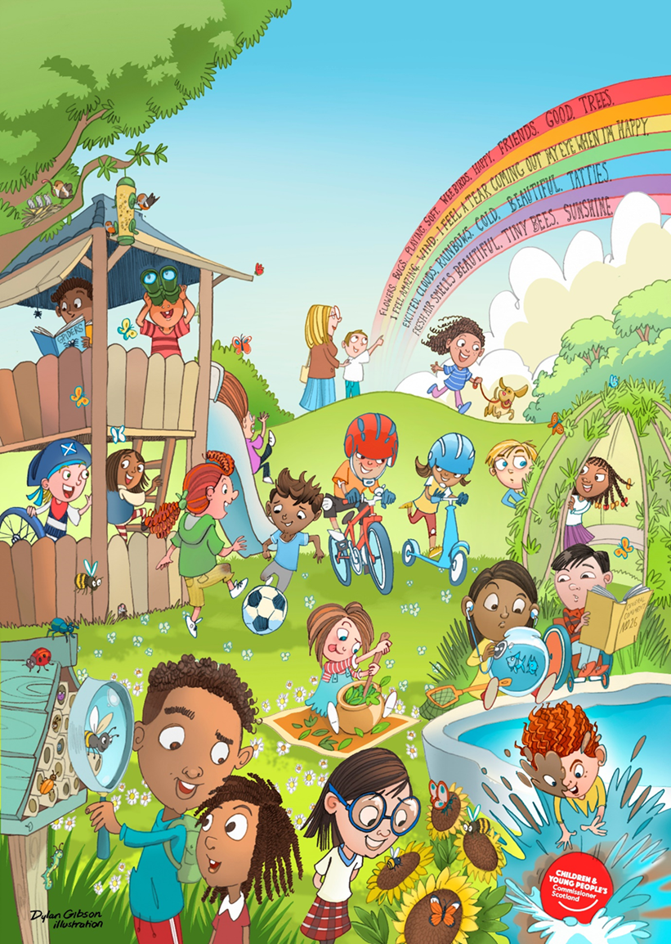
Draft General Comment No. 26, Children’s Rights, and the Environment with a Special Focus on Climate Change
Submission of the Children and Young People’s Commissioner Scotland (CYPCS)
February 2023

Established by the Commissioner for Children and Young People (Scotland) Act
2003, the Commissioner is responsible for promoting and safeguarding the rights of
all children and young people in Scotland, giving particular attention to the United
Nations Convention on the Rights of the Child (UNCRC). The Commissioner has
powers to review law, policy and practice, and to take action to promote and protect
rights. The Commissioner is fully independent of the Scottish Government.

Children and young people in Scotland have identified climate justice as a priority issue for the Commissioner’s work. Our office has supported young people to respond to domestic consultations on Net Zero, made submissions to the United Nations Special Rapporteur on the rights to freedom of peaceful assembly and of association, produced resources and information on the rights of children during climate strikes, and hosted events with children as part of COY16 and COP 26 in Glasgow during 2021 . Our work on climate change and climate justice continues to develop.
We welcome the publication of this draft General Comment on Children’s Rights and the Environment, with a Special Focus on Climate Change, and are pleased to provide our comments on it. Methods of engagement used to inform our response include:
- Engagement with children in early years nursery and primary 1 aged 0-6 years, to increase the participation of babies, infants, and young children.
- Recommendations from our Young Advisors aged 14 – 17, who undertook a year long climate project as part of the European Network of Young Advisors (ENYA).
- Online activity, inviting young children to tell us in one word, or by picture or sound, why the environment matters to them. These words and ideas have been combined and turned into a single image, the front page of this report. The image has been shared with all the children and nurseries who contributed.
The primary focus of this response will be to reflect the views of children aged 0-6 as they are often underrepresented in work on climate change.

Justice & Accountability
Climate change inherently affects children’s human rights, threatening their present and future. Children know what the impact of environmental degradation is and how it affects their immediate world and the world around them.
During our engagement activity, we joined young children on outdoor walks. These environmental walks are part of the children’s learning, delivered in a fun, engaging and experiential way.
As we walked, the children spoke about all the things that they could hear, see, and smell. They splashed in puddles, hopped over rocks, some danced in the woods, while others climbed trees and threw stones in the river. After the walk we asked children what they noticed whilst on their walk. They spoke about some of the amazing things such as “ice and frost”, “the clouds”, “tiny bees” “sky”, “a wee doggy”, “the river” and said they sometimes even see otters!
One child observed: “glass is jaggy but so are jaggy nettles”. The later describes the natural environment (the plant) and the former describes human destruction of man-made objects (the smashed glass). The child knew that the plant used its “jaggies” to protect itself. He said it was not ok to smash bottles and leave glass which he could fall on, or that a dog could “cut its paw on”.
Children also saw “rubbish”, “glass”, “plastic bags”, “cans” and “dog poo”. They were able to identify that these environmental hazards present a risk to animals, babies, children playing in parks, and older people in the form of slipping or falling. We asked children: How does this make you feel? Words such as “sad”, “upset”, “sick”, “angry”, “worried” and “annoyed” were used to describe their feelings. The children also used drawings to express this and spoke at length to early years practitioners and our staff.
In response to seeing signs of pollution:

“I would feel sad if the fish died, they would need to go to fish hospital” (aged 5)
“I was sad with all the rubbish” (aged 4)
“I felt angry like the Hulk” (aged 5)
“I felt sick” (aged 4)
We asked: what should happen to people and organisations if they do not look after the planet? For example, we asked what should happen to people if they discarded all their waste in their playground and who would they tell? The children responded with a range of views, including: “tell an adult”, “pick up the rubbish”, “call the police”, and “send them to jail”. None of the children were able to identify regulatory agencies or other organisations who have oversight and powers relevant to monitor children’s rights, abuses, and violations.
“Phone the police and put them in jail forever” (aged 4)
The children have a strong sense of right and wrong. However, they were not able to identify the role of the State and other actors such as regulatory bodies or an accountability mechanism which they could use to hold those in power to account. Children identified immediate adults in their lives as one of the main groups of people that they would go to for help. “I would tell my mummy and daddy”, “I would tell a grown-up,” and “the police”. This illustrates the significance that familiar adults play in helping young children to exercise their rights and to access information.
Key Messages:
- Learning about access to justice and accountability should be introduced into the curriculum as early as possible and delivered in fun, interesting, relatable, and engaging ways. It should encompass outdoor learning, be play based and help children to understand how to exercise all their rights.
- States Parties should undertake comprehensive children’s rights impact assessments (CRIA) and child rights impact evaluations (CRIE) on decisions relevant to the environment and climate change.
- States Parties should ensure all children have access to child-friendly complaints processes. Children should be involved in the design and creation of complaints mechanisms that meet their needs.
- Children’s rights to protest should be protected by the state.
- The government should introduce legislation to enforce sustainable lifestyles and make a climate friendly certificate for shops and businesses to show that they are addressing the issue of climate justice in all aspects of their business including paying the living wage, using green energy and having things like refill stations for products.

Environmental Education

The following quotes are from children who undertook an experiment with water, using different objects to see what impact water had on the item. It was a creative way of helping children to learn about the environment and recyclables.
“What happened to the plastic? nothing” (aged 4)

“I like bananas and you don’t throw them on the floor, as someone might slip” (aged 6)
“Birds might get sick” (aged 5)

Children told our team that they liked to learn through “playing”, “walking” and “eating biscuits”. There are a range of ways that children can learn about the environment both within the state curriculum and also through charitable organisations. In Scotland, children in early years settings learn about the environment, embedded within the curriculum. While this is positive, older children have told us that the current curriculum is narrow. It does not cover the obligations of the State, provide children with holistic environmental information, learning on accountability, or how to enforce their rights should they be violated or breached. As part of our ENYA project, young people told us that there is little to no learning in secondary school on environmental education. Where secondary schools do provide environmental education, young people told us that it only covered basic information, such as recycling, and tends to focus on individual responsibilities. One young person said that they cannot remember being taught anything about climate change or environmental education during their 5 years of secondary school.
At the Nursery, we spoke with staff who talked about the importance of the environment to babies and infants. Early years practitioners talked about babies’ facial expressions changing when they see different colours, such as the yellow sun and the green grass. Babies enjoy being outside, going for walks and express this by “giggling, “smiling”, “cooing” and “laughing”. In contrast to this, babies’ expressions are the opposite when they interact with something that they do not like or upsets them. Through observations, early years practitioners can see that the baby interacts with the environment, and it directly affects how they feel and behave. When older, these emotions are reflected in drawings with sunshine and scribbles of parks, green grass, rainbows, and choice of hobbies; all of the things the children see, hear and experience when interacting with their environment at a young age.
Nursery staff also used floor books as a method to capture and record the children’s behavior, responses, and interactions. Floor books contained detailed notes, pictures, and scribbles from both the staff and child, who in collaboration identify learning, hobbies, interests, and developmental milestones which are being met. Staff highlighted that these books could also be used as a robust evidence base in policy development and consultations.
Key Messages:
- We support the Committees draft position on environmental education. However, it could be strengthened by explicitly noting that States should do more to engage babies and infants.
- States Parties should develop a holistic environmental curriculum that supports educators, parents, and children to understand accountability mechanisms.
- Children should be involved in the development of the curriculum, providing advice and guidance on teaching methods and ways of disseminating information effectively and accessibly.
- Children and young people need to be better educated about climate justice, they need to know what things they need to do to reduce the effects of climate change and what skills they will need. Having workshops in schools from expert organisations and creating more environmental awards to aim for would help.
Poverty, Inequality & environmental harms
We welcome the links that the Committee have made to poverty, inequality, and environmental harms. We support the description of ‘multi-dimensional poverty’ linked to environmental harms that represent both direct and structural causes of poverty.
In 2022 we worked collaboratively with the Poverty and Inequality Commission to involve children in the scrutiny process of Government policy related to tackling poverty.. Whilst the collaboration was positive, we note that States must do more to involve children in all matters that affect them, including scrutiny. It needs to be systematic and continual, as opposed to one off participation, in line with General Comment No.12 (2009).
Early years practitioners shared with our team the frequency of discussions they have about the cost-of-living crisis and impact on children and families. Some children are living in homes that are not sufficiently heated, parents are going without food to support their family, and their standard of living is not adequate, with environmental harms present. More needs to be done to support those most affected by poverty.
Key Messages:
- States Parties should involve children in the scrutiny process on environmental issues, have clear mechanisms and meaningful forums to have dialogue and hold decision makers to account.
- States should develop comprehensive plans and engagement strategies which are accessible to children.
- States Parties must ensure that children have access to adequate housing.
- Remedy and redress should be available to all children affected by environmental harms.
Climate Finance
Our office is not aware of any Scottish specific examples of children and young people being involved in decision making regarding climate finance. This is an area that requires States Parties to demonstrate leadership, create methodologies and opportunities for children to be involved in line with their evolving capacity. In our 2022 submission to the Committee on the Rights of The Child, we noted that the absence of a child rights approach to national and local budgeting makes it difficult to identify how much funding is allocated to children, assess the effectiveness of resource allocation, hold bodies accountable, or evaluate the impacts on children’s services. Below are views from our Young Advisors in relation to child human rights budgeting.
“People who are involved in budgets will sometimes have a degree in finance or they’ll have worked with that for many years. How do you make that young people friendly?”
(Young Advisor)

“In my experience, I struggle to understand how it all happens because it’s such a big thing” (Young Advisor)
“It’s also important because we’re the next generation of taxpayers” (Young Advisor)
Key Messages:
- States Parties should collect and disseminate data in relation to climate finance and decision making, it should be accessible, identify how children have been involved in decision making and be subject to independent scrutiny.
- Child Human Rights budgeting approaches should inform decision-making.
- ENYA recommendation (page 13) - encourage local eco-activism with events, campaigns, action days and networking possibilities that allow for exchange of ideas: “Eurovision” of climate actions. These campaigns must include the experience of young people who have suffered detrimental effects of climate change.

Access to information
Children in early years settings rely most on the adults around them to help make sense of their world, more than any other group of children. Most do not have access to mobile phones and the internet, or the ability to access or understand independent sources of information. Children who were part of our engagement activities were clear that they identified adults in their immediate world as credible sources of support, as well as their favourite teddy who they would speak to if something was wrong:
“My teacher helps me” (aged 4)
“My dog and teddy, uncle Graham, other uncles, Mark, Steven, Ben, Dad and Mum” (aged 5)
“I would tell my uncle” (aged 5)
During our engagement activities, early years practitioners conducted science experiments, including ‘the litter game’. This game involved children looking at different types of litter and making decisions about what could and could not be recycled, placing it in the correct coloured bin. The children each picked up a piece of litter and then explained why they felt it should go in a certain bin. All the other children listened; they were also invited to share their opinion.
The highly skilled early years practitioners were able to provide clarity and information about each item, helping the children to learn. In most cases the children put the litter in the correct bin. They also taught the adults about some packets that on the surface look like they can be recycled, however they cannot. The children demonstrated excellent listening, debating skills and decision making, as well as sharing their own knowledge and understanding. At the end of each activity, we asked them the following questions:
Who do you tell when you have ideas or if something was wrong? The children responded with “mum, dad, gran, big sisters”, “the police”, “I would tell a grown up”, “firefighters”, “I tell my good ideas to my daddy” and “I tell granny and grandpa”.
How do you know when grownups are listening to you? “grown-ups help people, they help their children”, “the ladies (teachers) look at me when they listen”, “I know grown-ups listen if they look at you” and “I know if adults smile at me, they’re listening”.
The above illustrates that young children identify those who are closest to them as their biggest information source. Therefore, it is important that adults, parents and educators are also given accurate, relevant and accessible information, in order to effectively support the children. It was clear from speaking to the children and early years practitioners that they felt they had no direct relationship with the state to inform policy or decision making. General comment No. 5 on general measures of implementation for the Convention on the Rights of the Child notes that “It is important that Governments develop a direct relationship with children, not simply one mediated through non-governmental organizations (NGOs) or human rights institutions”. Older young people we worked with during the ENYA project also formed a specific recommendation around this issue, noted below.
Key Messages:
- States Parties should produce information that is accessible to children, parents and educators. Children require a more holistic environmental education, with stronger links established between youth and community groups in spaces where they play, learn and live.
- States Parties should develop direct relationships with children, including in early years settings, to inform policy, legislation, practice, and decision making.
- States Parties should ensure that educators receive high quality children’s human rights training.
- ENYA recommendation (page 13) - facilitate access to reliable information in climate change by providing information and training on media literacy and critical thinking and fighting fake news with truthful information. Governments should provide reliable and accessible information on their policies, on decision-making processes and on relevant environmental statistics. Governmental information should help children identify breaches of their rights and redress mechanisms. Truthful information should not be provided only on online channels, but also in analogic formats in mailboxes.

Key Messages from Young Advisors in Scotland

- States Parties should fund, and support youth lead campaigns and activities designed to tackle climate change and promote climate justice.
- States Parties should invest in national campaigns and be present on social media, providing rights-based information and information on climate change.
- States Parties should invest in public transport like electric buses and trains, promote active travel with improved ways that people can walk, cycle and wheeling, as well as making electric cars more affordable and build more charging points.
- States Parties should invest in housing with green spaces, recycling centres, local shops, and services, protecting playparks and green spaces.

We would like to thank all the amazing children who took part in these conversations and the organisations who supported them.

CYPCS, 2021. Consultation response to Net Zero. https://www.cypcs.org.uk/resources/net-zero-nation/
CYPCS, 2021. Submission to United Nations Special Rapporteur on the rights to freedom of peaceful assembly and of association. https://www.cypcs.org.uk/resources/submission-to-united-nations-special-rapporteur-on-the-rights-to-freedom-of-peaceful-assembly-and-of-association/
CYPCS, 2021. Commissioner’s letter to Education Directors urging support for schoolchildren participating in global climate strike https://www.cypcs.org.uk/resources/letter-to-education-directors-supporting-climate-strike/
Clyde in the Classroom, 2023. https://www.clydeintheclassroom.com/
Scottish Government, 2022. Sciences, experiences, and outcomes. https://www.education.gov.scot/documents/sciences-eo.pdf
Poverty & Inequality Commission, 2022. Child Poverty Delivery plan – Child Poverty Scrutiny https://povertyinequality.scot/wp-content/uploads/2022/06/Poverty-and-Inequality-Commission-Child-Poverty-scrutiny-report-2021-2022.pdf
CYPCS, 2022. Report of the Children’s Commissioners of Northern Ireland, Scotland and Wales to the United Nations Committee on the Rights of the Child https://www.cypcs.org.uk/resources/joint-report-crc2022/
UN Committee on the Rights of the Child, 2003. General Comment No.5. https://www.refworld.org/docid/4538834f11.html

