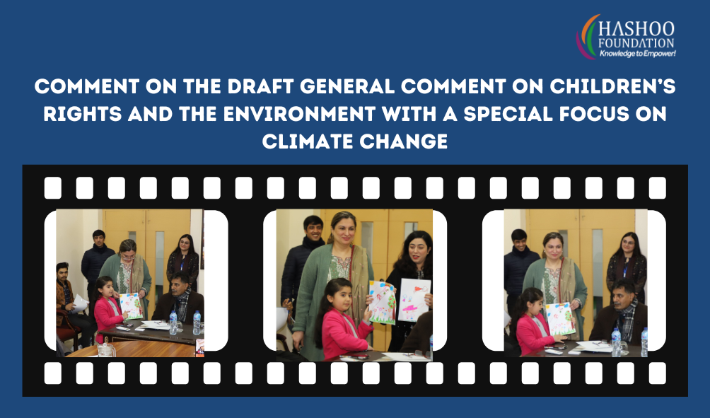

Overview
Environmental harm is an urgent and systemic threat to children's rights globally. The efforts of children to transform the environmental and climate justice movement are the inspiration for the present general comment. Children should be recognized as human rights defenders, and their demands for urgent and decisive measures to tackle global environmental harm should be met. A clean, healthy environment is necessary to fully enjoy a wide range of children's rights, including right to life, survival and development, health, education, food and water security etc. As rights-holders, children are entitled to protection from infringements of their rights stemming from environmental harm. The General Comment draws on the best available and accepted science to describe the ways in which climate-related and other environmental harm interferes with children's rights.

Critical Analysis/ Comment
Children's voices have become a powerful global force for environmental protection and their views add relevant perspectives and experience with respect to environmental matters at all levels. The draft excellently focuses upon how under-five mortality and disease can be prevented through the reduction of air pollution, water pollution, exposure to toxic substances, and other types of environmental harm.
In reference to section 1C of the general comment, we concede with the objectives that "Children's rights and the environment, with a focus on climate change" emphasizes the importance of protecting children's rights in the context of environmental degradation and the effects of climate change. Children's health, education, and well-being are jeopardized by climate change, and it is crucial that their rights are protected as we work to address this global challenge. This includes access to clean air and water, food and health services, and protection from natural disasters and other environmental hazards. In addition, children have the right to participate in decision-making processes that affect their lives and communities, and it is imperative that they be involved in the fight against climate change. By placing children's rights at the forefront of environmental policy and action, we can assure a sustainable future for everyone.
According to 2A, the concept of "sustainable development" is crucial in protecting the rights of children in relation to climate change. To ensure a better future for all, sustainable development seeks to strike a balance between economic growth, social welfare, and environmental protection. Sustainable development can help mitigate the negative effects of climate change on children's rights by promoting low-carbon and resilient communities, improving access to clean energy and water, and reducing environmental degradation. Moreover, integrating child rights into policies and programs for sustainable development can help ensure that children are not left behind in efforts to address the challenges posed by climate change. Sustainable development can help ensure the rights and well-being of future generations by, for instance, prioritizing access to education and healthcare, supporting local livelihoods, and including children in decision-making processes. Integration of sustainable development and child rights is crucial to achieving a more equitable and sustainable future for all individuals.
In accordance with section 2B entitled "Intergenerational equality and future generations," the committee also respects the intergenerational equity concept and the interests of future generations. Almost all children surveyed (88%) agreed that climate change and environmental damage posed a threat to future generations, and 63% believed that children were affected more than adults. Climate change-related child rights are highly dependent on intergenerational equity which refers to the principle that current generations should not undermine future generations' ability to meet their own needs. In the context of climate change, it entails addressing the implications of climate change on children, who will inherit a more difficult world if no action is taken to mitigate or adapt to its effects. In the face of climate change, current generations may defend children's rights by promoting intergenerational equity by reducing greenhouse gas emissions, investing in renewable energy, and promoting sustainable development for the benefit of both present and future generations, participation of children and youth in decision-making processes and the incorporation of their viewpoints into policies and programs.
In addition, section 2 focuses on best available service and precautionary principle; we believe by putting most emphasis on providing health services for children is not enough. In the context of child rights and climate change, "best available service" also refers to providing children with the resources, protection, and support they need to adapt to the effects of climate change and protect their rights. This may include access to education, healthcare, clean water, and electricity, as well as initiatives to mitigate the risk of extreme weather events, displacement, and other climate change-related consequences. The provision of the "best possible service" necessitates a commitment on the part of governments, communities, and other stakeholders to prioritize the rights of children and take action to mitigate the effects of climate change. It also necessitates investments in research, technology, and innovation to find new and more effective methods for preserving children's rights and mitigating climate change's effects.
Continuing with reference to section 3 The CRC recognizes numerous environmental rights essential to child rights. The CRC's most fundamental right, the right to life, survival, and development is closely linked to environmental protection. States must safeguard children from environmental harm and provide safe and healthy living conditions under the right to life. This includes clean air, water, food, and protection from pollution and hazardous waste. States must give children the resources and opportunities they need to thrive under the right to survival and development. This includes education, healthcare, and other essential services, as well as safe and healthy environments for their physical, mental, and emotional development. The right to life, survival, and development demands States to reduce greenhouse gas emissions, promote sustainable development, and invest in climate change adaptation to protect children. This involves protecting children against extreme weather, food and water insecurity, displacement, and other climate change impacts.
The right to survival and development is a crucial right enshrined in the Convention on the Rights of the Child (CRC) that relates to the environment. This right requires States to take action to ensure that children have the resources and opportunities they need to grow and develop to their full potential. In the context of the environment, the right to survival and development requires States to provide children with access to safe and healthy living conditions, including clean air, water, and food, as well as protection from environmental hazards such as toxic waste and pollution. This also involves ensuring that children have access to education, healthcare, and other essential services that support their physical, mental, and emotional development. The impacts of climate change can pose significant challenges to the realization of the right to survival and development for children. Climate change can result in food and water insecurity, displacement, and other threats to children's health and well-being. In response, States must take action to reduce greenhouse gas emissions, promote sustainable development, and invest in adaptation measures to protect children from the impacts of climate change.
The link between children's mental health and environmental harm is widely acknowledged and requires additional focus. Article 29(1)(e) of the Convention states that a child's education must foster respect for the natural environment. States should maintain physical access to schools during extreme weather or adopt other teaching techniques.
Climate-friendly school buildings can benefit children and help states meet their environmental responsibilities. The child rights impact assessment should be used to anticipate the environmental impact of any proposed policy, legislation, budget, or administrative decision affecting children. States should ensure that age-appropriate mechanisms are in place at all stages of the environmental decision-making process to ensure that children's voices are heard. They should encourage, acknowledge, and support the constructive contribution of children to environmental sustainability and climate justice. For abuses of their environmental rights, children should have access to timely, appropriate, and effective judicial and non-judicial measures.
In addition, with a slight contradiction to section 3F, "the right of indigenous children" demands a bit more attention. The Convention on the Rights of the Child (CRC) recognizes the environmental rights of indigenous children, as they have cultural, historical, and spiritual ties to their lands, territories, and natural resources. The CRC also recognizes the right of indigenous children to engage in cultural life, preserve their cultural heritage, and use their native language, as well as to be safeguarded from exploitation and discrimination. Climate change can also pose obstacles to indigenous children's rights, as it can lead to the loss of customary territory, food and water insecurity, and other challenges to their well-being.
According to section 4 which is the right to a clean, healthy, and sustainable environment recognized as a fundamental human right having intimate ties to the rights of children. Children are especially susceptible to environmental degradation and pollution, and they have the right to grow and develop in a safe and healthy environment. The Convention on the Rights of the Child (CRC) grants every child the right to the best achievable quality of health and to live in a healthy environment. This right requires states to ensure that children have access to clean water, food, and air, as well as protection from harmful waste and pollution. The right to a clean, healthy, and sustainable environment is more critical than ever in view of the ongoing global environmental catastrophe, which includes climate change. The effects of environmental degradation and climate change can have severe repercussions on the health, well-being, and development of children; therefore, states must take action to address these concerns. To ensure that the right of children to a clean, healthy, and sustainable environment is recognized and maintained, states must reduce greenhouse gas emissions, promote sustainable development, and invest in adaptation measures to shield children from the effects of climate change. States must also take measures to protect and preserve the environment, including tackling the core causes of environmental deterioration, such as deforestation, resource extraction, and other activities that might harm children and ecosystems.
For section 5, States shall utilize platforms at all levels to gather and process data on climate-related specifics pertaining to children's rights. Due to the unique status of children, the State owes them a greater obligation of care. Children must have access to knowledge to appreciate the potential implications of environmental degradation on their rights. States should evaluate the impact of climate-related policies on children, particularly the most vulnerable groups. This includes long-term effects, interaction effects, and effects on the many developmental phases of children. States are obligated to ensure that enterprises respect children's rights. The Committee proposes that enterprises establish strategies that incorporate the rights of children and the environmental impact of their operations. High-income states should support adaptation and mitigation activities in developing nations by enabling the transfer of green technologies and by contributing to climate mitigation and adaptation. States should work in good faith to build global responses to losses and damages caused by climate change in the most vulnerable nations.
Further, section 6 focuses on the climate catastrophe, which poses a grave threat to the enjoyment of the Convention's children's rights. States should establish a consistent approach to integrating climate action into all measures pertaining to children, including education, recreation, access to green spaces, and child protection legislation. Depending on the quality, equality, and sustainability of vital services for children, such as water, sanitation, and health care, states should identify climate-related child vulnerabilities. In accordance with the Paris Agreement and the Intergovernmental Panel on Climate Change's (IPCC) report on the effects of global warming, the Committee urges states to take advantage of the limited window of opportunity to reduce climate change impacts. It asks states to ensure prompt dissemination of any information that would enable children, carers, and communities to adopt protective actions. The developed nations should assist developing nations in planning and implementing mitigating measures to aid the most vulnerable children. Major contributors to greenhouse gas emissions are businesses, which negatively impact children's rights locally and contribute to both short- and long-term violations of their rights. Investors should do due diligence and other methods to analyze the impact of climate-related harm on children's rights on their transboundary activities, such as supply chains and worldwide operations. Businesses provide actual and predictable climate-related dangers to the rights of children that must be addressed by home states.

Conclusion
Developed States should cooperate with developing States to provide the necessary climate finance for climate action that upholds child rights. The current climate finance gap, which is excessively skewed toward mitigation initiatives at the expense of adaptation measures, has discriminatory impacts on children who reside in situations where additional funding is required. States should subject the approval and implementation of climate money to an assessment of its impact on children's rights. The concept of "best available service" is essential to guaranteeing the protection of children's rights in the face of climate change, as it provides children with the necessary resources, protection, and support. Intergenerational justice is essential for protecting children's rights, as it puts the needs and rights of future generations first. The Convention on the Rights of the Child recognizes the significance of the environment in the lives of indigenous children, and the right to survival and development as a fundamental right with significant implications for the environment and the preservation of child rights. These specific rights, such as the right to life, survival, and development, play an essential role in defending child rights. We can create a more sustainable and fair future for all children if we ensure that these rights are respected and maintained.

Consultative Session Findings
Date: 9th February 2023
Location: Plot 02, Street 02, H-8/1, Islamabad, Pakistan.
Type of Stakeholders: Academia Experts, CSO’s, Youth Organizations, Hashoo Youth Climateers from Gilgit Baltistan, Sindh, Islamabad, KP, Hashoo Youth Climate Champion, Chair and Members-Child Rights Movement, Chair- National Action and Coordination Group
Age: 5yrs- 60yrs
Gender: Male & Female
Origin of Participants: Pakistan
Format: Hybrid: Virtual as well as in person
A consultative session was held by Hashoo Foundation at their core office Islamabad-Pkaistan, where different stakeholders were invited to comment on the HF’s findings on the Draft General Comment. Discussion themes including climate change mitigation and adaptation, coping and adaption, adaptation capacity, vulnerability, and climate compatibility development were at the center of the session. During the presentation, numerous topics were discussed, including the context of challenges and issues of children's rights, key UN report findings such as UN general comments on how to prevent under-five mortality by reducing pollution, toxic exposures, and environmental harms, integration of child's policies and programs, intergenerational equity, resources, and opportunities, and investment in adaptations as a prime focus for children. HF shared recommendations with stakeholders on the following points: states should implement age-appropriate mechanisms to ensure children's voices are heard for access to judicial and non-judicial measures to protect them from environmental harm; States need to take joint action for climate mitigation and adaptation measures through the transfer of climate-friendly technologies and solutions with minimum cost and access to climate finance for to address climate change in the context of children as the most significant stakeholders; and state policies should be reviewed and revised by independent bodies to integrate child rights. The presentation addressed the current climate finance gap, which has disparate effects on children living in regions where greater funding is necessary. The participants also suggested Climate tax on multinational companies as well as countries that are the greatest emitters and put our future generations at risk. Through Zoom, the session continued with consultative exchanges between in-person and remote participants. Ms. Dua, the youngest 5 year old climate champion and HF’s child ambassador, expressed her message "children are the victim of climate change, help preserve the environment through some visuals that she had created herself.
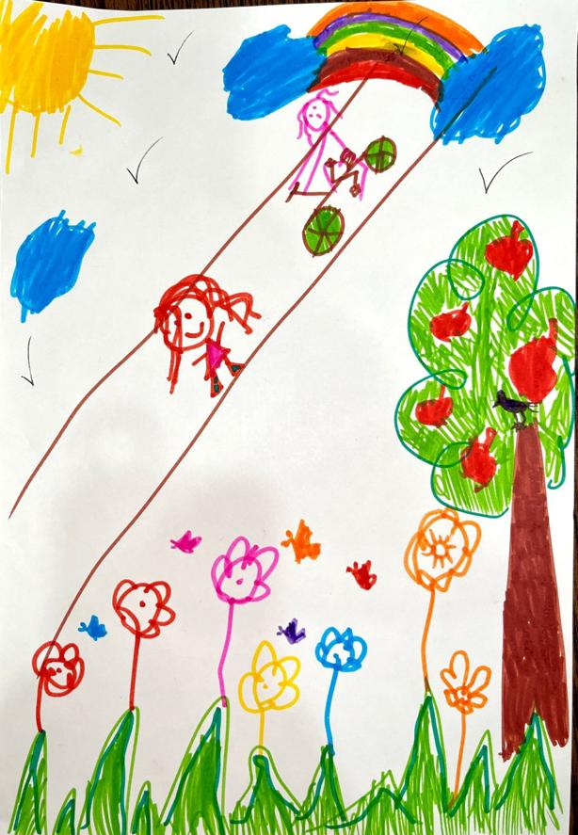  Hashoo Youth Climate Champion drew an illustration in which kids are playing and cycling around a green park surrounded by trees, flowers, and a rainbow. The sun is shining bright, and there is a gentle breeze in the air. The children are all smiles and seem to be enjoying the fresh air and the freedom of the outdoors. The scene is a perfect example of how a healthy environment can bring joy and happiness to kids. | 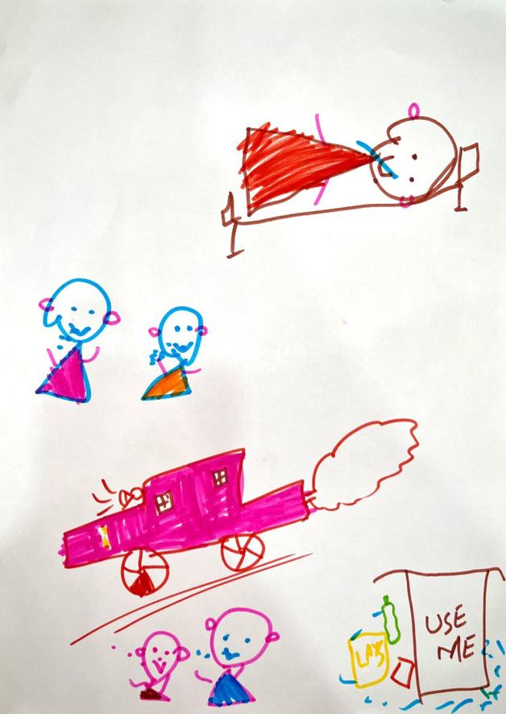  In the picture, a group of kids are standing on the side of a busy street, coughing, and covering their noses and mouths. The air is thick with smoke and pollution from the exhaust pipes of the cars passing by. The sky is hazy, and there is a distinct smell of fumes in the air. The children appear to be in discomfort, some of them are rubbing their eyes, while others are trying to find a place to escape the polluted air. The scene is a stark reminder of the harmful effects of air pollution on the health and wellbeing of children. | 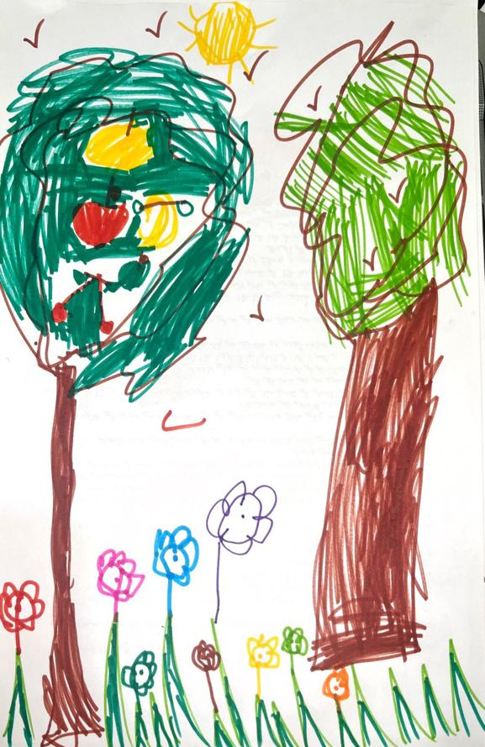  In the picture, there is a beautiful natural landscape with trees, flowers, birds, and a shining sun. The birds are perched on branches, and some of them are flying in the clear blue sky. The sun is radiating warm and golden light, casting a beautiful glow over the scene. The overall effect is peaceful and serene, highlighting the beauty and importance of nature in our lives and the need to plant as much trees as we can.

Furthermore, in the continuity of this Mr. Arshad( discussed the significance of climate change and outlined how environmental conservation produces the desired environment. Mr. Liaqat Masih said that concerted activities, such as DDR, water management, the sustainability of child life, and an understanding of the context of children's demands, are required. Mr. Niazullah Khan proposed ideas to enhance awareness of child rights to the population and promote water conservation, water lining, natural ecosystems. The Convention on Biological Diversity reaffirmed action items to include child rights and climate agenda in primary school instruction, effective water management, and resource mobilization. Ms. Mahwish Kayani and Ms. Memoona Tariq acknowledged the commencement of a consultation session on children's rights and the climate. Mr. Aurangzeb shed light on children's right to play and the lack of amenities in our environment which ultimately act as carbon sinks. Mr. Zia Rehman highlighted two techniques to enhance child rights: adaptative measures in children's education curriculum and enhancing state agenda implementation on child rights. Ms. Maria emphasized the impact of climate change on children with disabilities and thanked participants for their insightful comments and suggestions. Hashoo Climateers from four provinces voiced their concerns about their rights to seek Climate justice and to divert the resources to them, they also emphasized the significance of Climate literacy and programs like Hashoo Climateers which is enabling them to raise their voice to the policy makers.

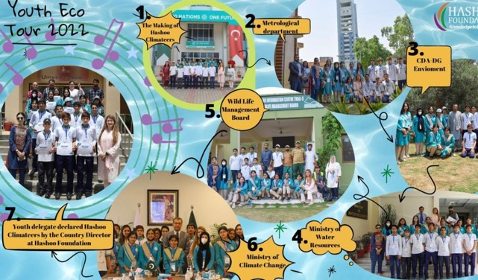

Visuals of Consultative Session

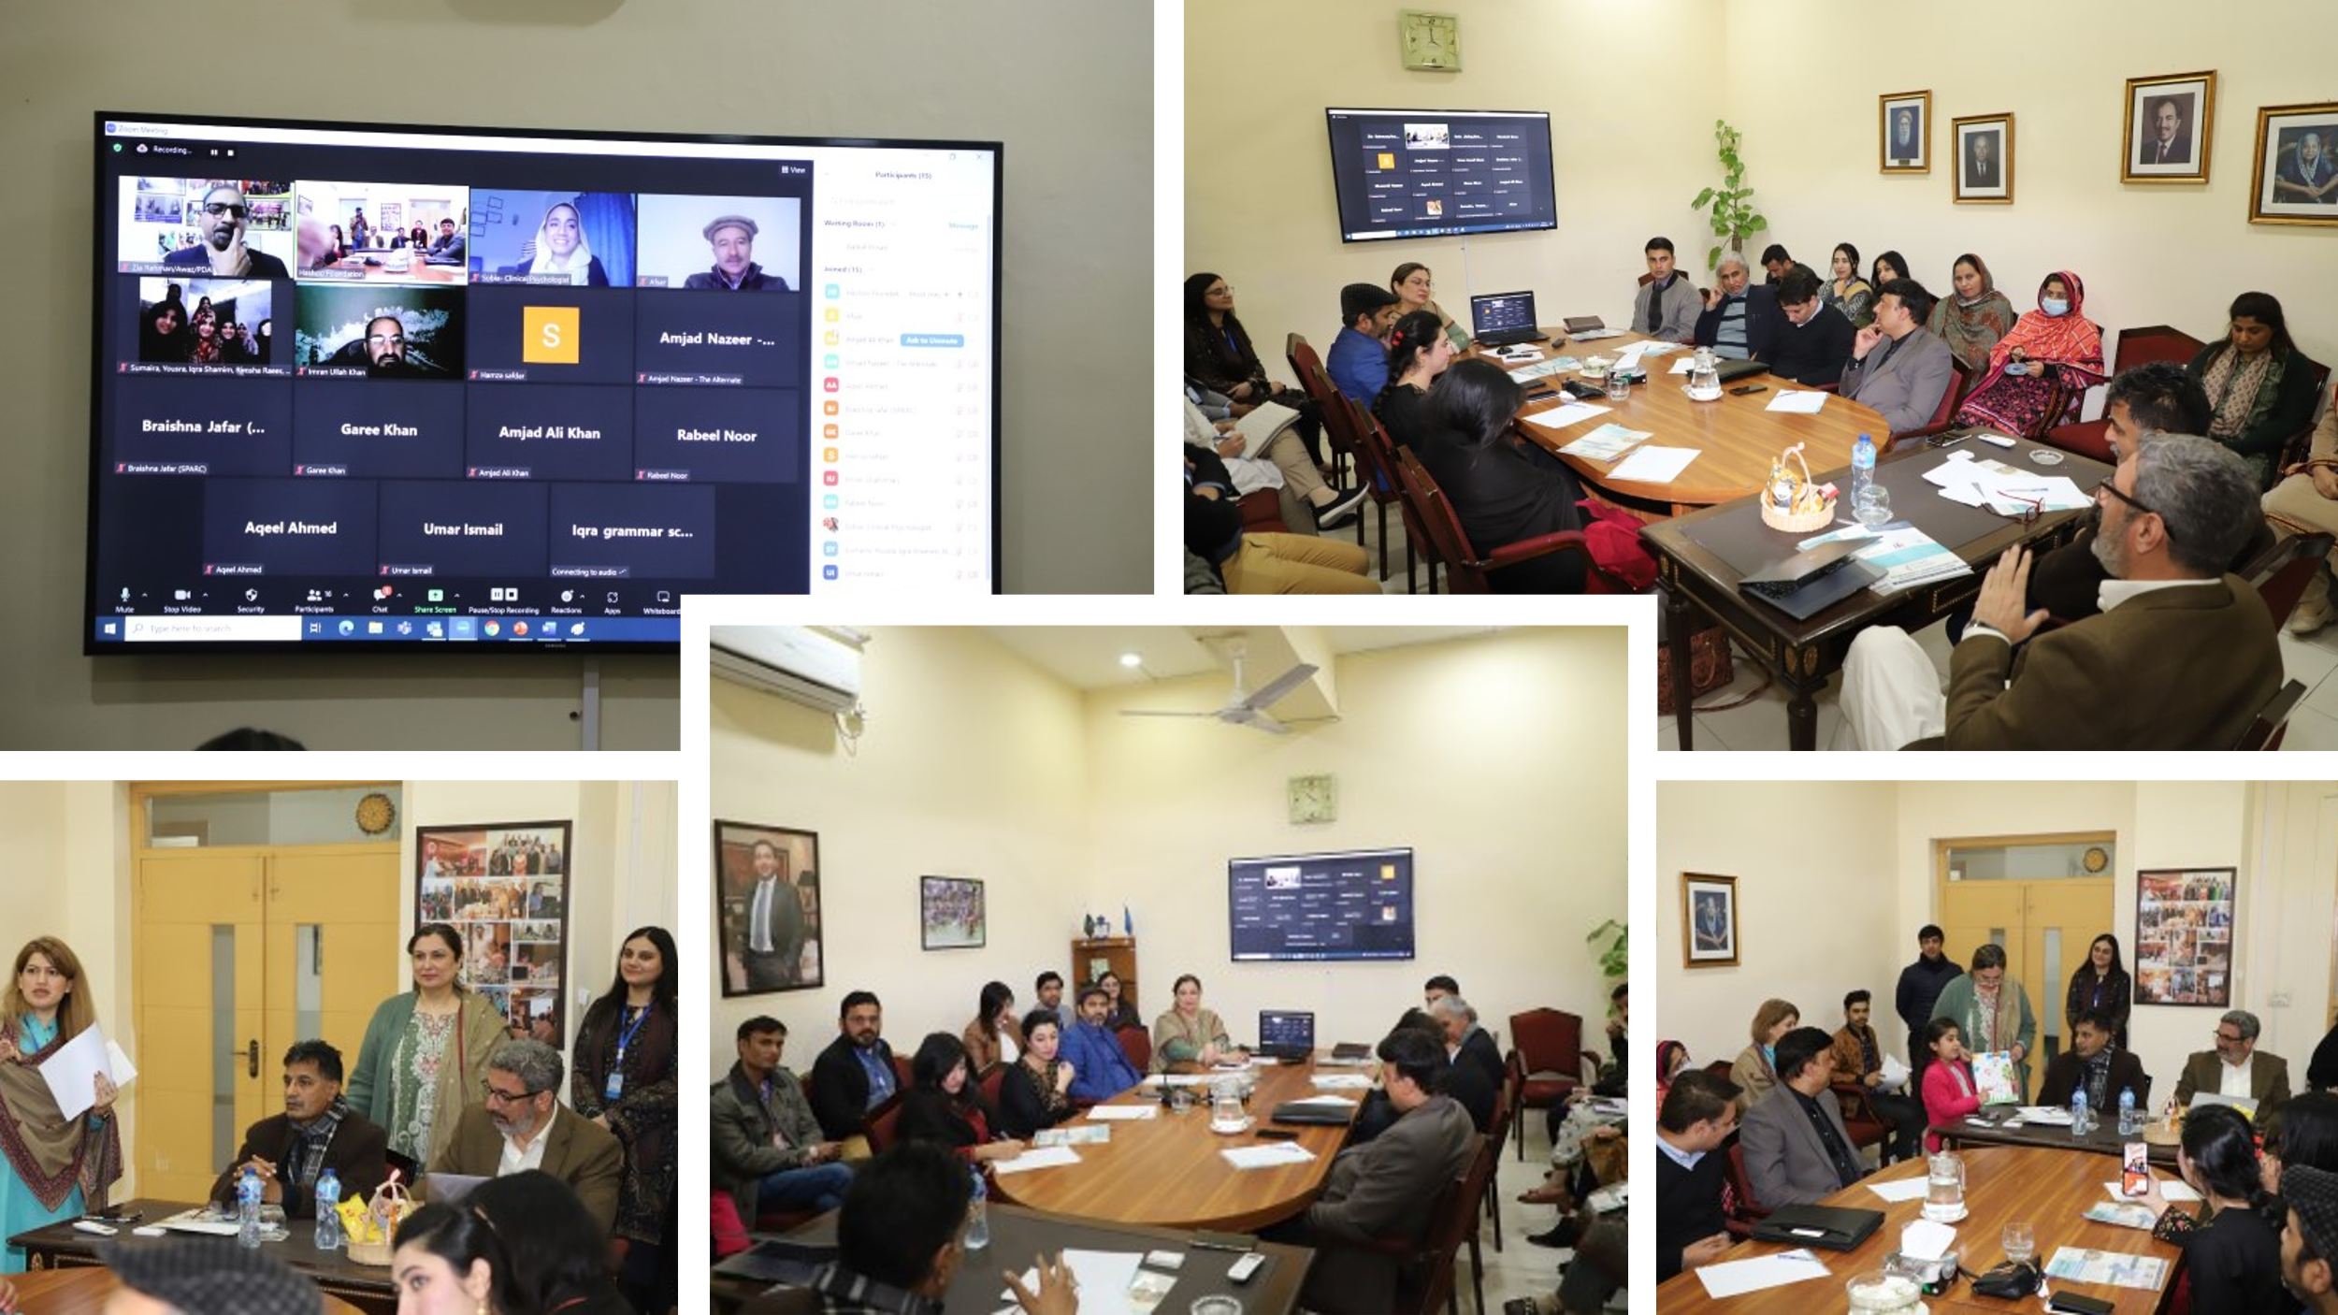
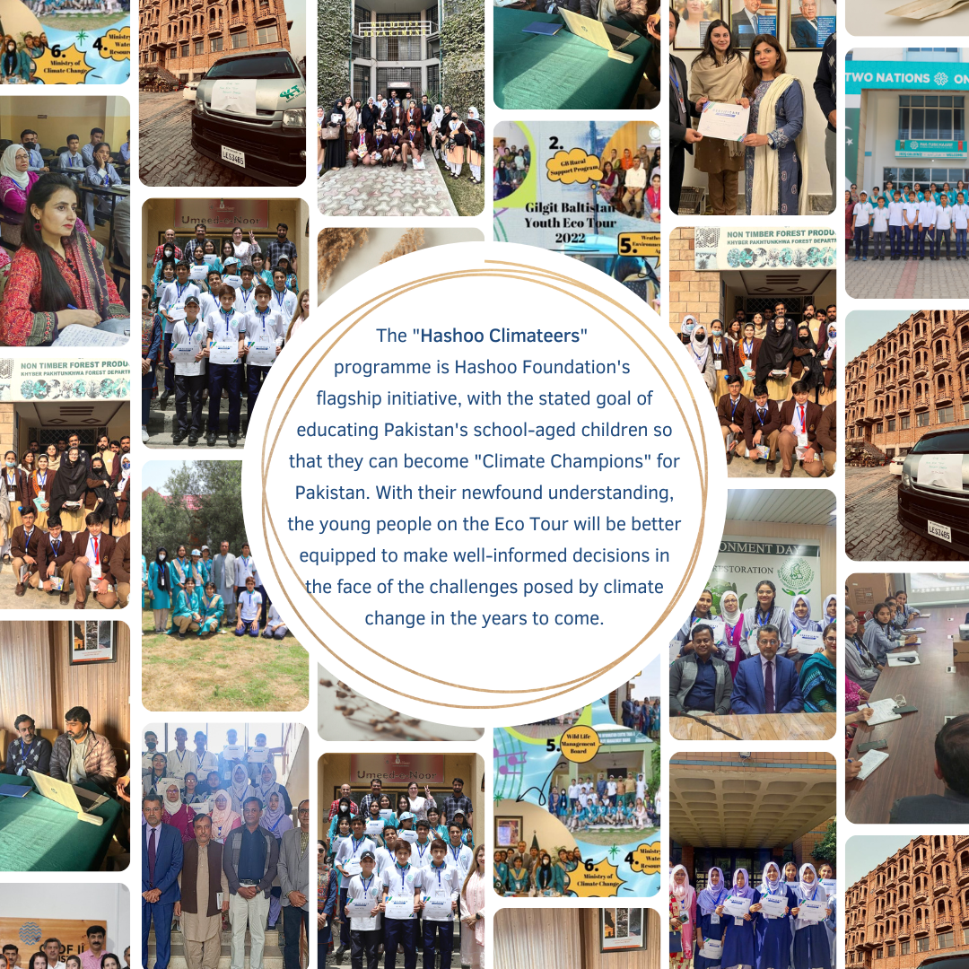

Mahwish Afridi
Head of Strategic Support Unit
mahwishafridi@hashoofoundation.org

