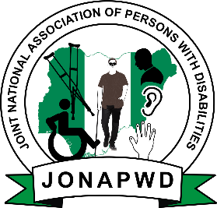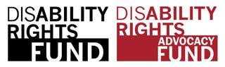

Report on Consultative Meeting with Children and Youths with Disabilities:
The Nigerian Climate Change Narratives for a Safe, Healthy and Sustainable World that Respects the Rights of Children
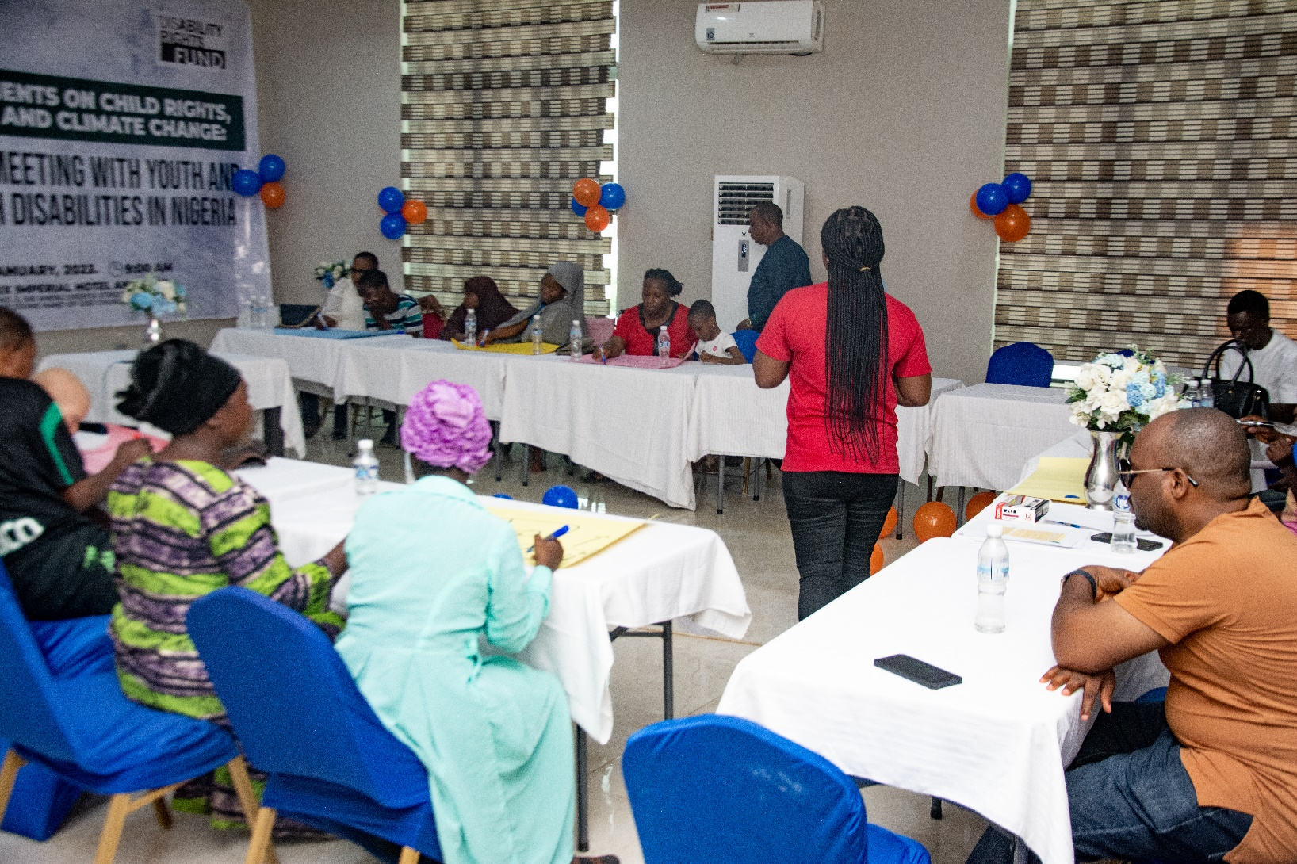
Abuja, Nigeria
January 28, 2023

Contents

INTRODUCTION………………………………………………………………………………… 2
Participants Information………………………………………..………………………………………………….2
Meeting Objective………………………………………………………………………………………………3
Consultation Methodology………………………………………………………………………………………..3
CONSULTATION PROCEEDINGS AND FINDINGS……………………………………………………………………………………3
…………………………….……………...3

RECOMMENDATIONS………………………………………………………………………….…7

1.0: Background
This report is a direct response to the call by the Committee on the Rights of the Child (CRC Committee) towards the drafting of a new General comment on children’s rights and the environment with a special focus on climate change (GC no 26). From children’s perspectives, it is aimed to explicitly address environmental issues with specific focus to article 25 of the United Nations Convention on the Rights of the Childs (CRC), paragraph 2 (c), which obliges States to take measures to combat disease and malnutrition, while also taking into consideration the dangers and risks of environmental pollution. It also considers other conditions under article 29, paragraph 1(e) which requires States to direct the education of children to the development of respect for the natural environment.
Since the adoption of the Convention in Nigeria, the acceptance on the wide-ranging interconnections between children’s rights, disabilities and environmental protection has garnered some form of development interest. Against the above background, The Joint National Association of Persons with Disability (JONAPWD), the umbrella organization of Organization of Persons with Disabilities (OPD) with supports from the Disability Rights Fund (DRF)/Disability Rights Advocacy Fund (DRAF) held a Consultative Meeting with children and youths with disabilities and their parents/guardians to extensively deliberate on issues around their rights and the environment, with a special focus on Climate Change.
The consultative meeting was conducted as part of JONAPWD’s mandate to ensure that children and youths with disabilities in Nigeria, as rights-holders, are entitled to protection from infringements of their rights, especially infringements stemming from environmental harm/climate change effects, and to be recognized and fully respected as active citizens using child-based approach.

2.0: Information about Participants

Table 1: Showing overall information about key participants at the consultative meeting.
Overall Details
Location (town/city/region/country) | Abuja, Federal Capital Territory (FCT) – Nigeria
Description of participating children (school group, community group, climate activists etc.) | Children and Teens with Disabilities representing diverse disability constituencies including children and youth with cerebral palsy, Down syndrome, physical disabilities, blind child, child with intellectual disabilities, autism, spinal bifida and albinism
Number of participating children with disabilities | Six (6)
Number of participating youth/teens with disabilities | Two (2)
Number of Participating Parents/Guardians | Eight (8)
Age (please state the number of children by each age) | 7 to 17 years old
Breakdown of gender (please state the number of children by gender) | Girls: 5  Boys: 3
Participating children’s environment (urban, rural, other) | Urban and rural
Preferred languages | English and Hausa (Indigenous)
Facilitators’ names, organization and contact details | Name: Adetunde Ademefun  Organisation: JONAPWD - Joint National Association of Persons with Disabilities (The Umbrella Organisation of Persons with Disabilities (OPD) in Nigeria)  Email: info@jonapwdng.org/ed@jonapwdng.org  Number: +234-8181320320

3.0: Objective, Questions and Methodologies
Specific objectives of this consultative meeting were to obtain and gather comments and views of children and youth with disabilities on their environment and climate change. Meeting was aligned toward objectives targeted at the general comment which are to:
- Emphasize the urgent need to address the adverse effects of environmental harm and climate change on children.
- Promote a holistic understanding of children’s rights as they apply to environmental protection.
- Clarify the obligations of states parties to the Convention and provide authoritative guidance on legislative, administrative and other appropriate measures to be undertaken with respect to environmental issues, with a special focus on climate change.
From the disability perspectives, the consultative meeting considered the following questions:
- How children and youths with disabilities in Nigeria are affected by climate change- including how climate change affects indigenous children with disabilities, girls with disabilities, and others?
- How children and youths with disabilities in Nigeria can or cannot access information and education about the environment and climate change; How that differs (or not) from other children in the country?
- How children and youths with disabilities in Nigeria have the opportunity (or not) to be heard and express their views on discussions on climate action?
- How states and other actors could better ensure the participation of children and youths with disabilities in climate action?
In activating learnings at the meeting, methodologies adopted at the Consultation included but were not limited to descriptive animation, creative arts and design, and interactive learning.

Parent/Child Consent: The consent of the children and their parents/guardians were obtained by filling a consent form. Without any form of assertive demands, this was conducted in such a way that no child or parent was under pressure to give consent, rather participants exhibited absolute willingness to give their consent. All participants signed the consent forms and they have been stored securely by JONAPWD and DRF/DRAF.

4.0: Proceedings and Findings
Photo1: Theophilus, DRF Program Officer (L) and Adetunde Ademefun ®, Executive Director of JONAPWD at the consultative meeting
  - Consultation with Children, Youths and their Parents/Guardians: JONAPWD commenced the consultation process by asking if the participants have heard about climate change. This pre-testing question revealed that only one (1: A Blind Girl of eight years) of the eight (8) children and youths with disabilities at the event have understanding about the context. Two (2) others exhibited some form of understanding while the rest showed no form of understanding:
Fig 1: Knowledge of Climate Change by children with disabilities

By switching participation roles, all parents exhibited high degree of understanding. This reality revealed that even though knowledge about contemporary issues by parents/guardian of children and youths with disabilities are high, it does not usually transmit to knowledge scope of the latter. Neither does age proximity to adulthood have any effect. From enquiry, the Blind Girl with absolute knowledge on climate change is currently being enrolled at a school for the Blind in the FCT where concepts on climate change and the environments are taught.
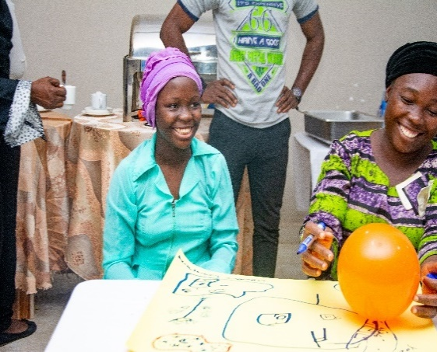
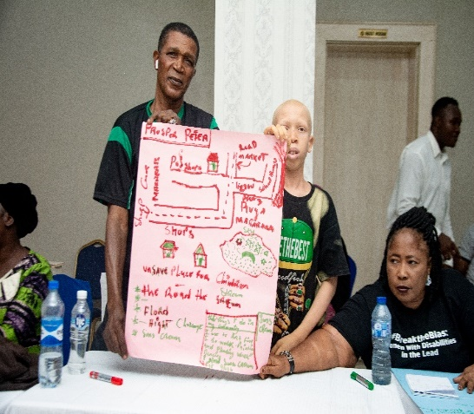
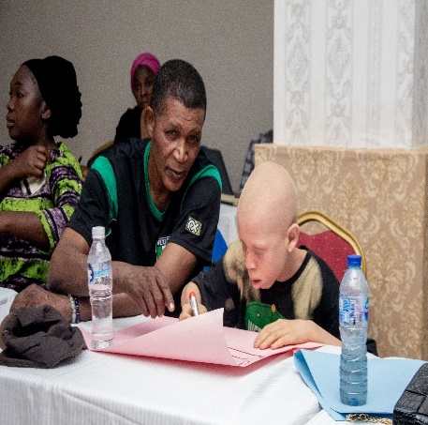
By means of this understanding, Juliana simplified the concept of climate change and its effects on the environments. After given this simplified background, participants, (children and youths with disabilities) with supports from their parents/guardian were asked to create a sketch of climate change and the following were captured:
3
2
1

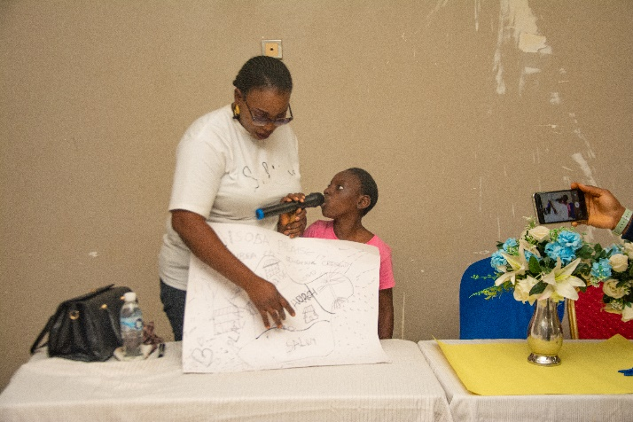
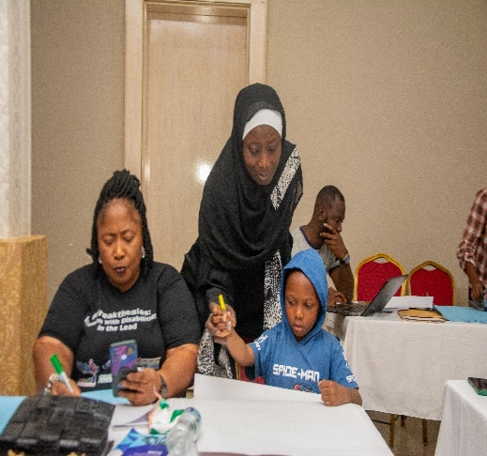
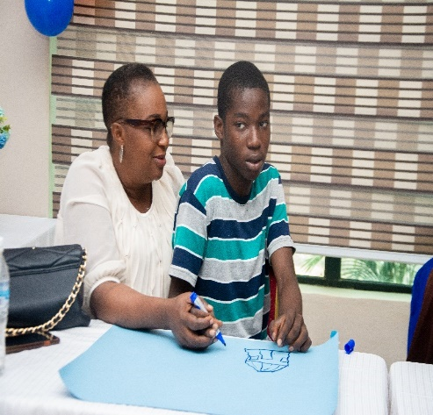
4
6
5

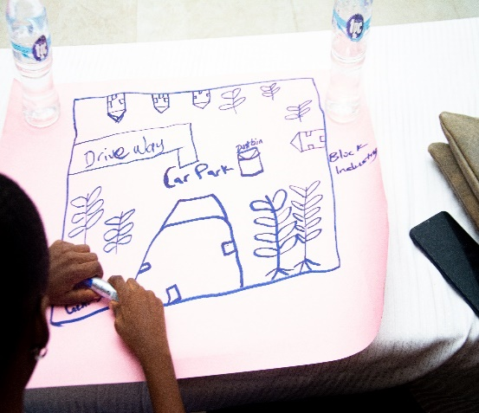
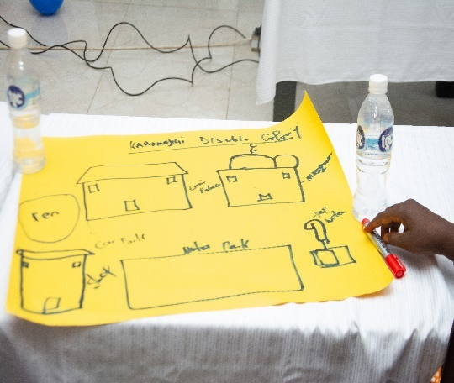
7
8

By descriptions, participants sketched maps of their various communities indicating where they live and the major landmarks in their community such as rivers, markets, worship places, dumped refuse, forest, trees, erosion prone areas. They also indicated, on the map, where they feel safe and unsafe. Some of the comments during presentations are captured below:
- In her community sketch, Khadija from Karomagiji area along airport road identified a stream as an unsafe place to be because garbage is being dumped which makes the stream prone to water borne diseases and one also risks drowning.
- Somtochukwu from Kubwa sketched his community with the help of his mother, identifying dogs, main road, trees, other houses surrounding them and a table water factory. He mentioned that he feels safe when he is under the tree playing but feels the highway is unsafe as no one will recognize from afar if he is a child with disability or not, and the motorist plying the road might knock him down.
- Victory sketched her community located at Aso Estate. She mentioned that there are no trees in her community hence there is excess heat in the environment which she feels is not safer for them to play due to absence of shades. Also, the wind easily destroys houses and shops.
- Prosper, a child with albinism identified a highway with no Zebra crossing on the road as unsafe for him. Due to his disability, he has poor sight during the day under excess sunlight and he doesn’t have a sunscreen that will enable him to prevent his skin from cancer.
In a similar vein, deliberations during this session gathered the following comments:
- “Trash bin in my environment is not hygienic for anyone to play with because it is infected” ..Victory (A blind girl)
- “I can’t cross the major road in my street, because of the lighting which can cause damage to the eyes” …Prosper, (A boy with Albinism)
- “Flood is a challenge which can cause loss of house”. Jumai (A teen with Spinal Bifida)
Some of the reactions from parents were:
- “These things in my environment are threats to my child, therefore government need to intervene. Example of such things are stream, lake and others which are mostly unhygienic which can lead to infection, bacterial, ring worm, skin cancer, aches, and several other. With these, children need to be safe from the chemicals.” Prosper’s Father
- Government and other partners should provide aid for persons with disabilities and children with disabilities should be shown love and be accepted whole heartedly.” Khadija’sGuardian
- “Underground drainage, air pollution and vehicles that bring smokes should be controlled by the government” .. Somtochukwu’s Mother

- Key Questions:
Comments were gathered in response to the following questions:
Question 1: Is climate change something to be concerned about?
- Victory, a blind girl responded and said she is personally concerned about climate change because it can result in flood and is a threat to her safety.
- Khadija said she is concerned about climate change because it may lead to disease outbreak which will be harmful to children.
- Perpetual (a girl with spinal bifida) mentioned that there is a Noodles Company in her community and chemicals exhaust from the company can be harmful especially as it causes difficulty in breathing.
- Peter mentioned that climate change can cause further eye defects and it is a major concern for him.
Question 2: What are the biggest impacts and challenges that you, your family and community face in relation to climate change?
- Victory responded and said her house was flooded and it only took the grace of God that she survived or else it would have been a different story. Her disability couldn’t let her realize what was going on and it was God that saved her from dying during the flooding.
- Adama responded that the roof of his parents’ house was blown off due to heavy rain and storm. This would have been prevented if there were enough trees in the community.
Question 3: Have you learned about and been informed about climate change in school or in your community? Is accessible information available to learn about it?
- Victory mentioned that she was taught about climate change in school and that her teacher mentioned it when their house was flooded. This is the primary reason why she hardly forgets about climate change given her personal experience. She also mentioned that information is available on the television to learn about climate change.
- All other participants responded that they have never been taught about climate change either in school or in their community and they have no access to information about climate change.
Question 4: Are measures being taken by your government to better prepare families and communities in the face of climate changes?
- Victory responded that the government warned the masses to desist from unnecessary cutting down of trees and also encouraged citizens to cultivate the habit of planting trees in their communities.
- Perpetual responded that government issued a statement on the need for people building houses and living in waterways to vacate to avoid flooding.
Question 5: Have you been invited to or involved in any discussions with community or government leaders about this?
- All the participants’ response was No; they have never been invited or involved concerning climate change.
Question 6: What would you like to share with the Committees on behalf of children and youth with disabilities in Nigeria related to climate change?
- Peter lamented on the effect of the sun on his eyesight and on behalf of all other children with albinism, he proposed budgetary provisions for sunscreens or community engagements with the government to make the provision for sunscreen and other protections to protect their skin and sight.
- Perpetual called on the communities to set up child-friendly spaces for children with disabilities, including to have clean and safe areas so that activities such as swimming could be introduced. She added that she experienced discriminations in the society especially at parks and other child spaces. She urged the government to help set up programs that will integrate children with disabilities with their counterparts.
- Victory lamented on the need for government to take drastic actions on running water, repair drainages and to build more dams to prevent flooding. In her words, she said, “If not God that help me, I would have been consumed by the flood”.
- Khadija, an indigenous girl who uses a wheelchair, speaking in Hausa language responded that government should regulate garbage companies and to ensure they stop illegal dumping of garbage in waterbodies around communities. “This will prevent disease breakout which will in turn affect children especially, we that can’t walk”.
- Praise’s mother expressed concern about government’s schools. She said that government should make provision for children with disabilities and that there should be no form of discrimination or marginalization against them. Schools with proper infrastructures should be made available with proper facilities that will enable children with disabilities to mingle with their peers.
- Parent to Abubakar (a Deaf child) mentioned that sign language interpreters should be encouraged in media houses so that Deaf children will understand what is being said. Without sign languages, children will not understand what has been said and this will be a barrier to their level of knowledge about important trends on television stations and other media centers including when issues around climate change are discussed.
- Mallam, guardian to Khadija, decried the unsatisfactory effort by the government on the need to provide wheelchairs for disabled children, and other vital needs that will aid them to stay away from danger and trouble. “Government should have facilities and should introduce sustainable training and orientation. Pollution from industries should be curbed, motorist with faulty vehicles emitting smoke should be arrested and made to fix their motors.’’

6.0 Recommendations
At the end of the consultative meeting, JONAPWD collated recommendations needed to envision a safe, healthy and sustainable Nigeria that respects the rights of all children and youths with disabilities across the diversities and demography. Some of the recommendations include but are not limited to the following:
- Government must fund specific resource hubs that supports the creation of accessible campaigns and outreach networks, targeting the public including children with disabilities, to raise awareness on climate change and its impacts.
- Based on Victory’s testimony (the blind girl who mentioned how she was miraculously saved from flood), government should ensure absolute mitigation plan to prevent flooding as it mostly affects persons with disabilities especially, children who are most affected by structural barriers. These plans should include construction of drainages along waterways and clearing the existing ones, making provisions for dams to help reduce overflooding the existing ones, and enabling accessible pathways using universal designs.
- Government should lead concrete actions with Civic Societies/Organizations of Persons with Disabilities (OPDs) on sensitizing the community around the need to plant more trees in their environments and to reduce unnecessary cutting down of trees. Government should modify existing environmental laws and policies in order to capture the needs and rights of children with disabilities. This set up should be backed by grassroot task force in various communities for enforcement.
- Communities should be sensitized on climate change and how to engage in environmentally friendly practices such as safer ways of cooking to avoid burning of charcoal and other fossil fuels as this will contribute to global warming which will make the environment unsafe for children.
- Topics such as greenhouse gas emission, depletion of the ozone layer, extreme harsh weathers and other effects of climate change should be included in children’s curriculum across all school levels so that children will be informed about dangers of climate change and be equipped to take action that will change the future conversations.
- Government should create inclusive consultations with children and youth with disabilities and those without disabilities where they can have access to information on climate change, its effect and also suggest proactive measures on how to survive in the event of disaster. These consultations should also be designed in such a way that they sustain alternative method of feedbacks to enable all children and youths with disabilities to sufficiently capture and express their opinions.
- Government should ensure that children are taught and informed about climate change in school, with accessible curricula and learning materials to guarantee the full participation of children with disabilities in the learning.

http://67.199.83.28/index.cfm/news_nigeria-ratifies-crpd-and-optional-protocol

