February 15, 2023

Sub: “Call for comments on the draft general comment on children’s rights and the environment with a special focus on climate change”.

Enact Earth Foundation (Enact) welcomes the Call for Input by the Committee on the Rights of the Child. Enact is a not for profit organisation that was founded in July 2021 with the goal of creating a ‘Climate Literate Society’. Its current primary focus of youth engagement and empowerment within the climate space. We hope that our effort can inspire more young persons to engage with processes like these. We hope that the submission might serve some use and to inform the Committee on the Rights of the Child in finalising the General Comment on children’s rights and the environment with a special focus on climate change.

Contributors: Hemavathi S Shekhar, Prerna Kaushal, Deyvani Pudale, Raghav Das, Akhilesh Anilkumar

- Right to Health and complementing the best interests of Child: Environment Pollution standards that consider children’s vulnerabilities. ( Part IV - Heading B and H)

As we consider the rights of children in relation to the environment, it is critical that we prioritise their health and well-being. Children are particularly vulnerable to the negative health impacts of environmental pollution due to their developing bodies, immature immune systems, and higher rates of respiration and physical activity. Therefore, it is imperative that environmental policies and standards take into account the unique vulnerabilities of children and prioritise their health in pollution mitigation strategies.

One key recommendation is to establish separate standards for pollutants that are particularly harmful to children, such as lead and air pollutants. These standards should be based on the specific health risks faced by children rather than relying on average adult exposures. Additionally, policies should consider children's unique exposure pathways and behaviours, such as spending more time outdoors or engaging in certain activities that increase their exposure to pollutants.

By prioritising the health of children in environmental policy, we can ensure that the next generation is protected from the harms of pollution and has the opportunity to thrive in a safe and healthy environment. This includes not only reducing exposure to harmful pollutants but also promoting access to clean water, healthy food, and safe housing. We have a responsibility to ensure that children's rights to health and a safe environment are protected, and taking a proactive approach to environmental policy is an essential step towards achieving this goal.

- Right to Education: Language Barriers to Access to education for migrant children (Part IV - Heading C)

Language barriers can also pose significant challenges for migrant children, particularly if they are moving from one state to another or from one country to another. In India, for example, there are over 22 official languages and several hundred dialects, which can make it difficult for migrant children to access education in a language they understand. This can result in a significant language barrier, which can prevent them from fully participating in the classroom and understanding the curriculum.

To address these challenges, it is essential to develop education policies that are inclusive and accessible to migrant children. This may involve providing language support services, such as multilingual textbooks, language classes, and interpreters, as well as developing culturally sensitive and relevant curriculum materials that reflect the diversity of migrant communities. Additionally, it is important to invest in infrastructure, such as schools and education centres, in areas with high concentrations of migrant populations.

In conclusion, addressing the right to education of migrant children in India requires a multi-faceted approach that considers the unique challenges they face. By promoting inclusive and accessible education policies that address language barriers and environmental challenges, we can ensure that all children have access to quality education, regardless of their migrant status. This, in turn, can support their health, well-being, and long-term success.

- Freedom of expression, association and peaceful assembly and access to justice and remedies (Part IV -Heading J and K)

The general assumption this paragraph 60. makes is that the state is an unquestionable do-gooder. In most countries, especially in the global south, when it comes to matters involving the environment, especially in the forms of public protests, there is usually no support by the states. Rather, it is usually the exact opposite. The document does not give any recourse in case the state does not uphold this freedom which is an important aspect with regard to such freedom.

One important point to raise at this juncture is the reality of state actions in some countries, particularly in the Global South, when it comes to protecting children who express their views on environmental issues or engage in public protests. It is true that in some countries, the state may not always act as an unquestionable do-gooder and may, in fact, be a source of threats, intimidation, and harassment against child rights defenders.

The paragraph recognises that states have an obligation to protect the rights of child rights defenders, including the right to freedom of expression, peaceful assembly, and association, and that this protection should extend to initiatives organised by children to defend human rights. However, it is also true that, in some cases, states may fail to uphold these obligations. The paragraph does not provide specific guidance on what children can do if the state does not protect their rights, particularly when the expression is against the state itself.

It is important to note that international human rights standards recognise the right to seek remedies for violations of rights, and this applies to child rights defenders as well. Children can seek redress through legal and non-legal means, such as filing complaints with national or international human rights bodies, seeking support from civil society organisations, or engaging in advocacy and awareness-raising activities.

It is also worth noting that the paragraph calls on states to adopt and implement laws to protect child rights defenders in accordance with international human rights standards and to raise awareness against the stigmatisation of activities. This indicates that international human rights bodies recognise the need for stronger legal protections for child rights defenders and the importance of changing societal attitudes towards their activities.

- Children’s rights and the business sector: Policies to uphold Intergenerational Equity by Businesses and in the context of Climate Change (Part V - Heading F and Part VI - Heading D)

Intergenerational equity is the principle that every generation has a responsibility to ensure that future generations inherit a healthy and sustainable planet. Businesses play a critical role in upholding child rights through their actions, and they should make decisions that prioritise intergenerational equity.

One way that businesses can do this is by prioritising environmental sustainability in their operations. By reducing waste, conserving energy, and reducing their carbon footprint, businesses can ensure that future generations have access to the same resources and opportunities that we do today. Additionally, businesses can ensure that their supply chains are free from child labour and other forms of exploitation and that their products and services are safe and healthy for children.

However, it is not enough for businesses to make these decisions on their own. Government policies and regulations play a critical role in ensuring businesses uphold intergenerational equity and child rights. Governments should create policies that push businesses to prioritise sustainability, ethical labour practices, and social responsibility. This can be done through incentives, such as tax breaks or subsidies, as well as through regulations that require businesses to meet certain standards and requirements.

Another critical reason why businesses should prioritise intergenerational equity is the urgent need to address climate change. The impacts of climate change, such as more frequent and intense natural disasters, rising sea levels, and food and water shortages, will disproportionately affect children and future generations. By prioritising sustainability and reducing their carbon footprint, businesses can help to mitigate the impacts of climate change and ensure that future generations have access to a livable planet.

Additionally, businesses that fail to address climate change may face reputational and financial risks as consumers and investors increasingly prioritise sustainability and social responsibility. Therefore, prioritising intergenerational equity and taking action on climate change is not only a moral imperative but also a smart business decision.

In conclusion, businesses have a responsibility to uphold child rights and ensure intergenerational equity through their decisions and actions. However, it is up to the government to create policies that incentivise and require businesses to take these actions and ensure that future generations inherit a sustainable and just world.

- Conversations on Loss and Damage due to Climate Change need more emphasis: (Part VI and Part IV -Heading B)

When it comes to child rights and loss and damage, it is important to recognise that children are particularly vulnerable to the impacts of climate change, both in terms of their physical and emotional well-being. For example, children may experience malnutrition, illness, and injury due to extreme weather events or food shortages. They may also be forced to flee their homes due to rising sea levels or other environmental hazards. In addition, the loss of important cultural and social traditions can also have a profound impact on the emotional and psychological well-being of children.

- Access to Trauma Care
Climate change can have a significant impact on children's physical and mental health, leading to trauma and distress.Policies for trauma care for a child due to climate change can help ensure that children who experience trauma due to climate change have access to appropriate care and support. Here are some policies that can be put in place:
  - Increase funding for mental health services: Governments can increase funding for mental health services that provide trauma care for children affected by climate change. This can include counseling, therapy, and other forms of support.
  - Develop trauma-informed care guidelines: Trauma-informed care guidelines can help health care providers understand the specific needs of children affected by climate change and provide appropriate care.
  - Provide training for first responders: First responders, such as emergency medical services, firefighters, and police officers, can be trained in trauma-informed care to provide appropriate care and support to children affected by climate change.
  - Develop community-based support systems: Community-based support systems, such as peer support groups and community health centers, can provide children with access to support and resources in their communities.
  - Increase awareness of the impact of climate change on mental health: Governments and organizations can increase awareness of the impact of climate change on mental health and the need for trauma care for children affected by climate change.
- Addressing Loss and Damage:
  - Ensure that child protection policies are in place: Governments should have clear policies in place to protect children in the aftermath of extreme weather events. These policies should prioritise the reunification of families, provide emotional and psychological support for children and families, and ensure access to basic needs such as food, shelter, and medical care.
  - Promote disaster preparedness: Governments should invest in disaster preparedness and response efforts to minimise the risk of separation and loss in the first place. This includes developing early warning systems, improving infrastructure to withstand extreme weather events, and ensuring that emergency response teams are equipped to provide support to families and communities in the aftermath of disasters.
  - Ensure the participation of children and families: It is important to ensure that children and families are included in the policy-making process to ensure that their voices are heard, and their needs are met. This can include engaging with local communities and involving them in the development and implementation of disaster preparedness and response policies.
  - Foster international cooperation: Extreme weather events often affect multiple countries, and therefore, there is a need for international cooperation to address the issue of loss and separation of children from their parents. International cooperation can facilitate the sharing of best practices, knowledge, and resources and help to build stronger, more resilient communities.

Annex 1

When it comes to environmental awareness and behaviour, economic class differences can be very important. Due to disparities in education, access to information, cultural beliefs, and lifestyles, people from different socioeconomic strata may have varying levels of environmental awareness. Generally speaking, those in higher socioeconomic classes tend to be more engaged with and aware of the environment. They frequently have greater access to education and awareness about environmental issues, as well as more financial means to promote sustainable behaviours, which may contribute to this. Furthermore, according to some studies, persons from higher socioeconomic strata are more prone to view environmental challenges as morally and ethically troubling. On the other hand, people from lower socioeconomic classes may be less aware of or engaged with environmental issues, due in part to limited access to education and information, as well as more pressing economic concerns.
We sought out to prove this as an important factor while commenting on the general draft and conducted a survey within youth from different social backgrounds.
Our first visit involves an NGO in a Delhi slum area. Slums in Delhi are typically characterised by overcrowding, inadequate housing, lack of basic amenities such as clean water and sanitation, and high levels of poverty.
We spoke to two groups of children, one of 10-15 years and the other group of below 10 years of age. The group of children below 10 years of age, a total of 30 of them, were confused about the topic and didn't really know anything about climate change, or of their life has been impacted. We assumed that this must be because these are the conditions they've grown up with. Meanwhile the 10-15 year cluster of kids, a total of 10 children, knew general information about climate change and environmental degradation. They said that their lives had been impacted because of untimely rains and dust storms. Upon being questioned on, they also said that they hadn't noticed the shift in seasons too much and that the change is sudden and jarring.
We next passed the questionnaire around a few students of grade 10 in a well established school. Out of a total of four children, all of them agreed on climate change and environmental damage impacting their life and communities, and knew what the concept behind these terms were. Three of them were aware of their rights and held the opinion that they could reach out to authorities if their rights were violated in relation to climate change. Only one student said that they don't have a say on these matters and are not taken seriously while the rest were leaning more towards the positive side (one agreeing that they're taken seriously and they have a say, while the other two lurking in the middle with the 'most of the time'). There was a brief, unrecorded conversation with a child living in the slums about the subject matter, but he simply said he didn't really know much about the topic and they haven't been taught about it so he doesn't know anything.

The questionnaire was next passed among a group of 15 children of an unknown economic background within the age group 14-18.
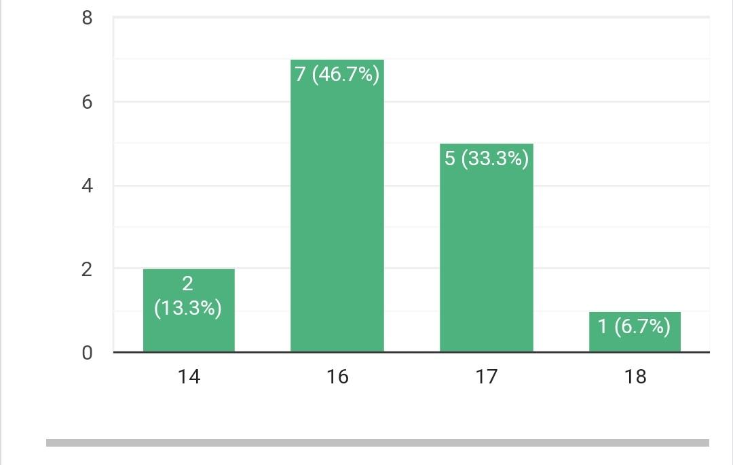
- Out of the bunch of 15, 5 of them responded with a strong yes regarding being aware of rights given under the Convention on the Rights of the Child, while 4 didn't know anything about them and 1 knew of them vaguely.
- A whopping 4 of them said they can reach out to authorities if their rights regarding climate change and environment are violated, but one of these 4 added that they didn't think the authorities would respond actively. 3 said they didn't think they could reach such authorities/don't know if they can, while 1 said maybe.
- 6 children didn't think their life had been changed because of the consequences of climate change, but out of these, 2 of them knew of peers or family whose lives had been affected by climate change. 1 child said yes to the question, 1 said somewhat as an answer and 1 was confused but said they had changed their way of living because of climate change so we can assume that their life must have been impacted on some level by climate change.
- 5 children agreed that their life had changed because of environmental damage, while 3 disagreed.
- 4 children were certain that they were taken seriously when they talked about climate change and had a say in the matter. 1 said they were taken seriously when they talked about climate change but didn't think they had a say in the matter. 7 children said no, but 2 of them tried to share as much knowledge as they knew on the subject.
Personal Opinions:
I've personally gotten a lot more prone to coughs and common illnesses because of the rising pollution level, I've also been unable to wear a variety of foods more often because we can never be too sure about what kinds of pollutants gave entered them during the process. I work with a lot of stay dogs in the neighborhood and it's gotten increasingly difficult keeping them comfortable in unpredictable climate changes, shared one student.
I am allergic to dust and smog, so I have to nebulize twice almost everyday and can't leave the house without a mask. Said another
Due to this I have faced extreme heat in summers. Severe rain and storms in the rainy season. Health issues. And also I haven’t experienced it but glaciers melting and oceans becoming warm are very dangerous signs of climate change. Another spoke from experience.
I have noted an increase in temperature in the summer months over the years, but it has not impacted me very severely. However, it is clear that if climate change continues at its current pace, there will surely be more disasters like untimely floods, unpredictable weather etc.
Or as very succinctly, one put it as, It is bad.
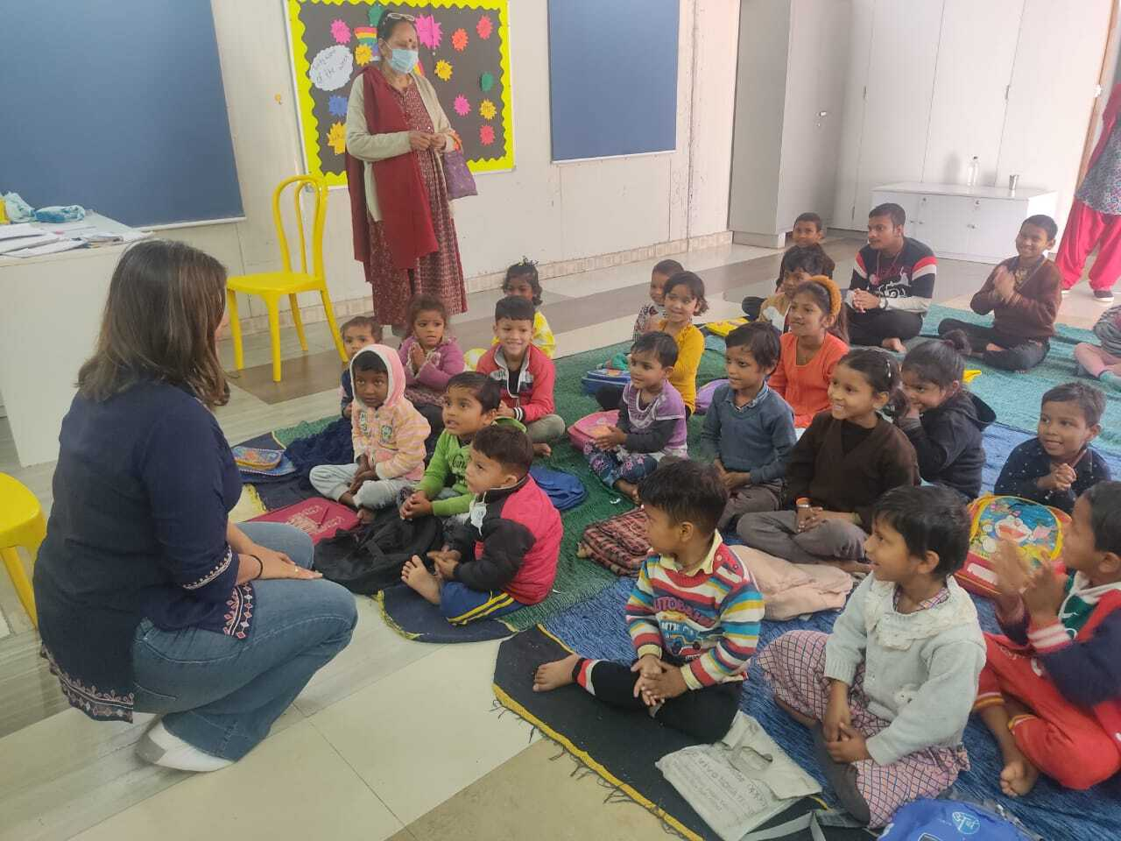
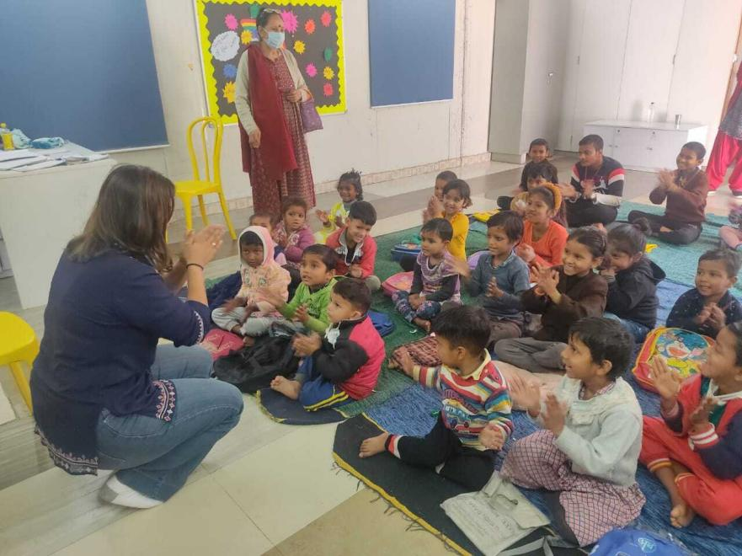

Note:Respecting the Privacy and unable to work on a process of wavier, we only took consent for 2 pictures with the children.

