15 FEBRUARY 2023

Executive summary

Background
The Australian Conservation Foundation (ACF) welcomes the opportunity to provide the following submission regarding the Draft General Comment No. 26 of the Committee on the Rights of the Child (Committee) on children’s rights and the environment with a special focus on climate change (GC26 or the Draft General Comment).
For over 50 years, ACF has been one of Australia’s most influential non-governmental organisations in championing pro-environmental action. ACF adopts a proactive approach to advocating for greater environmental awareness, engaging with communities, businesses and governments to achieve long-lasting change. ACF represents a community of more than 700,000 people, many of whom are children who are uniquely vulnerable to environmental issues, in particular climate change.
As the driest inhabited continent in the world, Australia is particularly vulnerable to the impacts of climate change and extreme weather events. Australian children and young people have been active in voicing their concerns about environmental degradation and climate change and have advocated for greater action by governments, businesses, and other key stakeholders to address these issues. Besides calling for action through online advocacy and public demonstrations, young Australians have also made headlines as litigants in domestic climate litigation and through complaints to intergovernmental bodies.
ACF notes the significance of GC26 in (among other objectives) providing State parties to the Convention on the Rights of the Child (Convention) such as Australia with authoritative guidance on legislative, administrative, and other appropriate measures to be undertaken with respect to environmental issues, and particularly climate change. Through this guidance, ACF hopes that GC26 can influence further legal developments in Australia towards greater recognition and protection of children’s rights to a clean, healthy, and sustainable environment.
While ACF broadly approves of the GC26’s current drafting, we recommend that the Committee consider the following discrete amendments to further recognise, protect, and clarify children’s right to a clean, healthy and sustainable environment.

Recommended amendments to draft GC26

The best interests of the child (art. 3)

Rationale

The Committee has provided meaningful draft guidance regarding the interpretation of article 12 of the Convention in the context of environmental issues and climate change. As noted in the Committee’s General Comment no. 12 (GC12), article 12 constitutes “one of the four general principles of the Convention” alongside the right to non-discrimination, the right to life and development, and the primary consideration of the child’s best interests. Article 12 is particularly interdependent with article 3 of the Convention concerning the best interests of the child.

However, the nexus between these two general principles is not immediately clear from the current drafting of GC26. Insofar as State parties and other relevant stakeholders are directed to make determinations of, assess, and take action in accordance with, the ‘best interests of the child’, it is imperative that a child or a group of children’s best interests be established in consultation with affected children consistent with article 12 of the Convention. Any consultations with children should be effective and meaningful and not tokenistic. All such processes in which a child or children are heard and participate to determine their best interests in the context of environmental decision-making should likewise be conducted in a manner consistent with the principles set out in GC12.

The suggested amendments below target the interdependency between articles 12 and 3 in GC26.

Suggested changes

ACF recommends paragraph 53 be amended as follows:

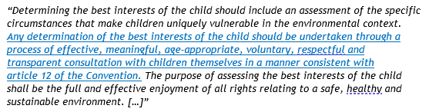

The right of the child to be heard (art. 12)

Rationale

GC12 also provides that all processes in which a child or children are heard and participate must be inclusive, safe, and sensitive to risk. While the current drafting of GC26 appears to recognise the importance of inclusivity and creating a safe space for children to express their views, there is scope for the Committee to provide further guidance to State parties and other key stakeholders on these issues, in order to facilitate effective and meaningful participation by children regarding environmental issues that impact their lives.

To ensure that consultation processes involving children are inclusive, GC12 directs that participation by children must “avoid existing patterns of discrimination, and encourage opportunities for marginalized children, including both girls and boys, to be involved”. The Committee has noted that children “are not a homogenous group” and that “participation needs to provide for equality of opportunity for all, without discrimination on any grounds”. Further, programmes “also need to ensure that they are culturally sensitive to children from all communities”. Consistent with the principles outlined in GC12, the Draft General Comment should also expressly note the importance of seeking a diversity of views when facilitating the participation of children in relation to environmental issues.

Likewise, while the draft GC26 notes that the “digital environment has potential for consulting with children and expanding their capacity and opportunities to effectively engage on environmental matters”, over-reliance on digital platforms for conducting consultations with children may conversely reinforce existing patterns of discrimination in contexts where children face structural barriers such as socio-economic background, geographic remoteness, or ethnic or national origin, which limit their access technology or digital literacy. Similarly, as recognised by the Committee’s previous General Comment no.25, children face unique risks online, including cyberaggression and harassment. We therefore recommend that the Draft General Comment specifically address the risk of harm in digital environments and caveat against over-reliance on digital platforms for consulting with children and youth, as outlined in the proposed amendments below.

Suggested changes

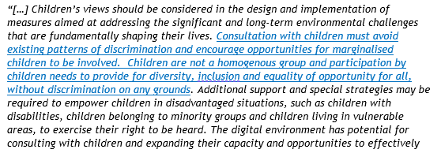
ACF recommends paragraph 56 be amended as follows:

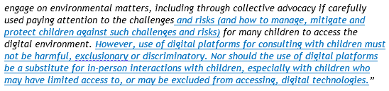

ACF recommends paragraph 57 be amended as follows:

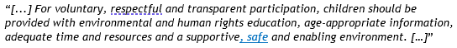

The right of children with disabilities (art. 23)

Rationale
The current drafting of GC26 does not contain any specific guidance for the interpretation of article 23 of the Convention in the context of environmental protection and climate change. This is despite the Committee’s prior recognition in its General Comment no. 9 (GC9), that “[p]aragraph 1 of article 23 should be considered as the leading principle for the implementation of the Convention with respect to children with disabilities”.

It is well acknowledged that environmental degradation and climate change present direct and acute challenges for the realisation of this right. Children living with disabilities are more vulnerable to environmental harm.
We therefore recommend that the Committee consider undertaking further consultations with relevant stakeholders (including children with disabilities, their parents and guardians, and relevant civil society organisations) to provide authoritative guidance on the interpretation of article 23 in the context of environmental issues and climate change, as well as related legislative, administrative and other appropriate measures to be undertaken to specifically protect and promote the rights of children with disabilities in relation to environmental issues, with a special focus on climate change.

The right of Indigenous children (art. 30)

Rationale
In relation to the interplay between article 30 and article 12 of the Convention, the Committee’s prior General Comment no. 11 (GC11) notes that State parties play an important role in promoting the participation of Indigenous children and should “design special strategies to guarantee that their participation is effective”. The Committee further recommends that State parties “work closely with indigenous children and their communities to develop, implement and evaluate programmes, policies and strategies for implementation of the Convention”.
Likewise, while the current drafting of GC26 encourages States to engage with Indigenous children and their families to integrate (as appropriate) Indigenous cultures and knowledge in mitigation and adaptation measures, it is imperative that such consultation is conducted in a culturally-sensitive manner, and is not tokenistic or exploitative.
Consistent with the Committee’s prior guidance in GC11, we therefore recommend the below amendments to paragraph 49 of the draft General Comment to expressly recognise the importance of effective and meaningful engagement with Indigenous children and their communities in relation to environmental issues and climate change.

Suggested changes

ACF recommends paragraph 49 be amended as follows:

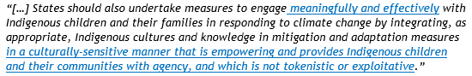

Role of NHRIs in relation to children’s rights and the environment

Rationale

In its General Comment no. 2 (GC2), the Committee provided authoritative guidance to State parties regarding the role of independent national human rights institutions (NHRIs), as well as specialised children’s ombudspersons, children’s commissioners and other independent bodies, in the promotion and protection of the rights of the child. The Committee has explicitly recognised that such institutions “are an important mechanism to promote and ensure the implementation of the Convention”, and that NHRIs “have a duty to seek to ensure that children have effective remedies – independent advice, advocacy and complaints procedures – for any breaches of their rights”.

However, the Draft General Comment does not contain any detailed consideration of the roles that NHRIs play in relation to children’s rights and the environment. While the current drafting of GC26 does briefly recognise the role of such institutions in connection with access to justice and remedies, and as recognised by the Committee in GC2, NHRIs can play a broader role besides simply providing a complaints mechanism for children: for example, through human rights education and public advocacy activities. We therefore encourage the Committee to further consider the role of NHRIs for the protection and promotion of children’s rights to a healthy environment and any further guidance which can be provided in GC26 on this topic. As a starting point, and consistently with the terms of GC2, we recommend the below amendments to the Draft General Comment to further recognise the role of NHRIs.

Suggested changes

ACF recommends the following paragraph be inserted after paragraph 33:

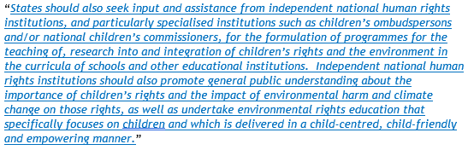

ACF recommends the following paragraph be inserted after paragraph 65:

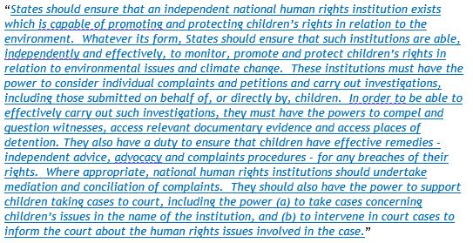

Accountability, monitoring and periodic reporting obligations

Rationale

Pursuant to article 44 of the Convention, State parties are obliged to submit periodic reports to the Committee regarding measures adopted to give effect to the rights recognised in the Convention and progress made regarding enjoyment of those rights. In its General Comment no.5, the Committee explained that this reporting process “provides a unique form of international accountability for how States treat children and their rights”.

The periodic national review process has also increasingly become a forum for holding State parties accountable for action on environmental issues and climate change. For example, following its review of Australia’s joint fifth and sixth periodic report and related submissions by civil society organisations, the Committee noted in its Concluding Observations on 27 September 2019 that it was “very concerned about the State party’s position that the Convention does not extend to protection from climate change” and “emphasize[d] that the effects of climate change have an undeniable impact on children’s rights, for example the rights to life, survival and development, non-discrimination, health and an adequate standard of living”.

Despite these trends, the current drafting of GC26 contains limited guidance regarding how State parties should be held accountable for, or monitored in relation to, their actions (or inactions) to respect, protect and fulfil children’s rights in the context of environmental harm and climate change. Notably, the Draft General Comment does not contain any reference to article 44 or the periodic reporting procedure.

We therefore recommend the Committee consider further guidance to directly address accountability and monitoring mechanisms to ensure State parties to the Convention respect, protect and fulfil children’s rights that are exercised in relation to the environment. The proposed amendments set out below are not exhaustive and should be treated as a starting point to assist this exercise.

In parallel, and given the Committee’s recognition in the draft text of GC26 that a “clean, healthy and sustainable environment is necessary for the full enjoyment of a broad range of children’s rights”, we also recommend that the Committee consider developing specific guidelines for periodic reports under article 44, to require State parties to report on what measures they are taking to protect and promote children’s rights in connection with environmental issues and climate change.

Suggested changes

ACF recommends the following paragraph be inserted after paragraph 81:

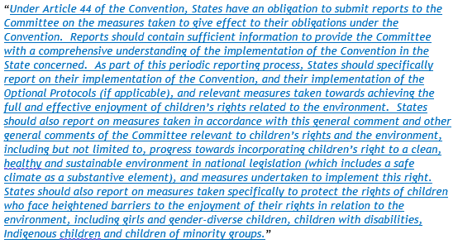

Children’s rights and the business sector

Rationale

We recommend that the Committee consider the following points in more detail to supplement the existing guidance set out in the Draft General Comment concerning State obligations regarding the impact of the business sector on children’s rights and the environment.

First, to ensure greater accountability for, and to help influence, responsible corporate behaviour, companies should be required to undertake enhanced due diligence internally in relation to their operations (whether domestic or offshore). They should also be required to publicly disclose environmental, health-related and children’s rights impacts of their business activities and their plans to address such impacts.

Second, to create a robust regulatory support for children’s rights and the environment, States should take positive steps to ensure legal accountability of companies both for domestic as well as offshore operations. As has been recognised by the Committee in its General Comment no. 16 (GC16), business enterprises “increasingly operate on a global scale through complex networks of subsidiaries, contractors, suppliers and joint ventures” and their impact on children’s rights “is rarely the result of the action or omission of a single business unit”. In GC16, the Committee recommended that: “[b]oth home and host States should establish institutional and legal frameworks that enable businesses to respect children’s rights across their global operations”. Besides domestic law reform, States should take measures to strengthen cooperation with other countries and ensure conformity with global standards for implementing environmental and children’s rights due diligence.

Third, domestic regulatory agencies responsible for oversight of standards relevant to children’s rights and the environment should have sufficient powers and resources to be able to effectively monitor, investigate and take enforcement action against companies involved in the violation of children’s rights in relation to the environment. As the Committee has previously remarked in GC16: “[g]enerally, it is the lack of implementation or the poor enforcement of laws regulating business that pose the most critical problems for children”.

Suggested changes

ACF recommends paragraph 92 be amended as follows:

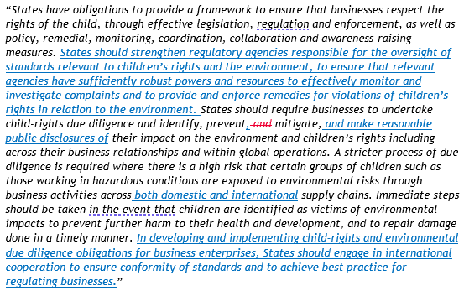

ACF recommends the following paragraph be inserted after paragraph 92:

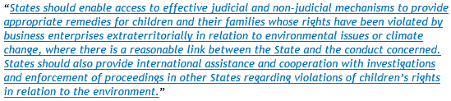

See: Australian Academy of Science, The risks to Australia of a 3ºC warmer world (Report, 24 June 2021) <https://www.science.org.au/supporting-science/science-policy-and-analysis/reports-and-publications/risks-australia-three-degrees-c-warmer-world>. The Intergovernmental Panel on Climate Change’s recent Sixth Assessment Report warns that “the [Australasia] region faces an extremely challenging future”: Intergovernmental Panel on Climate Change, Climate Change 2022: Impacts, Adaptation and Vulnerability (Report, 2022) 1585 <https://www.ipcc.ch/report/ar6/wg2/>.
See, eg, Sharma by her litigation representative Sister Marie Brigid Arthur v Minister for the Environment [2021] FCA 560; Waratah Coal Pty Ltd v Youth Verdict Ltd & Ors (No 6) [2022] QLC 21.
For example, the complaint filed on 25 October 2021 by five Australians – including members of First Nations and disability communities – to the UN Special Rapporteurs on Human Rights and the Environment, on the rights of Indigenous peoples and on the Rights of Persons with Disabilities. The Complainants assert that the Australian government’s emission targets are insufficient to meet the Paris Agreement and has breached the Convention on the Rights of the Child, the Convention on the Rights of Persons with Disabilities, and the United Nations Declaration on the Rights of Indigenous Peoples. See: Letter from Environmental Justice Australia to Dr David R Boyd (Special Rapporteur on Human Rights and the Environment), Francisco Cali Tzay (Special Rapporteur on the rights of Indigenous peoples) and Gerard Quinn (Special Rapporteur on the rights of persons with disabilities), 25 October 2021 <https://envirojustice.org.au/wp-content/uploads/2022/02/UN_Climate_Change_Human_Rights_FINAL_complaint.pdf>.
Committee on the Rights of the Child, Draft General comment No. 26 (202x) on Children’s rights and the environment with a special focus on climate change (5 December 2022) <https://www.ohchr.org/en/calls-for-input/2023/call-comments-draft-general-comment-childrens-rights-and-environment-special> (‘Draft General Comment No 26’) [56] to [58].
Committee on the Rights of the Child, General comment No. 12 (2009) on the right of the child to be heard, UN Doc CRC/C/GC/12 (20 July 2009) (‘General Comment No 12’).
Ibid [2].
Ibid [68].
Ibid [132] to [134].
Ibid [134(f)].
Ibid [134(h)].
Ibid [134(f)].
Ibid.
Ibid.
Draft General Comment No. 26, above n 4, [56].
Committee on the Rights of the Child, General comment No. 25 (2021) on children’s rights in relation to the digital environment, UN Doc CRC/C/GC/25 (2 March 2021).
Ibid [14] to [15].
Committee on the Rights of the Child, General comment No. 9 (2006) on the rights of children with disabilities, UN Doc CRC/C/GC/9 (27 February 2007).
Ibid [11].
Human Rights Council, Report of the Special Rapporteur on the issue of human rights obligations relating to the enjoyment of a safe, clean, healthy and sustainable environment, UN Doc A/HRC/37/58 (24 January 2018) [65]. See also, Save the Children, Born into the Climate Crisis: Why we must act now to secure children’s rights (Report, 2021) 24 https://resourcecentre.savethechildren.net/pdf/born-into-the-climate-crisis.pdf/ “[c]limate change exacerbates the barriers experienced by children with disabilities, as well as children living with parents with disabilities. […] As climate change increases the frequency and intensity of extreme weather events, more children with disabilities will be endangered more often. Despite this, people with disabilities and their representative organisations face systemic barriers to participation in decision-making.”
Committee on the Rights of the Child, General comment No. 11 (2009) on Indigenous children and their rights under the Convention, UN Doc CRC/C/GC/11 (12 February 2009).
Ibid [39].
Ibid.
Committee on the Rights of the Child, General Comment No. 2 (2002): The role of independent national human rights institutions in the promotion and protection of the rights of the child, UN Doc CRC/GC/2002/2 (15 November 2002) (‘General Comment No 2’).
Ibid [2].
Ibid [13].
Draft General Comment No 26, above n 4, [64].
General Comment No 2, above n 23, [19].
This proposed drafting is based on the principles set out in GC2. See: General Comment No. 2, above n 23, [13] to [14].
Committee on the Rights of the Child, General Comment No. 5 (2003): General measures of implementation of the Convention on the Rights of the Child (arts. 4, 42 and 44), UN Doc CRC/GC/2003/5 (27 November 2003) [71].
Committee on the Rights of the Child, Concluding observations on the combined fifth and sixth periodic reports of Australia, UN Doc CRC/C/AUS/CO/5-6 (1 November 2019, adopted 27 September 2019) <https://docstore.ohchr.org/SelfServices/FilesHandler.ashx?enc=6QkG1d%2fPPRiCAqhKb7yhsk5X2w65LgiRF%2fS3dwPS4NWFNCtCrUn3lRntjFl1P2gZpa035aKkorCHAPJx8bIZmDed5owOGcbWFeosUSgDTFKNqA7hBC3KiwAm8SBo665E> [40].
Draft General Comment No 26, above n 4, [8].
Committee on the Rights of the Child, General Comment No. 16 (2013) on State obligations regarding the impact of the business sector on children’s rights, UN Doc CRC/C/GC/16 (17 April 2013) (‘General Comment No 16’) 6.
Ibid.
Ibid 7.
Ibid 9.
This new paragraph has been drafted consistently with the Committee’s prior guidance in GC16. See: General Comment No 16, above n 32, 7.

