GENERAL COMMENT NO. 26: MALAWI REPORT ON CHILDREN’S SECOND CONSULTATION
FEBRUARY 2023
Table of Contents
1. INTRODUCTION 2
2. METHODOLOGY 3
2.1 Data collection 3
2.2 Consent 4
3. Limitations 5
4. Findings 6
5. Recommendations to the CRC Committee from children with disabilities in Malawi 10
6. Annex: MESSAGES FROM CHILDREN 12

INTRODUCTION
The following is a brief report on the process and outcomes of the Children’s Consultation for Malawi on the Draft General Comment no 26 of the Committee on the Rights of the Child (CRC Committee) held on 22 January 2023 in Blantyre City. The consultation was carried out by Parents of Children with Disabilities in Malawi (PODCAM) with the support of the Disability Rights Fund (DRF).
The purpose of the consultation was to solicit input (views, experiences, and ideas) from Malawi’s children being part of children across the globe, on actions which need to be implemented to protect their rights especially those occasioned by climate change. The consultation involved only children with disabilities. Findings from the consultation will inform and guide the CRC Committee to come up with a final report on General Comment no. 26 (GC 26).
Apart from highlighting the process and methodology for collecting and recording input from children on climate change and its adverse effects on the environment and consequently, on children’s rights, the report highlights input from children on three keys theme, namely,
- Issues the Government of Malawi (GoM) and its stakeholders need to consider to ensure that the rights of children are protected whenever it makes decisions and implements measures to protect the environment, slow down climate change and help the country to adapt to current and future impacts of climate change
- Measures that GoM and its stakeholder need to implement to promote access to information on the environment and climate change by children especially those with disabilities.
- Strategies that GoM and other stakeholders need to put in place to promote active participation of children in sharing of views and ideas on issues to do with the environment and climate change
In addition, the report shares messages from children through: quotations, poetry, a letter to the CRC Committee, thoughts on effects of climate change on children and their communities and artwork (see Annex at end of this report).

METHODOLOGY

Data collection
Data was collected through a half day consultation workshop which involved a total of 14 children with disabilities including children with intellectual disabilities, children with physical disabilities, blind children, children with developmental disabilities and children with albinism. The children comprised boys and girls aged from 10 to 17 years. The process adhered to guidelines in General Comment no 26: Children and Young People’s Second Consultation Toolkit as well as other prescribed guidelines on: child safeguarding, basic requirements for meaningful and ethical children participation and on planning and moderating events with children.
Generation of data was guided by 9 preset themed questions and related prompts. To ease understanding of the questions and related prompts, all instruments for data collection were translated to Chichewa language - the most commonly used language by all the children.
To ensure active participation of all the children, initial responses to themed questions were obtained through small group discussions. Each group was assigned a co-facilitator (from its membership). Reponses from the small group discussions were shared with the other group, Responses were obtained also through a plenary session. Throughout the three activities, children that desired to (also) express themselves through poetry; artwork, letter writing etc. were encouraged to do so. Further, throughout the process of collecting data, considerable effort was made to assist participants to participate in workshop proceedings actively. For example, instructions for each activity were repeated several times, individual attention was given whenever required and ample time was provided for participants to complete each of the activities.

Consent
Each guardian was given a prescribed consent form customized in simplified Chichewa to read and complete to indicate whether or not they assented to their child’s participation. It was emphasized that participation in the consultation workshop was voluntary and that as such participants were free to withdraw from participating at any point during the consultation. All the guardians consented to their children’s participation.
All documents (consent forms, participation forms, activity templates, etc.) have been stored securely by PODCAM and DRF/DRAF.
Lastly, two attendants and all the parents/guardians were readily available throughout the consultation to provide personal support to the children as required. In addition, two senior staff members from PODCAM were in attendance to look into safeguarding issues.

Limitations
Data is not representative of the population of children in Blantyre District (from where participating children were drawn), the southern region of Malawi as well as Malawi as a whole. Findings from the consultative workshop on how climate change and environment damage affect realization of children’s rights represent the view of a very small proportion of children with disabilities in Malawi. The findings are likely to underrepresent the effects of climate change on children at country level.

Findings
Findings on the views, opinions and experiences of children in general and children with disabilities in particular on climate change and its effects on their rights are presented (below) per themed question under each of the three activities below.
  - Findings on issues that GoM and its stakeholders need to consider to ensure that the rights of children are protected whenever it makes decisions and implements measures to protect the environment, slow down climate change and help the country to adapt to current and future impacts of climate change.
    - Asked to reflect on what GoM is doing (or not doing) to protect the environment, slow down climate change and help Malawi to adapt to the current and future impact of climate change, the children outlined the following positive measures that GoM is implementing in its efforts to mitigate against the effects of environmental degradation due to climate change:
That GoM:
- has set aside a day each year for planting trees and that children with disabilities take part in planting trees
- has recently revised and introduced stronger penalties for persons that cut down trees wantonly as well as those that sell charcoal
- runs public awareness campaigns through radios and community awareness meetings on the negative effects of cutting down tree and starting of bush fires. Through the campaigns, GOM also encourages the general public to plant trees around schools and homes.

On the other hand, the children noted that notwithstanding the commendable work that GoM is doing, the GoM does not adequately enforce laws against wanton cutting down of trees and starting of bus fires - People are still cutting down trees carelessly as well as starting bush fires unnecessarily.

    - Children were also asked to identify the kind of issues that GoM and its stakeholders should think about when considering the impact their plans and decisions will have on children’s right to enjoy a healthy environment?
In response the children agreed that Government and its stakeholders should be asking the following questions:

To what extent would the plans and decisions promote:
- school attendance by children with disabilities?
- access to hospitals and other health facilities and services by children with disabilities?
- means of livelihoods (food security, businesses) for parents and guardians to ensure that the children have enough food?

The children were of the view that should the responses to the questions above imply that the children’s rights would be violated, GoM should review the decisions and plans. Hence, the need for child rights impact assessments, including particularly the impact on the rights of children with disabilities.
    - Lastly the children were asked to indicate the type of action which in their view, should be taken against GoM and its stakeholders whenever they fail in their responsibility of protecting the rights of children as may be occasioned by climate change. In their response, the children indicated that persons and or leaders that fail to carry out their responsibilities should be subject to appropriate disciplinary measures including being replaced.

  - Findings on measures that GoM and its stakeholders need to implement to promote access to information on the environment and climate change by children especially those with disabilities.
    - When asked to explain the challenges that they face in finding information and in learning about the environment and climate change, the children responded as follows:

- Some of the information given to the public is transmitted through radio and television programs and mobile phones. Due to higher levels poverty among households that have children with disabilities, most of such households cannot afford to own radios, mobile phones and television sets. As such most of the children with disabilities are unable to access the information.

- Information taught in schools on the environment is not accessible to blind children or children with low vision as it not transcribed in Braille or presented in large print. In addition, some schools do not have resource centers for children who are blind, deaf or hard of hearing and those with intellectual disabilities where such children could receive support to access such information.

- Most children with disabilities do not attend school because available schools do not have resource centers or qualified teachers that can support them. This deprives them education on and access to information on the effects of climate change on the environment and what they need to know to fight climate change.

    - The children were also asked to indicate what, in their view, is (or could be) the best ways for them to find information about:
- their rights
- the impact of environmental damage and climate change on their lives and communities
- government and businesses’ responsibilities to protect children’s rights to a healthy environment
- how to get help if their rights are not being respected
In response, children identified:
- schools as being better placed to provide accessible information if the school curricula included adequate information on: practical actions that the children can take to protect the environment, children’s right to education, to good health, to a secure environment and to food. In addition, the children underlined that lessons on good citizenship should include content on the role of children in protecting the environment.
- Accessible public awareness campaign meetings in their communities on the environment and climate change as a viable means for children to access information. They indicated that children with disabilities readily attend community meetings as do their parents and guardians. The children were emphatic on the point that, although children with intellectual disabilities and Deaf and hard of hearing children may face barriers in accessing the information presented during public awareness meetings, their parents and guardians would readily share such information.

    - Lastly, children were asked on what they think they should learn in school about the environment and climate change and how should this be taught?
The children’s view is that they should learn or learn more on the following:

- The importance of planting trees
- How to protect the environment
- Skills on how to mitigate the effects of climate change
- more information about indigenous/natural trees
- What GoM is doing and not doing (enough) to protect the environment and mitigate against the impact of climate change
- Information on other actions that children can do to help their respective communities and GOM to protect the environment

The children explained that that the lessons should be taught using a variety of accessible methodologies including picture presentations and practical sessions (raising tree nurseries and planting trees around the school). Use of various teaching methods would ensure that all children with disabilities could also access the information

  - Findings on strategies that GoM and other stakeholders need to put in place to promote active participation of children in sharing of views and ideas on issues to do with the environment and climate change

    - Children were asked on how they can (or could) share their views and ideas when governments and other stakeholders are making plans and decisions that impact the environment and/or climate change?

The children’s response was that GoM should allow them to participate in radio programs that focus on issues to do with the environment and climate change in general as well as dedicated programs where children could reflect on what the GoM and other stakeholders are doing or plan to do to mitigate the effects of climate change. In addition, the children hold the view that public radio stations should schedule a program on a specified day during which children with disabilities could express their views on issues to do with the environment and climate change and how these particularly affect their right to education, health services, shelter and food. Further, the children expressed their views on the effects of climate change through poetry and letters and to channel these to GoM through the Federation of Organizations of Persons with Disabilities for relevant consideration. Lastly, the children resolved to form clubs through which they could to receive and share information on issues to do with the environment and climate change.

    - In response to the question on how the children can (or could) be involved in reviewing GoM and other stakeholders’ decisions which impact the environment and/or climate change, the children indicated the need for them to be given information (on government’s decisions and plans in relation to the environment and climate change) in accessible formats and that once they have the information, they should be allowed to provide comments and through the Federation of Organizations of Persons with Disabilities, to channel their feedback to GoM.
    - Lastly the children were asked to provide their opinions on what GoM need to do to keep children safe and well when they are expressing their views, standing up for their rights, or taking action.

In their response, the children indicated that they need to be talked to respectfully and not to be intimidated and to be given space to complain without being intimated.

For more details on children’s views and opinions in response to the themed questions, see the confidential annexes: Template B: Children Second Consultation Recording Sheet and the voices of children in Message from Children in Annex 6.

Recommendations to the CRC Committee from children with disabilities in Malawi

  - GC26 should highlight more prominently the unique impact of climate change on children with disabilities by including a separate paragraph specifically focusing on children with disabilities, like the separate paragraph on Indigenous children. In this way, GoM and other governments will be made attentive to ensuring disability-inclusive climate action and to seeking the views of children with disabilities in all climate action. In addition, the rights of children with disabilities should be mainstreamed throughout the text of GC26.
  - Schools should include accessible and disability-inclusive curricula on climate change. Teachers should always make sure that children with disabilities are supported so that they can also access learning materials and other relevant and accessible information about the environment and climate change.
  - Lessons in schools should be taught using a variety of methods including presentation of accessible information through pictures and practical sessions (taking climate-smart action such as raising tree nurseries and planting trees around the school). The use of various teaching methods would ensure that children with different types of disabilities readily access the information.
  - Children with disabilities should be given information on government’s decisions and plans in relation to the environment and climate change in accessible formats. Their views and comment on the plans should be sought by GoM.
  - Government should support and make resources available to enable children with disabilities to participate in radio programs that focus on the environment and climate change in general as well as dedicated programs where they can reflect on what GoM and other stakeholders are doing or plan to do to mitigate the effects of climate change.
  - Government should carry out awareness-raising campaigns and disseminate accessible information on the environment and the impacts of climate change on particular populations including children and children with disabilities. Both public and private media and radio stations should dedicate a program on the environment and climate by inviting children with disabilities and other children to freely express their views on issues to do with the environment and climate change and how these affect our right to education, health services, shelter and food.

Annex: MESSAGES FROM CHILDREN

1.0 Quotations:
‘’Government should put in place a mechanism for us as children with disabilities and our parents to report challenges that we face due to environment degradation and climate change as well as to lobby government to address such challenges’’(Boy, 17 years, Malawi)
“Government should give us change to address members of Parliament on the effects of environmental degradation on our ability as children to access public services” (Girl, 17 years, Malawi)

2.0 Poetry
Listen you people
I am tired of what you do
You kill animals in my jungle
You burn my cover

Listen you people
I am tired of what you do
You cut trees in my jungle

Listen you people
We give you shelter
We give you life

(10 year old girl, Malawi)

3.0 Letter to CRC Committee

22nd January 2023

Dear CRC Committee

I have written this letter to make my contribution on how all of us can protect the environment.

We can protect it by not cutting down trees carelessly, not killing wild animals unnecessarily and not setting up bush fires.

Taking care of trees helps us to have enough rains which result in bumper harvest and enough food.

Not setting up bush fires helps to preserve soil fertility which in turn results in bumper harvest. It also ensures that wild animals have a place to live in.

Not killing wild animals unnecessarily helps our country to have more wild animals which in turn attracts tourists. The tourists bring money for our country’s development.

(17 year old boy, Malawi)

4.0 Thoughts

4.1 Problems that children and other people face due to climate change
During the rains, we children fail to go to school because our parents fail to leave us their children at school
When the land is flooded, our crops are flooded too.
When there are floods, we fail to cross the roads to go to school
Whenever there are bush fires, our animals do not have food because the bush fire destroys the grass.
COVID 19 affects us children in that we cannot go to school

(From a group discussion comprising one (1) 17 year old girl and 5 boys aged 13 to 17 years, Malawi)

4.2 Problems that children face due to climate change
4.2.1 Our education goes down
Due to flooding, there is lack of clean water, cholera spreads fast and government decides to close schools to keep us safe.
Flooding destroys roads. As a result we fail to go to school

4.2.2 Hunger
Flooding causes soil erosion leaving no good soil for our crops
Floods destroy crops resulting in hunger

4.2.3 Leisure
Due to indiscriminate cutting down of trees, we children do not have enough shade for playing

4.2.4 Hygiene
Drought results into shortage of water for drinking, cooking and bathing.

4.2.5 Shelter
Strong winds destroy houses resulting in our not having good shelter to live in.
When people make bush fires, wild animals do not have places where to live.
(From a group discussion comprising 5 girls and 3 boys aged 10 to 12 years, Malawi)

5.0 Artwork
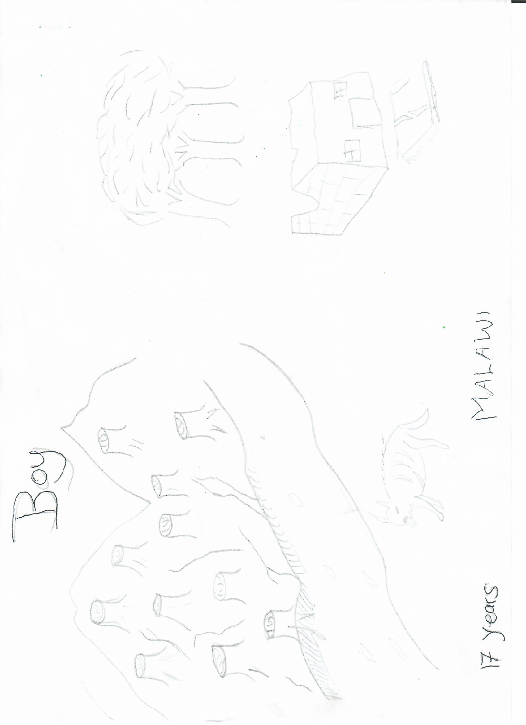

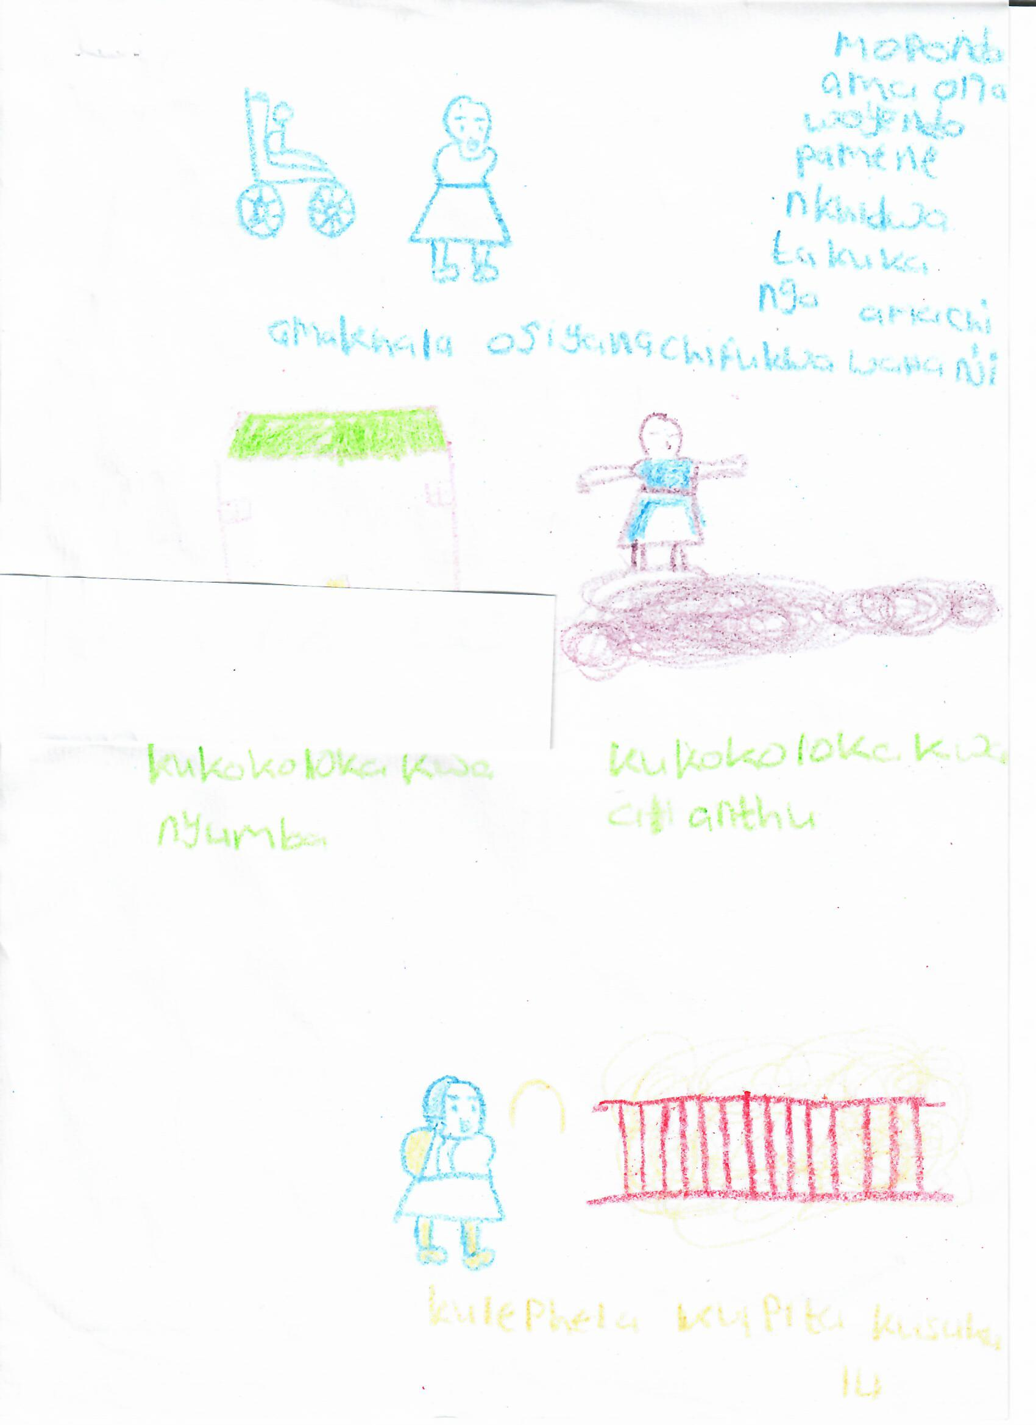
Drawn by a 10-year-old girl from Malawi:
Main Messages from the artwork
- Each person with a disability faces different challenges due to climate change: The challenges faced by a boy who uses a wheelchair are different from those that a girl with a sensory disability faces
- Floods result in destruction of houses and displacement of people
- Floods cause damage to roads and bridges resulting in failure by us children to go to school

PODCAM was established and registered in 2001. Its mission is to empower parents of children with disabilities, conduct civic education, and prevent the abuse of children with disabilities. DRF and its sister organization the Disability Rights Advocacy Fund (DRAF) serve to resource, strengthen, and connect organizations of persons with disabilities (OPDs) through participatory grantmaking, advocacy, and technical assistance. DRF/DRAF support OPDs in the Global South to advance the recognition of rights as set forth in the Convention on the Rights of Persons with Disabilities (CRPD) and to engage in human rights, inclusive development, climate action, and peace and security at local, national, and global levels, for the equal and full participation and inclusion of persons with disabilities in society.

