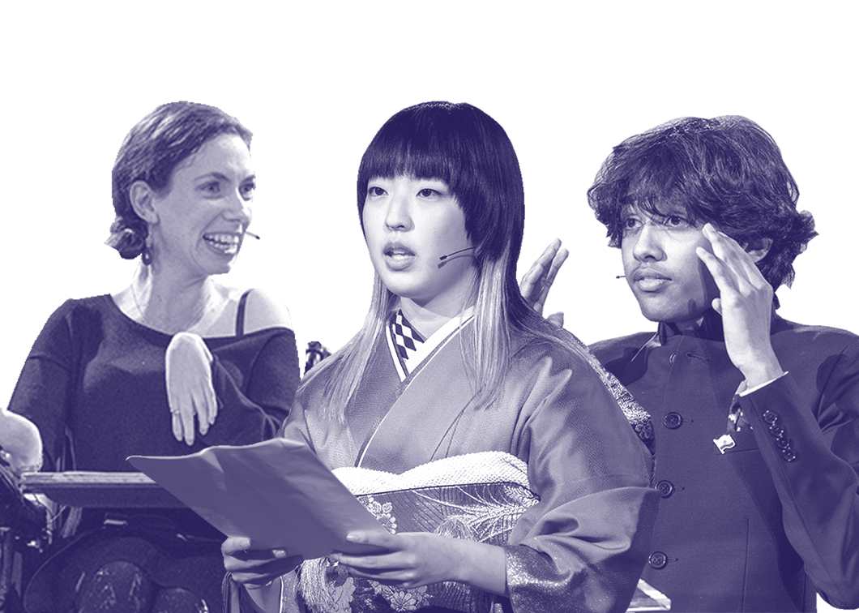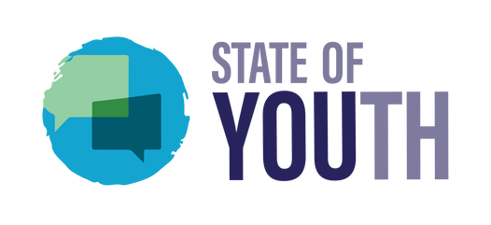

Report
GENERAL COMMENT N° 26

By: Ujjwal Dubey, Lauren O’Neill, Rob Goudriaan, Flavia Lorenzin and Marie-Pier Giroux

TABLE OF CONTENTS

Introduction
03
04
05
07
10
11

Participation & Information

Education

Life, Health, Protection & Prevention

Legislation

Conclusion

GENERAL COMMENT N° 26

Echoes of thoughts...

Our Climate Is Changing.
Why Aren't We?
(Age 15, India)
As world leaders, you have an obligation to protect us from the harms of climate change. We need you to take urgent action to reduce emissions and develop climate-resilient policies.

(Age 18, Bhutan)

The government’s neglect of the environment is sapping the hope of our nation, our youth, and our children's lives. (Age 17, Philippines)
I’m writing this as a young person who’s 14 yrs old. I’m ready to work with my government to achieve all the suggestions that I've made. (Age 14, Kenya)

Every child deserves a livable Planet (Age 13, India)

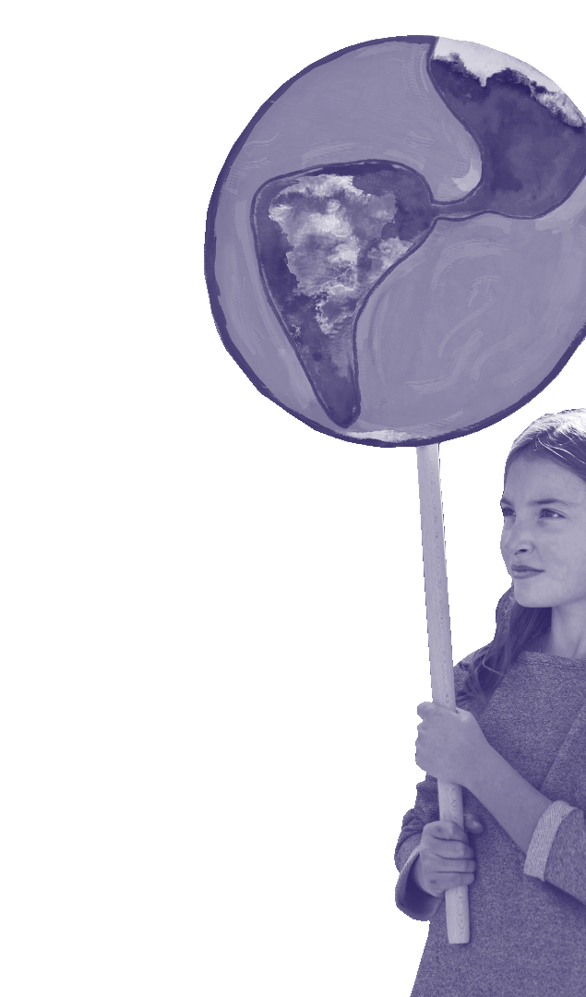

INTRODUCTION

KidsRights is an international NGO based in Amsterdam, the Netherlands. KidsRights promotes the wellbeing of children across the world and advocates for their rights. Most notably known for the International Children’s Peace Prize, KidsRights strives for a world where all children have access to their rights and are empowered to realize the great potential, they carry within them.

Article 12 of the Convention on the Rights of the Child, the right to be heard, underpins the work carried out at KidsRights. Our Action Program, more widely known as State of Youth, is the first borderless state where young people between the ages of 12-24 are encouraged to raise awareness and advocate for children’s rights and the Sustainable Development Goals. State of Youth is physically present through 214 Chapters in 34 countries across the world.[1]

The General Comment 26 Campaign: “Your Voice Matters” ran on our State of Youth social media platforms for 3 weeks. Young people from across the world were encouraged to give their opinion on the draft General Comment 26. In total, we received 43 opinions from young people in 23 different countries. The subsequent report has been compiled based on these opinions.

This report, with several comments made by children and young people, has been divided into four domains based on how climate change plays a part in the realization and enjoyment of fundamental children’s rights as specified by the United Nations Convention on the Rights of the Child. These are: A. Participation and Information, B. Education, C. Life, Health, Protection and Prevention, and D. Legislation.

- Accurate as of 9th February 2023 3

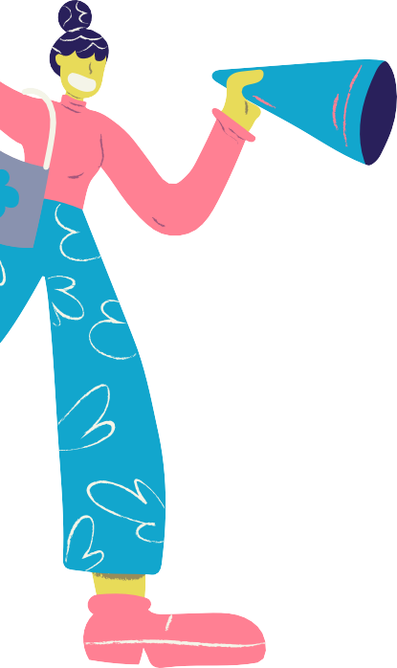Let us, the youth, talk, let us be bold, let us bring a change.
(Age 18, Bangladesh)

PARTICIPATION & INFORMATION
Children, from an early age, have the capacity to enhance the quality of environmental solutions by providing invaluable insights into various issues that might affect them directly or indirectly. The views of children should be acknowledged, recognized, and considered in designing and implementing the policies that are aimed at addressing the significant and long-term environmental challenges that fundamentally shape their lives in the context of environmental challenges.[2]
From Kenya, a 14-year-old child thinks that the government can collect feedback from the children’s assembly which they can use to get real perspectives on issues affecting children in their community.
The digital environment provides an opportunity for consulting with children and expanding their capacity and opportunities to effectively engage on environmental matters, including through collective advocacy if carefully used paying attention to the challenges for many children to access the digital environment.[3]
A 12-year-old Filipino child believes that youth must be empowered by giving them an avenue to voice their opinions and enable change from within the community. This can be done by organizing seminars and symposiums for children and youth to disseminate information about climate change because ‘knowledge is power’. These events should be organized not only at national or state levels but in local, rural communities as well to ensure inclusivity and understand the requirements of the children living in more vulnerable situations as well as children with lesser access to preventive solutions and remedies.

Children should be provided with environmental and human rights education along with age- appropriate information, adequate time, and resources in an enabling environment for a voluntary, respectful, and transparent participation. Children should be able to receive information about the outcomes of environment-related consultations and feedback on how their views were considered or disregarded in environmental context.[4]

A 15-year-old child from Pakistan commented in this regard that ‘the government should initially provide precise and clear-cut information to children about how they can protect themselves and others from environmental harm, such as climate change and imbalance in the ecosystem’.

Moreover, to bring into perspective the awareness of children and their requirements; two siblings (8 years old and 5 years old) from United Arab Emirates said that ‘the government should encourage kids and youth to get more involved, make them a part of solution and harness the energy and kindness that young people have in abundance for the greater good of our planet’.

Our children are continuously striving to stay informed, aware, and act in all (in)decisions related to environment that might directly or indirectly affect them. Therefore, it is important for governments to provide clear information about the environment directly to children.

- CRC/ DRAFT GC/26 (202x), para 56
4
- Ibid.
- CRC/ DRAFT GC/26 (202x), para 57

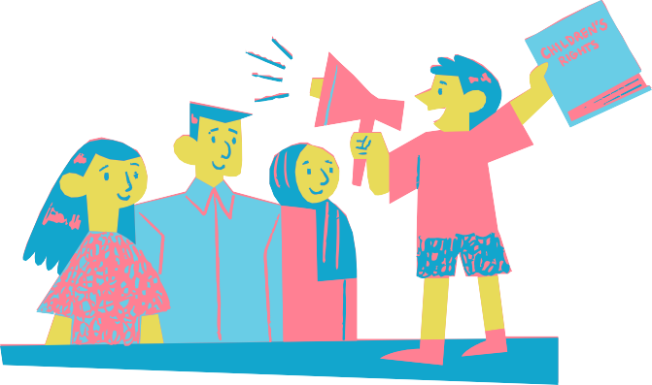

EDUCATION

Globally, children make significant contributions towards environmental sustainability and climate justice. They should have access to adequate environmental information and education focusing on respect for the natural environment, sustainable lifestyles and leading a responsible life in a free society.[5]
Our changemakers endorse the importance of access to good information about our environment. For example, a 24-year-old young person from Sudan gave the following message: “Stop the problems that cause harm to environment, if not at least provide information and knowledge about impact of climate change on coming generations.”

And a 17-year-old boy from Bangladesh echoed a similar message:
“As Bangladesh’s climate is one of the most unexpected, so public awareness through media, leaflets materials must be arranged.”

Children highlighted that education is instrumental in protecting children’s rights and the environment and in increasing their awareness and preparedness for environmental damage, while the right to education is highly vulnerable to the impact of environmental harm, described by children as school closures and disruptions, dropouts from school, and destruction of schools and places to play.[6]
Emphasis on education is even more evident within the points of feedback we received from our changemakers regarding General Comment 26. Here, most children stress the responsibility that the government has in providing good education. For example, a 14-year-old from Kenya wrote: “My government in Kenya should ensure that each school has a representative in the children’s assembly. I think my government should ensure that all schools educate the community about children’s rights and the [way] that children can use their voice to create a positive impact.”

Another 15-year-old from Mexico commented:
“I believe that the Mexican Government should make the National Strategy Against Climate Change known in all schools and at all education levels. This is because informed children, adolescents and young people are more aware and determined to take actions which benefit everyone and benefit our dear planet.”

And two children (15-year-old and 13-year-old) from the United Arab Emirates have written the following:
“Educating young minds will surely make an impact towards preserving the earth’s resources for the future.”

Article 29(1) € of the Convention requiring that the education of a child be directed to the development of respect for the natural environment shall be read in conjunction with article 28 of the Convention to ensure that every child has the right to receive an education which reflects environmental values.[7]

- CRC/ DRAFT GC/26 (202x), para 22
5
- CRC/ DRAFT GC/26 (202x), para 31
- CRC/ DRAFT GC/26 (202x), para 32

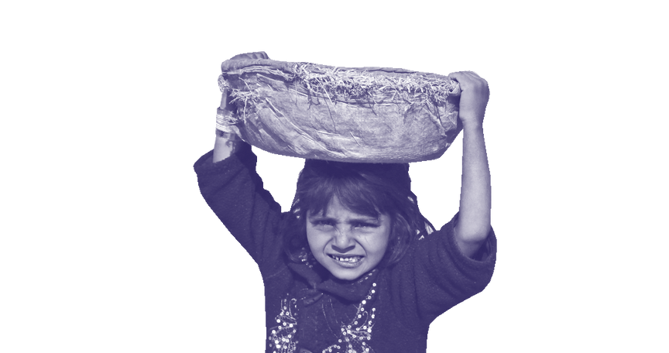

EDUCATION

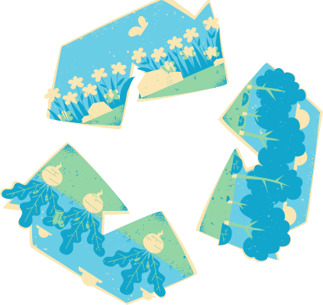A rights-based environmental education should be child-centred, child-friendly, and empowering and pursue the development of the child’s personality, talents and abilities, in line with article 29(1)
These two articles are also spelled out by our changemakers. They think that good education can lead to a better environment. A 24-year-old from Sudan wrote:
“[The] educational arena is supposed to involve environmental health program to all educational levels I think that will help more from reducing environmental impact.”

And a 13-year-old from India along with a seventeen-year-old from Pakistan, wrote:
“Provide children with climate education and greens skills, critical for their adaptation to and preparation for the effects of climate change.”

It is clear that children and young people across the world are calling for an education which more clearly reflects environment values.
(a) of the Convention.[8] School curricula should be tailored to children’s specific environmental, social, economic, and cultural contexts and promote understanding of the contexts of other children affected by environmental impacts[9]. Curricula should reflect changing environments and new environmental science. Teaching materials should provide accurate, updated and age- and developmentally appropriate environmental information.[10] All children should be equipped with the skills necessary to face expected environmental challenges in life such as disaster risks, including the ability to critically reflect upon such challenges, solve problems, make well-balanced decisions, and assume environmental responsibility in accordance with their evolving capacities.[11]
The importance of environmental education within curricula is also stressed by our changemakers. A 20-year-old from Zimbabwe wrote:
“Catch them young campaigns should be put to full swing -investment in early child learning programs through textbook printing that have environmental contexts allover be it cover graphics with trees or anything environment like this will help raise awareness to the growing generation. Scientific and technical jargon should be toned down to allow everyone to access the knowledge.”

And another 19-year-old changemaker from Bangladesh stressed the importance of practical information in the following manner:
“Starting from everything, if we give practical education to school, college and university students through various trainings and various activities, then it will develop in them to keep the environment beautiful, [this is] how we can keep the environment beautiful and build the future world.”

- CRC/ DRAFT GC/26 (202x), para 33
- Ibid.
- Ibid.
- Ibid.
6

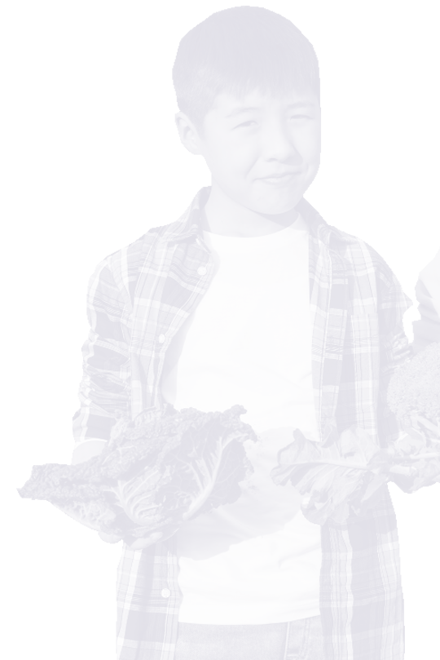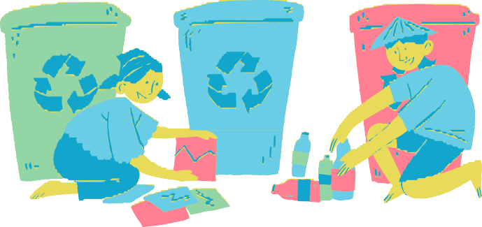

LIFE, HEALTH, PROTECTION & PREVENTION:

States should take positive action to ensure that children are free from acts and omissions intended or expected to cause their premature or unnatural death. This includes tackling structural and long-term challenges and taking all appropriate measures to address environmental conditions that may lead to direct threats to the right to life.States should adopt environmental standards that are protective of children’s right to life, for example related to air quality, lead exposure and greenhouse gas emissions, and adopt special measures of protection of children, especially young children, and those in disadvantaged situations.[12]

In the responses of our changemakers, we see two different thought processes. On the one side, we see changemakers reflecting critically on how governments are currently dealing with climate change. For example, a 23-year-old changemaker from Yemen writes:
“The government must not deprive children of their right to live and obtain rights and services”.

There is a clear dissatisfaction with the current state of affairs expressed in this comment. He supports this statement further by stating that:
“The government must refrain or stop supporting environmental and water pollutants, such as factories close to the possibility of children”.

On the other hand, we see changemakers naming, in concrete terms, what governments need to change if they are to comply with the UNCRC. Children thus hold governments accountable for failing to act and tell them what they should do. So here it is visible that children are solution- oriented, and in this way they can contribute to a better future. A 17-year-old from Bangladesh wrote, for example:
“The government should make the recycling process of plastics and other sustainable solutions easier and more efficient. Keeping the waterbody clean- everywhere. Taking necessary steps to ensure the betterment of waterbody.”

Other examples of these solution-orientated responses are:
“The government should protect and restore key ecosystems; promote green energy; support small agricultural producer” (Age 13, Nigeria)
“The environmental footprint of every work done should be assessed and made sure that it is not negative.” (Age 15, India)
“I want to recommend that the government provide more support for the Environment Protection Agency (EPA) and the Forestry Development Authority (FDA) to better fight environmental issues.” (Age 22, Liberia)

The obligation of States to respect and ensure the right to life extends to protection of children from the harm caused by reasonably foreseeable threats and situations that can result in loss of life with dignity. This requires taking precautionary measures to protect children against environmental harm which would impact their enjoyment of life with dignity.[13]

- CRC/ DRAFT GC/26 (202x), para 16
7
- CRC/ DRAFT GC/26 (202x), para 17

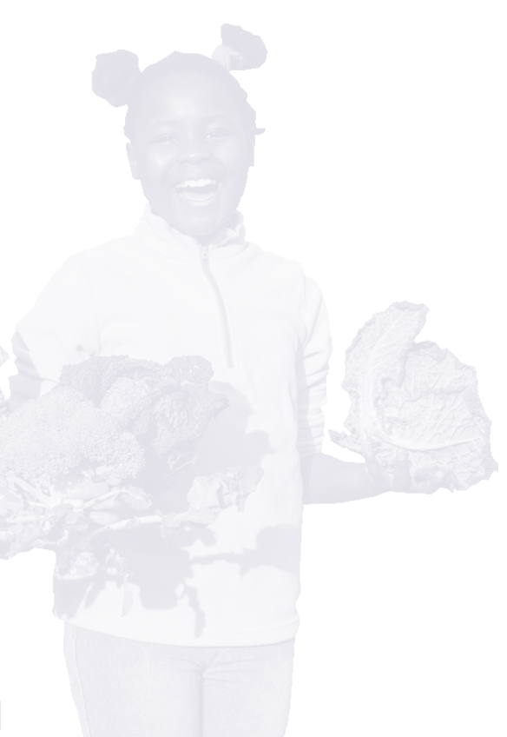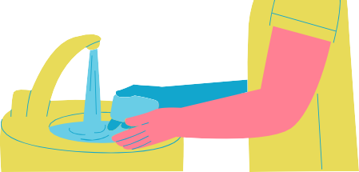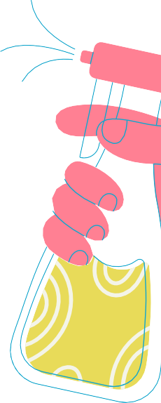

LIFE, HEALTH, PROTECTION & PREVENTION:

Our changemakers stress that whilst precautionary measures are important, it is vital that governments do not just take precautionary measures, but also take action in the areas already greatly affected by climate change. A 15-year-old-boy from Pakistan wrote, for example:
“The government can also protect children who are already experiencing the effects of climate change, build water pipes against storms, flooding, and other weather extremes, and provide food supplies in cases of emergency.”

Facilities, programmes and services should be equipped to respond to environmental health hazards. Health protection also applies to the conditions in which children can lead a healthy life, such as the provision of safe and clean drinking water and sanitation, adequate housing, access to nutritionally adequate and safe food, and healthy working conditions.[14]

The importance of healthy and unpolluted food is also endorsed by our changemakers. In doing so, they emphasize the role of the government and why this benefits children. A 15-year-old changemaker from India wrote, for example:
“The availability of drinking water sources should be ensured from the government levels. It will be very useful for school going children.”

And a 17-year-old changemaker from Bangladesh wrote:
“After the calamity situation, the children should be supplied with proper sanitary items, medical supplies, food, and other necessities. A fixed and healthy amount of monetary fund from the government should be kept locked for the entire calamity situation and have to take stratospheric initiatives to raisethe patronisation by arranging foreign seminars and advertisements to bring entire worldly conscious to the deplorable situation of the children.”

States are obliged to build physically safe, healthy and resilient infrastructure for effective learning. This includes ensuring the availability of walking and biking routes and public transport to school; that schools are located at safe distances from sources of pollution and other environmental hazards, including contaminated sites; and the construction of buildings and classrooms with adequate heating and cooling, access to sufficient, safe, and acceptable drinking water and sanitation facilities, especially for girls.[15]
Our changemakers also mention the importance of good infrastructure, which we often see within the projects that changemakers carry out. Often changemakers focus on improving good sanitation in their area. We consequently see this reflected in the responses.
A 13-year-old Indian changemaker wrote:
“Increase investment in climate adaptation and resilience in key services for children. To protect children, communities and the most vulnerable from the worst impacts of the already changing climate, critical services must be adapted, including water, sanitation and hygiene systems, health and education services.”

- CRC/ DRAFT GC/26 (202x), para 29
8
- CRC/ DRAFT GC/26 (202x), para 36

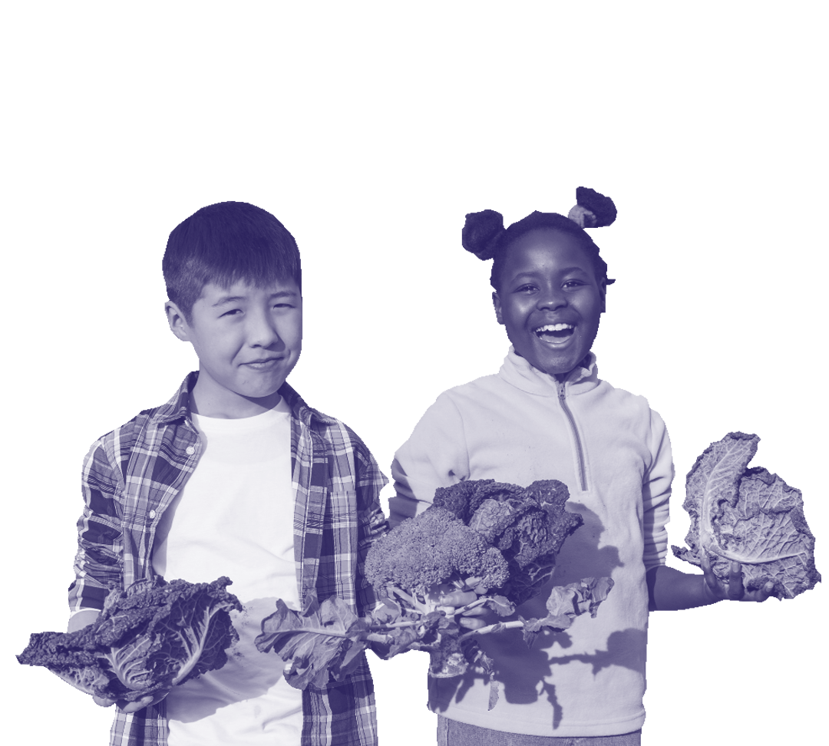

LIFE, HEALTH, PROTECTION & PREVENTION:
Another a 17-year-old changemaker from Pakistan wrote:
“[the] government should also take steps to ensure that children affected by the impacts of climate change have access to adequate food, water, and shelter, as well as education and healthcare. This can include providing emergency assistance and long-term support for families and communities affected by extreme weather events, and investing in infrastructure and services that can withstand the effects of climate change.”
States parties are urged to introduce features into social security policies and social protection floors that provide children and their families with protection against climate and environmental shocks and slow-onset harm. States should strengthen child-centred poverty alleviation programmes in areas that are most vulnerable to climate and environmental risks.[16]

We also see the need to bolster child-centred social security policies concretely in the responses of our changemakers. A 23-year-old changemaker from Yemen emphasized that these measures should protect children whose lives are already affected by climate change:
“Protect children who are already suffering from the effects of climate change. Strengthening school buildings and water pipes, against storms, floods, and other severe weather conditions, providing emergency food supplies.”

- CRC/ DRAFT GC/26 (202x), para 41 9

LEGISLATION
‘[the] government must include developing and implementing policies and legislations in their efforts to promote sustainable development, such as reducing carbon emissions and protecting natural resources’. – 17-year-old, Pakistan.

The UNCRC GC no. 26 draft, highlights that the states should adopt a comprehensive process for identifying and addressing environmental health concerns relevant to children within their national plan, policy, or strategy.[17] Legislative and institutional frameworks, including regulation dealing with the business sector, should effectively protect children’s environmental health in all relevant settings, including where they live, study, play and work; be consistent with the best available science and all relevant international environmental health and safety standards; and be strictly enforced.[18]

It is important to realize that children around the world feel the urgent need of such policies and legislations to be put in place. Children at a very young age are aware of this, as seen in a comment made by a 15-year-old from India who rightly says,
‘A comprehensive legislation should be made to promote tree conservation and afforestation’.

Another 17-year-old from the Philippines believes that their government must
‘promote and enact laws to shield specific natural resources from the negative impacts of industries.’

- 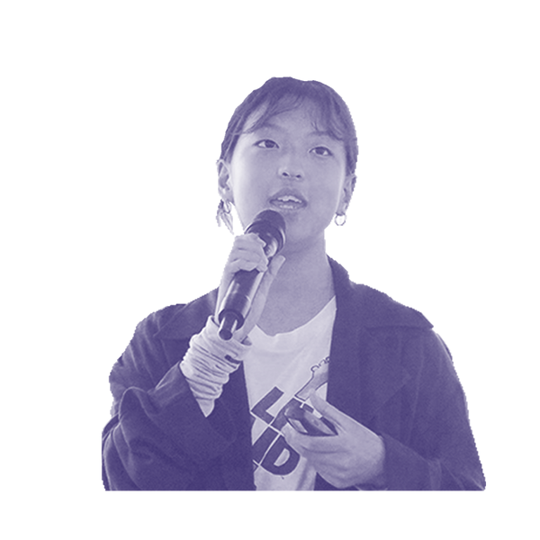CRC/ DRAFT GC/26 (202x), para 28
10
- Ibid.

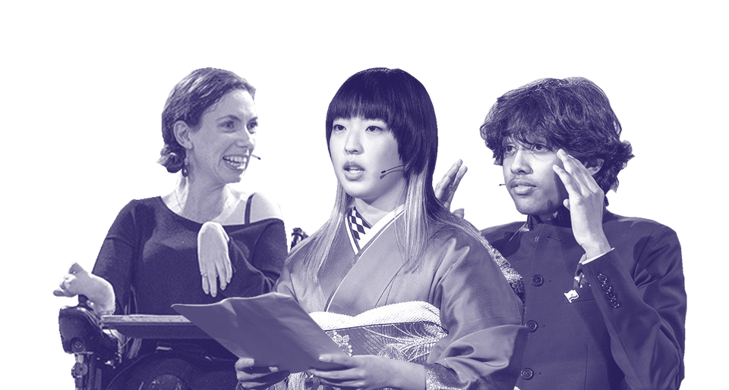
As a civil-society organization with a huge network of children who are changemakers globally, KidsRights has tried to bring the views of children and young people through this report to the UNCRC. We hope that this feedback report on the draft of General Comment No. 26, will provide valuable insights to the Committee and bring into focus the needs and requirements of children to better understand the impact of climate change on children’s rights.
GENERAL COMMENT N° 26
11

CONCLUSION

To recap and summarize the four sections of the report:

- Participation and Information: Children and young people are aware of their evolving capacities and their ability to take part in decision-making. The comments clearly show the needs of the children to be able to speak and be heard. Almost every child or young person who has participated in this campaign has asked to be heard and that their opinions be acknowledged and considered through symposiums, school programs, seminars, etc.

- Education: Children and young people recognize the need to be educated not only themselves but to also educate the whole society on the issues related to environment and climate change. Our young generation believe that awareness and education, through media, schools and other mediums, can make our society more prepared in dealing with the impacts of climate change and help protect the environment.

- Life, Health, Protection, and Prevention: The children and young people, through their comments, have a clear dissatisfaction with the current state of affairs. They believe that for them to stay protected and to be fully able to exercise their right to life and health, the government must take strict actions against the root causes of environmental degradation, for example: water pollution, uncontrolled carbon emission, excessive use of plastic, deforestation etc. These young people believe that their governments must not only enhance the protective measures like strengthening of health care system, disaster management-emergency mechanisms and food supplies but also pay attention to preventive measures such as making school buildings stronger or building a pipe or water management system in case of floods.

- Legislation: The comments received in this campaign have clearly shown that children as young as 15 years old have knowledge of existing policies and legislation that affect them. Our young generation, through their comments, highlight the importance of developing legislation that promote sustainable development, take defence against negative impacts of our activities and work towards healing the environment. They recognize that there is a lack of comprehensive legislation around environment conservation and urge the government to address this issue through legislation.

A lack of resources and specified format in the policy- and legislation-making procedures are a huge obstacle in facilitating meaningful and effective child participation. It is a fact that there is no specific procedure or format available within the UNCRC to consult the children globally and all at once regarding a draft or a policy that is being released that directly or indirectly affects them. Moreover, children from under-developed nations and even several developing nations find themselves deprived of the opportunity to have their voices heard because they are not in as privileged circumstances as other children who have access to platforms where their opinions can be heard and given recognition and consideration.

GENERAL COMMENT N° 26

