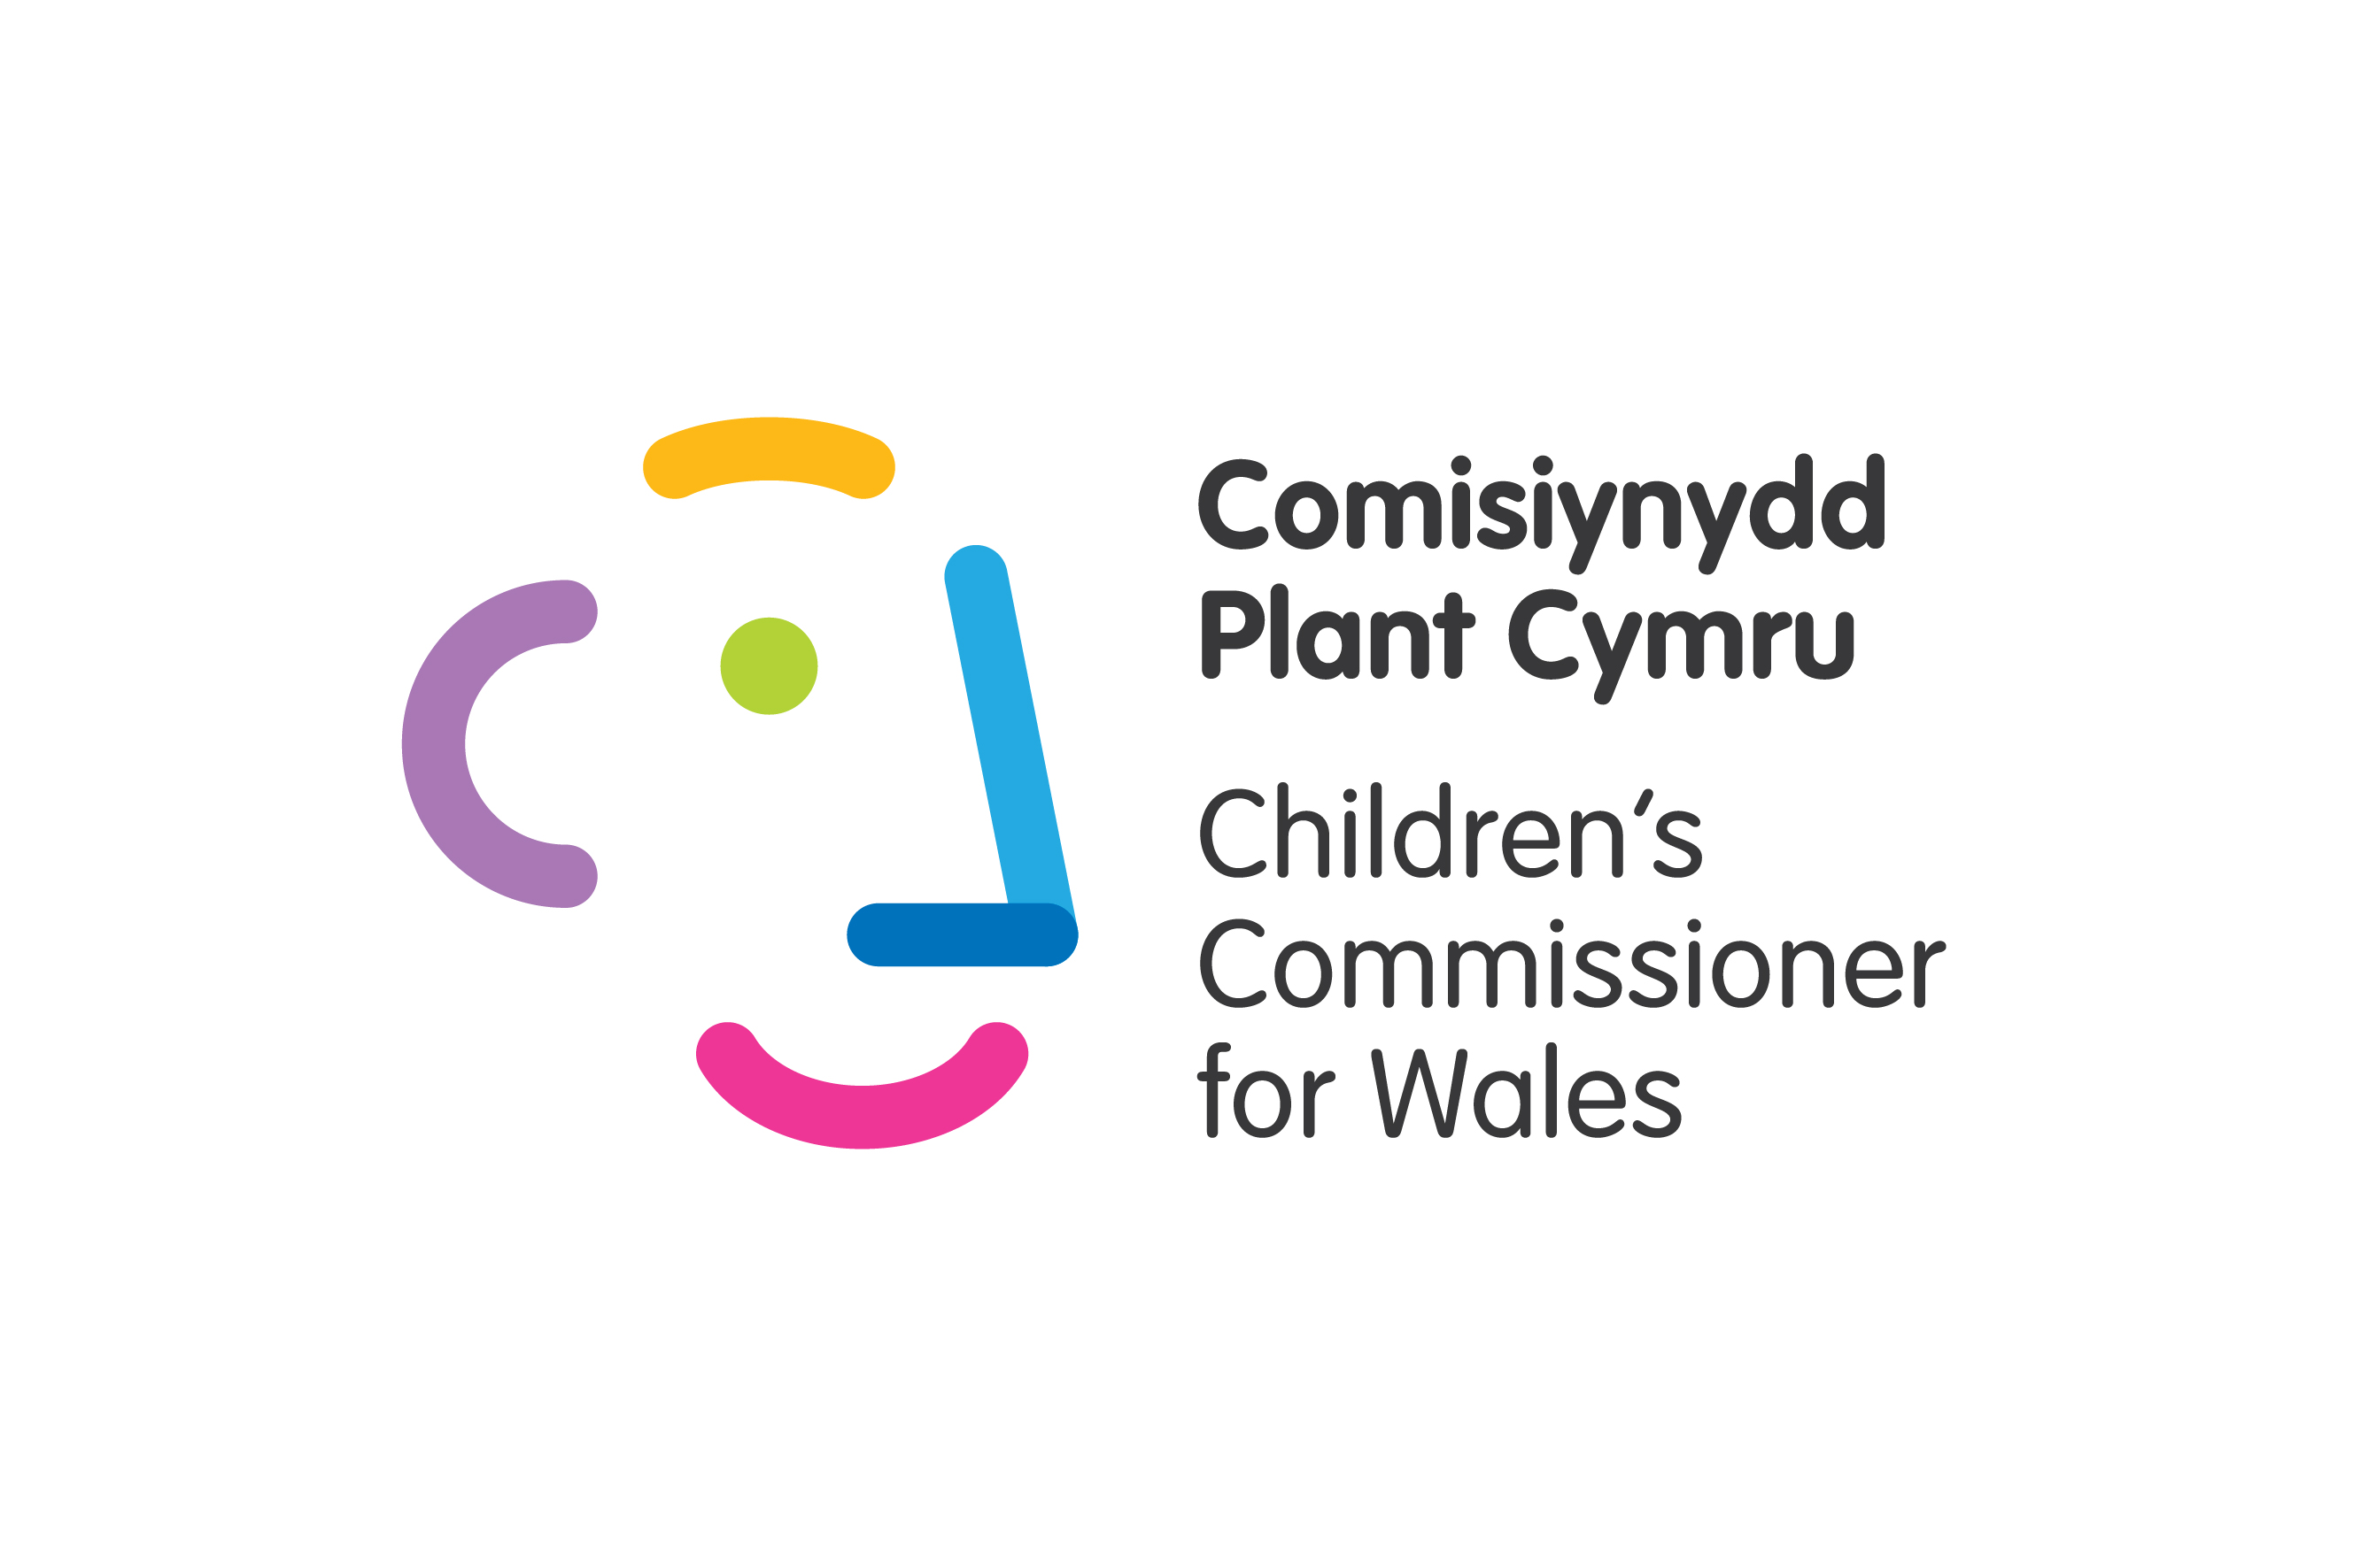
Ymateb i Ymgynghoriad / Consultation Response
Date / Dyddiad: 23.06.2021

Subject / Pwnc: Day of General Discussion: "Children’s Rights and Alternative Care"

Background information about the Children’s Commissioner for Wales

The Children's Commissioner for Wales' principal aim is to safeguard and promote the rights and welfare of children. In exercising their functions, the Commissioner must have regard to the United Nations Convention on the Rights of the Child (UNCRC). The Commissioner’s remit covers all areas of the devolved powers of the Senedd that affect children’s rights and welfare.

The UNCRC is an international human rights treaty that applies to all children and young people up to the age of 18. The Welsh Government has adopted the UNCRC as the basis of all policy making for children and young people and the Rights of Children and Young Persons (Wales) Measure 2011 places a duty on Welsh Ministers, in exercising their functions, to have ‘due regard’ to the UNCRC.

This response is not confidential.

Policy and legislation;

The Social Services and Well-being (Wales) Act 2014 (SSWB Act) is the principal legislation in Wales on local authorities’ duties regarding the care and support of looked after children. ‘Looked after’ means that they are accommodated by the state in alternative care either through a court order or with the voluntary agreement of their parents. ‘Looked after’ children may be placed with wider family networks and some return to their parents while still subject to a court order.

Wales has the highest proportion of children looked after in the UK, with 1.14% of all children being looked after. 7,170 children were looked after in Wales in 2020, with 1,200 of these being placed with their parents.

There is a growing recognition here of the need to invest in high quality, preventive family support networks. Research by the Nuffield Trust of 1,000 women who became involved in care proceedings has helped inform the needs profile of some mothers who face separation from their children. 53% of mothers entered motherhood as teenagers, 76% lived in the two most deprived areas of Wales and 53% reported a mental health condition. 63% presented at their initial antenatal assessment by the 12th week of pregnancy, presenting a window of opportunity for preventative work. The report recommended more intensive engagement with women at the earliest point from both health and social care services to reduce the risk of care proceedings.

The Welsh Government established a Ministerial Advisory Group on Improving Outcomes for Children, which placed a significant focus on improving services for looked after children. One element of this work explored an enhanced community support offer to reduce the numbers in alternative care and help families remain together. A £15m investment was made to build reunification services and family conferences, along with improved access to therapeutic support in 2018. However, Wales is yet to see a significant reduction in the numbers of children in alternative care.

In Wales an overarching duty is placed on practitioners delivering functions of the SSWB Act to pay due regard to the United Nations Convention on the Rights of the Child. Whilst greater efforts are needed to further embed this duty into practice, this provision requires professionals supporting families to be aware of children rights. Therefore, rights such as Article 9, Article 16, and Article 18 should be firmly in the minds of practitioners when working directly with families. Practitioners are encouraged to balance the risks and rights in the best interests of children.

In regards to protection from violence, Welsh Government introduced the Violence against Women, Domestic Abuse and Sexual Violence (Wales) Act 2015 to improve the public sector response in Wales to gender-based violence, domestic abuse and sexual violence. This has led to the creation of National Strategy, which works across health, social and police services to prevent violence and support vulnerable people. The strategy also recognises the needs of children, as victims and witnesses of violence and has set an objective to develop more robust and effective support services.

The Children and Family Court Advisory and Support Service Cymru (CAFCASS) operates to support families who are involved in care proceedings, through advice and guidance to families and children involved in the Court process. In Wales, CAFCASS has a strong commitment to promoting children’s rights; their work is underpinned with the guiding principles of being child-centred, inclusive and working with integrity and respect.

Wales has introduced the National Approach to statutory advocacy to ensure all children who require care or support from the local authority can access an independent advocate. This means that all children who are looked after are entitled to an independent, professional advocate to support them to participate in decisions that impact their lives. This is an important step in promoting children’s rights in Wales, ensuring children are listened to and encouraged to meaningfully participate in decisions relating to their care.

Characteristics of high-quality alternative care;

High quality alternative care for children should have their rights under the UNCRC at its core. My Office has produced a practical framework developed with children and professionals across Wales, to help services pay due regard to children’s rights in service design and practice. The framework, ‘The Right Way: Social Care’ is designed to help those working to support children in a social care context, by providing practical, real-life examples of how children’s rights can be further promoted in everyday practice.

The framework is based on the five principles of embedding rights, equality and non-discrimination, empowerment of children, participation and accountability. It is designed to help organisations consider what they are already doing to support and promote children’s rights, and to identify gaps and areas for development. Positive case studies included things like;
- Children’s Rights Champions, to deliver practical training on children’s rights;
- Partnership programmes delivered by health, early years and social care practitioners, to support young parents on their parenting journeys, with an emphasis on positive parenting and keeping families safely together;
- Strong participation networks bringing children together to help shape and design services;
- Accessible complaints processes

Whilst Wales places a statutory duty on those working in a social care context to pay due regard to children’s rights, there is still a way to go until this is fully embedded in the everyday practices of alternative care. For example, despite children’s rights to recover from traumatic experiences, to achieve their potential and to access education, children placed in alternative care face wide-spread barriers in accessing support in relation to;
- Appropriate wellbeing, mental health and behavioural support;
- Lower educational attainment than their peers not in alternative care;
- Over-representation in Wales’ youth justice system;
- Higher levels of criminal charges and cautions than their peers.

High quality alternative care should also be delivered through a not–for-profit model. I have welcomed the Welsh Government’s commitment to eliminating profit from children’s services during the next five years. This is an important step, as it will remove the ‘market’ element of children’s care, which too often am I informed that children are aware of. It will help to prevent decisions being made on the basis of cost.

How can children be meaningfully involved in decision-making?

In Wales, most local authorities have fora for looked after children to meet peers and advise on policies and practices. Some have regular meetings with senior leaders to give feedback and help to develop services. Many have met or work with me and my team to inform our work. As an example, many young people complained to me about the impact of profit making by private companies delivering their care. I made a formal recommendation to the Welsh Government to phase out the ability to make a profit from children in care. The Welsh Government have since pledged to eliminate profit within the next 5 years.

Support for Care Leavers;

Insufficiencies in the alternative care system can have significant impacts on young people leaving care, such as poor educational attainment, unresolved trauma and poor support networks.
I have consistently called for children leaving care to receive the below support
- Those leaving residential care must have the same options for accommodation as those leaving foster care, including remaining in their accommodation beyond the age of 18;
- All care leavers up to the age of 25 to have the support of a local authority Personal Adviser who can help them navigate their transitions to adulthood;
- Local authorities and surrounding businesses should provide adequate training and work opportunities for care experienced young people, to help develop skills;
- Alternative care should equip young people with independent living skills and provide accessible financial information.
Transitions from care to independent living are often too abrupt for many children. Attention must be given to develop high quality semi-independent living arrangements, to help children make a successful transition. As care leavers no longer receive ‘care’ but ‘support’, their accommodation is not regulated to such a high degree. This means the quality and standards can vary widely. Young people can become increasingly vulnerable if they are living without support in insufficient, poor quality accommodation.

I welcome the St David’s Day fund in Wales which is a flexible fund to support care leavers’ needs.

Impact of COVID-19 on alternative care;

The Welsh Government did not repeal its duties towards children and families under emergency legislation, so a strong safeguarding lens remained in place. It was the only UK nation not to temporarily repeal these duties during this period. Despite this, the manner in which services were accessed by children and families changed significantly. For example;
- Face to face visits with social workers were paused unless a visit was absolutely necessary.
- Care Reviews and meetings were held virtually, requiring children to adapt to this new way of participating.
- Local Authorities developed risk frameworks, determining the level of intervention and support families could receive;
- Children placed on the child protection register and those in alternative care could attend school hubs, despite education being delivered remotely. This helped provide ongoing support to families and acted as an additional safeguard for children who were at risk. However not all children were able to attend Hubs, with attendance levels varying across the regions. It was also unclear to what extent social workers could encourage attendance of a child living with their parents, where there were concerns about their welfare at home, as attendance was not mandatory.
- Many care experienced young people have additional learning needs, and will have faced challenges in adapting to remote learning without support. This could have lasting consequences for children’s attainment, particularly those at risk of disengaging with education.
- Many children in alternative care were unable to see their birth families. My Office continued to push for the needs of care experienced children to be reflected in national guidance. My Office intervened in a number of cases where family visits were in jeopardy for children in the lead up to Christmas.
- Wales experienced a drop in child protection referrals however children did continue to enter alternative care. As more restrictive measures ease, Wales is preparing for an increase in child protection work.
- Regulator Care Inspectorate Wales paused physical inspections of children’s homes opting for remote methods. Whilst regulations were not repealed for homes, this reduction in physical presence of inspectors amongst homes is yet to be fully realised.

Strengthening cross-border cooperation;

The Welsh Government is considering a cross-border protocol for children who are placed in England from Wales and vice versa. Whilst small numbers of children may benefit from being placed further afield for specific placements, some children face disruption when placed far away from their home authority, eg. fewer visits from professionals and disruption to health support and education. A high quality alternative care system would place a greater focus on keeping children closer to home, to support important family and community links. Removing the element of profit from children’s care could also support this as it would remove the market driver for homes to be filled in order to be profitable, which results in some homes offering placements to children across England in Wales, opposed to providing directly for local need.

Preventing the institutionalisation of children?

In 2016 my Office researched children’s experiences of residential care in Wales. ‘The Right Care’ Report found mixed experiences of living in residential care. Some were excelling educationally and felt settled in the home and surrounding community. Others had experienced a number of placement moves, with one girl involved in our study living in 25 different placements by the age of 13. The report evidenced that not all children living in residential care were having their full rights to receive information, be listened to and have their views taken into account when important decisions about their care are being made. This is why it is important that children living in residential care have the same entitlement to access an Independent Professional Advocate, as children can become encouraged to actively participate in their care. Advocacy can act as an additional safeguard for children if they struggle to have their voices listened to by other services.

Our report also found that children in residential care experienced higher levels of criminalisation than their peers. This is was due in part to the fact that challenging behaviour was being managed differently than it would in the family home. Wales is currently developing a National Protocol to Reduce the Criminalisation of Care Experienced Young People, which will support police, local authorities and children’s care providers, to develop more robust processes, which can reduce the risk of children being unnecessarily criminalised.

The Regulation and Inspection of Social Services (Wales) Act introduced an enhanced ‘responsible individual’ role, to ensure that each care setting has a dedicated person to monitor and improve service delivery and to ensure compliance with the principles of the Act. One such objective of the role is to ‘promote a culture of openness and accountability’ in the provision of care services.

Alternative care arrangements for unaccompanied and separated children;

In Wales, unaccompanied children who become looked after receive the same entitlements as all other children in care. However, concerns have been raised that there is a lack of diversity in Wales’ fostering sector, limiting the availability of religious, cultural and linguistically diverse placements for children.

What measures can be taken to ensure there is a well-trained, supported and supervised multi-sectoral workforce in your context or area of work? What makes them effective?

My Office provides a number of training resources aimed at a range of public facing professions to help build practical understanding and awareness of children’s rights. Further embedding the ‘due regard’ duty in Wales with widespread training on the practical application of rights would help ensure the multi-sectoral workforce had a strong foundation of rights to inform their practice. Social Care Wales regulate the social care workforce and provide an introduction to the UNCRC in their induction framework.

Submitted by:

Professor Sally Holland
Children’s Commissioner for Wales

Children looked after at 31 March by local authority and placement type (gov.wales)
https://www.researchgate.net/profile/Ashley-Akbari/publication/343810213_Born_into_care_One_thousand_mothers_in_care_proceedings_in_Wales/links/5f410997299bf13404e05b08/Born-into-care-One-thousand-mothers-in-care-proceedings-in-Wales.pdf?origin=publication_detail
https://gov.wales/violence-against-women-domestic-abuse-and-sexual-violence-national-advisers-annual-plan-2021-2022-html
https://www.childcomwales.org.uk/wp-content/uploads/2021/04/RightWaySocialCare_Final-Amendments.pdf
https://www.childcomwales.org.uk/wp-content/uploads/2016/06/The-right-care.pdf
https://www.childcomwales.org.uk/resources/

