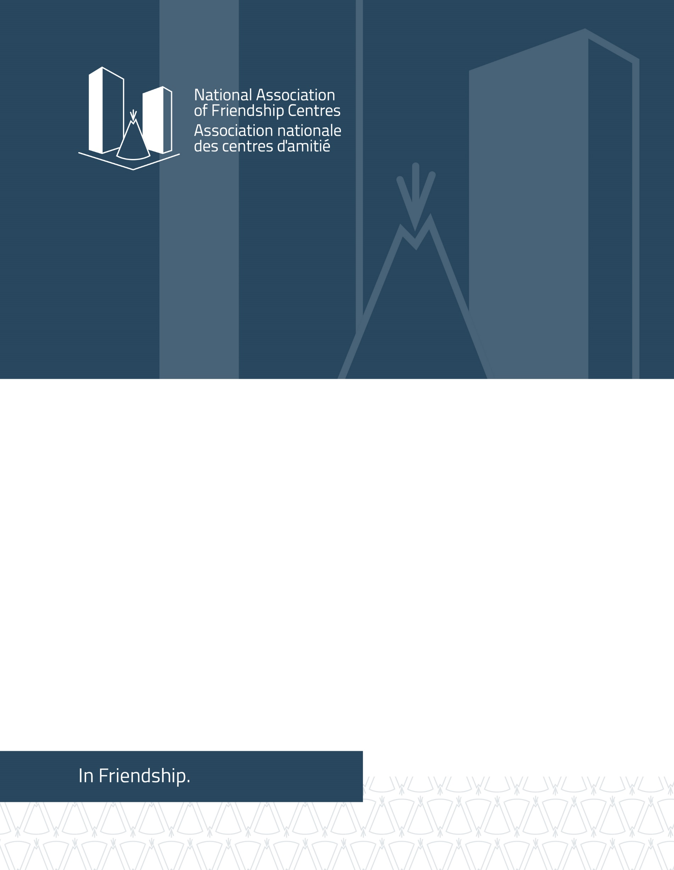
CANADA: Submission to the Committee on the Rights of the Child (CRC) in advance of its preparation of the Day of General Discussion: "Children’s Rights and Alternative Care" 16 - 17 September 2021

Contact:
Jocelyn Formsma, H.B.Soc.Sci, J.D.
Executive Director. National Association of Friendship Centres
275 MacLaren Street, Ottawa, Ontario K2P 0L9 CANADA
1 (613) 563-4844 ext. 318
www.nafc.ca
jwformsma@nafc.ca
June 2021

About NAFC
The National Association of Friendship Centres (NAFC) is a national network of Indigenous owned and operated civil society, not for profit, and service delivery organizations across Canada. Collectively, we refer to our network of over 100-member local Friendship Centres (FCs) and Provincial/Territorial Associations as the Friendship Centre Movement (FCM). The FCM is the most significant urban Indigenous service delivery infrastructure in Canada. For over half a century, FCs have been developed and advanced by Indigenous peoples living in urban environments and helped individuals access the vital culturally appropriate services they need to succeed in urban settings across Canada.

Introduction
The NAFC submits this written statement to the United Nations (UN) Committee on the Rights of the Child (CRC) in advance of its preparation of the Day of General Discussion: "Children’s Rights and Alternative Care" 16 - 17 September 2021. This submission is intended to acknowledge the harms of care and the abuse of children in care and explore the measures that can be taken to ensure prevention, intervention, access to justice and accountability. The NAFC seeks to provide perspectives based on urban Indigenous realities in Canada.
Indigenous children are disproportionately represented in the Canadian child welfare system which is a “growing crisis”. 52 per cent of children in foster care are Indigenous despite Indigenous children accounting for only seven per cent of the youth population in the 2016 Census. Indigenous Services Canada classified 9,246 children as “in care” in the 2017/18 fiscal year but that data does not include Inuit, Métis, off-reserve Indigenous children or the Northwest
Territories. It is unknown how many Indigenous children are in the child welfare system in Canada due to problems in how the federal government collects data.

The high number of Indigenous children in care is directly related to of the lasting impacts of residential schools such as poverty, addictions, and domestic and sexual violence according to the findings of the Truth and Reconciliation Commission of Canada (TRC). The TRC report states that for over a “century” the Canadian Governments Indigenous policies were to “eliminate Aboriginal governments; ignore Aboriginal rights; terminate the Treaties” and to assimilate Indigenous people into Canadian society which amounted to “cultural genocide.” From 2008 to 2015 the TRC heard from over 7000 survivors and their family members. The TRC documented the incredible death rates and abuses of Indigenous children and youth who attended these schools. The TRC outlined the intergenerational impacts experienced in Indigenous communities such as language loss, family separation, violence, and substance use.
There is a clear connection between the crisis of Indigenous children in care and the tragedy of missing and murdered Indigenous women, girls and two-spirited, lesbian, gay, bisexual, transgendered, queer, questioning, intersex, asexual and non-binary people (2SLGBTQQIA+). Cindy Blackstock, the executive director of the First Nations Child and Family Caring Society has stated that Canada’s child welfare system is “creating and perpetuating conditions that place Indigenous women and girls at greater risk for violence.” The Government of Canada launched the National Inquiry on Missing and Murdered Indigenous Women and Girls (NIMMIWG) in 2016 with a mandate to investigate the systemic causes of violence against Indigenous women and girls. Qajaq Robinson, one of the commissioners for the NIMMIWG asserted that approximately “a third to a half” of all NIMMIWG testimonies discussed Canada’s flawed child welfare system. Many NIMMIWG testimonies outlined struggles with trauma that resulted in their children being seized by Canadian child and welfare services. Some of the testimonies discussed Tina Fontaine’s murder and that at the time of her death she was supposed to be under the care and protection of Child and Family Services in Winnipeg, Canada. Tina Fontaine’s murder sparked outrage across Canada and illuminated how the Canadian child welfare system has failed many Indigenous children, youth, and families.
The Canadian government has continued its pattern of ignoring the needs of Indigenous children and youth. In 2016, the Canadian Human Rights Tribunal found that Canada was racially discriminating against 165,000 First Nations children by providing them with inequitable services. The Canadian Human Rights Tribunal asserts that Canada’s policies were causing the unnecessary removal of Indigenous children from their families, homes, and communities.
The TRC made five specific calls to action (CTA) regarding child welfare. For this submission, NAFC will focus on three of these child welfare calls - the 1st, 4th and 5th calls.
- The first call being, “We call upon the federal, provincial, territorial, and Aboriginal governments to commit to reducing the number of Aboriginal children in care by, providing adequate resources to enable Aboriginal communities and child-welfare organizations to keep Aboriginal families together where it is safe to do so, and to keep children in culturally appropriate environments, regardless of where they reside.”
- The fourth call is, “a call upon the federal government to enact Aboriginal child-welfare legislation that establishes national standards for Aboriginal child apprehension and custody cases.”
- The fifth call is, “a call upon the federal, provincial, territorial, and Aboriginal governments to develop culturally appropriate parenting programs for Aboriginal families.”
NAFC calls of the Canadian Government to take immediate action to implement the Truth and Reconciliation Commission of Canada’s (TRC) 94 calls to action and the National Inquiry into Missing and Murdered Indigenous Women and Girls (MMIWG) 231 calls for justice. NAFC supports the work of the TRC and MMIWG Inquiry and upholds that the Canadian Government must outline a clear timeline with allocated funding to address the crisis of Indigenous children in the Canadian welfare system. NAFC upholds that Friendship Centres wraparound programming plays a role in providing children and youth with prevention, intervention, access to justice, accountability, and suitable reparation. The Canadian Government must support Friendship Centres across the country that execute this work as part of their mandate and mission to assist Indigenous children, youth, and families.
COVID-19 Impact
First Nations, Inuit and Métis are among the most at-risk population groups during the COVID- 19 crisis. COVID-19 and the public health measures put in place to contain its spread have magnified pre-existing inequities. These inequities are rooted in colonialism and racism. The long-term consequences of the pandemic and its restrictions on child development are expected to be worse for children in care because of the added stress of the pandemic.
A call to action was created to address the needs of children in care during the pandemic by Native Child and Family Services of Toronto, The Hospital for Sick Children, and researchers from the Factor-Inwentash Faculty of Social Work at the University of Toronto. The organizations called on the Ontario provincial government to “prioritize our children’s optimal health and development” and “apply Indigenous tools and approaches to well-being through access to the outdoors and physical activity” in urban environments in order to overcome challenges and mitigate risks faced during and after the COVID-19 pandemic. NCFST began offering safe outdoor programming in select City of Toronto parks in June 2020 to help improve the mental and physical health of children and youth. Children and youth can overcome hurdles presented by the COVID-19 pandemic by participating in programs that are trauma-informed and foster a connection with nature.
Indigenous Services Canada launched a distinction- based Indigenous Community Support Fund (ICSF) to address the immediate needs of communities such as the call for land-based programming. Educational and other support for children were a noted focus of the fund. ICSF was offered directly to communities as well as Indigenous organizations including the NAFC. NAFC has successfully administered previous ICSF funding to Friendship Centres. The Canadian Government’s 2021 budget has only one specific mention of funding for urban Indigenous people which is captured under ICSF. Budget 2021 allocated $760.8 million additional funding for ICSF. NAFC views ICSF as crucial to Friendship Centres and organizations like Native Child and Family Services of Toronto to secure predictable long-term funding to support urban Indigenous organizations as they navigate COVID-19 lockdowns, vaccine roll-out and build capacity for a post-pandemic world.
Rights of Indigenous Children
Indigenous children deserve the full benefit of both Indigenous and children’s rights. Article 30 of the Convention on the Rights of the Child asserts that “In those States in which ethnic, religious or linguistic minorities or persons of Indigenous origin exist, a child belonging to such a minority or who is Indigenous shall not be denied the right, in community with other members of his or her group, to enjoy his or her own culture, to profess and practise his or her own religion, or to use his or her own language.” These sets of rights ought to work in full concert with each other and mutually reinforce each other for the benefit of all Indigenous children regardless of residency.
The right to self-determination is connected to the practice of self-governance and recognition of collective interests to allow individuals and communities to chart their own course. There is rarely focus on a fundamental call for broader unity and mobilizing national alignment. TRC CTA 43 asks for the implementation of UNDRIP that recognizes articles in defense of Indigenous peoples’ rights. Teamwork, mutual learning, and strategizing all uphold Article 23 of UNDRIP, which states that “Indigenous peoples have the right to determine and develop priorities and strategies exercising their right to development,” and more fundamentally, reifies the freedom to “pursue their economic, social and cultural developments” that Article 3 puts forward.
UNDRIP and the CRC support the assertion that solutions to the crisis of Indigenous children in care can be found within Indigenous communities and organizations. Friendship Centres advocate to reduce the number of children admitted to the Canadian welfare system and assist with prevention, intervention, access to justice, accountability, and suitable reparation to support Indigenous families. Mobilizing Friendship Centres nationally, sharing best practices, and creating broader support systems are all elements that advance and uphold the rights of urban Indigenous children and youth.
Alternative Child Care Models and Holistic Care
Historically, Indigenous families in Canada raised their children within their own communities with a strong connection to the land. However, due to intergenerational trauma caused by colonization, many have experienced a disconnect from their families, communities, and Indigenous identity. Holistic remedies grounded in traditional and cultural teachings support Indigenous families and communities through their spiritual, emotional, and physical healing journeys.
Organizations such as the Native Child and Family Services of Toronto (NCFST) work to keep children and families together while receiving child and family services. The NCFST focuses on three alternative care options including Customary Care, Kinship Care, and the Fostering System. Customary Care allows children to be cared for by another member of their family or First Nations community member rather than their parents. Strong communal and cultural ties are necessary when children live outside of their communities. Several Indigenous children's assistance groups have established effective operating models of customary care for protection cases.
Kinship Care is “[an] alternative care arrangement in which an identified family, community member, or someone known to the child is willing to care for the child under the Ministry of Children, Community, and Social Services criteria (MCCSS).” When Customary Care or Kin Care is unavailable, the care provider will seek alternative options within the fostering model. The foster parent is required to collaborate with caregivers and community members to ensure the child's needs are fulfilled following MCCSS guidelines.
Indigenous regional health survey data in Canada outlines the importance of maintaining traditional wellness among the urban Indigenous child in Canada. In the province of British Columbia, the report First Nations Regional Health Survey Phase 3 (2015-17), BC Provincial Report, by the First Nations Health Authority, discusses how First Nations achieve traditional wellness through connections to Indigenous families and communities in Canada. Traditional practices such as “cultures and teachings [to] express their shared connection to the land through their traditional languages, foods, art, activities and medicines” are tied to Indigenous peoples’ identity.
The MMIWG 2SLGBTQQIA+ National Action Plan was released in 2021 and calls of all levels of the Canadian government to “recognize Indigenous self-determination and inherent jurisdiction over child welfare, and support enhancements for child and family services”. The National Action Plan calls for “system navigators” to assist with “Child and Family Services, Health Care, Housing, Education, Justice, Policing, and Victim’s Services.” The Urban Working Group chapter states “urban service organizations have provided support for the navigation of rights, and as such are a gateway to exercise rights.” Friendship Centres have demonstrated their ability to hire and support system navigators that are needed to assist Indigenous children and youth in care or those who are ageing out of care. System navigators connect Indigenous children, youth and their families with culturally safe and wraparound services and advocate for justice on a local, provincial, and national level.
Conclusion
NAFC asserts that there remains a need for permanent and increased funding for programming and services in all service areas that reach urban Indigenous children, youth and families. NAFC recognizes the importance of culture, tradition, and ceremony in supporting Urban Indigenous community members and especially Indigenous children who may be in the child welfare system. Practicing culture, tradition, and ceremony is an act of self-determination, and is enshrined within Indigenous rights that are recognized in domestic and international law. UNDRIP supports the need for culture and ceremony within Indigenous communities and calls for greater acknowledgement of this work—and in doing so, the greater acknowledgement of the Friendship Centre Movement across Canada leading this work in urban Indigenous contexts.
In recognizing Friendship Centres capability to support the holistic wellbeing and safety of urban Indigenous children, youth and families there are also necessary next steps governments, policymakers, and funders must pursue to enable them to sustainably deliver these services with dignity and amplified success. These steps include:
- Providing resources for capacity building and program design, delivery, data collection, and evaluation,
- Recognizing diversity within urban Indigenous communities, urban Indigenous contexts, and the portability of Indigenous peoples’ rights, and
- Acting to effectively address systemic causes of Indigenous children being placed in the Canadian welfare system.
We share this submission to help inform the ways in which we view the work that lies ahead to ensure the equality and non-discrimination of all Indigenous children, youth, and families regardless of residency, and inclusive of their layered and intersectional identities. We will continue to work to ensure that there are mechanisms available for Indigenous peoples who are urban based to have effective participation in the matters that affect them in public and political life.

The term “Indigenous” will be used to include peoples in Canada who are First Nations, Métis and Inuit, regardless of their legal status with the government of Canada.
The term “urban” encompasses Indigenous peoples who are living in large metropolitan cities, rural, remote and northern communities. Specifically, First Nations who are living off-reserve, Métis living outside of Métis homelands, and Inuit living outside of Inuit Nunangat (Inuit homelands).
Truth and Reconciliation Commission of Canada. Canada's Residential Schools: The Legacy: The Final Report of the Truth and Reconciliation Commission of Canada, Vol.5 (2015), p.60, http://www.trc.ca/assets/pdf/Volume_5_Legacy_English_Web.pdf
Government of Canada; Indigenous Services Canada. “Reducing the Number of Indigenous Children in Care.” Government of Canada; Indigenous Services Canada, 7 June 2021, www.sac-isc.gc.ca/eng/1541187352297/1541187392851.
Lamirande, Kenneth Jackson | Todd. “How Many First Nations Kids Are in Care? Canada Is Trying to Figure That out Now.” APTN News, 21 May 2020, www.aptnnews.ca/nation-to-nation/how-many-first-nations-kids-are-in-care-canada-is-trying-to-figure-that-out-now/.
Truth and Reconciliation Commission of Canada. Canada's Residential Schools: What We Have Learned: The Final Report of the Truth and Reconciliation Commission of Canada, Vol.5 (2015), p.10, https://ehprnh2mwo3.exactdn.com/wp-content/uploads/2021/01/Principles_English_Web.pdf
Taylor, Jillian. “'Tina Fontaine Is That Direct Link' between MMIWG, Child Welfare System, Advocate Says at Inquiry Hearing” CBC/Radio Canada, 3 Oct. 2018, www.cbc.ca/news/canada/manitoba/mmiwg-national-inquiry-cindy-blackstock-winnipeg-1.4848538.
Diana Oproescu “Child-Welfare System Comes up in a Third to Half of MMIWG Testimonies, Commissioner Says.” The Discourse., 27 Apr. 2020. thediscourse.ca/child-welfare/newsletter-child-welfare-system-comes-third-half-mmiwg-testimonies-commissioner-says.
Ibid.
Kirkup, Kristy. “Human Rights Tribunal Sought to Compensate Canada's 'Victims of Discrimination': Lawyer.” The Globe and Mail, 15 June 2021, www.theglobeandmail.com/politics/article-human-rights-tribunal-sought-to compensate-canadas-victims-of/.
Truth and Reconciliation Commission of Canada: Calls to Action (2015) http://trc.ca/assets/pdf/Calls_to_Action_English2.pdf
Ibid. 1.
Ibid.
Ibid.
Government of Canada; Indigenous Services Canada. “Indigenous Community Support Fund.” Government of Canada; Indigenous Services Canada, 2 June 2021, www.sac-isc.gc.ca/eng/1585189335380/1585189357198.
“What Is COVID-19? And How Does It Relate to Child Development?” Center on the Developing Child at Harvard University, 30 Oct. 2020, developingchild.harvard.edu/resources/what-is-covid-19-and-how-does-it-relate-to-child-development/#graphic-text.
“Let the Children Play: Getting Children and Youth Outdoors Now for an Active Recovery.” SickKids, 14 May 2021, www.sickkids.ca/en/news/archive/2021/let-children-play/.
Ibid.
Ibid.
“Canada’s COVID-19 Economic Response Plan.” Canada, Department of Finance. 23 June 2021, www.canada.ca/en/department-finance/economic-response-plan.html.
UN Commission on Human Rights, Convention on the Rights of the Child., 7 March 1990, E/CN.4/RES/1990/74, https://www.ohchr.org/en/professionalinterest/pages/crc.aspx
UN General Assembly, United Nations Declaration on the Rights of Indigenous Peoples : resolution / adopted by the General Assembly, 2 October 2007 https://www.un.org/esa/socdev/unpfii/documents/DRIPS_en.pdf
“Holistic Services.” Native Child and Family Services of Toronto, 17 May 2021, https://nativechild.org/holistic-services/
Ibid.
Ibid.
First Nations Health Authority. First Nations Regional Health Survey Phase 3 (2015-17). BC Provincial Report at 19. Accessed on February 12, 2021 at: https://www.fnha.ca/Documents/FNHA-First-Nations-Regional-Health-Survey-Phase-3-2015-2017-BC-Provincial-Report.pdf )
Missing and Murdered Indigenous Women, Girls and 2SLGBTQQIA+ National Action Plan. 2021. pg 28. https://4c3tru4erdnui9g3ggftji1d-wpengine.netdna-ssl.com/wp-content/uploads/2021/06/NAP_Report_EN.pdf
Ibid. 41.
Missing and Murdered Indigenous Women, Girls and 2SLGBTQQIA+ National Action Plan: Urban Path to Reclaiming Power and Place, Regardless of Residency. 2021.pg 41. https://4c3tru4erdnui9g3ggftji1d-wpengine.netdna-ssl.com/wp-content/uploads/2021/06/NAP-Urban-Framework_EN.pdf

