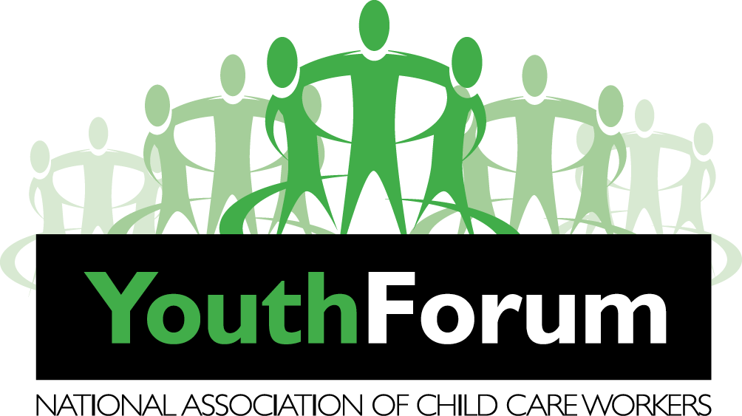

Submission On Children’s Right and Alternative Care
Name | Jubilee
Surname | Rivombo
If you were nominated to present an organization | Yes
Name of organization | NACCW Youth Forum
Your position in the organization | National Youth Chairperson
Aims of the organization | The NACCW is a NPO in South Africa which provides the professional training and infrastructure to promote healthy child and youth development and improve standards of protection, care and treatment for orphaned, vulnerable and at-risk children and youth in family, community, educational and residential group care settings.  The NACCW Youth Forum, is the NACCW led children and youth initiative to provides a platform for young people to participate in civil matters that concern them including to ensure that young people participate in services that benefit them.
How many people belong to the organization | Approx. 2000

CONTACT DETAILS:
Postal Address | 220 Ottery Road  Wynberg  Cape Town  7800
Street Address | Same As Above
Province | Western Cape
Tel no. | N/A
Cell no. | 067 305 3250
Fax | N/A
E-mail : Please send all correspondence to:  Ms Danielle Heynes – Youth Forum  National chairperson  Mr Donald Nghonyama – NACCW  Deputy Director | daniellejamaxheynes@gmail.com  067 305 3250  donald@naccw.org.za  0827078333

WISH TO APPEAR BEFORE THE COMMITTEE:
Yes -

No -
Other people to appear with you before the committee, either to speak or to support. Include their names and roles.
Name and Surname | Reason | Role
Nkateko Bendiction | Youth Representative | National Secretary
Avanda Godongwane | Youth Representative | Deputy National Secretary
Lisa Segobaetso | Youth Representative | Deputy National Chairperson
Donald Nghonyama | Adult Representative + Mentor | Deputy Director
Jubilee Rivombo | Youth Representative | Liaison Officer

The NACCW Youth Forum, if given the opportunity to present, would like to make a presentation preferably after school or school holidays or weekend.
Our submission is drawn from the South African Children’s Amendment Bill (CAB) [B18 2020].
When initially introducing the Children’s Act to the youth forum, The Children’s Institute and other organizations connected to educate youth members about the Children’s Act, what covers and in which context it can be used as reference. These workshops were all conducted via Zoom and were children and youth friendly.
Working on the amendments itself was quite an intriguing process. Through this process the young people were well educated on the law and then questioned about whether or not they feel that the amendments should be made. In order for parliament to acknowledge and approve the amendments, the youth forum decided that using real life experiences and stories would serve as a great motivation.
The young people, along with the support of their CYCW’s, and our mentors managed to efficiently collect data during the consultation process and ultimately made submissions on the bill a reality. One CYCW writes:
“they really enjoyed themselves, we had a quiet number of young people almost 60+ attendance also joined by those staying in Alternative care in Sunny Place of Safety* they were so excited to be part of this session that is important towards their rights, also I must say Orangefontein* Youth forum also gave their feedback as they also had their session on Tuesday!”
The youth leaders of the forum established a social media strategy for purposes of safe consultation to ensure the voices of children and young people are heard.
ACKNOWLEDGEMENTS
A big thank you to the Children’s Institute and all the other organizations that helped us to learn about the CAB and the parliamentary process. We also acknowledge all the young people who have shared their personal stories, Pseudonyms have been used for their protection.

Alternative Care
Section 191 of the Children's Amendment Bill says “A registered Child and Youth Care Centre must provide therapeutic and developmental programmes designed for the residential care of children outside the family environment which may include: (n) the assistance of a person prior to leaving a child a child and youth care centre and to provide after care services for a period not exceeding 12 months.
The Children’s Act clearly states that each CYCC must make provision for therapeutic and developmental programmes for those who are recipients of residential care, however, when speaking about persons who are exiting care, support services are not guaranteed. They are a “may” not a “must”. When young people don’t get support post residential care they can end up in dire circumstances once leaving care. This undo the good work done in the care system and leaves young saying, “the system is failing us”.
A 20 year old female who has exited the system without any support prior and post her leaving tells us: “I am a product of the failing system. At the age of three I was placed in into foster care and remained with my foster family for a period of nine years. Thereafter I was placed in the care of my biological mother and things took a turn down the wrong road. As a result of my mother’s substance abuse, at the age of fifteen, I found myself being a recipient of residential care services.”
After being in a centre for two years, the family that raised me, reached out and were eager to have me back ‘home’ with them however, I declined the offer . I was often referred to as ‘the star resident’ within the CCYC because of the numerous awards that I had received for academic excellence, sport, leadership and the list goes on. In 2018 I spent my last year at the centre and I was being prepared to go ‘home’.
I enjoyed spending short periods of time with the family when I got a chance to visit but I made the internal social worker aware that I wasn’t comfortable with returning back to my foster family and would rather want to be placed into independent living. As usual my feelings were disregarded because she “knew what was best for me”. In 2019 after receiving my well anticipated grade 12 results, I received extremely disheartening news that my university application was incomplete and due to this I had not been accepted. I was shattered.
The first thing I did was go the centre that had been my home for the past three years. I arrived there in total mess, looking worse than what I felt. After trying to explain my problem to the social worker I was turned away because they had other obligations. I haven’t returned to the centre since. 2019 was one of the hardest years of my life. Despite living with a family, I felt so alone.
Before and after leaving the child and youth care centre I hadn’t received any support whatsoever and this made my transition into the ‘real world’ extremely difficult. Towards the end of 2019, I found myself being absorbed in alcohol and neglecting my personal wellbeing. I had no one to talk to and had lost my sense of belonging. I was a college dropout and homeless by the end of November 2019.” – [Mpho Mkhize* 20]
Mpho’s story emphasizes the desperate need for support services for those transitioning out of care. Young people who have left the CYCC without receiving any support are forced to find support in places and things that are not conducive to their wellbeing. The sad reality is that the very system that once saved these young people’s lives is the reason why their lives end the moment they are placed out of the CYCC. It’s extremely saddening to see young people fall into the trap of social ills that they fought against within this youth forum and were protected from within the CYCC. When comparing the life of young person who has received support compared to that of a young person who had not received support, the contrast is stark.
Masilo Tshabalala* [21], currently resides in a CYCC and is about to leave. We asked Brandon about his transition and he said: “Living in a CYCC is not easy because you’re not alone and there are many other boys who are the same age or older than you. In normal household this wouldn’t be the case. In the centre you have to be mentally strong to not be influenced by those around you. In the CYCC there are people who support you. People who can relate to you. Whether it’s day to day support or someone to talk to.
Another story, Eyethu Maluleka* “Talking from experience on my side, I know that raising someone's child in this country is challenging and difficult but delegating yourself with compassion to remedy the situation, might help this type of issue. I have delegated myself to at least take care of others around me, you can find out that child and youth care workers activities helps us to be matured, independent and stronger to take care of ourselves and others. I also make sure that I lead by example, I teach others humanity and how things are done in life. I have learnt from experience in order for me to rectify problems or issues. We can slightly consider the child and youth care workers training, I have examined the way current child and youth care workers work, and they can make friends with other children or youth because they are more familiar with the current generation or current life. Their age corresponds with the life of current children, making friendship with them, makes the safety of the children a priority”. But most of all it the kind of training that cement them well enough to understand how children in these situations should be treated and supported.
Boitshepo Patsho* ” I grew up with my grandparents. I ran away from home after grandpa died. My grandmother killed my grandfather in front of me. My grandma was very abusive. She would abuse me in all kinds of ways. So when I got the chance, I ran away from home and lived on the streets for about 6 months. I would steal to survive.
I was then taken into alternative care where I stayed for about 10 years. Whilst living in alternative care, I used to steal and got punished severely for it. That habit of stealing stayed with me. Later on, I got adopted into a family with a single mother with two kids and I did the same. I struggled to fit into the family structure and adapt to the new environment. The family never understood me, so I ended up having to go back to the place of safety. The place of safety I was placed better than most places of safety. They had therapy there and so for me, it was a therapeutic place. We had a nurse, social worker, teacher and a therapist. We would get evaluated, and got appropriate help. I didn’t go to school for a while, but I had a teacher that would help me catch up.
When placed in a family, I was never comfortable in a family with a male figure. I was sexually harassed by my uncle when I was younger and so I had trust issues. The family that adopted me would be my holiday family. I was scared that they would take me back and I was scared that if I was placed there permanently, something would go wrong. The experience of being taken back to the place of safety is traumatic I wouldn’t wish it on any child”.
Children need full attention, care, supporting staff members and love. These are essentials that requires that everyone needs but in the situation of a child in alternative care, this is of greater importance as provision of this may help them deal with the challenges of life better. Child and youth care workers and other authorities ought to remain in constant communication with the child and ensure safety and create a hopeful environment.
All of these factors make for a better experience for the child who lives in alternative care. It is also important that alternative care within the region is conceptualized within a child. If we want children in care homes to have a positive experience there then we need not assume that the needs of children across the country are the same. This means that adults then have to fight to figure out how best to serve the child in such a way that the child grows optimally.
Recommendations
- We want parliament to prioritise the therapeutic and developmental needs of young people, who are aging out of the centre, to ensure their success in life post residential care. Amendment of section 191 (2) "(2) A registered child and youth care centre must offer [a] therapeutic [programme] and developmental programmes designed for the residential care of children outside the family [environment] environment, and for the transition from care when they return to family or community or reach the age of 18 years or older. These may include a programme designed for—"; 6 (n) the preparation of a child who is leaving a child and youth care centre to return to family, and support for a period of 12 months after leaving care; and (o) the preparation of a child or young person with the transition when leaving a child and youth care centre after reaching the age of 18 or older, and support for a period of 12 months after leaving.
Children in normal families are supported until they are 24 years or older. We, who have none of these are sent out on our own at the age of 18. This is highly unfair.
- Training of child and youth care workers must be stricter. Rigorous training should be the norm and even after certification, the child and youth care workers must be trained at least once a year.
- Increase funding of the places of safety so that we can have different professionals.
- Children tend to struggle academically. There should be academic support in the facilities as well to ensure that the child excels academically or at least catches up with other learners.
- Once the child has ‘aged out’, help the child with a place to stay. Programmes in this regard should be funded and monitored.
- Monitor all placements of children regularly.
- Child and youth care workers must be trained to help with University applications and to give emotional support once the child goes to university.
- Student social workers, can do their practicals at alternative care areas. They can be a much needed resource in the different alternative care centres.
- CYCWs must be evaluated by external parties at least once a month by interviewing the children. Abusive behaviour by child and youth care workers is underrated in alternative care facilities.
Conclusion
The NACCW Youth Forum would like to thank you for giving us an opportunity to represent a voice of so many children in care. We are speaking of experience and we are mandated by our NACCW Youth Forum from all Provinces to share this with the law makers. Our well being is dependent on you. We beg you to put yourselves in our shoes when you read our submission.

