**2021 Day of General Discussion**

**UN Committee on the Rights of the Child**

Abridged Version 2

VIEWS FROM CARE EXPERIENCED CHILDREN

**Children’s Rights and Alternative Care**

**Written submission in advance of the**

**Day of General Discussion 16th - 17th September 2021**

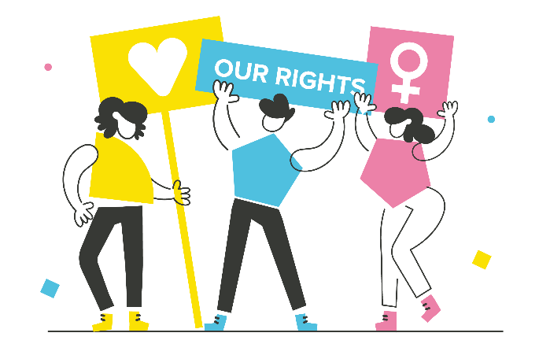

**Wales UNCRC Monitoring Group**



**Grŵp Monitro CCUHP Cymru**

**Children in Wales** and the **Wales UNCRC** **Monitoring Group** wish to acknowledge the following organisations for their contributions to our Call for Evidence - Action for Children Cymru/Wales, Children in Wales, MEIC- ProMo Cymru, NSPCC Cymru, NYAS Cymru, TACT Fostering Cymru, The Children’s Society, The Fostering Network in Wales and Voices from Care Cymru

**Disclaimer: Views expressed in this report may not reflect the views of the organisations listed above**

This is an **abridged version** of the points made by care experienced children and young people captured in our full report. This version has been produced to meet the strict word/page limit. The full report can be accessed at [www.childreninwales.org.uk](http://www.childreninwales.org.uk). There is also an **abridged version** of the points focused on ‘Innovate Practice and Priorities’ available.

Sean O’Neill, Policy Director, Children in Wales June 2021

**TOP PRIORITIES FOR CARE EXPERIENCED CHILDREN**

Ahead of the recent Welsh Parliamentary elections (May 2021), CSOs asked care experienced children for their top priorities. Here are two examples -

**NYAS Cymru** - [Listen if you Care](https://www.nyas.net/wp-content/uploads/NYAS-Listen-If-You-Care-Report-ENGLISH.pdf)

1. **Voice** - “We want to have our say in the decisions that affect us”
2. **Rights** - “We want all care-experienced children and YP in care to know what their rights and entitlements are”
3. **Mental health** - “We want mental health support in place for every care-experienced child or young person that needs it”
4. **Leaving care** - “We want care leavers to be properly prepared for independence, and to have a stable support network if they need any help”
5. **Jobs** - “We want support and advice to find jobs and careers that we love”

1. **Future support** - “We want it recognised that the impacts of the care experience do not end at 18, or 21, or even 25”

**Voices from Care Cymru** - [1000 Voices](https://vfcc.org.uk/our-manifesto/)

1. **Mental Health and Well-being** - “This is important for individuals who are unable to deal with their own issues. Past experiences, anxiety and depression can cause mental health issues which then have a knock-on effect with life.”
2. **Sibling Relationships -** “This will help children feel like they are able to keep the relationship and bonds with their families and not be cut off from them. Also helps to make them feel secure and protected.”
3. **Being Loved -** “This is important for care-experienced children to feel that they are loved by someone. It does not have to be in any particular way but everyone wants to be loved and by having someone doing that can increase their moral and help them to feel they are worthy.”
4. **Breaking the Stigma** - “Children in care have the label/stigma that they cannot do things that others can do. It does not matter that they are care-experienced, it is about recognising that they have hopes and dreams just like everyone else!”
5. **Stability** - “This is important for children to feel happy and stable within their home. Whether it’s foster care, residential or independent living YP do not want to keep moving around as they are unable to build positive relationships with others and they are made to feel that they cannot settle anywhere as their placement is not stable.”

**And finally….**

**Voices from Care Cymru** asked care experienced children and young people the following question

“If you could change one thing for care experienced children, what would that change be?”

* I’m happy – don’t need to change anything right now!!
* Nothing much at present but maybe the education system especially GCSE department as you need a grade C and above
* Social workers to listen more and understand how you feel
* To be able to use my phone / iPad through the night and have no cut off time to be able to listen to music when I feel anxious
* Access to more things (activities)
* Easier transport to places
* More social workers, less work (smaller caseloads) and better pay
* Better accommodation / housing
* PA support beyond the age of 21
* Mental health – lack of proper transitional support to adult services
* Make funding the same across Wales i.e. setting up home grant and funding for university
* Funding post 22 – i.e. housing benefit and benefits for college
* Better social work support after 18 – feel dumped when turning 18
* First homes grant - £1250 is not enough to set up first home
* Offer independent living skills training when in care – currently not given
* Give care experienced young people a chance to be a foster carer in the future
* More education and employment support
* Look at the transition from 17 to 18 – if you’re in a job when you’re 17 it’s difficult to keep it long term if you have all the stress of moving when you’re 18 and leaving care, especially when your new place is far away from your job and you need help and support with transport
* More support for the older ages of care experienced young people
* More support for transgender youths – transition in youths
* More education about the LGBTQA+ community
* Easier access to transport
* More social activities – this will help with mental health problems too
* Mental health awareness month events
* More information about public service jobs
* Second chance in housing post 21
* Smaller case files and input from the young people (need to know how to access and check all the information is accurate)
* Training for foster carers (LGBT / dealing with anger etc.)
* More recruitment of good quality foster carers and from ALL walks of life (e.g. Even those with minor criminal records so they can show us how change is possible)
* Second chances and more social workers

Children in Wales & Voices from Care Cymru (2017) [Written Evidence to Senedd Public Accounts Committee inquiry into Care Experienced Children](https://business.senedd.wales/documents/s66381/CECYP_06%20Children%20in%20Wales.pdf)

**See also –**

**Abridged Version 1 –** INNOVATIVE PRACTICE & PRIORITIES

**Full Version** – [www.childreninwales.org.uk](http://www.childreninwales.org.uk)