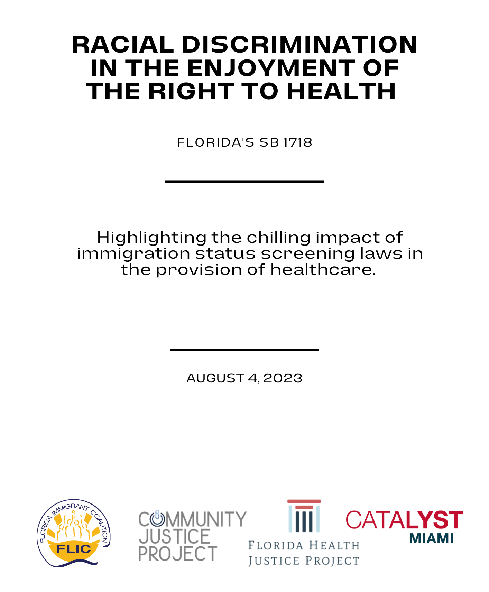
August 4, 2023

United Nations Office of the High Commissioner for Human Rights
Committee on the Elimination of Racial Discrimination
via electronic submission: ohchr-cerd-gr37@un.org

Re: Racial Discrimination in the Enjoyment of the Right to Health

Dear Members of the Committee on the Elimination of Racial Discrimination:

On behalf of the Florida Immigrant Coalition, Community Justice Project, Catalyst Miami, and Florida Health Justice Project, we are grateful for the opportunity to contribute comments on Draft General Recommendation n°37. Specifically, we would encourage Members of the Committee on the Elimination of Racial Discrimination (“the Committee”) to explicitly name screening questions designed to discourage immigrants from accessing healthcare as violative of the Right to Health in section II.B.2.16, as well as throughout the other subsections of II.B.2.

All Member States of the United Nations have an obligation to ensure a Right to Health. Article 5(e)(iv) from the 1965 International Convention on the Elimination of All Forms of Racial Discrimination (ICERD) protects “the right to public health, medical care, social security and social services.” The Draft General Recommendation reminds us that freedom from racial discrimination is essential to achieve “the highest attainable standard of physical and mental health.” As you are aware, the United States has ratified treaties to protect these rights, including the Convention on the Elimination of All Forms of Racial Discrimination (CERD). The legislation enacted by the state of Florida, against the backdrop of increasingly violent and ongoing harassment of immigrants, is a betrayal of these commitments.

Here in the state of Florida, many immigrants with and without lawful status are being affected by draconian state laws that further marginalize them and now have a direct impact on their ability to access hospital care. On May 10, 2023 Florida Governor Ron DeSantis signed into law Senate Bill (SB) 1718, “An act relating to immigration.” Along with other provisions that further the precarity of immigrants in Florida, SB 1718 includes a section on “patient immigration status data collection,” which requires most hospitals to ask patients their legal immigration status. This provision was designed to generate fear and create obstacles deterring immigrants from accessing essential and life-saving medical care. It builds on years of deliberate efforts by Governor DeSantis to make Florida uninhabitable for immigrants.

Before SB 1718 passed, dozens of Florida healthcare providers spoke out against the bill, predicting that it would cause mistrust in the healthcare system, undermine the ability of healthcare professionals to provide quality service and deter individuals from seeking help. The chilling effect from Trump-era policies - like public charge and increased targeting of immigrants - is still being felt. This forces many immigrants to choose between accessing healthcare or risking their ability to stay safely in the US. When faced with that choice, people tend to choose to stay safe, at the expense of seeking care, in some cases delaying or entirely forgoing medically necessary care. “We already ask if patients have insurance, which immediately induces fear and suspicion. Asking about citizenship will only make this worse,” said Critical Care Nurse Kevin Cho Tipton.

SB 1718 is designed to exacerbate the barriers immigrants face in accessing healthcare, particularly in an emergency or when attempting to reach a specialist or diagnostic services. This is an unreasonable burden for anyone in time sensitive and fearful situations. On top of needing to navigate an already complex and confusing healthcare system, it is understandable that many immigrants have been confused and hesitant to seek healthcare. Dr. Antonio Gonzalez, a practitioner in Immokalee, says that he has seen fewer patients since SB 1718 came into effect on July 1, even though the new law does not apply to him. Gonzalez said some migrants were afraid to see him even before the new law. “They were afraid of being caught by immigration [enforcement]. Now, with this law, they’re not even coming to the doctor. This is gonna have a great impact in…the medical care of those poor people out there.” He expects people to die.

Consequences of the Florida government’s rising anti-immigrant policies implicate and diminish the rights of citizens, as well. Drishti Pillai, Director of Immigrant Health Policy at the Kaiser Family Foundation, notes that “Increased fears among immigrants…will have some broad chilling effects by leading immigrant families to avoid seeking health care not only for themselves, but also for their children who may include U.S.-born citizens, just out of fear of drawing attention to their immigration status.” Discrimination in healthcare is a matter of racial, economic, and political justice.

Though SB 1718 insists that inquiries about a patient’s immigration and citizenship status “must be followed by a statement that the response will not affect patient care or result in a report of the patient’s immigration status to immigration authorities,” it also mandates quarterly reports on patient data collection of said status. Such data collection efforts are designed to build the case for defunding hospitals that serve immigrant communities and stoke fear in hospital administrators and healthcare providers, pushing them to further limit access to their services.

Concerns over requirements such as this one, combined with all other provisions in the bill, have underscored the Florida government’s intent to discriminate against and further marginalize immigrants. In response, many immigrants are leaving Florida. David Guerrera, a construction worker originally from El Salvador, believes that the environment changed after SB 1718 was passed. “Many Americans didn’t even greet you anymore, they looked down on you, so to speak,” he said. “That was what most led me to make the decision to come to Maryland.”

These attacks on immigrant rights have been met with fierce opposition from human rights defenders such as the Florida Immigrant Coalition, who have mobilized around a Decline to Answer Campaign that draws attention to the fact that patients are not required to disclose their immigration or citizenship status to healthcare providers. Their efforts have brought together healthcare workers and regular Floridians—both with and without legal status—to protect fundamental human rights in Florida.

Reporting Organizations:

Florida Immigrant Coalition
The Florida Immigrant Coalition (FLIC) is a statewide coalition of more than 65 member organizations and over 100 allies, founded in 1998 and formally incorporated in 2004. We are led by our membership, including grassroots and community organizations, farmworkers, youth, advocates, lawyers, union members, and more. FLIC is a hub for a bold, agile, and strategic social movement to protect Florida immigrants. Our mission is to grow the connection, capacity and consciousness of communities to strengthen pro-immigrant power in Florida.

Community Justice Project
When communities organize, we have their backs. Community Justice Project is made up of movement lawyers, researchers, and artists supporting grassroots organizing for power, racial justice, and human rights. We use innovative lawyering, advocacy, and creative strategies to advance justice and amplify the voices of directly impacted people. Based in Miami, Florida, Community Justice Project is deeply and unapologetically committed to the Black and brown communities organizing throughout Florida.

Catalyst Miami
Catalyst Miami is a nonprofit that works with communities to address immediate needs and build a better future together. Our mission is to build power with frontline communities throughout Miami-Dade County to collectively advance justice and achieve shared prosperity. Our vision is a just society where everyone can lead healthy, prosperous, self-determined lives.

Florida Health Justice Project
Florida Health Justice Project engages in comprehensive advocacy to expand health care access and promote health equity for vulnerable Floridians.

Fla. Laws ch. 2023-40.
Hospitals that accept Medicaid, a federal health insurance program administered by state governments, are bound by this new law.
Fla. Stat. § 395.3027 (2023).
Matt Dixon, DeSantis scrutinizes health care costs for the undocumented, Politico (May 6, 2022).
https://pifcoalition.org/our-work/public-charge
Fadia Patterson, Florida healthcare providers discuss dangers of HB 1617 and SB 1718, asking immigration status, Spectrum Bay News 9 (April 29, 2023).
Michelle Alvarez, Doctor fears Florida’s new immigration law is scaring away patients, WINK (July 18, 2023).
Rodaris Richardson, Doctors fear deadly consequences from Florida immigration bill, WINK (May 5, 2023).
Caroline Catherman, On Saturday, Florida hospitals start asking patients’ immigration status. Advocates call requirement ‘dangerous’, Orlando Sentinel (June 29, 2023).
See supra note 1.
See supra note 4.
Governor of Florida, Governor Ron DeSantis Announces Legislation to Counteract Biden’s Border Crisis (February 23, 2023).
Anagilmara Vilchez, Florida immigrants detail their exit following DeSantis immigration law: 'I had to leave', NBC News (June 25, 2023).
Ana Goñi-Lessan, Florida hospitals comply with new immigration law with advocates 'on alert', Tallahassee Democrat (August 2, 2023).

