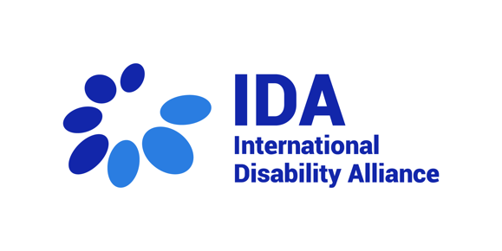
28th session of the CRPD Committee –
Africa and Middle East
8 March 2023

Statement by Mirriam Nthenge, International Disability Alliance

Honorable members of the CRPD Committee,
My name is Mirriam Nthenge and I deliver this statement on behalf of International Disability Alliance.
Climate change disproportionately affects persons with disabilities. For more than a decade now, several countries in Africa including Kenya, Sudan, South Sudan, Namibia among others have experienced inconsistent rainy seasons which have resulted to widespread livestock deaths, dried up water sources and food shortage. In Kenya for instance, about 3.5 million people including persons with disabilities are in urgent need of food assistance.
Additionally, many people including persons with disabilities especially indigenous persons with disabilities who depend on their livestock have lost their livelihoods. As such, their access to basic needs such food and water during this crisis becomes a challenge. On several occasions, people are forced to walk several miles in such of water. To persons with disabilities, such trips remain impossible- the inaccessible terrains and limited access to assistive devices forces them to remain within their homes. This situation is aggravated by lack of comprehensive disability inclusive social protection systems.
Natural disasters such as floods remain a major concern. In April 2022, the President of South Africa declared a national state of disaster following the death of 448 people, displacement of over 40,000 people and destruction of over 12,000 houses in the south-east part of South Africa. It is worth noting the correlation between socio-economic status and those disproportionately affected by floods. Persons with disabilities are overrepresented among the poor. This affects their affordability to land and housing thus bearing the greatest brunt of natural disasters such as flooding.
Persons with disabilities face heightened risk of harm during armed conflict and crisis. In 2022, a report by the Ethiopia Human Rights Commission documented “grave human rights violations committed both by state and non-state actors in the context of conflict that resulted in widespread deaths, psychosocial and physical injury, sexual and gender-based violence, displacement and destruction of property, targeting civilians, including persons with disability persons with disabilities”. In 2015, a Human Rights Watch's report showed that children with disabilities, in several countries among them Cameroon, face several challenges during armed conflict including difficulties in fleeing due to lack of appropriate support and assistive devices and are at increased risk of abandonment.
IDA’s recommends that the Committee in its General Comment on Article 11:
- Stresses the interrelationship between article 11 and article 28 on social protection in paying attention to systems that address adequate standard of living including both basic income security and coverage of disability related extra costs.
- Recognizes multiple and intersectional discrimination that persons with disabilities face due to their diverse identities including indigenous persons with disabilities, women with disabilities and children with disabilities.
- Reinforces the importance of international cooperation during humanitarian crisis.
Thank you very much for your attention.

