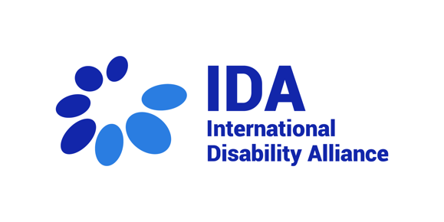
28th session of the CRPD Committee –
Asia Pacific, Eastern Europe and Central Asia
7 March 2023

Statement by Juan Ignacio Pérez Bello, International Disability Alliance
Distinguished members of the CRPD Committee
Good morning! I am Juan Ignacio Pérez Bello, and It is my pleasure to deliver this statement on behalf of International Disability Alliance.
IDA welcomes the regional focus of this Day of General Discussion. Having six regional members, joins this consultation to complement the views of national and regional actors, highlighting a few elements:
Firstly, the situation faced by many countries in the Pacific Region, especially small islands States, is dramatic, being their existence at risk due to the rise of the sea levels. Reading news on the potential first State victim Kiribati is simply heartbreaking. Emigration to other countries is already taking place. IDA believes the CRPD Committee must address climate change and action to first call for inclusion of persons with disabilities in response measures by States Parties, both of origin and of destination. The Committee should address key related legal issues including migration law and State responsibility (on the latter taking, into account the development by the Committee on the Rights of the Child).
Natural disasters keep hitting, such as the recent earthquake in Türkiye and Syria and the floods in Pakistan last year. This CRPD Committee has a vast jurisprudence under article 11 of the CRPD calling for ensuring participation in an active role and inclusion of persons with disabilities throughout the emergency cycle, including prevention, preparedness, response and recovery. This general comment process should serve to systematise such guidance.
While the situation constantly evolves and fluctuates, Covid-19 and States responses measures remain of great concern. The CRPD Committee has elaborated plenty already Covid19 and persons with disabilities, especially in terms of safety, specific impact of response measures and access to information and vaccination; but maybe this process becomes also an opportunity to provide guidance around derogations and restrictions to civil and political rights in times of emergency from a disability perspective, reflecting on the interaction of the CRPD with Article 4 of the International Covenant on Civil and Political Rights.
Finally, the armed conflict in Ukraine, and the work of this Committee and of the Special Rapporteur have raised visibility for guidance to States on the interaction between the CRPD and both international humanitarian law and refugee law. IDA’s submission for this DGD encourages the Committee to reflect on the need for:
- International Humanitarian Law to adopt a CRPD perspective to reinterpret legal provisions.
- Refugee law, both international and national, to :
  - ensure the provision of procedural accommodation in , and
  - to consider factoring in “disability” in the concept of “persecution” for refugee status determination, building upon your decisions in two views on individual communications against Sweden, which implicitly address this relying on article 15 CRPD.
Thank you very much for your attention.

