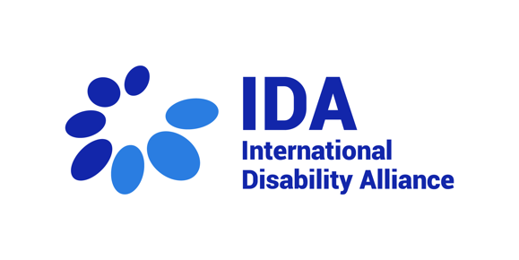
28th session of the CRPD Committee –
Western Europe and the Americas
7 March 2023

Statement by Klaus Lachwitz, International Disability Alliance

Distinguished members of the CRPD Committee
Good afternoon! My name is Klaus Lachwitz and I am pleased to deliver this statement as Member of the Board of the International Disability Alliance (IDA).
IDA welcomes the regional focus of this Day of General Discussion. Having six regional members, IDA joins this consultation to complement the views of national and regional actors, in particular our member the European Disability Forum who already intervened.
The armed conflict in Ukraine has pushed its inhabitants to flee the conflict zone and seek asylum in other countries, including Western European countries. Among those that have had the chance to leave the country, asylum seekers with disabilities and their relatives face the risks and harms that all people fleeing face and also face specific barriers related to disability.
This Committee has elaborated on States obligations to tackle this situation in its Chapter on the situation on Ukraine at its 27th session. In this general comment process, the CRPD has the chance to consolidate previous work and provide guidance related to refugee law.
In terms of asylum-seeking procedures, the CRPD Committee should make clear that persons with disabilities must be provided with “procedural accommodation”, as it stems from its Concluding Observations to Bangladesh on Article 13 CRPD, and Turkey and Switzerland on Article 28 CRPD. Procedural accommodation is not conditioned by any proportionality test as reasonable accommodation is, so that States have no excuse not to ensure effective engagement of persons with disabilities in procedures. In addition, careful consideration should be given to consider disability issues within the concept of “persecution” in refugee law, as suggested implicitly in two views on individual communications against Sweden.
On the Americas, migration remains important in numbers, going north towards the United States of America and moving away from Venezuela towards other Latin-American countries. In occasions, such phenomenon relates to humanitarian emergencies as it has been the case of Venezuela, documented by the UNHCR. The CRPD Committee should stress on the relationship between Articles 11 and 18 of the CRPD, under which it has criticised legal provisions that discriminate against persons with disabilities in migration, such as the so called “health requirement” and in requiring “procedural accommodation” in migration procedures.
For both regions, the CRPD Committee should emphasize that all persons with disabilities, regardless of their status as asylum seeker, refugee or migrant in any given country, should enjoy the rights recognised to persons with disabilities under the CRPD. In particular, social protection laws should ensure an adequate standard of living for those persons with disabilities, including both basic income security and coverage of disability related extra costs.
Let me finish up with the remark that it seems to be worthwile to check and recognize some of the submissions already made by OPDs with regard to some of the Sustainable Development Goals. These Goals are not legally binding, but nevertheless very useful tools. I just mention here Goal 1 (End Poverty), Goal 2 (Zero hunger), Goal 13 (Climate action) and Goal 14 (Life below water).
Thank you very much for your attention and we look forward to continuing inputting this process.

