We would like to draw your attention to the case of Mr. Od Sayavong and Mr. Phetphouthon Philachan.
Mr. Sayavong is a citizen of the LaoPDR who was a migrant worker in Thailand. During his time in Thailand, he began working for human rights and democracy in Laos in 2015. He applied for resettlement to a third country from a UN refugee agency, and was linked to the "Free Lao Group," a network of migrant workers and activists living in exile in Bangkok and occasional protests held and campaigned peacefully for human rights and democracy in Laos. Several members of the network told HRW that they had been monitored and intimidated by Thai and Lao authorities. Mr. Syavong disappeared without a trace on August 26 2019. Colleagues of the Lao activist filed a complaint with Thai police on September 2, 2019, but no progress in the investigation was reported. On September 7, HRW expressed concern over possible foul play in Od's disappearance. They accused the Lao government of arbitrarily arresting and detaining activists and those considered critical of the government.
Mr. Phetphouthon Philachan also active in the same group disappeared after visiting his family in Vientiane on November 13, 2019. Apparently, Mr Philachan was arrested by the police, which they in turn denied. However, the information from relatives is clear. Immediately after his arrest, Mr Philachan disappeared. Both activists also campaigned for the release of the 3 bloggers from 2015.
Thank you for your attention, you can reply this Email for more informations and you can publish our report like you want.
Best regards
Alliance for Democracy in Laos
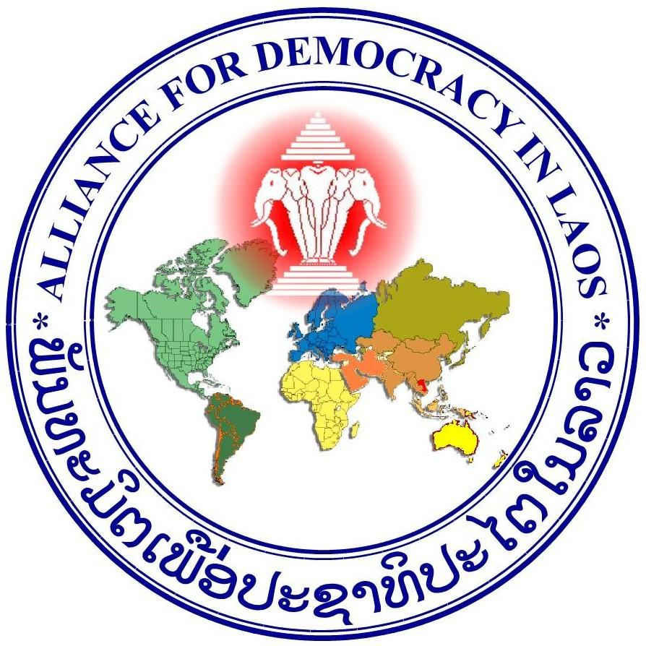
www.laoalliance.org
The Alliance for Democracy in Laos (ADL) is a worldwide network of Lao human rights and democracy advocates committed to a peaceful change for genuine democracy in Laos.
ADL is an independent NGO with their headquarter in Germany and international chapters in some host countries of the Lao diaspora. The members are mostly Laotians living in exile in different countries all over the world, including USA, Canada, Australia, New Zealand, Germany, France, Switzerland, Spain, Japan, Thailand, Laos and others where native citizens of the respective host counties join as active members and supporters.
Office in Germany: Dr. Bounthone Chanthalavong- Wiese, President, Letmather Str.71, 58119 Hagen, Germany, Phone: +49-2334-44 44 668, Email: chanthalavong@aol.com
France: Mr.Sompheth Vatthanou Vice-President , 2 AV Combattant en a.f.n.69140, Rillieux La Pape, Phone: +33-6-15192201, s.vatthanou@gmail.com
USA: Ms.Khamphene Souvannasane, regional president, ADL chapter of USA , 3837 Rusty Dell St., Fortworth, TX 76111, Phone:+1-682- 554- 6675 , Email: khamhene@yahoo.com
Canada: Mr.Kambane Anonthisen, regional president, ADL chapter of Canada, 84 Highgatz Rord Kichener , ONT, Phone:+1-519-58 80 502, email: khambane@hotmail.com
Australia: Mr.Pheng Sacksady, regional president, ADL chapter of Australia, 6 Quambone Place,Isabella Plains A.C.T, Phone:+61-2- 923544, Email: pheng-sone52@gmail.com
New Zealand: Mr. Somchine Sithivong, regional president, ADL chapter of New Zeeland, 6 Ropata Cres, Lower Hutt. Wellington. +64- 49 34 86 35, E-Mail: x sittivong24@gmail.com

