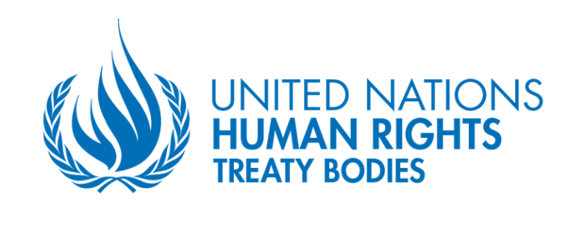
Launching of the CED’s first General Comment on “Enforced Disappearances in the Context of Migration”
28 SEPTEMBER 2023 – 3pm-6pm
Palais des Nations – Geneva – Room XXIII
The Committee on Enforced Disappearances is the UN human right Treaty Body in charge of addressing enforced disappearances. At its 24th session, the Committee adopted the first draft of its first General Comment on “enforced disappearances in the context of migration”, that the Committee decided to develop to raise awareness on the phenomenon, and to assist States in addressing their related obligations arising from the Convention. This draft has been shared with member States, civil society actors, NHRIs and United Nations actors for inputs and comments. During its 25th session, the Committee will adopt and launch the General Comment, in a moment where the issue of enforced disappearances in the context of migration is a daily worldwide concern.

Much attention has indeed been brought in recent years to the thousands of migrants who go “missing” en route to reach their destination country, or in the destination country itself. Among missing migrants are persons who have been subject to enforced disappearances. Triggered by massive migration movements, enforced disappearances in the context of migration have become an increasingly worrying human rights violation that occur along various migration routes around the world.

This phenomenon was initially articulated in the UN Working Group on Enforced or Involuntary Disappearances (WGEID) 2017 Report on Enforced Disappearances in the Context of Migration. Similarly, the Guiding Principles for the Search for Disappeared Persons adopted by the Committee in 2019 emphasize the particular vulnerability of migrants and call upon States to pay attention to the risks of enforced disappearance, which increase as a result of migration, and ask for specific coordinated search and protection measures taking into account the difficulties linked to migration situations.

Despite the identification of the issue of enforced disappearances of migrants, it remains marginalised in the political and legal discourse, including the specificities of the legal obligations of States in these cases. Rigid migration policies of States such as refusal of entry, pushbacks often accompanied by violence, expulsion or detention, and the increasingly perilous journeys of migrants cause a particular risk to become victims of enforced disappearances. This is by no means a problem of certain states only. Deaths and disappearances on various migration routes are widely reported. However, there is a lack of statistical data, and it is not possible to establish the exact number of migrant victims of enforced disappearances.

The Committee will adopt the final text of the General Comment during the second week of its upcoming 25th session, from 18th to 20th September 2023. With the aim to disseminate and promote the content of the adopted general comment and foster its implementation, the Committee will hold a launching event on 28th September 2023, 3pm-6pm Geneva time, in Palais des Nations, Conference Room XXIII.

To this end, the Committee wishes to invite and bring together key actors in the field, namely: States parties, NGOs, victims, the academia and research community, UN agencies, international and regional human rights mechanisms to share views on the adopted General comment, and information about related projects and experiences.

From this, the Committee hopes to develop and implement a step-by-step approach that is based on the mobilisation of the existing resources as well as to coordinate and use existing projects, programmes, and initiatives to prevent and eradicate enforced disappearances in the context of migration.

Objectives of the launching:

- To present the content of the General Comment
- To assess the existing and planned projects, programmes, initiatives, and capacities
- To identify future actions to promote the implementation of the General Comment
- To discuss capacities of the General Comment as a tool to further foster the ratification process

Modalities/ Programme

- Date: 28th September 2023
- Time: 3-6 pm CET
- Location: Palais des Nations, Room XXIII

Agenda:

We hereby share with you a preliminary agenda, that remains to be confirmed in view of the replies we will receive:

- Opening:
- CED Chair (5 min)
- High Commissioner – statement (video) (5 min)

- Part 1: Presentation of the General Comment and expectations
Moderation: Mohammed Ayat

- Barbara Lochbihler and Milica Kolakovic (15 min)
- Vincent Chetail - Geneva Academy (7 min)
- Bühler Carmela - Switzerland (7 min)
- Gabriela Oviedo Perhavec - CEJIL (7 min)
- Idrissa Sow – Chair of the Working Group on Death Penalty, Extrajudicial, Summary or Arbitrary Killings, African Commission on Human and Peoples’ Rights (online) (7 min)
- Debate (20 min)

- Part 2: Way forward: existing and future projects to promote the implementation of the General Comment
Moderation: Carmen Rosa Villa Quintana

- Omar Zniber, Ambassador – Morocco (7 min)
- Patrick Eba, Deputy Director of the Division of International Protection - UNHCR (7 min)
- Felipe González Morales, Special Rapporteur on the human rights of migrants (online) (7 min)
- Ana Lorena Delgadillo Pérez, Working Group on Enforced and Involuntary Disappearances (7 min)
- Michela Pugliese - Euro-Med Human Rights Monitor (7 min)
- Debate (20 min)

- Part 3: General Comment as a tool to further foster the ratification process
Moderation: Suela Janina

- Francisca E. Mendez Escobar, Ambassador - Mexico (8 min)
- Grażyna Baranowska, Working Group on Enforced and Involuntary Disappearances (8 min)
- Barbara Lochbihler and Milica Kolakovic, Committee on Enforced Disappearances (8 min)
- Debate (20 min)

- Closing: CED Chair (5 min)

