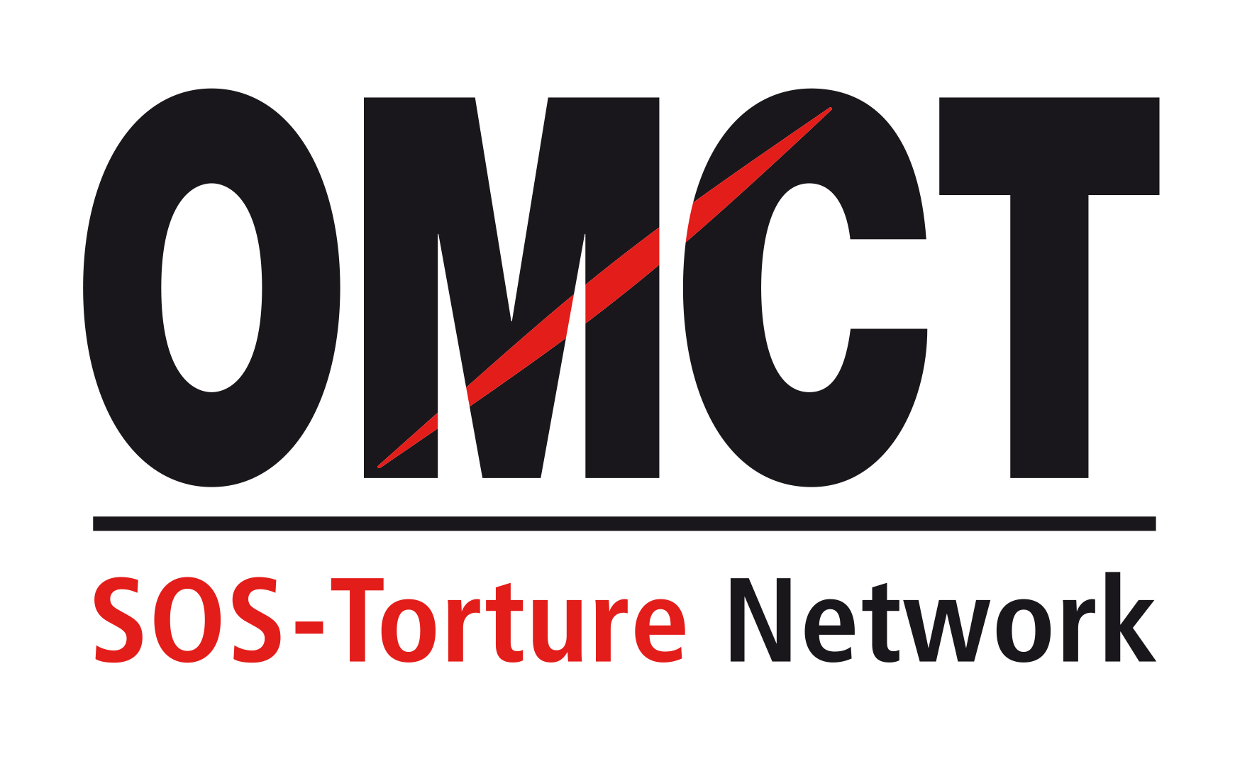

78th Committee Against Torture session (CAT)
30 October 2023 – 24 November 2023
Confirmation of attendance for in-session NGO briefing
Please return this form to the OMCT at cat@omct.org before 16 October 2023.

State concerned

Name of State

Alternative report
Title
Author(s)
Short summary
(50 to 100 words)

NGO presenting the report
Name of NGO
Address
Country
Telephone
Email

Person(s) attending
Surname /Name
Email
Telephone/Mobile
Indicate whether online or in-person participation
Surname /Name
Email
Telephone / Mobile
Indicate whether online or in-person participation

Principal issues of concern to be raised before the Committee against Torture
Principal issue 1
Principal issue 2

Your recommendation(s) for the follow up procedure

