Check against delivery
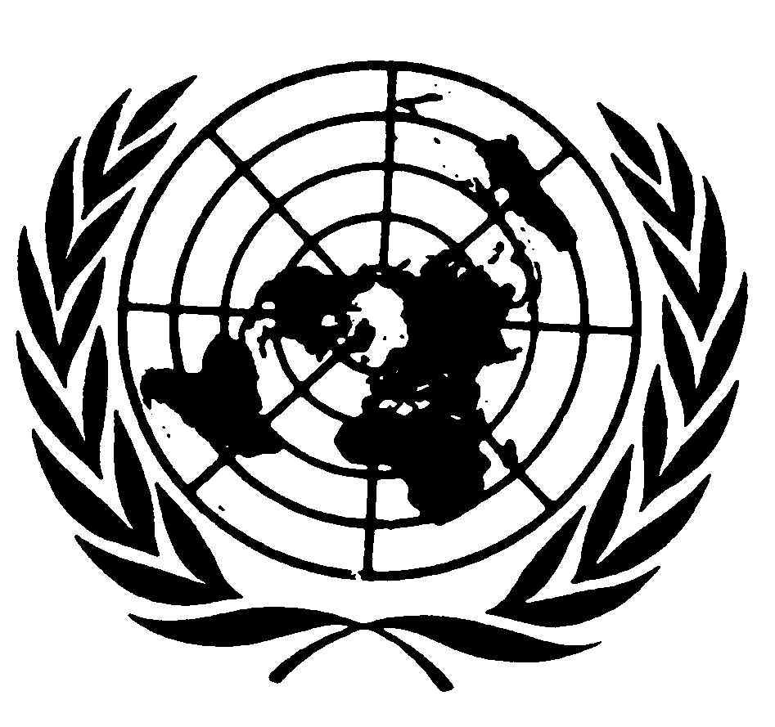

Statement of
Ms. Isha Dyfan
Independent Expert on the Situation of Human Rights in Somalia

78th session of the General Assembly

New York, 24 October 2023

Mr President,
Excellencies,
Distinguished delegates,
Ladies and gentlemen,

It is my honour to address you in my capacity as the Independent Expert on the situation of human rights in Somalia and to present my report covering the period from 1 July 2022 to 30 June 2023. My report to the Human Rights Council, presented on 10 October 2023, focused on political, security and humanitarian developments, and highlights the impact of climate change on human rights as well as the most pervasive human rights violations against civilians, especially in situations of vulnerability in Somali society.

Excellencies,
At the outset, I would like to commend the President of the Federal Government of Somalia, His Excellency Hassan Sheikh Mohamud for convening the National Consultative Council meetings, which was attended by leaders of the Federal Member States, except for Puntland. I welcome the decisions taken by the National Consultative Council on several key issues including speeding up the drought response, prioritizing the constitutional review process, adopting a one-person, one-vote electoral model for Somalia, delegating powers among the federal and state levels and the federal model of the judiciary.
On a positive note, I welcome the Federal Government of Somalia`s recent appointment of Shamsa Abdulkadir Dahir, as Senior Advisor on Women’s Affairs and Human Rights at the Prime Minister’s Office, and former Al-Shabaab leader of the militant group, Mukhtar Robow, as the Minister for Endowment and Religious Affairs, and its ongoing efforts on political reconciliation.

Excellencies,
The security situation in Somalia remains volatile. During the reporting period, the Government of Somalia launched a military offensive against the Al-Shabaab militant group with the support of clan militias, the African Union’s Transition Mission in Somalia (ATMIS) troops and the U.S. Africa Command (AFRICOM).

Although important gains have been made by the Somali security forces during the ongoing offensive, Al-Shabaab continued to carry out deadly attacks through suicide bombings across the country. According to the report of the Secretary-General on Somalia covering significant developments from 8 February to 7 June 2023, a total of 255 improvised explosive device attacks were recorded, resulting in 692 casualties. On 16 October 2023, a suicide bomber detonated explosives in a restaurant in Boondhere district, Mogadishu killing at least two civilians, including a journalist and injuring about three others.

I strongly condemn the continued deadly attacks perpetrated by Al-Shabaab and urge the Government to take all steps to ensure the protection of civilians and armed groups to comply strictly with the obligations applicable to them under international humanitarian and human rights law.

Excellencies,
I express deep concern at the imposition of the death penalty on children in Puntland and urge the Federal Government and federal member states to treat children accused of crimes under international law committed while they were allegedly or actually associated with armed forces or armed groups, as victims rather than as perpetrators, to use detention only as a measure of last resort and for the shortest appropriate period of time, and to refer them to relevant child protection actors for their recovery and reintegration and adopt age verification guidelines.

Excellencies,
I welcome the Government of Somalia`s announcement of amnesty for Al-Shabaab in August 2023 and urge members of the Al-Shabaab group to avail themselves of the amnesty deal and turn in their weapons to the Government. I encourage Al-Shabaab fighters to lay down their weapons and join hands with the Government and the Government to help former members of the Al-Shabaab militant group to fully reintegrate into mainstream Somali society and rebuild their lives.

I note the request by the Federal Government of Somalia for a three-month technical pause of the second phase drawdown of 3,000 ATMIS troops. However, the lack of funding by ATMIS poses a significant risk to the security transition and could threaten hard-won gains. In this regard, I call for continued funding and thank the Political and Security Council of the European Union for approving additional support for the Somali National Army (SNA) and for the military component of the African Union Transition Mission in Somalia (ATMIS) in March 2023. I believe that such support will help enhance the security situation in Somalia and reduce human rights violations among civilians.

Excellencies,
Despite calls for an immediate and unconditional cessation of hostilities and attempts by the Federal Government of Somalia to de-escalate tensions, violence regrettably continued between the Somaliland security forces and the armed Dhulbahante clan members in Laascaanood. Civilians have continued to pay the heaviest price in human lives. According to UNSOM, at least 552 civilian casualties, of whom 87 were killed and 465 were injured between 27 December 2022 and 15 June 2023. In addition, more than 185,000 people, mostly women and children, have been displaced from Laas Caanood to neighbouring towns and villages and some have fled across the border to Ethiopia, according to an inter-agency assessment mission by the Office for the Coordination of Humanitarian Affairs.

The fighting has also resulted in the destruction of civilian infrastructure, notably schools and medical facilities. According to reports, at least 33 primary schools and seven secondary schools have been closed in Laascaanood, affecting about 11,690 primary and 3,560 secondary school students and 700 teachers. Coupled with this, here have also been recurrent attacks on medical facilities thereby forcing Médecins Sans Frontières (MSF) to withdraw its services from Las Anod General Hospital mid this year.

Excellencies,
The humanitarian situation in Somalia remains dire due to insecurity, armed violence, climate shocks, including recurring droughts and flooding. According to the Office for the Coordination of Humanitarian Affairs, 8.25 million people, mostly women and children in Somalia were in urgent need of assistance owing to the prolonged and severe drought. While the Gu rains brought some relief to drought-affected communities, they also brought widespread flooding, affecting at least 468,000 people and displacing over 247,000 people, as of 6 June 2023. According to a recent report by the Food and Agriculture Organization, at least 1.2 million people and 1.5 million hectares of productive land are at high risk of flooding in Somalia due to El Niño rains thereby increasing food insecurity and heightening poverty.

Excellencies,
I remain dismayed by the continuing restrictions on civic space, including the arbitrary arrest and detention of journalists and censorship of the media and self-censorship by journalists. During the period 8 June to 5 October 2023, UNSOM documented what appeared to be the arbitrary detention of eight male journalists, five in Mogadishu, two in “Somaliland” and one in Jubaland and the conviction and sentencing of two others in “Somaliland” to one year in prison. I call on the authorities in Somalia to review the Penal Code and to decriminalize journalism.

In conclusion, I wish to thank the Government of the Federal Republic of Somalia for extending the invitation to me to visit the country next month and I look forward to meeting a variety of stakeholders.

I thank you for listening.

