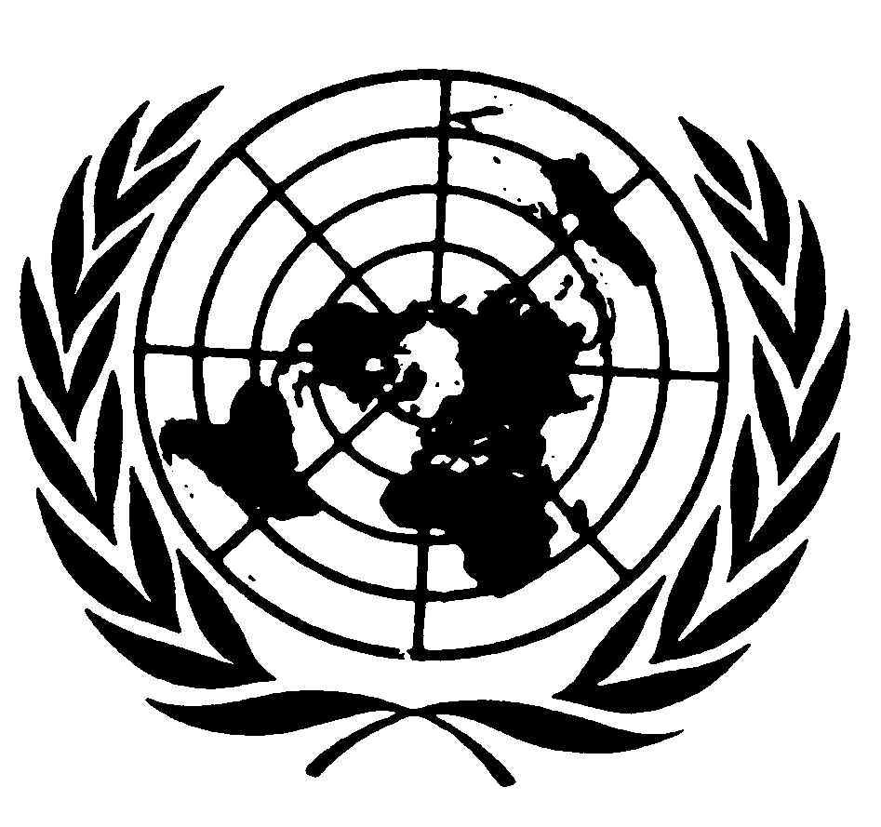

End of mission statement by Ms. Isha Dyfan
Independent Expert on the situation of human rights in Somalia, on her second visit to Somalia

6 to 19 November 2023

Members of the press,
Ladies and gentlemen,
Good morning and thank you for coming. I would like to begin by thanking the Government of the Federal Republic of Somalia for the invitation and excellent cooperation extended to me during the visit.
I appreciate the continued support of the United Nations Assistance Mission in Somalia (UNSOM), particularly the Human Rights and Protection Group (HRPG), for facilitating the visit, providing logistics as well as other support to ensure the smooth running of the visit.
During my visit, I held meetings in Mogadishu, Beletweyne (Hirshabelle) and Hargeisa (Somaliland) with authorities at the federal and state level including the State Minister for Foreign Affairs and International Cooperation, the Federal Minister of Women and Human Rights Development, the Federal Deputy Minister for Women and Human Rights Development, the Minister of Women and Human Rights of Hirshabelle, the Minister of Justice of Somaliland, the Director Generals of the Ministry of Environment and Climate Change, and the Ministry of Interior of Somaliland, the Human Rights Parliamentary Committee of Somaliland, Senior Ministerial Advisers, the Commissioners of the Somali Disaster Management Agency (SoDMA), and the representatives of the National Commission for Refugees and IDPs and the National Disability Agency, among many others.
The exchanges focused on legislative, policy and programmatic developments, progress, challenges, remaining gaps and priorities for the future based on the key benchmarks highlighted in my previous reports submitted to the United Nations Human Rights Council. I also met with leaders of political parties in opposition and representatives of the “Somaliland” National Human Rights Commission.
I also held meetings with representative of the African Union Transition Mission in Somalia (ATMIS), UN Agencies, Funds and Programs and the Human Rights Working Group (HRWG) in Mogadishu. In addition, I held meetings with civil society representatives, including journalists, internally displaced persons, vulnerable and marginalised groups minorities, migrants and persons with disabilities, to exchange views on human rights issues of concern and to provide ideas on the way forward.
My statement today will focus on my recent visit to Somalia, including field visits to Beletweyne and Hargeisa. I will now provide some preliminary observations from my visit, which I will elaborate further in my report to be presented to the United Nations Human Rights Council and General Assembly in 2024.
Somalia´s security situation in Somalia remains unstable, with civilians facing daily threats and targeted killings and infrastructure damage by Al-Shabaab as well as inter-clan conflicts. I remain concerned about the impact the ongoing joint military offensive by the Somali National Army, local clan militias known as “community defence forces” and the ATMIS has on the civilian population and infrastructure. The US Africa Command (AFRICOM) continues to carry out targeted airstrikes, at the Government’s request and in support of the Somali National Army against Al-Shabaab. I urge all parties to uphold their responsibilities under human rights and international humanitarian law and ensure the protection of civilians.
I note the 90-day “technical pause” in the drawdown of 3,000 ATMIS personnel, as set out in resolution 2687 of 27 June 2023 requested by the Federal Government in a letter addressed to the President of the Security Council on 19 September 2023. In a 30 September communiqué, the African Union Peace and Security Council (AUPSC) supported the Somali government’s request and took note of financial shortfalls that could impede the operationalisation of such a pause.
Recently, I had the opportunity to exchange views with the Chair of the Sool, Sanaag, and Cayn (SSC) Committee regarding the current human rights situation in Laascaanood, the capital of the Sool region. The risk of further clashes between “Somaliland” forces and clan militia contribute to insecurity and human rights violations. Since the conflict started in February 2023, at least 81 civilians have been killed and 410 injured, an estimated 200,000 people have been displaced and destruction of infrastructure, exacerbating an already dire humanitarian situation. I reiterated my call for dialogue and urged all parties to refrain from divisive rhetoric. All grievances and tensions should be resolved peacefully and through dialogue. I am deeply concerned about reports of large numbers of detainees and expect those involved to abide by human rights and international humanitarian law, in particular the protection of civilians and civilian infrastructure.
During a meeting, the Federal Government confirmed that eleven bills relating to security were passed. The Ministry of Interior, Federal Affairs and Reconciliation also adopted policies and frameworks, including mapping conflict areas and the age verification policy. It also has been working through community engagement to foster integrity between the army and local community, provided training in human rights and international humanitarian law as well as conducting specialized training on women, peace and security. The Ministry of Youth and Sports facilitated reconciliation and consultation sessions on youth, peace and security by organizing youth tournaments, forums and panel discussions.
In the areas of rule of law, the Federal Government reported that the Juvenile Justice Bill has been presented to the Federal Parliament and it has initiated an amendment to the Prison law. I also note the Federal Government`s request for technical assistance to improve and accelerate the process of legal drafting.
I am encouraged by recent efforts by the Federal Government to fight corruption, including prosecuting public officials accused of corruption and abuse of power. This is a first step towards ensuring access to justice and accountability.
Reports indicate that individuals are arbitrarily held in detention centres in Hargesia for failing to pay their civil liabilities and they are often held beyond their sentences. I call on the authorities in Somaliland to establish alternatives to detentions in these circumstances.
The continued use of the death penalty in the past few months is disturbing. On 1 November 2023, members of the “Somaliland” security forces executed five persons near Mandheera prison, Woqooyi Galbeed region, after they were sentenced to death by the “Somaliland” Supreme Court between 2019 and 2021 for the murder of five civilians. I urge all authorities
I was briefed by the Chairperson and Executive Director of the “Somaliland” National Human Rights Commission and received their annual report for 2022 setting out the work of the Commission, including human rights monitoring, complaint mechanism and the advisory role to the authorities. I also note the existence of a Human Rights Commission in Puntland. Against this backdrop, I am encouraged by the ongoing efforts of the Federal Government to establish a National Human Rights Commission.
However, I remained concerned about the laws and guidelines that restrict freedom of expression. The use of the Somali Penal Code against journalists and media workers and the constant threat of being arrested, held in detention, and subjected to trials, fines and imprisonment leads to self-censorship. I look forward to the declaration of a moratorium on the use of the penal code against journalists as well as the updating of the Somali penal code in line with the commitment of Somalia during previous Universal Periodic Review (UPR) cycles.
In the context of freedom of association and peaceful assembly, I am disappointed by reports of arbitrary arrest and detention of persons belonging to opposition parties and violence during demonstrations in Somaliland. On 11 August 2023 in Burao, Togdheer region, at least 10 civilians, nine male and one female, were injured when the “Somaliland” Police Force dispersed a protest organized by the youth wing of Waddani opposition party. I reiterate my call for all parties involved to engage in dialogue to find a peaceful resolution to disagreements among them.
With regard to women’s rights, I would like to salute the various organisations providing support to survivors of sexual and gender-based violence against women and girls. Their work is essential and must be encouraged and supported.
Female genital mutilation is a harmful traditional practice, which continues in Somalia and violates the right to health and the right to life, often resulting in the death of the victim. Members of the minority organisations in Hargeisa reported that female genital mutilation is on the rise because it remains an alternative source of income for those who perform this harmful practice. I wish to call upon the Federal Government and the authorities in “Somaliland” to take measures to end the practice of female genital mutilation.
The Gender-Based Violence Information Management System is in place in Somalia and through it, a referral pathway system is in place managed at the Federal Member State level as well as in Banadir. However, the challenge is that information on what services and where to access those services is sometimes lacking. The Government envisions a comprehensive response to sexual and gender-based violence through one-stop survivor-friendly centers which provide medical and psychosocial services. Such as on-stop centres are operational in Baidoa, Kismayo, Mogadishu, Hargeisa and Dhusamareb.
I note that the Sexual Offences Bill of 2018 is still being reviewed by the Federal Government.
I am encouraged by the continued advocacy by all stakeholders on gender equality and women’s representation and participation in political and public life. In particular, the work on the 30 per cent minimum quota has been ongoing by the female members of parliament, through their two caucuses. In addition, the Federal Minister of Women and Human Rights Development reported that she has initiated the women’s leadership technical committee to advocate with the National Consultative Council on women's issues, including the 30 per cent representation of women in public life and the constitutional review process.
According to the Federal Government, there is a National Action Plan on the United Nations Security Council Resolution 1325 on Women, Peace and Security, which is being localised and women are at the forefront of supporting community mediation and alternative dispute resolution.
I reiterate my call for the Federal Government to ratify the Convention on the Elimination of All Forms of Discrimination Against Women (CEDAW), as one of the first steps towards efforts to prevent the violation of women’s rights.
I continue to follow the developments relating to the legal framework for the protection of children, especially the Juvenile Justice Bill and the Child Rights Bill, which in its current form maintains the age of majority at 18. I understand that it has been approved by the Federal Cabinet, is awaiting assent by Parliament. I also commend the age verification guidelines signed by the Minister of Justice and Constitutional Affairs which will assist age assessment and should be applied consistently by the Federal Government. However, I note that the National Action Plan on Children has not yet been adopted.
I reiterate the call made by the Secretary General Report on Children and Armed Conflict of June 2023 for all parties to immediately cease and prevent violations and to comply with their obligations under international humanitarian law and international human rights law. I stress the need to continue prioritising the protection of children in light of the phased ATMIS drawdown.
Since the conflict began in Laascaanood on 6 February, there has been displacement of the local population, including to Garowe and other parts of Puntland. The Ministry of Interior, Federal Affairs and Reconciliation together with UNICEF and other partners conducted an assessment and reorganized their programmes to respond to the needs of the displaced people. Currently, UNICEF is implementing its programmes to the displaced communities comprising of children and youth and living in schools and government buildings, via Garowe.
At the inter-ministerial meeting, the Federal Government reported that it is implementing the 2019 road map on children and armed conflict by conducting trainings to prevent recruitment of children by security forces, initiating screening processes and raising awareness within the security forces and launching campaigns and establishing a robust system for monitoring the violations of children’s rights.
The Federal Government further reported the development of the National Youth Policy and the initiation of a National Youth Council and the establishment of youth centres in Banadir and some Federal states. They also reported that they have conducted trainings and sport activities for approximately 1,525 young individuals.
During the Inter-ministerial meeting, the Federal Government informed that in 2015 Somalia endorsed the Safe Schools Declaration, which outlines a set of commitments to strengthen the protection of education from attack and restrict use of schools and universities for military purposes. It seeks to ensure the continuity of safe education during armed conflict. A National Policy to implement the Declaration was endorsed in August 2022.
Internally displaced persons in Beletweyne reported that armed conflict and climate-related disasters, including drought and floods, have left them destitute. Some have been in internally displaced persons camps for 20 years and are unable to return to their areas of origin, while others have lost farms and animals because of the conflict, drought and floods. Their children do not go to school, there are no nutrition programs for their children and the minimal humanitarian aid received is used to compensate landowners for living on the land.
The internally displaced persons claimed that since the flooding, UN agencies have conducted assessments and provided non-food items, but have received no support from the Federal Government, private individuals and non-governmental organisations. They added that they survive through casual labour in the community. Their greatest need is shelter, nutrition, employment, education and health care.
While the Federal Government increased the health budget, provision remains poor, and access is severely inadequate especially in internally displaced persons, marginalised communities and rural areas. Women are reported to have died of childbirth on their way to seek medical attention in Beletweyne town and where services are provided, they would have to pay. As minorities and persons with disabilities are unable to meet these charges, the sick end up dying. I therefore recommend the provision of regular mobile clinics to internally displaced persons and other remote communities.
Given the recurring crises of drought and flooding and their impact on economic, social, and cultural rights, the Federal Government must focus not only on providing urgent humanitarian aid but also on building resilience in communities by putting in place mitigation and adaptation measures in the medium and long term. To this end, I welcome the adoption by the Federal Government, with support from its partners of the enactment of the Regulatory Control Act for materials depleting the ozone layer and the Environment Management Bill of 2023, which brings the nexus between humanitarian aid and development. .
During my visit to Beletweyne and Hargeisa, I interacted with internally displaced persons, persons with disabilities, and representatives of minority and marginalized groups, who raised several concerns about their situation, including that state systems are still clan based and that there are three parallel laws namely customary law, sharia law and statutory law, which subjects them to disparate legal systems. While this system applies generally to the whole of Somalia, there is inconsistencies in the application of the law and resolution of conflicts. Internally displaced persons claimed that they suffer additional vulnerabilities.
In Hargeisa, the internally displaced persons also reported that they do not receive any services through the state system. They called for an establishment of a minority fund to specifically address their needs. They also stated that they do not report cases of human rights violations to the police as they lack trust in them, for they contribute to human rights violations.
Minorities mostly live in slum areas and are often subjected to abuse, hate speech and humiliation, especially towards their children. They easily lose their homes because they are thrown out by landowners and their children are often bullied at school. They further highlighted that internally displaced persons are not registered by the local authorities and have no role in the electoral process.
While I welcome the establishment of a National Disability Agency, I note that matters of disability remain a challenge in society. Disability is engendered by polio, birth disabilities and war explosions. Persons with disabilities are dependent on their families to provide for them resulting in stigmatization that they are not independent and cannot contribute to society at large. The priority of the National Disability Agency is to raise awareness of the rights of persons with disabilities, improve their skills and employment opportunities, advocate for their participation in political and public life and improve access to health care services.
Let me conclude by reiterating my gratitude to the Federal Government of Somalia for the invitation extended to me to conduct the visit and the opportunity to meet with all relevant interlocutors, who showed preparedness to engage on the human rights issues that I raised.
It is important to recall the cross-cutting nature of human rights. The struggles against armed groups, peace, security, development, humanitarian action, climate change and the environment cannot be addressed in isolation from human rights.
Based on the commitments made and priorities identified by the Federal Government, I have requested to visit the country again in April or May next year to assess progress on the human rights situation and how gaps and challenges are being overcome by the authorities and priorities are being implemented. This will help inform the development of options on possible adjustments to the scope of the mandate to better respond to the technical assistance needs of the Federal Government, with a view to revising the focus and scope of the mandate and improving its ability to support Somalia’s efforts to implement human rights standards and norms.
I thank you for your attention.

