Check against delivery
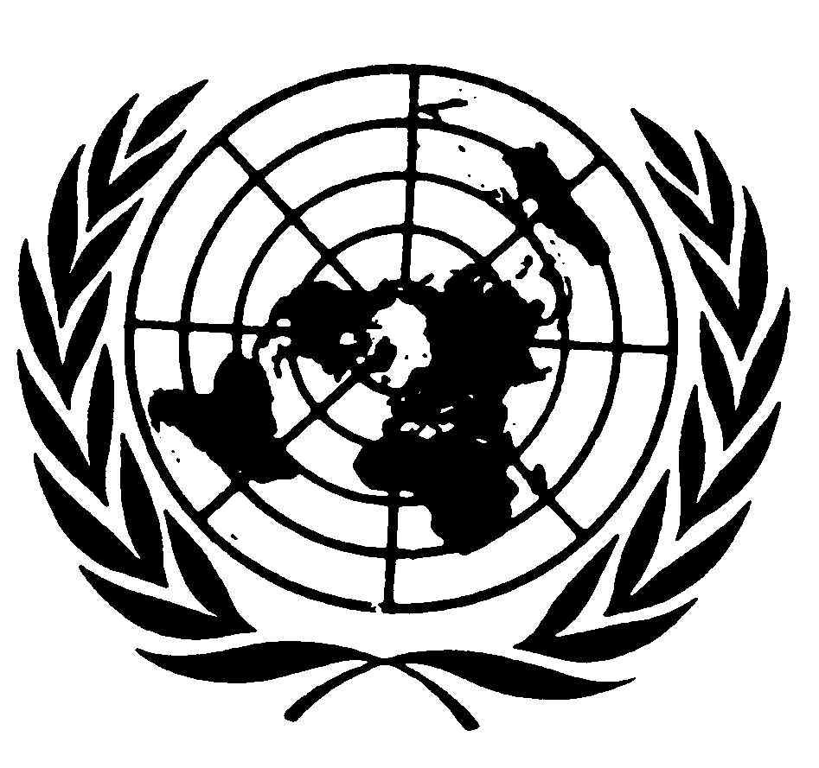

Statement of
Ms. Isha Dyfan
Independent Expert on the Situation of Human Rights in Somalia

77th session of the General Assembly

New York, 27 October 2022

Honourable Chairperson,
Excellencies,
Distinguished delegates,
Ladies and gentlemen,

I would like to express my appreciation for the opportunity to address the Third Committee for the second time, as the Independent Expert on the situation of human rights in Somalia.

As reported during my last briefing, the security situation in the country remains a cause for serious concern, despite the efforts of the Federal Government of Somalia and the African Union Transition Mission in Somalia (ATMIS) to maintain peace and security. During the reporting period, and since the appointment of the new Government a few months ago, Al-Shabaab and various armed groups have escalated their attacks throughout the country resulting in a high number of civilian casualties. Recent reports indicate that on 23 October 2022, Al-Shabaab militants stormed a hotel in Kismayo killing and injuring an unidentified number of people. In another incident, on 3 October 2022, at least 17 civilians were killed and 53 others injured when three vehicle-borne improvised explosive devices exploded in the central town of Beletweyne town in Hiran region.

It should also be noted that parties to the conflict continue to perpetuate the six grave violations against children at alarming rates and unabated. Between January 2021 and June 2022, the United Nations verified more than 4,400 grave violations of children’s rights. I therefore call on the Government of Somalia to intensify its efforts to protect the human rights of civilians.

On a positive note, I am pleased with the Government’s approach to civilian protection. Together with the support of the international community, the approach focuses on transferring security responsibilities from the African Union Transition Mission in Somalia (ATMIS) to the Somali security forces and institutions; enhancing an inclusive reconciliation process led by the community; and working with civil society and the international community to minimize the impact of armed conflict and insecurity, which continues to exact a heavy toll on civilians, damaging infrastructure and livelihoods, displacing millions of people and impeding access to humanitarian relief for communities in need. According to the UN Office for the Coordination of Humanitarian Affairs (OCHA), an estimated 366,000 people have been displaced by conflict and insecurity in 2022, including 99,000 people in August alone.

Excellencies,
The election of President Hassan Sheikh Mohamud by a decisive majority of the Federal Parliament of Somalia in May 2022, and the setting up of the framework for governance, including the appointment of a new Prime Minister and cabinet, offers an opportunity for the acceleration of the implementation of the human rights agenda, including undertaking long standing legislative and institutional reforms.

I reiterate that although this was hailed as an important milestone, it fell short of the principle of one-person, one vote, as stipulated in article 42 (2) (g) of the Provisional Constitution of the Federal Republic of Somalia of 2012. Women remain seriously under represented, holding only 54 of the 275 House of the People seats, falling short of the 30 per cent minimum quota. I call on the Government of Somalia to ensure greater participation of women in politics and public affairs.

Participation in the electoral process requires a safe environment in which all human rights are fully respected and enjoyed by all individuals, in particular the rights to equality and non-discrimination, freedom of opinion and expression, freedom of peaceful assembly and association, and security of the person, including for minorities and marginalized groups.

Excellencies,
Freedom of opinion and expression is a cornerstone upon which the very existence of a democratic society rests and the media is entrusted with the role of informing and educating the public on issues of national interest. However, violations of the right to freedom of opinion and expression remains a particular concern, especially in Somaliland. Security personnel continue to attack media freedoms by harassing, intimidating and arbitrarily arresting an increasing number of journalists. According to the National Union of Somali Journalists (NUSOJ), on 22 October 2022, a reporter for HornCable TV, was arrested by Somaliland police in Gabiley district. In a separate incident, the Secretary General of the Somali Journalists Syndicate was arrested and detained by National Intelligence and Security Agency (NISA) officers at Aden Adde International Airport in Mogadishu on 11 October 2022 and later released on bail on 22 October 2022.

I therefore urge the Government to take urgent steps to bring media legislation in line with the Provisional Federal Constitution of Somalia as well as regional and international human rights standards, by amending laws criminalizing the work of journalists and media houses and ensuring accountability.

Excellencies,
The Federal Government is faced with the multi-faceted challenges of addressing the complex security situation, building fairer political institutions that serve the people, and responding to a humanitarian crisis caused by conflict and exacerbated by the impacts of climate change all of which result in increasing violations of human rights including sexual violence as well as limited access to basic services such as food, water and sanitation, education and health care, to name a few.

According to the latest situation report of the UN Office for the Coordination of Humanitarian Affairs (OCHA) of August 2022, the country`s humanitarian situation remains extremely dire, with 7.8 million people impacted and more than one million people displaced by drought, including nearly 99,000 in August. Somalia is facing a humanitarian catastrophe and imminent famine if the next rainy season fails or proves to be on the below-average cycle.

I therefore urge the international community to increase technical cooperation and support to the Government and people of Somalia beyond the immediate humanitarian need towards building local resilience to withstand the recurring drought and environmental degradation in line with the Government’s vision.

Excellencies,
In my second report to the Human Rights Council, I proposed seven key benchmarks and indicators, serving as a minimum guide to assessing progress on the human rights agenda in the country, whereas in my last report to the Human Rights Council, presented on 5 October 2022, I focused on economic, social and cultural rights. Both reports should be read together.

The Government`s efforts at addressing security, political and institutional reforms cannot be sustainable without addressing economic, social, and cultural rights issues, such as improved and increased access to education, health care, water and sanitation, housing for an adequate standard of living. The Government’s approach to supporting the operationalization of the humanitarian and development and peace-building nexus agenda is encouraging. Nevertheless, an acceleration of the Heavily Indebted Poor Countries (HIPC) process would be timely and crucial in assisting the Government fulfill its human rights obligations as provided in the Joint Programme on Human Rights.

I look forward to working closely with all stakeholders in advancing the implementation of the benchmarks and indicators set out in my report. Finally, I wish to call on the Government to prioritize the establishment of the National Human Rights Commission and finalize the comprehensive review of all pending bills relating to the promotion and protection of women and children’s rights and bring them in line with international human rights law and standards.

I thank you for your attention.

