Check against delivery
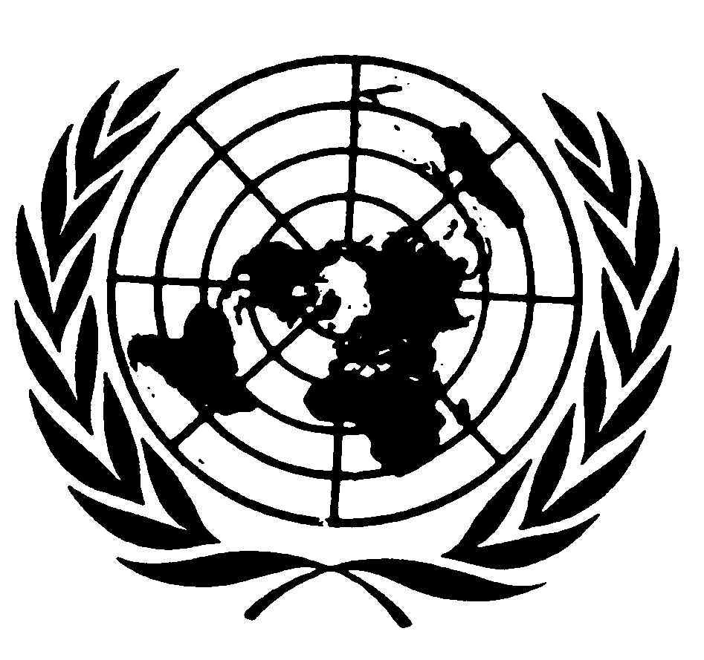

Statement of
Ms. Isha Dyfan
Independent Expert on the Situation of Human Rights in Somalia

51st session of the Human Rights Council

Geneva, 5 October 2022

Mr. President,
Distinguished Members of the Council,
It is my pleasure to present my third report on the situation of human rights in Somalia to the Human Rights Council. The focus of the report is on economic, social and cultural rights, as they relate to the seven key benchmarks mentioned in my last report to the Council and the political and security developments, as well as the humanitarian situation, including the impact of climate change.

As part of my mandate, I undertook my first visit to Somalia from 28 March to 2 April 2022 and engaged the Federal Government on a number of human rights issues, including the current security and drought situation, the right to freedom of opinion and expression, access to health care, the electoral process, participation and representation of women, youth and marginalised groups in public and political life, alternative dispute resolution, reconciliation and the peace process, disability and minority issues, and the main challenges facing women and children. Let me take this opportunity to express my appreciation to the Government of Somalia for its continued constructive engagement and excellent cooperation.

I would also like to express my appreciation to the senior leadership and staff of the United Nations Assistance Mission in Somalia, the African Union Mission in Somalia, UN Agencies and members of civil society and non-governmental organisations for their cooperation and support.

Mr President,

Somalia is experiencing a fourth consecutive failed rainy season, which has led to unprecedented drought and ravaged at least ninety per cent of Somalia`s districts. The drought has caused a grave humanitarian crisis affecting more than seven million people, in terms of food shortage, child mortality and acute malnutrition, and increased fighting over ever scarcer resources, which has resulted in mass displacement and an increase in violence against women and children.

According to the Somalia: Drought Response and Famine Prevention report of the UN Office for the Coordination of Humanitarian Affairs (OCHA) of September 2022, about 7.8 million people have been affected by the drought, with more than 1 million displaced by drought including nearly 99,000 in August. According to the Food and Agriculture Organization of the United Nations (FAO), approximately 6.7 million people across Somalia will likely endure high levels of acute food insecurity between October and December this year (IPC Phase 3 or above).

As of July 2022, more than 5.3 million people have received humanitarian assistance, up from 4.4 million in June. I commend the efforts of UN humanitarian agencies and other humanitarian actors to deliver lifesaving assistance to vulnerable populations and condemn the obstruction of humanitarian assistance. However, there is an urgent need to ensure adequate and sustained funding that goes beyond immediate lifesaving and humanitarian response towards sustainable activities to prevent this recurring crisis.

This leads me to the situation in terms of economic, social and cultural rights that remains a matter of serious concern, including access to land and water and, services such as health care and education, which are very limited and negatively impacts the rights of women and girls, particularly internally displaced persons, persons with disabilities, people of minority clans and other marginalised groups.

In this regard, the new political dispensation and funding that will be released from gaining heavily indebted poor country status could provide the Government with an opportunity to prioritize the triple nexus of human rights protection and a humanitarian and development approach to realize the rights of all Somali`s.

Mr. President,

I welcome the significant political developments in Somalia, including the election of Hassan Sheikh Mohamud as the new President, the appointment of the new Prime Minister and the formation of the new cabinet consisting of 65 males and ten females. I also welcome the swearing-in of the newly elected members of the Lower House (House of the People) and the Upper House (Senate) of the Federal Parliament of Somalia on 15 April 2022 and the election of the first female Deputy Speaker of the Lower House of the Federal Parliament of Somalia, on 28 April 2022, culminating in a peaceful transition of power.

Although this was hailed as an important milestone, it fell short of the principle of one-person, one vote, as stipulated in the Provisional Constitution of the Federal Republic of Somalia of 2012. Women remain seriously under represented, holding only 54 of the 275 House of the People seats, falling short of the 30 per cent minimum quota. I therefore call on the Government of Somalia to ensure greater participation of women in politics and public affairs.

Mr. President,

The major challenge to the peace-building and state-building efforts in Somalia continues to be the long-running armed conflict and its heavy toll on civilians, damage infrastructure and livelihoods, forcibly displacing millions of people, and impeding access to humanitarian relief for communities in need.
Al-Shabaab continues to be a major threat and carry out targeted attacks on civilians and civilian infrastructure, including markets and hotels in the capital, Mogadishu and other towns under government authority. According to the recent report of the Secretary-General on Somalia of September 2022, the security situation remained volatile with a monthly average of 227 incidents recorded in Somalia between May and July 2022. On 3 October, Al-Shabaab carried out a deadly attack in Beletweyne, HirShabelle, resulting in many casualties, including state officials. I extend my condolences to the families of the deceased, and wish the injured a quick recovery. May the soul of the deceased persons rest in eternal peace. Ameen.

These deadly attacks by Al-Shabaab serves as a reminder that much work remains to be done in the fight to ensure security for all people in Somalia. I welcome the recent commitment of the new Federal Government to address the security threat from Al-Shabaab and other armed groups, and the recent establishment of the African Union Transition Mission in Somalia (ATMIS).

Mr. President,

The ongoing reports of intimidation, harassment, arbitrary arrest and detention, prosecution and ill treatment of human rights defenders and journalists by security forces – without accountability – are deeply worrying and the continuing application of the 1964 penal code provides a legal umbrella for human rights violation by security forces. Last year, the UN Mission in Somalia (UNSOM), the Federation of Somali journalists and the National Union of Somali Journalists (NUSOJ) documented violations of the rights of journalists and media workers. In the media report of 2021, NUSOJ documented two cases of killings of journalists in Mogadishu and Galkayo, and 63 cases of physical attacks, harassment, unlawful arrests, detentions, torture, cyberbullying and threats directed at journalists. Media houses were also targeted with four cases reported. The report also documented 13 cases of violent attacks, four of which involved female journalists. I condemn these acts and any actions that restrict freedom of expression.

For freedom of expression guaranteed by the Provisional Constitutional of Somalia 2012 to become a living reality, Somalia must take urgent steps to bring media legislation in line with the provisional Federal Constitution and regional and international human rights standards, and amend laws criminalizing the work of journalists and media houses and ensure accountability.

I welcome the recent arrest on 18 September of two soldiers accused for violently attacking and seriously wounding a journalist on 21 August 2022, while covering the Hayat Hotel siege in Mogadishu. I encourage the Government to move quickly on its stated commitment to improve justice and prevent such actions in the future.

Mr. President,

Concerns about the application of the death penalty in Somalia continue. During the reporting period, both state and non-state actors carried out extrajudicial executions. On 4 August 2022, in a joint letter on allegations of extrajudicial executions and executions as a consequence of the imposition of the death penalty, I sent a communication to the Government of Somalia enquiring about the allegations, detailed information about the total number of individuals executed so far in 2022 and the existing procedures for persons sentenced to death to seek clemency or a pardon. To date, I have not received a response from the Government.
In addition, the high rates of sexual and gender-based violence also remain a concern. According to the UNFPA Advocacy Brief of May 2022, the already large number of recorded incidences of Gender-Based Violence (GBV) in 2021 continued to increase in 2022, especially for sexual violence and Intimate Partner Violence (IPV), due to multiple displacements, flooding, droughts and armed conflicts. I call on the Government of Somalia to finalise and implement the Sexual Offences Bill to ensure a legal framework to protect the rights of women and girls and hold perpetrators accountable.

The delay or failure to finalize the constitution, operationalize the National Human Rights Commission and form the Judiciary Commission are problematic and undermine accountability efforts. I urge the Federal Government and Federal Parliament of Somalia to address them as a matter of urgency.
Mr. President,
I concluded my report by making a number of recommendations, to the international community to urgently redouble its efforts to support Somalia in light of the joint appeal for funding to address the ongoing humanitarian crisis, to manage the ATMIS disengagement from Somalia by ensuring that the Somalia National security forces are properly trained; to the Federal Government of Somalia to establish a national human rights commission, ratify CEDAW; ensure a safe and enabling environment for journalists and media workers, and declare a moratorium on the use of the Penal Code of 1964 aimed at protecting freedom of expression, and declare a moratorium on the death penalty.
I thank you for your attention

