***Check against delivery***

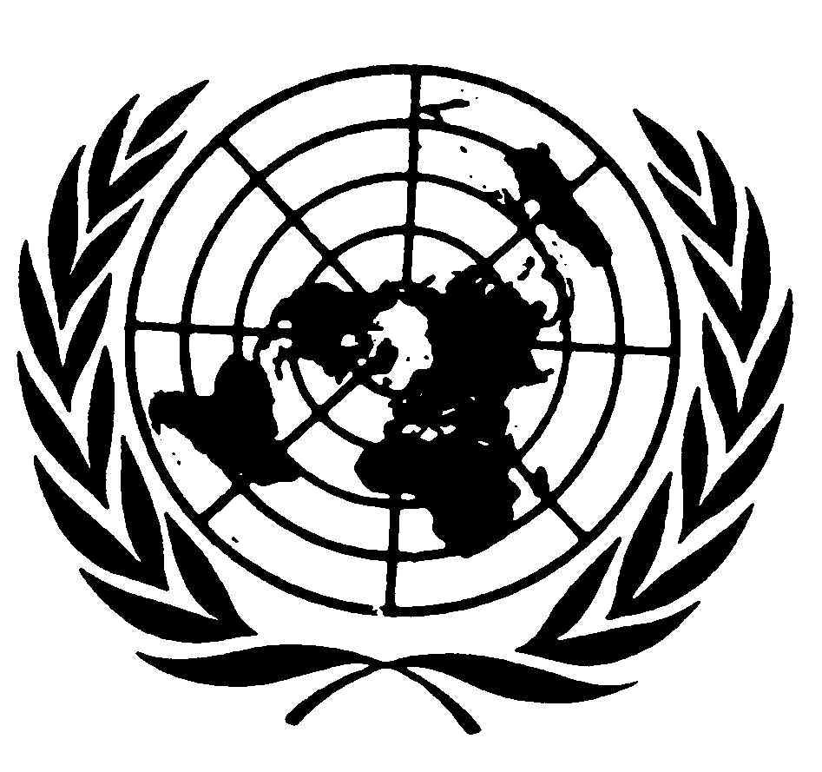

**Statement by**

**Ms. Mariana Katzarova**

## Special Rapporteur on the situation of human rights in the Russian Federation

79th session of the General Assembly

Item 71 (a-d): Promotion and protection of human rights

29 October 2024

New York

**Mister Chair, Excellencies, Representatives of Civil Society,**

It is with profound concern that I present to this Assembly the findings of my report on the widespread and systematic use of torture in the Russian Federation, and the pervasive impunity for these grave human rights violations.

The entrenched use of torture in the Russian Federation has been documented for over three decades. But the full-scale invasion of Ukraine in February 2022 has exacerbated these practices and embedded them into daily life in Russia. The use of torture is no longer confined to specific places of detention or groups and individuals. It has become a widespread tool used to silence and crush anyone perceived to express dissent, and to stifle the exercise of civic and political freedoms.

The aim is to control by fear and repression, to subjugate Russians by brute force. Torture is now a weapon aimed at the very foundations of human rights and civic space in Russia.

**Mister Chair,**

There is no distinct criminal offense of torture in Russian Federation law. This is contrary to Russia’s obligations under the United Nations Convention Against Torture. Instead, acts of torture are prosecuted under less serious crimes, like “excess of authority”, that fail to acknowledge the gravity of the crime of torture, and do not provide appropriate penalties for torturers nor adequate redress for victims. This reflects the deliberate tolerance, and even encouragement, of torture at all levels of governance.

My report sheds light on the disturbing connection between violence perpetrated by private individuals and the State’s complicity in torture. This is driven by a lack of essential legal protections, such as against gender-based and domestic violence, leaving victims unprotected and vulnerable. In failing to address these forms of abuse, the Russian state is, in effect, condoning them and enabling a culture of violence to flourish unchecked.

**Mister Chair,**

The situation within law enforcement and the penitentiary system calls for immediate attention. There, torture, in its most brutal forms, is being used against individuals deprived of their liberty, often for politically motivated reasons. These abuses are not isolated incidents—they are deliberate and deeply entrenched in a culture of impunity that permeates the very institutions tasked with upholding justice and human rights.

The methods of torture used include brutal physical and psychological violence, as well as prolonged solitary confinement. Victims are subjected to lengthy bouts of electric shocks applied to sensitive areas of the body, including the genitals, in methods dubbed a “Call to a friend” or a “Call to Putin”.

Alarming reports of rape, including with objects, such as a rubber baton, a mop handle or a bottle are common, particularly in prisons and during pre-trial detention. These brutal tactics are employed not only to punish but to humiliate and break individuals—physically, mentally, and emotionally.

Another example from the dictionary of torture documented in the report, is ‘slonik’ or, in English, ‘baby elephant’-- a seemingly innocent word. But in Russian prisons it means asphyxiation. It involves repeatedly subjecting a detainee toperiods of suffocation by placing a gas mask over their head and blocking the air valve.

**Mister Chair,**

Courts routinely turn a blind eye to credible reports of torture, even when victims appear before judges bearing visible, undeniable signs of physical abuse inflicted on them while in custody. Instead of delivering justice, the judiciary most often sides with the perpetrators, highlighting the profound collapse of judicial independence in Russia. This wilful complicity perpetuates injustice and illustrates how the legal system is a mere extension of state repression.

Accountability for perpetrators is virtually non-existent. There are no safeguards in place to protect individuals who dare to report torture. In fact, many victims face retaliatory punishment, including more torture, forcing them to retract their complaints out of fear for their own safety. This unchecked impunity has led to the “normalization” of torture within Russian society, where violence is not just tolerated, but is considered a “legitimate” tool of state control and coercion. A recent poll showed that 47 per cent of Russians believe torture should be used on suspects of serious violent crimes and only 35 per cent oppose the use of torture.

**Distinguished delegates,**

This brutal culture and impunity extend far beyond the walls of the penitentiary system. Russian authorities have unleashed the violent force of its law enforcement and state security institutions against peaceful protesters, anti-war dissenters, journalists, human rights defenders and individuals who dare to exercise their fundamental rights.

Take the case of this poet: his torture and gang rape while in police custody was captured on video, yet, despite this evidence, his complaint and request for an investigation was denied by the court. He was then sentenced to seven years in jail for reading anti-war poetry in public. His torturers remained unpunished and ready to torture the next victim. This is not an isolated or unusual case. Repressive and brutal tactics like this are not just silencing individual voices—they are suffocating the very essence of civil society in Russia.

Russia has also revived the use of punitive psychiatry, a practice alarmingly reminiscent of the Soviet era’s way of handling those who spoke out against the system.

Activists, journalists, and peaceful protestors are sent to indefinite confinement in psychiatric wards to silence them and break their spirit~~.~~ For example: a few months ago, a human rights defender who for years has reported on widespread violations within Russia’s penitentiary system, was arbitrarily detained, beaten, subjected to threats of sexual violence, and forced to undergo a month-long psychiatric examination. The available information strongly suggests that this is an act of reprisal, including for his reporting to United Nations human rights mechanisms.

**Mister Chair, Your Excellencies**

The State’s assault on individuals has not been limited to political dissent. Vulnerable and marginalized groups are being systematically persecuted and face heightened risks of torture and abuse.

The situation for LGBT persons, in particular, has grown more perilous. The use of conversion therapy, a practice that amounts to torture, continues unchecked. Individuals, sometimes young children, are being subjected to brutal and painful practises portrayed as “treatment”, and harmful punishment that is supposed to “cure” them. In Chechnya, LGBT persons are routinely raped and tortured by the military and police. On release, their families are told that they are free to kill them with impunity, in so-called “honour killings”. Others are forced to join the war against Ukraine under the threat of further torture.

Indigenous Peoples and members of ethnic minorities are particularly vulnerable to torture and ill-treatment. The report also documents brutality against migrants, hundreds of whom are held in prison-like, overcrowded detention centres and many are forced into signing contracts with the Russian army.

**Mister Chair,**

As my report documents, the aggressive war against Ukraine unleashed by the Russian authorities is fuelling domestic repression. The same violence and disregard for human rights and human dignity drives government actions both at home and in the war abroad.

Enforced disappearances and torture are weapons of war in this conflict that has already cost countless lives. Ukrainians are arbitrarily detained, then forcibly transferred within the Russian-occupied territories or deported to prisons in the Russian Federation.

Hundreds of Ukrainian detainees, including civilian women and men as well as military prisoners of war, are being tortured to extract information or simply to punish them. Electric shocks, beatings, and sexual violence have all been documented as part of the horrific treatment meted out to Ukrainians held in Russian detention. It has taken the lives of at least 177 Ukrainians, according to Ukraine’s Defense Ministry. The actual number of deaths of Ukrainians in Russian custody is probably much higher because Russian authorities do not provide information. These deaths included that of 27-year-old journalist Victoria Roshchyna, who died in Russian custody on 19 September. She had been held incommunicado for a year without any charge.

The use of convicts to fight in Ukraine has fuelled a rise in domestic violence within Russia. Convicts are pardoned if they join the army. When they return from the war many commit violent crimes, including rape and murder. Women and girls bear the brunt of this violence, and there is no legal framework to protect them. The perpetrators often face lenient penalties because service in the war is considered a mitigating circumstance, and if they rejoin the war, the new charges against them are dropped.

The state’s complicity in crimes against women and girls, including honour killings and female genital mutilation, entrenches the violence they face, especially in the North Caucasus region, where such practices are common.

**Excellencies,**

The Russian authorities continue to deny access or engage with my mandate. I call on the Russian Federation to reconsider its stance and start a dialogue to address the severe human rights violations documented in my report.

International human rights mechanisms, such as my mandate, will continue to monitor and report on the situation inside the Russian Federation. But the pursuit of human rights, justice, and accountability must be supported by all States in accordance with their obligations under universal jurisdiction. We owe it to the countless victims who have been silenced, tortured, imprisoned or killed.

Thank you.

**END**