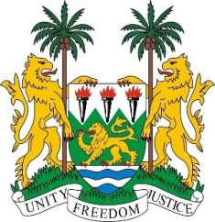
PERMANENT MISSION OF SIERRA LEONE TO
THE UNITED NATIONS AT GENEVA
57th Session of the Human Rights Council
(9th September - 11th October 2024)
Item 10: Enhanced interactive dialogue on the nuclear legacy in the Marshall Islands
4 October 2024
Check against delivery
Mr. President,

Sierra Leone affirms the importance of addressing the adverse impact of the nuclear legacy on the realisation and enjoyment of human rights by the people of the Marshall Islands. We urge the United Nations to provide assistance to the Government of the Marshall Islands in addressing these long-lasting consequences.

We commend the Government of the Marshall Islands for its ongoing efforts to mitigate the impacts of nuclear testing and its commitment to the full realisation of human rights for its people. We recognise the country's right to a clean, healthy, and sustainable environment and its dedication to fulfilling this right while addressing the human rights implications of its nuclear legacy.

We recognise that the presence of nuclear waste, radiation and contamination continue to present significant challenges, hindering the full enjoyment of human rights by the people of the Marshall Islands. These issues have a significant impact on both human health and the environment, with implications that extend across the entire Pacific region.

We call on all states, relevant United Nations agencies, and other stakeholders to provide support to the Marshall Islands in improving the health and environment of its people.

Sierra Leone supports the request for the Office of the High Commissioner to provide technical assistance to the Marshall Islands' National Nuclear Commission, with a view to facilitating the advancement of its national strategy for nuclear justice.

I thank you.

