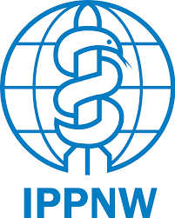

**57th Regular Session of HRC (9/9/2024–11/10/2024)**

**Enhanced interactive dialogue on the nuclear legacy in the Marshall Islands**

Thank you Mr. President. My name is Chris Serrao, speaking for the International Physicians for the Prevention of Nuclear War.

I encourage all of you to think about what it was truly like in the Marshall Islands on March 1, 1954. Imagine living in the tropical islands replete with diverse flora and fauna. Suddenly, a massive flash is followed by a hot gust of wind and a deafening explosion. Hours later, a powdery white substance rains down from the sky, causing people’s skin to burn and peel off, inducing vomiting, diarrhea, hair loss, and a plethora of diseases down the line. This was the experience of the people of Rongelap and Ailinginae during Castle Bravo.

Many Bikinians present at the first test still recall a promise by US Commodore Ben Wyatt. He told them, “No matter if the Bikinians found themselves on a sandbar or adrift on a raft at sea, they would be taken care of as if they were the children of America.” The US has abandoned this promise, and in doing so the Marshallese people. The whole of the Marshall Islands were contaminated by radiation from 67 nuclear tests equivalent to more than 7200 Hiroshima bombs.

We urge the Human Rights Council to approve and implement the recommendations of the High Commissioner’s report. We call upon the US to pay the compensation claims requested by the people of RMI and to release all pertinent data to the Marshallese government and the public. We also entreat all those within the international sphere to support the implementation of the Marshallese transitional justice work. We urge all Member States to join the TPNW.

Thank you.