CHECK AGAINST DELIVERY

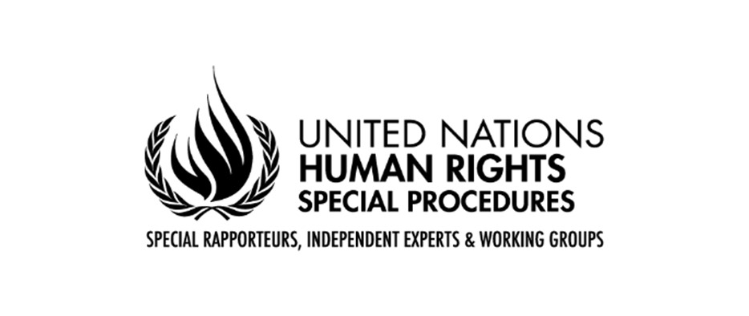

Fiftieth Session of the Human Rights Council
Urgent Debate on the situation of women and girls in Afghanistan

Statement by Richard Bennett, Special Rapporteur on the situation of human rights in Afghanistan and on behalf of the Coordination Committee of Special Procedures

Geneva, 1 July 2022
Mr. President,
Excellencies,
Afghan Women and Girls,

I have the honour to address you for the first time, as the Special Rapporteur on the situation of human rights in Afghanistan and, in light of the subject matter of the debate today, the Coordinating Committee of Special Procedures has asked me to deliver our joint statement.

First, I express profound sympathy for the communities affected by last week’s earthquake. Our best wishes for a speedy recovery. I also note the need for intensified humanitarian aid and support, ensuring aid is delivered in a way that it reaches Afghan women and girls, and other marginalized groups.

Excellencies,

Since August 2021, when this Council held a Special Session on the situation of human rights in Afghanistan, my colleagues have consistently and increasingly raised concerns about the situation of women in Afghanistan. They deplored the backsliding and regression on women’s and girls’ rights. They stressed the crucial importance of women’s full participation in public and political life. They condemned the decision to deny girls secondary education. They denounced the Taliban’s continuing resolve to erase women and girls from the public life of the country, to deny them their fundamental human rights and to institutionalize large scale and systematic gender-based discrimination and violence against women and girls. Since I took up my mandate and visited Afghanistan, information received confirms these bleak findings and points to a rapidly deteriorating state of affairs.

Information from areas where the Taliban had been in control in the period leading up to the overthrow of the Islamic Republic indicated that degradation of women’s rights were central to their ideology. These violations included forced, early, and child marriage; restrictions on women’s attire and movement, exclusion from education and public life and barriers to employment. These rights violations also align precisely with those reported by the Special Procedures under Taliban rule in the 1990s.

Therefore, it should come as no surprise that, despite public assurances from the Taliban that they would respect women’s and girls’ rights, they are reinstituting step-by-step the discrimination against women and girls’ characteristic of their previous term and which is unparalleled globally in its misogyny and oppression.

Excellencies,

From 15 to 26 May, I visited Afghanistan to assess the human rights situation. I visited the north and south as well as the capital and met with a broad range of stakeholders, including several courageous women’s groups.

I met with the acting Foreign Minister twice, an acting deputy Prime Minister and several other acting ministers and provincial governors. They told me that they will respect the international human rights treaties ratified by Afghanistan, but only to the extent that they are not in conflict with Sharia law. Human rights mechanisms have repeatedly stated that religion or belief can never justify discrimination and violence.

In every meeting, I raised concerns about abuses of women’s rights, including the ongoing suspension of girls from secondary education. The authorities informed me that a committee led by the acting Chief Justice was examining the matter, but they gave no indication of when schools would reopen or under what conditions.

The resumption of girls’ secondary education is far from the only requirement. There has been a raft of restrictions during the last months, including violent crack-down on protesters, by the Taliban that have wiped out gains made by women and girls over the last 20 years including restrictions on employment, travel and attire.

It seems the Taliban’s intentions are not only to impose absolute gender segregation, they are aimed at making women invisible by excluding them almost entirely from society. These measures contravene Afghanistan’s obligations under numerous human rights treaties to which it is a State party. They massively diminish women’s lives, deliberately attack women and girls’ autonomy, freedom and dignity, and create a culture of impunity for domestic violence, child marriage and sale and trafficking of girls, to name a few of the consequences.

Denying women’s and girls’ rights is also denying the whole society its opportunity for development. Two young Afghan women told me “the international community cannot leave us the darkest moment in our history, if you do, soon Afghan women will disappear fully from society and our dreams will be broken. We are 50% of the population, and we want to speak to the Taliban directly”.

Therefore, with my colleagues from the Coordination Committee:

I call on the Taliban to:
- create a meaningful dialogue with Afghan women, listen and respond to their demands, and ensure that women freely and fully participate in civil, political, economic life including being in positions of power;
- respect all women and girls’ right to education at all levels, open secondary schools for all children now, and provide undisrupted quality education with sufficient resources for teachers;
- ensure that women can play an active part in the workforce, remove the restrictions on movement that impedes women’s daily life and ensure access to health care;
- respect the right to protest peacefully by women and girls and refrain from all forms of violence;
- abide by all international human rights obligations and commitments incumbent upon Afghanistan including engaging with human rights mechanisms

I call upon Member States to:
- ensure a concerted effort demanding women’s participation at all levels of decision-making processes, including in the delivery of humanitarian aid so it is inclusive and reaches women and girls proportionately;
increase their support for Afghan women and girls and take the strongest possible measures to ensure that their rights are protected, including by intensifying pressure on the de facto authorities to restore and respect them;
- provide Afghan female-led civil society organizations inside and outside the country with the necessary support to continue their work for equal rights for women and girls;
- Through international assistance and cooperation, ensure maximum available resources with a view to realising human rights of women and girls.

Violations of women’s and girls’ rights are being documented by my mandate and by other human rights mechanisms with a view to providing redress and gender-justice for victims. I call for meaningful support for this from the Council.

The human rights situation for women and girls is devastating for Afghanistan and deserves our maximum attention and decisive action. In August 2021, during the Special Session on the situation of human rights in Afghanistan, my colleagues urged the Council to act. This call remains just as valid today. My colleagues and I will continue to monitor all human rights, with a focus on women and girls’, and I will further address the matter in my report in September.

I thank you.

