“Violence, abuse and neglect of older persons.” UN Questionnaire
Ireland submission February 2023

- Legal, policy and institutional frameworks
  - Domestic Violence Act 2018 including amendment on coercive control
  - Non-fatal Offences against the Person Act 1997
  - Safeguarding Vulnerable Adults Policy 2014
  - Institutional frameworks include HSE Safeguarding Service
  - Equality Act 2015 (anti-discriminatory legislation)

- Manifestations of Violence
On average there are 3,500 safeguarding concerns reported to the HSE Safeguarding and Protection Team relating to individuals over 65 years. This equates to a reporting rate/100,000 population over 65 of between 5.05 in 2016 to 5.89 in 2021. The rate of reporting is higher in females than in males across all years. Physical abuse against older people accounts for on average 26% of concerns reported. The HSE data does not have comprehensive data over time on the form of abuse experienced.
In the National Prevalence Study, the overall prevalence of mistreatment in the previous 12 months was 2.2% (Naughton et al 2012). Physical abuse and neglect accounted for .5% and .3% respectively. The majority of physical abuse reported related to being pushed followed by being threatened or harmed with an object, kicked and denied access to equipment such as a walking or hearing aid or being restrained.

- Intersectionality-
There are some services that support older people who also have intersectionality needs. For example- https://lgbt.ie/get-information/older-lgbt-people
Research highlights that LGBT people of all age groups are subjected to ongoing prejudice and discrimination in all areas of life (BeLonG To, 2005; Equality Authority, 2002; Gibbons, Manandhar, Gleeson, & Mullan, 2007; Layte et al., 2006; Mayock, Bryan, Carr, & Kitching, 2009; Norman, Galvin, & McNamara, 2006).

Research on domestic violence within the Irish Travelling Community conducted by Mary Allen explored the experience of intimate partner violence within ethnic minority community in Ireland. Using a mixed-method approach that sought the views of both traveller women and a range of Irish service providers, the complex interaction of culture, racism and discrimination on women experiencing abuse is explored. The impact of these factors on traveller women’s ability to leave a violent relationship is discussed and the implications for social work practice are outlined. While social workers need to fully comprehend the dynamics and complexities of such forms of abuse, the particular needs of women in ethnic groups such as the traveller community need to be understood and appreciated when interventions are being planned and implemented.

Gender: Females living longer and are often subject to significant inequalities. IPV grown old. Pooled prevalence of 50 publications-14.7% (within a 12 month period). Gender roles-traditional, Systemic oppression (Yon et al., 2017).
Health: Poor health of the older person (esp frailty), dependency, dementia Socio-economic status: Lower income and poverty (Burnes et al., 2015)

Red C Poll conducted for Safeguarding Ireland looking at public attitudes to disability in Ireland
- Three-quarters of people agree that stronger laws are required in Ireland to safeguard people with disabilities from all forms of abuse.
- But public opinion is not very strong when it comes to viewing people with disabilities as having equal rights in Ireland. In fact, more than one-third of the public disagree that those with disabilities have equal rights. Meanwhile, at least two-in five people disagree that those with disabilities (physical or intellectual) are supported adequately to make their own decisions.
- Those in older age groups are considerably more likely to disagree that people with disabilities (physical or intellectual) are supported adequately to make their own decisions.

- HSE (Health Service Executive) Safeguarding Data
  - Over 65 Safeguarding Reporting Rate 2018-2021
  - HSE Safeguarding Annual Report 2018
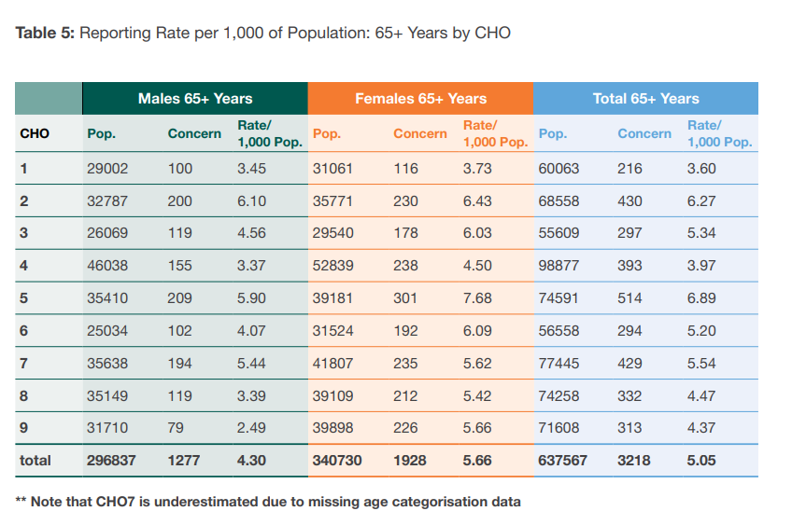
  - HSE Safeguarding Annual Report 2019

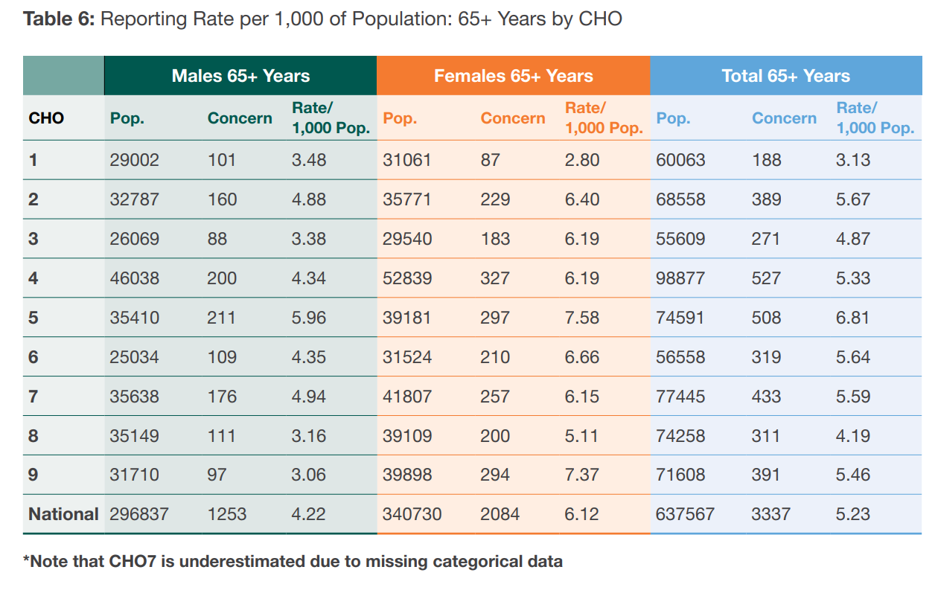
  - HSE Safeguarding Annual Report 2020
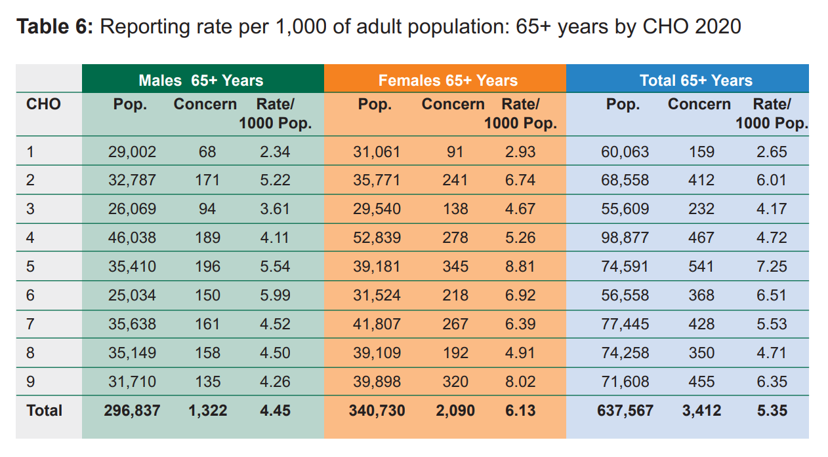

  - HSE Safegaurding Annual Report 2021
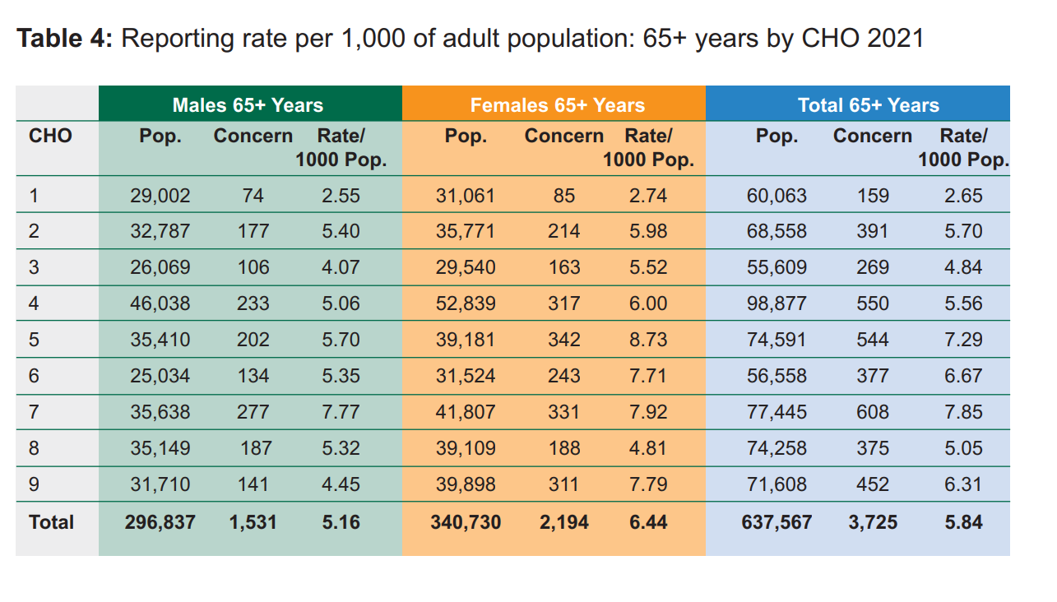

  - Profile of Abuse Types Alleged by Age of Adult at Risk 2018-2021

    - HSE Safeguarding Annual Report 2018

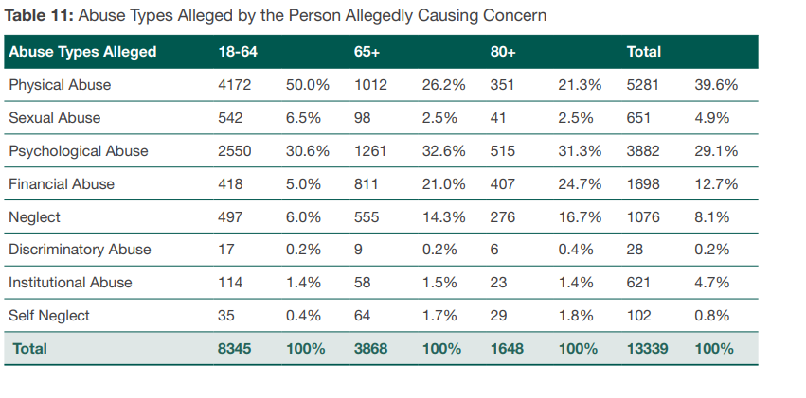

  - HSE Safeguarding Annual Report 2019
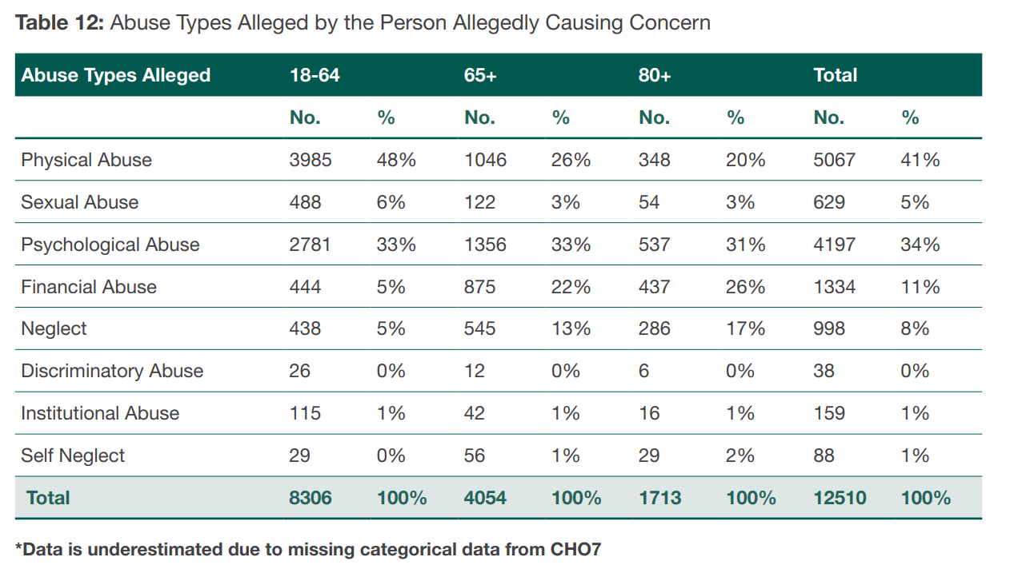

  - HSE Safeguarding Annual Report 2020
Not Available in Report

  - HSE Safeguarding Annual Report 2021
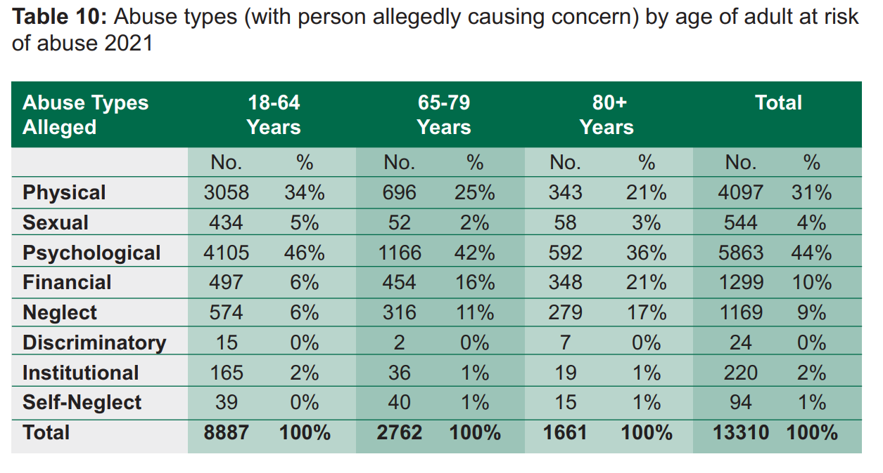
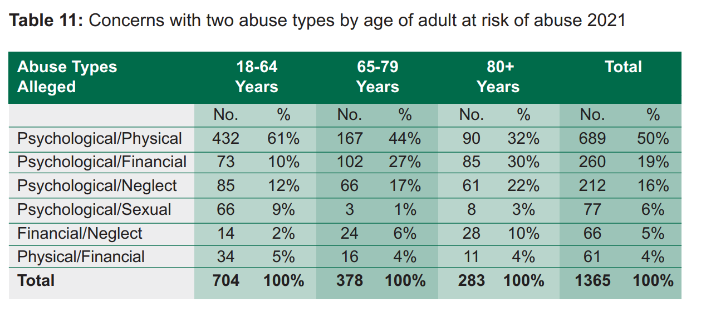

- Profile of Person Causing Concern by Age of Adult at Risk 2018-2021

  - HSE Safeguarding Annual Report 2018

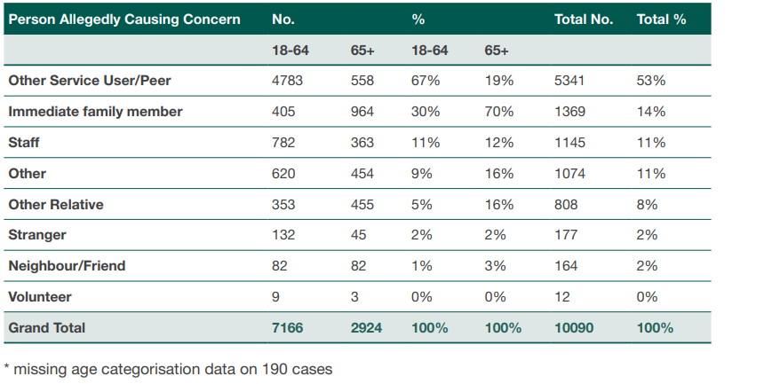

  - HSE Safeguarding Annual Report 2019

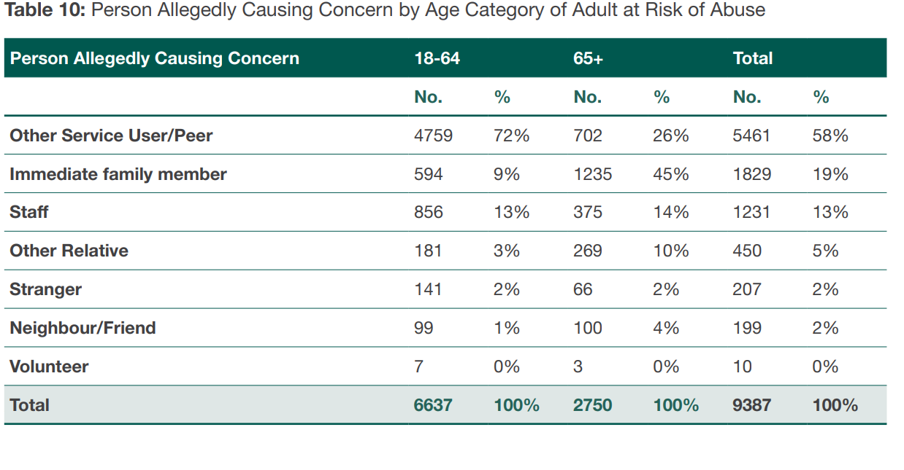
  - HSE Safeguarding Annual Report 2020
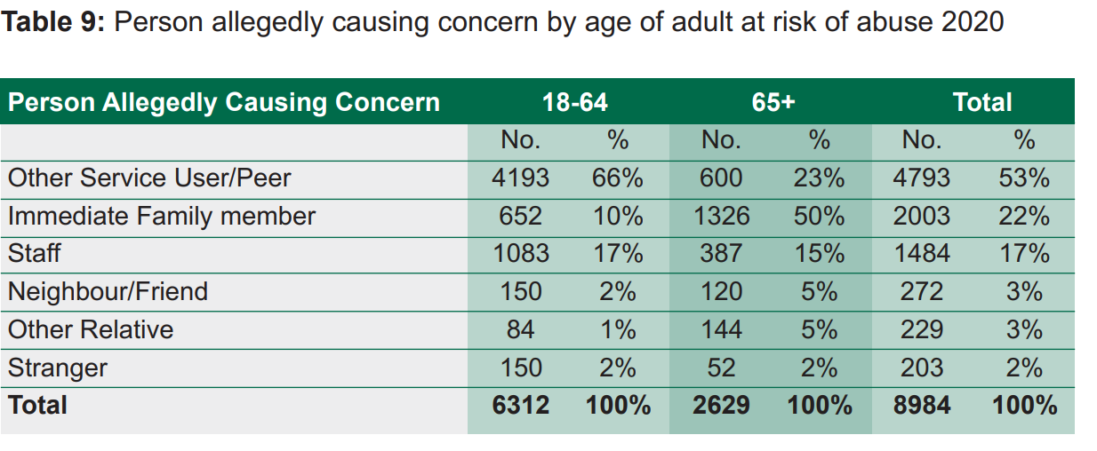

  - HSE Safeguarding Annual Report 2021
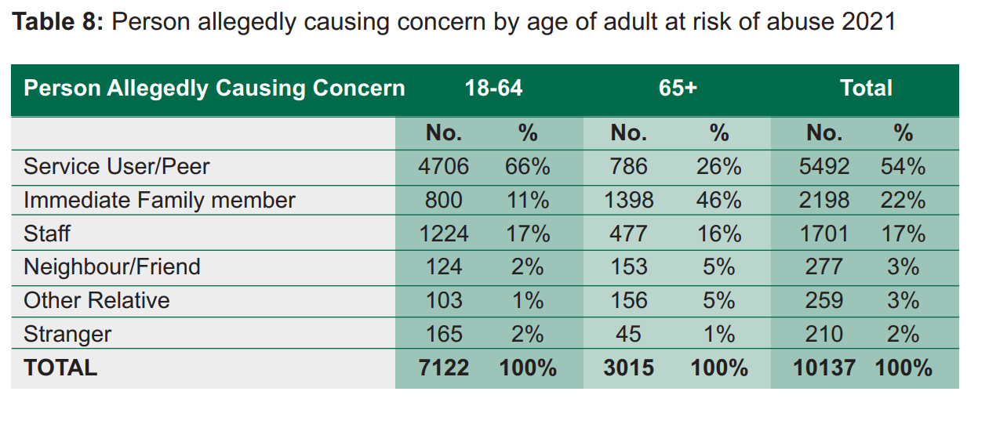

- Access to Justice
- HSE Safeguarding and Protection Teams can provide support and information on legal redress, protection orders etc.
- Women’s Aid and Men’s Aid also provide support and information.
- Free Legal Advice Centres.
- An Garda Síochána.
- Domestic Violence Act 2018
- Court Services

- Access to information
- HSE- World Elder Abuse Awareness Day Annually
- Age Action Ireland
- SAGE Advocacy
- Free Legal Advice Centres
- Citizen’s Information
- Family Carers Ireland
- Safeguarding Ireland (Adult Safeguarding Awareness Days annually)

- Good practices-input from a team leader in HSE Safeguarding and Protection Team as follows:
“Local church organisations are active in supporting older people in their communities, this lends itself to the creation of supportive friendships that can reduce social isolation, a significant risk in harm or abuse of older people. Also, organisations like ALONE, St Vincent DePaul, Age Action and SAGE are all actively engaged with older people in terms of advocacy and support. The role of the area Public Health Nurses, home help service and local day centres are also vital to maintaining connections with older people and identifying potentially abusive situations at an early stage. The Gardaí generally hold a register of older people in their functional area and we have a mechanism whereby we alert the Garda (via the notification system) when we are particularly concerned about a situation so that we can share information and when necessary work collaboratively. In terms of practice models, we have a day centre/ supported housing project in Connemara called Terman Eanna which has been really proactive in raising awareness of elder abuse issues.”

Department of Foreign Affairs, Ireland
Human Rights Unit
February 2023

