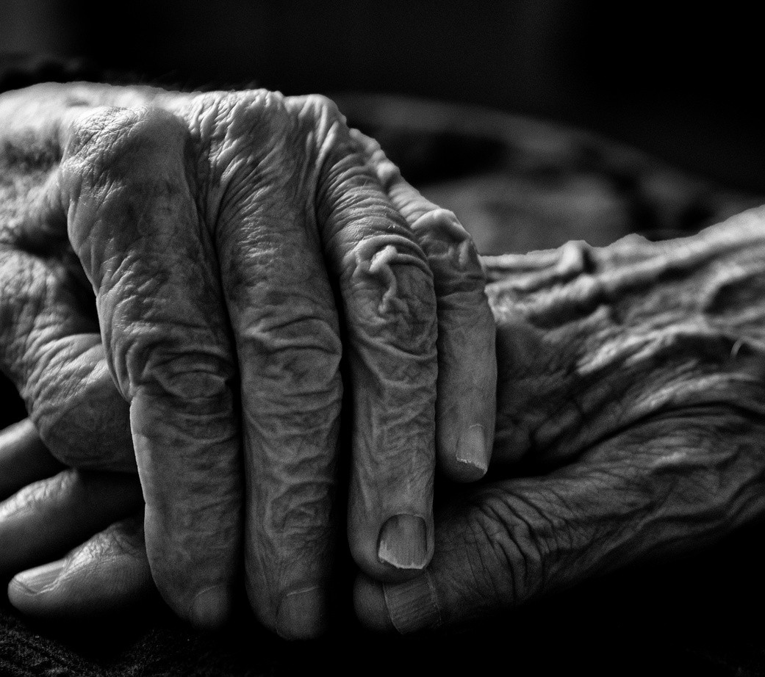

20

23
MARCH

INPUTS BY THE FEDERAL PUBLIC DEFENDERS' OFFICE OF BRAZIL
REPORT ON VIOLENCE, ABUSE AND NEGLECT OF OLDER PERSONS

CONTRIBUTIONS TO THE
HUMAN RIGHTS COUNCIL

5923056v6 08038.001220/2023-30

FEDERAL PUBLIC DEFENDERS' GENERAL OFFICE
Setor Bancário Norte Quadra 01 Bloco F - Bairro Asa Norte - Postal Code 70040-908 - Brasília - DF - www.dpu.def.br Edifício Palácio da Agricultura

MANIFESTATION No. 5923056 - DPGU/SGAI DPGU/GTPID DPGU

Brasília, February 17, 2023.

This is a request for information from the United Nations High Commissioner for Human Rights (OHCHR) on violence and neglect against older persons. The aim is that responses from States will assist the Independent Expert, Dr. Claudia Mahler, in preparing the report for the 54th session of the Human Rights Council. To this end, the information provided herein will take into account official documents from State agencies, as well as from civil society entities, placing, whenever possible, the appropriate reference in a footnote. For each item, we will seek to present concrete actions, internal legislation, and good practices of the Brazilian State in the promotion and protection of the Human Rights of Older Persons.

Legal, political, and institutional structures

Is there a non-discrimination law that prohibits discrimination on the basis of age?

Despite so many other laws that provide for the fight against discrimination based on age (ageism/ageism), it can be indicated as the main legislation for the protection and promotion of the rights of the elderly person Law No. 10.741[1], known as the Older Persons Statute. The Statute in question has been in force in the country since 2003 and in its article 3rd establishes obligations for the family, the community, society and the public authorities, all as guarantors of the right to life, health, food, education, culture, sport, leisure, work, citizenship, freedom, dignity, respect and family and community life.
The right to non-discrimination can be more strongly identified in article 10th of the Older Person Statute, which deals with the right to respect. However, the Brazilian State considers non-discrimination also as part of other rights. Thus, the right to non-discrimination is also reflected in the right to life, health, etc.
Still, on the right to non-discrimination, the Constitution of the Federative Republic of Brazil provides in the main section of its article 5th that "all are equal before the law, without distinction of any kind", this being the highest expression of the right to non-discrimination at the domestic level.
We emphasize that the Statute distinguishes between older persons and super older persons. The former is understood as those aged 60 and over, while the super older persons are those aged 80 and above (article 15th, paragraph 7).

Is there legislation on violence against persons and/or domestic violence that includes violence, abuse and/or neglect of older persons?

The Older Persons Statute is a law with several provisions on the rights of this population. This means that it not only provides rights, but also provides means to enforce them, as well as important concepts for a better understanding and application of the law.

On article 19th[2] In cases of suspected violence against older persons, public or private health services must notify the healthcare authority, in addition to the police authority, the Federal prosecution Service, the City, State, or National Council of the Older Persons. Recognizing the vulnerability of older persons and that they often fail to denounce, either out of fear or ignorance, this provision aims to combat the impunity of violence against them. Nevertheless, according to the law in question, violence against the older person is defined as “any action or omission practiced in a public or private place that causes death, damage or physical or psychological suffering”.
The Older Person Statute does not provide for any penal provision in its content. However, for this purpose Brazil adopts the Penal Code[3], in addition to other extravagant legislation. A significant part of the crimes provided for in the Penal Code may be committed against older persons, but in these cases, under the terms of article 61st, item II, "h", will be considered as aggravating. Aggravating circumstances are those that always aggravate the penalty and should be applied in the second phase of the dosimetry of the penalty. Also, in some crimes, such as defamation (article 140), the victim's age may be a qualifying factor, that is, an element that changes the parameters for sentencing. In other cases, such as the crime of human trafficking (article 149-A), if the victim is an older person, the penalty will be increased from one third to one half (paragraph 1st, item II).

Does the law establish an independent specialised body that receives complaints of age
discrimination?

Brazil has several bodies responsible for protecting older persons, directly and indirectly. For example, the National Secretariat for the Promotion and Defence of the Rights of Older Persons and the National Council for the Rights of Older Persons are mentioned.
At the state level, each of the 26 states of the Federation, as well as the Federal District, can establish State Councils on the Rights of Older Persons, and some municipalities can also create monitoring bodies.
Complaints, denunciations and requests for assistance may also be sent to the Federal Public Defenders' Office, to the State Public Defenders' Offices (and Federal District), as well as to the Federal, State (and Federal District) Prosecution Service, which will act according to their institutional powers.

Is there a national plan, policy or strategy to address violence against older persons, which is overseen by a national mechanism to monitor and implement it?

Yes. One can mention the Action Plan to Confront Violence Against Older Persons made[4] in 2005 by the Presidency of Brazil in collaboration with the Ministry of Social Development, Ministry of Education, Ministry of Cities, Ministry of Culture, Ministry of Health, and Ministry of Science and Technology. The objective of this plan, which lasted two years, was to create mechanisms and institutional instruments for awareness and implementation of public policies to promote the rights of older people.
With regard to public policies, some can be indicated, without prejudice to many others that are fundamental for the protection of the rights of older persons, as well as for the improvement of the quality of life of this vulnerable group. Thus, one can mention the National Policy for the Health of Older Persons[5], which deals with the universal access to healthcare guaranteed in Brazil by the 1988 Federal Constitution and its application to older people. In the Ordinance of the Ministry of Health, "the National Policy of the Older Persons, promulgated in 1994 and regulated in 1996, ensures social rights to them, creating conditions to promote their autonomy, integration, and effective participation in society, reaffirming the right to healthcare at the various levels of service provided by the Brazilian Unified Healthcare System (SUS) (Law No. 8.842/94 and Decree No. 1.948/96). It should be noted that in many cases healthcare professionals are responsible for recognising the occurrence of ill-treatment and physical or moral violence against older people and determining the referrals to the competent authorities.
Law No. 8.842 (January 4, 1994) establishes the National Policy for Older Persons and creates the National Council for the Rights of Older Persons. Pursuant to article 3, will be governed by important principles such as the obligation of society as a whole – without defining an specific guarantor

ensure the rights of older people, prohibiting discrimination of any kind and the leading role of older people. Several bodies are responsible (intersectoral perspective) for the national policy in the fields of social assistance, healthcare, education, justice, labour, social welfare, culture, sport and leisure, indicating, in each of them, concrete actions that should be adopted.

Manifestations of violence

What forms of violence, abuse and neglect are faced by older people?

In Brazil, the most common forms of violence suffered by older people are: physical violence, psychological or affective violence, sexual violence, abandonment, financial or economic violence, and medication violence.[7].
The Brazilian State has acted to reduce human rights violations perpetrated against older persons. 'Disque 100'[8] is the reporting channel created by the Ministry of Human Rights and Citizenship to receive, filter and forward reports of human rights violations. Most of the complaints made refer to vulnerable groups and among them are the older persons. In 2022 alone, the complaints channel recorded more than 35,000 reports of human rights violations against older people[9].
The Institute of Applied Economic Research (IPEA) annually prepares the Atlas of Violence, that is, a report that portrays the most commonly practiced violence in Brazil and which groups usually appear as victims and aggressors. Due to the Covid-19 pandemic, reporting was not possible in some years. Therefore, the most recent publication is the Atlas 2021.[10].
According to the report[11], the incidence of homicides involving older persons as victims in the year 2019 presented diminishing numbers compared to the previous year. Attempted homicides in 2019, on the other hand, had an increase over 2018, but was still lower than 2017 and 2013, the years with the highest incidence. Bodily injury perpetrated against older persons in 2019 reached the highest mark compared to the last eight years (since 2011).

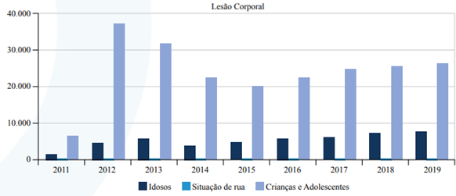

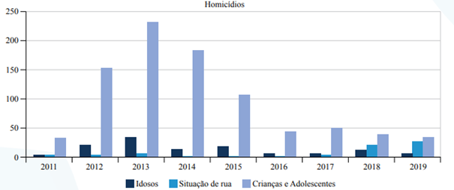

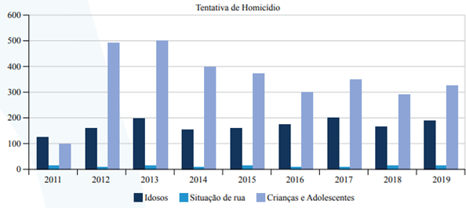

In what situations does this happen? Please provide detailed information.

Violence against older persons happens in various spaces, the most common of which is the family environment, as verified by the 'Disque 100' in the year 2022, when 87% of the reports of human rights violations against this population happened in the house where they live.[12] This reality is translated by the social coexistence of older persons with family members, which facilitates the practice of violence and its concealment. Furthermore, the elderly are victims of a wide range of violence in public spaces, healthcare establishments, etc.

Intersectionality

How violence, abuse and neglect affect specific groups of older people (e.g. older women, older LGTBI people, older people belonging to ethnic and indigenous groups, older refugees and internally displaced persons, older people with disabilities etc.) Please provide detailed information.

In a survey conducted by the Brazilian Institute of Geography and Statistics (IBGE) in the year 2017, compared to the year 2012, Brazil had an increase of 18% of its older population, i.e. people aged 60 years or more. In that year, the mark reached was approximately 30.2 billion older persons according to the Continuous National Household Sample Survey - Characteristics of Residents and Households[3], showing a tendency for Brazil to have its population over the age of 60 increasing each year.

This research allows us to identify that the increase in the population of older people is a fact and that the State must act to ensure the realization of the rights of this population because of their vulnerabilities. On the other hand, if we analyse age in conjunction with other factors that also result in the vulnerability of a certain group, we will have a situation of accentuated vulnerability. In this sense, a white male older person is not on the same level of vulnerability as a black female or LGBTQIA+ older person.
Older women, for example, in addition to age discrimination, also face machismo and domestic violence. In 2015 FLACSO Brazil in partnership with PAHO/WHO, UN Women and the Special Secretariat for Women's Policies prepared the Map of Violence 2015: Homicide of Women in Brazil[14], where it was possible to perceive a variation in the homicide rate by sex and age.
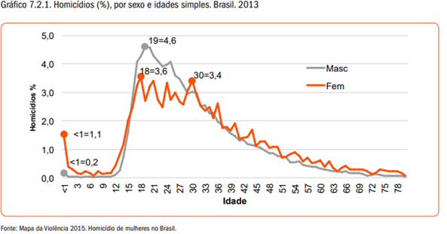
In the same research, it is possible to see that the aggressors of older women are generally their own children and in second place their spouses.
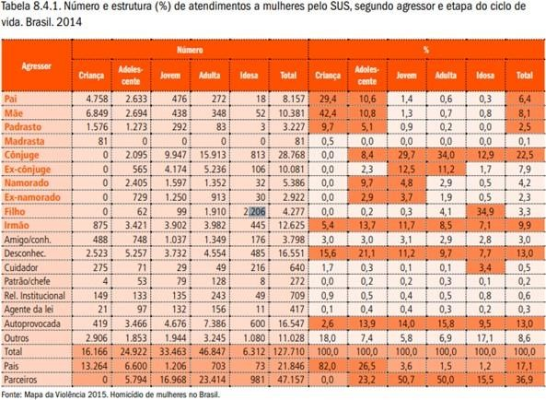

Older queer or LGBTQIA+ people face other problems. Firstly, it should be noted that the life expectancy of a cisgender person, that is, a person who identifies with the gender assigned at birth, is approximately 77 years.[15]. Trans people have a life expectancy of only 35 years[16].

Do national surveys on violence include experiences of older people?

The main surveys at national level take into account the experiences of older people to develop data on the topic under analysis. The 'Disque 100', for example, is a communication channel and often the communicants are older persons themselves. In other hypotheses, if the informant is not the older victim, they may be heard at a later time.
The IBGE, which is the main body responsible for data and statistics in Brazil, periodically carries out the Census, defined as a questionnaire with 26 questions that makes it possible to find out the living conditions of the Brazilian population.

Access to justice

How does the State meet its obligations to ensure access to justice for older persons and to obtain remedies and reparations, when their human rights have been violated as a result of violence, abuse, and neglect?

The Federal Constitution of 1988, in its article 5, item XXXV: access to justice for all Brazilian and foreign citizens in the national territory. Although the constitutional text does not directly address access to justice for older persons, in the Older Persons Statute[17] we can identify some provisions that enable and even facilitate this access. Firstly, article 69, the mandatory use of summary proceedings (more rapid) in lawsuits involving older persons.
Another important provision is in article 80, which establishes as absolute jurisdiction the jurisdiction of the court of residence in lawsuits in which older persons appear as parties, except in cases of jurisdiction of the Federal Court or the Superior Courts. Priority is also given to cases with parties aged 60 or over, and even more so to people aged 80 or over under the terms of article 71. Finally, article 81, of the Older Persons Statute, lists a series of legal entities to request in court the protection of the rights of older persons. Among them are the Brazilian Bar Association, the Federal Prosecution Service, the Union, the States, the Federal District, and the Municipalities, as well as associations. This provision aims to combat any difficulty that a person over 60 years of age may have to enter into court alone, facilitating access to justice and the judiciary.
Also noteworthy is the performance of the Federal Public Defenders' Office, under the terms of article 134 of the Brazilian Federal Constitution;

Access to Information

How to raise public awareness about violence against older people? How is information on access to essential services (e.g. medical care, legal assistance, social services, access to shelters) made accessible and available to older persons?

The Brazilian State has several information mechanisms regarding the human rights of older people. Over the years, the various Ministries have published primers and information documents on rights and how older people and other interested parties can seek them. The Brazilian State also disseminates information and good practices for the treatment of older people and the protection of their rights in the various media available to it, such as radio, television, and newspapers, as well as through the various institutions that look after the protection of the rights of this vulnerable group.

In addition to the booklets and campaigns covering a wide range of topics on the rights of older people, Brazil has the Federal Public Defenders' Office and 27 other Public Defenders' Offices (one in each of the 27 states of the federation), which provide full legal assistance free of charge, enabling this group to have access to justice, as well as providing clarification and information about their rights.
Without any addition for now, we renew our esteem and consideration and remain at your disposal for any further information you may require.

- BRAZIL. Law No. 10,741 (October 1st, 2003). Provides for the Older Persons Statute and makes other provisions. Brasília – DF: Federal Official Gazette (October 3, 2003). Available at: https://www.planalto.gov.br/ccivil_03/leis/2003/l10.741.htm. Accessed on: February 14, 2023.
- BRAZIL. Law No. 10,741 (October 1st, 2003). Provides for the Older Persons Statute and makes other provisions. Brasília – DF: Federal Official Gazette (October 3, 2003). Available at: https://www.planalto.gov.br/ccivil_03/leis/2003/l10.741.htm. Accessed on: February 14, 2023.
- BRAZIL. Decree-law No. 2848 (December 7, 1940). Penal Code. Rio de Janeiro – RJ: Federal Official Gazette (December 31, 1940). Available at: https://www.planalto.gov.br/ccivil_03/decreto- lei/del2848compilado.htm. Accessed on: February 14, 2023.
- BRAZIL. Presidency of Brazil. Undersecretariat of Human Rights. Action Plan to Confront Violence Against Older Persons / Presidency of Brazil. Undersecretariat of Human Rights. – Brasília: Undersecretariat of Human Rights. 2005. Available at: Plano_Acao_Enfrent_Viol_Idoso.pdf(prattein.com.br). Accessed on: February 15, 2023.
- BRAZIL. Ordinance No. 2,528 (October 19, 2006). Approves the National Health Policy for Older Persons. Available at: Ministry of Health (saude.gov.br). Accessed on: February 15, 2023.

- BRAZIL. Law No. 10,741 (October 1st, 2003). Provides for the Older Persons Statute and makes other provisions. Brasília – DF: Federal Official Gazette (October 3, 2003). Available at: https://www.planalto.gov.br/ccivil_03/leis/2003/l10.741.htm. Accessed on: February 14, 2023.
- LONGEVITY INSTITUTE. Violence against older persons begins at home: numbers grow and worry authorities. Available at: See the types of violence against older people (institutodelongevidade.org). Accessed on: February 15, 2023.
- BRAZIL. MINISTRY OF HUMAN RIGHTS AND CITIZENSHIP. 'Disque
100'. Available at: Disque100 — Ministry of Human Rights and Citizenship (www.gov.br). Accessed on: February 15, 2023.
- BRAZIL - MINISTRY OF HUMAN RIGHTS AND CITIZENSHIP. 'Disque
100' registers more than 35,000 reports of human rights violations against older people in 2022. Available at :https://www.gov.br/mdh/pt-br/assuntos/noticias/2022/junho/disque-100-registra-mais-de-35- mil- denuncias-de-violacoes-de-direitos-humanos-contra-pessoas-idosas-em-2022. Accessed on: February 16, 2023.
- INSTITUTE OF APPLIED ECONOMIC RESEARCH. Atlas of Violence, 2021.
Institutional Website. Available at: https://www.ipea.gov.br/atlasviolencia/publicacoes. Accessed on: February 16, 2023.
- CERQUEIRA, Daniel. Atlas of Violence 2021 / Daniel Cerqueira et al., — São Paulo: FBSP, 2021. Includes Bibliography. 1. Violence. 2. Public Security. 3. Public Policies. 4. Brazil. Page 61. Available at: https://www.ipea.gov.br/atlasviolencia/arquivos/artigos/5141- atlasdaviolencia2021completo.pdf. Accessed on: February 16, 2023.
- BRAZIL - MINISTRY OF HUMAN RIGHTS AND CITIZENSHIP. 'Disque
100' registers more than 35,000 reports of human rights violations against older people in 2022. Available at :https://www.gov.br/mdh/pt-br/assuntos/noticias/2022/junho/disque-100-registra-mais-de-35- mil- denuncias-de-violacoes-de-direitos-humanos-contra-pessoas-idosas-em-2022. Accessed on: February 16, 2023.
- BRAZILIAN INSTITUTE OF GEOGRAPHY AND STATISTICS – IBGE. National Survey
by Continuous Household Sample – Characteristics of Residents and Domiciles. Published in 2018. Available at: https://agenciadenoticias.ibge.gov.br/agencia-noticias/2012-agencia-de- noticias/noticias/20980-numero-de- idosos-cresce-18-em-5-anos-e-ultrapassa-30-milhoes-em-2017. Accessed on: February 16, 2023.

- WAISELFISZ, Julio Jacobo. Map of Violence 2012: Homicide of Women in Brazil. Available at: http://www.onumulheres.org.br/wp- content/uploads/2016/04/MapaViolencia_2015_mulheres.pdf.
Accessed on: February 16, 2023.
- BRAZILIAN INSTITUTE OF GEOGRAPHY AND STATISTICS – IBGE. Life expectancy of Brazilians increases by 3 months and reaches 76.6 years in 2019. Available at: https://agenciadenoticias.ibge.gov.br/agencia-noticias/2012-agencia-de-noticias/noticias/29505-expectativa- de-vida-dos-brasileiros-aumenta-3-meses-e-chega-a-76-6-anos-em-2019. Accessed on: February 16, 2023.
- BENEVIDES, Bruna. Dossier of murders and violence against Brazilian transvestites and transsexuals in 2020 / Bruna G. Benevides, Sayonara Naider Bonfim Nogueira (Orgs). – São Paulo: Expressão Popular, ANTRA, IBTE, 2021. Page 42. Available at: https://antrabrasil.files.wordpress.com/2021/01/dossie-trans-2021-29jan2021.pdf. Accessed on: February 16, 2023.
- BRAZIL. Law No. 10,741 (October 1st, 2003). Provides for the Older Persons Statute and makes other provisions. Brasília – DF: Federal Official Gazette (October 3, 2003). Available at: https://www.planalto.gov.br/ccivil_03/leis/2003/l10.741.htm. Accessed on: February 14, 2023.

Document electronically signed by Olinda Vicente Moreira, Member of the Working Group, on 17/02/2023, at 11:37 a.m., according to paragraph 2 of article 10 of Provisional Presidential Decree No. 2,200-2 (August 24, 2001).

The authenticity of this document can be checked at http://www.dpu.def.br/sei/conferir_documento_dpu.html informing the verification code 5637554 and the CRC code 5A111C3D.

