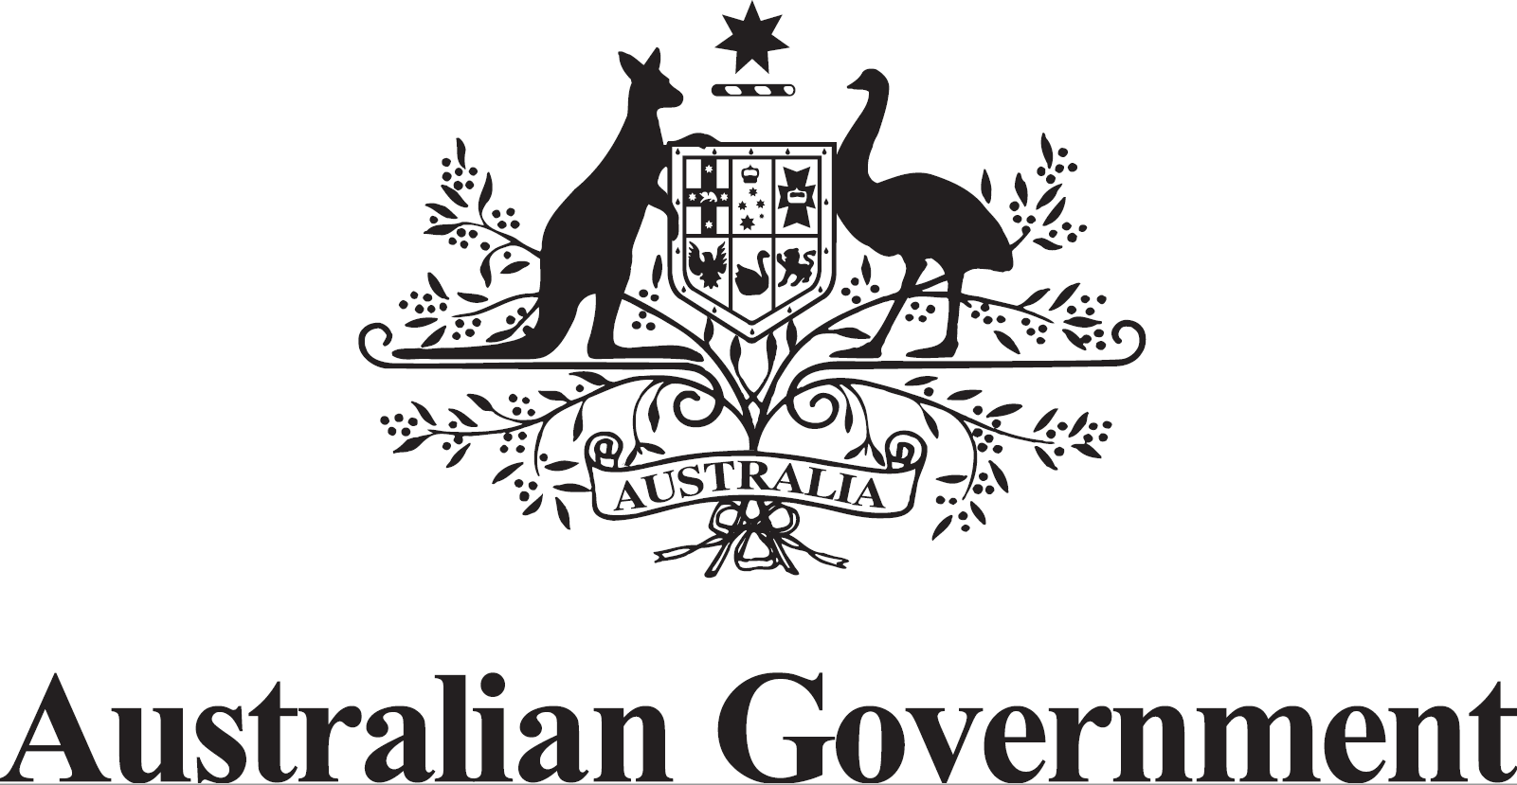

Australian Submission

UN Special Rapporteur Report of the Independent Expert on protection against violence and discrimination based on sexual orientation and gender identity on the realisation of the right of persons affected by violence and discrimination based on sexual orientation and gender identity to the enjoyment of the highest attainable standard of physical and mental health, in relation to SDG3
Contents
Section 1: Research: understanding the health care needs of LGTBI and GNC people 1
Section 2. Inclusion: LGTBI and GNC people in the decision-making process 2
Section 3: Access: ensuring that LGTBI and GNC people have access to health care 4
Section 4: Training and Education: health care professionals and educational institutions 5
Section 5 - Sustainable Development Goals 6

Section 1: Research: understanding the health care needs of LGTBI and GNC people
Does the State (or other stakeholders) gather data, including data disaggregated by sexual orientation and/or gender identity, on:

☐ access to and/or delivery of health services?

☐ the number of new HIV infections per 1000 uninfected population?

☒ The suicide mortality rate?

☒Coverage of treatment interventions for substance use disorders?

☒ Harmful use of alcohol?

☐ Access to sexual and reproductive health care?

☐Coverage of essential health services?

Guiding questions:
- What steps have been taken to research and understand the health care needs of LGTBI and GNC people of all ages at the national level?
- Is this data analysed through an intersectional lens, such as by disaggregating data by sexual orientation and/or gender identity, as well as intersecting identities including social or geographic origin, ethnicity, socio-economic status, nationality or migration status, minority, disability, and indigenous or other identity or status?

Response:

The National Drug Strategy Household Survey disaggregates data on the use of alcohol and other drugs by sexuality for people aged 14 and over. Data is present for people who identify as heterosexual, homosexual/bisexual, and not sure/other. This is a result of people identifying as LGBTQI being a priority population in the National Drug Strategy. This data is presented in an easily accessible form through the Australian Institute of Health and Welfare’s (AIHW) Alcohol, Tobacco and Other Drugs in Australia online compendium, which is funded by the Department of Health. Data are also collected for other priority populations including Aboriginal and Torres Strait Islander people, however an intersectional analysis of these populations are not reported on.

The Alcohol and other drug treatment services in Australia report disaggregates clients of attending services by male, female and other.

Family, domestic and sexual violence hospitalisations can be drawn from the AIHW National Hospital Morbidity Database (NHMD), with Family and domestic violence cases identified as those where a perpetrator is coded as ‘Spouse or domestic partner’, ‘Parent’, or ‘Other family member’.
The NHMD is based on hospital admissions records where patient sex is recorded as ‘male’, ‘female’, or ‘other’. Individual hospital practices differ as to whether demographic records are recorded by the patient, recorded by hospital staff, or are pre-filled based on an existing hospital record for the patient, which may include details that no longer apply or reflect how an individual identifies. Further, it is unknown whether people completing admission records interpreted ‘sex’ to mean sex at birth or gender identity. Gender is not recorded separately and GNC people are unable to be identified. Details relating to sexual identity are also not recorded.

Section 2. Inclusion: LGTBI and GNC people in the decision-making process
Guiding questions:
- What measures have been put in place to consult with and include persons affected by violence and discrimination based on sexual orientation and gender identity in law and policy making in relation to the right of everyone to the enjoyment of the highest attainable standard of physical and mental health, and in relation to realising the SDGs?
- To what extent are persons affected by violence and discrimination based on sexual orientation and gender identity included in policies and practice around sexual and reproductive health care?
- What support or technical assistance is needed to ensure that the health care needs of persons affected by violence and discrimination based on sexual orientation and gender identity people are comprehensively addressed and included in relevant laws, policies, and practices?
- What are the main barriers, in law or practice, for persons affected by violence and discrimination based on sexual orientation and gender identity to receive care that meets their physical and mental health needs and rights?

Response:
Australia's universal health programs such as the Medicare Benefits Schedule, the Pharmaceutical Benefits Scheme and free access to public hospitals facilitates equal access to health services for all Australians, regardless of their sexual orientation or gender identity. While Australia’s universal health system ensures there are no legal barriers to care, actual or anticipated negative experiences of health services can lead LGBTIQ+ people to delay or under-utilise services, as well as limit their disclosure of information relevant to their health needs. This may arise from a provider’s discomfort, lack of training or knowledge, incorrect assumptions about gender or sexuality, or lack of referral options. There may also be fewer LGBTIQ-aware services and support in certain locations, such as rural and remote regions. LGBTIQ+ people require trusted and culturally safe health services which understand their experiences. This is particularly important for potentially sensitive areas such as mental health, sexual health, drug and alcohol treatment, and responses to violence and discrimination.

The Australian Government is committed to working with a wide range of stakeholders, health professionals, and state and territory governments, to ensure better health and equitable access for the LGBTIQ+ community. To demonstrate this commitment the Government has included LGBTIQ+ people as a priority population across a number of national strategies, plans and frameworks.

The Australian Government is developing a Primary Health Care 10 Year Plan to drive reform of the primary health care system in Australia over the next decade. Over the life of the Plan, the ambition is for significant shifts in the way primary health care is delivered and how individuals and communities are engaged. A comprehensive consultation process was undertaken in developing the plan, with representation from general practice, nursing, allied health, mental health consumers, researchers and rural health organisations, to guide the development of the plan. The LGBTIQ+ community were consulted via roundtable supported by LGBTIQ+ Health Australia on the development of the Plan.

LGBTIQ+ Health Australia was involved in the consultation process to develop the National Preventive Health Strategy, which identifies the LGBTIQ+ community as a priority population that requires tailored approaches to preventive health in order to improve health equity in Australia. The National Preventive Health Strategy aims to provide more balance to the health system by enhancing the focus on prevention and by building systems-based change over a 10-year period.

The Australian Government is developing the National Plan to End Violence against Women and Children 2022-2032 to replace the existing National Plan to Reduce Violence against Women and their Children 2010–2022 when it ends in mid-2022. The draft National Plan has been developed through consultation with victim-survivors, specialist services, representatives from the health, law and justice sectors, business, and community groups, all levels of government and other experts. Targeted consultation with the LGBTIQ+ community supported LGBTIQ+ input in the development of the next Plan.

Section 3: Access: ensuring that LGTBI and GNC people have access to health care
Guiding questions:
- What measures have been taken to ensure access to affordable non-discriminatory health care services for persons affected by violence and discrimination based on sexual orientation and gender identity?
- What policies or programmes exist to address the mental health care needs of persons affected by violence and discrimination based on sexual orientation and gender identity, specifically around depression and anxiety, suicidal ideation, and substance abuse?
- What policies or programmes exist to assist the health care needs of persons affected by violence and discrimination based on sexual orientation and gender identity following the experience of assault or gender-based violence?
- Have adequate human and financial resources been allocated to implement those policies and/or programmes?

Response:

Australia's universal health coverage programs such as the Medicare Benefits Schedule, the Pharmaceutical Benefits Scheme and free access to public hospitals facilitates provide access to health services for all Australians, regardless of their sexual orientation or gender identity.

LGBTIQ+ Australians are identified as a priority population in key Australian Government health strategies, in recognition of the health disparities experienced by the community and that tailored approaches are required to improve health equity. These plans include the National Preventative Health Strategy 2021-2030, National Women’s Health Strategy 2020-2030, National Men’s Health Strategy 2020-2030 and the National Action Plan for the Health of Children and Young People 2020-2030.

The draft National Plan to End Violence Against Women and Children 2022-2032 recognises violence experienced by LGBTIQ+ people of all genders and includes a focus on cultural safeguards for LGBTIQ+ people and targeted activities to support specific communities including LGBTIQ+.

The Australian Government recognises the impact of mental health issues in the LGBTIQ+ community. In 2021-22, headspace National Youth Mental Health Foundation received $7.0 million to support eheadspace, which includes qheadspace – a digital platform where gender and sexually diverse young people can connect with others and seek support within a peer moderated online community.

The Australian Government also provides funding to LGBTIQ+ Health Australia:
- $1.2 million to improve quality, access to and knowledge of palliative care for LGBTIQ+ communities across Australia;
- $2.6 million in 2021-22 for QLife - an anonymous and free LGBTI peer support and referral service for people in Australia wanting to talk about sexuality, identity, gender, bodies, feelings or relationships. QLife will also receive additional funding support to increase QLife telephone and online service capacity to meet COVID demand;
- $1.5 million for the National Suicide Prevention Leadership and Support Program initiatives, and
- $2.9 million as an Aged Care Consumer Peak Body.

The Sex Discrimination Act 1984 (Cth) as part of Australia’s federal anti-discrimination framework makes it unlawful to discriminate on the basis of sex, gender identity, intersex status, sexual orientation, marital or relationship status, family responsibilities, pregnancy/potential pregnancy or breastfeeding. The Act also prohibits sexual harassment and sex-based harassment. These forms of discrimination and harassment are prohibited in specified areas of public life including employment, accommodation, education, the provision of goods, facilities and services, the disposal of land, the activities of clubs and the administration of Commonwealth laws and programs.
The Australian Human Rights Commission Act 1986 allows individuals to lodge complaints under the Sex Discrimination Act with the Australian Human Rights Commission who will investigate and attempt to conciliate such complaints. If the conciliation is unsuccessful or the complaint is terminated, in certain circumstances the individual may commence legal proceedings regarding the complaint in the Federal Court of Australia or the Federal Circuit and Family Court of Australia.

Section 4: Training and Education: health care professionals and educational institutions
Guiding Questions:

- Are sexual orientation and gender identity, and the specific health needs of persons affected by violence and discrimination based on sexual orientation and gender identity, included in training and education of health care professionals?
- What measures are being taken to provide age-appropriate comprehensive sexuality education inclusive of sexual and gender diversity in educational institutions?
- Are evidence-based and up-to-date guidelines that include SOGI issues available? How are they used to influence health related decisions on policy, programming, services including diagnostic manuals, and practices within the health care institutions?

Response:

Australian States and Territories offer multidisciplinary healthcare services for gender diverse people and fund community-based organisations to deliver education and training to mainstream services.
For example, in 2018, Victoria invested $3.4 million to the Trans and Gender Diverse Health Initiative to expand the health system's capacity to support and better meet the needs of trans and gender diverse people, including young people. This included:
- The establishment of two new multidisciplinary gender clinics;
- Training and skills development for health professionals to assist clinicians across Victoria to better service the needs of trans and gender diverse Victorians; and
- Peer support for trans and gender diverse Victorians.
The Victorian Government developed an online resource - the Rainbow eQuality Guide - to assist mainstream health and community services agencies identify and adopt inclusive practices and become more responsive to the health needs of LGBTIQ individuals and communities.
In 2020, the Western Australian Government launched the Western Australian Lesbian, Gay, Bisexual, Transgender, Intersex Health Strategy 2019–2024. The strategy is the first of its kind in the state, setting out clear priorities and outcomes for the health system over the next five years and will support existing LGBTI health services and initiatives including a gender diversity service for young people up to 18 years’ old which provides assessment care and treatment (where appropriate) for issues relating to gender dysphoria and gender identity.
In Western Australia, the Perth Children’s Hospital Gender Diversity Service is a multidisciplinary group of professionals including a clinical nurse specialist, consultant psychiatrist, clinical psychologist, consultant endocrinologist, consultant gynaecologist, research assistant and speech therapist. The Service provides specialist outpatient assessment and care of children and adolescents experiencing gender diversity issues.
The Western Australian Gender Pathways Service also provides education and training in the youth sector to increase inclusive and gender affirming practices.
In the Australian Capital Territory, the Canberra Inclusive Partnership (made up of local LGBTIQ community controlled organisations) provides peer-led psychosocial support services for LGBTIQ+ people and their families and training to build the capacity of mainstream service providers to deliver inclusive and appropriate services.
In the Northern Territory, the ‘Northern Territory Health Inclusion Strategy: respecting people with diverse sexualities and gender identities’ was launched in 2019.

Section 5 - Sustainable Development Goals
Guiding questions:
- Where the State measures its progress against SDG3, does it make reference to the health outcomes and needs of persons affected by violence and discrimination based on sexual orientation and gender identity?
- Does the State measure progress against any of the following SDG3 indicators for persons affected by violence and discrimination based on sexual orientation and gender identity? If so, please comment on whether health outcomes are improving or declining:

- Indicator 3.3.1: Number of new HIV infections per 1,000 uninfected population, by sex, age and key populations;

- Indicator 3.4.2: Suicide mortality rate;

- Indicator 3.5.1: Coverage of treatment interventions (pharmacological, psychosocial and rehabilitation and aftercare services) for substance use disorders;

- Indicator 3.5.2: Harmful use of alcohol, defined according to the national context as alcohol per capita consumption (aged 15 years and older) within a calendar year in litres of pure alcohol;

- Indicator 3.7.1: Proportion of women of reproductive age (aged 15-49 years) who have their need for family planning satisfied with modern methods, including lesbian and bisexual women, and trans persons;

- Indicator 3.7.2: Adolescent birth rate (aged 10-14 years; aged 15-19 years) per 1,000 women and trans men in that age group, particularly among LBT and GNC young individuals;

- Indicator 3.8.1: Coverage of essential health services (defined as the average coverage of essential services based on tracer interventions that include reproductive, maternal, newborn and child health, infectious diseases, non-communicable diseases and service capacity and access, among the general and the most disadvantaged population); and

- Indicator 3.8.2: Proportion of population with large household expenditures on health as a share of total household expenditure or income.

Response:

Australia is actively implementing the 2030 Agenda for Sustainable Development nationally, regionally and globally. Australia’s approach to the 2030 Agenda is to integrate the Agenda into our policies, strategies and programs, ensuring a coordinated whole-of-government approach to give effect to the agenda. Achieving the SDGs is not just about government initiatives and activity: it is about the efforts of the business sector, civil society, academia, communities and individuals.
Australia reports on our progress against the SDG’s online through: Good health and well-being (SDG 3) | Sustainable Development Goals (sdgdata.gov.au). An Australian Government dataset is included on the Platform as it:
- follows the globally agreed methodology;
- is drawn from an Australian national indicator or dataset and is being used as an approximation of the SDG Indicator;
- has been sourced from the UN SDG database;
Where it is not a quantitative data set, the responsible agency has identified the relevant policy/legislation appropriate for the Australian context.
However, the reporting does not make reference to the health outcomes and needs of persons affected by violence and discrimination based on sexual orientation and gender identity.

