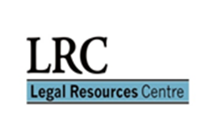
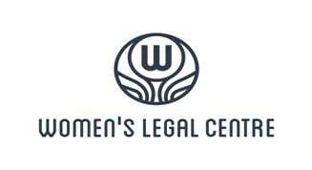
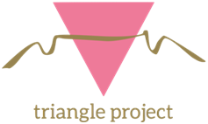
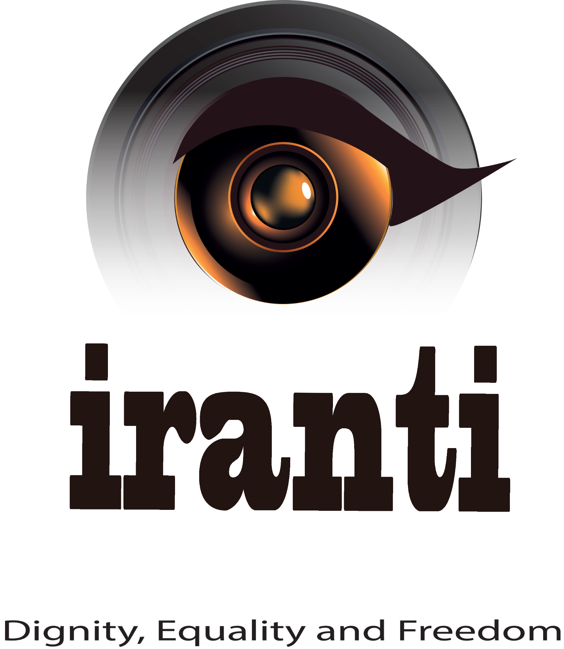

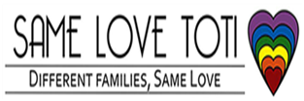
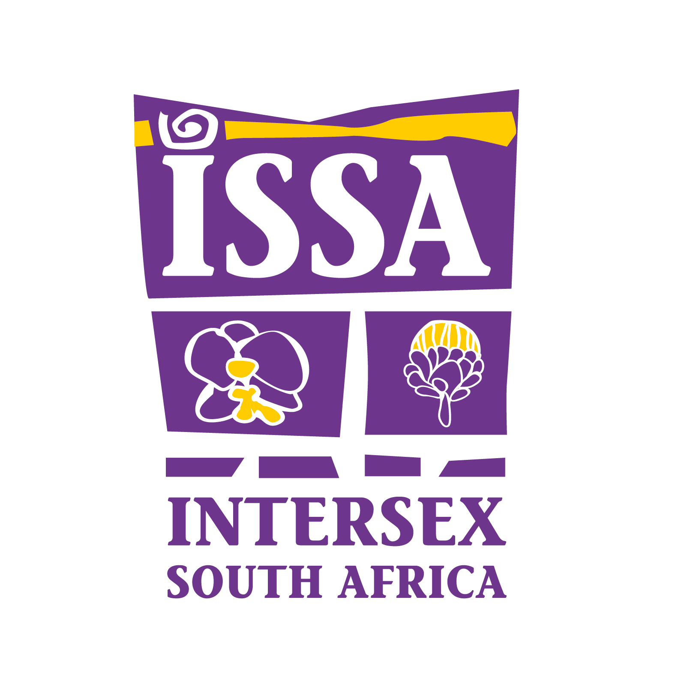

SUBMISSIONS TO THE UNITED NATIONS INDEPENDENT EXPERT ON PROTECTION AGAINST VIOLENCE AND DISCRIMINATION BASED ON
SEXUAL ORIENTATION AND GENDER IDENTITY
ON
SOUTH AFRICA’S REALISATION OF THE RIGHT OF PERSONS AFFECTED BY VIOLENCE AND DISCRIMINATION BASED ON SEXUAL ORIENTATION
AND GENDER IDENTITY TO THE ENJOYMENT OF THE HIGHEST ATTAINABLE STANDARD OF PHYSICAL AND MENTAL HEALTH, IN RELATION TO SDG3

By Gender Dynamix, Iranti, Triangle Project, Intersex South Africa, Same Love Toti,
Women’s Legal Centre and Legal Resources Centre

7 February 2022

SUBMITTED WITH INPUT AND CONTRIBUTIONS FROM THE FOLLOWING ORGANISATIONS:
Gender Dynamix
- Hape Peshoane, Regional Advocacy Coordinator, regional@genderdynamix.org.za
- Savuka Matyila, Health Advocacy Officer, advocacy1@genderdynamix.org.za
- Anil Padavatan, Health and Legal Programmes Manager, programmes@genderdynamix.org.za

Iranti
- Sylvester Kazibwe, Trans Rights Programme Officer sylvester@iranti.org
- Nthuthuzo Ndzomo, Programmes manager ntuthuzo@iranti.org
Triangle Project
- Thozama Njobe, Research Coordinator, thozama@triangle.org.za
- Sharon Cox, Health and Support Services Manager, health@triangle.org.za
- Estian Smit, Research, Advocacy and Policy Manager, estian@triangle.org.za
Intersex SA
- Crystal Hendricks, Intersex Rights Programme Officer crystal@iranti.org.za
Same Love Toti
- Kim Lithgow, Founder, samelovetoti@gmail.com
Women’s Legal Centre
- Mandi Mudarikwa, Attorney, mandi@wlce.co.za
Legal Resources Centre
- Amy-Leigh Payne, Attorney, amyleigh@lrc.co.za
- Charlene Kreuser, Candidate Attorney, charlene@lrc.org.za

I. INTRODUCTION
1. We refer to the call for written submissions by the United Nations Independent Expert on Protection against Violence and Discrimination Based on Sexual Orientation and Gender Identity, on the Call for input to Report to the Human Rights Council on the realisation of the right of persons affected by violence and discrimination based on sexual orientation and gender identity to the enjoyment of the highest attainable standard of physical and mental health, in relation to SDG3.
2. We hereby respond to this call and accordingly provide this submission for consideration in the development of this report.
3. We welcome and appreciate this opportunity to make written submissions and to engage with issues related to gender, sexual orientation and gender identity, and diverse sex characteristics.

II. INTRODUCTION TO THE AUTHORS OF THE SUBMISSION
4. The Women’s Legal Centre (“The WLC”) is an African feminist legal centre that advances women’s rights and equality through strategic litigation, advocacy, education, and training. We aim to develop feminist jurisprudence that recognises and advances women’s rights. The Centre drives a feminist agenda that appreciates the impact that discrimination has on women within their different classes, race, ethnicity, sexual orientation, gender identity and disability. The Centre does its work across five programmatic areas including the right to be free from violence, women’s rights in relationships, and women’s rights to land, housing property and tenure security, women’s sexual and reproductive health rights and women’s rights to work and at conditions of work.
Website: www.wlce.co.za
5. The Legal Resources Centre (“The LRC”) is a public interest, non-profit law clinic in South Africa that was founded in 1979. The LRC has since its inception shown a commitment to work towards a fully democratic society underpinned by respect for the rule of law and constitutional democracy. The LRC uses the law as an instrument for justice to facilitate the vulnerable and marginalised to assert and develop their rights; promote gender and racial equality and oppose all forms of unfair discrimination; as well as to contribute to the development of human rights jurisprudence and to the social and economic transformation of society.
Website: www.lrc.org.za
6. Same Love Toti (SLT) is a registered non-profit organisation that provides support to LGBTI and advocates for the human rights of sexual and gender minorities in South Africa by providing psychosocial support & safe spaces for LGBTI and their families, and empowering lesbians, gays, transgender, intersex, and gender non-conforming individuals to live authentic lives. Same Love Toti also works alongside other organisations to challenge bullying in schools, discrimination in communities and hate crimes in society. Their work includes advocacy projects to change or amend policies that need to be inclusive and affirming of sexual and gender minorities. They continue to work for an inclusive and more equitable society.
Website: https://www.pflagsouthafrica.org/
7. Triangle Project is a non-profit human rights organisation offering professional services to ensure the full realisation of constitutional and human rights for lesbian, gay, bisexual, transgender, queer, intersex, plus (LGBTQI+) persons, their partners, and families. Our three-core services centre around Health and Support, Community Engagement and Empowerment, and Research and Advocacy. We offer a wide range of services to LGBTQI+ communities. These include sexual health clinical care, a needle and syringe programme, nutrition support, counselling, support groups, a helpline, public education and training services, solidarity spaces, community outreach, and court support to survivors of hate crimes. This submission falls within our Research, Advocacy and Policy Programme that works to advance the inclusion and protection of the human rights to sexual orientation, gender identity, gender expression and sex characteristics (SOGIESC) within South African legislation, policy, and practices.
Website: http://triangle.org.za/
8. Gender Dynamix (GDX) is the first registered trans and gender diverse-led organisation in Africa that specifically focuses on advancing, promoting, and securing the human rights of trans and gender diverse persons in Southern Africa. The organisation’s four strategic priority areas include: legal gender recognition based on self-determination; accessible gender affirming healthcare; inclusive quality education; and regional movement strengthening. GDX’s strategic drivers include advocacy and research, capacity enhancement, facilitating community access to direct services and organisational development. The organisation has a track record spanning 15 years. We firmly believe that positive change for trans and gender diverse persons is only possible through the development and maintenance of multidisciplinary and intersectoral partnerships. The organisation, therefore, partners with diverse stakeholders to bring about positive change.
Website: https://www.genderdynamix.org.za
9. Iranti is a Johannesburg-based media-advocacy organisation which advocates for the rights of LGBTI+ persons, with specific focus on lesbian, transgender (including gender non-conforming) and intersex persons in Africa. Iranti works within a human rights framework raising issues on gender identities, and sexuality, through the strategic use of multimedia storytelling, research, and activism. Iranti is an organisation by and for trans, lesbian and intersex persons and was formed with the clear intention of building strategic partnerships and movements that use media as a key platform for critical engagement, mobilisation, capacity development, reframing of perceptions, and advocacy interventions across Africa. Iranti works at country, regional (Africa) and international levels.
Website: https://www.iranti.org.za
10. Intersex South Africa (ISSA) seeks to contribute towards the creation of a world where being intersex is not seen as a condition, disorder or abnormality but rather naturally occurring variations that are part of human diversity. We envision an inclusive and diverse South Africa where the human rights, bodily autonomy and integrity of intersex people are respected, protected, and affirmed. A world where the birth of an intersex child is celebrated like any other birth, where intersex people have the power and control over the decisions that affect their lives. ISSA works to transform our communities into places where intersex people can freely decide, without force or coercion, whether they want to undergo any medical procedure. A society where all intersex persons are recognized as full citizens, enjoy their human rights, and have access to quality and affirming health, education, counselling, employment, legal and social services, and opportunities.

III. SUBMISSIONS
11. The legal protection and recognition of every person’s sexual orientation, gender identity, gender expression and sex characteristics (SOGIESC) by the State is vital for equality and improves their psychological, physical, and social well-being. This submission addresses access to health in the context of South Africa.
12. In our view, it is important to consider South Africa within its regional context. In the Southern African region, the absence of legal protection for LGBTIQ+ persons remain a huge obstacle towards the enjoyment of human rights, with the notable exception of South Africa, which has taken legal steps to decriminalise same sex relations, legalised same-sex marriage and has a Constitution that protects against discrimination based on sexual orientation, sex, and gender. While the certain offenses and identities have been decriminalised in Botswana, Mozambique, and Angola, this alone has not necessarily granted legal protection. A number of states have failed to uphold their obligation to protect LGBTQI+ persons against violation of their human rights, including the right to health. It is impossible to speak to accessibility and enjoyment of the right to health in the region without speaking to legal recognition. It is therefore important to consider that LGBTIQ+ persons in neighbouring countries also often depend on South Africa for access to inclusive and affirming healthcare.

1. Research: understanding the health care needs of LGTBI and GNC people

i. Does the State (or other stakeholders) gather data, including data disaggregated by sexual orientation and/or gender identity, on:
    - access to and/or delivery of health services
    - the number of new HIV infections per 1000 uninfected population?
    - The suicide mortality rate?
    - Coverage of treatment interventions for substance use disorders?
    - Harmful use of alcohol?
    - Access to sexual and reproductive health care?
    - Coverage of essential health services
The South African government generally does not gather national health data disaggregated by sexual orientation and/or gender identity (SOGI), or diverse sex characteristics (SC).
The State gathers data on new HIV infections per 1000 uninfected population, but not on LGBTQI+ people, trans people and men who have sex with men (MSM). Data is disaggregated by binary sex (female/male), but not disaggregated by SOGI or diverse SC, even though the South African National Strategic Plan (NSP) for HIV, TB and STIs 2017-2022 includes transgender people and MSM as key populations for HIV and STIs, and ‘other LGBTI populations’ as vulnerable populations for HIV and STIs. South Africa has a national LGBTI HIV Plan and trans people are included in the National Sex Worker HIV, TB and STI Plan.
The State gathers data on the suicide mortality rate disaggregated by binary sex (female/male), but not disaggregated by SOGI or diverse SC.
The State gathers data on harmful use of alcohol disaggregated by binary gender (women/men), but not disaggregated by SOGI or diverse SC.
The State gathers some data on access to and/or delivery of health services, access to sexual and reproductive healthcare and coverage of essential health services disaggregated by binary gender (women/men), but not disaggregated by SOGI or diverse SC, and not specific to the healthcare needs of LGBTI and gender diverse people. Where health programming data is collected for LGBTQI+ people, it is usually focused on “key populations'' as vectors of disease, rather than on providing comprehensive care for LGBTQI+ health needs. CSOs that receive funding from government departments to provide health services to LGBTQI+ people, report their statistics to these departments, but to our knowledge these have not been made publicly available by the government.

ii. What steps have been taken to research and understand the health care needs of LGTBI and GNC people of all ages at the national level?
Although some LGBTI research or data collection is done by various statutory and multi-sectoral bodies, and government departments, this data is not integrated into official national health statistics. Research on LGBTQI+ and gender diverse people is also often undertaken by others, including civil society organisations (CSOs) and academic institutions. What is known about LGBTQI+ persons is also often based on research conducted by the global north, although this research does not address the nuances of LGBTQI+ health in under-resourced contexts, with varied socio-cultural factors.

iii. Is this data analyzed through an intersectional lens, such as by disaggregating data by sexual orientation and/or gender identity, as well as intersecting identities including social or geographic origin, ethnicity, socio-economic status, nationality or migration status, minority, disability, and indigenous or other identity or status?
Some data is analysed through an intersectional lens, including disaggregation by SOGIESC, race, socio-economic status, religion, geographic area and/or nationality, etc., particularly in research conducted by CSOs and research institutions.

2. Inclusion: LGTBI and GNC people in the decision-making process

i. What measures have been put in place to consult with and include persons affected by violence and discrimination based on sexual orientation and gender identity in law and policy making in relation to the right of everyone to the enjoyment of the highest attainable standard of physical and mental health, and in relation to realising the SDGs?
Occasional multi-sectoral consultations take place, especially in relation to HIV and hate crimes, but no measures are in place to systematically involve SOGIESC minorities in broader health-related law and policy making (including the National Health Insurance) and realising the SDGs.

ii. To what extent are persons affected by violence and discrimination based on sexual orientation and gender identity included in policies and practice around sexual and reproductive health care?
There has been some consultation of LGBTIQ+ persons in national HIV/AIDS and STI planning, but there are no programmes that comprehensively cover SRH needs of LBTIQ+ persons. Yet LGBTIQ+ persons still face pervasive discrimination in public health facilities and challenges to access SRH.

iii. What support or technical assistance is needed to ensure that the health care needs of persons affected by violence and discrimination based on sexual orientation and gender identity people are comprehensively addressed and included in relevant laws, policies, and practices?
There is a need to eliminate a long history of institutional healthcare discrimination, raise awareness on the needs of SOGIESC minorities among health care professionals, lobby for the inclusion of LGBTIQ+ topics in all health sciences curricula to equip healthcare providers with knowledge on competent healthcare provision for LGBTIQ+ people, fund CSOs to conduct behavioural change health seeking practices and equip LGBTIQ persons to use accountability mechanisms within the health system when their right to access healthcare is violated.

iv. What are the main barriers, in law or practice, for persons affected by violence and discrimination based on sexual orientation and gender identity to receive care that meets their physical and mental health needs and rights?

Barriers include a lack of laws, policies and/or practices that ensures data collection on LGBTQI+ healthcare needs, prevent discrimination against SOGIESC minorities in healthcare, ensure legal gender recognition based on gender self-determination, make provision for gender affirming healthcare from primary healthcare level, prohibit intersex genital mutilation (IGM) and protect intersex rights in medical settings.
The National Health Act 61 of 2003 and National Health Insurance Policy do not include LGBTIQ+ persons as vulnerable groups, making it difficult to attain universal health coverage for LGBTIQ+ persons. Healthcare professionals frequently misgender trans or GNC/gender diverse persons, refuse treatment or make derogatory comments on the SOGIESC of LGBTQI+ persons, and/or create an unwelcoming environment.

Legal gender recognition in South Africa remains exclusionary, medicalised and binary (only female/male gender markers). Altering your gender marker or forenames can take years. Lack of identity documents that reflect one’s gender identity presents a major barrier for transgender, nonbinary and intersex persons who wish to access services, including healthcare.

3. Access: ensuring that LGTBI and GNC people have access to health care

i. What measures have been taken to ensure access to affordable non-discriminatory health care services for persons affected by violence and discrimination based on sexual orientation and gender identity?
The South African Constitution prohibits discrimination based on sex, gender or sexual orientation, and Section 27 states that every person “has the right to access health care services” and “no person may be refused emergency treatment”. The Promotion of Equality and Prevention of Unfair Discrimination Act (2000) also protects from unfair discrimination by the state or an individual on the abovementioned prohibited grounds. The National Government has adopted a service delivery policy, the Batho Pele principles, which guide public servants to put people first, but these have generally not translated into action in the public health system. There are no specific Department of Health SOGIESC policies that ensure LGBTQI+ persons receive competent, appropriate healthcare, or to address stigma and prejudice against LGTBI and GNC community members within the healthcare system.

ii. What policies or programmes exist to address the mental health care needs of persons affected by violence and discrimination based on sexual orientation and gender identity, specifically around depression and anxiety, suicidal ideation, and substance abuse?
The Department of Health’s Norms and Standards for the Provision of Primary Health Care guide healthcare professionals to identify and provide appropriate interventions in cases of depression, anxiety, stress-related problems, domestic violence, and substance abuse. The state-initiated victim support Thuthuzela Centres assists victims of sexual violence with medical support, evidence collection, opening a case and ongoing counselling support. However, due to 84 percent of the population utilizing the public sector, emigration of skilled professionals and limited services that are inclusive of SOGIESC diversity, many individuals have limited information or are unable to receive adequate psychosocial support from the state.
At present, the Department of Health does not provide specific services for people who have experienced violence or discrimination based on their gender identity or sexual orientation. LGBTIQ+ persons often opt for assistance from CSOs, through Lifeline, Masithethe or via private facilities if they can afford.

iii. What policies or programmes exist to assist the health care needs of persons affected by violence and discrimination based on sexual orientation and gender identity following the experience of assault or gender-based violence?
In relation to GBV, the Department of Social Development initiated a Victim Empowerment Programme towards developing knowledge of victim issues, strengthening resources, addressing victim needs, and stimulating volunteer participation and prevention of secondary victimization. Monitoring of human rights violations is documented through ReACt, a programme headed by SANAC and AfSA, facilitated by CSOs that link persons to necessary healthcare services. The Department of Justice coordinates a national multisectoral LGBTI task team, National Intervention Strategy and Communication Strategy in response to the violence plaguing LGBTI communities. CSOs across the country are engaged in sensitization trainings targeting public servants, including police officers and healthcare workers, to better cater for the needs of SOGIESC minorities as victims of violence.

iv. Have adequate human and financial resources been allocated to implement those policies and/or programmes?
Although South Africa has made tremendous promises in the National Strategic Plan on Gender-Based Violence and Femicide, government has not provided adequate human capital and financial support for the implementation of programmes under Response, Care, Support and Healing for LGBTIQ+ GBV survivors.

4. Training and Education: health care professionals and educational institutions

i. Are sexual orientation and gender identity, and the specific health needs of persons affected by violence and discrimination based on sexual orientation and gender identity, included in training and education of health care professionals?
The Allied Health Science Curricula of South Africa does not cover any LGBTIQ related content and although the MBChB curriculum has some topics that speak to LGBTIQ issues, these are not comprehensive and structured. Most of the effort to create LGBTIQ comprehensive content for professionals has been from CSOs that may not have the required resources to disseminate such content nationally. There is an urgent need to educate and sensitize health care professionals, as hostile, abusive and pathologising attitudes of healthcare professionals frequently prevent LGBTQI+, intersex, trans and gender diverse individuals from receiving adequate healthcare.

ii. What measures are being taken to provide age-appropriate comprehensive sexuality education inclusive of sexual and gender diversity in educational institutions?
The Department of Basic Education (DBE) introduced comprehensive sexuality education in 2000 which deals with sex, sexuality, gender, and relationships. In 2015, the DBE developed scripted lesson plans to strengthen the teaching of CSE in schools. CSOs in consultation with DBE have developed SOGIESC Guidelines for schools, which seeks to strengthen some of the inclusive trainings already in progress. There have been efforts to involve higher education institutions in health science curriculum development to ensure non-discriminatory access for LGBTQI+ individuals to institutions of higher learning, and to assist to produce more informed and capacitated health care professionals delivering gender affirming healthcare services.

iii. Are evidence-based and up-to-date guidelines that include SOGI issues available? How are they used to influence health related decisions on policy, programming, services including diagnostic manuals, and practices within the health care institutions?
Professional healthcare associations and CSOs have developed national Gender-Affirming Healthcare Guidelines to address the need for access to competent gender affirming healthcare, as well as psychology practice guidelines for sexually and gender diverse people. However, adoption and implementation of these guidelines by the Department of Health have yet to take place.

5. Sustainable Development Goals

i. Where the State measures its progress against SDG3, does it make reference to the health outcomes and needs of persons affected by violence and discrimination based on sexual orientation and gender identity?
No, when measuring SDG3 progress, the State only mentions binary sex (female/male), not SOGI or diverse SC. The NDP 2030 and its operational document, the MTSF 2019-2024, does not include a clear, comprehensive articulation of SOGIESC healthcare issues in relation to LGBTQI+ and gender diverse people. South Africa’s Census 2022, currently in progress, also does not make provision for diverse SOGIESC, but Stats SA has now committed to ensure LGBTQI inclusion in the next census.

ii. Does the State measure progress against any of the following SDG3 indicators for persons affected by violence and discrimination based on sexual orientation and gender identity? If so, please comment on whether health outcomes are improving or declining:
    - Indicator 3.3.1: Number of new HIV infections per 1,000 uninfected population, by sex, age and key populations;
    - Indicator 3.4.2: Suicide mortality rate;
    - Indicator 3.5.1: Coverage of treatment interventions (pharmacological, psychosocial and rehabilitation and aftercare services) for substance use disorders;
    - Indicator 3.5.2: Harmful use of alcohol, defined according to the national context as alcohol per capita consumption (aged 15 years and older) within a calendar year in litres of pure alcohol
    - Indicator 3.7.1: Proportion of women of reproductive age (aged 15-49 years) who have their need for family planning satisfied with modern methods, including lesbian and bisexual women, and trans persons;
    - Indicator 3.7.2: Adolescent birth rate (aged 10-14 years; aged 15-19 years) per 1,000 women and trans men in that age group, particularly among LBT and GNC young individuals;
    - Indicator 3.8.1: Coverage of essential health services (defined as the average coverage of essential services based on tracer interventions that include reproductive, maternal, new-born and child health, infectious diseases, non-communicable diseases and service capacity and access, among the general and the most disadvantaged population); and
    - Indicator 3.8.2: Proportion of population with large household expenditures on health as a share of total household expenditure or income.
Although South Africa measures progress against most of the above SDG3 indicators, it does not currently do so for persons affected by violence and discrimination based on SOGI or diverse sex characteristics. Some government departments seem to be collecting some LGBTI statistics, but it is not explicitly reported on in SDG monitoring, nor publicly available.

****ENDS****

Call for inputs: Report to the Human Rights Council on the realisation of the right of persons affected by violence and discrimination based on sexual orientation and gender identity to the enjoyment of the highest attainable standard of physical and mental health, in relation to SDG3. https://www.ohchr.org/EN/Issues/SexualOrientationGender/Pages/CFI-IE-SOGI-report-50thsession-HRC.aspx
Stats SA. Sustainable Development Goals: Country report 2019 - South Africa, pp.65, 74-75. Pretoria: Statistics South Africa. http://www.statssa.gov.za/MDG/SDGs_Country_Report_2019_South_Africa.pdf
Research suggests HIV prevalence of 25% among trans women in sub-Saharan Africa (Poteat et al, 2020), and between 45.5%-63.4% in three South African metros (Cloete et al, 2019). Poteat, T., Malik, M., van der Merwe, L.L.A., Cloete, A., Adams, D., Bareng, A., Nonyane, S. & Wirtz, A.L., 2020. PrEP awareness and engagement among transgender women in South Africa: a cross-sectional, mixed methods study. The Lancet HIV, 7(12), pp.e825-e834. https://www.thelancet.com/journals/lanhiv/article/PIIS2352-3018(20)30119-3/fulltext Cloete, A., Wabiri, N., Savva, H., Van der Merwe, L., Simbayi, L. 2019. The Botshelo Ba Trans study: Results of the first HIV prevalence survey conducted amongst transgender women (TGW) in South Africa. Paper presented at 9th South Africa AIDS Conference, Durban ICC, Kwazulu-Natal (11–14 June 2019). https://repository.hsrc.ac.za/bitstream/handle/20.500.11910/14780/10995.pdf
SANAC. (2017). South Africa's National Strategic Plan for HIV, TB and STIs 2017-2022. https://sanac.org.za//wp-content/uploads/2017/06/NSP_FullDocument_FINAL.pdf
SANAC. (2017). South African National LGBTI HIV Plan 2017-2022. https://sanac.org.za/wp-content/uploads/2017/06/LGBTI-HIV-Plan-Final.pdf
SANAC. 2019. South Africa’s National Sex Worker HIV, TB and STI Plan, 2019-2022. Pretoria: South African National AIDS Council Trust. https://sanac.org.za/wp-content/uploads/2021/11/NATIONAL-SEX-WORKER-PLAN-WEB-FINAL.pdf
Stats SA. Sustainable Development Goals: Country report 2019 - South Africa, pp.69, 75. Pretoria: Statistics South Africa. http://www.statssa.gov.za/MDG/SDGs_Country_Report_2019_South_Africa.pdf
WHO. 2021. Suicide Worldwide in 2019: Global Health Estimates. Geneva: World Health Organisation. https://www.who.int/publications/i/item/9789240026643
Stats SA. 2021. Mortality and causes of death in South Africa: Findings from death notification 2018. Statistical Release P0309.3, pp.54-55. (See information on intentional self-harm under non-natural causes of death by age and sex). https://www.statssa.gov.za/publications/P03093/P030932018.pdf
Research suggests HIV prevalence of 25% among trans women in sub-Saharan Africa (Poteat et al, 2020), and between 45.5%-63.4% in three South African metros (Cloete et al, 2019). Poteat, T., Malik, M., van der Merwe, L.L.A., Cloete, A., Adams, D., Bareng, A., Nonyane, S. & Wirtz, A.L., 2020. PrEP awareness and engagement among transgender women in South Africa: a cross-sectional, mixed methods study. The Lancet HIV, 7(12), pp.e825-e834. https://www.thelancet.com/journals/lanhiv/article/PIIS2352-3018(20)30119-3/fulltext Cloete, A., Wabiri, N., Savva, H., Van der Merwe, L., Simbayi, L. 2019. The Botshelo Ba Trans study: Results of the first HIV prevalence survey conducted amongst transgender women (TGW) in South Africa. Paper presented at 9th South Africa AIDS Conference, Durban ICC, Kwazulu-Natal (11–14 June 2019). https://repository.hsrc.ac.za/bitstream/handle/20.500.11910/14780/10995.pdf
Stats SA. Sustainable Development Goals: Country report 2019 - South Africa, pp.69, 75. Pretoria: Statistics South Africa. http://www.statssa.gov.za/MDG/SDGs_Country_Report_2019_South_Africa.pdf
National Department of Health (NDoH), Statistics South Africa (Stats SA), South African Medical Research Council (SAMRC), and ICF. 2019. South Africa Demographic and Health Survey 2016. Pretoria, South Africa, and Rockville, Maryland, USA: NDoH, Stats SA, SAMRC, and ICF, pp.315-316. https://dhsprogram.com/pubs/pdf/FR337/FR337.pdf
Research suggests much higher alcohol use among South African LGBTI people than the general population (Muller et al, 2019: 64-67). Müller, A., Daskilewicz, K. & the Southern and East African Research Collective on Health (2019). Are we doing alright? Realities of violence, mental health, and access to healthcare related to sexual orientation and gender identity and expression in South Africa. Research report based on a community-led study in nine countries. Amsterdam: COC Netherlands, pp.64-67. http://www.ghjru.uct.ac.za/sites/default/files/image_tool/images/242/PDFs/Dynamic_feature/SOGIE%20and%20wellbeing_07_South%20Africa.pdf
National Department of Health (NDoH), Statistics South Africa (Stats SA), South African Medical Research Council (SAMRC), and ICF. 2019. South Africa Demographic and Health Survey 2016. Pretoria, South Africa, and Rockville, Maryland, USA: NDoH, Stats SA, SAMRC, and ICF. https://dhsprogram.com/pubs/pdf/FR337/FR337.pdf
For instance, the Human Sciences Research Council (HSRC, http://www.hsrc.ac.za/) and South African Medical Research Council (SAMRC, https://www.samrc.ac.za/).
For example, the South African National Aids Council (SANAC, https://sanac.org.za/) and the Department of Justice and Constitutional Development (DOJCD) LGBTI Rapid Response Team (RRT, https://www.justice.gov.za/vg/lgbti/TOR-RRT.pdf).
For example, the Department of Health (DOH), Department of Social Development (DSD,) and Department of Justice and Constitutional Development (DOJCD).
Müller, A., Daskilewicz, K. & the Southern and East African Research Collective on Health (2019). Are we doing alright? Realities of violence, mental health, and access to healthcare related to sexual orientation and gender identity and expression in South Africa. Research report based on a community-led study in nine countries. Amsterdam: COC Netherlands. http://www.ghjru.uct.ac.za/sites/default/files/image_tool/images/242/PDFs/Dynamic_feature/SOGIE%20and%20wellbeing_07_South%20Africa.pdf
Müller, A., Meer, T. & Haji, M. (2020). Quality through Inclusion? Community-led healthcare delivery, training and advocacy related to sexual and reproductive health of lesbian, gay, bisexual, and transgender people in South Africa. Amsterdam: COC Netherlands. https://triangle.org.za/wp-content/uploads/2020/10/Muller-Meer-Haji-2020-Quality-Through-Inclusion-community-led-healthcare-delivery-training-advocacy-SRH-of-LGBT-people-in-South-Africa.pdf
The South African National AIDS Council (SANAC) brings together government, civil society and the private sector to create a collective response to HIV, TB and STIs in South Africa (https://sanac.org.za/about-sanac/). SANAC includes LGBTQI+ CSOs.
The DOJCD National Task Team on Gender and Sexual Orientation-Based Violence Perpetrated Against LGBTI Persons consists of government departments, Chapter 9 institutions and LGBTI CSOs. https://www.nationallgbtitaskteam.co.za/images/Resources/NTT_TOR.pdf
Even though the UN Committee on Economic, Social and Cultural Rights under General Comment 14 (para. 18) on the right to the highest attainable standard of health, stresses that state parties to the International Covenant on Economic, Social and Cultural Rights, which include South Africa, should develop strategies and programmes designed to eliminate health-related discrimination.
SANAC. (2017). South Africa's National Strategic Plan for HIV, TB and STIs 2017-2022. https://sanac.org.za//wp-content/uploads/2017/06/NSP_FullDocument_FINAL.pdf
SANAC. (2017). South African National LGBTI HIV Plan 2017-2022. https://sanac.org.za/wp-content/uploads/2017/06/LGBTI-HIV-Plan-Final.pdf
Mampane, J.N., 2019. Community Participation in the National Development Plan Through Primary Health Care: The Case of LGBT Organizations in South Africa. In Human Rights, Public Values, and Leadership in Healthcare Policy (pp. 160-178). IGI Global. https://www.igi-global.com/chapter/community-participation-in-the-national-development-plan-through-primary-health-care/217260 .
Müller A. (2016). Health for All? Sexual Orientation, Gender Identity, and the Implementation of the Right to Access to Health Care in South Africa. Health and Human Rights, 18(2), 195-208. https://www.ncbi.nlm.nih.gov/pmc/articles/PMC5395001/
For example, lesbians and transgender people still find it difficult to access hysterectomy in South Africa, which is a violation of their right to bodily autonomy.
Müller, A. 2014. Public Health Care South African Lesbian, Gay, Bisexual and Transgender people : Health Rights Violation and Accountability Mechanisms.
The Combating and Prevention of Hate Crimes and Hate Speech Bill, which is currently before Parliament, would require that the State begin to monitor some of this data in relation to hate crimes and hate speech. Prevention and Combating of Hate Crimes and Hate Speech Bill, [B 9—2018]. https://www.justice.gov.za/legislation/hcbill/B9-2018-HateCrimesBill.pdf Parliamentary Monitoring Group. Bill History: Prevention and Combating of Hate Crimes and Hate Speech Bill (B9-2018). https://pmg.org.za/bill/779/
Matthyse, L., Payne, A-L, Mudarikwa, M., Smit, E., Camminga, B. & Rossouw, R. (2020). Keeping the Promise of Dignity and Freedom for All: A Position Paper on Legal Gender Recognition in South Africa. Gender DynamiX & Legal Resources Centre. https://drive.google.com/file/d/1Wx7d9o06qec0ka2aJ32G47JsT1BR2DI0/view
For example, in September V Subramoney NO, the Court had the opportunity to make a judgment (but unfortunately failed to do so) which would confirm that gender affirming surgical procedures should be viewed as necessary for the health and wellbeing of transgender inmates who require healthcare services to fully attain a healthy sense of self through medical and social transitioning. September v Subramoney NO and Others (EC10/2016) [2019] ZAEQC 4; [2019] 4 All SA 927 (WCC). http://www.saflii.org/za/cases/ZAEQC/2019/4.html Venter, L. LGBTQIA+ rights in South Africa. https://www.ibanet.org/article/854B8E51-E931-403D-BDC3-1386B30F9591 (accessed 02 February 2022).
Intersex South Africa, Women’s Legal Centre, Triangle Project & Joshua Sehoole. (2020, 27 November). Submission to the Portfolio Committee on Social Development on the Children’s Amendment Bill [B18-2020]. http://triangle.org.za/wp-content/uploads/2020/11/ISSA-WLC-TP-Sehoole-2020-Nov-Intersex-South-Africa-Submission-on-Childrens-Amendment-Bill-regarding-Intersex-Genital-Mutilation.pdf
National Health Act, No. 61 of 2003. https://www.saflii.org/za/legis/consol_act/nha2003147/
National Department of Health. 2017. National Health Insurance Policy: Towards Universal Health Coverage. Government Notice No. 627 of 2017. Government Gazette, 30 June 2017, No.40955. https://www.gov.za/sites/default/files/gcis_document/201707/40955gon627.pdf
Deyi, B., Kheswa, S., Theron, L., Mudarikwa, M., May, C. & Rubin, M. (2015). Briefing Paper: Alteration of Sex Description and Sex Status Act, No. 49 of 2003. Cape Town: Gender DynamiX & Legal Resources Centre. https://drive.google.com/file/d/1xvXcmoa5OZ1gsrzMk-z7JbCvd_T0zz5W/view
Gender Diversity Coalition & Minister of Home Affairs Press Statement, 21 September 2020. http://triangle.org.za/wp-content/uploads/2020/09/Joint-Statement-by-Home-Affairs-Minister-Motsoaledi-Trans-Activist-Coalition-on-trans-gender-diverse-legal-gender-recognition-21-Sept-2020.pdf
https://section27.org.za/wp-content/uploads/2010/04/Chapter2.pdf
https://www.justice.gov.za/legislation/acts/2000-004.pdf
Implementation Of The “Batho Pele” (People First) Principles in One Public Hospital in South Africa: Patients’ Experiences, Khoza, VL, Du Toit, HS, Roos, JH, Africa Journal of Nursing and Midwifery 12 (2) 2010 pp. 58–68.
State Of Healthcare for Key Populations, 2022. https://ritshidze.org.za/wp-content/uploads/2022/01/Ritshidze-State-of-Healthcare-for-Key-Populations-2022.pdf
https://www.who.int/workforcealliance/031616south_africa_case_studiesweb.pdf
https://gbv.org.za/programmes/
South Africa’s National Human Rights Plan: A Comprehensive Response to Human Rights-Related Barriers to HIV and TB Services and Gender Inequality in South Africa. https://sanac.org.za/wp-content/uploads/2020/03/HR-STRATEGY-FULL-electronic.pdf
The National Task Team (NTT) on Gender and Sexual Orientation-Based Violence Perpetrated Against LGBTI Persons. https://www.nationallgbtitaskteam.co.za/images/Resources/NTT_TOR.pdf
The National Intervention Strategy (NIS) for Lesbian, Gay, Bisexual, Transgender, and Intersex (LGBTI) Sector is currently being reviewed. https://www.gov.za/sites/default/files/gcis_document/201409/2014dojnationalinterventionstrategylgbtisector.pdf
Communication Strategy - National Task Team on Gender and Sexual Orientation-Based Violence Perpetrated on LGBTI Persons. https://www.gov.za/sites/default/files/gcis_document/201409/2014-lgbti-commstrategya.pdf
Gender-Based Violence and Femicide National Strategic Plan. https://www.justice.gov.za/vg/gbv/NSP-GBVF-FINAL-DOC-04-05.pdf
Human Rights Watch ‘South Africa Broken Promises to Aid Gender Based Violence Survivors’ accessed https://www.hrw.org/news/2021/11/24/south-africa-broken-promises-aid-gender-based-violence-survivors
A Muller “ Teaching lesbian, gay, bisexual and transgender health in South African health sciences faculty: addressing the gaps (2013) accessed https://bmcmededuc.biomedcentral.com/track/pdf/10.1186/1472-6920-13-174.pdf
State Of Healthcare for Key Populations, 2022 https://ritshidze.org.za/wp-content/uploads/2022/01/Ritshidze-State-of-Healthcare-for-Key-Populations-2022.pdf
https://www.education.gov.za/Home/ComprehensiveSexualityEducation.aspx
https://www.education.gov.za/Home/ComprehensiveSexualityEducation.aspx
Civil society is eagerly awaiting the final approval, release and implementation by the Department of Basic Education of the Guidelines for the Socio-Educational Inclusion of Diverse Sexual Orientations, Gender Identities, Gender Expressions and Sex Characteristics (SOGIESC) in Schools.
Tomson A, McLachlan C, Wattrus C, et al.; for the Southern African HIV Clinicians Society. (2021). Southern African HIV Clinicians Society Gender-Affirming Healthcare Guideline for South Africa – Expanded Version. October 2021. https://sahivsoc.org/Files/SAHCS%20GAHC%20guidelines-expanded%20version_Oct%202021.pdf
Psychological Society of South Africa. (2017). Practice Guidelines for Psychology Professionals Working with Sexually and Gender-Diverse People. Johannesburg: Psychological Society of South Africa. https://www.psyssa.com/wp-content/uploads/2018/04/PsySSA-Diversity-Competence-Practice-Guidelines-PRINT-singlesided.pdf
Stats SA. Sustainable Development Goals: Country report 2019 - South Africa, pp.60-76. Pretoria: Statistics South Africa. http://www.statssa.gov.za/MDG/SDGs_Country_Report_2019_South_Africa.pdf
Goal Tracker South Africa. Data Download. Accessed 6 February 2022. https://south-africa.goaltracker.org/platform/south-africa/data
National Planning Commission. National Development Plan 2030: Our future - make it work. https://www.gov.za/sites/default/files/gcis_document/201409/ndp-2030-our-future-make-it-workr.pdf
Department of Planning, Monitoring and Evaluation (DPME). Medium-Term Strategic Framework (MTSF) 2019-2024. https://www.dpme.gov.za/keyfocusareas/outcomesSite/MTSF_2019_2024/2019-2024%20MTSF%20Comprehensive%20Document.pdf
Stats SA. Census 2022. http://census.statssa.gov.za/
Igual, Roberto. 2022. LGBTIQ community excluded from Census 2022. MambaOnline, 1 February 2022. https://www.mambaonline.com/2022/02/01/lgbtiq-community-excluded-from-census-2022/
Stats SA. Sustainable Development Goals: Country report 2019 - South Africa, pp.60-76. Pretoria: Statistics South Africa. http://www.statssa.gov.za/MDG/SDGs_Country_Report_2019_South_Africa.pdf

