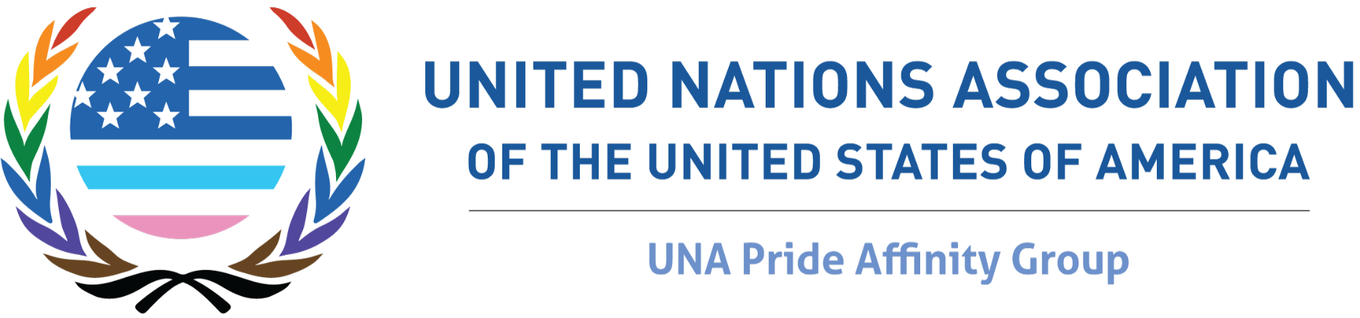

Submission to the Report to the Human Rights Council on the realization of the right of persons affected by violence and discrimination based on sexual orientation and gender identity to the enjoyment of the highest attainable standard of physical and mental health, in relation to Sustainable Development Goal 3: Good Health and Well-being.

Submitted: February 6, 2022

About the United Nations Association of the USA (UNA-USA)
The United Nations Association of the USA (UNA-USA) is a grassroots movement of Americans dedicated to supporting the lifesaving work of the United Nations. With over 20,000 members—60% of whom are under the age of 26—and more than 200 chapters across the country, UNA-USA members are united in their commitment to global engagement and their belief that each of us can play a part in advancing the UN’s mission and achieving the Sustainable Development Goals. For more information, please visit: https://unausa.org.

About the UNA Pride Affinity Group
The UNA Pride Affinity Group takes direction from the interests and passions of current UNA-USA members who convene in person and virtually to advance important and timely issues related to LGBTQIA+ rights. UNA Pride champions attend high-level events at the United Nations, march for LGBTQIA+ equality in Pride events across the country, organize local events connecting LGBTQIA+ equality to the Sustainable Development Goals, and take action to support UN initiatives like the Free & Equal campaign.

About the Authors
Emerson Victoria Johnston is a fourth-year honors student at Northeastern University earning a B.S. in Philosophy, Politics, and Economics and a B.A. in History, Culture, and Law, and currently serves as a Co-Chair for the UNA Pride Affinity Group.

Riley Reed is a fourth-year honors student at DePaul University earning a Bachelor of Arts in Political Science and Peace, Justice, and Conflict Studies, and currently serves as a Co-Chair for the UNA Pride Affinity Group.

Introduction
Upon hearing UN Independent Expert on Sexual Orientation and Gender Identity (IESOGI) Victor Madrigal-Borloz's Call for Inputs for the next IESOGI Report on Health & SDG 3: Good Health and Well-being, the UNA Pride Affinity Group held an open-call online survey for all members of UNA Pride to participate in. The survey was comprised of modified versions of the questions that accompanied the call for input, edited to better encompass the UNA Pride audience and their experiences. The full list of questions can be found in Annex 1.

This report gives insight into the challenges and barriers that continue to exist regarding the realization of SDG 3 in relation to persons affected by violence and discrimination based on sexual orientation and gender identity (herein referred to as ‘affect persons’) as well as recommendations on how best to combat them.
Demographics
Of our respondents who opted in for questions regarding race, sexuality, and income, the demographic data for the survey breakdown is as follows:

95% of respondents were under the age of 30, with most (43%) falling between the ages of 18 - 26. 83% of respondents identified as female and 35% of respondents identified as transgender or nonbinary. 100% of respondents identified as not straight, with most (55%) identifying as Gay, Homosexual or Lesbian.

65% of respondents identified as white, non-Hispanic.
12% of respondents identified as white, Hispanic.
9% of respondents identified as African American or Black.
8% of respondents identified as Asian or Pacific Islander.
4% of respondents identified as two or more races.
1% of respondents identified as Indigenous or Alaska Native.
All respondents reported being in countries in the Global North.

We collected this data by asking respondents to voluntarily provide information regarding their age, race, gender identity, sexual identity, and city and state of residence.

Results

Inclusion
Regarding our three questions related to inclusion, all participants responded as having seen measures taken to include affected persons in procedure and practice making in relation to the right of everyone to the enjoyment of the highest attainable standard of physical and mental health. This remains true across all workplace demographics. Of those who chose to expand, many reported that although companies and institutions did have related measures in place, few allowed affected persons in on the deciding conversations. The main barriers, in law or practice, for affected persons to receive care that meets their needs and rights are:

- Implicit and explicit bias,
- Lack of understanding and education, and
- Fear and stereotypes.

More specifically, respondents cited the lack of understanding to non-white, queer, and trans-specific presentation and symptoms related to common and uncommon medical conditions that many believe aren’t taught in medical schools. Recommendations made when asked what support or technical assistance is needed to ensure that the health care needs of affected persons are comprehensively addressed include:

- Adding preferred pronouns and information about gender identity and expression on medical and insurance forms, as it relates to medical necessity;
- Adding training related to the safe and respectful treatment of transgender patients to include how to appropriately address and respond to preferred pronouns, and how to evaluate and treat transgendered victims of sexual assault; and
- Educating physicians and nurses of all levels about the differences in presentation and symptoms that certain medical conditions have across race and gender.

Access
98% of participants responded ‘yes’ that they have access to affordable mental and physical healthcare services in their area, and those who responded ‘no’ did not comment further. Moreover, all participants responded that their medical insurance included coverage of treatment interventions for substance use disorders.

Training & Education
98% of participants responded ‘yes’ that they and their peers received adequate training and education in the workplace and/or in an academic setting to promote the inclusion of persons affected by violence and discrimination based on sexual orientation and gender identity. A single respondent answered ‘no’ to this question and elaborated that as a member of their country’s military, this was because their workplace was not a place where conversations surrounding sexual orientation and gender identity frequently occurred. The most training they had received was regarding sexual assault but they reported it as “abysmal”.

An overwhelming number of respondents, 83%, responded ‘no’ to having, at their current or previous academic institutions, age-appropriate comprehensive sexuality education. Those who elaborated said that their sex education in secondary school was primarily tailored toward straight, cis-gendered students. Further, they said that most of their education came from personal research and the internet.

Recommendations to solve for these issues include:

- Permanently incorporating sexuality and gender identity education into secondary schools’ sex education curricula

The SDGs
All participants responded ‘yes’ to being asked whether their needs for family planning were satisfied using modern methods. On the percentage of total household expenditure on healthcare expenses, the breakdown is below.

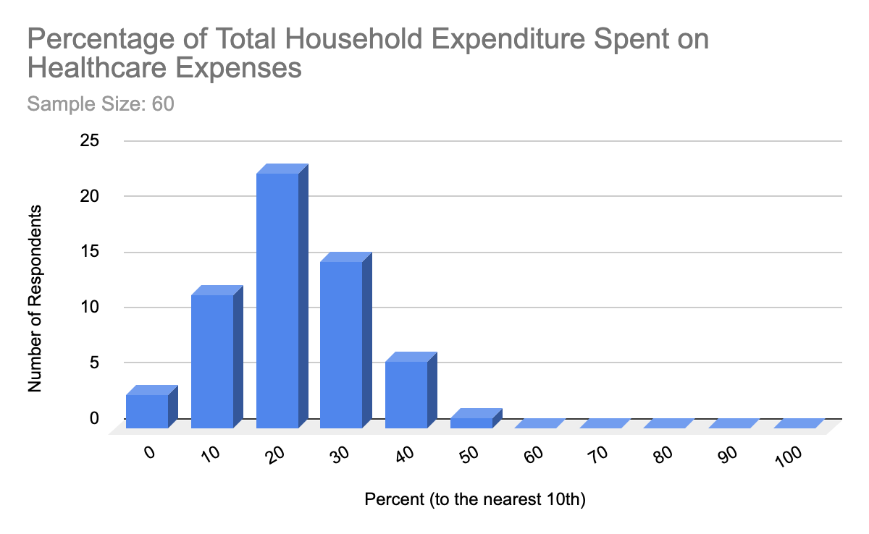

Conclusions and Recommendations
Overall, members of the UNA Pride Affinity Group believe most of the challenges and barriers that continue to exist preventing the realization of SDG 3 involve inclusion and education. Ultimately, to see the most improvement in realizing SDG 3, the education and training of medical professionals must be more inclusive of queer and trans identities and issues.

Below is a complete list of the UNA Pride Affinity Group’s recommendations to influence the 2022 IESOGI Report on Health & SDG 3: Good Health and Well-being to aid in the realization of SDG 3 in relation to persons affected by violence and discrimination based on sexual orientation and gender identity.

- Including preferred pronouns and information about gender identity and expression on medical and insurance forms, as it relates to medical necessity;
- Adding training related to the safe and respectful treatment of transgender patients to include how to appropriately address and respond to preferred pronouns, and how to evaluate and treat transgendered victims of sexual assault, and more;
- Educating physicians and nurses of all levels about the differences in presentation and symptoms that certain medical conditions have across race and gender; and
- Permanently incorporating sexuality and gender identity education into secondary schools’ sex education curricula.

Annex 1: Survey Questions.

1 | Inclusion: Have you observed, either in an academic or professional setting, any measures taken to include persons affected by violence and discrimination based on sexual orientation and gender identity in procedure and practice making in relation to the right of everyone to the enjoyment of the highest attainable standard of physical and mental health?
2 | Inclusion: What support or technical assistance is needed to ensure that the health care needs of persons affected by violence and discrimination based on sexual orientation and gender identity are comprehensively addressed and included in relevant laws, policies, and practices?
3 | Inclusion: What are the main barriers, in law or practice, for persons affected by violence and discrimination based on sexual orientation and gender identity to receive care that meets their physical and mental health needs and rights?
4 | Access: Do you have access to affordable healthcare services, in general, in your area? Feel free to elaborate using the "other" option.
5 | Access: Do you have access to affordable healthcare services in your area, specifically following the experience of assault or gender-based violence? Feel free to elaborate using the "other" option.
6 | Access: Do you have access to affordable mental health services, in general, in your area? Feel free to elaborate using the "other" option.
7 | Access: Do you have access to affordable mental health services in your area, specifically related to depression, anxiety, suicidal ideation, and/or substance abuse? Feel free to elaborate using the "other" option
8 | Training and Education: Do you believe, in your workplace or academic setting, that you and your peers have the adequate training and education to promote the inclusion of persons affected by violence and discrimination based on sexual orientation and gender identity? Feel free to elaborate using the "other" option.
9 | Training and Education: Do you believe, at your current or previous academic institutions, that you and your peers were given age-appropriate comprehensive sexuality education, inclusive of sexual and gender diversity in education institutions? Feel free to elaborate using the "other" option.
10 | SDGs - Relating to Indicator 3.5.1: - Does your current medical insurance include coverage of treatment interventions for substance use disorders? Feel free to elaborate using the "other" option.
11 | SDGs - Relating to Indicator 3.7.1: For those of reproductive age (15-49 years) who identify as women, regardless of sexuality and sex assigned at birth, are your needs for family planning satisfied with modern methods? Feel free to elaborate using the "other" option.
12 | SDGs - Relating to Indicator 3.8.2: How much of your total household expenditure or income is spent on healthcare expenses?

