February 7, 2022

Mr. Victor Madrigal-Borloz
UN Independent Expert on Sexual Orientation and Gender Identity

Via email: ohchr-ie-sogi@un.org

Dear Mr. Madrigal-Borloz:

On behalf of the Southern Poverty Law Center, a leading US civil and human rights organization, I write to provide the below responses to your recent call for input.

SPLC was founded in 1971. Since that time, SPLC’s mission has been to stamp out hate and extremism and to ensure that the rights of all persons are equally protected. Our work includes litigation and policy advocacy to advance the rights, dignity and freedom of the LGBTQ community in the Southern United States.

2. Inclusion: LGTBI and GNC people in the decision-making process

i. What measures have been put in place to consult with and include persons affected by violence and discrimination based on sexual orientation and gender identity in law and policy making in relation to the right of everyone to the enjoyment of the highest attainable standard of physical and mental health, and in relation to realising the SDGs?

During the previous administration, the US government adopted a number of policies harmful to LGBTQ persons. These included such actions as banning transgender people from military service and removing HIV+ members from military service, the issuance of regulations allowing employers to claim religious exemption in order to terminate the employment of LGBTQ workers, retraction of Department of Justice interpretation of civil rights laws as protecting people from discrimination based on gender identity or expression, eliminating Department of Education rules requiring transgender students to be treated consistent with their gender identity, and denying emergency shelter access to transgender and gender non-conforming people, just to name a few.

In February 2021, President Biden issued a Memorandum on Advancing the Human Rights of Lesbian, Gay, Bisexual, Transgender, Queer, and Intersex Persons Around the World. The memorandum directed US government agencies engaged abroad to ensure the promotion and protection of rights for LGBTQI people, including by “strengthen[ing] the role ... of civil society advocates on behalf of the human rights of LGBTOI+ persons.” In addition, the memorandum directed domestic agencies to rescind any regulations or policies inconsistent with its purposes. Since that time, the White House has conducted a number of roundtable discussions with LGBTQI+ civil society advocates and appointed a Special Envoy to advance the rights of LGBTQI+ people globally.

Unfortunately, as the federal government works to undo harmful laws, regulations and policies, state governments (especially in the Southern United States) are adopting new laws and policies that directly violate the human rights of LGBTQI+ people in ways that endanger their physical and mental health, with little or no consultation with the very people and communities who are impacted by them. As of January 2022, at least 280 anti-LGBTQ bills had been introduced. These laws and pending bills are detailed below.

iv. What are the main barriers, in law or practice, for persons affected by violence and discrimination based on sexual orientation and gender identity to receive care that meets their physical and mental health needs and rights?

In the Southern US, where SPLC primarily works, state non-discrimination laws uniformly omit any protections against discrimination based on sexual orientation or gender identity. In some states, such as Mississippi and Louisiana, state law also prohibits local governments from passing their own non-discrimination laws. State legislatures have adopted or are currently considering numerous laws that impede the ability of LGBTQI+ persons to receive care or otherwise threaten their physical or mental health. It is not just the laws themselves harmful to the physical and mental health of those targeted by them – the introduction of and debate about such proposed laws is also damaging.

- Alabama:
  - In 2017, Alabama passed a “medical refusal” bill allowing healthcare providers to refuse medical care that is not in line with their personal or religious beliefs.
  - In 2017, Alabama also passed a bill allowing foster and adoption agencies to discriminate based on the sexual orientation of the adoptive or foster parent(s). A shortage of foster parents is damaging to the physical and mental health of children.
  - Alabama has an HIV criminalization law - AL Code § 22-11A-21 (2019).
  - For the past three years, legislators have introduced bills targeting medical care provided to transgender children. This year, those bills are HB266 and SB184. They have yet to pass.
  - In 2021, Alabama adopted a law targeting trans children in sports and excluding them from participating in school sports aligning with their gender identity in kindergarten through grade 12. These bans are damaging to the mental health of transgender youth, and deprive them of opportunities to maintain and improve their physical health by participating in sports.
  - In addition, Alabama has multiple bills filed this session targeting the teaching of so-called “divisive concepts” which could be used to target LGBTQ communities – HB8, HB9, HB11, and SB7
  - Though there are processes for changing a name or gender marker on one’s driver’s license, Alabama will not issue a new birth certificate with a changed name or gender marker (only an amended one).
  - None of Alabama’s state discrimination laws provide for protection based on sexual orientation or gender identity.

- Florida:
  - Florida’s state employee health care plan explicitly excludes transition-related care for transgender persons.
  - Florida Stat. Ann. 775.0877 criminalizes the transmission of HIV, provides for sentencing enhancements, and may require sex offender registration. UNAIDS has recognized such laws as a threat to public health and urges governments to limit such laws only to intentional transmission.
  - In 2021, Florida Stat. 1006.205 (“Fairness in Women’s Sports Act”) was signed into law. It excludes transgender youth from competing on women’s or girl’s sports teams in public secondary schools and postsecondary institutions.
  - In the current session, legislators are considering the following bills:
    - HB 211 would criminalize the provision of gender-affirming medical care to transgender youth.
    - HB 747 would permit health care providers and payors to use a religious exemption to justify not participating in or paying for any health care service that they claim would “violate their conscience.”
    - SB1300 - “Sale or Distribution of Harmful Materials” - subjectively limiting the resources and information that counselors, librarians, and teachers could share with LGBT+ youth based on 1 parent’s objection.
    - HB 1557/SB 1834 “Don’t Say Gay” bills would block teachers from talking about LGBTQ issues or people and undermine existing protections for LGBTQI youth in schools.

- Georgia:
  - Current law criminalizes HIV/AIDS: GA Code § 16-5-60 - “Reckless conduct causing harm to or endangering the bodily safety of another; conduct by HIV infected persons; assault by HIV infected persons or hepatitis infected persons.”
  - Georgia has transgender exclusions in its state Medicaid coverage, which impairs the ability of low income transgender people to obtain needed care
  - Georgia law does not allow a person to have a gender other than the one assigned at birth on a state ID unless they can prove they have had gender reassignment surgery
  - Georgia doesn’t include transgender medical care for state employee benefits.
  - During the current legislative cycle (2021-2022), the General Assembly has introduced the following bills:
    - SB 226 – “Sale or Distribution of Harmful Materials” - subjectively limiting the resources and information that counselors, librarians, and teachers could share with LGBT+ youth based on 1 parent’s objection.
    - SB266, HB276 – the “Save Girls Sports Act” would prohibit persons incorrectly defined as male from participating in certain school sports; allows for the discrimination of transgender kids participating in organized sports
    - HB1 - “Forming Open a Robust University Minds” Act, drafted and promoted by the Alliance Defending Freedom (an SPLC-identified hate group), previous iterations of the bill allowed for on-campus groups and clubs to prevent the membership of LGBT+ youth.
    - HB401 – the “Vulnerable Child Protection” Act criminalizes gender-affirming healthcare for youth
    - HB372 – provides for an incorrect definition of gender and prohibits those whose biological sex doesn’t match their gender from participating in organized sports.

- Louisiana:
  - State law Louisiana Rev. Stat. Ann. 14:43.5 criminalizes HIV transmission, provides sentencing enhancements, and may require sex offender registration.
  - Louisiana’s state employee health care plan explicitly excludes transition-related care for transgender persons.
  - A broad “religious freedom” law provides exemptions to anti-discrimination requirements.
  - A bill to ban transgender athletes from competing in girls’ or women’s sports was passed by the Louisiana legislature but was vetoed by the Governor.

- Mississippi:
  - HIV transmission is criminalized pursuant to Mississippi Code Ann. 97-27-14.
  - Mississippi law also allows medical professionals to claim religious exemption to deny health care services to LGBTQ persons except with respect to emergency care.
  - Mississippi’s state employee health care plan explicitly excludes transition-related care for transgender persons.
  - In 2021, the “Mississippi Fairness Act” was signed into law. It prohibits transgender athletes from competing on girls’ or women’s sports teams.
  - During the current session, legislators are considering HB 1099, which prohibits transgender prisoners from seeking a name change or legal gender marker change.

In addition, the criminal justice system subjects people charged with or convicted of offenses to conditions that endanger both their physical and mental health. For example, SPLC recently filed a lawsuit on behalf of a group of transgender people in Florida who suffered physical and mental abuse, including being denied medical care and being held in solitary confinement, while held at a male correctional facility on minor charge. A Black transgender woman, also an SPLC client, continues to be held in a male prison in Georgia despite being sexually victimized and deprived of adequate medical care. Several of SPLC’s clients in another lawsuit over inadequate mental health care in Alabama prisons are also transgender women held in male prisons and subjected to similarly inhumane conditions. Finally, SPLC represents a group of incarcerated people in the Florida prison system, including LGBTQI people, who are disproportionately subjected to inhumane solitary confinement.

LGBTQ individuals also experience extreme health and safety challenges due to high rates of poverty and homelessness. Only 7% of youth in the US are LGBTQ, yet as many as 40% of all youth experiencing homelessness are estimated to be LGBTQ. Of the respondents in the 2015 U.S. Transgender Survey, 29% were living in poverty, and nearly one third had experienced homelessness at one point in their lifetime. The rate of homelessness experienced by transgender individuals is increasing at an alarming rate of 88% since 2016. Transgender individuals are more likely to be unsheltered when experiencing homelessness, which can be attributed to difficulties in accessing safe and affirming emergency shelters. Transgender individuals experiencing unsheltered homelessness experience severe vulnerabilities and health issues, significant risks to safety, and average substantially more ambulance rides, emergency room visits, police contacts, and jail stays.

The failure of states to provide adequate protections in law contributes to an alarmingly high rate of murders and violent assaults on transgender people. The atmosphere of animosity against transgender people is only worsened by the conduct of right-wing state legislators introducing and creating public uproar around bills seeking to restrict transgender rights in health care, education, and elsewhere. In 2020, the Human Rights Campaign reported there were at least 44 violent fatal incidents committed against transgender and gender non-conforming people in the United States (highest on record since tracking began), with that number exceeding 50 in 2021. This epidemic of violence is illustrated by the tragic loss of life in the Southern U.S. that occurred in 2021 alone: Bianca “Muffin” Bankz, a Black transgender woman was shot to death in Atlanta; Dominique Jackson, a Black transgender woman, was shot to death in Jackson, Mississippi; Fifty Bandz, a 21-year old Black transgender woman, was shot to death in Baton Rouge, Louisiana; Alexus Braxton, a 45-year old Black trans woman, was killed in Miami, Florida; Keri Washington, a 49-year old Black transgender woman, was killed in Clearwater, Florida; Sophie Vásquez, a 36-year old Latina transgender woman, was shot and killed in Georgia; Serenity Hollis, a 24-year old Black transgender woman, was shot and killed in Albany, Georgia; Pooh Johnson, a 25-year old Black trans woman, was killed in Shreveport, Louisiana; Mel Groves, a 25-year old Black trans man, was fatally shot in Jackson, Mississippi; Royal Poetical Starz, a 26-year old Black trans woman, was fatally shot in Miami Gardens, Florida; Jenny DeLeon, a 25-year old Latina transgender woman, was found dead in Tampa, Florida.

3. Access: ensuring that LGTBI and GNC people have access to health care

i. What measures have been taken to ensure access to affordable non-discriminatory health care services for persons affected by violence and discrimination based on sexual orientation and gender identity?

None of the Southern states in which SPLC maintains offices (Alabama, Florida, Georgia, Louisiana and Mississippi) have taken any such steps.

ii. What policies or programmes exist to address the mental health care needs of persons affected by violence and discrimination based on sexual orientation and gender identity, specifically around depression and anxiety, suicidal ideation, and substance abuse?

SPLC is not aware of any state-sponsored programs for this purpose in its five-state practice area. In some states, modest efforts to address these issues in schools are being rolled back. For example, the Florida Department of Education recently removed anti-bullying and harassment resources for LGBTQI youth from its website even though that population is at significantly greater risk of bullying in schools and the mental health harms that result from such harassment. As noted above, transgender prisoners are held in male facilities where they are denied appropriate medical care, subject to physical, sexual and psychological abuse, and placed in solitary confinement without adequate justification.

4. Training and Education: health care professionals and educational institutions

ii. What measures are being taken to provide age-appropriate comprehensive sexuality education inclusive of sexual and gender diversity in educational institutions?

Schools in SPLC’s core states do not provide adequate sexuality education, especially in the context of sexual orientation and gender diversity. Sexuality education provided in schools is primarily focused on abstinence.

- Alabama: In 2021, HB 385 was passed to update language in Alabama’s sex education law to make it more medically accurate and remove homophobic language. However, under Alabama Code Sec. 16-40A-2, sex education in Alabama remains non-compulsory and emphasizes abstinence.

- Georgia: Sex education is compulsory in Georgia schools pursuant to Georgia Code Sec 20-2-143. Local school boards prescribe the content of the instruction. The law was amended in 2018 to require schools to provide “age-appropriate sexual abuse and assault awareness and prevention education.” There have been other attempts to require medically-accurate education on HIV/AIDS and other reproductive issues, but those have not been successful. There are some local, community-based efforts to provide comprehensive sex education, but for the most part any curriculum does not have to be comprehensive or include information about sexual orientation or gender identity, and must emphasize abstinence. Parents can op-out from any sex education.

- Florida: In January 2022, a Florida House of Representatives committee passed HB 1557, the so-called “Parental Rights in Education Bill,” which seeks to ban discussion of sexual orientation and gender identity in schools. The bill would also require educators to notify parents of information “affecting a student's mental, emotional, or physical well-being,” effectively requiring them to “out” students who confide in them about issues relating to sexual orientation or gender identity.

- Louisiana: Louisiana Revised Statute 17:281 does not require any sex education to be taught in schools, leaving this to local control. To the extent schools do choose to offer any sex education in grades 7-12, it must emphasize abstinence. Parents must be allowed to opt their children out of any such instruction. It may not include use of “any sexually explicit materials depicting male or female homosexual activity.”

- Mississippi: The law, Mississippi Code Sec. 37-13-171, requires only that schools teach either “abstinence-only” or “abstinence-plus” sex education, focused on teaching sexual risk avoidance. Students report much of the instruction being shame-based. Sexual orientation and gender identity issues are not required to be included.

I hope that this submission will prove useful to you as you prepare your report. Please do not hesitate to contact me if you have any questions or if there is any further information we can provide.

With best regards,
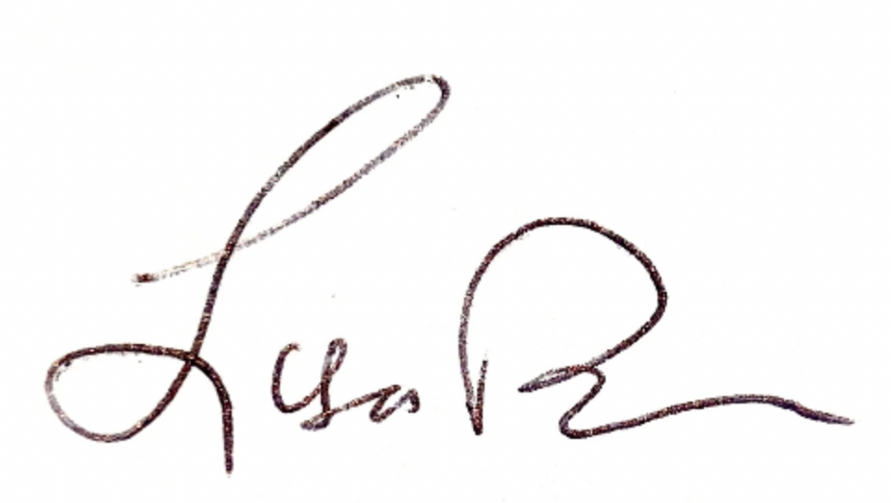
LISA W. BORDEN
Senior Policy Counsel, International Advocacy

