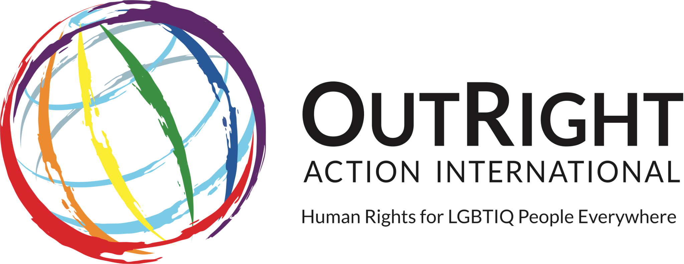 | 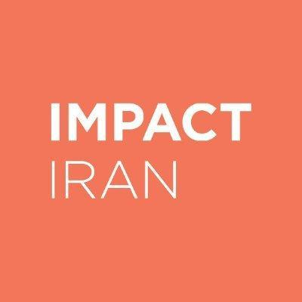

Submission to the Special Rapporteur
on protection against violence and discrimination based on sexual orientation and gender identity

Outright Action & Impact Iran

Introduction: 2
The State initiatives to understand the health care needs of LGTBI and GNC people 2
Inclusion of LGTBI and GNC people in the decision-making process 4
The State initiatives to ensure that LGTBI and GNC people have access to healthcare 6
Inclusive training and education for health care professionals and educational institutions 9
Annex: Data related to the SDG3, targets, and indicators 13

Introduction:

- LGBTQI+ people in Iran face severe discrimination, restrictions, and marginalization in law and society. The country's legal framework prescribes harsh punishments, including the death penalty, for engaging in homosexual acts, and individuals enjoy impunity for heinous acts of violence against LGBTQI+ persons in the country. Consequently, LGBTI+ Iranians suffer from significant isolation, depression, and other mental health problems. Further to this, systematic discrimination and restrictions on LGBTI+ Iranians in the country renders them highly vulnerable to violations of their right to health. The following information explores how the human rights of people with diverse sexual orientations and gender identities are incorporated into Iran’s national plans aimed at the realization of the right of everyone to the enjoyment of the highest attainable standard of physical and mental health under the rubric of Sustainable Development Goal (SDG).

State initiatives to understand the health care needs of LGTBI and GNC people
- The State's Welfare Organization reported that shelters care for approximately 2,000 victims of domestic violence annually. Further, the existing shelters generally located solely in major cities are reportedly poorly resourced and advertised and cannot provide long-term support. But cases of violence, including gender-based violence, are believed to be underreported due to a lack of adequate and enforced legal protections for the LGBTQ members and social stigma.

Inclusion of LGTBI and GNC people in the decision-making process
- No measures have been put in place to consult with or include LGBTI+ persons in decision-making processes in law and policymaking concerning the right of everyone to the enjoyment of the highest attainable standard of physical and mental health.
- Reports have shown that police and judges often consider domestic violence an internal family matter. Police intervention has reportedly been discouraged, and parties are urged to settle out-of-court. State institutions and Iranian authorities have reportedly been unwilling to investigate, punish perpetrators, and provide social services to sexual assault or rape victims. This issue is exacerbated when it comes to violence against the LGBTQ community in Iran. Because many LGBTQ members refuse to report violence to the authorities if they encounter it, reporting violence to police officials does not help the victims. It can also lead to more problems for the victim due to the criminalization of homosexuality in Iranian law. For this reason, even the same minimal protections that exist for women or children do not exist for LGBTI+ persons.

State initiatives to ensure that LGTBI and GNC people have access to healthcare

- The 2013 Penal Code of the Islamic Republic of Iran explicitly forbids consensual sexual relations between same-sex partners. The offenses and punishments for males engaged in same-sex sexual or intimate conduct (including acts such as kissing or lustful touching) are described in Articles 233 to 237. Depending on whether the convicted individual is active/passive partner, married/single, or Muslim/non-Muslim, the punishment can range from flogging to the death penalty. The 2013 Penal Code also criminalizes female same-sex relations and intimate conduct through Articles 238 to 240, the punishment for which is flogging regardless of circumstance. There are no available statistics on the number of executions for same-sex relations. However, NGO reports have shown that it occurs and suggest the incidence rate is high.

- In 1986, Supreme Leader Ayatollah Khomeini issued a fatwa (a ruling or a religious decree on a point of Islamic law given by a recognized authority) permitting the acceptance of sex reassignment surgery for transgender people. Sex reassignment surgery is now codified in Article 4 of the Family Law (2013), which stipulates that those seeking medical intervention should obtain prior judicial and medical approval officially stating that they have been diagnosed with Gender Identity Disorder. The Ministry of Health has overall responsibility for implementing this law by ensuring the provision of medical care to recognized transgender people. The State Welfare Office provides social and psychological support, and several Government institutions, such as the Ministry of Labor, support transgender individuals who pursue or have been through sex reassignment procedures. But Government policies have reinforced societal stigma by pathologizing transgender identities because State policies imply that any divergence from cisgender heterosexuality can only be due to a person's gender dysphoria and is a medical condition that requires treatment.

- Further, among these individuals, only those who are officially diagnosed with agender identity disorder and who obtain a permit to undergo sex reassignment surgery can have their gender legally recognized by the Government. Others cannot benefit from the State Welfare's services, including sex-change procedures or counseling, and cannot receive a state-issued identity card that legally affirms their gender. As a result, individuals of varying sexual and gender identities which cannot or will not pursue medical transition are not protected from abuse, including arrest, detention, and prosecution.

- Besides the criminalization of same-sex conduct, several other legal provisions directly impact the rights of LGBTI+ individuals, particularly Iranian laws related to public decency. For instance, Article 639 of the 2013 Islamic Penal Code criminalizes the facilitation or encouragement of "people to immorality or prostitution." Article 6 of the Press Law (1986) prohibits the dissemination of material "which violates public chastity," including "forbidden practices" such as same-sex relations. Similarly, Article 14 of the Law on Computer Crimes criminalizes the distribution of "immoral content." Governmental-mandated organizations set up to preserve "public morality," notably the Basij militia, reportedly harassed, arrested, detained, and abused LGBT individuals based on the regulations mentioned above.

- Similarly, law enforcement forces have been reportedly arresting and detaining transgender individuals for appearing cross-dressed in public, an act considered haram (forbidden under Islamic law) until a 'disorder' could be medically and legally established. Additionally, Article 638 of the 2013 Penal Code stipulates that all women must appear in public wearing the mandatory hijab. This provision has been reportedly used against both transgender men pressured into wearing a hijab and transgender women accused of "cross-dressing" in public, regardless of whether their gender change has been legally recognized. In several reported cases, transgender individuals arrested on charges have been detained, prosecuted, and sentenced to flogging. Due to the lack of official reporting and victims' fear of social stigma, the number of cases of abuse and discrimination against individuals based on their sexual orientation and gender identity is likely much higher than those reported by human rights organizations.

- There is, as of now, no evidence that the Iranian Government is currently considering repealing or amending laws that result or could result in discrimination, prosecution, and punishment of people because of their sexual orientation or gender identity. Iranian law does not recognize transgender individuals who haven't been diagnosed with GID and implicitly supports the notion that transsexuality is a condition that needs to be medically 'corrected' and criminalizes same-sex relations. Such behavior may well pressure transgender individuals to undergo treatments and medical procedures to escape discrimination and persecution and incentivize forced medical procedures. In a few reported cases, such medical interventions have been carried out without prior informed consent. Individuals were subjected to forced administration of hormones and medication, a grave violation of the right to health , and may amount to torture.

- No readily available information might indicate that the Government has engaged in steps to ban forced, coercive, or otherwise involuntary psychological, medical, and surgical procedures designed to change or reassign people's sexual orientation, gender, or sex characteristics without their free, prior, and informed consent.

Inclusive training and education for health care professionals and educational institutions
- The Council, a supranational body, is responsible for macro-policies in education and cultural matters. Accordingly, if a subject wants to be included in the curriculum of the educational plan of the country, it must have the approval of this institution. The Council is directly accountable to the Supreme Leader of the Islamic Republic, and the country's legislative bodies cannot adopt any law that contradicts the resolutions of this Council.

- In addition, issues related to sex, sexual awareness, sexual education are often considered "taboo" in Iranian society, especially in the traditional strata. Any awareness-raising around these issues is viewed as "promoting corruption and prostitution."

- These include the events surrounding the Government's efforts to implement the 2030 Sustainable Development Goals (“SDGs”) document. The Ministry of Education had planned to implement a national plan on sexual education that drew upon the SDGs, but these measures were stopped in the face of religious resistance. The efforts, which religious institutions opposed, were banned by Supreme Leader Ayatollah Khamenei. Among the topics that religious institutions objected to was the emphasis on the need to provide sexual education to children and adolescents, which opponents of the plan referred to as "promoting corruption and teaching sex to children."
- The Committee on the Rights of the Child stipulates that State parties should provide adolescents with access to sexual and reproductive information, including information on family planning and contraceptives, the dangers of early pregnancy, and prevention and treatment of HIV/AIDS sexually transmitted diseases. The Government has reportedly provided some sexual health and reproductive education to adolescents.
- The Government's behavior towards LGBTI+ persons has been hostile and Iranian authorities publicly criticize the country's lesbian, gay and bisexual communities. Iranian officials regularly use dehumanizing terms to describe LGBTI+ persons, such as "immoral," "corrupt," "animals," "sick," or "Western." Such openly hostile behavior towards the lesbian, gay and bisexual community from government officials may further impair LGBT persons' access to employment, social services, health care, and education. It creates a permissive environment for excluding and societal stigmatization against LGBT individuals in Iran. No readily available information might indicate the existence of state measures to address discrimination against lesbian, gay, bisexual, and non-legally recognized transgender individuals.

Statistical yearbook of the Welfare Organization of the country - 1399 http://media.behzisti.ir/d/2021/10/12/0/134192.pdf
www.hamshahrionline.ir/x66FG; https://www.radiozamaneh.com/488134 (in Persian); Ceasefire Centre for Civilian Rights, Centre for Supporters of Human Rights and Minority Rights Group International September 2019, https://www.justice.gov/eoir/page/file/1203136/download
2019 Country Reports on Human Rights Practices: Iran, U.S. Department of State, https://www.state.gov/reports/2019-country-reports-on-human-rights-practices/iran/
UN General Assembly, ‘Situation of human rights in Iran’ (para 32), 31 August 2015, https://undocs.org/Home/Mobile?FinalSymbol=A%2F70%2F352&Language=E&DeviceType=Desktop ; Australian Department of Foreign Affairs and Trade, Country Information report, Iran, 2020, https://www.dfat.gov.au/sites/default/files/country-information-report-iran.pdf
Iran Human Rights Documentation Center, 2020, https://iranhrdc.org/access-to-justice-for-victims-of-sexual-violence-in-iran/
Islamic Penal Code 2013, Iran Human Rights Documentation Center, https://iranhrdc.org/english-translation-of-books-i-ii-of-the-new-islamic-penal-code/
Small Media, 2018, https://smallmedia.org.uk/media/projects/files/BreakingTheSilence_2018.pdf
Amnesty International, 2017, https://www.amnesty.org/en/latest/news/2016/08/iran-hanging-of-teenager-shows-brazen-disregard-for-international-law/ ; Amnesty International, 2018, https://www.amnesty.org.uk/urgent-alireza-arrested-15-tortured-confession-be-executed-tomorrow; Iran Human Rights, 2019, https://iranhr.net/en/articles/3611/ ; Human Dignity Trust, https://www.humandignitytrust.org/country-profile/iran/ ; International Lesbian Gay Bisexual Trans and Intersex Association (ILGA), 2019, https://ilga.org/downloads/ILGA_State_Sponsored_Homophobia_2019.pdf
Outright International, 2016, https://outrightinternational.org/sites/default/files/OutRightTransReport.pdf
Outright International, 2016, https://outrightinternational.org/sites/default/files/OutRightTransReport.pdf
Outright International, 2016, https://outrightinternational.org/sites/default/files/OutRightTransReport.pdf
Small Media, 2018, https://smallmedia.org.uk/media/projects/files/BreakingTheSilence_2018.pdf ; Outright International, 2016, https://outrightinternational.org/sites/default/files/OutRightTransReport.pdf
Outright International, 2016, https://outrightinternational.org/sites/default/files/OutRightTransReport.pdf
Outright International, 2016, https://outrightinternational.org/sites/default/files/OutRightTransReport.pdf
Islamic Penal Code (2013), Iran Human Rights Documentation Center, https://iranhrdc.org/islamic-penal-code-of-the-islamic-republic-of-iran-book-five/
International Lesbian Gay Bisexual Trans and Intersex Association (ILGA), 2019, https://ilga.org/downloads/ILGA_State_Sponsored_Homophobia_2019.pdf
International Lesbian Gay Bisexual Trans and Intersex Association (ILGA), 2019, https://ilga.org/downloads/ILGA_State_Sponsored_Homophobia_2019.pdf
Iranian Lesbian & Transgender Network (6Rang), 2014, http://6rang.org/english/wp-content/uploads/2014/06/Pathologizing-Identities-Paralyzing-Bodies.pdf ; Iranian Railroad for Queer Refugees (IRQR), 2018, https://irqr.net/wp-content/uploads/2018/09/IQW-Report.pdf ; OutRight International, 2016, https://outrightinternational.org/sites/default/files/OutRightLesbianReport.pdf?_ga=2.78516692.1992181521.1595330838-780871412.1595330838
Outright International, 2016, https://outrightinternational.org/sites/default/files/OutRightTransReport.pdf
Outright International, 2016, https://iranhrdc.org/islamic-penal-code-of-the-islamic-republic-of-iran-book-five/
Outright International, 2016, https://outrightinternational.org/sites/default/files/OutRightTransReport.pdf
Outright International, 2016, https://outrightinternational.org/sites/default/files/OutRightTransReport.pdf
Small Media, 2018, https://smallmedia.org.uk/media/projects/files/BreakingTheSilence_2018.pdf ; Iranian Lesbian & Transgender Network (6Rang), 2015, https://tbinternet.ohchr.org/Treaties/CRC/Shared%20Documents/IRN/INT_CRC_NGO_IRN_19808_E.pdf
Iranian Lesbian & Transgender Network (6Rang), 2014, http://6rang.org/english/wp-content/uploads/2016/02/Diagnosing-Identities-Paralyzing-Bodies.pdf ; Report of the Secretary General on the situation of human rights in the Islamic Republic of Iran, 2019, https://undocs.org/en/A/74/273 ; Iranian Lesbian & Transgender Network (6Rang), 2018, http://6rang.org/english/2422
Report of the Special Rapporteur on the right of everyone to the enjoyment of the highest attainable standard of physical and mental health, August 2009, https://undocs.org/A/64/272
Interim report of the Special Rapporteur n torture and other cruel, inhuman or degrading treatment or punishment, July 2008, https://undocs.org/en/A/63/175 ; Yogyakarta Principles, http://yogyakartaprinciples.org/wp-content/uploads/2016/08/principles_en.pdf and http://yogyakartaprinciples.org/wp-content/uploads/2017/11/A5_yogyakartaWEB-2.pdf
https://sccr.ir/en
https://www.mashreghnews.ir/news/978633/
https://www.bbc.com/persian/iran-features-39835884
https://tn.ai/1423953
General Comment No. 4 (2003), CRC/GC/2003/4, para 28, https://undocs.org/CRC/GC/2003/4
https://www.ilna.news/fa/tiny/news-924283
Iranian Lesbian & Transgender Network (6Rang), 2017, http://6rang.org/english/wp-content/uploads/2017/12/Official-Hate-Speech-against-LGBT-People-in-Iran.pdf
Iran Human Rights Documentation Center, https://iranhrdc.org/denied-identity-human-rights-abuses-against-irans-lgbt-community/#2 ; Iranian Lesbian & Transgender Network (6Rang), 2015, https://tbinternet.ohchr.org/Treaties/CRC/Shared%20Documents/IRN/INT_CRC_NGO_IRN_19808_E.pdf ; OutRight International, 2016, https://outrightinternational.org/sites/default/files/OutRightLesbianReport.pdf?_ga=2.78516692.1992181521.1595330838-780871412.1595330838 ; Iranian Lesbian & Transgender Network (6Rang), 2015, https://tbinternet.ohchr.org/Treaties/CRC/Shared%20Documents/IRN/INT_CRC_NGO_IRN_19808_E.pdf ; Committee on the Rights of the Child, 2016, https://tbinternet.ohchr.org/_layouts/15/treatybodyexternal/Download.aspx?symbolno=CRC/C/IRN/CO/3-4&Lang=En ; Small Media, 2018, https://smallmedia.org.uk/media/projects/files/BreakingTheSilence_2018.pdf

