Report to the UN Human Rights Council on the realisation of the right of persons affected by violence and discrimination based on sexual orientation and gender identity to the enjoyment of the highest attainable standard of physical and mental health, in relation to SDG3.
Document made by Amicus, DH

Name or survey respondents: Pablo de los Cobos Alcalá and Juan Pablo Delgado Miranda (although we prefer that any reference to this document be made in the name of Amicus)

Introduction and context

Amicus is a civil society organization based in Guanajuato, Mexico aimed to change society through human rights. After experiencing the lack of data to raise awareness and evidence of the human rights violations of LGBTI people in the country, we develop Visible: the first online platform to report acts of violence and discrimination against these populations in Mexico. These reports can be made both by victims and witnesses answering a confidential questionnaire. This platform generates an open database from these reports intended to influence the decision-making processes in public, social and private organizations. From October 2018 until February 2022, we have received 1,042 reports referring to different types of aggressions related to several dimensions, in which physical and mental health has been one of them. Besides the information, Visible is also a way of empowering victims offering them a safe space to express and report acts of violence and discrimination, as well as a way to link them with other social and public organizations with which we have alliances in their respective states/regions. Based on this information, we have made diagnoses and delved into the barriers to the achievement of rights and the advances or setbacks by different government actors. In this document, we summarize the main findings from these activities carried out.

Answers to specific questions

1. Research: understanding the health care needs of LGTBI and GNC people
Question

1.1. Does the State (or other stakeholders) gather data, including data disaggregated by sexual orientation and/or gender identity, on:
- Access to and/or delivery of health services
- Access to sexual and reproductive health care?

Answer to question 1.1:

We have compiled 38 reports of violence or discrimination in healthcare contexts: either committed by health personnel or in places such as clinics, laboratories, or hospitals. Although some reports were about acts representing more than one type of violence the most common aggression was the denial of entry, services or rights (57.9% of the 38 reports), followed by both psychological and verbal violence (13.2% each). Although of the total of 1,042 reports received by Visible, two out of three were made by witnesses, in the case of reports related to healthcare, the majority have been made by the victims themselves: 52.6%. Most cases involve young people: 36.8% were 18 to 25 years old, and 23.7% were 26 to 30. The main victims’ sexual orientations are gay (39.5%), bisexual (18.4%), and heterosexual (15.8%). From the different victims’ gender identities referred to in the reports, the most common were cisgender men (36.8%), trans women (31.6%), and cisgender women (13.2%). On non-normative sex characteristics, so far we have not received reports regarding intersex people.

Aggressions have occurred mainly in public (57.9%) and private places (36.8%), although two cases in social networks have also taken place (online medical or psychological care). In relation to healthcare, Visible has received reports from 12 Mexican states, and they concentrate mainly in Mexico City, Jalisco, the State of Mexico, Guanajuato, and Veracruz. Prevalence reflected in our database does not necessarily mean that such places have higher rates of victimization. Among others, population size, greater media coverage, and the presence of alliances within certain local organizations could be factors to explain higher reporting rates. Similarly, we have received reports from 21 municipalities, in which Guadalajara, La Paz, Toluca, León, and Zapopan are the ones with the higher prevalence. Detailed information on each case could be found in our open data section, which does not contain personal information.

One of the most common type of segregation is the impediment to gay persons to donate blood. In some cases, it is a public guideline towards the entire population, while in other cases it is a decision made after questions by health personnel in specific cases. Similarly, we have documented cases where health care personnel formulate stigmatizing questions to LGB victims regarding their identities, which leads to the extreme of holding patients responsible for their diseases given their sexual orientation. There is indeed fear of expressing the own sexual orientation due to the consequences it can bring, such as the refusal to perform certain procedures, such as sexual and reproductive ones in the case of lesbian and bisexual cis women.

The other most common type of segregation is the refusal to attend an LGBT person arguing personal/religious beliefs or fear of infection. This last motivation is of great importance since, in an investigation carried out by Visible for its annual report, we noticed that public agencies at the state level in Mexico conceive the right to health of LGBTI persons consisting only on providing HIV treatment (although the population is a key population of attention, this is not the only aspect to consider in their access to the right).

Based on our reports, trans people are particularly affected in their attempt to access health care because, in addition to being misgendered, health personnel does not always have the training or awareness to understand their need to carry out clinical studies commonly associated with a gender expression. It is common to hear phrases such as “women do not need testosterone tests” or “men do not get HPV” and suggestions to get their appointments at night “so as not to drive away other patients who go during the day”.

Question 1.3. Is this data analyzed through an intersectional lens, such as by disaggregating data by sexual orientation and/or gender identity, as well as intersecting identities including social or geographic origin, ethnicity, socio-economic status, nationality or migration status, minority, disability, and indigenous or other identity or status?

Answer to question 1.3:

At the end of the report on the online platform, we have an optional questionnaire that asks different questions to be able to carry out an intersectional analysis. Among the questions asked, we gather information about nationality, education, occupation, income, and affiliation to different identities (ethnic, religious). This information will soon be available in our open data section.

Question 2.4. What are the main barriers, in law or practice, for persons affected by violence and discrimination based on sexual orientation and gender identity to receive care that meets their physical and mental health needs and rights?

Answer to question 2.4:

One of the barriers that we have observed for dealing with cases of aggression (in any context, including cases related to healthcare) is that this is not even known by the corresponding authorities or persons. For example, 40% of the victims that made a report in Visible in relation to health did not make a previous report elsewhere, so the information collected is extremely important not only because of the systematization and openness, but because it would not be possible to find it anywhere else. The main reasons to not make a prior report than the one made in Visible in these cases were because victims did not know where to report it or that they could do it (50%), they did not believe that there would be consequences (25%) and they were afraid to report (25%). This information can give insights into understanding the (lack of) interaction of victims with authorities and the reasons behind it.

Question 1.2. What steps have been taken to research and understand the health care needs of LGTBI and GNC people of all ages at the national level?

Question 4.1. Are sexual orientation and gender identity, and the specific health needs of persons affected by violence and discrimination based on sexual orientation and gender identity included in training and education of health care professionals?

Answer to questions 1.2 and 4.1:

As part of our research activities for our annual report, we make requests for information to state governments in Mexico with the intention of assessing the advances and setbacks in the generation of information and the implementation of public policies. The requests were made to 20 different types of ministries or institutes per state. Some questions were about cross-cutting issues, while others were specific. We asked the ministries of health if they had policies that guaranteed equal conditions for LGBTI people who work for the organization, if they collected information on the sexual orientation or gender identity of the people who were attended or benefited by any program, and if they trained its staff to guarantee respectful treatment of LGBTI citizens. Likewise, in the specific questions, we asked them if they had any medical care protocol for LGBTI people (Q1), and if they had information on hormonal treatments, gender affirmation surgery, pregnancies of trans men, or the birth of intersex people (Q2).

In total, 19 requests were delivered, of which 6 states did not respond. No state showed compliance in guaranteeing work conditions of equality and non-discrimination. There was also a strong tendency to associate the entire request to care only for HIV/AIDS cases. While some of the LGBTI populations are key populations for HIV/AIDS care, testing, or treatment, it is not the only health service that LGBTI people turn to. Unlike with the requests made to prosecutors and judicial powers (which have protocols about non-discrimination), the Protocol for Access without Discrimination to the Provision of Medical Care Services for LGBTTTI people has not had a great influence on, for example, increasing the number of states that train their staff, although some states made reference to it.

One of the ministries that, except for the working conditions, showed very good compliance is the Health Services of Chihuahua. This dependency had satisfactory compliance in two questions and partial compliance in the other two. On the subject of information collection, this agency showed that certain federal formats that may not contemplate these information variables are not an impediment to generating statistics in this regard since it stated that it has an equality program that is seeking to include in the electronic file "the gender of the patient giving greater opening so that the users be registered with the gender they identify with”. In addition to referring to being ruled by the mentioned protocol and training his staff on the matter, this agency replied that it has had a case of “a trans patient who received pregnancy and childbirth care… who received comprehensive and multidisciplinary medical care. All of the foregoing within a framework of dignity and respect without violating both individual and legal rights”. In Jalisco, Jalisco Health Services mentioned that hormonal treatments and births of trans men “are rarely requested; however, when this happens they are sent to the Sexual Medicine Unit” of the Western General Hospital.

Among the twenty ministries and institutes evaluated, those of health acquired, on average, the 13th position. Although there is a general lag in different entities as well as areas of public policy, health is one of those that require the most attention.

Figure 1. Responses to requests for information from the health areas
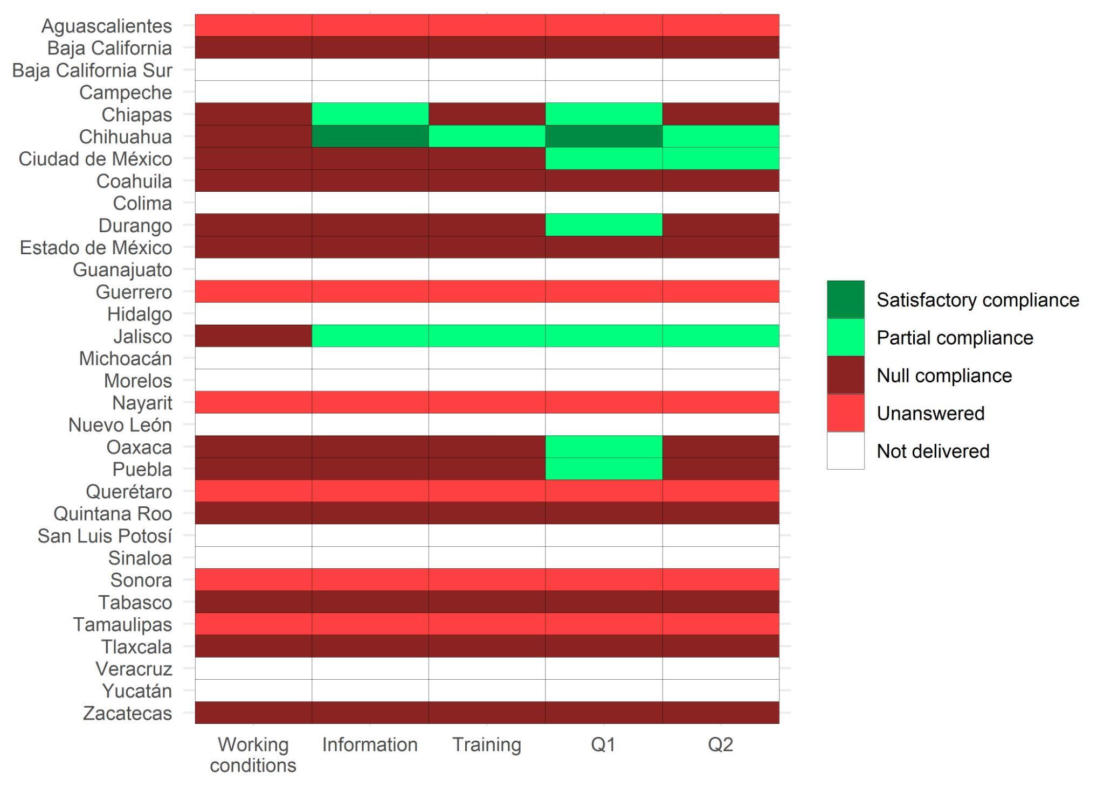
Source: Responses obtained in requests for information with the National Transparency Platform.

