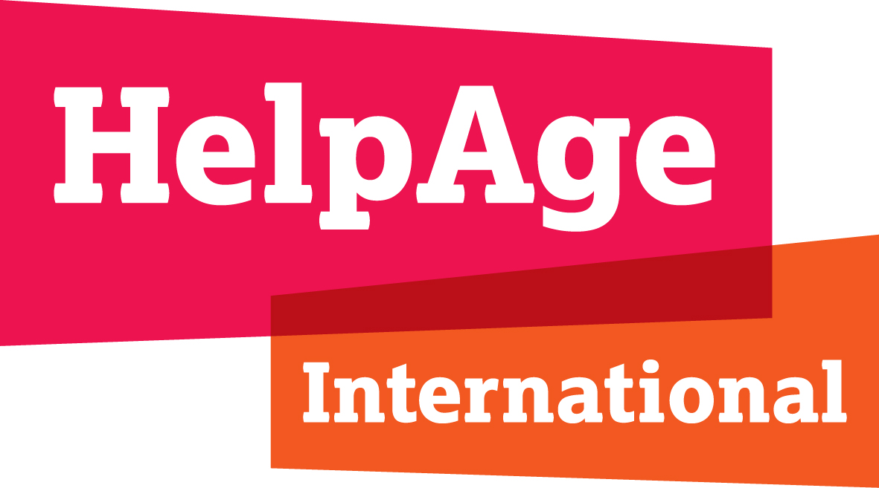

HelpAge International submission to the call for inputs for a report on older persons in the context of climate change-induced disasters and building back better

May 2023

About us
HelpAge International coordinates a global network of 171 member organisations across 90 countries who promote the right of all older persons to lead dignified, healthy and secure lives. Our mission is to promote the wellbeing, rights and inclusion of older persons so we can all enjoy a future free from poverty, inequality and discrimination.

Legal, policy and institutional framework
Comprehensive laws, policies and plans are vital to an effective response to disasters. The effects of climate change, as reflected in increasingly frequent and intense extreme natural events signifies the need to have broad national plans, polices and strategies to address climate induced disasters. In most countries, a single agency (such as a national disaster management agency/authority) acts as the central national focal point for disaster response, preparedness, and recovery and sets the national policy directions. Emergency response and prevention in legal frameworks is less prominent. The interaction between law and policy, whilst complex, is often essential for successful implementation.
At the national level, climate change is often not integrated in disaster management structures. Instead, it is increasingly treated as a separate subject under the ministry of environment or as a standalone agency, with environment and forestry as subdivisions under it. In this case interconnections with disaster response are very important. However, these institutions often need to strengthen their coordination not only with each other but also with other sectors such as health, food security and development planning.
Most national frameworks on disaster response and climate change lack visibility of older persons, meaning that their rights are not respected, and their needs are not recognized, assessed and budgeted. It could also mean that older persons have weak legal protection at the national level. Few countries have included ‘older persons’ = as one of the more at-risk groups in their policies without realizing that older persons have different needs when confronted with climate induced emergencies.
Age sensitive WASH facilities, nutrition requirements, health care and psychosocial support are the key needs that arise after a climate induced disaster hits a community (National Ageing Network of Zimbabwe or NANZ).
Ensuring appropriate relief access for older persons relies on making government agencies aware of the particular problems and obstacles older persons face in times of climate induced disasters, such as ageism and age discrimination, lack of autonomy, lack of accessibility, and lack of full and effective participation and inclusion in society. Not recognizing ‘specific needs’ means that older persons are ignored in relief interventions and hence not part of building back better initiatives too.
There are no programmes for older persons on climate change actions in Nigeria since 2012 when the National climate change policy was launched by the Federal government, as reported by Age Nigeria Foundation.
Access to age-appropriate shelter both at individual and communal level is challenging for older persons. With climate change it is expected that older persons would require climate solutions that works for them in higher temperatures, hence a need to include them in recovery and climate change plans.

Access to information
Most research concludes that older adults face higher risks from climate change compared to the rest of the population. For example, older adults can be at risk of being trapped in poor environments through lack of mobility or disability. They are at increased risk of heat-related illnesses and higher risk of dehydration due to physiological changes that occur as part of the ageing process. Similarly low nourishment from poor diets during hunger periods compounds the impact and long-term implications for health.
Awareness raising for the public on existing measures in relation to climate induced disasters have been expressed at a very general level in most of the national plans and strategies without specific guidance for implementation.
Access to information is challenging for older persons as Governments often fail to provide accessible and age-inclusive communication channels. This is particularly problematic in the global south where illiteracy rates are high among older persons. Mostly they rely on family members to inform them about essential services that might be available for them.
It has been observed that ensuring meaningful engagement of older persons from the planning/relief stage can help overcome barriers of assessing information and to have better services that reflect distinctive needs of older persons in building back better.
Mostly CSOs and organizations working on older persons rights are advocating with the government to make essential services information accessible to older persons. Equally important is to recognise and appreciate older persons as a channel for providing information that matters to them but also for their communities.
Emergency and recovery interventions too often fail to notice, utilise or enhance the capacities and contributions of older persons. Their lived experience makes older persons well placed to take leadership roles in emergencies, encourage conflict resolution and community justice, and foster problem solving, especially if regular leadership structures are disrupted.
Climate change debates on restoring natural assets and looking at solutions like ecosystem-based adaptation offer unique opportunity for government and other stakeholders to include older persons in the design and implementation of such solutions.
Older persons play a valuable role as natural resource managers because of the knowledge they hold and should be central to the development of community coping strategies in and after climate induced crises. Their sense of history can help preserve communities’ cultural and social identity, even in situations of displacement.

Participation
Older persons themselves need to be able to effectively and meaningfully participate in the development, implementation and review of relevant laws and policies.. In most countries, however, their participation is non-existent or limited while in few countries, especially in the developing and less developed countries, participation of older persons in addressing climate change related disasters is left to informal structures which are mostly CSO led.
There are numerous informal structures that exist to ensure participation of older persons but there are no formal forums and structures to ensure meaningful participation of older persons (GRAVIS).
It is noted that there is lack of awareness on the part of national governments as well to fully understand the importance of inclusive planning and actions to address climate related disasters. In most national policies older persons are treated as a vulnerable group not realising the importance of lived experience and expertise of older persons.
Older persons are seen as vulnerable people and not as a change agent (Ageing Nepal)
They have witnessed disaster before and can educate the community (Age Nigeria Foundation)
Meaningful participation of older persons in few countries like in Vietnam and Sri Lanka is nationally promoted through the formation of older people associations (OPAs) which can rapidly increase their capacity for self-management and implementation of community development activities especially in pre and cost climate induced emergencies.

Intersectionality
Older persons can face multiple issues when facing climate induced disasters at the intersection of two or more attributes. including race, sexual orientation and having a disability. Older women, older persons from ethnic minorities, older Indigenous people and older persons with disabilities, for example, are disproportionately affected by climate change-related harms.
It is noted that more granular research is needed to understand the intersections of two or more attributes faced by older persons facing climate emergencies especially in global south. This granular understanding within countries could guide appropriate disaster management and climate policies.

Data
There is a serious data gap regarding older persons and their responses to climate induced disasters. Many countries still lag behind in producing data on older persons and lack systematic disaggregated analysis.
Currently, several migration data sources provide migration data disaggregated by age. Collecting and disaggregating migration data by age is not sufficient to tackle the challenges faced by older persons in a migration context. Older persons in migration contexts are at risk of being overlooked, which might perpetuate vulnerabilities and inequalities. In addition, there is a lack of data on older persons left behind and their needs. Climate induced disasters could exacerbate displacement and migration too. In some cases migration could be the only solution left for communities to adapt to climate change. More research is needed to understand the intersections of climate change and migration and more from the perspective of older persons.
There are examples of emerging good practices addressing the needs of older persons in preventing, mitigating and responding to climate change-related disasters.
- Bangladesh has included attention to older persons in the provisions of a number of climate and disaster laws and policies.
- Mexico has incorporated respect for the rights of older persons in the implementation of its nationally determined contribution under the Paris Agreement, in its strategies relating to forests and deforestation and in a programme providing support specifically to older farmers engaged in sustainable agricultural practices.
- Cambodia prioritises older persons in disaster evacuation, and in the Philippines, the National Economic and Development Authority mandates the collection of age disaggregated data in its Disaster Rehabilitation and Recovery Planning Guide.
- Civil society initiatives in Cambodia, El Salvador, Nicaragua and the Philippines seek to take older persons into account in disaster response and risk reduction.
- In Bangladesh, the nongovernmental organisation Young Power in Social Action, which provides housing assistance to climate-displaced persons, includes presence of older persons within a family in its criteria for prioritising aid recipients.”
- Charter 14 for Older persons in Disaster Risk Reduction of the UNISDR outlines 14 minimum standards to incorporate the needs of older persons in DRR.

Annexes
- HelpAge International (2021), A rising force for change: Older persons and climate action, HelpAge briefing October 2021: https://www.helpage.org/download/617fbd7665b05/

- Pillemer, K. (2021), “Older persons and Action on Climate Change: A Powerful But Underutilized Resource”, UNESCAP and HelpAge International: https://www.unescap.org/sites/default/d8files/event-documents/KPillemer_paper.pdf

- HelpAge International (2023), “Things have just gotten worse” The impact of the global food, fuel and finance crisis on older persons, London, HelpAge International: https://www.helpage.org/silo/files/things-have-just-gotten-worse--report.pdf (See in particular pg. 26-27 on the impact of climate change)

Contact
For more information, contact Javeria Afzal, Global Climate Change Adviser at HelpAge International: javeria.afzal@helpage.org

See for example, a case study on how an intergenerational approach can help address the knowledge gap between younger and older people in India’s Thar Desert through its project, Enhancing Women and Girls’ Leadership in Climate Change Adaptation in the Thar Desert: https://www.helpage.org/download/62cee690dc7b0/
HelpAge International (2021), A rising force for change: Older persons and climate action, HelpAge briefing October 2021: https://www.helpage.org/download/617fbd7665b05/
https://www.migrationdataportal.org/themes/older-persons-and-migration

