OLDER PEOPLE IN CRISES AND THE ISSUE OF AGE-FRIENDLINESS OF INTEGRATED RESCUE SYSTEMS

This input is delivered as a part of the sub-project of the National Institute for Research on Socioeconomic Impacts of Diseases and Systemic Risks SYRI (LX22NPO5101), which deals with interdisciplinary research on society with regard to new social, demographic, environmental and health risks by Lucie Vidovićová and Světlana Nedvědová, Faculty of Social Studies, Masaryk University, Brno, the Czech Republic, contact: vidovicova@fss.muni.cz, +420602515886

Introduction
The ageing of the population, which is expected to peak in the Czech Republic between 2050 and 2060 and to reach up to 30% of people aged 65 and older (CZSO, 2018), brings, among other things, a continuous increase in the number and proportion of older people among the people with whom the Integrated Rescue System comes into contact. Firefighters, police, paramedics, as well as the army, local government and many other actors form a wide network of health and property protection services (hereinafter referred to as the Integrated Rescue System, IRS) and are part of the so-called first responders, which cope with the impact of various types of crises. Despite the components of the IRS are key actors in this broadly defined physical and social environment, their 'frontline' role is woefully neglected and underdeveloped from the perspective of an age-friendly society. In the text below, we showcase examples of materials that offer guidance on how to build age-friendliness in dealing with different types of crises in terms of age-friendly recommendations for meeting the basic needs of populations at specific risk of fragility due to older age.

Definition of crises
Crises, the resolution (and in some respects also prevention) of which IZS units are involved in, can be divided into micro, meso and macro, respectively. Crises of "individual" scope (missing persons, domestic violence and abuse, falls and injuries), crises of medium scope/extent (local; fire, tornado, flood, earthquake, migration, heat waves, extremely low temperatures in winter) and crises of large scope/extent (multi-local, national, global; covid-19 and other epidemiological crises, war conflicts, humanitarian disasters). From the perspective of the older population, they can then be divided into crises that involve the older persons and occur as a result of the risk of the individual's physical and cognitive decline (the individual health and social condition is directly related to the situation), and crises in which the frailty of the older people is a significant factor, increasing the risk of death, threats to health and quality of life, or deepening multidimensional social exclusion (the sources of the crisis are external to the older person).

A key issue is that these types crises disproportionately affect older persons (Kwan & Walsh, 2017). During the 1995 Chicago heat wave, three-quarters of the victims were over the age of 65 (Klinenberg, 2002). As many as 70% of the victims of Hurricane Katrina in 2005 were people aged 60 years and older, even though they made up only 16% of the population (Wilson, 2006). A similar situation occurred in Japan in 2011, where people 65 years and older may have made up about 23% of the population, but during the earthquake and subsequent tsunami, more than 60% of the victims were in this age group, similar to the fatalities of Typhoon Haiyan in the Philippines in 2013. Here, older victims (60+) accounted for nearly two-fifths of those killed by the typhoon, although the population proportion of older persons in the worst affected areas was only 8% (Kulcsar, 2013). A recent example in the Czech context is the higher proportion of deaths of older patients in the covid-19 pandemic (CSO, 2022). Among recent local examples, we recall the tornado that struck several communities in South Moravia, including a large nursing home in city Hodonín (late June 2021), during the third wave of the covid-19 pandemic, when evacuation and relocation of about 130 older people had to be arranged. Media coverage noted the absence of crisis plans and the very low level of preparation for crises of this magnitude.
Picture 1a,b,c The S-Centre for older persons in Hodonín, Southern Moravia, the Czech Republic, after the tornado in 2021

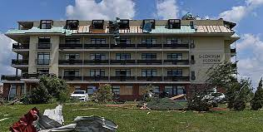
Source: https://1gr.cz/fotky/idnes/21/093/cl6/KRU8c4f74_133803_1742567_1.jpg

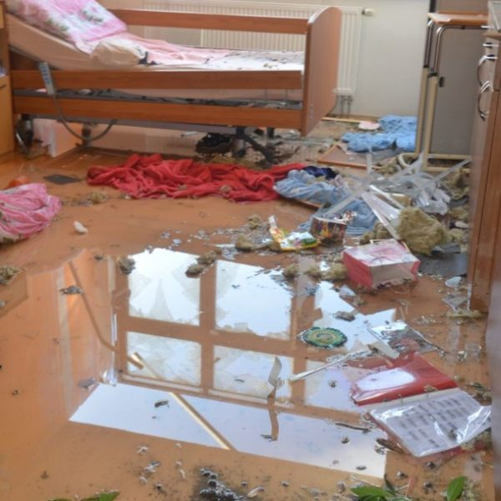
Source:https://www.transparency.cz/wp-content/uploads/2022/04/S-centrum-Hodoni%CC%81n-zdroj-Jihomoravsky%CC%81-kraj-5-600x600.jpeg
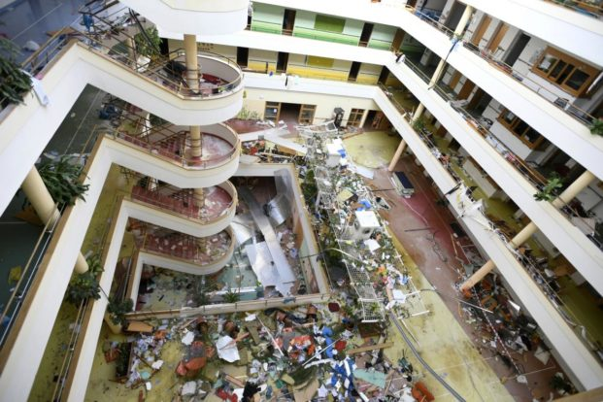
Source:https://www.transparency.cz/wp-content/uploads/2022/04/S-centrum-Hodoni%CC%81m-zdroj-C%CC%8CTK-Michaela-R%CC%8Ci%CC%81hova%CC%81-768x512.jpeg

However, age alone is not the only factor that increases the vulnerability of older people. Other variables include, for example, chronic diseases often associated with older age (diabetes, cardiovascular disease or Alzheimer's disease); the need to use mobility aids or to facilitate visual or hearing impairments; and the regular use of medications (Gibson & Hayunga, 2006). Sociodemographic and psychosocial factors, such as the social network of the older persons, their place of residence or their ability to drive, also influence the level and intensity of risk (Gibson & Hayunga, 2006). The older people are also less likely to receive early warning of a crisis and to be willing to evacuate, increasing the risk of death as a direct result of the event (Cherry et al., 2008). As mentioned by Brown et al. (2012, p. 160), while a physically and psychologically healthy senior with an active social network is vulnerable during a crisis in a similar way to the rest of the population, a frail, socially isolated and homebound senior becomes extremely vulnerable. Vulnerability and risk of injury, post-crisis problems and death is further increased if the senior has a physical or cognitive disability (Maltais, 2019). As the proportion of frail and vulnerable seniors increases, it is imperative that key stakeholders recognize them as a distinct group with specific needs for whom targeted strategies and practices must be developed and implemented to prepare for, cope with, and recover from crisis (Fernandez et al, 2002). Yet, some studies show that stakeholders either count on the self-sufficiency of older people in the event of a crisis (Astill & Miller, 2017) or rely on their active social network in the form of family or community (Brown et al., 2012). However, these assumptions are questionable, as even the material existence of other people around the older person is not necessarily a reliable indicator of the absence of social exclusion (Kuypers & Trute, 1978).

Inspirational practice in the Czech Republic
Although there are no uniform guides on national level in the Czech Republic, a good example is the leaflet for municipalities (Fig. 2) published in 2020 in response to the covid-19 pandemic. The project "Seniors in the Regions: Implementation of Ageing Policy at the Regional Level" is responsible for transferring the ageing strategy into existing regional documents and supporting their implementation (Seniors in the Regions, n. The leaflet entitled Recommended measures (not only) for the older people in municipalities in times of crisis takes the form of a tick list, with the items always further developing the question "Are we covered?". Crisis management, or rather the mayors for whom the leaflet is intended, are given a simplified guide to what should be arranged and prepared in the event of a crisis. The list does not offer solutions and tips in the form of key actions. In addition to having a crisis staff of experts, volunteers and active seniors, other categories cover support and protection for workers (including, for example, the creation of childcare groups), provision of food, protective equipment, pharmaceuticals (including the possibility of e-prescriptions), financial and psychosocial support (including social and psychological counselling for seniors), the involvement of volunteers and the use of community self-help. This includes the possibility of cooperation with other entities, including organisations specialising in working with people with different types of disabilities (e.g. the Association of Volunteer Firefighters, the Czech Red Cross, but also local libraries, shops and NGOs) and the coverage of outreach health and social services (including, for example, the provision of communication between registered and private services and its online form in residential facilities). The section on communication not only with the older persons contains the most items, which includes, among other things, age-friendly aspects of communication, such as "We use a typeface of Arial for the text of leaflets for the older people, with a minimum size of 14." Like previous examples from abroad, this leaflet concludes with resources and web links that stakeholders can draw on when developing their own methodologies.

Fig 2. A leaflet for municipalities
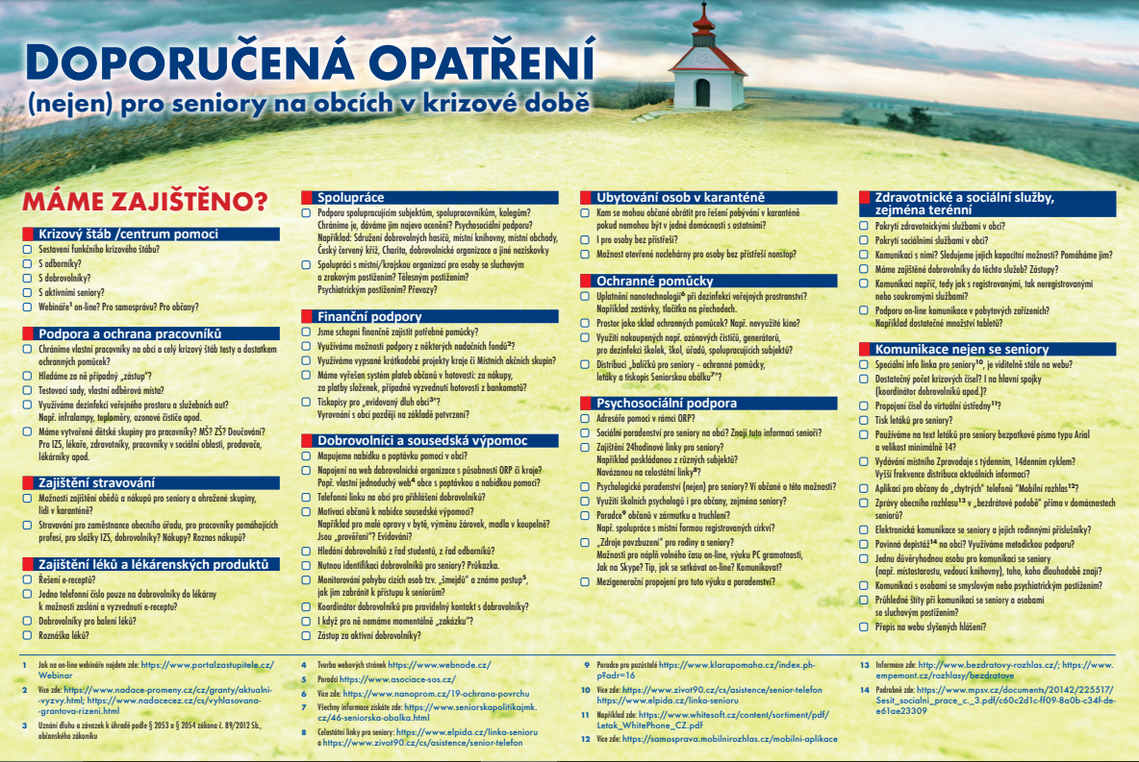

The Fire and Rescue Service of the Czech Republic (HZS CR) offers the possibility for persons who use a special method of emergency call or whose rescue requires special rules and procedures to be applied to register on a special list maintained by the HZS CR. When receiving an emergency call from a registered person, the emergency operator will automatically be shown the specific communication needs of the person (e.g. deaf) or other relevant information that will inform the responding firefighters about the specific needs of the person (e.g. transport of a person in a wheelchair) (HZS JmK, n.d.). Contrary to the recommendations of the professional community, however, seniors with a higher level of care allowance or carers are not explicitly listed in the target groups of this service, although it is of course likely that the sets of listed persons with disabilities and persons of older age may partially overlap. Thus, in practice, when a frail, lonely older person calls, operators must continue to rely on their intuition and judgement as to how challenging and specific a given intervention may be. However, the service may be of particular interest for the possibility to act proactively and to warn of a known threat with an adequate form of communication.

Resources:
Astill, S., & Miller, E. (2017). "We expect seniors to be able to prepare and recover from a cyclone as well as younger members of this community": Emergency management's expectations of older adults residing in aging, remote hamlets on Australia's cyclone-prone coastline. Disaster Medicine and Public Health Preparedness, 12(1), 14-18. https://doi.org/10.1017/dmp.2017.33
Brown, L. M., Gibson, M., Elmore, D. L. (2012). Disaster behavioral health and older adults: American and Canadian readiness and response. In J. L. Framingham & M. L. Teasley (Eds.), Behavioral health response to disasters (pp. 159-174). CRC Press, Taylor & Francis Group.
Czech Statistical Office. (2022, January 14). Seniors in the Czech Republic in Data 2021. https://www.czso.cz/documents/10180/142141241/31003421.pdf/9a7568fd-10f1-4e6e-bfb7-7a9001f6313c?version=1.17
Czech Statistical Office. (2018, November 28). The age composition of the Czech population will change significantly. https://www.czso.cz/csu/czso/vekova-skladba-obyvatel-ceska-se-vyrazne-promeni
Cherry, K. E., Galea, S., Silva, J. L. (2008). Successful aging and natural disasters: Role of adaptation and resiliency in late life. In M. Hersen & A. M. Gross (eds.), Handbook of clinical psychology. Vol. 1: Adults (pp. 810-833). John Wiley.
Ebi, K. L., Vanos, J., Baldwin, J. W., Bell, J. E., Hondula, D. M., Errett, N. A., Hayes, K., Reid, C. E., Saha, S., Spector, J., & Berry, P. (2021). Extreme weather and climate change: population health and health system implications. Annual Review of Public Health, 42(1), 293-315. https://doi.org/10.1146/annurev-publhealth-012420-105026
Fernandez, L., Byard, D., Lin, C., Benson, S., & Barbera, J. (2002). Frail elderly as disaster victims: Emergency management strategies. Prehospital and Disaster Medicine, 17(2), 67-74. https://doi.org/10.1017/S1049023X00000200
Gibson, M. J., & Hayunga, M. (2006). We can do better: lessons learned for protecting older persons in disasters. AARP.
Grant, M. J., & Booth, A. (2009). A typology of reviews: an analysis of 14 review types and associated methodologies. Health Information and Libraries Journal, 26, 91-108. https://doi.org/10.1111/j.1471-1842.2009.00848.x
Fire Rescue Service of the South Moravian Region. (n.d.). Records of persons with special needs. https://www.hzscr.cz/clanek/sluzby-pro-verejnost-evidence-osob-se-specifickymi-potrebami-evidence-osob-se-specifickymi-potrebami.aspx?fbclid=IwAR09TfaIxfUv4g9J9J6njx6Ti5DIqkJv9Ckf1rObg2G7BU3V2uZrNSkqsK0
Klinenberg, E. (2002). Heat Wave: A Social Autopsy of Disaster in Chicago. University of Chicago Press.
Kulcsar, A. (2013, December 5). Older people disproportionately affected byTyphoon Haiyan. HelpAge International. https://www.helpage.org/newsroom/latest-news/older-people-disproportionately-affected-by-typhoon-haiyan/
Kuypers, J. A., & Trute, B. (1978). The Older Family as the Locus of Crisis Intervention. The Family Coordinator, 27(4), 405-411. https://doi.org/10.2307/583444
Kwan, C., & Walsh, C. A. (2017). seniors' disaster resilience: A scoping review of the literature. International Journal of Disaster Risk Reduction, 25, 259-273. https://doi.org/10.1016/j.ijdrr.2017.09.010
Maltais, D. (2019). Elderly people with disabilities and natural disasters: Vulnerability of seniors and post trauma. Journal of Gerontolgy & Geriatric Medicine, 5(4), 1-7. http://doi.org/10.24966/GGM-8662/100041
Ostrava City Police. (2023, January 13). The Senior Line continues to fulfil its mission. https://mpostrava.cz/1323-senior-linka-i-nadale-plni-sve-poslani
Ostrava City Police. (2016, December 29). Senior line. https://mpostrava.cz/caste-dotazy/senior-linky
Nishikawa-Pacher, P. (2022). research questions with PICO: A universal mnemonic. Publications, 10(3), 21. https://doi.org/10.3390/publications10030021
Seniors in the regions. (n.d.). Recommended actions (not only) for seniors in communities in times of crisis. https://seniorivkrajich.mpsv.cz/wp-content/uploads/2021/01/2020_Letak_obce.pdf
Wilson, N. (2006). Hurricane Katrina: Unequal opportunity disaster. Public Policy & Aging Report, 16(2), 8-13. https://doi.org/10.1093/ppar/16.2.8

Grant support / Funding: This work was carried out within the framework of the project "National Institute for Research on Socioeconomic Impacts of Diseases and Systemic Risks SYRI", No. LX22NPO5101, funded by the European Union - Next Generation EU (MoEYS, NPO: EXCELES), and its interdisciplinary sub-project "Health System Efficiency" (https://www.syri.cz/vyzkum/efektivita-zdravotniho-systemu).

