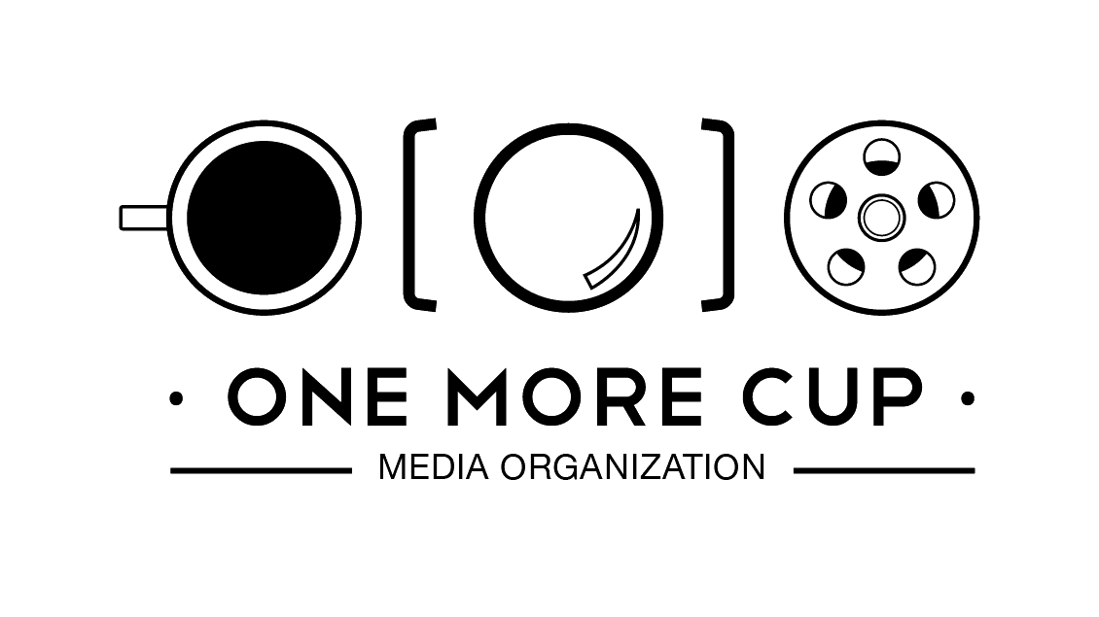
Submission: report on Colonialism and SOGIESC.

It's pivotal to comprehend the multifaceted impact of colonization on individuals of diverse Sexual Orientations, Gender Identities and Expressions, and Sex Characteristics (SOGIES). Within countries such as Egypt, Tunisia, Lebanon, Syria, Palestine, Iraq, and Jordan, personal experiences can be enormously disparate. The persistent struggles for recognition, rights, and acceptance of the LGBTIQA+ community are molded by an amalgamation of historical, cultural, religious, and political factors that define each nation's distinctive milieu.
Throughout the colonial epoch, the sway of European powers brought an imposition of Western standards and values, including inflexible norms related to gender and sexuality. These colonial directives led to the marginalization and stigmatization of individuals with diverse SOGIES, as they deemed same-sex relationships and non-binary gender identities as taboo or criminal.
Exploring the questions within the context of SWANA countries and the impact of colonialism on sexual orientation and gender identity would require a comprehensive analysis and research of each country's historical and legal framework. The responses to these questions involve an in-depth examination of historical records, legal documents, scholarly research, and the experiences of marginalized communities. It's beyond the scope of our financial capacities and lack of research funds to address these questions adequately. Although we find this topic critical to advance the rights of people with diverse SOGIESC in the region, we have been searching for research funds to do this extensive research which would take around six months for each country. It felt like an unapproachable dream, but now finding you asking these critical questions that their answers would be the key for us to advance the rights through advocacy strategies that understand the roots of the problem to advocate for equality for all.
Yes, indeed, the imposition and enforcement of colonial laws or policies significantly altered pre-colonial perceptions and treatments of sexual orientation and gender identity. This paper provides a detailed account of certain policies and laws that instigated these changes in Egypt: https://www.hrw.org/reports/2004/egypt0304/9.htm
The impact of colonial policies was not limited to Egypt. Other regions were similarly influenced by colonial-era cisgender men, many of whom were significant figures in the medical or cultural sectors. Their contributions, often rooted in homophobia, played a substantial role in shaping the contemporary attitudes and treatment of the LGBTQ+ community.
Not only did colonial policies affect Egypt in particular, but colonial cis-men in other medical or cultural figures also aided the current situation with their homophobic contributions. A striking example of this continued influence is Egypt's use of invasive "anal tests," a practice employed by the government to identify and subsequently prosecute men who have sex with men. Tragically, there have been instances where the police have killed individuals under investigation for such allegations.
As for historical or anecdotal evidence about the treatment of gender and sexual diversity before the experiences of colonization, it is quite diverse and complex, depending largely on specific cultures and regions. However, a comprehensive analysis of such evidence is beyond the scope of this text.
The practice of using anal tests to identify gay men was a deeply troubling aspect of history, and one notable figure associated with it was Dr. Félix Broussais, a French physician. During the colonial period, including the French colonial rule in parts of North Africa, Broussais played a role in implementing and enforcing discriminatory laws targeting homosexuality. He championed using anal examinations, known as "anal tests," to detect and incriminate men suspected of engaging in same-sex sexual activity. This invasive and degrading procedure was based on the erroneous assumption that the physical characteristics of a person's anus could reveal their sexual orientation. The legacy of Broussais and other medical professionals who advocated for and conducted these tests stands as a stark reminder of the harmful medicalization of homosexuality and the violation of human rights. It is essential to acknowledge and learn from this dark chapter in history to ensure the protection and respect of the rights of LGBTIQA+ individuals today and in the future.
Tunisia still suffers from this practice; although it is banned legally, it has been used against people who refuse to undergo it. In Lebanon, it was abolished with the help of an advocacy campaign from Helem when Dr Charbel Maydaa was the director of the organization, and the intelligent mobilization of other stakeholders, such as the media and syndicate of doctors at the time, played a significant role in abolishing the anal exams.
Check this advocacy campaign for more evidence and victims' testimonials, a campaign produced by 1MORECUP media organization
https://www.facebook.com/MOSAIC.MENA/videos/interview-with-health-expert-regarding-anal-examinations/797796837504348/
https://www.facebook.com/MOSAIC.MENA/videos/interview-with-legal-expert-regarding-anal-examinations/268997131396445/
https://youtu.be/o6SRe5WqNuw

On May 11, 2001, Egyptian authorities raided the Queen Boat, which was docked on the Nile River. The boat was known as a gathering place for the LGBTQ+ community in Cairo. As a result of the raid, over fifty individuals were arrested and charged with "habitual debauchery" and "contempt of religion." The charges were based on Egyptian law, which criminalizes homosexuality under the broad interpretation of "habitual debauchery."
The arrests and subsequent trial attracted international attention and condemnation from human rights organizations. The trial was marked by concerns of due process violations, including allegations of torture and mistreatment of the defendants. The case highlighted the ongoing persecution and discrimination faced by LGBTQ+ individuals in Egypt.
In 2002, the court delivered its verdict, sentencing the defendants to various prison terms ranging from one to five years. The case drew widespread criticism from human rights organizations, which denounced the arrests, the trial, and the criminalization of consensual same-sex activity.
The Queen Boat incident significantly impacted the LGBTIQA+ community in Egypt, further contributing to a climate of fear, discrimination, and stigmatization. It served as a stark example of the legal and social challenges faced by LGBTIQA+ individuals in Egypt. It highlighted the urgent need to reform the country's laws and policies concerning sexual orientation and gender identity.
Let's bear in mind that the queen boat had political gains as The lead defendant, Sherif Farhat, was a businessman related by blood and marriage to eminent Egyptians. State Security officers arrested him weeks before the others. Many of Farhat's family believe he was the victim of a political vendetta aimed at his relatives. One defendant jailed with him says Farhat, in prison, called the trial "a revenge match between two big families in the country." What is certain is that prosecutors built up a story of a conspiratorial homosexual group around Farhat, using it to discredit him—and fifty-two other men.
The trial's effects, though, spread beyond Farhat's wrecked reputation or his inadvertent co-defendants' devastated lives. Homosexuality abruptly became visible in Egyptian society and politics as a vociferously condemned corruption.
Reference: In a Time of Torture: The Assault on Justice in Egypt's Crackdown on Homosexual Conduct | HRW. https://www.hrw.org/report/2004/02/29/time-torture/assault-justice-egypts-crackdown-homosexual-conduct
https://www.hrw.org/reports/2004/egypt0304/3.htm#_ftnref47

In Egypt, political forces found a way to manipulate the lives of people with diverse sexual orientations, gender identities, and sex characteristics (SOGIESC) without their consent. In stark contrast to any local government, the invading forces exploited these diverse individuals for their own political ends. Merely two years later, this dark pattern repeated on an even larger stage – the 2003 US-British invasion of Iraq.
As the dust of the invasion began to settle in May 2003, voices of dissent rose in America. Among these were activists from the LGBTIQA+ community, who walked shoulder to shoulder on the streets, protesting the war. That year, the world saw an unprecedented wave of legal changes that significantly impacted the lives of LGBT people. As many as 76 such changes took place globally, including 37 notable modifications within the United States – a country recovering from the aftershocks of the invasion.
Looking back, the previous year, 2002, had seen only 16 such legal shifts on the international stage, one of which was Sweden opening the door to same-sex adoption.
Yet, amid this progress, a disturbing trend was emerging. In the infamous Abu Ghraib prison, homosexual acts were weaponized as a form of violence, fueling regional homophobia and stating that the word GAY is a Western agenda and a violent term. These instances, viewed as acts of dominance and a nefarious colonial agenda, led to a horrific increase in violence against the LGBTIQA+ community in the area.
I would direct you to Abu Ghraib Torture and Prisoner Abuse:
https://www.amnesty.org/en/wp-content/uploads/2021/09/amr510772004en.pdf
Thanks for taking the time to ask yourselves and us these crucial questions. These inputs and answers matter to us and to a range of people who can't be their authentic selves under what colonialism did and is doing to them.
We hope that we have given you an insight into the impact and the reality, and we expect more research will come to tackle necessary yet essential steps that need to be taken in order to advance the diverse SOGIESC lives in the region and the world.
"People with diverse SOGIESC in the SWANA region not only live in fear and ignorance but, most importantly, despair."

Report by 1MORECUP media organization

