CHECK AGAINST DELIVERY

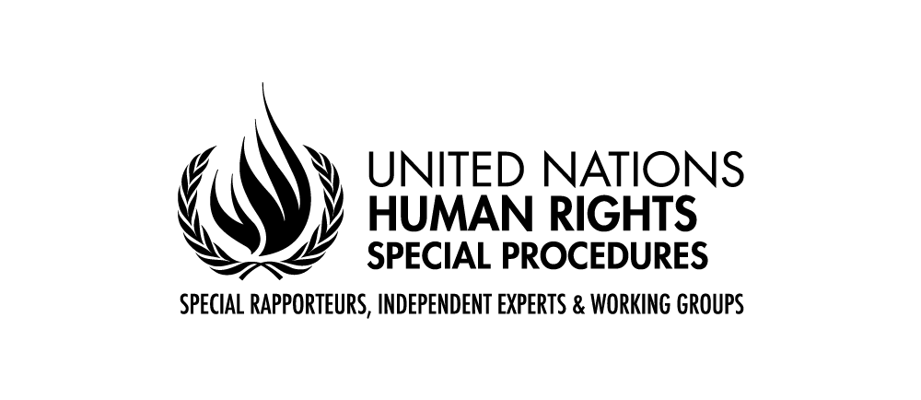

Human Rights Council Resolution 38/18
-
First Intersessional Seminar
9-10 April 2019, Geneva, Palais des Nations room XVI

Statement by Dainius Puras
Chairperson of the Coordination Committee of Special Procedures

Geneva, 10 April 2019
Mr. Chair,
Ladies and gentlemen,
I am grateful for this opportunity to address the prevention role of the Human Rights Council and how special procedures contribute to it. It is indeed crucial for special procedures to be involved in this discussion as we are a very important tool of this Council in relation to prevention. Our reflection should explore how to use this potential in a more strategic way and ensure that all the means at our disposal are used.
(1)
In preparation of this event I have asked my colleagues to share their thoughts on the preventive role of special procedures. The contributions received confirmed that prevention indeed is part and parcel of the work of special procedures.
Several of my colleagues confirmed that prevention is one of the goals in the implementation of their mandate. Actually the prevention dimension is mentioned explicitly in several mandates, such as the ones on disappearances, racism or albinism. Several of my colleagues have a specific prevention strategy and have addressed the concept of prevention in several reports and recommendations. The prevention aspect is also integrated in their country visits.
The system of special procedures is composed of 56 mandates, covering all sets of rights. This represents a wealth of expertise and prevention potential concentrated in a group of 80 dedicated individuals looking at human rights issues worldwide.
Special procedures are the most accessible human rights mechanism and receive ‘warnings’ daily from people from all around the world. Through their visits or contact with all stakeholders, they are often the first to observe the initial signs of an emerging crisis. Thematic special procedures are able to address concerns in any country, as their reach does not depend on treaty ratification. The attention of country mandates is confined to the country they are established to address, but they are able to address a broad range of issues in the country and act at any time.
More concretely, in average special procedures conduct approximately 60 to 80 visits to countries per year. They also address individual cases or legislative developments by sending around 500 to 600 communications per year covering all regions of the world. These communications can indicate patterns of violations and the nature and scale of violations. They are also helpful in that they allow human rights concerns to be raised at an early stage. Similarly, thematic reports can contribute to greater understanding of complex situations. These reports also address topics that contribute to prevention and early warning. This could give the UN useful tools to understand and prevent emerging crisis. The public and collective actions of special procedures have also the power to alert the international community and call for appropriate action.
In addition, their capacity to assist States through the provision of expert advice on implementation of human rights obligations has an important preventative role.

Hence, mandate holders can, and do, alert the international community to emerging issues or crises through the tools that they have at their disposal, be they their reports; country visits; communications; public statements; and collective action, including through their Coordination Committee.
(2)
I have received several examples from colleagues about how concretely their mandates have contributed to the prevention of human rights violations. Given the time constraints I will not be able to present all of them today. I can do so in writing if it helps. However all these examples highlighted common experiences and practices:
- Several of these examples relate to the situation of individuals and groups that have improved following actions taken by mandate holders.
- The work on legislations with the country concerned has also been identified as a successful prevention tool.
- The engagement with the country concerned on follow-up to the recommendations issued by mandate holders has also often born fruit.
- Several new instruments and guidelines have been developed also at the initiative of SP which had a prevention impact.
- The identification of good practices has also proven useful from a prevention perspective.
- There are several examples of cases where the HRC acted following information shared by SP be it on thematic issues such as the food crisis and privacy or country situations such as Burundi or Myanmar.
  - An important part of this thematic work is based on the work of special procedures. For example it was a special rapporteur who raise the alarm about the unfolding food crisis in 2008, SP were among the first to draw attention to the emerging risks affecting the right to privacy. Special procedures were also among the first to address issues related to new technologies such as the issue of drones and autonomous weapons and their impact on human rights.
  - In recent years calls by special procedures that were followed by HRC action include the Central African Republic, Sri Lanka, Burundi, South Sudan or Myanmar.
(3)
Mr. Chair,
Special procedures have consistently played an important role in prevention and early warning, sounding the alarm on emerging crises. Back in 1994 in Rwanda, the then Special Rapporteur on extrajudicial, summary or arbitrary executions forewarned of a potential genocide, and, more recently, mandate holders warned about emerging concerns in relation to Burundi, the Central African Republic and Myanmar, for example. Over the years, the system has taken early action in relation to several country situations. Aside country situations, special procedures also raised alarm about worrying developments on thematic issues such as climate change, migration or the need to protect human rights in the fight against terrorism and the shrinking space for civil society.
While there is no doubt on the ability of special procedures to identify risks of violations and give early warning of emerging developments or crisis, the challenge has been to ensure that the UN system and Member States properly act on such information.
The question is therefore how to fully realize the prevention potential of special procedures and overcome possible bottlenecks?
The problem is not the availability of or access to information. What is lacking is ensuring appropriate and timely attention and discussion on the issues raised by mandate holders.
Early warning signs identified by the different human rights mechanisms need to reach the political and conflict-prevention bodies of the UN. Effective channels of communication are needed between different parts of the UN system to enable decision makers to take appropriate and timely action.
Special procedures have increased their engagement with other UN bodies and representatives. They have done so individually but also as a system. The Coordination Committee has invested efforts in promoting the SP system throughout the UN and these efforts have proven successful as demonstrated by the engagement of some of my colleagues with the Security Council, the Peace Building architecture, the SDGs architecture or more generally UN country teams. Recent example of this engagement include a letter sent by the CC Chair to the Security Council sharing information about the work of special procedures that is deemed pertinent to the work of the Security Council in terms of country and thematic issues. The idea would be to develop similar engagement with other bodies and processes, such as the SDGs. We hope that the Council will continue to support such efforts.
Follow-up to SP recommendations is another area that deserves strong attention by States, by mandate holders and by the Council as a whole as it will undoubtedly maximize the preventive potential of this body. SP have developed various follow-up tools. However implementation of recommendations is primarily the responsibility of States which should give the same attention to recommendations stemming from all human rights mechanisms. In this context, the fact that some States have established national mechanisms to follow up to all recommendations is welcome. This Council should also provide for sufficient time and space for States to share more systematically information on measures taken to implement human rights recommendations with the Council. The Council agenda item 5 provides a good opportunity to do so.
It has also to be stressed that prevention should cover all human rights, including economic, social and cultural rights. History has indeed shown that the roots of many conflicts are often based on inequalities, discrimination or economic crisis.
(4)
I would like to conclude with a few more recommendations for discussion with the main objective to ensure the integration of a prevention perspective.
- An issue that has often been raised in relation to country visits is that the related reports are often presented a long time after the visit. The HRC could look at ways to have these reports presented earlier or at least allowing the concerned mandate holders to share their recommendations in a more flexible manner. For example, should the Council have a discussion or hear a report by the High Commission on a country, it would be useful to invite mandate holders who recently visited that country. The example of Pablo de Greiff, the then Special Rapporteur on truth and transitional justice, participating in the presentation of the report of the HC on Sri Lanka last year is a very good precedent in that context. The advantage of SP in comparison to other mechanisms is that they don’t follow a strict cycle and can intervene anytime and engage with any country. This asset should be used better by the Council.
- There is a need for a better connection and exchange of information among human rights mechanisms. For example the involvement of mandate holders in the UPR review could be considered, especially those who have engaged with the country concerned on follow-up.
- Given their specific focus on a theme or a country, special procedures elaborate precise and concrete recommendations and are available for a continued dialogue with States to assist them in the implementation. This aspect should be used better by States and HRC.
- Issues of cooperation with SP, or lack thereof, should also be used as a criteria for prevention. It is indeed usually a worrying sign if a State does not engage with human rights mechanisms. The HRC should look at this issue more closely in a prevention angle.
- The HRC should create a space where States can share their experience and challenges in relation to human rights and the implementation of human rights recommendations, without stigmatisation, possibly with participation of relevant mandate holders. SP should do their parts by sharing more positive stories and achievements.
- In this context, efforts should also be made to demonstrate that the HR system has an added value for other UN bodies. In this context, HRC resolutions, SP recommendations and other outputs should also propose solutions and not only identify the problems. SP are currently working on collecting better the good stories on how they impacted positively on the peace and security and development areas, including at the country level. An essential part of a prevention strategy is indeed to accompany the States in the process of improvement of the HR situation and implementation of HR recommendations. SP can play a role here as shown by the experience of several of my colleagues who engaged with several States in this context.
- Prevention cannot occur in isolation. Cooperation and partnership with other bodies and stakeholders at the international, regional and national level should be part of a prevention strategy. SP have a key role to play in bridging the gap with other UN entities and other stakeholders, but also with stakeholders at the national level.
Through their mandate SP are actively engaging with various actors outside Geneva and New York. Not only through our official visits, but also through the multiple events, consultations and workshops they organise in various countries, they are contributing to bringing the UN human rights system closer to the people on the ground. This capacity to reach out at all levels and to bring these perspectives back to the UN is one of the main added values of SP. In the implementation of their mandate, all my colleagues are engaging with specific UN agencies or bodies and several intergovernmental bodies. This flexible access to stakeholders is a clear advantage for prevention and should be exploited better.
- SP are quite innovative in their approach. For example, they have progressively engaged with non-traditional stakeholders, including non-state actors, such as the business sector. This is one of the assets of the system that should be preserved as engaging with non-traditional stakeholders will certainly contribute to an effective prevention strategy.
My colleagues and I look forward to a continued discussion with all of you on this important issue.
Thank you

