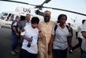

UN Photo/Olivier Chassot
Ibrahim Gambari (centre), Joint Special Representative for the African Union-United Nations Hybrid Operation in Darfur (UNAMID), embraces two South African UNAMID peacekeepers, who along with two colleagues, were abducted 16 days ago near their private quarters in South Darfur. Mr. Gambari traveled to Nyala to meet the staff members, all of whom were released. Behind Mr. Gambari are Mohamed Yonis (second from left), his Deputy for Operations and Management, and Micheal J. Fryer (left), UNAMID Police Commissioner.
26 April 2010
Nyala, Sudan

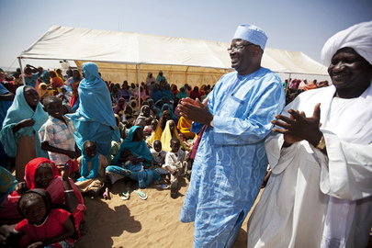

UN Photo/Albert González Farran
Ibrahim Gambari (standing second from right), Joint Special Representative for the African Union-United Nations Hybrid Operation in Darfur (UNAMID), visits a camp for internally displaced persons (IDPs) in Shangil Tobaya, North Darfur. Mr. Gambari met with UNAMID officers there and IDP leaders.
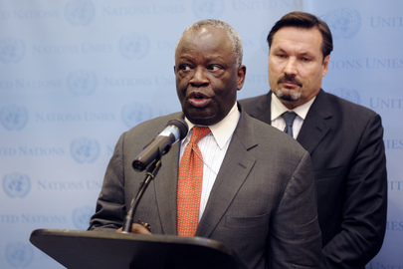
23 November 2010
Shangil Tobaya, Sudan

UN Photo/Ky Chung
Ibrahim Gambari, Joint Special Representative for the African Union-United Nations Hybrid Operation in Darfur (UNAMID), briefs reporters following the ninth Tripartite (African Union-United Nations-Sudan) Coordination Mechanism meeting on Darfur. Behind Mr. Gambari is his Deputy, Georg Charpentier.
27 September 2010
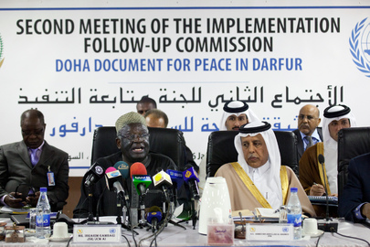

UN Photo/Albert González Farran
Ibrahim Gambari (front, left), Joint Special Representative for the African Union-United Nations Hybrid Operation in Darfur (UNAMID), speaks at the second meeting of the Implementation Follow-Up Commission on the Doha Document for Peace in Darfur (DDPD), chaired by the Government of Qatar, in El Fasher, Sudan. Next to Mr. Gambari is Ahmed bin Abdullah Al Mahmoud, Qatar’s Minister of State for Cabinet Affairs.
16 January 2012
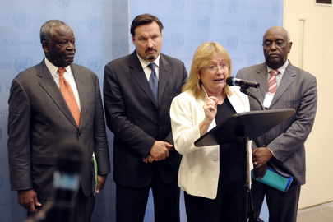

UN Photo/Ky Chung
Susana Malcorra, Under-Secretary-General for Field Support, briefs reporters following the ninth Tripartite (African Union-United Nations-Sudan) Coordination Mechanism meeting on Darfur. Ms. Malcorra is joined by Ibrahim Gambari (left), Joint Special Representative for the African Union-United Nations Hybrid Operation in Darfur (UNAMID), and Mr. Gambari’s Deputy, Georg Charpentier (second from left).
27 September 2010
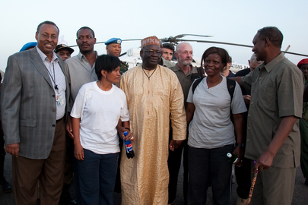

UN Photo/Olivier Chassot
Ibrahim Gambari (centre), Joint Special Representative for the African Union-United Nations Hybrid Operation in Darfur (UNAMID), and Mohamed Yonis (left), Deputy Joint AU-UN Special Representative for Operations and Management, greet four South African UNAMID staff, two women and two men, who were abducted near their private quarters in South Darfur and held in captivity for 16 days. Mr. Gambari and Mr. Yonis traveled to Nyala, Sudan, to meet the peackeepers upon their return.
26 April 2010
Nyala, Sudan
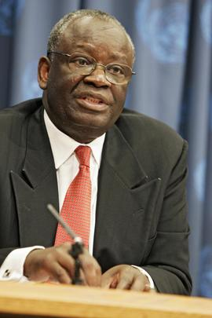

UN Photo/Mark Garten
Under-Secretary-General for Political Affairs Ibrahim Gambari speaking to reporters today at UN Headquarters during his first press conference since his appointment last month. Gambari, formerly Annan's Special Adviser on Africa, said long-term aid for Africa must remain at the top of the agenda for Britain's Prime Minister Tony Blair and the leaders of the world's other industrial powers meeting in Gleneagles, United Kingdom, despite the "barbaric" terrorist attacks in London earlier today.
07 July 2005
United Nations, New York
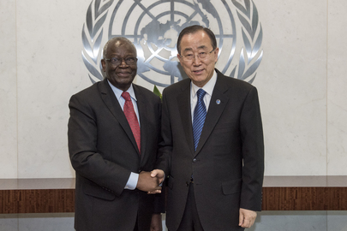

UN Photo/Cia Pak
Secretary-General Ban Ki-moon (right) meets with Ibrahim Gambari, Nigerian scholar, diplomat and former Head of the African Union-UN Hybrid Operation in Darfur (UNAMID).
29 September 2016
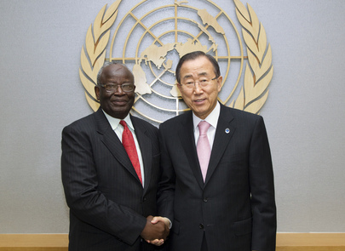
United Nations, New York

UN Photo/Rick Bajornas
Ibrahim Gambari (left), outgoing Joint African Union-United Nations Special Representative for Darfur and Head of the AU-UN Hybrid Operation in Darfur (UNAMID), pays a farewell call on Secretary-General Ban Ki-moon.
03 October 2012
United Nations, New York

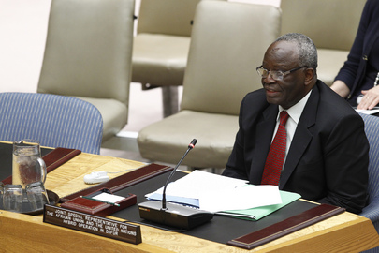

UN Photo/JC McIlwaine
Ibrahim Gambari, Joint African Union-United Nations Special Representative for Darfur and Head of the AU-UN Hybrid Operation in Darfur (UNAMID), briefs the Security Council.
24 July 2012
United Nations, New York
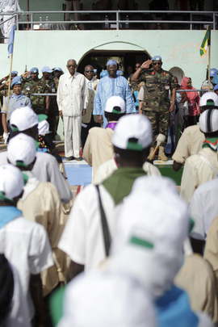

UN Photo/Olivier Chassot
UNAMID Joint Special Representative, Ibrahim Gambari (centre) with the UNAMID Force Commander, Lieutenant General Patrick Nyamvumba (right) and a representative of the Government of Sudan (left) during a military and police parade for United Nations Day 2011, in El Fasher, Sudan.
24 October 2011
El Fasher, Sudan
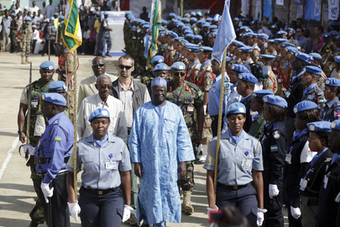

UN Photo/Olivier Chassot
UNAMID Joint Special Representative, Ibrahim Gambari (centre) with the UNAMID Force Commander, Lieutenant General Patrick Nyamvumba (right) and a representative of the Government of Sudan (left) during a military and police parade for United Nations Day 2011, in El Fasher, Sudan.
24 October 2011
El Fasher, Sudan

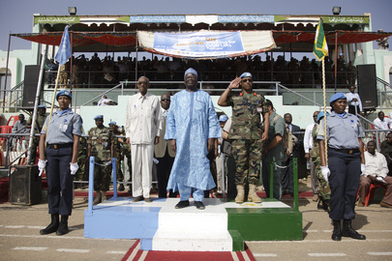

UN Photo/Olivier Chassot
UNAMID Joint Special Representative, Ibrahim Gambari (centre) with the UNAMID Force Commander, Lieutenant General Patrick Nyamvumba (right) and a representative of the Government of Sudan (left) during a military and police parade for United Nations Day 2011.
24 October 2011
El Fasher, Sudan
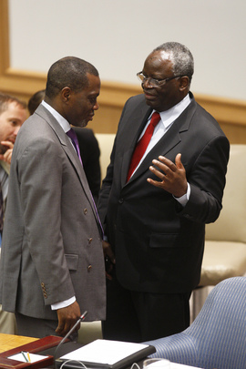

UN Photo/Rick Bajornas
Ibrahim Gambari (right), Joint African Union-United Nations Special Representative for Darfur, and Nelson Messone, Permanent Representative of Gabon to the United Nations, exchange views before the start of the Security Council meeting.
22 July 2011
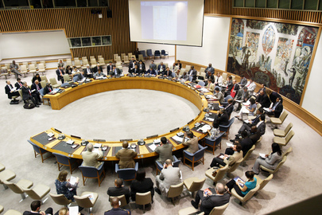
United Nations, New York

UN Photo/Rick Bajornas
A wide view of the Security Council. Ibrahim Gambari, Joint African Union-United Nations Special Representative for Darfur, stresses that the imperative for peace in Sudan is now as the people of Darfur have suffered too long.
22 July 2011

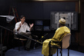

United Nations, New York
UN Photo/Eskinder Debebe
Ibrahim Gambari, Joint Special Representative for the African Union-United Nations Hybrid Operation in Darfur (UNAMID), is interviewed by Ari Gaitanis for UN News Service, UN Radio and UNTV.
21 July 2011
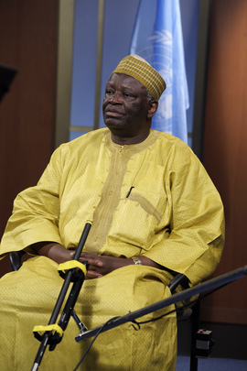
United Nations, New York

UN Photo/Eskinder Debebe
Ibrahim Gambari, Joint Special Representative for the African Union-United Nations Hybrid Operation in Darfur (UNAMID), listens to the UN reporter interviewing him for UN News Service, UN Radio and UNTV.
21 July 2011
United Nations, New York

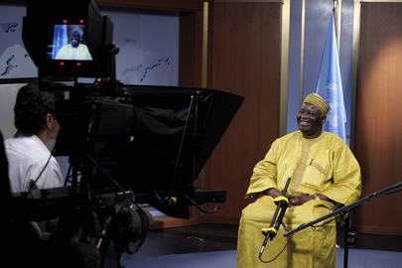
UN Photo/Eskinder Debebe
brahim Gambari, Joint Special Representative for the African Union-United Nations Hybrid Operation in Darfur (UNAMID), is interviewed by Ari Gaitanis for UN News Service, UN Radio and UNTV.
21 July 2011
United Nations, New York

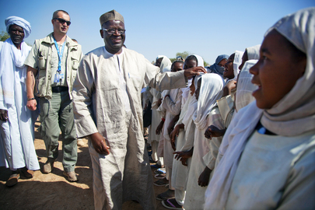

UN Photo/Albert González Farran
Ibrahim Gambari (front), Joint Special Representative for the African Union-United Nations Hybrid Operation in Darfur (UNAMID), pays a visit to students at the Oumoul Mouminina School in Forobaranga, West Darfur, Sudan.
24 January 2011
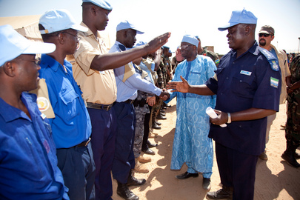
Forobaranga, Sudan

UN Photo/Albert González Farran
Ibrahim Gambari (third from right), Joint Special Representative for the African Union-United Nations Mission in Darfur (UNAMID), visits Tawila camp site and meets UNAMID staff and Internally Displaced Persons (IDPs).
23 November 2010
Tawila, Sudan
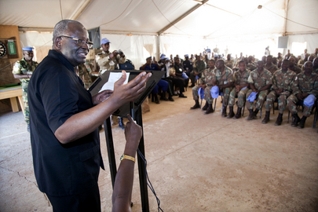

UN Photo/Albert González Farran
Ibrahim Gambari, Joint Special Representative for the African Union-United Nations Hybrid Operation in Darfur (UNAMID), addresses officers at UNAMID’s team site in Malha, North Darfur.
22 November 2010
Malha, Sudan

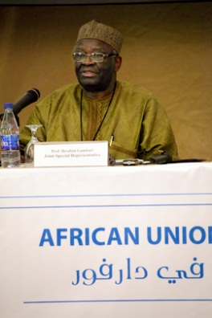

UN Photo/Albert González Farran
Ibrahim Gambari, Joint Special Representative for the African Union-United Nations Hybrid Operation in Darfur (UNAMID), holds a press conference at the Rotana Hotel in Khartoum, Sudan.
14 November 2010
Khartoum, Sudan
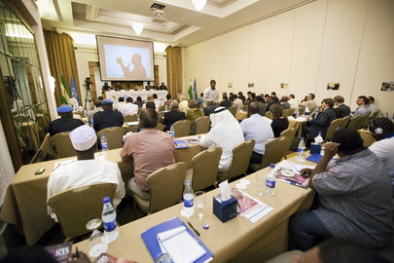

UN Photo/Albert González Farran
Wide view of a press conference given by Ibrahim Gambari, Joint Special Representative of the African Union-United Nations Hybrid Operation in Darfur (UNAMID).
14 November 2010
Khartoum, Sudan
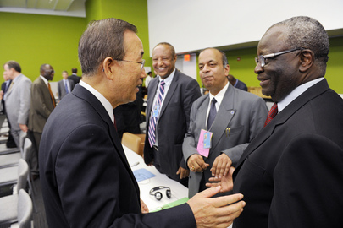

UN Photo/Eskinder Debebe
Secretary-General Ban Ki-moon (left) converses with Ibrahim Gambari, Joint Special Representative for the African Union-United Nations Hybrid Operation in Darfur (UNAMID), at the Ministerial Meeting on Sudan held at UN Headquarters.
24 September 2010
United Nations, New York

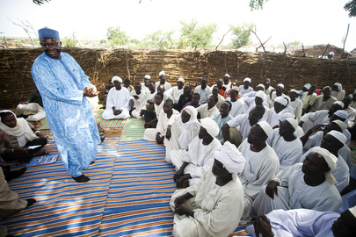

UN Photo/Albert González Farran
Ibrahim Gambari (standing), Joint Special Representative for the African Union-United Nations Hybrid Operation in Darfur (UNAMID), meets with local Sudanese sheiks at Mornei Internally Displaced Persons (IDP) Camp in El Geneina, West Darfur.
22 August 2010
El Geneina, Sudan
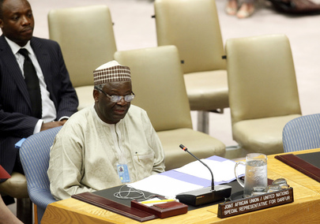

UN Photo/JC McIlwaine
Ibrahim Gambari, Joint Special Representative for the African Union-United Nations Hybrid Operation in Darfur (UNAMID), reports on the situation in Darfur and progress achieved by UNAMID.
27 July 2010
United Nations, New York

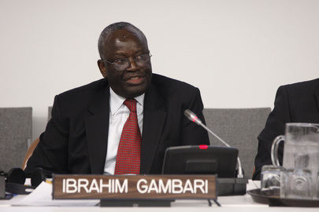

UN Photo/Eskinder Debebe
Ibrahim Gambari, Joint Special Representative for the African Union-United Nations Hybrid Operation in Darfur (UNAMID), addresses the General Assembly's thematic debate, "United Nations Peacekeeping: Looking into the Future".
22 June 2010
United Nations, New York

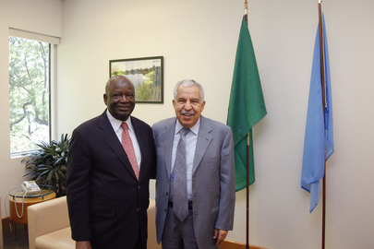

UN Photo/Evan Schneider
Ali Abdussalam Treki (right), President of the sixty-fourth session of the General Assembly, meets with Ibrahim Gambari, Joint Special Representative for the African Union-United Nations Hybrid Operation in Darfur (UNAMID).
15 June 2010
United Nations, New York
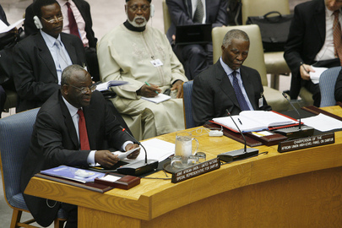

UN Photo/Evan Schneider
Ibrahim Gambari, Joint Special Representative for the African Union-United Nations Hybrid Operation in Darfur (UNAMID), presents to the Security Council the latest reports of the Secretary-General on the Sudan.
14 June 2010
United Nations, New York
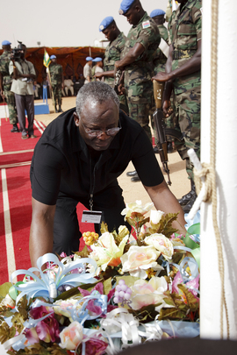

UN Photo/Olivier Chassot
Ibrahim Gambari, Joint Special Representative for the African Union-United Nations Hybrid Operation in Darfur (UNAMID), lays a bouquet of flowers in honour of the International Day of United Nations Peacekeepers, in El Fasher, Sudan.
30 May 2010
El Fasher, Sudan

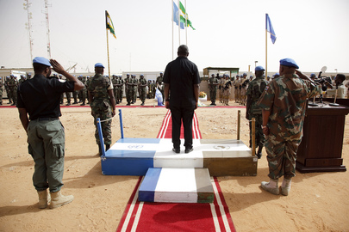

UN Photo/Olivier Chassot
Ibrahim Gambari (centre, on platform), Joint Special Representative for the African Union-United Nations Hybrid Operation in Darfur (UNAMID), leads UNAMID officers in a ceremony honouring the International Day of United Nations Peacekeepers in El Fasher, Sudan.
30 May 2010
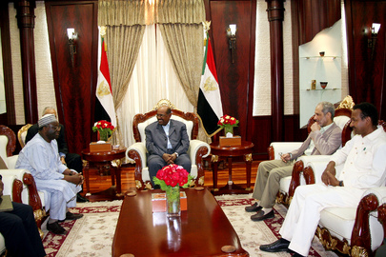
El Fasher, Sudan

UN Photo
Ibrahim Gambari (left), Joint Special Representative for the African Union-United Nations Hybrid Operation in Darfur (UNAMID), and senior UNAMID staff meet with Omer Hassan A. Al-Bashir (centre), President of the Republic of the Sudan, and members of Mr. Al-Bashir's government.
25 April 2010
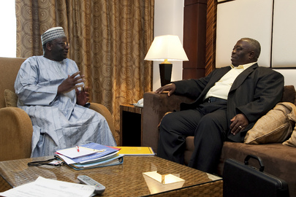
Sudan

UN Photo/Olivier Chassot
Ibrahim Gambari (left), newly-arrived Joint Special Representative for the African Union-United Nations Hybrid Operation in Darfur (UNAMID), meets with Henry Anyidoho, Deputy Joint Special Representative for UNAMID, in Khartoum, Sudan.
23 January 2010
Khartoum, Sudan

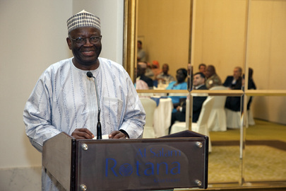

UN Photo/Olivier Chassot
Ibrahim Gambari, new Joint Special Representative for the African Union-United Nations Hybrid Operation in Darfur (UNAMID), speaks at a luncheon hosted by Nigerian Ambassador to Sudan Salihu Ahmed-Sambo, in Khartoum, Sudan.
23 January 2010
Khartoum, Sudan
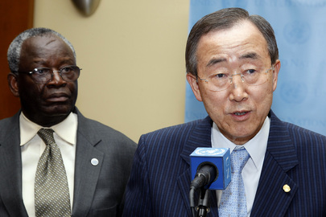

UN Photo/Paulo Filgueiras
Secretary-General Ban Ki-moon (right) briefs correspondents following a meeting of the Group of Friends on Myanmar, as Ibrahim Gambari, Special Adviser to the Secretary-General on Myanmar, looks on.
05 August 2009
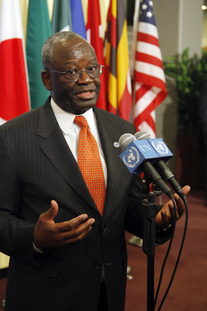
United Nations, New York

UN Photo/Eskinder Debebe
Ibrahim Gambari, Special Adviser on the International Compact with Iraq and Other Political Issues, briefs the media following the Security Council consultations on Myanmar and other matters.
20 February 2009
United Nations, New York
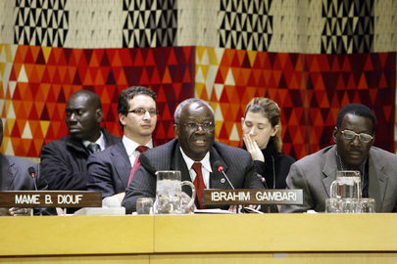

UN Photo/Mark Garten
Ibrahim Gambari, Special Adviser of the Secretary-General on the International Compact with Iraq and Other Political Issues, addresses a meeting to launch the "Third World Black Arts Festival."
14 January 2009
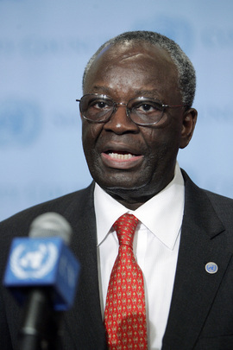
United Nations, New York

UN Photo/Ryan Brown
Ibrahim Gambari, Special Adviser of the Secretary-General on the International Compact with Iraq and Other Political Issues, briefs journalists following the Security Council consultations on the latest developments in Myanmar and his recent trip to that country.
11 September 2008
United Nations, New York
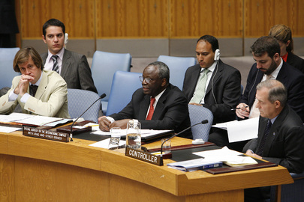

UN Photo/Evan Schneider
Ibrahim Gambari (thrid from left), Special Adviser of the Secretary-General on the International Compact with Iraq and Other Issues, briefs the Security Council.
13 June 2008
United Nations, New York

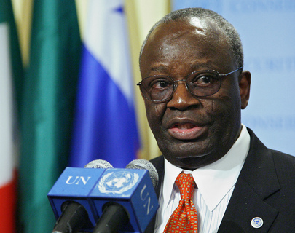

UN Photo/Eskinder Debebe
Ibrahim Gambari, Special Adviser of the Secretary-General on the International Compact with Iraq and Other Political Issues, briefs journalists, following the Security Council consultations on the situation in Myanmar.
18 March 2008
United Nations, New York
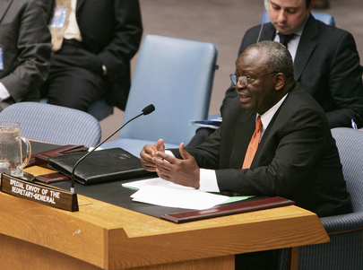

UN Photo/Jenny Rockett
Ibrahim Gambari, Special Adviser of the Secretary-General on the International Compact with Iraq and Other Political Issues, briefs the Security Council on the situation in Myanmar.
18 March 2008
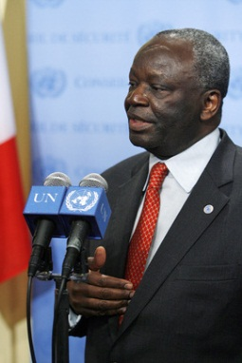
United Nations, New York

UN Photo/Evan Schneider
Ibrahim Gambari, Special Envoy of the Secretary-General for Myanmar, briefs correspondents on the current situation in Myanmar.
17 January 2008
United Nations, New York
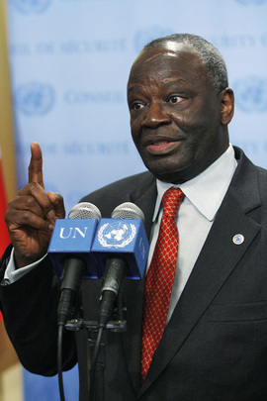

UN Photo/Evan Schneider
Ibrahim Gambari, Special Envoy of the Secretary-General for Myanmar, briefs correspondents on the current situation in Myanmar.
17 January 2008
United Nations, New York
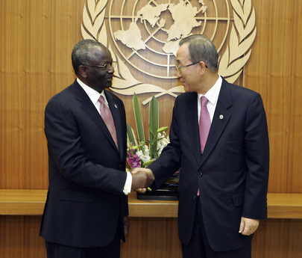

UN Photo/Eric Kanalstein
Secretary-General Ban Ki-moon (right) meets with Ibrahim Gambari, Special Envoy of the Secretary-General on the situation in Myanmar and the Special Adviser on the International Compact with Iraq and Other Political Issues.
03 December 2007
United Nations, New York
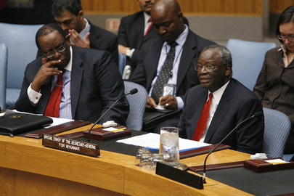

UN Photo/Paulo Filgueiras
Ibrahim Gambari (right), United Nations Special Envoy for Myanmar, briefs the Security Council on the current situation in Myanmar, at UN Headquarters in New York.
13 November 2007
United Nations, New York

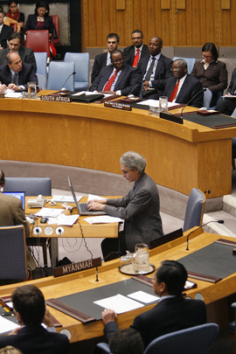

UN Photo/Paulo Filgueiras
Partial view of the Security Council meeting during a briefing by Ibrahim Gambari, United Nations Special Envoy for Myanmar, on the current situation in Myanmar, at UN Headquarters in New York.
13 November 2007
United Nations, New York
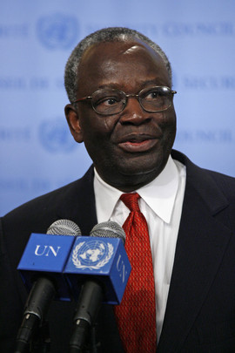

UN Photo/Evan Schneider
Ibrahim Gambari, United Nations Special Envoy for Myanmar, briefs correspondents on the current situation in Myanmar, at UN Headquarters in New York.
13 November 2007
United Nations, New York
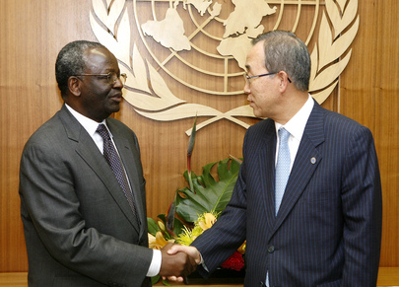

UN Photo/Eskinder Debebe
Secretary-General Ban Ki-moon (right) meets with Ibrahim Gambari, Special Envoy of the Secretary-General on the situation in Myanmar and the Special Adviser on the International Compact with Iraq and Other Political Issues.
04 October 2007
United Nations, New York

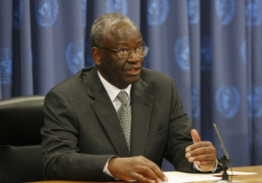

UN Photo/Paulo Filgueiras
Ibrahim Gambari, Special Adviser on the International Compact with Iraq and other Issues, updates journalists on the implementation of the United Nations Secretary-General's good offices mandate in Myanmar, at UN Headquarters in New York.
05 September 2007
United Nations, New York
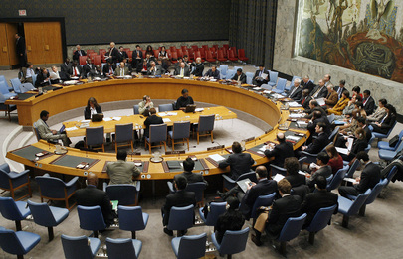

UN Photo/Paulo Filgueiras
Wide view of the Security Council meeting to hear a briefing by Ibrahim Gambari, Under-Secretary-General for Political Affairs, on the situation in the Middle East, including the Palestinian question, at UN Headquarters in New York.
25 January 2007
United Nations, New York
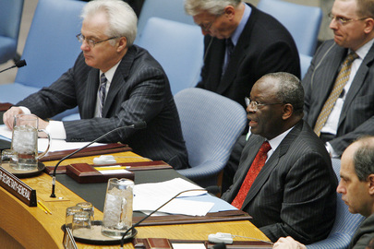

UN Photo/Paulo Filgueiras
Ibrahim Gambari (second from left), Under-Secretary-General for Political Affairs, briefs the Security Council on the situation in the Middle East, including the Palestinian question, at UN Headquarters in New York.
25 January 2007
United Nations, New York
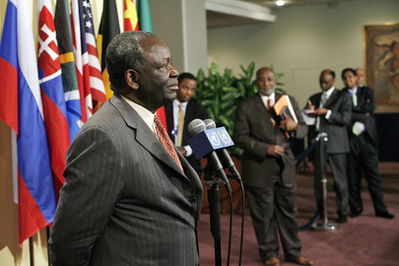

UN Photo/Mark Garten
Ibrahim A. Gambari (left), Under-Secretary-General for Political Affairs, addresses correspondents outside the Security Council chamber, at United Nations Headquarters in New York.
10 January 2007
United Nations, New York

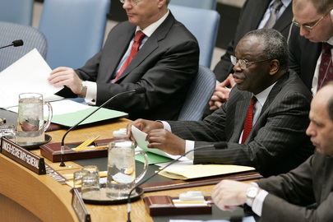

UN Photo/Eskinder Debebe
Ibrahim A. Gambari (second from right), Under-Secretary-General for Political Affairs, briefs the Security Council on the situation in the Democratic Republic of the Congo, at United Nations Headquarters in New York.
09 January 2007
United Nations, New York
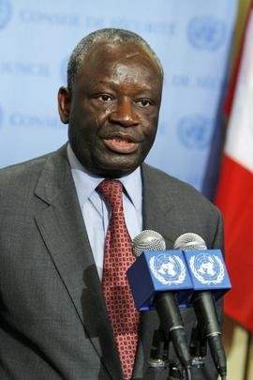

UN Photo/Eskinder Debebe
Ibrahim A. Gambari, Under-Secretary-General for Political Affairs, speaks to news correspondents outside the Security Council chamber after he briefed the Council on Myanmar, at UN Headquarters in New York.
27 November 2006
United Nations, New York
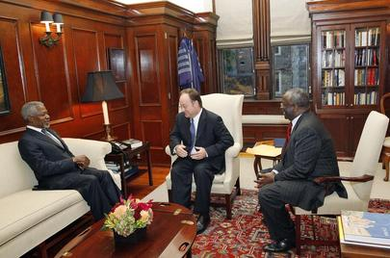

UN Photo/Mark Garten
Secretary-General Kofi Annan (left), accompanied by Ibrahim A. Gambari (right), Under-Secretary-General for Political Affairs, meets John J. DeGioia, President of Georgetown University, in Washington, D.C.
30 October 2006
Washington DC, United States

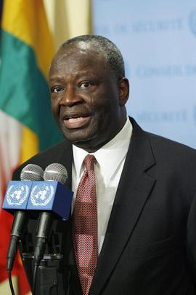

UN Photo/Mark Garten
Ibrahim Gambari, Under-Secretary-General for Political Affairs, speaks to correspondents at UN Headquarters in New York.
29 September 2006
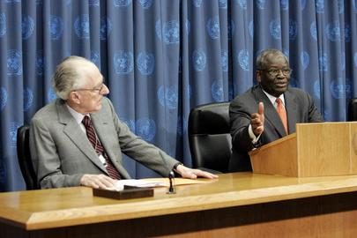
United Nations, New York

UN Photo/Paulo Filgueiras
Ibrahim Gambari (right), Under-Secretary-General for Political Affairs, and David Hamburg, Chairman of the Secretary-General's Advisory Committee on Genocide Prevention, brief correspondents at UN Headquarters in New York.
06 September 2006
United Nations, New York

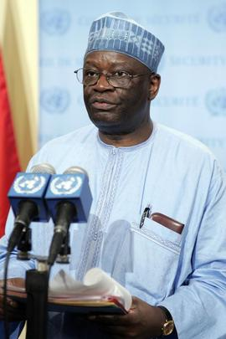

UN Photo/Paulo Filgueiras
Ibrahim Agboola Gambari, Under-Secretary-General for Political Affairs, briefing correspondents following Security Council consultations on the situation in the Middle East, at UN Headquarters in New York.
17 July 2006
United Nations, New York

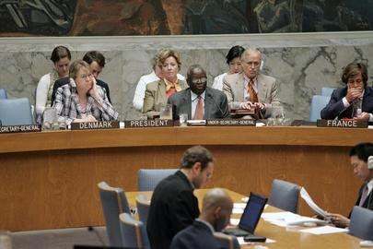

UN Photo/Paulo Filgueiras
Ibrahim A. Gambari, Under-Secretary-General for Political Affairs briefs the Security Council on the situation in the Middle East, including the Palestinian question, at UN Headquarters in New York.
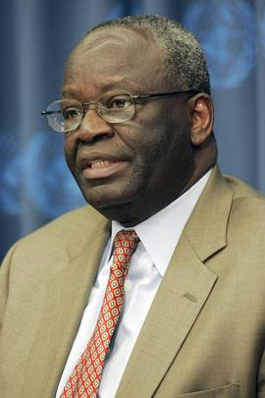
21 June 2006
United Nations, New York

UN Photo/Paulo Filgueiras
Ibrahim Gambari, Under-Secretary-General for Political Affairs briefs journalists on his recent trip to Myanmar, at UN Headquarters in New York.
24 May 2006
United Nations, New York
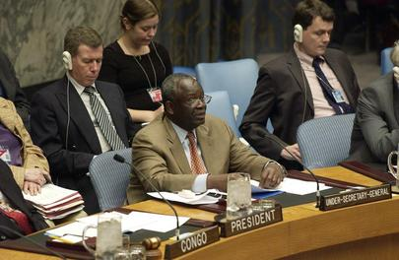

UN Photo/Ryan Brown
Ibrahim Gambari (left), Under-Secretary-General for Political Affairs, briefing the Security Council on the situation in the Middle East, including the Palestinian question, today at UN Headquarters in New York.
24 May 2006
United Nations, New York

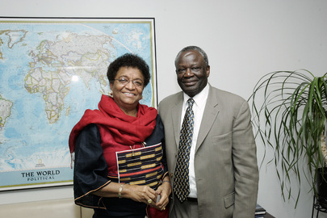

UN Photo/Mark Garten
Ibrahim Gambari (right), Under Secretary-General for Political Affairs, pictured with Ellen Sirleaf-Johnson, President-elect of Liberia, today at UN Headquarters in New York.
12 December 2005
United Nations, New York

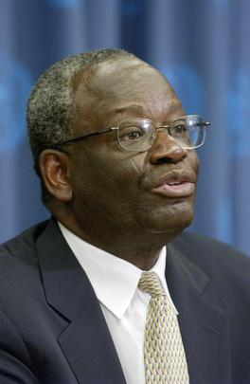

UN Photo/Paulo Filgueiras
Ibrahim A. Gambari, Under-Secretary-General for Political Affairs, briefs correspondents following today's Security Council meeting on the situation in the Middle East, including the Palestinian question, today at UN Headquarters.
30 November 2005
United Nations, New York

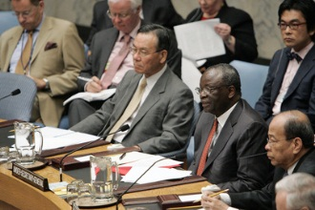

UN Photo/Mark Garten
Ibrahim Gambari (second from right), Under-Secretary-General for Political Affairs, addresses the Security Council during its monthly briefing on the situation in the Middle East, today at UN Headquarters.
24 August 2005
United Nations, New York
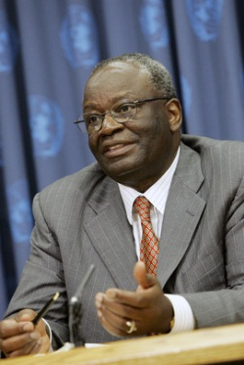

UN Photo/Mark Garten
Ibrahim Gambari, Under-Secretary-General for Political Affairs, speaking to correspondents, today at UN Headquarters.
22 August 2005
United Nations, New York
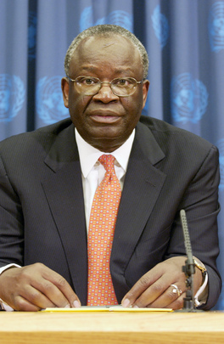

UN Photo/Eskinder Debebe
Ibrahim Gambari, Under-Secretary-General for Political Affairs, addresses correspondents on the role of civil society in the prevention of armed conflict, today at UN Headquarters.
22 July 2005
United Nations, New York
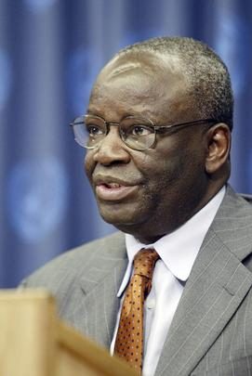

UN Photo/Ky Chung
Ibrahim Gambari, Special Adviser to the Secretary-General for Special Assignments in Africa, addressing correspondents this afternoon on progress made towards peace and development in Africa.
18 October 2004
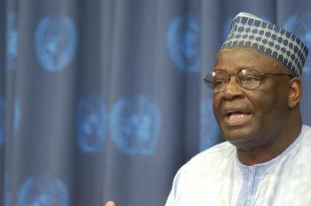
United Nations, New York

UN Photo/Sophia Paris
Ibrahim Gambari, United Nations Special Adviser on Africa, addresses a press conference concerning the appointment of the Secretary-General's Advisory Panel on International Support for the New Partnership on Africa.
20 July 2004
United Nations, New York
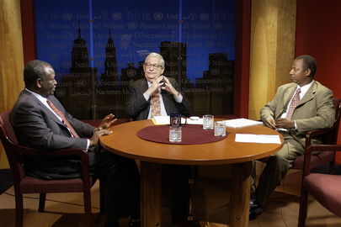

UN Photo/Evan Schneider
Ibrahim Gambari (left), Special Advisor of the Secretary-General for Africa, is a guest on World Chronicle today.
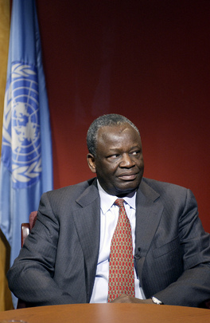
31 March 2003

UN Photo/Evan Schneider
Ibrahim Gambari, Special Advisor of the Secretary-General for Africa, is a guest on World Chronicle today.
31 March 2003
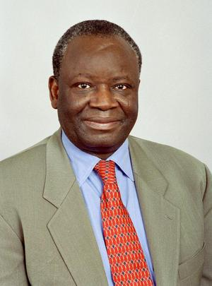
United Nations, New York

UN Photo/Milton Grant
Portrait of Ibrahim Gambari, Under-Secretary-General and Special Adviser for Assignments in Africa.
27 November 2000
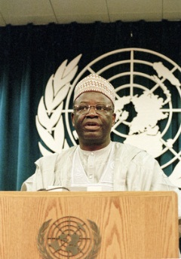
United Nations, New York

UN Photo/Eskinder Debebe
Ambassador Ibrahim A. Gambari, Permanent Representative of Nigeria, addresses a press Conference at Headquarters, concerning the death of Chief
Moshood Abiola.
07 July 1998
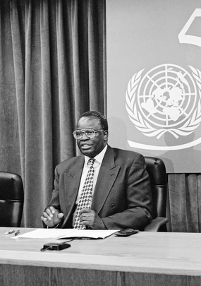

UN Photo/Milton Grant
Ibrahim Gambari, Permanent Representative of Nigeria to the United Nations, addressing correspondents today at UN Headquarters in response to the controversy regarding the capital punishment of Ken Saro-Wiwa and eight others in Nigeria.
22 November 1995
United Nations, New York

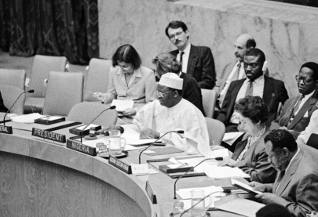

UN Photo/Milton Grant
Ibrahim Gambari (Nigeria) (centre, in white robe), President of the Security Council, reads out a statement by the Council on the situation in Angola.
12 October 1995
United Nations, New York

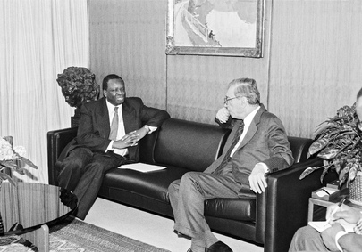

UN Photo/James Bu
Secretary-General Boutros Boutros-Ghali (right) meets with Ambassador Ibrahim A. Gambari, Permanent Representative of Nigeria.
13 April 1995
United Nations, New York
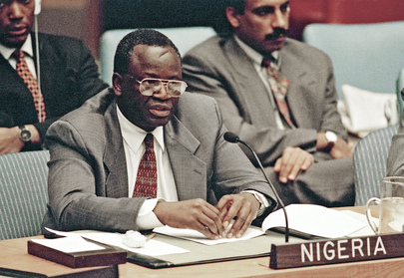

UN Photo/Evan Schneider
Addressing the Council is Ambassador Ibrahim A. Gambari, Permanent Representative of Nigeria.
28 February 1995
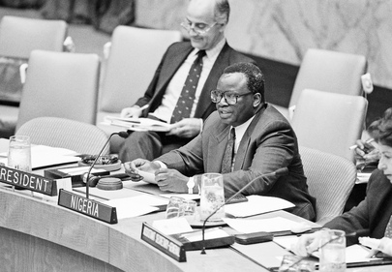
United Nations, New York

UN Photo/Milton Grant
Ambassador Ibrahim A. Gambari (Nigeria), President of the Security Council, addressing a meeting of the Security Council, as it expands the sanctions regime against Haiti.
06 May 1994
United Nations, New York
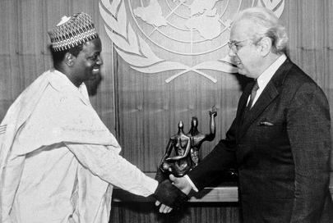

UN Photo/John Isaac
Ambassador Ibrahim A. Gambari of Nigeria presents his credentials to Secretary-General Javier Perez De Cuellar (right).
22 January 1990
United Nations, New York

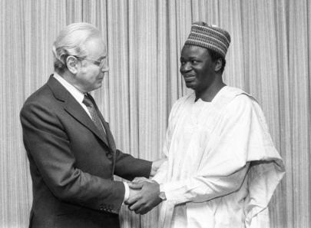

UN Photo/Yutaka Nagata
Secretary-General Javier Perez de Cuellar (left), meeting with Ibrahim Agboola Gambari, Minister for Foreign Affairs of Nigeria, at UN Headquarters today.
15 October 1984
United Nations, New York
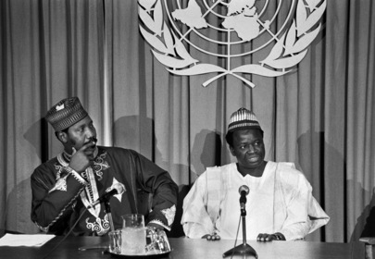

UN Photo/Milton Grant
Ibrahim Gambari (right), Foreign Minister of Nigeria receiving questions from correspondents at his press conference today. At left is Ambassador Joseph N. Garba (Nigeria), Chairman of the Special Committee against Apartheid.
09 October 1984
United Nations, New York

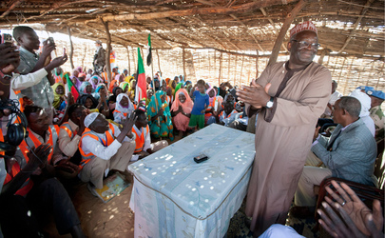

UN Photo/Albert González Farran
Ibrahim Gambari (right), Joint Special Representative for the African Union-UN Hybrid Operation in Darfur (UNAMID), meets with local leaders of the Donke Apieye Camp for internally displaced persons (IDPs) in Graida, South Darfur.
Mr. Gambari visited the camp to emphasize his support for the Doha Document for Peace in Darfur, which seeks a comprehensive political settlement to the conflict in the area and has already been signed by the Government of Sudan and the rebel group, the Justice and Equality Movement (JEM).
23 January 2012
Graida, Sudan

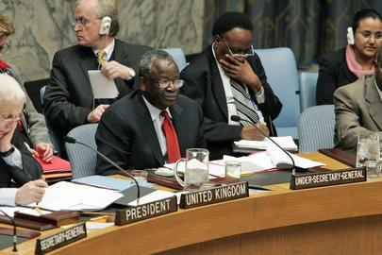

UN Photo/Eskinder Debebe
Under-Secretary-General for Political Affairs Ibrahim Gambari (centre) briefs the Security Council today, following his visit to Iraq last month with Secretary-General Kofi Annan. Mr. Gambari said that, after the election tomorrow (15/12/05), a new political landscape would emerge in Iraq. The framework laid out in resolution 1546 (2004) had sought to promote national dialogue and reconciliation. In turn, that was intended to improve the security situation. That had not occurred, and much remained to be done to develop a momentum within the political process that emphasized what the Iraqis had in common rather than what divided them.
14 December 2005
United Nations, New York

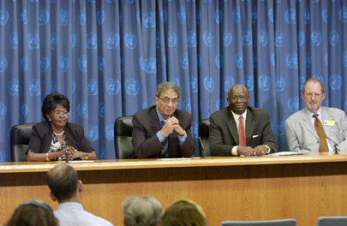

UN Photo/Eskinder Debebe
Ibrahim Gambari (3rd from left), Under-Secretary-General for Political Affairs; with, left to right, Florence Mugasha, Deputy Secretary-General of the Commonwealth Secretariat; Amre Moussa, Secretary-General of the League of Arab States; Mr. Gambari; and Karel Kovanda, Deputy Director-General for External Relations of the European Commission; speak about the results of the High-Level meeting between the United Nations and regional and other inter-governmental organizations, during a press conference today at UN Headquarters.
26 July 2005
United Nations, New York

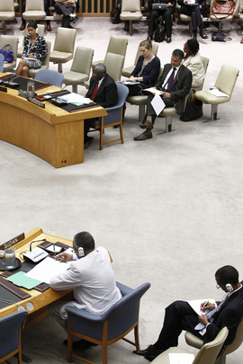

UN Photo/JC McIlwaine
Ibrahim Gambari (top, centre), Joint African Union-United Nations Special Representative for Darfur and Head of the AU-UN Hybrid Operation in Darfur (UNAMID), briefs the Security Council.
At left in foreground is Daffa-Alla Elhag Ali Osman, Permanent Representative of the Republic of the Sudan to the U.N.
24 July 2012
United Nations, New York
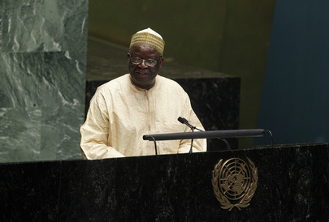

UN Photo/Devra Berkowitz
The General Assembly marked Nelson Mandela International Day at a special meeting, honouring the leader’s contributions to democracy, racial justice and reconciliation.
Ibrahim Gambari, last Chair of the UN Special Committee against Apartheid, addresses the meeting.
18 July 2012
United Nations, New York

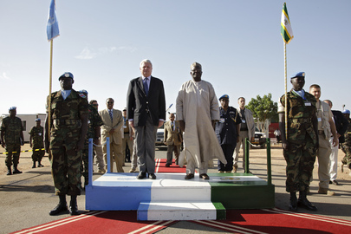

UN Photo/Olivier Chassot
Hervé Ladsous (centre left), Under-Secretary-General for Peacekeeping Operations, arrives at the headquarters of the African Union-United Nations Hybrid Operation in Darfur (UNAMID) in El Fasher, Sudan, one of the stops on his week-long visit to UN peacekeeping missions in the region. Beside Mr. Ladous is Ibrahim Gambari, Joint Special Representative for UNAMID.
30 October 2011
El Fasher, Sudan

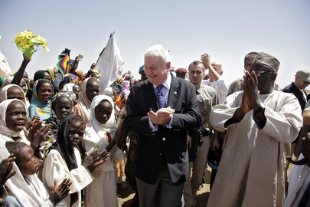

UN Photo/Olivier Chassot
Residents of Shangil Tobaya village, located 65 km south of El Fasher, North Darfur, welcome Hervé Ladsous, Under-Secretary-General for Peacekeeping Operations and Head of the UN's peackeeping department (DPKO). Pictured next to Mr. Ladsous is Ibrahim Gambari, Joint Special Representative for the African Union-United Nations Hybrid Operation in Darfur (UNAMID).
30 October 2011
Shangil Tobaya, Sudan
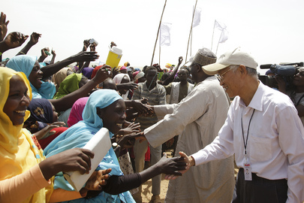

UN Photo/Olivier Chassot
Ibrahim Gambari (second from right, back to camera), Joint Special Representative for the African Union-United Nations Hybrid Operation in Darfur (UNAMID), and Lui Guijin (right), Ambassaodor of China and Special Envoy to Sudan, greet residents of Mukjar, West Darfur, after participating in the Fourth Special Envoys Retreat in nearby El Geneina.
20 October 2011
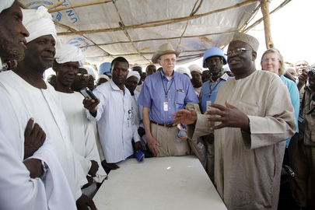
Mukjar, Sudan

UN Photo/Olivier Chassot
Ibrahim Gambari (right), Joint Special Representative for the African Union-United Nations Hybrid Operation in Darfur (UNAMID), and Dane Smith (centre, in hat), Ambassador of the United States and Senior Adviser on Darfur, meet with locals in Mukjar, West Darfur, after participating in the Fourth Special Envoys Retreat in nearby El Geneina.
20 October 2011
Mukjar, Sudan

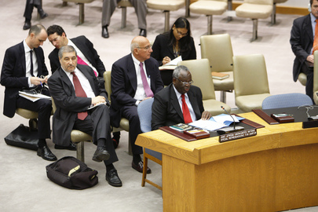

UN Photo/Rick Bajornas
Ibrahim Gambari, Joint Special Representative for the African Union and the United Nations Hybrid Operation in Darfur (UNAMID), addresses the Security Council. He stresses that the imperative for peace in Sudan is now as the people of Darfur have suffered too long.
22 July 2011
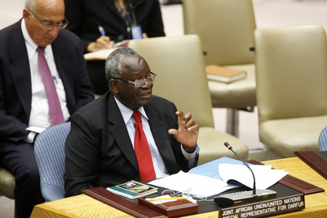
United Nations, New York

UN Photo/Rick Bajornas
Ibrahim Gambari, Joint Special Representative for the African Union and the United Nations Hybrid Operation in Darfur (UNAMID), addresses the Security Council. He stresses that the imperative for peace in Sudan is now as the people of Darfur have suffered too long.
22 July 2011
United Nations, New York
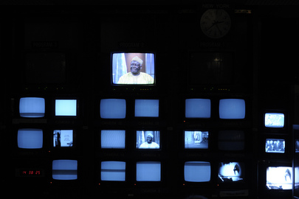

UN Photo/Eskinder Debebe
A view of the UNTV studio, photographed during the interview of Ibrahim Gambari, Joint African Union-United Nations Special Representative for Darfur (UNAMID), for UN News Service, UN Radio and UNTV.
21 July 2011
United Nations, New York
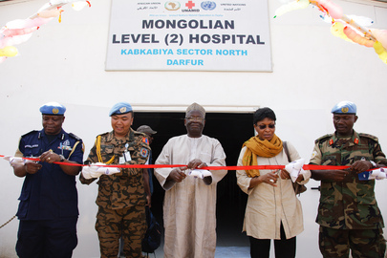

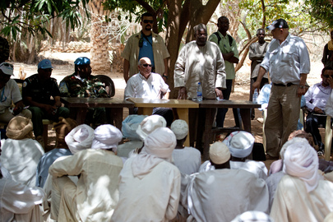
UN Photo/Olivier Chassot Ibrahim Gambari (centre), Joint African Union-United Nations Special Representative for Darfur (UNAMID), accompanied by senior UNAMID officials, inaugurates a hospital in Kabkabiya, North Darfur, which will serve UNAMID personnel and the community in the region. The level II hospital was built, and will be run, by the Mongolian contingent of the peacekeeping force.

UN Photo/Olivier Chassot
Ibrahim Gambari (standing), Joint Special Representative of the African Union-United Nations Mission in Darfur (UNAMID) speaks to local people during his visit to North Darfur where he announces a project designed to significantly increase accessibility for humanitarian agencies to meet the needs of hard-to-reach communities in the conflict-affected areas.
01 May 2011
North Darfur, Sudan
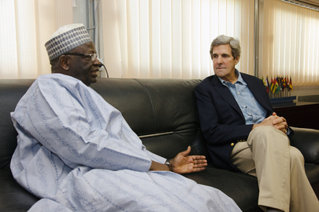

UN Photo/Olivier Chassot
Ibrahim Gambari (left), Joint Special Representative for the African Union-United Nations Hybrid Operation in Darfur (UNAMID), meets with John Kerry, U.S. Senator from Massachusetts and Chairman of the Senate Foreign Relations Committee, in El Fasher, North Darfur.
07 January 2011
El Fasher, Sudan

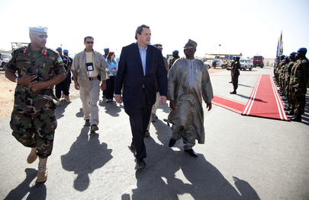

UN Photo/Albert González Farran
Alain Le Roy, Under-Secretary-General for Peacekeeping Operations, arrives in El Fasher, Sudan, for his visit with the leadership of the African Union-United Nations Hybrid Operation in Darfur (UNAMID). He is flanked by Ibrahim Gambari (right), Joint Special Representative for UNAMID, and Patrick Nyamvumba (front, left), UNAMID Force Commander.
09 November 2010
El Fasher, Sudan
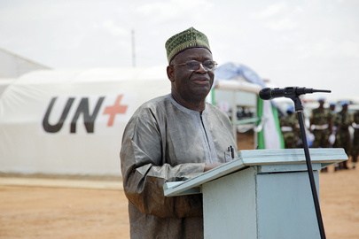

UN Photo/Olivier Chassot
Ibrahim Gambari, Joint Special Representative for the African Union-United Nations Hybrid Operation in Darfur (UNAMID), officially opens UNAMID’s newly-built Nigerian level II hospital in El Geneina, West Darfur. The hospital will be able to provide emergency medical care and first aid training.
20 September 2010
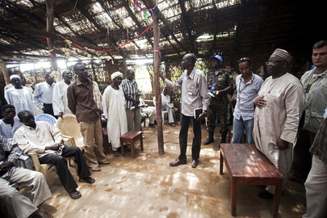
El Geneina, Sudan

UN Photo/Albert González Farran
Ibrahim Gambari (right, standing at table), Joint Special Representative for the African Union-United Nations Hybrid Operation in Darfur (UNAMID), meets with leaders of the Hasahisa Camp for Internally Displaced Persons (IDPs) in Zalingei, West Darfur.
22 August 2010
Zalingei, Sudan
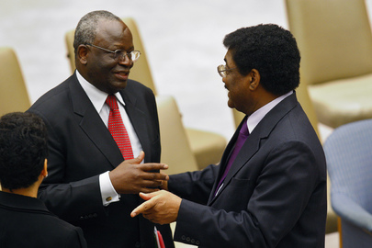

UN Photo/Eskinder Debebe
Ibrahim Gambari (left), Joint Special Representative for the African Union-United Nations Hybrid Operation in Darfur (UNAMID), speaks with Abdalmahmood Abdalhaleem Mohamad, Permanent Representative of the Republic of the Sudan to the UN, during a Security Council meeting on UNAMID and the situation in Darfur.
20 May 2010
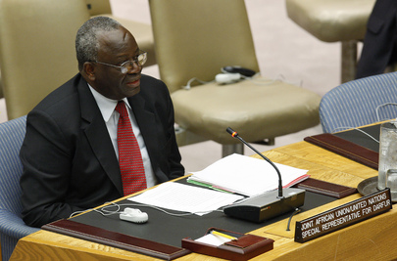
United Nations, New York

UN Photo/Eskinder Debebe
Ibrahim Gambari, Joint Special Representative for the African Union-United Nations Hybrid Operation in Darfur (UNAMID), presenting the Secretary-General's latest report on Darfur, briefs the Security Council on the situation in the region and on challenges faced by UNAMID.
20 May 2010
United Nations, New York
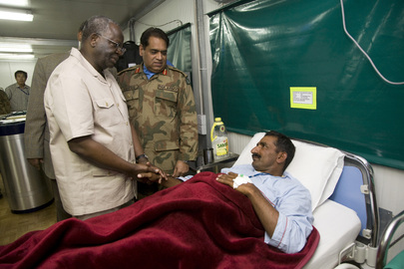

UN Photo/Albert González Farran
Ibrahim Gambari (left), Joint Special Representative for the African Union-United Nations Hybrid Operation in Darfur (UNAMID), visits a Pakistani Formed Police Unit (FPU) officer at UNAMID's hospital and thanks him for his service. The officer was among six others working with UNAMID who were wounded in an ambush outside Nyala, South Darfur, Sudan.
17 February 2010
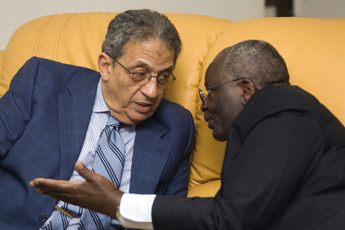
Nyala, Sudan

UN Photo/Albert González Farran
Ibrahim Gambari (right), Joint Special Representative for the African Union-United Nations Hybrid Operation in Darfur (UNAMID), meets with Amre Moussa, Secretary General of the League of Arab States, in El Fasher, Sudan.
14 February 2010 El Fasher, Sudan
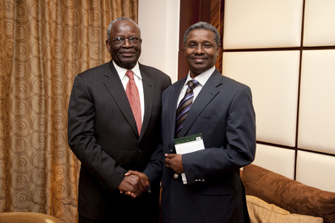

UN Photo/Olivier Chassot
Ibrahim Gambari (left), Joint Special Representative for the African Union-United Nations Hybrid Operation in Darfur (UNAMID), meets with Atta al-Mannan Bakhit, Assistant Secretary-General of the Organisation of the Islamic Conference (OIC), in Khartoum, Sudan.
24 January 2010
Khartoum, Sudan
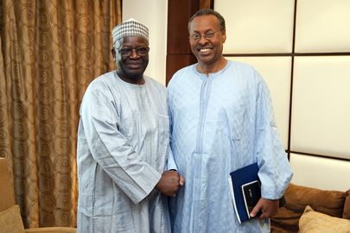

UN Photo/Olivier Chassot
Ibrahim Gambari (left), new Joint Special Representative for the African Union-United Nations Hybrid Operation in Darfur (UNAMID), meets with Mohamed Yonis, Deputy Joint African Union-United Nations Special Representative for Operations and Management, in Khartoum, Sudan.
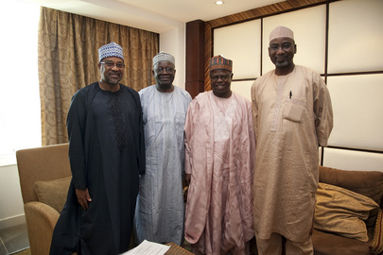
23 January 2010
Khartoum, Sudan

UN Photo/Olivier Chassot
Ibrahim Gambari (second from left), Joint Special Representative for the African Union-United Nations Hybrid Operation in Darfur (UNAMID), meets with Salihu Ahmed-Sambo (second from right), Nigerian Ambassador to the Sudan, in Sudan's capital, Khartoum.
23 January 2010
Khartoum, Sudan
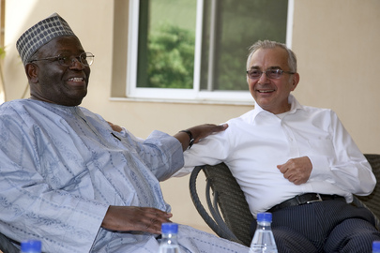

UN Photo/Olivier Chassot
Ibrahim Gambari (left), new Joint Special Representative for the African Union-United Nations Hybrid Operation in Darfur (UNAMID), meets with Ashraf Jehangir Qazi, Special Representative of the Secretary-General for the Sudan, in Sudanese capital Khartoum.
23 January 2010
Khartoum, Sudan
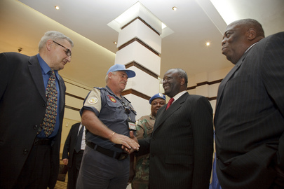

UN Photo/Olivier Chassot
Ibrahim Gambari (second from right), new Joint Special Representative for the African Union-United Nations Hybrid Operation in Darfur (UNAMID), arrives in Sudanese capital Khartoum, to take up his post. Beside him is Henry Anyidoho (right), Deputy Joint African Union-United Nations Special Representative.
22 January 2010
Khartoum, Sudan
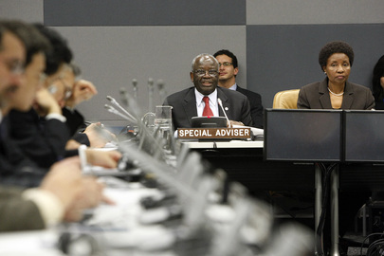

UN Photo/Paulo Filgueiras
Ibrahim Gambari (at table, left), Special Adviser to the Secretary-General on the International Compact with Iraq and Other Issues, addresses the discussion 'The United Nations in Iraq in 2010: Lessons learnt from the Iraq Compact and the way forward' at UN Headquarters.
18 January 2010
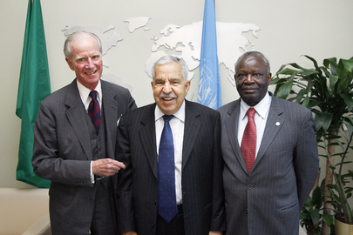
United Nations, New York

UN Photo/Evan Schneider
Ali Abdussalam Treki (centre), President of the sixty-fourth session of the General Assembly, meets with Joseph V. Reed (left), Special Adviser to the Secretary-General, and Ibrahim Gambari, Special Adviser to the Secretary-General on the International Compact with Iraq and Other Issues.
21 October 2009
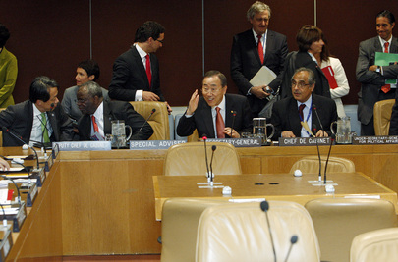
United Nations, New York

UN Photo/Mark Garten
Secretary-General Ban Ki-moon (centre) attends the High-Level Group of Friends on Myanmar meeting. Vijay Nambiar (right), Chef de Cabinet, and Ibrahim Gambari (second from left), Special Adviser to the Secretary-General on Myanmar, also attended.
23 September 2009
United Nations, New York

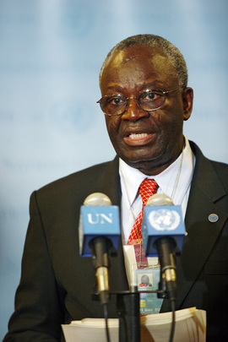

UN Photo/Sophia Paris
Ibrahim Gambari, Special Adviser to Secretary-General Ban Ki-moon on Myanmar, reads out to the press a statement by the Secretary-General on the second meeting of the 14-member Group of Friends on Myanmar which he convened earlier in the day.
23 September 2009
United Nations, New York
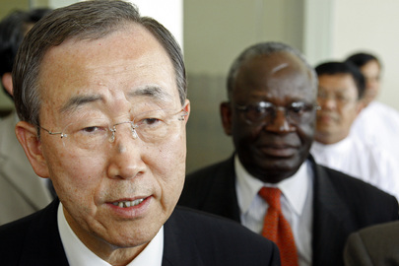

UN Photo/Mark Garten
Secretary-General Ban Ki-moon (left) briefs journalists outside Bayint Naung Yeiktha after meeting with Senior General Than Shwe, Chairman of the State Peace and Development Council of the Union of Myanmar, as Ibrahim Gambari, Special Adviser to the Secretary-General on Myanmar, looks on.
03 July 2009
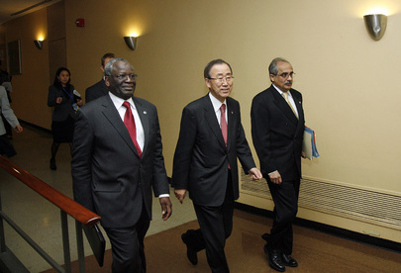
Naypyitaw, Myanmar

UN Photo/Evan Schneider
Secretary-General Ban Ki-moon (centre), flanked by Ibrahim Gambari (left), Special Adviser of the Secretary-General on the International Compact with Iraq and Other Political Issues, and Vijay Nambiar, Chef de Cabinet, en route to a meeting of the Group of Friends for Myanmar.
05 December 2008
United Nations, New York
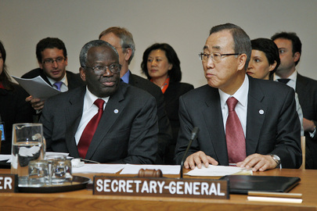

UN Photo/Evan Schneider
Secretary-General Ban Ki-moon addresses a meeting of the Group of Friends of Myanmar, as Ibrahim Gambari (second from left), Special Adviser of the Secretary-General on the International Compact with Iraq and Other Political Issues, listens.
05 December 2008
United Nations, New York
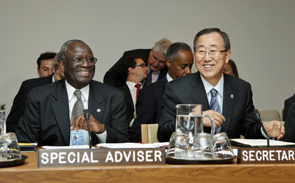

UN Photo/Eskinder Debebe
Secretary-General Ban Ki-moon and Ibrahim Gambari, Special Adviser of the Secretary-General on the International Compact with Iraq and Other Political Issues, participate in a meeting of the "Group of Friends of the Secretary-General on Myanmar."
27 September 2008
United Nations, New York
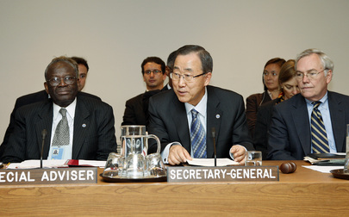

UN Photo/Eskinder Debebe
Secretary-General Ban Ki-moon, flanked by Ibrahim Gambari (left), Special Adviser of the Secretary-General on the International Compact with Iraq and Other Political Issues; and B. Lynn Pascoe, Under-Secretary-General for Political Affairs, addresses a meeting of the "Group of Friends of the Secretary-General on Myanmar."
27 September 2008
United Nations, New York
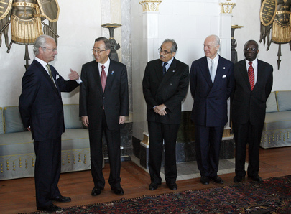

UN Photo/Mark Garten
Secretary-General Ban Ki-moon (second from left) meets with Carl XVI Gustaf, King of Sweden. Senior UN Officials accompanying him (from left to right): Vijay Nambiar, Chef de Cabinet; Staffan de Mistura, Special Representative for Iraq; and Ibrahim Gambari, Special Adviser on the International Compact with Iraq and Other Issues.
29 May 2008
Stockholm, Sweden
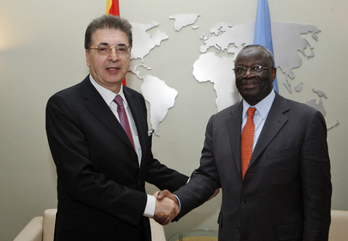

UN Photo/Eskinder Debebe
Srgjan Kerim (left), President of the sixty-second session of the General Assembly meets with Ibrahim Gambari, Special Envoy of the Secretary-General on the situation in Myanmar and the Special Adviser on the International Compact with Iraq and Other Political Issues.
04 December 2007
United Nations, New York
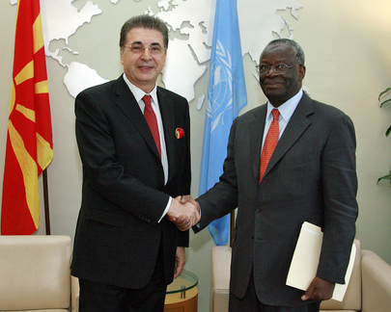

UN Photo/Mark Garten
Srgjan Kerim (left), President of the sixty-second session of the General Assembly meets with Ibrahim Gambari, Special Envoy of the Secretary-General on Myanmar and Special Adviser on the International Compact with Iraq and Other Issues, at UN Headquarters in New York.
12 November 2007
United Nations, New York
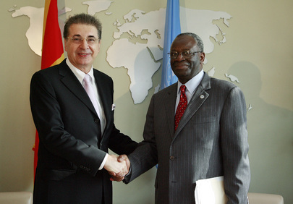

UN Photo/Mark Garten
Srgjan Kerim (left), President of the sixty-second General Assembly meets with Ibrahim Gambari, Special Envoy of UN Secretary-General on Myanmar and Special Adviser on the International Compact with Iraq and Other Issues, at UN Headquarters in New York.
05 October 2007
United Nations, New York
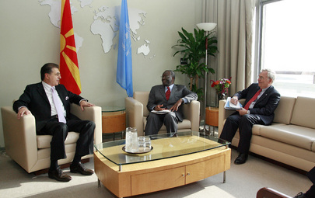

UN Photo/Mark Garten
Srgjan Kerim (left), President of the sixty-second General Assembly meets with Ibrahim Gambari (centre), Special Envoy of UN Secretary-General on Myanmar and Special Adviser on the International Compact with Iraq and Other Issues; and B. Lynn Pascoe, Under-Secretary-General for Political Affairs, at UN Headquarters in New York.
05 October 2007
United Nations, New York

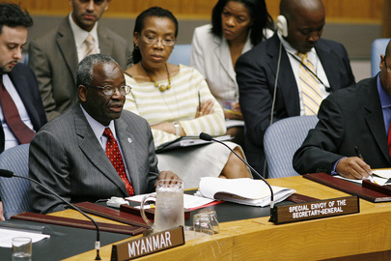

UN Photo/Evan Schneider
Ibrahim Gambari, Special Envoy of the Secretary-General on the situation in Myanmar and on the International Compact with Iraq and Other Political Issues, briefs the Security Council on his recent visit to Myanmar, at UN Headquarters in New York.
05 October 2007
United Nations, New York
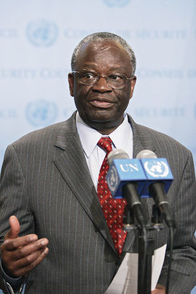

UN Photo/Ryan Brown
Ibrahim Gambari, Special Envoy of the Secretary-General for Myanmar, and Special Adviser on the International Compact with Iraq and Other Issues, briefs correspondents following a meeting of the Security Council concerning the current situation in Myanmar, at UN Headquarters in New York.
05 October 2007
United Nations, New York
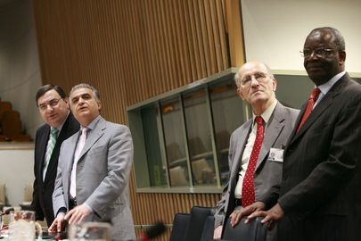

UN Photo/Mark Garten
Ibrahim Gambari (right), Special Adviser of the United Nations Secretary-General on the International Compact with Iraq and Other Issues, is one of the speakers at a meeting on the latest developments in the implementation of the commitments under the International Compact with Iraq, at UN Headquarters in New York.
20 July 2007
United Nations, New York

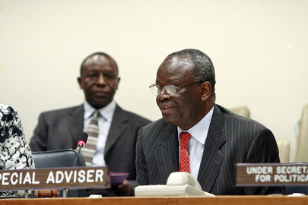

UN Photo/Mark Garten
Ibrahim Gambari (right), United Nations Secretary-General's Special Adviser on the International Compact with Iraq and Other Issues, reports on the latest developments in the implementation of the commitments under the International Compact with Iraq, at UN Headquarters in New York.
20 July 2007
United Nations, New York

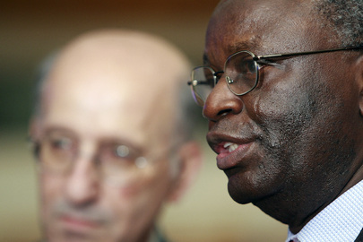

UN Photo/Mark Garten
Ibrahim Gambari (right), Special Adviser of the Secretary-General on the International Compact with Iraq and Other Issues, speaks to reporters after presenting a progress report on the latest developments in the implementation of the commitments under the International Compact with Iraq, at UN Headquarters in New York..
20 July 2007
United Nations, New York
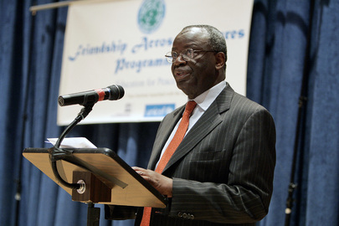

Ibrahim Gambari, Special Assistant to the Secretary-General on International Compact with Iraq and other Political Issues, speaks at the launch of the U Thant Institute Friendship Across Cultures Programme, at UN Headquarters in New York.
13 June 2007
United Nations, New York
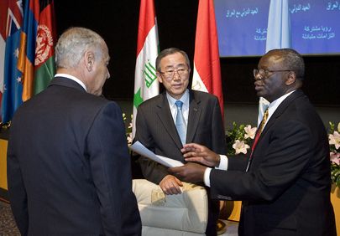
UN Photo/Devra Berkowitz

UN Photo/Mark Garten
From left to right: Ahmed Aboul Gheit, Foreign Minister of the Arab Republic of Egypt; Secretary-General Ban Ki-moon; and Ibrahim Gambari, Special Advisor to the Secretary-General on the International Compact with Iraq and Other Political Issues, participate in the launch of the International Compact with Iraq in Sharm El-Sheikh, Egypt.
03 May 2007
Sharm El-Sheikh, Egypt
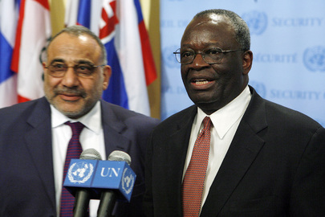

UN Photo/Eskinder Debebe
Adel Abdul Mahdi (left) Vice President of Iraq, and Ibrahim Gambari, Secretary-General's Special Advisor on the International Compact with Iraq and Other Political Issues, brief correspondents outside the Security Council chamber, at UN Headquarters in New York.
16 March 2007
United Nations, New York
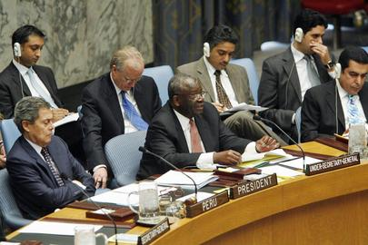

UN Photo/Paulo Filgueiras
Ibrahim A. Gambari (second from left), Under-Secretary-General for Political Affairs, briefs the Security Council on the situation in the Middle East, including the Palestinian question, at UN Headquarters in New York.
21 November 2006
United Nations, New York
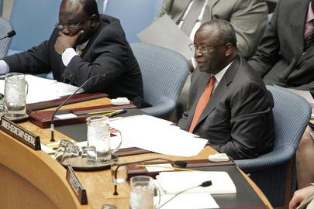

UN Photo/Paulo Filgueiras
Ibrahim Gambari (right), Under-Secretary-General for Political Affairs, briefs the Security Council on the situation in the Middle East, including the Palestinian question, at UN Headquarters in New York.
22 August 2006
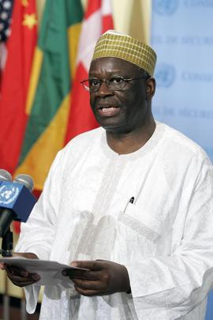
United Nations, New York

UN Photo/Eskinder Debebe
Ibrahim Agboola Gambari, Under-Secretary-General for Political Affairs, briefing correspondents at UN Headquarters in New York following the Security Council meeting on the escalating conflict between Israel and Lebanon and the broader crisis in the Middle East region.
14 July 2006
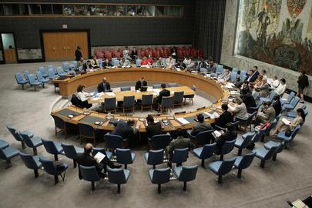
United Nations, New York

UN Photo/Paulo Filgueiras
Wide view of the Security Council getting briefed by Ibrahim A. Gambari, United Nations Under-Secretary-General for Political Affairs, on the situation in the Middle East, including the Palestinian question, at UN Headquarters in New York.
21 June 2006
United Nations, New York

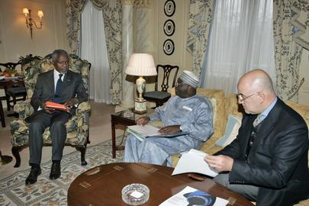

UN Photo/Eskinder Debebe
Secretary-General Kofi Annan (left) meets with Ibrahim A. Gambari, (centre), Under-Secretary-General for Political Affairs; and Alvaro deSoto, before attending the Middle East Peace Process Quartet meeting, today in London, United Kingdom.
30 January 2006
London, United Kingdom
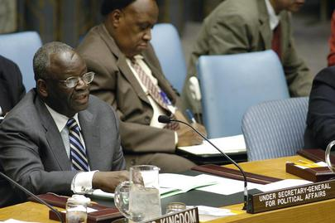

UN Photo/Devra Berkowitz
Ibrahim A. Gambari, Under-Secretary-General for Political Affairs, addresses the Security Council Meeting on the situation in the Middle East, including the Palestinian question, today at UN Headquarters.
20 December 2005
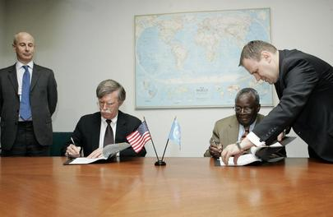
United Nations, New York

UN Photo/Paulo Filgueiras
John R. Bolton (left, at table), Permanent Representative of the United States to the United Nations, and Ibrahim Gambari (right, at table), Under-Secretary-General for Political Affairs, sign the "United States/United Nations Security Agreement on Iraq", today at UN Headquarters.
08 December 2005
United Nations, New York

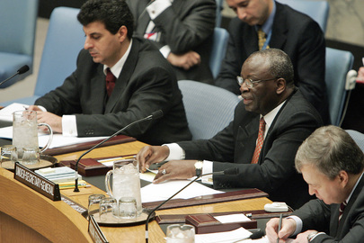

UN Photo/Mark Garten
Ibrahim Gambari (centre), Under-Secretary-General for Political Affairs, briefs the Security Council when it met on the situation in the Middle East, including the Palestinian question, today at UN Headquarters.
20 October 2005
United Nations, New York
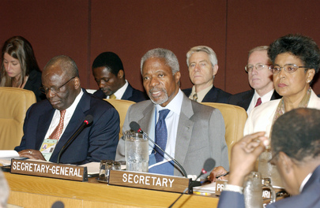

UN Photo/Eskinder Debebe
Secretary-General Kofi Annan, centre, opens the sixth high-level meeting of regional and other intergovernmental organizations, today at UN Headquarters. On the left is Ibrahim Gambari, Under-Secretary-General for Political Affairs.
25 July 2005
United Nations, New York
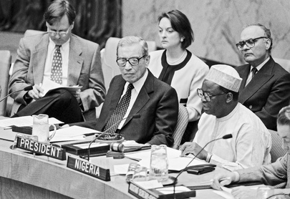
UN Photo

Ambassador Ibrahim Gambari, of Nigeria, (right) President of the Security Council, issues a statement concerning the inspection of nuclear reactors in the Democratic Peoples' Republic of Korea. On the left is Secretary-General Boutros Boutros-Ghali.
30 May 1994
United Nations, New York

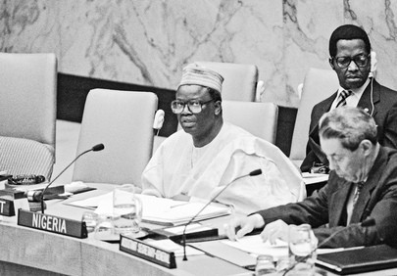

UN Photo/R Da Silva
Ambassador Ibrahim A. Gambari (Nigeria), President of the Security Council, addressing a meeting of the Security Council as it sets factors to be considered in establishing new peacekeeping operations.
03 May 1994
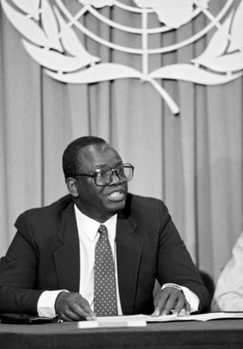
United Nations, New York

UN Photo/John Isaac
During a press briefing, Mr. Ibrahim A. Gambari, Chairman of the Special Committee Against Apartheid, tells correspondents that the United Nations need take prompt action to end the violence that has resulted in the deaths of 1,800 people in South Africa this year.
09 July 1992
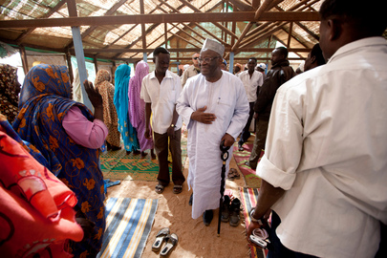
United Nations, New York

UN Photo/Albert González Farran
Ibrahim Gambari (centre), Joint Special Representative for the African Union-UN Hybrid Operation in Darfur (UNAMID), greets residents of Kassab Camp for Internally Displaced Persons (IDPs) in Kutum, North Darfur. Mr. Gamabari met with Kassab’s community leaders, who expressed concern over an increase in rapes and attacks inside the camp.
19 January 2012
Kutum, Sudan

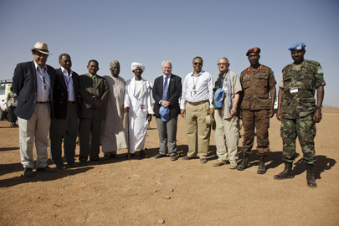

UN Photo/Olivier Chassot
Hervé Ladsous (centre), Under-Secretary-General for Peacekeeping Operations, poses for a group photo with a delegation of the African Union-United Nations Hybrid Operation in Darfur (UNAMID), including Joint Special Representative Ibrahim Gambari (fourth from left), and Deputy Representative Mohamed Yonis (right of Mr. Ladsous), during their visit to Shangil Tobaya village, 65 km south of El Fasher, North Darfur.
30 October 2011
Shangil Tobaya, Sudan
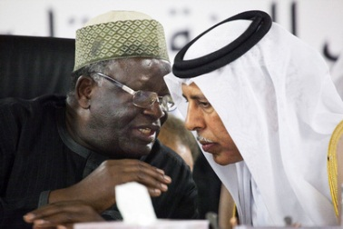

UN Photo/Albert González Farran
Ibrahim Gambari (left), Joint Special Representative for the African Union-United Nations Hybrid Operation in Darfur (UNAMID), speaks privately with Ahmed bin Abdullah Al Mahmoud, Qatar’s Minister of State for Cabinet Affairs, during the second meeting of the Implementation Follow-Up Commission on the Doha Document for Peace in Darfur (DDPD), in El Fasher, Sudan. The Commission is chaired by the Government of Qatar.
16 January 2012
El Fasher, Sudan
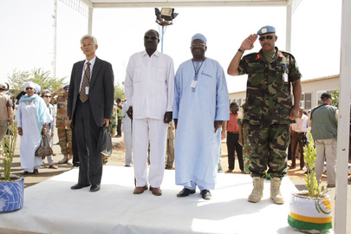

UN Photo/Olivier Chassot
Ibrahim Gambari (second from right), Joint Special Representative for the A.U.-UN Hybrid Operation in Darfur (UNAMID), and UNAMID Force Commander Lieutenant General Patrick Nyamvumba (right) arrive at the Fourth Special Envoys Retreat in El Geneina, West Darfur, Sudan. With them are Lui Guijin (left), Ambassaodor of China and Special Envoy to Sudan, and Jaffer Abdulhakim, Wali of West Darfur.
19 October 2011
El Geneina, Sudan

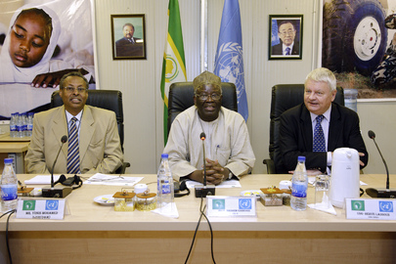

UN Photo/Olivier Chassot
Hervé Ladsous (right), Under-Secretary-General for Peacekeeping Operations, meets with civil society representatives in El Fasher, Sudan, during his week-long visit to UN peacekeeping missions in the region. With him are Ibrahim Gambari (centre), Joint Special Representative for the African Union-United Nations Hybrid Operation in Darfur (UNAMID), and Mohamed Yonis, UNAMID Deputy Representative for Operations and Management.
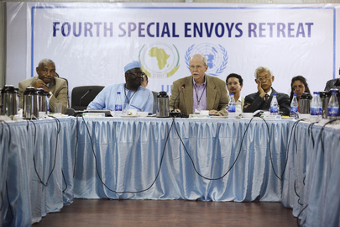
30 October 2011
El Fasher, Sudan

UN Photo/Olivier Chassot
Dane Smith (second from right), Ambassador of the United States and Senior Adviser on Darfur, speaks at the Fourth Special Envoys Retreat in El Geneina, West Darfur, Sudan. With him, from left: Mahmoud Kane, Head of the African Union (A.U.) Liaison Office in Khartoum; Ibrahim Gambari, Joint Special Representative for the A.U.-UN Hybrid Operation in Darfur (UNAMID); and Lui Guijin, Ambassaodor of China and Special Envoy to Sudan.
19 October 2011
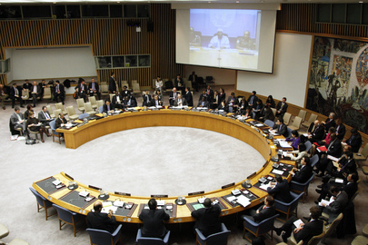
El Geneina, Sudan

UN Photo/Paulo Filgueiras
A wide view of the Security Council as Members hear a briefing via video link from Ibrahim Gambari (on screen, centre), Joint Special Representative for the African Union-United Nations Hybrid Operation in Darfur (UNAMID), on the situation in that region. Assistant Secretary-General for Political Affairs, Atul Khare, also briefed the Council on South Sudan’s referendum process.
26 January 2011
United Nations, New York

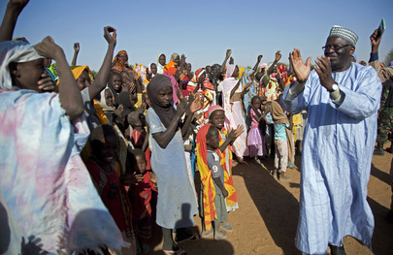

UN Photo/Albert González Farran
Ibrahim Gambari (right), Joint Special Representative for the African Union-United Nations Hybrid Operation in Darfur (UNAMID), meets Sudanese refugees who have settled outside an UNAMID team site in Khor Abeche, South Darfur, since fleeing violence in their native villages last December. UNAMID is providing water and security to the community while urgent humanitarian relief is requested.
10 January 2011
Khor Abeche, Sudan
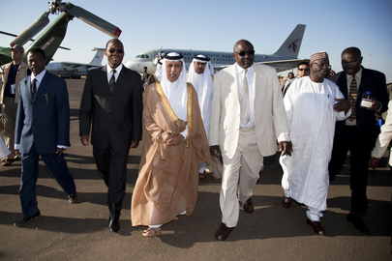

UN Photo/Albert González Farran
Djibril Bassolé (second from left), Joint African Union-United Nations Chief Mediator for Darfur; Ahmed bin Abdullah al Mahmoud (right of Mr. Bassolé), Qatar’s Minister of State for Foreign Affairs; and Ibrahim Gambari, Joint Special Representative for the African Union-United Nations Hybrid Operation in Darfur (UNAMID); are greeted by the Acting Wali of North Darfur (third from right) as they arrive in North Darfur capital El Fasher.
28 November 2010
El Fasher, Sudan
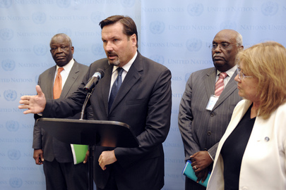

UN Photo/Ky Chung
Georg Charpentier, Deputy Special Representative for the African Union-United Nations Hybrid Operation in Darfur (UNAMID), briefs reporters following the the ninth Tripartite (African Union-United Nations-Sudan) Coordination Mechanism meeting on Darfur. Mr. Charpentier is joined by Ibrahim Gambari (left), Joint Special Representative for UNAMID, and Susana Malcorra (right), Under-Secretary-General for Field Support.
27 September 2010
United Nations, New York

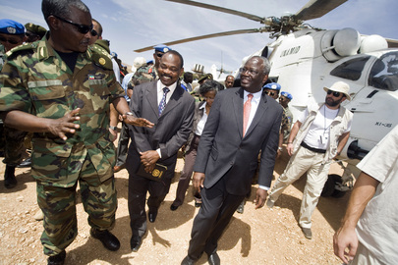

UN Photo/Albert González Farran
Ibrahim Gambari (front, right), Joint Special Representative for the African Union-United Nations Hybrid Operation in Darfur (UNAMID), and Mohammed Abdullah Idris (second from left), Director of Peace and Humanitarian Affairs at the Sudanese Ministry of Foreign Affairs, attend a ceremony in Nyala, Sudan, to celebrate UNAMID's receipt of five long-awaited tactical helicopters from the Federal Democratic Republic of Ethiopia.
25 February 2010
Nyala, Sudan
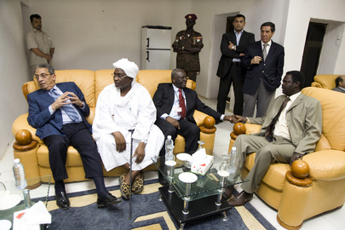

UN Photo/Albert González Farran
Amre Moussa (seated, left), Secretary General of the League of Arab States, meets with Othman Kibir (centre left), Governor of North Darfur; Ibrahim Gambari (centre right), Joint Special Representative for the African Union-United Nations Hybrid Operation in Darfur (UNAMID); and Minni Arko Minnawi, Senior Assistant to the President of Sudan and Chairperson of the Transitional Darfur Regional Authority (TDRA); in El Fasher, North Darfur, Sudan.
14 February 2010
El Fasher, Sudan

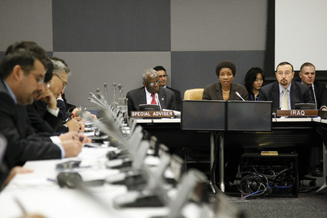

UN Photo/Paulo Filgueiras
Deputy Secretary-General Asha-Rose Migiro (centre, at table) opens the discussion 'The United Nations in Iraq in 2010: Lessons learnt from the Iraq Compact and the way forward'. Ms. Migiro is flanked by Hamid Al Bayati (right), Permanent Representative of Iraq to the United Nations, and Ibrahim Gambari (left), Special Adviser to the Secretary-General on the International Compact with Iraq and Other Issues.
18 January 2010
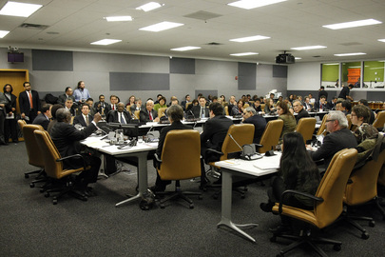
United Nations, New York

UN Photo/Paulo Filgueiras
A wide view of a discussion on 'The United Nations in Iraq in 2010: Lessens learnt from the Iraq Compact and the way forward', held at UN Headquarters in New York. Deputy Secretary-General Asha-Rose Migiro and Ibrahim Gambari, Special Advisor to the Secretary-General on the International Compact with Iraq and Other Issues, participated in the discussion.
18 January 2010
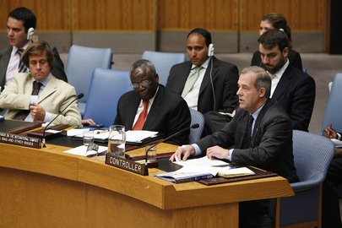
United Nations, New York

UN Photo/Evan Schneider
Warren Sach (right, front row), Assistant Secretary-General and Controller for the Office of Programme Planning, Budget and Accounts, briefs the Security Council on the Development Fund for Iraq (DFI) and the International Advisory and Monitoring Board (IAMB), in his capacity as the Secretary-General's representative on the IAMB. Also attending the meeting: Ibrahim Gambari (second from right, front row), Special Adviser of the Secretary-General on the International Compact with Iraq and Other Issues.
13 June 2008
United Nations, New York

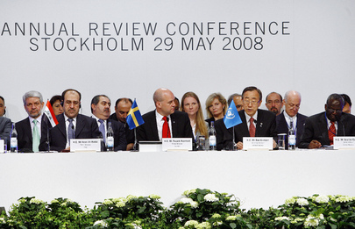

UN Photo/Mark Garten
Secretary General Ban Ki-moon (second from right, front row), addresses the annual review conference of the International Compact with Iraq. Seated with him on the podium, in the front row (from left to right): Nuri Kamel Al-Maliki, Prime Minister of Iraq; Frederick Reinfeldt, Prime Minister of Sweden; and Ibrahim Gambari, Special Adviser of the Secretary-General on the International Compact with Iraq and Other Political Issues.
29 May 2008
Stockholm, Sweden
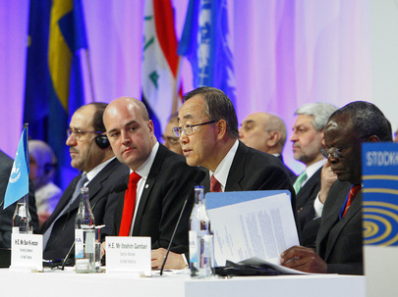

UN Photo/Mark Garten
Secretary General Ban Ki-moon (fourth from right), addresses the annual review conference of the International Compact with Iraq (ICI). Also seated with him at the podium (from left to right, front row) Nuri Kamel Al-Maliki, Prime Minister of Iraq; Frederick Reinfeldt, Prime Minister of Sweden; and Ibrahim Gambari, Special Adviser of the Secretary-General on the International Compact with Iraq and Other Political Issues.
29 May 2008
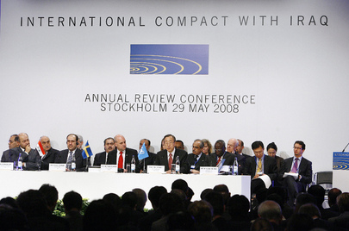
Stockholm, Sweden

UN Photo/Mark Garten
Secretary General Ban Ki-moon (second from right, front row), addresses the annual review conference of the International Compact with Iraq (ICI). Also participating in the conference and seated with him at the podium from left to right: Barham Ahmad Salih, Deputy Prime Minister of Iraq; Nuri Kamel Al-Maliki, Prime Minister of Iraq; Frederick Reinfeldt, Prime Minister of Sweden; and Ibrahim Gambari, Special Adviser of the Secretary-General on the International Compact with Iraq and Other Political Issues.
29 May 2008
Stockholm, Sweden
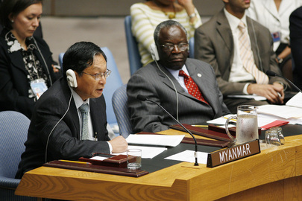

UN Photo/Evan Schneider
Kyaw Tint Swe (left), Permanent Representative of the Union of Myanmar to the United Nations, addresses the Security Council meeting on the situation in his country, as Ibrahim Gambari (right), Special Envoy of the Secretary-General on the situation in Myanmar and the International Compact with Iraq and Other Political Issues listens, at UN Headquarters in New York.
05 October 2007
United Nations, New York

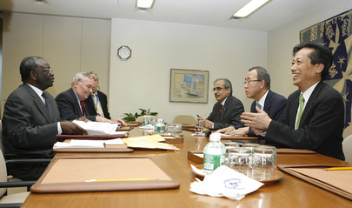

UN Photo/Eskinder Debebe
Ibrahim Gambari (left), Special Envoy of the Secretary-General for Myanmar, and Special Adviser on the International Compact with Iraq and Other Issues, briefs Secretary-General Ban Ki-moon (centre, right side of table), on his recent visit to Myanmar. Also present at meeting (from left to right): B. Lynn Pascoe, Under-Secretary-General for Political Affairs; Vijay Nambiar, Chef de Cabinet; and Kim Woo-soon, Deputy Chef de Cabinet.
04 October 2007
United Nations, New York
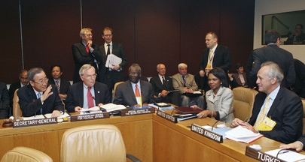

UN Photo/Eskinder Debebe
Secretary-General Ban Ki-moon (left) participates in a high-level meeting on the situation in Iraq. Also participating in the meeting from left to right: B. Lynn Pascoe, Under-Secretary-General for Political Affairs; Ibrahim Gambari, Special Adviser of the Secretary-General on the International Compact with Iraq and Other Issues; Condoleeza Rice, United States Secretary of State; and Mark Malloch Brown, UK Foreign Office Minister for Africa, Asia and the United Nations.
22 September 2007
United Nations, New York
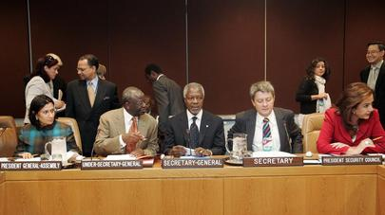

UN Photo/Mark Garten
Secretary-General Kofi Annan (centre, front row) is pictured at the opening of the seventh high-level meeting of the Regional and Intergovernmental Organizations, at UN Headquarters in New York. With him are (from left to right): General Assembly President Haya Rashed Al Khalifa; Ibrahim A. Gambari, Under-Secretary-General for Political Affairs; Mr. Annan; Jarmo Sareva, Disarmament and Decolonization Affairs Chief of Branch; and Foreign Minister of Greece and Security Council President, Dora Bakoyannis.
22 September 2006
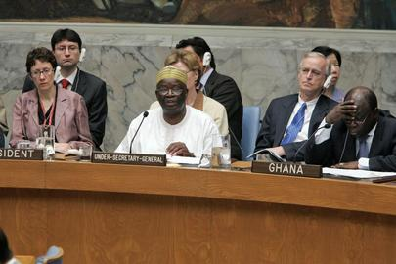
United Nations, New York

UN Photo/Eskinder Debebe
Ibrahim Agboola Gambari (centre), Under-Secretary-General for Political Affairs, addressing the Security Council debate on the escalating conflict between Israel and Lebanon and the broader crisis in the Middle East region. Secretary-General Kofi Annan decided on 13 June to dispatch a three person team led by his Special Advisor, Vijay Nambiar, to the Middle East to help defuse the major crisis in the region. The other members will be Alvaro de Soto and Terje Roed-Larsen.
14 July 2006
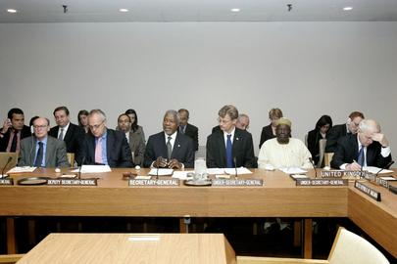
United Nations, New York

UN Photo/Eskinder Debebe
Left to right: Hédi Annabi, Assistant Secretary-General for Peacekeeping Operations, Deputy Secretary-General Mark Malloch Brown, Secretary-General Kofi Annan, Jan Egeland, Under-Secretary-General for Humanitarian Affairs and Emergency Relief Coordinator, Ibrahim Agboola Gambari, Under-Secretary-General for Political Affairs, and Emyr Jones Parry, Permanent Representative of the United Kingdom to the United Nations, at a meeting of the Group of Friends on Darfur, Sudan, at UN Headquarters.
04 May 2006
United Nations, New York

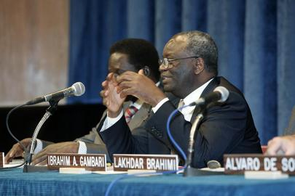

UN Photo/Mark Garten
Ibrahim Gambari (right), Under-Secretary-General for Political Affairs, leads a panel discussion on bolstering UN Peacemaking, today at UN Headquarters. In keeping with the decisions of the 2005 World Summit, the Department of Political Affairs is advancing proposals to bolster the ability of the Secretary-General to bring his "good offices" to bear in preventing and resolving deadly conflicts around the world. At left is Ibrahima Fall, Special Representative of the Secretary-General for the Great Lakes Region.
30 November 2005
United Nations, New York
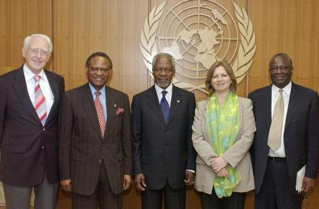

UN Photo/Eskinder Debebe
Secretary-General Kofi Annan (centre) meets with Members of the Secretary-Generals Advisory Panel on International Support for the New Partnership for Africas Development (NEPAD). From left to right: Richard Jolly, Member of the Panel; Emeka Anyaoku, Chairman of the Panel; Mr. Annan; Anne Kristin-Sydnes, Member of the Panel; Ibrahim Gambari, Special Adviser to the Secretary-General on Africa.
03 June 2005
United Nations, New York
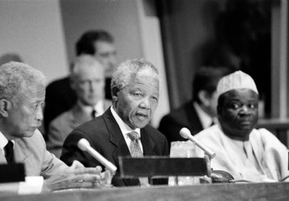

UN Photo/John Isaac
Nelson Mandela (centre), President of the African National Congress of South Africa (ANC), addressing correspondents at a press conference held today at UN Headquarters. He is flanked by Ibrahim Gambari (right), Chairman of the Special Committee against Apartheid, and David Dinkins, Mayor of the City of New York.
24 September 1993
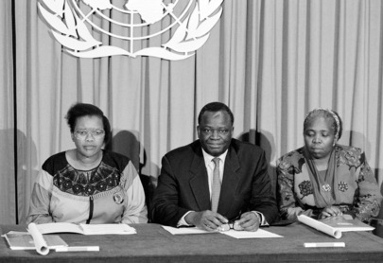
United Nations, New York

UN Photo/Michos Tzovaras
Addressing the correspondents were Cynthia Bekwa (left), of the Pan Africanist Congress of Azania (PAC), and Nkosazana Zuma (right), of the African National Congress of South Africa (ANC). Ibrahim Gambari (centre), Permanent, Representative of Nigeria and Chairman of the Special Committee against Apartheid, introduced the women to those who attended the briefing.
09 August 1993
United Nations, New York

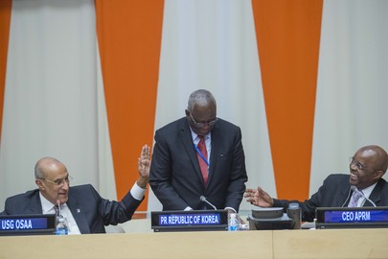

UN Photo/Amanda Voisard
High-level event entitled “A Renewed Global Partnership for Entrenching Good Governance and the Rule of Law in Africa”. The meeting was co-organized by the Office of the Special Adviser on Africa (OSAA), the Department of Public Information (DPI), the Economic Commission for Africa (ECA) and the African Union (AU).
Maged Abdelaziz (left), Under-Secretary-General and Special Adviser on Africa, and Eddy Maloka (right), Chief Executive Officer (CEO) of the Secretariat of the African Peer Review Mechanism (APRM), share a laugh with Ibrahim Gambari, former Head of the African Union-UN Hybrid Operation in Darfur (UNAMID).
12 October 2016
United Nations, New York
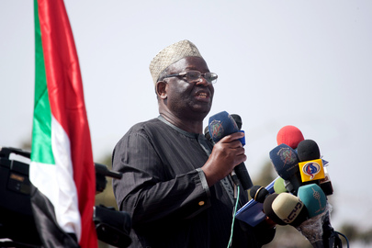

UN Photo/Albert González Farran
Ibrahim Gambari, Joint Special Representative for the African Union-UN Hybrid Operation in Darfur (UNAMID), addresses the people gathered El Negaa Stadium, El Fasher, for a public rally in support of the launch today, of the headquarters of the Darfur Regional Authority (DRA). The DRA was established as part of the Doha Document for Peace in Darfur, signed by the Government of Sudan and the Liberation and Justice Movement (LJM). It will be responsible for coordinating and implementing the Document’s stipulations, as well as other development activities and projects.
08 February 2012
El Fasher, Sudan
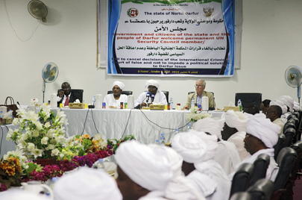

UN Photo/Olivier Chassot
Mark Lyall Grant (head of table, right), Permanent Representative of the United Kingdom to the UN, attends a meeting in El Fasher, Sudan, with Ibrahim Gambari (left), Joint Special Representative for the African Union-United Nations Hybrid Operation in Darfur (UNAMID); Osman Mohammed Yousif Kibir (second from right), Wali (Governor) of Sudan’s North Darfur state; and other North Darfur officials. Mr. Grant was part of a Security Council delegation visiting Sudan to reaffirm international support for the implementation of the country’s Comprehensive Peace Agreement.
08 October 2010
El Fasher, Sudan

UN Photo/Olivier Chassot
Susan Rice (second from right), Permanent Representative of the United States to the UN, and Mark Lyall Grant (second from left), Permanent Representative of the United Kingdom of Great Britain and Northern Ireland to the UN, meet with Ibrahim Gambari (centre), Joint Special Representative for the African Union-United Nations Hybrid Operation in Darfur (UNAMID), and Patrick Nyamvumba (right), UNAMID Force Commander, during the visit of the Security Council delegation to El Fasher in the western region of Darfur, Sudan. The delegation’s visit to Sudan aims to reaffirm support for the implementation of the Comprehensive Peace Agreement and to encourage a peaceful, comprehensive resolution of the situation in Darfur.
07 October 2010
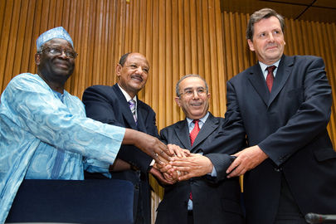
El Fasher, Sudan

UN Photo/Olivier Chassot
Under-Secretary-General for Peacekeeping Operations Alain Le Roy (right) joins hands with participants from the eighth meeting of the African Union, United Nations, Government of the Sudan Tripartite Mechanism on the African Union-United Nations Hybrid Operation in Darfur (UNAMID), held in Addis Ababa, Ethiopia. With Mr. Le Roy, from left to right: Ibrahim Gambari, Joint Special Representative for UNAMID; Magzoub Rahma Al Badawi, Director of International Cooperation at the Sudanese Ministry of Defense; and Ramtane Lamamra, Commissioner for Peace and Security of the African Union.
10 May 2010
Addis Ababa, Ethiopia
UN Photo/Olivier Chassot

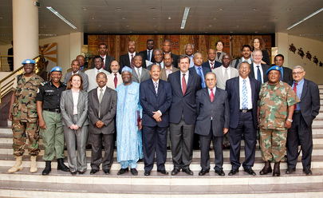

Alain Le Roy (front, fifth from right) poses for a group photo with participants of the eighth meeting of the African Union, United Nations, Government of the Sudan Tripartite Mechanism on the African Union-United Nations Hybrid Operation in Darfur (UNAMID), in Addis Ababa, Ethiopia. Among the participants: Ibrahim Gambari (fifth from left), Joint Special Representative for UNAMID; Magzoub Rahma Al Badawi (sixth from left), Director of International Cooperation at the Sudanese Ministry of Defense; Ramtane Lamamra (fourth from right), Commissioner for Peace and Security of the African Union; and Mohamed Yonis (third from right), Deputy Joint African Union-United Nations Special Representative for Operations and Management.
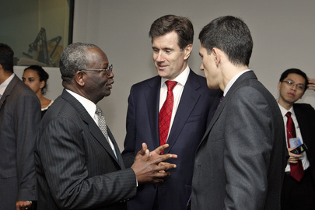
10 May 2010
Addis Ababa, Ethiopia

UN Photo/Eskinder Debebe
Ibrahim Gambari (left), Special Adviser of the Secretary-General on the International Compact with Iraq and Other Political Issues, converses with John Sawers (centre), Permanent Representative of the United Kingdom of Great Britain and Northern Ireland to the United Nations, as well as David Miliband (right), Secretary of State for Foreign and Commonwealth Affairs of the United Kingdom of Great Britain and Northern Ireland, prior to a meeting of the Group of Friends of the Secretary-General on Myanmar.
27 September 2008
United Nations, New York
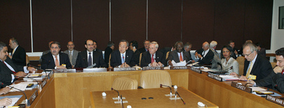

UN Photo/Eskinder Debebe
Secretary-General Ban Ki-moon (third from left) participates in a high-level meeting on the situation in Iraq. Also participating in the talks from left to right: Hoshyar Zebari, Minister for Foreign Affairs of Iraq; Nouri Kamel al-Maliki (left), Prime Minister of Iraq; B. Lynn Pascoe, Under-Secretary-General for Political Affairs; Ibrahim Gambari, Special Adviser of the Secretary-General on the International Compact with Iraq and Other Issues; Condoleeza Rice, United States Secretary of State; and Mark Malloch Brown, UK Foreign Office Minister for Africa, Asia and the United Nations.
22 September 2007
United Nations, New York
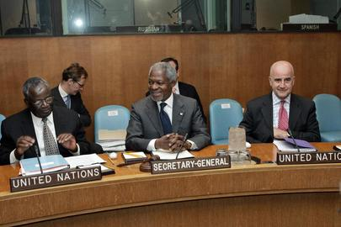

UN Photo/Mark Garten
Secretary-General Kofi Annan (centre) is flanked by his two top advisors, Alvaro de Soto (right), UN Special Coordinator for the Middle East Peace Process and the Secretary-General's Personal Representative to the Palestine Liberation Organization and the Palestinian Authority; and Ibrahim Gambari, Under-Secretary-General for Political Affairs, at today's meeting of the Quartet principals from the European Union, the Russian Federation, the United States and the United Nations on the Israeli-Palestinian peace process, at UN Headquarters in New York.
09 May 2006
United Nations, New York
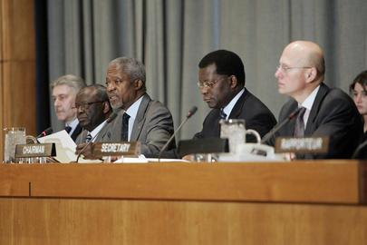

UN Photo/Mark Garten
Secretary-General Kofi Annan (third from left) delivers his remarks at the opening meeting of the 2006 session of the Committee on the Exercise of the Inalienable Rights of the Palestinian People, today at UN Headquarters in New York. With him are (left to right) Yuri Gourov,Chief of the Division for Palestinian Rights; Ibrahim Gambari, Under-Secretary-General for Political Affairs; Mr. Annan; Paul Badji, Chairman of the Committee on the Exercise of the Inalienable Rights of the Palestinian People; and Wolfgang Grieger, Secretary of the Committee.
10 February 2006
United Nations, New YorK

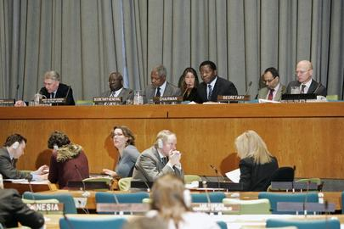

UN Photo/Mark Garten
Secretary-General Kofi Annan (third from left) flanked by Ibrahim Gambari, Under-Secretary-General for Political Affairs (second from left; and Paul Badji (fourth from left, front), Chairman of the Committee on the Exercise of the Inalienable Rights of the Palestinian People, pictured at the opening meeting of the 2006 session of the Committee on the Exercise of the Inalienable Rights of the Palestinian People, today at UN Headquarters in New York. Also with him are Yuri Gourov (left), Chief of the Division for Palestinian Rights; and Wolfgang Grieger (right), Secretary of the Committee.
10 February 2006
United Nations, New York
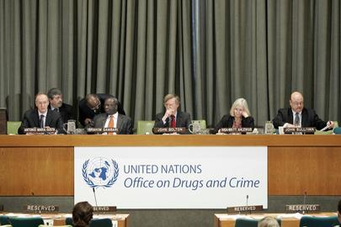

UN Photo/Mark Garten
Wide view of a panel discussion on "Combating Corruption" in recognition of the entry into force of the United Nations Convention Against Corruption, held today at UN Headquarters. From left to right: host and moderator Antonio Maria Costa, Under-Secretary-General, UN Office on Drugs and Crime; Ibrahim Gambari, Under-Secretary-General for Political Affairs; John R. Bolton, Permanent Representative of the United States to the UN; Inga-Britt Ahlenius, Under-Secretary-General, UN Office for Internal Oversight Services (OIOS); and John Sullivan, Executive Director of the Center for International Private Enterprise.
15 December 2005
United Nations, New York
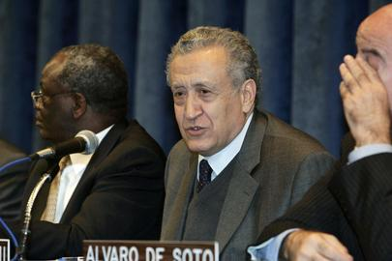

UN Photo/Mark Garten
Lakhram Brahimi (centre), Special Adviser to the Secretary-General, addresses the pannel discussion on bolstering UN peacemaking process. In keeping with the decisions of the 2005 World Summit, the Department of Political Affairs is advancing proposals to bolster the ability of the Secretary-General to bring his "good offices" to bear in preventing and resolving deadly conflicts around the world. From left to right: Ibrahim Gambari, Under-Secretary-General for Political Affairs; Mr. Brahimi; and Alvaro de Soto, Special Coordinator for the Middle East Peace Process, and Personal Representative of the Secretary-General to the Palestine Liberation Organization and the Palestinian Authority.
30 November 2005
United Nations, New York
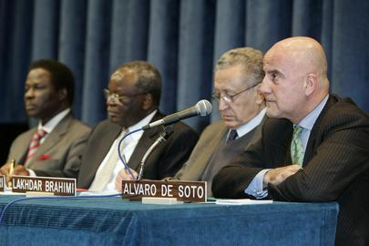

UN Photo/Mark Garten
Wide view of the panel discussing the need for bolstering UN peacemaking, today at UN Headquarters. In keeping with the decisions of the 2005 World Summit, the Department of Political Affairs is advancing proposals to bolster the ability of the Secretary-General to bring his "good offices" to bear in preventing and resolving deadly conflicts around the world. From left to right: Ibrahima Fall, Special Representative of the Secretary-General for the Great Lakes Region; Ibrahim Gambari, Under-Secretary-General for Political Affairs; Lakhram Brahimi, Special Adviser to the Secretary-General; and Alvaro de Soto, Special Coordinator for the Middle East Peace Process.
30 November 2005
United Nations, New York
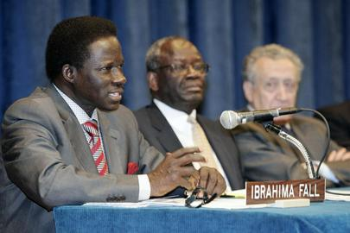

UN Photo/Mark Garten
Ibrahima Fall (left), Special Representative of the Secretary-General for the Great Lakes Region, addresses the panel discussion on bolstering UN peacemaking, today at UN Headquarters. In keeping with the decisions of the 2005 World Summit, the Department of Political Affairs is advancing proposals to bolster the ability of the Secretary-General to bring his "good offices" to bear in preventing and resolving deadly conflicts around the world. From left to right: Mr. Fall; Ibrahim Gambari, Under-Secretary-General for Political Affairs; and Lakhram Brahimi, Special Adviser to the Secretary-General.
30 November 2005
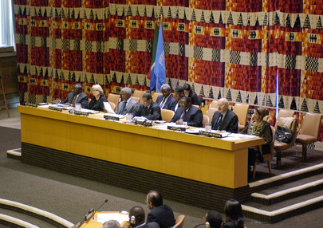
United Nations, New York

UN Photo/Sophia Paris
Left to right: Ibrahim Gambari, Under-Secretary-General and Special Adviser on Africa; Marjatta Rasi, President of the Economic and Social Council and Permanent Representative of Finland to the United Nations; Secretary-General Kofi Annan; Julian Robert Hunte (Saint Lucia), President of the fifty-eighth session of the General Assembly; Dumisani Shadrack Kumalo, Permanent Representative of the Republic of South Africa to the United Nations; Gunter Pleuger, President of the Security Council for the month of April and Permanent Representative of Germany to the United Nations; Angela King, Assistant Secretary-General and Adviser on Gender Issues.
27 April 2004
United Nations, New York
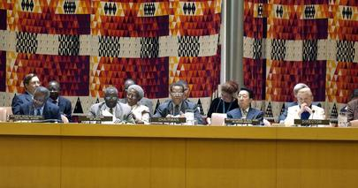

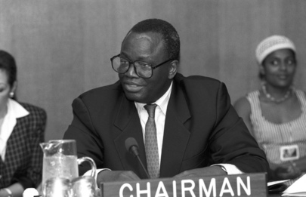
UN Photo/Eskinder DebebeLeft to right at the podium: Tuliameni Kalomoh, Assistant Secretary-General for Political Affairs, Ibrahim Gambari, Special Adviser to the Secretary-General on Africa, Julian Robert Hunte (Saint Lucia), President of the fifty-eighth session of the General Assembly, and Chen Jian, Under-Secretary-General for General Assembly and Conference Management, and Margaret Ann Kelley, Director of the General Assembly and ECOSOC Affairs Division of the Department for General Assembly and Conference Management.

UN Photo/John Isaac
The Special Committee against Apartheid today held a commemorative meeting to mark the International Day of Solidarity with the Struggle of Women in South Africa. During today's annual event representatives of the African National Congress of South Africa (ANC) and the Pan Africanist Congress of Azania (PAC) called for an end to the violence in South Africa and for greater participation by women in the political process.
Ibrahim Gambari, Chairman of the Special Committee against Apartheid, addresses the Committee.
09 August 1993
United Nations, New York
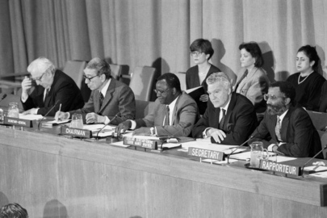

UN Photo/M Tzovaras
The Special Committee against Apartheid held its first meeting of 1992. Secretary-General Boutros Boutros-Ghali said that courageous steps had been taken in South Africa in the past two years, among them, the launching of the Convention for a Democratic South Africa. It was now possible to envision a new society -- one which respected human rights; did not discriminate on grounds of colour, sex, political affiliation or creed; and in which all shared economic wealth and opportunity.
Seated from left to right at the head-table are: Vasiliy Safronchuk, Under-Secretary-General for Political and Security Council Affairs; Secretary-General Boutros Boutros-Ghali; Ibrahim A. Gambari (Nigeria), Chairman of the Special Committee against Apartheid; and Tesfaye Tadesse, Secretary of the Committee.
18 February 1992
United Nations, New York

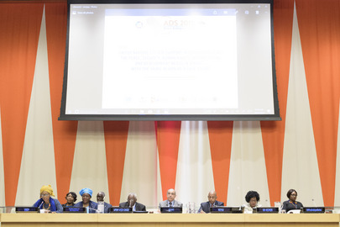

UN Photo/Manuel Elias
Ahunna Eziakonwa (left), Assistant Administrator and Regional Director, UNDP Regional Bureau for Africa, moderates the event "United Nations system support in operationalising the Peace, Security, Human Rights, Humanitarian and Development nexus in Africa - with focus on the Sahel", part of the Africa Dialogue Series 2018.
On her side from left to right is: Finda Koroma, Vice President of the Economic Community of West African States (ECOWAS) Commission; Ibrahim Gambari, Founder and Chairperson of the Savannah Centre for Diplomacy, Democracy & Development and former United Nations Special Adviser on Africa; Mohamed Fathi Ahmed Edrees, Permanent Representative of Egypt to the United Nations and Representative of the incoming African Union Chairperson 2019; Ibrahim Mayaki, Chief Executive Officer of New Partnership for Africa's Development (NEPAD); and Tolulope Lewis-Tamoka, Programme Advisor for Africa for the UN Entity for Gender Equality and the Empowerment of Women (UN Women).
18 October 2018
United Nations, New York

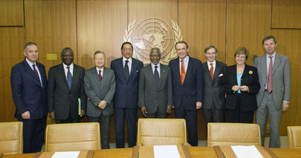

UN Photo/Eskinder Debebe
Secretary-General Kofi Annan (centre) is pictured with the heads of the six Principal Organs of the United Nations (General Assembly, Security Council, Economic and Social Council, Trusteeship Council, International Court of Justice and the Secretariat) when they held their seventh annual meeting in New York today. Left to right are Nicolas Michel,Under-Secretary-General for Legal Affairs and United Nations Legal Counsel; Ibrahim Gambari, Under-Secretary-General for Political Affairs; Shi Jiuyong, President of the International Court of Justice (ICJ); Munir Akram, Permanent Representative of Pakistan to the United Nations and President of ECOSOC; Mr. Annan; Jan Eliasson, President of the sixtieth session of the General Assembly; Michel Duclos, Deputy Permanent Representative of France to the United Nations and President of the Trusteeship Council; Deputy Secretary-General Louise Fréchette; and Jean-Marie Guéhenno, Under-Secretary-General for Peacekeeping Operations..
25 October 2005
United Nations, New York
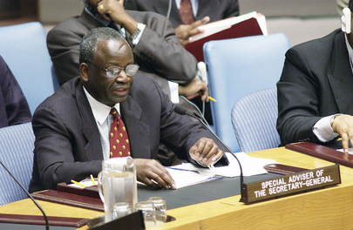

UN Photo/Evan Schneider
In a matter of days, two Security Council missions would be departing for Central and West Africa with a powerful message that the Council remained actively engaged on all issues plaguing the subregions, that body heard today as it met to review the United Nations' involvement in Africa. More than 30 speakers hailed today's meeting as helping to forge the right context for peace. The discussion ended a month in which the dire situation in the interior region of the continent had commanded much of the Council's attention. It had taken several actions, including earlier today, when it authorized the establishment of an Interim Emergency Multinational Force in the town of Bunia, Democratic Republic of the Congo, to quell the fierce inter-ethnic fighting there. Under-Secretary-General and Special Adviser on Africa, Ibrahim Gambari, addresses the Council.
30 May 2003
United Nations, New York
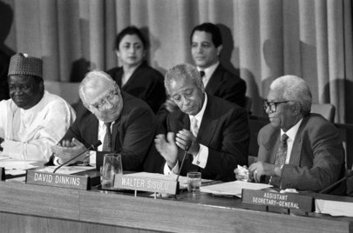

UN Photo/E Debebe
The Special Committee against Apartheid observes the Day of Solidarity with South African Political Prisoners. The Day marks the anniversary of the adoption of a General Assembly resolution in 1963, calling on the South African regime to release unconditionally all persons imprisoned, interned or subjected to other restrictions for their opposition to apartheid. In 1976, the General Assembly called for the annual observance of this Day.
Addressing the gathering is Walter Sisulu (extreme right), Deputy President of the African National Congress (ANC). From left to right are: Ambassador Ibrahim A. Gambari (Nigeria), Chairman of the Special Committee against Apartheid; Vasiliy S. Safronchuk, Under-Secretary-General, Department of Political and Security Council Affairs; Mayor David Dinkins of New York City; and Walter Sisulu, Deputy President of the African National Congress (ANC).
11 October 1991
United Nations, New York

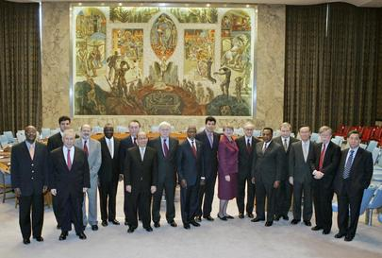

UN Photo/Eskinder Debebe
Members of the Security Council are pictured with Secretary-General Kofi Annan for the end of the year group photo. From left to right: Simon Bodéhoussè Idohou, Permanent Representative of the Republic of Benin to the United Nations; Adamantios Vassilakis, Permanent Representative of Greece to the United Nations; Mircea Ioan Motoc, Permanent Representative of Romania to the United Nations; Ronaldo Mota Sardenberg, Permanent Representative of Brazil to the United Nations; Ibrahim A. Gambari, Under-Secretary-General for Political Affairs; César Mayoral, Permanent Representative of Argentina to the United Nations; Lauro L. Baja, Jr., Permanent Representative of the Republic of the Philippines to the United Nations, Emyr Jones Parry, Permanent Representative of the United Kingdom of Great Britain and Northern Ireland to the United Nations; Kofi Annan, UN Secretary-General, Abdallah Baali, Permanent Representative of Algeria to the United Nations; Ellen Margrethe Løj, Permanent Representative of Denmark to the United Nations, Jean-Marc de La Sablière, Permanent Representative of France to the United Nations; A. Augustine Mahiga, Permanent Representative of the United Republic of Tanzania to the United Nations; Andrey I. Denisov, Permanent Representative of the Russian Federation to the United Nations; Kenzo Oshima, Permanent Representative of Japan to the United Nations; John R. Bolton, Permanent Representative of the United States to the United Nations; and Zhang Yishan, Deputy Permanent Representative of the People's Republic of China to the United Nations.

