A/HRC/41/CRP.2
25 June 2019
English only
Human Rights Council
Forty-first session
24 June–12 July 2019
Agenda item 10
Technical assistance and capacity-building
Report on the human rights situation in Ukraine 16 February to 15 May 2019*

Contents
Page
I. Executive summary 4
II. OHCHR methodology 7
III. Impact of hostilities 9
A. Conduct of hostilities and civilian casualties 9
B. Economic and social rights 11
IV. Right to physical integrity 14
A. Access to places of detention 15
B. Arbitrary detention, enforced disappearances, torture and ill-treatment 15
C. Situation of pre-conflict prisoners 17
D. Missing persons 17
V. Accountability and administration of justice 17
A. Administration of justice 17
B. Accountability for human rights violations 20
VI. Civic space and fundamental freedoms 21
A. Freedom of opinion and expression and freedom of the media 21
B. Language rights 22
C. Freedom of peaceful assembly and association 23
D. Freedom of religion or belief 24
E. Discrimination, racially-motivated violence and manifestations of intolerance 24
VII. Human rights in the Autonomous Republic of Crimea and the city of Sevastopol, Ukraine
temporarily occupied by the Russian Federation 25
A. International humanitarian law 25
B. Rights of detainees in Crimea 26
C. Right to education in native language and right to maintain one’s identity, culture and
tradition 27
VIII. Technical cooperation and capacity-building 27
IX. Conclusions and recommendations 28

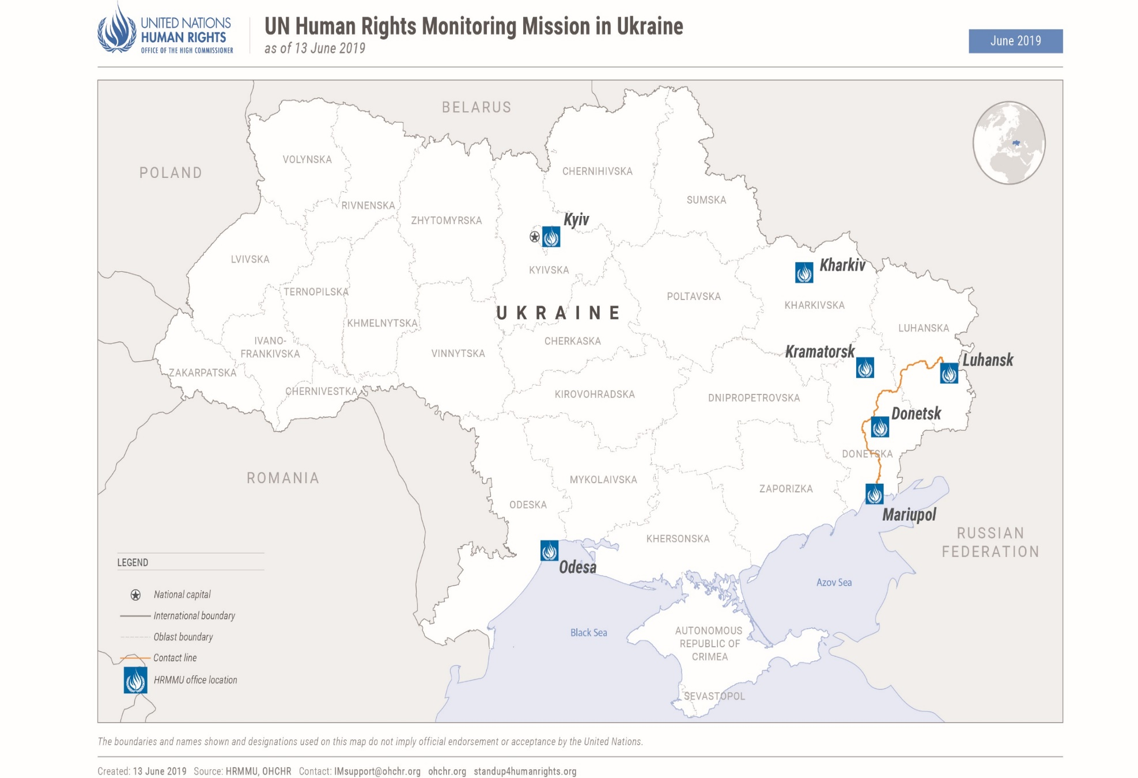

I. Executive summary
1. This twenty-sixth report on the situation of human rights in Ukraine by the Office of the United Nations High Commissioner for Human Rights (OHCHR) is based on the work of the United Nations Human Rights Monitoring Mission in Ukraine (HRMMU), and covers the period from 16 February to 15 May 2019.
2. On the basis of its monitoring work, OHCHR documented 230 human rights violations and abuses as having occurred during the reporting period, affecting 220 victims, notably violations and abuses of the rights to life, physical integrity, a fair trial, non-discrimination, fundamental freedoms, as well as social and economic rights. These figures are comparable to the last reporting period. An additional 198 violations and abuses that occurred before the reporting period were documented during this reporting period.
3. Of the violations and abuses documented by OHCHR, the Government of Ukraine was responsible for 168 violations, the self-proclaimed ‘Donetsk people’s republic’ for 14 of these and self-proclaimed ‘Luhansk people’s republic’ for 206. The Government of the Russian Federation was responsible for 40 violations in the Autonomous Republic of Crimea and the city of Sevastopol, Ukraine, temporarily occupied by the Russian Federation.
4. As described in the report, while the armed conflict in eastern Ukraine continues to affect the population throughout the country, the ongoing hostilities in a number of hotspots along the contact line have a significant impact on the lives of people who live there. During the reporting period, OHCHR documented 45 conflict-related civilian casualties: 10 killed and 35 injured, which represents a 181 per cent increase compared with the previous reporting period from 16 November 2018 to 15 February 2019, but the lowest figures compared with the same periods in 2015-2018. Shelling and small arms and light weapons fire killed two civilians and injured 18 – one of the lowest figures for the entire conflict period. Of these, 16 were recorded in territory controlled by ‘Donetsk people’s republic’ and ‘Luhansk people’s republic’ and are attributable to the Government, and four were recorded in Government-controlled territory and are attributable to armed groups of ‘Donetsk people’s republic’ and ‘Luhansk people’s republic’. Mines and explosive remnants of war killed seven civilians and injured 17. The total civilian death toll of the conflict reached at least 3,331 as of 15 May 2019.
5. Overall, as of 15 May, average monthly civilian casualties in 2019 were 50 percent lower than in 2018 and were among the lowest for the entire conflict period. These numbers demonstrate that it is possible to progressively decrease civilian casualties to close to zero. Until the conflict is resolved, adherence to the Minsk Agreements and respect of international humanitarian law are key factors in making this happen.
6. More generally, OHCHR reiterates its concern about the need to ensure broader protection of the rights of conflict-affected civilians wherever they may be. Civilians residing in proximity to the contact line continued to lack access to basic services and social support. Remedy and reparation for people injured and whose relatives have been killed, as well as those whose properties have been damaged or destroyed are still lacking. Furthermore, freedom of movement continued to be one of the main concerns with nine persons dying while crossing entry-exit checkpoints (EECPs). Efforts by the Government to facilitate travel across the contact line are welcome, notably the removal of expiry dates of permits to cross EECPs issued online as of 28 March 2019. In practice however, there was little improvement in crossing conditions. There remains an acute need for more crossing points and long-awaited reconstruction of the bridge at Stanytsia Luhanska EECP.
7. While OHCHR welcomed efforts to improve conditions for IDPs through Ministry of Social Policy draft amendments to resolutions regulating the payment of pensions and social benefits, the Government continues to link access to pensions to IDP registration. As a result, over 700,000 people living in territory controlled by ‘Donetsk people’s republic’ and ‘Luhansk people’s republic’ have lost effective access to their pensions.
8. OHCHR welcomes the transfer of 120 pre-conflict prisoners from territory controlled by ‘Luhansk people’s republic’ to Government-controlled territory that took place in March and April 2019, and encourages the continuation of this practice.
9. OHCHR is concerned about the practice of arbitrary arrest, incommunicado detention, torture and ill-treatment of civilians in Government-controlled territory. During the reporting period, OHCHR documented four cases of arbitrary detention of civilians allegedly by officers of the Security Service of Ukraine (SBU). Individuals in territory controlled by ‘Donetsk people’s republic’ and ‘Luhansk people’s republic’ continued to be subjected to ‘administrative’ arrest and ‘preventive’ arrest, respectively, which constitutes arbitrary and incommunicado detention, and may amount to enforced disappearance. OHCHR documented reports of poor detention conditions and forced labour in a number of penal colonies in territory controlled by ‘Luhansk people’s republic’. In Government-controlled territory, OHCHR had access to official places of detention and conducted confidential interviews with detainees in accordance with international standards. In territory controlled by ‘Donetsk people’s republic’ and ‘Luhansk people’s republic’, OHCHR does not have such access, and continues to call for confidential access to detainees to be granted to international observers including OHCHR.
10. Due process and fair trial violations persist as a result of the pervasive practice of prolonged pre-trial detention, and the use of force and coercion to obtain confessions or to accept plea bargains in conflict-related cases. Interference into the work of courts in conflict-related and other high-profile trials continued during the reporting period. Despite repeated calls by OHCHR for accountability for the killings of protestors and law-enforcement officers during the violent incidents in the Maidan protests in 2014 and the killings and violent deaths resulting from the 2 May 2014 violence in Odesa, this remains largely unaddressed by the authorities: few perpetrators have been identified and where trials have begun, they are protracted.
11. OHCHR is concerned about the occasional violent nature of acts in relation to the transition of churches and religious communities from the Ukrainian Orthodox Church to the newly-established Orthodox Church of Ukraine involving supporters of both churches, local authorities and extreme right-wing groups.
12. In the territory controlled by ‘Donetsk people’s republic’, premises belonging to the Orthodox Church of Ukraine were seized, reportedly by the ‘ministry of state security’ of ‘Donetsk people’s republic’. During the reporting period, the ‘ministry of interior’ of ‘Luhansk people’s republic’ reportedly conducted searches in church premises and in priests’ residences, and seized items including personal correspondence. Activities of several Christian denominations continued to be targeted by ‘law enforcement agencies’ of ‘Donetsk people’s republic’, which prevented the congregation of worshippers due to lack of ‘registration’.
13. Peaceful, competitive and largely inclusive presidential elections were held in Ukraine during the reporting period. The first round of elections was held on 31 March 2019, the second round on 21 April 2019. OHCHR observed an increase in peaceful assemblies in the context of elections, and commends the professional conduct of law-enforcement officers policing them. However, the lack of accountability for prior attacks on other peaceful assemblies remains of concern. Accountability for attacks against individuals belonging to minorities, including Roma, remains outstanding more than a year since the events occurred.
14. The final version of the law on the use of the Ukrainian language approved on 25 April 2019 reflects a more balanced approach than that used in the first draft of the law. However, a law protecting the use of minority languages should be developed without undue delay, as the current framework does not provide sufficient guarantees for the protection and use of such languages.
15. Physical attacks against media professionals and civil society activists occurred during the reporting period, although OHCHR notes a lower number of such attacks in comparison with previous reporting periods. The lack of accountability for past attacks remains an issue. Civic space remained highly restricted in territory controlled by ‘Donetsk people’s republic’ and ‘Luhansk people’s republic’, with all assemblies observed reportedly organised by ‘Donetsk people’s republic’ and ‘Luhansk people’s republic’.
16. The Russian Federation, the occupying Power in Crimea, has still not granted OHCHR access to the peninsula in line with the UN General Assembly (GA) resolution on the territorial integrity of Ukraine 68/262 and UN GA resolutions 71/205, 72/190 and 73/263. OHCHR monitors the human rights situation on the peninsula from mainland Ukraine. During the reporting period, the Russian Federation continued to apply its laws, in violation of international humanitarian law applicable to an occupying Power, and committing human rights violations, including against detainees, and those seeking access to education in Ukrainian. The rights of the Crimean Tatars have also been particularly affected.
17. In this reporting period, OHCHR engaged in a number of technical cooperation and capacity-building activities, including the provision of training sessions, on, e.g. the protection of civilians, international standards for the treatment of prisoners and torture documentation, to a variety of actors and the preparation of analytical thematic papers intended for diverse audiences.
18. OHCHR operations in territory controlled by ‘Donetsk people’s republic’ and ‘Luhansk people’s republic’ continued to be restricted between 16 February and 15 May 2019. Ongoing discussions through regular meetings with representatives of both ‘Donetsk people’s republic’ and ‘Luhansk people’s republic’ have yet to secure the full resumption of OHCHR operations in the territory they control.
II. OHCHR methodology
19. This report is based on 179 in-depth interviews with individuals, including victims and witnesses of human rights violations and abuses. Information is generally obtained from victims, witnesses, relatives of victims and lawyers, site visits, Government representatives, civil society and other interlocutors, trial monitoring, as well as court documents, officials records, open-source and other relevant material. Findings are based on verified information collected from primary and secondary sources that are assessed as credible and reliable. Findings are included in the report where the “reasonable grounds” standard of proof is met, namely where, based on a body of verified information, an ordinarily prudent observer would have reasonable grounds to believe that the facts took place as described and, where legal conclusions are drawn, that these facts meet all the elements of a violation.
20. OHCHR applies the same due diligence and standard of proof when documenting conflict-related civilian casualties. OHCHR documents such casualties by consulting a broad range of sources and types of information that are evaluated based on credibility and reliability: victims and their relatives; witnesses; official records; open-source documents, photo and video materials; forensic records and reports; criminal investigation materials; court documents; public reports of the OSCE Special Monitoring Mission to Ukraine; reports by international and national non-Governmental organizations; public reports by law enforcement and military actors; data from medical facilities and local authorities; and other relevant and reliable materials. In some instances, documenting occurrences may take weeks or months before conclusions can be drawn, meaning that numbers on civilian casualties may be revised as more information becomes available. OHCHR attributes a civilian casualty to a particular party based on the geographic location where it occurred, the direction of fire, and the overall context surrounding the incident.
21. Consent is sought from sources on the use of information, ensuring confidentiality as appropriate, including an assessment of the risk of reprisals, in respect of OHCHR’s ‘do no harm’ principle.
22. While OHCHR cannot provide an exhaustive account of all human rights violations committed throughout Ukraine, it is able to obtain and verify information through a range of means according to its methodology, and bases its conclusions of patterns of human rights violations, abuses and harm on verified individual cases.

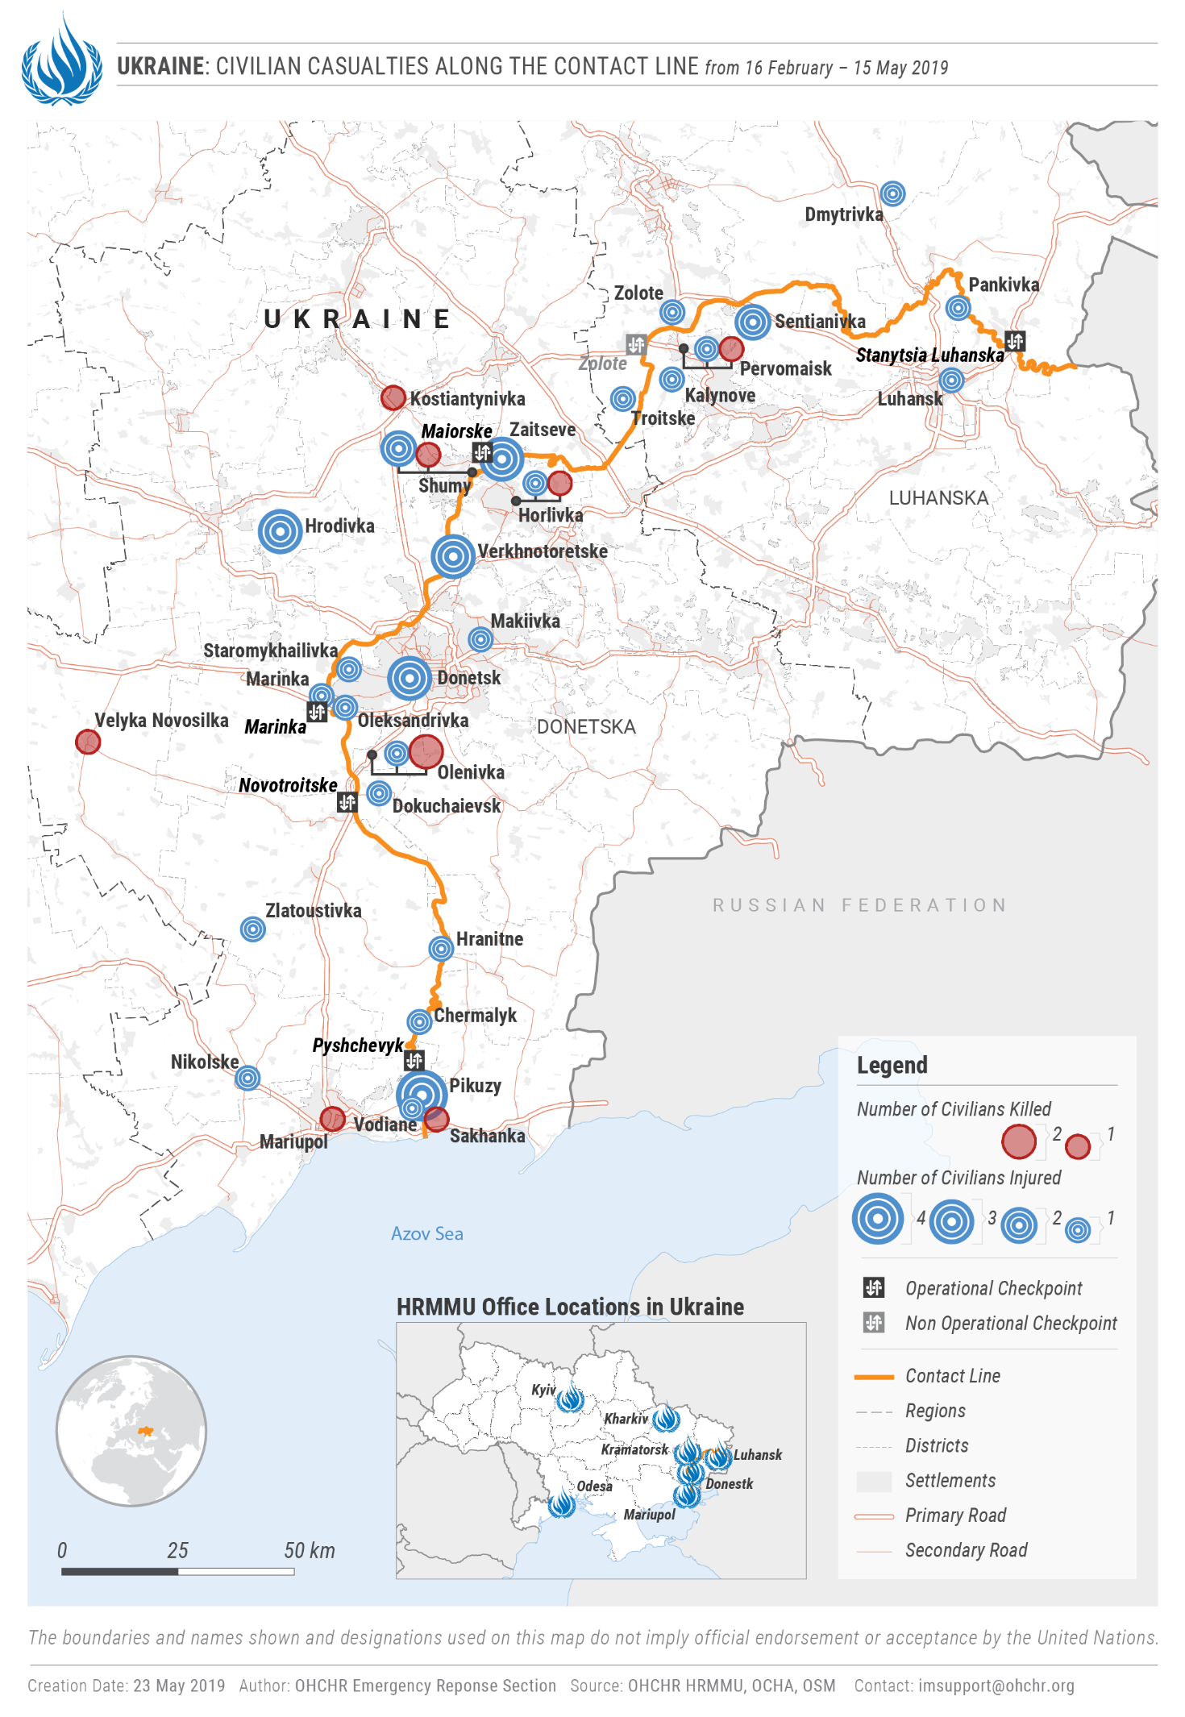

III. Impact of hostilities
“When the shelling starts at night, I put him to bed and tell him it is just rain drops falling.”
- A woman on how she explains the hostilities to her four-year-old grandchild in Oleksandrivka
23. During the reporting period, hostilities continued to affect, directly or indirectly, the lives of 3.9 million civilians residing in the conflict zone of eastern Ukraine. Regular exchanges of fire across the contact line continue to expose those residing nearby to a constant threat of death or injury, while their civilian property and critical civilian infrastructure continued to be damaged, often in disregard for the principles of distinction, proportionality and precaution. In addition to the threat of shelling, civilians continued to be at risk from mines and explosive remnants of war. OHCHR continued to observe the presence of military personnel or objects within, or near, populated areas on both sides of the contact line. Over the reporting period, OHCHR documented nine cases in which Ukrainian forces established a presence in, or near, residential areas. For instance, in Verkhnotoretske (Donetsk region), OHCHR observed trenches belonging to Ukrainian forces approximately 15 metres from the nearest inhabited house. Over the reporting period, the OSCE Special Monitoring Mission to Ukraine (OSCE SMM) identified at least 10 cases of military positions or weapons in or near residential areas in territory controlled by ‘Donetsk people’s republic and ‘Luhansk people’s republic’. For instance, in Verkhnoshyrokivske (formerly Oktiabr) in Donetsk region, OSCE SMM observed three tanks close to a probable mortar position next to houses.
24. OHCHR recalls in this regards that placement of military positions in and near residential areas puts civilians and civilian objects at increased risk of being affected and may amount to a violation of international humanitarian law.
A. Conduct of hostilities and civilian casualties
25. Between 16 February and 15 May 2019, OHCHR recorded 45 conflict-related civilian casualties: 10 killed and 35 injured, a 181 per cent increase compared with the previous reporting period of 16 November 2018 to 15 February 2019 when 16 civilian casualties (two killed and 14 injured) were recorded. The number of locations where civilian casualties were recorded increased from 11 to 28. The reporting period saw the lowest number of civilian casualties compared with same calendar periods (mid-February to mid-May) from 2015 to 2018.
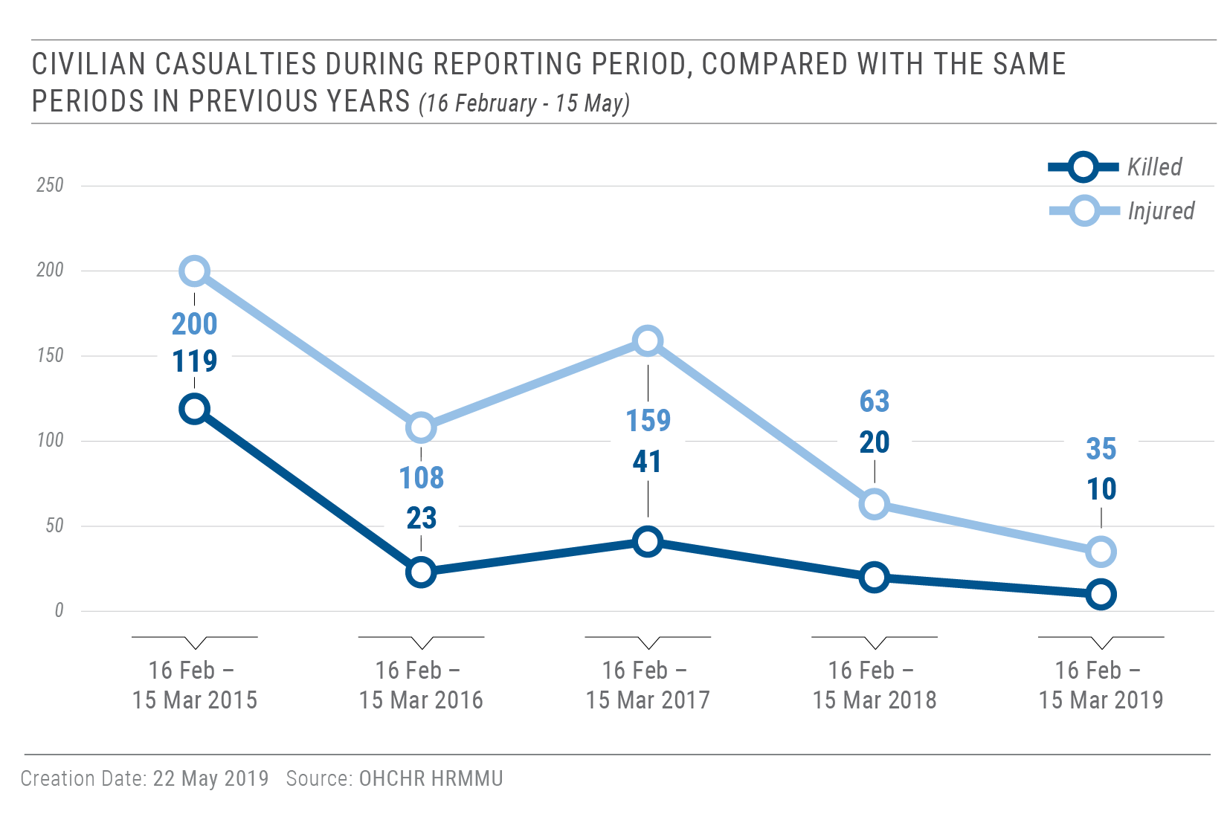
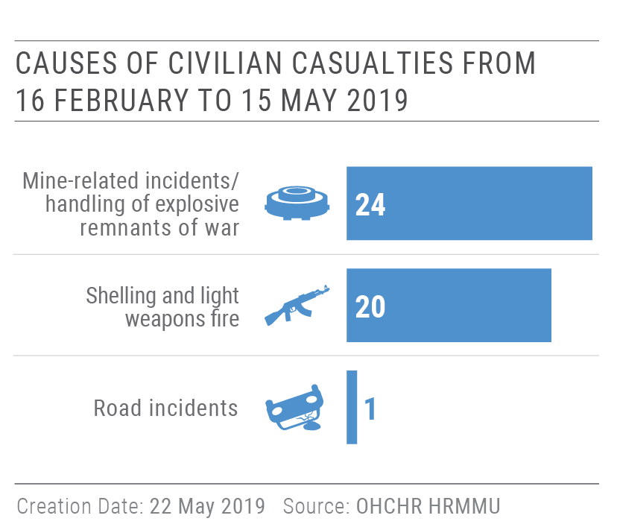
26. During the reporting period, shelling and SALW fire killed two civilians (one man and one woman) and injured 18 (eight men, eight women, one boy and one girl). This is a 100 per cent increase with the previous reporting period (ten injured), but still one of the lowest figures for the entire conflict period. Of the 20 civilian casualties caused by shelling and SALW fire, four injured were recorded in Government-controlled territory and are attributable to armed groups (three to armed groups of ‘Donetsk people’s republic’ and one to armed groups of ‘Luhansk people’s republic’); two civilians were killed and four injured in territory controlled by ‘Donetsk people’s republic’, and one civilian killed and three injured in territory controlled by ‘Luhansk people’s republic’, all attributable to the Government.
27. During the reporting period, seven civilians were killed (five men, one woman and one boy) and 17 were injured (14 men, two women and one boy) in mine-related incidents and as a result of ERW handling. Of these, 14 (four killed and 10 injured) were recorded in Government-controlled territory, and 10 (three killed and seven injured) – in territory controlled by ‘Donetsk people’s republic and ‘Luhansk people’s republic’.
28. In 2019, civilian casualties remained among the lowest for the entire conflict period: 11 on average per month (2-3 killed and 8-9 injured). These levels have been observed since July 2018. If they sustain until the end of the year, 2019 would see over 50 percent decrease in civilian casualties compared with 2018 which, in turn, saw a 50 percent decrease compared with 2017 and had the lowest civilian casualty figures for the entire conflict period. These numbers demonstrate that it is possible to progressively decrease civilian casualties to bring them close to zero, until a sustainable solution to the conflict is found. Adherence to the Minsk Agreements and respect of international humanitarian law have been key factors in making this happen.
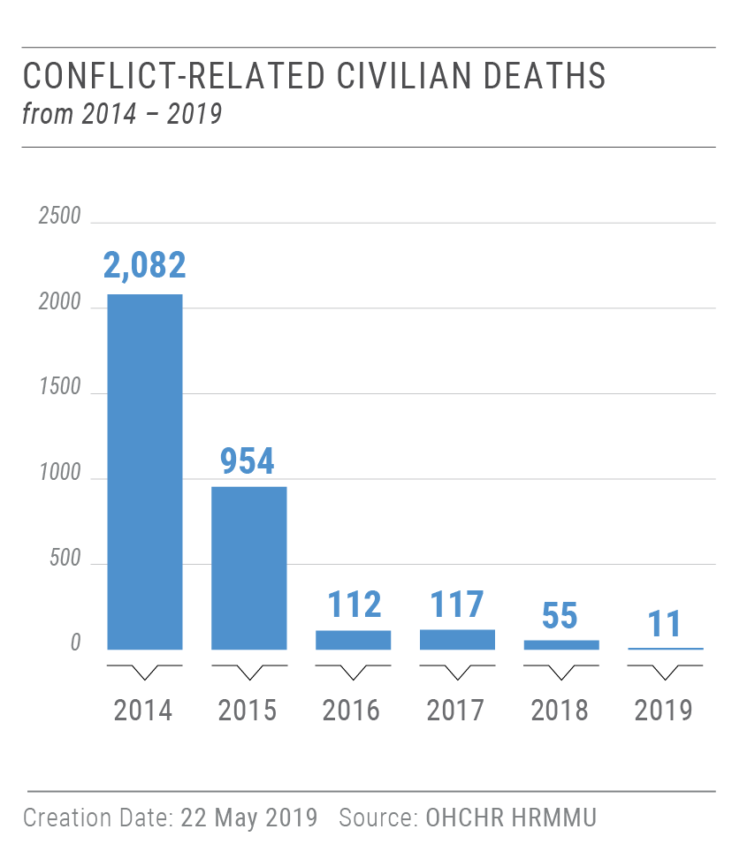
29. During the entire conflict period, from 14 April 2014 to 15 May 2019, OHCHR recorded in total 3,033 civilian deaths (1,800 men, 1,049 women, 98 boys, 49 girls and 37 adults whose gender is unknown). Taking into account the 298 deaths on board of Malaysian Airlines MH17 flight on 17 July 2014, the total death toll of the conflict on civilians has been at least 3,331. The number of injured civilians is estimated to exceed 7,000.

30. OHCHR welcomes the Government’s decision, taken in March 2019, to develop a national policy framework that would establish institutional authorities and responsibilities for the protection of civilians and civilian objects in hostilities as recommended in the 2018 United Nations Secretary General’s report on protection of civilians in armed conflict. The policy should be adopted without delay and its implementation supported by the development of the relevant plan of action.
B. Economic and social rights
31. The socio-economic situation in Ukraine continues to be jeopardised by the continuing conflict in the east. People living in isolated villages and near the contact line are especially affected, due to the lack of access to quality services. Divisive and discriminatory policies, legislation and practices continued to affect, among other rights, freedom of movement and access to pension and social benefits.
1. Remedy and reparation to civilian victims
32. Five years after the outbreak of the conflict, remedy and reparation to civilian victims – especially those injured (including hundreds of individuals whose injury resulted in disability), and families of those killed – remains lacking. Despite the advances for the social protection of victims brought about by the implementation of amendments to the law on war veterans relating to persons whose disabilities resulted from conflict-related injuries, the lack of a comprehensive State policy and mechanism on remedy and reparation in line with international standards, advocated for by OHCHR, remains a concern. During the reporting period, the inter-agency commission created to establish the nexus between disability and conflict-related injury considered 32 cases, having approved 24 applications, rejected five and requested additional clarifications on three.
33. OHCHR notes positive court cases regarding remedy and reparation to families who lost their family members due to hostilities. Two courts in Donetsk and Kharkiv regions issued decisions in favour of civilians, obliging the Government of Ukraine to provide monetary reparation to families who lost loved ones due to the hostilities. OHCHR commends these positive steps by the judiciary and encourages the Government of Ukraine to ensure implementation of these rulings. OHCHR also notes that the Grand Chamber of the Supreme Court is formulating its position on this category of cases.
Court case on reparation for family member killed due to hostilities, Luhansk region
The Appeal Court of Luhansk region ruled in favour of a woman seeking reparation for the death of her daughter during the armed conflict in eastern Ukraine. According to that judgment, the Government of Ukraine was obliged to provide monetary reparation for the family. The decision entered into force on 19 November 2018. While the Supreme Court previously refused to suspend its execution, this decision was then suspended by the Supreme Court upon the second request of the Ministry of Justice which argued that this amount of compensation, if provided to the plaintiff, would constitute an excessive intake from the State Budget.

OHCHR recalls that under international law, victims should be provided with adequate, effective and prompt reparation for harm suffered. Civilians who have received injuries and families who have lost their members due to the conflict must be provided with remedy and reparation.

2. Restitution and compensation for use or damage of private property
“How can I evaluate the amount of compensation due to me? What is the value of my son’s childhood in the village? What is of cost of my family’s separation for three years and the rented flats I paid for? What is the cost of my father’s early death because he couldn’t obtain proper medical assistance during the armed conflict? How can I evaluate all this? The compensation that I might eventually receive is not worth the time and nerves I would need to spend going from one governmental office to another and hearing from them ‘could you come tomorrow?’ And how can I prove that I had this and that if it is all gone now?”
- Civilian who has not been provided compensation for the military use of his house
34. During the reporting period, OHCHR continued to document, including remotely, cases of pillage of civilian homes on both sides of the contact line. For instance, OHCHR received allegations that civilian homes and property were pillaged in the village of Bezymenne (territory controlled by ‘Donetsk people’s republic’), and in the Government-controlled villages of Novozvanivka, Staryi Aidar and Troitske, in violation of international humanitarian law.
35. In Government-controlled Novozvanivka, Staryi Aidar, Troitske and Zolote-4 of Luhansk region, OHCHR documented cases of military use of civilian property without the provision of compensation, nor alternative housing to the owners. Military units do not conclude lease agreements with civilian owners in a regular and systematic manner, despite a legislative requirement to do so. Even when prompted or justified by imperative military necessity, lease agreements are necessary to guarantee owners access to compensation for the use of their property.
36. In the village of Bezymenne (territory controlled by ‘Donetsk people’s republic’), OHCHR received allegations of the continued military use of a civilian property, after armed groups forcibly evicted the owners of the house in December 2014. The armed groups did not provide any protection to the owners, nor adequate housing.
3. Right to social security and social protection
37. OHCHR regrets the continued lack of Government action to guarantee the payment of a pension to all Ukrainian citizens irrespective of their place of residence and registration. Despite positive developments in the judicial system when the national courts continued to rule in favour of pensioners, restoring their right to a pension in the line with international human rights standards, the Government failed to implement the decisions in a comprehensive and non-discriminatory manner. As of December 2018, 562,000 pensioners with original residence registration in territory controlled by ‘Donetsk people’s republic’ and ‘Luhansk people’s republic’ continued to receive pensions – out of an estimated 1,278,200 pensioners registered there as of August 2014. This continued non-inclusive access to social rights entrenches community divides and limits the space for peace and reconciliation efforts in eastern Ukraine.
38. OHCHR commends the Pension Fund of Ukraine initiative to develop draft amendments to resolutions regulating the payment of pensions to internally displaced persons (IDPs) which annul the residency verification requirement for pensioners. Nevertheless, OHCHR reiterates key concerns submitted jointly with UNCHR to the Pension Fund: current draft amendments do not protect IDPs from arbitrary suspension of their pensions. Moreover, the amendments do not resolve the main problem – that IDP registration is a requirement for pension payments. In addition, the draft amendments refer to a document regulating the payment of accumulated arrears, but such a document does not yet exist.
39. On 24 April 2019, the President of the Russian Federation signed an executive order ‘On Identifying Groups of Persons Entitled to a Fast-Track Procedure when Applying for Russian Citizenship on Humanitarian Grounds, which applies for individuals permanently residing in ‘certain areas’ of the Donetsk and Luhansk regions in Ukraine. The preamble states that its aim is to “to protect the rights and freedoms of a person and a citizen”. On 8 May 2019, the Government of Ukraine approved its official position that obtaining a Russian Federation passport under the aforementioned simplified procedure will not lead to a loss of Ukrainian citizenship. Recognising that it remains within the State’s sovereign power to determine retaliatory measures against other States, OHCHR notes that such measures must not be contrary to the State’s human rights obligations. OHCHR will continue monitoring the impact of the implementation of the order on Ukrainians’ citizens.
4. Freedom of movement
40. Crossing conditions between Government-controlled and territory controlled by ‘Donetsk people’s republic’ and ‘Luhansk people’s republic’ remained harrowing over the reporting period, due to the insufficient number of EECPs and the precarious crossing conditions. During the reporting period, at least nine civilians (eight men and one woman) died from health complications while crossing the EECPs in both directions.
41. In March 2019, SBU changed the validity of permits that civilians can apply to cross the contact line through the five EECPs in Donetsk and Luhansk regions. Permits requested or renewed as of 28 March 2019 no longer have an expiry date. Permits applied for, and approved before, or on, 28 March 2019 will be valid for one year but will be renewed thereafter without an expiry date. OHCHR welcomes this positive development, which should facilitate civilian crossing of the contact line.
42. OHCHR notes a recent court decision rendering void a list issued by the Ministry of Temporarily Occupied Territories of goods allowed for transfer across the contact line, which is currently being appealed. The implementation of any decision without a clear pre-established procedure regulating the transfer of goods, including a list of prohibited goods, may create a gap at the legislative level and could lead to arbitrary decisions by authorities administrating the EECPs. OHCHR reaffirms its recommendation to the Government on the necessity of substituting such list with a list of goods prohibited from transfer.
IV. Right to physical integrity
43. OHCHR documented 231 human rights violations and abuses involving arbitrary detention, torture, ill-treatment and/or threats to physical integrity, committed on both sides of the contact line. Sixty-eight violations occurred within the reporting period, which affected 39 victims (38 men and one woman). Of these, 14 are attributed to the Government of Ukraine, four are attributed to ‘Donetsk people’s republic’ and 50 are attributed to ‘Luhansk people’s republic’.
A. Access to places of detention
44. OHCHR enjoyed access to official places of detention and conducted confidential interviews with detainees and prisoners in accordance with international standards in Government-controlled territory. During the reporting period, OHCHR interviewed 125 conflict-related detainees (120 men and five women) in pre-trial detention facilities (SIZO) in Bakhmut, Kyiv, Mariupol, Odesa, Starobilsk, Zaporizhzhia and colonies in Hostomel and Kharkiv.
45. In territory controlled by ‘Donetsk people’s republic’ and ‘Luhansk people’s republic’, OHCHR had no access to places of deprivation of liberty. Confidential and unrestricted access to detention facilities in territory controlled by ‘Donetsk people’s republic’ and ‘Luhansk people’s republic’ for international monitors, including OHCHR, must be provided in line with international standards in order to address serious concerns about the treatment of detainees and conditions of detention.
B. Arbitrary detention, enforced disappearances, torture and ill-treatment
46. During the reporting period, OHCHR continued to document cases of arbitrary and incommunicado detention, torture and ill-treatment both in territory controlled by the Government and by ’Donetsk people’s republic’ and ‘Luhansk people republic’. Although the prevalence of such cases continued to be considerably lower than in 2014, 2015 and 2016, reporting on such human rights violations and abuses is generally delayed, including because recent victims often do not feel safe reporting such violations.
47. In Government-controlled territory, OHCHR continued to receive allegations that the SBU arbitrarily detain, torture, ill-treat and intimidate individuals, including in unofficial places of detention, in order to obtain information, pressure them to confess or cooperate. For example, on 17 April 2019, a man was apprehended at Marinka EECP, reportedly, by two SBU officers in civilian clothes. They took him to a booth, where they held him for approximately two hours. On the same day, two men drove him together with his wife to Kurakhove. They left his wife at the hotel, put a bag on his head and took him to an unknown location, where he was reportedly beaten. They brought him back to the hotel in a few hours with visible bruising on his face. After the incident, his health deteriorated and he was hospitalised. His wife appealed to the police about the incident at the EECP. On 23 April 2019, two SBU officers visited her at the hospital and pressured her to withdraw the complaint.
48. OHCHR followed the case of a foreign national, who was arbitrarily arrested and tortured in December 2018, reportedly by SBU officers. In early February 2019, the man and his family moved to the Odesa region, fearing further intimidation. On 12 February 2019, the State Bureau of Investigation (SBI) launched a probe into the victim’s allegations of arbitrary arrest and torture by the SBU. On 15 March 2019, two men, who introduced themselves as SBU officers, came to his apartment and asked about his complaint to the SBI. They asked him to come with them to Odesa, allegedly to sign some documents. In their car, the men put on masks, and seized his passport, wallet and phone. The individuals told him that he had to leave Ukraine. One of them showed the victim a live video stream of two armed men near his apartment were his wife and two children were, and told him they would enter his home if he did not agree to leave. They then forced him to make a statement on video saying he was leaving Ukraine voluntarily and that he had not been abused physically or psychologically. At the border crossing between Ukraine and Moldova, the individuals gave him a document to sign, which stated that he agreed to leave the country, and walked with him to the passport control at the border. One of the individuals threatened the victim: “If you return to Ukraine, we will kill you. If you talk about what happened to you, remember that you have a family in Ukraine.”
49. OHCHR remains concerned about the practice of 30-day ‘administrative arrest’ and ‘preventive arrest’ in territory controlled by ‘Donetsk people’s republic’ and ‘Luhansk people’s republic’ respectively. Such practices constitute arbitrary and incommunicado detention and may amount to enforced disappearance.
50. In territory controlled by ‘Donetsk people’s republic’, OHCHR documented four cases of civilians detained at EECPs by the ‘ministry of state security’ of ‘Donetsk people’s republic’. For example, on 26 February 2019, a mother finally learned that her two sons had been transferred to the Donetsk SIZO and charged with “espionage” following their disappearance in 2018. On 8 November 2018, two brothers, one with a physical disability travelled by car to territory controlled by ‘Donetsk people’s republic’ in Novoazovsk, to visit relatives. Their mother tried to call them after they had crossed the Government-controlled EECP, but their phones were switched off. In November 2018 and January 2019, their mother received several written replies from the ‘ministry of state security’ of ‘Donetsk people’s republic’ and the ‘ombudsperson office’ stating that they did not have any information about her sons’ location. It was the ‘general prosecutor’s office’ that confirmed her sons’ whereabouts on 26 February 2019.
51. On 3 March 2019, reportedly, a man got into an argument with representatives of the ‘ministry of state security’ of ‘Donetsk people’s republic when crossing the contact line through Olenivka EECP by car. The incident began after some cars were allowed to cut the line. The man was taken into a booth and was verbally abused there. When he resisted, he was beaten. He fainted, and when he regained consciousness, he realised he had been handcuffed and thrown on the floor. He was then taken outside and left handcuffed to a fence for an hour. They then threatened to kill him. He was released after signing documents which he was not allowed to read.
52. In territory controlled by ‘Luhansk people’s republic’, OHCHR documented a case when a civilian was detained at an EECP. On 23 February 2019, representatives of the ‘ministry of state security’ of ‘Luhansk people’s republic’ detained a man travelling to visit his friends in territory controlled by ‘Luhansk people’s republic’ at Stanytsia Luhanska EECP. After a witness informed the victim’s mother about what had happened, she went to the EECP to inquire about her son’s whereabouts. The representatives of the ‘ministry of state security’ told her that they had no information about him. It was only on 19 March 2019 that his mother was informed that her son had been detained under the ’preventive arrest’ procedure by the ‘ministry of state security’ of ‘Luhansk people’s republic’. On 26 April 2019, the victim was released from the premises of the ‘ministry of state security’ of ‘Luhansk people’s republic’.
53. In April 2019, OHCHR followed up on a case, previously documented, regarding the apprehension of two brothers by unidentified persons in Luhansk region on 17 February 2017. In the beginning of March 2017, their mother visited the ‘ministry of state security’ and the ‘ministry of interior’ of the ‘Luhansk people’s republic’ and filed an application to request information on the whereabouts of her sons. Only in April 2017 did she receive a phone call from a lawyer, informing her that both of them had been detained by the ‘ministry of state security’ on 17 February 2017 and kept in the premises of the ‘ministry of state security’. In January 2018, both victims were transferred to Luhansk SIZO.
C. Situation of pre-conflict prisoners
54. OHCHR welcomes the transfer of 120 pre-conflict prisoners (115 men and five women) that took place on 20 March and 22 April 2019 from places of detention in territory controlled by ‘Luhansk people’s republic’ to Government-controlled territory. The pre-conflict prisoners were transferred from eight penal colonies and a pre-trial detention facility in Luhansk. The transferred prisoners said that necessary medicine was not available or very limited in the penal colonies. The majority of prisoners did not complain due to the absence of an adequate complaint mechanism and fear of reprisals, such as placement into the isolation cell. Transferred prisoners interviewed by OHCHR said that administration forced them to work and in case of refusal, prisoners were put into the isolation cell, particularly in penal colonies in Sukhodilsk, Sverdlovsk and Khrustalnyi (formerly Krasnyi Luch). They also complained about the absence of fair remuneration, safe working environment, and no days off. A majority of prisoners said that they worked for free or for tea and cigarettes. Two prisoners said that they were beaten by colony staff for speaking in Ukrainian.
D. Missing persons
55. OHCHR welcomes the establishment of the Commission on Persons Missing due to Special Circumstances that will coordinate the efforts of the Government to clarify the fate and whereabouts of individuals that are unaccounted for as a result of the armed conflict. OHCHR stresses the importance of providing sufficient resources for the effective realisation of the Commission’s mandate.
V. Accountability and administration of justice
A. Administration of justice
56. OHCHR documented 95 violations of the right to a fair trial in conflict-related criminal cases. In particular, prolonged trials and the use of detention pending trial as a method to pressure defendants continued.
57. During the reporting period, Ukrainian courts of first instance passed 70 verdicts in conflict-related criminal cases. The court acquitted the defendant from criminal responsibility under articles 110 and 258-3 of the Criminal Code of Ukraine in only one of these cases, after the defendant had already spent one and a half years in detention. In the remaining 69 cases, all the defendants were found guilty, including 10 in absentia. In 52 of the 59 guilty verdicts judged under regular criminal proceedings, the defendant pleaded guilty or entered into plea bargain agreements.
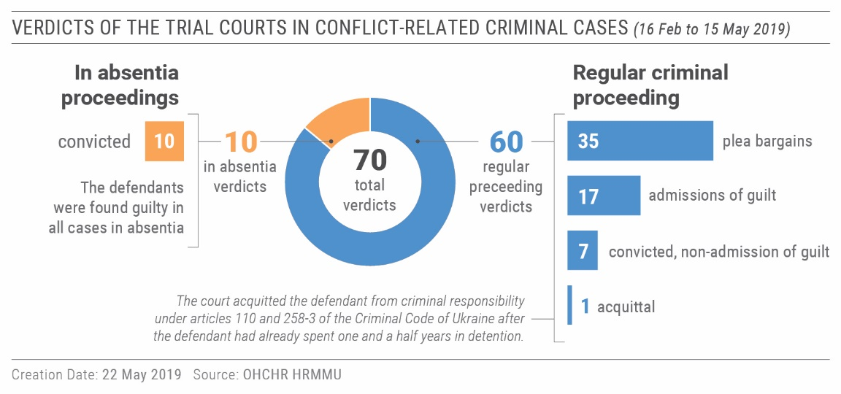
58. OHCHR notes with concern the lack of a uniform approach to the qualification of conflict-related crimes. Prosecutors take advantage of this practice to draw defendants into pleading guilty by charging them under articles carrying lower sentences if they cooperate. Another related issue is the loose interpretation of article 258 (3) and 258 (5) of the Criminal Code of Ukraine, which criminalizes, inter alia, “any support to the creation or activity of a terrorist group or terrorist organisation” and “financing terrorism”. OHCHR monitored four such cases and found reasonable grounds to believe that a broad interpretation of support to the activity of the armed group was adopted specifically to allow for the detention in custody of the defendant(s) under article 176.5 of the Criminal Procedure Code of Ukraine.
59. During the reporting period, OHCHR continued to document the persistent practice of prolonged, automatically ordered and extended pre-trial detention of defendants in conflict-related criminal cases. OHCHR notes that in the majority of cases observed, the prosecution, which is obliged to prove before the court specific risks that necessitate pre-trial detention due to individual circumstances, failed to provide any evidence, but only quoted the law and the alleged existence of such risks.
60. OHCHR continued to monitor unduly delayed criminal cases, in which defendants have been held in custody for more than three years. In another 34 documented cases, the defendants have already spent more than four years in custody. As in previous reporting periods, OHCHR notes that prolonged pre-trial detention continues to be used as a means of pressure to force defendants to plead guilty.
61. OHCHR is concerned that one of the reasons for protracted trials is the insufficient number of judges in trial courts. All 29 local courts in Donetsk and Luhansk regions are 47 percent understaffed, leading to a strained workload for judges, and hearings being scheduled only once every month or two.
62. Against this trend, as a positive development, in one documented case, a local court allowed a defendant to be released on bail, referencing international human rights standards and the case law of the European Court of Human Rights (ECtHR), in line with recommended practice.
63. During the reporting period, OHCHR also documented attempts by activists to obstruct justice in one conflict-related case through the exertion of pressure on judges and the intimidation of the defence lawyer and the defendant.
“We came to oversee the court, to ensure you pass the right ruling”
– an observer to the trial, to the judge of a local court
64. OHCHR also notes with concern the absence of progress in the investigation and prosecution of previous attacks and intimidation of judges and defence lawyers in conflict-related criminal cases, despite numerous complaints to the police and the High Council of Justice.
65. OHCHR is also concerned about the situation of individuals, who are ‘tried’ by ‘courts’ in territory controlled by ‘Donetsk people’s republic’ for crimes allegedly committed before the beginning of the armed conflict in eastern Ukraine. According to information received by OHCHR, such ‘trials’ are marked with many procedural violations jeopardising the rights of defendants to a fair trial. OHCHR is concerned that the conviction of individuals in such ‘courts’ may result in double jeopardy in case of their transfer to the Government-controlled territory of Ukraine.
B. Accountability for human rights violations
66. This reporting period marks the fifth anniversary of the culmination of the 2013-2014 Maidan protests and the violent events of 2 May 2014 in Odesa. No individuals responsible for acts of killing or violent deaths have been brought to justice in these cases, raising concerns about the authorities’ genuine intention to ensure accountability and justice for victims.
1. Accountability for killings during the Maidan events
67. Five years after the tragic events at Maidan that shook Ukraine in the winter of 2014, nobody has been brought to account for the acts of killing and violent deaths of 84 protestors, a man who did not participate in the protests, and 13 law enforcement officers. The investigations into the violent deaths of 17 protestors and 13 law enforcement officers have yet to identify individual perpetrators.
68. OHCHR is concerned that independent and impartial investigations and prosecution of the killings and violent deaths perpetrated during the Maidan protests have been hampered by the lack of cooperation extended by the Ministry of Internal Affairs and the SBU to the Prosecutor General’s Office Special Investigations Department (SID). Moreover, a number of senior police officers suspected or accused of committing crimes against the protestors retained their positions, having a chilling effect on their subordinates to testify about police involvement in the killings. The then senior police officials also disregarded their duty to ensure that their subordinates bore identification, posing a serious challenge to the identification of those who clashed with the protestors. In addition to the above, lack of organisational support and funding for the work of forensic bureaus complicates identification of individual perpetrators. OHCHR also notes that the ‘immunity law’ prevents the SID from effectively proceeding with investigation into the killings of 13 law enforcement officers during the Maidan events.
69. In its analytical paper on systemic obstacles to investigation of crimes committed during the Maidan protests, the Head of the SID confirmed OHCHR’s findings and referred to senior public officials’ lack of genuine intent, including by the Prosecutor General, in ensuring accountability for these crimes.
70. OHCHR is concerned that construction of the Maidan Museum on Instytutska street in Kyiv, which began in early May 2019, may disturb the onsite inquests that are regularly performed there. These inquests require preservation of the scene, which is being irreversibly damaged by the construction. This may create an additional obstacle for the investigations into the killings of 18 and 20 February 2014.
71. During the reporting period, OHCHR continued to monitor trials in the cases of killings of protestors in January and February 2014, noting their protracted nature.
2. Accountability for the killings and violent deaths on 2 May 2014
72. Five years after the violence in Odesa on 2 May 2014, those responsible for the killings and violent deaths of 48 people have yet to be brought to justice, with some of the perpetrators yet to be identified and investigations ineffective. During the reporting period, OHCHR noted no progress in the trials against regional police and State Emergency Service officials whose misconduct allegedly resulted in the deaths of up to 48 people, and limited progress in the trial against a participant of the mass disturbances accused of murder. As noted in its briefing note analysing obstacles to accountability for crimes committed during the 2 May 2014 events, while some positive developments have occurred, a number of trials continue to be unduly delayed.
“Can you request my recusal? I’d be very grateful if you did.”
“But your Honour, why would I do that?”
“Because I want to get rid of this case.”
- Conversation between a judge and a defence counsel during a hearing in a case related to the 2 May violence.
VI. Civic space and fundamental freedoms
73. Peaceful, competitive and largely inclusive presidential elections were held in Ukraine during the reporting period. The first round of elections was held on 31 March 2019, the second round on 21 April 2019. Despite tensions existing between supporters of competing candidates, expressed in numerous mass assemblies that preceded the first round, the electoral process was generally peaceful and ensured a smooth democratic transition. OHCHR did not document any incidents of election-related violence throughout the election process, including the second round. However, procedures for registering to temporarily change their voting location were especially burdensome for IDPs, and persons with disabilities. This also affected residents of territory controlled by ’Donetsk people’s republic’ and ‘Luhansk people’s republic’, and OHCHR noted an unusually low number of persons crossing the contact line on that day, and in particular few for the purpose of voting.
A. Freedom of opinion and expression and freedom of the media
74. OHCHR documented violations to the freedoms of opinion and expression as well as that of the media. In particular, investigations and court cases launched in the context of attacks by individuals against those exercising their civic freedoms were subject to delays and inappropriate qualification of the charges.
75. OHCHR is concerned about potential violations to the freedom of the media, and specifically about the possible negative impact of court cases where the prosecution has requested access to information that should be protected, including to personal data of journalists’ sources. It commends the decision of the Kyiv court of appeal to refuse such access in one case.
76. OHCHR is alarmed about other interference in the work of media professionals, in particular, physical attacks and acts of intimidation by a variety of actors. In one case, an unidentified individual attacked a well-known investigative journalist on 4 May 2019 in Cherkasy, placing him in a coma. In another case, on 6 March 2019, representatives of the local authorities attacked journalists and members of the film crew of the investigative television programme “Schemy” in the premises of Chabany village council in Kyiv region. While police have opened an investigation into the attack, OHCHR is concerned that they have classified it exclusively as ‘interference into the activities of journalists’, disregarding other possible charges, even though the victims were injured.
77. OHCHR commends progress in the case of the lethal attack against Kateryna Handziuk, but the trial appears protracted. On 23 April 2019, the prosecution changed the classification of the crime, with the five alleged suspects, previously charged with murder, now charged with “aggravated intended grievous bodily injury”, which carries a lighter sentence.
78. OHCHR is concerned about lack of accountability for attacks on journalists and media professionals. For example, journalist Oles Buzyna was killed four years ago. In the subsequent trial, which lasted 1 year and 4 months, the judge presiding in the case recused himself from the case on 6 May 2019, stating that the defence had attempted to discredit him and his colleagues, potentially affecting his impartiality. The case will now be retried.
79. The ability to enjoy freedoms of opinion and expression remains highly limited in territory controlled by ‘Donetsk people’s republic’ and ‘Luhansk people’s republic’. Based on OHCHR media monitoring, critical, independent media operating in territory controlled by ‘Donetsk people’s republic’ and ‘Luhansk people’s republic has yet to be identified.
B. Language rights
80. On 25 April 2019, the Parliament of Ukraine approved a law which lays the ground for a new language policy focused on strengthening the role of the official language. OHCHR notes that the final version of this law reflects a more balanced approach, compared to the text of the draft law adopted in the first reading, particularly in respect to language proficiency requirements for accessing public office, as well as to the linguistic requirements in the electoral process, in printed media and in commercial spheres. It also aims to ensure adequate educational opportunities, such as preparatory language training programmes.
81. However, the main concern remains that, in the absence of special legislation regulating the use of minority languages in Ukraine, the legal framework does not provide sufficient guarantees for the protection and use of minority languages. The law thus requires the Cabinet of Ministers to submit to the Parliament a draft law on the realisation of the rights of indigenous peoples and national minorities of Ukraine by January 2020. It is also concerning that the legislator continues to distinguish between minorities speaking an official language of the EU and other national minorities.
C. Freedom of peaceful assembly and association
82. Before the first round of the Presidential elections, OHCHR observed an increase in the number of peaceful assemblies organised by Presidential candidates, civic activists and extreme right-wing groups. All assemblies, including large assemblies monitored by OHCHR on 2 May 2019 in Odesa, and on 9 May 2019 in Kharkiv, Kyiv and Odesa, were peaceful and sufficiently secured by law-enforcement agencies.
83. OHCHR commends the professional conduct of the police during the peaceful events organised in support of women’s rights throughout Ukraine on 8 March 2019. Participants of these events in Kyiv, Uzhhorod, Kharkiv, Lviv, and Mariupol were able to enjoy their right to freedom of peaceful assembly. In Kyiv, approximately 1500 people participated in the march to support women’s rights. While extreme right-wing groups protested against the march, police prevented them from disrupting it.
84. Despite this positive development, OHCHR is concerned about the lack of accountability for prior attacks on similar assemblies. For instance, attacks on women’s marches in Kyiv, Lviv and Uzhhorod on 8 March 2018 have not yet been investigated and perpetrators have not been brought to account. As long as such impunity remains unaddressed, space for the promotion and protection of fundamental freedoms is at risk.
85. In territory controlled by ‘Donetsk people’s republic’ and ‘Luhansk people’s republic’, OHCHR continues to observe an absence of free and peaceful assembly. All assemblies observed during the reporting period were reportedly organised by ‘Donetsk people’s republic’ and ‘Luhansk people’s republic’ and participants reportedly did not express any critical views.
D. Freedom of religion or belief
86. OHCHR monitored the process of transition of churches and religious communities from the Ukrainian Orthodox Church to the newly-established Orthodox Church of Ukraine, noting that these processes are often conflictual, and in some cases, violence occurred, involving supporters of both churches. OHCHR documented nine cases in Kyiv and Rivne regions involving violence by supporters of the Orthodox Church of Ukraine. OHCHR is concerned about the involvement of non-religious actors in such transitions, including local authorities and extreme right-wing groups, as well as the police’s inaction during these incidents.
87. In six cases, OHCHR documented the continued intimidation and threats against clergy and parishioners of the Ukrainian Orthodox Church even after the community lost control over the church’s premises. Furthermore, in at least ten documented cases, police reportedly contributed, or did not react to violence, threats and intimidation while present during incidents.
88. On 22 April 2019, the District Administrative Court of Kyiv ruled to halt the process of the mandatory renaming of the Ukrainian Orthodox Church until the court’s final decision. The Ukrainian Orthodox Church was required to end its renaming process before 26 April 2019 by amendments to the law “On freedom of consciousness and religious organisations” adopted by the Parliament on 20 December 2018.
89. The situation in relation to freedom of religion or belief remains worrying in the territory controlled by ‘Donetsk people’s republic’ and ‘Luhansk people’s republic’. In April 2019, the premises of one of the Orthodox Churches of Ukraine were seized by ‘law enforcement agencies’ in ‘Donetsk people’s republic’. The premises will reportedly be transmitted to the Ukrainian Orthodox Church. In ‘Luhansk people’s republic’, searches were conducted in church premises and priests’ residences, and items including personal correspondence seized.
E. Discrimination, racially-motivated violence and manifestations of intolerance
90. Compared to the previous reporting period, OHCHR documented fewer incidents of discrimination, racially motivated violence and manifestation of intolerance targeting individuals belonging to minority groups or holding alternative or minority opinions.
91. OHCHR is concerned about the lack of accountability in cases documented in 2018 of attacks against Roma settlements, often with the involvement of extreme right-wing groups. In one case, a Roma man was stabbed to death and four others injured. The court hearings on the merits of the case are ongoing. While OHCHR welcomes this development, it is concerned that the initial qualification of additional charges under Article 161 of the Criminal Code of Ukraine (referring to racial discrimination) were removed from the list of charges.
92. OHCHR is also concerned that the Holosiivsky district court of Kyiv cancelled the note of suspicion against an alleged perpetrator in another violent attack against a Roma settlement in Kyiv in April 2018 on procedural grounds although the perpetrator publicly took responsibility for the attack. Additionally, during the reporting period, OHCHR documented a new arson attack against a Roma settlement in Ivano-Frankivsk on 25 March 2019. OHCHR is concerned that impunity for past attacks may contribute to fuelling new attacks.
93. In a separate case of forced eviction of Roma residents in Loshchynivka village, Odesa region, in August 2016, OHCHR welcomes the decision of the Fifth appeal administrative court (Odesa) on 25 April 2019, in which the court found that both the inaction of police during the forced eviction in the village and the act of the Head of Loshchynivka village council, who signed the decision on the eviction of Roma families from the village, were unlawful. Nonetheless, even though nearly three years have passed since the forced eviction, not a single person has been found criminally liable.
94. In the territory controlled by ‘Donetsk people’s republic’ and ‘Luhansk people’s republic’ reportedly due to the application of laws criminalizing so-called “propaganda of same-sex relationships”, social stigma and intolerance based on sexual orientation and gender identity have become more acute.
VII. Human rights in the Autonomous Republic of Crimea and the city of Sevastopol, Ukraine, temporarily occupied by the Russian Federation
95. The situation in the Autonomous Republic of Crimea and the city of Sevastopol, Ukraine, temporarily occupied by the Russian Federation continued to be characterised by human rights and international humanitarian law violations committed by the Russian Federation as the occupying Power on the peninsula. During the reporting period, OHCHR recorded human rights violations, including, inter alia, restrictions on fundamental freedoms and education rights, as well as infringements of the right to physical and mental integrity. In total, OHCHR documented 15 violations which occurred within the reporting period; with the Government of the Russian Federation responsible for 14 and the Government of Ukraine for one. In addition, OHCHR documented 26 violations which occurred outside the reporting period, all of which are attributable to the Government of the Russian Federation.
A. International humanitarian law
96. In violation of its obligations as an occupying Power, the Russian Federation continued applying its legal framework, including its criminal legislation, to the residents of the Crimean peninsula. In addition, the application of this legislation continues to disproportionally affect devout Muslims and sympathisers of religious organisations banned in the Russian Federation.
97. On 27 March 2019, the Federal Security Service of the Russian Federation (“FSB”) together with Russian Federation police and National Guard launched a large-scale operation against alleged members of Hizb ut-Tahrir in Crimea, an organisation considered terrorist in the Russian Federation, but lawful in Ukraine. Twenty-six house searches were carried out in one day in the city of Simferopol, as well as Simferopol, Bilohirsk and Krasnohvardiisk districts. Following simultaneous raids and house-to-house visits, FSB arrested 20 Muslim men on criminal charges of setting up (participating) in a terrorist organisation and remanded them in prison. Four more individuals were arrested on the same charges on 28 March and 17 April 2019. Reportedly, most of the arrested individuals are Crimean Tatars affiliated with the civic movement “Crimean Solidarity”, a non-registered initiative launched by relatives of detained Crimean Tatars.
98. Since the beginning of the occupation, 59 individuals have been arrested or convicted on accusations of affiliation with banned Muslim groups in Crimea, the vast majority of whom are Crimean Tatars. Twelve of them have been found guilty and received criminal sentences. OHCHR notes that all the individuals were prosecuted under Russian Federation law.
99. On 17 April 2019, the 24 crew members seized during the 25 November 2018 incident near the Kerch Strait had their measure of restraint extended for another three months until 24 or 26 July 2019. OHCHR recalls that international human rights law requires detention to be consistent with applicable international law in order to avoid being arbitrary.
100. The International Tribunal on the Law of the Sea hearing in the case between Ukraine and the Russian Federation was held on 10 and 11 May 2019, with an order on provisional measures issued on 25 May. The provisional measures called for the Russian Federation to immediately release the Ukrainian naval vessels, and immediately release the 24 detained Ukrainian crew members and allow them to return to Ukraine. It also called for both Ukraine and the Russian Federation to refrain from taking any action which might aggravate or extend the dispute.
B. Rights of detainees in Crimea
101. Over the reporting period, OHCHR continued to receive credible reports about inhuman conditions in official places of detention in Crimea, which may amount to ill-treatment. As in previous years, “SIZO No. 1” in Simferopol, the only pre-trial detention facility in Crimea, remained heavily overcrowded. Built with a maximum capacity of 747 individuals, during 2018, the average number of prisoners was 1,349. Inside prison cells, overcrowding necessitated sleeping schedules. Because of the broken toilet flushing system, inmates had to use empty bottles to push faeces through the canalisation, and faced extremely cold winter conditions. Prior to detention visits by the Russian Federation Ombudsperson, the SIZO administration reportedly instructed detainees not to complain or risk “making [the conditions of detention] even worse”.
“The more you scream, the worse you make it for yourself and your relatives.”
- An FSB officer to a torture victim.
102. Detainees belonging to vulnerable groups, including the elderly and people with disabilities, are disproportionally affected. OHCHR documented the case of a 58-year-old Ukrainian citizen with an amputated leg and a first-degree disability who was detained in inhuman conditions in Simferopol for more than three months before being transferred to the medical ward after his health had significantly deteriorated. He was unable to access an exercise yard, or a shower, remaining confined in his cell twenty-four hours a day, and had to ask a cellmate to help him to shower by pouring water on him while he sat on the toilet.
C. Right to education in native language and right to maintain one’s identity, culture and tradition
103. OHCHR recalls the order delivered by the International Court of Justice (ICJ) on 19 April 2017 in proceedings brought by Ukraine against the Russian Federation. The court concluded that the Russia Federation must “[E]nsure the availability of education in the Ukrainian language” and “[R]efrain from maintaining or imposing limitations on the ability of the Crimean Tatar community to conserve its representative institutions, including the Mejlis.” UNESCO Guidelines on Language and Education recommend that instruction in the mother tongue is “extended as late a stage in education as possible”.
104. According to Russian Federation statistics, in the 2018/2019 academic year, one Ukrainian school and eight Ukrainian classes in five Russian schools in Crimea continued to deliver instruction in Ukrainian, attended by 249 children (0.2 % of all Crimean students enrolled in schools). The number of children educated in Ukrainian has dropped steadily since the beginning of the occupation.
105. Russian Federation statistics indicate that in the current academic year, there are 6,100 students educated in Crimean Tatar who attend 15 Crimean Tatar schools and 126 Crimean Tatar classes in 27 Russian schools. This reported number has remained stable over the years since the beginning of the occupation. However, OHCHR has documented cases of discrepancies between the formal language status of the school and the de facto use of Crimean Tatar in the curriculum. In addition, in several documented cases, school administrations rejected parents’ requests to organise a Crimean Tatar class or increase the hours the Crimean Tatar language was taught.
106. OHCHR notes the lack of progress in removing the limitations on the operations of the Mejlis, a key self-governing institution of the Crimean Tatar people. Since the 26 April 2016 decision of the Supreme Court of Crimea that declared the Mejlis an extremist organisation, the institution has remained effectively banned.
VIII. Technical cooperation and capacity-building
107. OHCHR regularly engages in technical cooperation and capacity-building activities to assist the Government of Ukraine, and other stakeholders that have a role to play in the promotion and protection of human rights in Ukraine.
108. During the reporting period, OHCHR provided training to a variety of actors, including Government officials, monitors from the national prevention mechanism (NPM), military officers, lawyers, representatives of international organisations and civil society. This included sessions on the protection of civilians in armed conflict, prevention of torture and ill-treatment in the places of deprivation of liberty and international standards for the treatment of prisoners, and documentation of torture.
109. During this reporting period, OHCHR also provided analytical papers to a variety of stakeholders on human rights issues such as the practice of automatic pre-trial detention of individuals charged with conflict-related infractions, and detention conditions. This aimed at ensuring that legislation and practice of actors was in conformity with international human rights standards.
IX. Conclusions and recommendations
110. While welcoming the ongoing decline in conflict-related civilian casualties, OHCHR continues to observe the incremental impact of the conflict on people living along both sides of the contact line, as well as throughout the country. All parties should amplify their efforts to end the conflict, and in the meantime, ensure the protection of civilians.
111. The realisation of economic and social rights for those affected by the conflict would significantly contribute to restoring peace and stability in eastern Ukraine. Consequently, inclusive and non-discriminatory policies, laws and practices should be at the core of all efforts to bring about greater social cohesion in Ukraine.
112. Accountability is essential to stem systematic practices that continue to lead to violations of human rights and humanitarian law. Full respect for the rule of law, including prompt, independent and impartial investigations into such violations and respect for fair trial standards, would have widespread benefits the enjoyment of all rights by all.
113. OHCHR commends Ukraine’s vibrant media and civil society, but the lack of protection for individuals in these spheres is a persistent concern, and further exacerbated by impunity for attacks by a multitude of actors, including members of extreme right-wing groups.
114. Following the peaceful holding of presidential elections during this reporting period, in the run up to which mass assemblies were policed effectively, the Government should redouble its efforts to secure the space for civic expression, essential for ensuring peaceful and inclusive parliamentary elections. This should include addressing impunity for attacks on media professionals, civil society activists, lawyers and political opponents, which reduces the space for civic expression.
115. In Crimea, violations of international humanitarian and human rights law continued unabated, including in detention, as the Russian Federation continued to apply its legislation in violation of its obligation as an occupying Power, notably affecting those speaking Ukrainian, and Crimean Tatars.
116. OHCHR refers to its recommendations made in previous reports, a number of which remain outstanding. It further recommends the following, on the basis of its findings from the current reporting period of 16 February to 15 May 2019:
117. To the Ukrainian authorities:
(a) condemn all acts of violence and promptly, impartially and efficiently investigate all violent attacks against media professionals, civic and political activists, human rights defenders, political parties, and defence lawyers. Motives of perpetrators and other aggravating circumstances should be considered during initial criminal classification and investigations into these attacks;
(b) ensure adequate and effective security for all peaceful public assemblies, prevent, stop and investigate all acts of violence, while facilitating the exercise of freedom of peaceful assembly without discrimination;
(c) ensure the right to freedom of religion or belief for all without discrimination while avoiding interference of non-religious groups in religious matters.
To the Ukrainian President, as the guarantor of constitutional rights:
(d) until a sustainable peaceful solution to the conflict in the east is found, ensure that Joint Forces Operation of Ukraine fully abide by ceasefire and other security provisions of the Minsk Agreements, and comply with international humanitarian law;
(e) support a culture of accountability and respect for the rule of law, and fighting impunity through prompt, independent and impartial investigations, prosecutions and trials, of violent acts and human rights violations, by ensuring adequate resources are made available for the State Bureau of Investigation and combating pressure on judges in cooperation with the General Prosecutor;
Parliament of Ukraine:
(f) adopt and harmonize legislation to serve as a base for developing a comprehensive mechanism and administrative procedure for restitution and compensation for property damaged and destroyed during the armed conflict in eastern Ukraine, as well as property, currently in military use.
Cabinet of Ministers:
(g) complete, without delay, the development of a national policy framework for the protection of civilians and civilian objects in hostilities, and to develop a relevant action plan with concrete measures and State institutions responsible for execution of the action plan, supported by the funding required for effective implementation of the action plan;
(h) develop a comprehensive mechanism, including an administrative procedure, for restitution of property and compensation for any damages and destruction of civilian property in the armed conflict in eastern Ukraine;
(i) develop a non-discriminatory and accessible mechanism for compensation for property, which is in military use, including keeping records of such use;
(j) allocate financial support to local authorities in order to provide safe and adequate housing to the conflict-affected population and IDPs;
(k) adopt a non-discriminatory policy to provide equal access for all citizens of Ukraine to pensions and social benefits, regardless of their place of residence, IDP registration, and verification and identification requirements;
(l) adopt the Resolution regulating movement of civilians and transfer of goods, as well as a by-law listing prohibited goods, across the contact line in accordance with human rights standards and recommendations put forth by civil society and international organisations;
(m) ensure swift and full implementation of the law ‘On the legal status of missing persons’, in particular by providing sufficient resources for effective realisation of the mandate of the Commission on Missing Persons due to Special Circumstances;
(n) elaborate, in an inclusive consultative process and without undue delay, a law on the realisation of the rights of indigenous peoples and national minorities of Ukraine, ensuring a fair correlation between the protection of the rights of minorities, and the preservation of the State language as a tool for integration within society.
Ministry of Social Policy:
(o) ensure payment of pensions accumulated in arrears to all Ukrainian citizens;
(p) ensure payment of pensions to all Ukrainian citizens regardless of their place of residence, IDP registration status, and verification and identification requirements;
(q) implement the positive court decisions reinstating payment of pension to Ukrainian citizens.
Ministry of Defence and Joint Forces Operation Command:
(r) further build up the capacity of the Working Group for Collection and Consolidation of Information on Injuries and Deaths of Civilian Population;
(s) facilitate documentation (namely, the signing of lease agreements) of the military use of civilian homes and other property, including when such use caused damage to property;
(t) facilitate access of the commissions documenting the damages and destruction to civilian property.
Military-Civil Administrations of Donetsk and Luhansk regions and local authorities:
(u) provide housing solutions to conflict-affected population and IDPs, including by requesting funding from the State Budget and allocating funds from the regional reserve funds.
Court administration and judges:
(v) expedite the process of the qualification evaluation of active judges and candidates for the position of judges to rectify the insufficient number of judges which causes protracted trials;
(w) consider alternatives to pre-trial detention when trials in conflict-related cases become protracted;
(x) conduct rigorous assessments of suspicion, available evidence and risks necessitating pre-trial detention conflict-related crimes.
Office of the Prosecutor General and law enforcement agencies:
(y) the SBI to undertake a prompt, effective and transparent investigation into accusations made against the SBU by individuals who have been arbitrarily arrested, and other violations falling under its mandate;
(z) ensure effective and transparent investigation into allegations of looting committed by the military or law enforcement personnel;
(aa) avoid broad and diverse qualification of crimes under articles 110, 258-3, and 260 of the Criminal Code of Ukraine.
118. To all parties involved in the hostilities in Donetsk and Luhansk regions, including the Ukrainian Armed Forces, and armed groups of ‘Donetsk people’s republic’ and ‘Luhansk people’s republic’:
(a) put an end to fighting and violence in the conflict zone and fully observe the regime of “complete silence” along the contact line;
(b) fully comply with provisions of the Minsk agreements concerning the withdrawal of heavy weapons and weapons below 100mm for 30-140km from the contact line;
(c) avoid, to the extent feasible, locating military objectives within or near populated areas, and in any event, take all feasible precautions to protect the civilian population and civilian objects under their control against the effects of attacks;
(d) take all feasible measures to protect civilian property from damage and destruction, and to refrain from looting; provide adequate response to housing needs of the conflict affected population, and ensure compensation for military use of such property;
(e) ensure free and non-discriminatory access for all civilians through official EECPs.

119. To the self-proclaimed ‘Donetsk people’s republic’ and self-proclaimed ‘Luhansk people’s republic’:
(a) ensure unimpeded and confidential access by OHCHR and other international organisations to all places of deprivation of liberty and allow private, confidential interviews with detainees in accordance with international standards;
(b) refrain from practice of ‘preventive arrest’ and ‘administrative arrest’;
(c) promptly provide information on the whereabouts of detainees to their families;
(d) treat all persons detained humanely in all circumstances and ensure conditions of detention in accordance with international standards;
(e) ensure that prisoners are not forced to work, a system of equitable remuneration of the work of prisoners is in place, and prisoners are allowed to spend at least a part of their earnings on approved articles for their own use;
(f) enable and facilitate the voluntary transfer of all pre-conflict prisoners who want to be transferred to Government-controlled territory, regardless of their registered place of residence, to enable contact with their families.
120. In the context of the Autonomous Republic of Crimea and the city of Sevastopol, Ukraine, temporarily occupied by the Russian Federation, to the Government of the Russian Federation:
(a) uphold its obligations as duty bearer under international human rights law in Crimea and respect obligations that apply to an occupying Power pursuant to international humanitarian law; refrain from enforcing Russian Federation legislation in Crimea;
(b) ensure proper and unimpeded access of international human rights monitoring missions and human rights non-Governmental organisations to Crimea, pursuant to General Assembly resolutions 71/205, 72/190, and 73/263, as well as full implementation of their provisions;
(c) conduct effective investigation of all allegations of ill-treatment, torture and arbitrary deprivation of liberty in Crimea; bring perpetrators to justice and provide redress for victims;
(d) ensure humane treatment of all detainees in Crimea, including the provision of necessary medical care, communication with the outside world, and adequate standards of accommodation;
(e) allow unimpeded exercise of freedom of religion or belief for all groups in Crimea without any unjustified interference;
(f) comply with ICJ order of 19 April 2017: lift any limitations on the ability of the Crimean Tatar community to conserve its representative institutions, including the Mejlis and ensure the availability of education in native languages in Crimea.
121. To the international community:
(a) urge the Russian Federation to comply with its obligations as a duty bearer under international human rights law and as an occupying Power under international humanitarian law;
(b) encourage the Russian Federation to grant international and regional human rights monitoring mechanisms unimpeded access to Crimea.

* Reproduced as received, in the language of submission only.
Deployed on 14 March 2014 at the invitation of the Government of Ukraine, HRMMU is mandated to “monitor the human rights situation in the country, with particular attention to the Autonomous Republic of Crimea, Eastern and Southern regions of Ukraine, and provide regular, accurate and public reports by the High Commissioner on the human rights situation and emerging concerns and risks”. HRMMU is also mandated to “recommend concrete follow-up actions to relevant authorities of Ukraine, the UN and the international community on action to address the human rights concerns, prevent human rights violations and mitigate emerging risks”. For more details, see paras. 7-8 of the report of the United Nations High Commissioner for Human Rights on the situation of human rights in Ukraine of 19 September 2014 (A/HRC/27/75).
Between 16 November 2018 and 15 February 2019, OHCHR documented 221 human rights violations which occurred during that reporting period.
Hereinafter ‘Donetsk people’s republic’ and ‘Luhansk people’s republic’.
This high number is explained by the documentation during the reporting period of abuses of the rights of pre-conflict prisoners which occurred before the reporting period.
Official Records of the General Assembly, Seventy-third Session, Resolution (A/RES/73/263), para 11. Hereafter Crimea.
Twelve in territory controlled by ‘Donetsk people’s republic’ and four in territory controlled by ‘Luhansk people’s republic’.
Three to armed groups of ‘Donetsk people’s republic’ and one to armed groups of ‘Luhansk people’s republic’.
Eleven (2-3 killed and 8-9 injured) on average a month in 2019 versus twenty-three (4-5 killed and 18-19 injured) on average a month in 2018.
Eight men and one woman. Reportedly, the deaths occurred due to health complications.
Resolutions Nos. 365, 637 and 649.
United Nations Briefing Note on Pensions for IDPs and persons living in the areas not controlled by the Government in the east of Ukraine, available at https://www.humanitarianresponse.info/en/operations/ukraine/document/briefing-note-pensions-united-nations-ukraine-february-2019.
One hundred and fifteen men and five women.
HRMMU issued two briefing notes on these events, both available at http://www.un.org.ua/en/publications-and-reports.
Often referred to as the Ukrainian Orthodox Church of Moscow Patriarchate to differentiate it from the Ukrainian Orthodox Church of Kyiv Patriarchate. According to the official registration, it is the Ukrainian Orthodox Church and will be referred to as such throughout this report.
Made up of Ukrainian Orthodox Church of Kyiv Patriarchate, Ukrainian Autocephalous Orthodox Church and some elements of the Ukrainian Orthodox Church.
With the exception of field visits to document civilian casualties and conflict-related damage to civilian property in territory controlled by ‘Donetsk people’s republic’ which resumed during the reporting period.
Estimated population of Donetsk and Luhansk regions on both sides of the contact line, See Multi-Year Humanitarian Response Plan (HRP) 2019-2020.
OHCHR, field visits, 12 February and 4 April 2019.
OSCE SMM daily report, 20 March 2019.
Six men, three woman and a boy.
Twenty-two men, 10 women, two boys and one girl.
Small arms and light weapons.
Incidents in which civilians were killed or injured by mines (antipersonnel or anti-vehicle) or explosive devices triggered in the same way, such as booby traps, or by ERW (explosive remnants of war) that are inadvertently detonated by unsuspecting civilians.
Victims of ERW handling manipulate with an ERW for a certain period of time and take additional efforts to make it detonate (for instance, by trying to dismantle it), or were near those, who manipulated an ERW.
All cases are represented in courts by national NGO Right to Protection.
Judicial proceeding No. 265/6582/16.
ICRC, Customary International Humanitarian Law Database, Rule 52. This rule is applicable to both international armed conflicts and non-international armed conflicts.
Ministry of Defence Order No. 380 adopted in July 2018, requires military units to sign an official lease agreement with the owner for the use of civilian homes, available at https://zakon.rada.gov.ua/laws/show/z1020-18.
Supreme Court decision of 22 October 2018 with a reference to the Namibian exception, recognised the document issued in armed group-controlled territory to count towards the time a person had contributed to the pension fund and, hence, afford the gained pension, available at http://reyestr.court.gov.ua/Review/77310529.
See OHCHR Report on the human rights situation in Ukraine, 16 August to 15 November 2018, para. 37.
United Nations Briefing Note on Pensions for IDPs and persons living in the areas not controlled by the Government in the east of Ukraine, available at https://www.humanitarianresponse.info/en/operations/ukraine/document/briefing-note-pensions-united-nations-ukraine-february-2019.
Resolutions Nos. 365, 637 and 649.
For instance, the procedure of informing an IDP about the suspension of his or her pension and the grounds for this decision.
Executive Order of the President of the Russian Federation No. 183, dated 24 April 2019.
According to the Resolution of the Cabinet of Ministers No. 362-p of 8 May 2019, as of 31 May 2019 passports issued in Novoshahtynsk and Pokrovske (Rostov region of the Russian Federation) after 29 and 30 April 2019 respectively will not be recognised as valid documents and cannot be used in the territory of Ukraine.
At least three civilian deaths (60-year-old and 66-year-old men and an 86-year-old woman) were recorded at EECP Stanytsia Luhanska (two on Government-controlled territory and one in armed group-controlled territory); at least two men died (81 year-old, the age of the second man is unknown) at EECP Maiorske (reportedly, while crossing from the armed group-controlled territory to Government-controlled territory). Two deaths occurred on the Government-controlled territory of EECP Novotroitske (64-year-old and 83-year-old men). Another 65-year-old man died at EECP Marinka (Government-controlled territory), and another in unknown circumstances.
The information is available at https://urp.ssu.gov.ua/.
Crossing permits valid for one crossing will be valid for 20 days.
The provision for termless electronic passes was introduced in April 2017, following advocacy on the implementation of such amendments by OHCHR with other organisations. See OHCHR Report on the human rights situation in Ukraine, 16 May – 15 August 2017, para 94. Also see OHCHR Report on the human rights situation in Ukraine, 16 February – 15 May 2017, para. 100.
The decision is available at http://reyestr.court.gov.ua/Review/80383536?fbclid=IwAR3zQnLsEnGBXfEZ6hKDlnY4WM4dDy_ feU8ZSTsKqhxSic48au8WPbLngVY.
This number includes violations of the right to decent detention conditions and humane treatment documented by OHCHR while interviewing pre-conflict prisoners transferred on 7 February and 20 March 2019 from detention facilities in the territory controlled by ‘Luhansk people’s republic’ to Government-controlled territory.
The majority of these abuses were documented by OHCHR via interviews with pre-conflict prisoners transferred to Government-controlled territory and related to detention conditions in detention facilities in territory controlled by ‘Luhansk people’s republic’. Having no current access to detention facilities, OHCHR was able to verify information provided by transferred prisoners only through corroborating this information through interviews with other prisoners held in the same facilities.
OHCHR interview, 23 April 2019.
See also OHCHR report, 16 November 2018 to 15 February 2019, para. 49.
According to SBU letter No. 01-3664 dated 28 March 2019, the investigation is still ongoing.
According to SBU letter No. 34/MK-61 dated 29 April 2019, on 15 March 2019, the victim voluntarily left the territory of Ukraine. The SBU also issued a decree prohibiting his entry to Ukraine for three years.
‘Administrative arrest’ was introduced on 8 August 2014 in territory controlled by ‘Donetsk people’s republic’. During 30-day period, individuals are held incommunicado. After the initial 30 days expire, the ‘prosecutor’ would often issue an ‘order’ with new ‘grounds’ for ‘administrative arrest’ and detention. See also OHCHR Report 16 November 2017 to 15 February 2018, para. 33.
‘Preventive arrest’ was introduced on 2 February 2018 in territory controlled by ‘Luhansk people’s republic’. It may be applied for up to 30 days, with the possibility to extend to 60 days, based on allegations that a person may have been involved in crimes against the security of the ‘republic’. During ‘preventive arrest’, detainees are denied access to lawyers or relatives. See also OHCHR report 16 November 2018 to 15 February 2019, para. 53.
OHCHR interview, 13 March 2019.
OHCHR interview, 27 February 2019.
OHCHR interviews, 31 January and 17 April 2019.
OHCHR is aware of separate barracks for prisoners with disabilities in at least three colonies.
According to the prisoner, the letters are read by the prison administration, and the ones with complaints are not sent.
For example, one prisoner told OHCHR that he was put in an isolation cell for 15 days after he complained. This penalty was not included in his case file.
One prisoner complained that prison staff broke his left arm during the beatings. See also OHCHR report, 16 November 2018 to 15 February 2019, para. 96.
Cabinet of Ministers Order No. 248-p “On the establishment of the Commission on Persons Missing due to Special Circumstances” (10 April 2019). See OHCHR Reports on the human rights situation in Ukraine, 16 August to 15 November 2018, para. 55 and 16 May to 15 August 2018, para. 59.
The Criminal Code of Ukraine, articles 109-114-1, 258-258-5, 260 and 261. These crimes constitute “conflict-related crimes”.
Local general courts, which are courts of first instance. See articles 21 and 22 of the Law of Ukraine “Law of Ukraine on the Judiciary and Status of Judges”.
Statistics from the Register of the court decisions of Ukraine.
Violation of the territorial integrity and inviolability of Ukraine and creation of a terrorist group or terrorist organisation respectively.
Verdict of the Shevchenkivskyi district court of Zaporizhzhia in case № 336/295/18 (27 March 2019). See http://www.reyestr.court.gov.ua/Review/80747741.
Ukrainian courts convicted defendants for participation in the military formations of armed groups alternatively under articles 258-3, 260 or 110 of the Criminal Code of Ukraine.
Each of the referenced criminal rules provides for penalties of varying severity. Crimes falling under paragraph 1, article 258-3 of the Criminal Code of Ukraine are punishable by eight to 15 years of imprisonment. Crimes under paragraph 2, article 260 and paragraph 2, article 110 of the Criminal Code are publishable by from three to eight and from five to 10 years of imprisonment respectively.
OHCHR trial monitoring.
The lack of judges is caused by the lengthy obligatory qualification evaluation of active judges, carried out in accordance with the Law of Ukraine “On ensuring the right to a fair trial” of 12 February 2015. Many judges refused to undergo the evaluation and preferred to resign. The judges who have not undergone the evaluation but have arrived at the end of their 5-year initial appointment are not authorised to render justice.
According to information provided by the High Qualification Commission of Judges in the letter of 23 April 2019.
Judges in the Donetsk and Luhansk regions are also overloaded with civil cases, establishing birth or death certificates for individuals residing in territory controlled by ‘Donetsk people’s republic’ and ‘Luhansk people’s republic’. According to article 317 of the Civil Procedure Code of Ukraine, the courts shall consider such cases urgently.
Ruling of Velykonovosylivskyi district court of Donetsk region (27 February 2019). See http://reyestr.court.gov.ua/Review/80126440.
According to the article 17 of the Law of Ukraine “On the Fulfilment of Decisions and Application of Practice of the European Court of Human Rights”, Ukrainian courts shall apply case law of the European Court of Human Rights as a source of law.
HRMMU, Analytical paper on the human rights impact of article 176.5 of the Criminal Procedure Code of Ukraine, available at http://search.ligazakon.ua/l_doc2.nsf/link1/MU19012.html. OHCHR also made recommendations regarding the application of article 176.5 of the Criminal Procedure Code of Ukraine in its 21st report on the human rights situation in Ukraine covering the period 16 November 2017 to 15 February 2018. See paras. 44, 45 and 150.
According to one judge’s complaint, on 21 March 2019 a hearing in the case was postponed. An activist outraged by this fact entered the judge’s office and began insulting the judge. Later, the activist published a post insulting the judge and other court judges on her Facebook page. Consequently, the judge recused herself from the case.
OHCHR documented the presence of activists verbally abusing the defence lawyer during a court hearing. Some unidentified individuals in Vuhledar also put up leaflets accusing the defence lawyer of “defending armed insurgents”.
OHCHR documented the presence of activists verbally abusing the defendant during court hearings.
One male office worker died in the office of the then ruling political party (‘Party of Regions’), which was set on fire during the clashes on 18 February 2014 in Kyiv.
HRMMU, Briefing Note on Accountability for Killings and Violent Deaths During the Maidan Protests, paras. 10 and 11, available at http://un.org.ua/images/documents/4700/Accountability%20for%20Killings%20and%20Violent%20Deaths%20During%20the%20Maidan%20Protest_2.pdf.
The Law on prevention of prosecution and punishment of individuals in respect of events, which have taken place during peaceful assemblies and recognising the repeal of certain laws of Ukraine, adopted by the Parliament on 21 February 2014, available at https://zakon.rada.gov.ua/laws/show/743-18.
Special Investigations Department of the Prosecutor General’s Office of Ukraine, Analytical paper on the systemic impediments to the investigation of crimes perpetrated during Euromaidan (19 February 2019), available at https://docs.google.com/document/d/1YnxFCgzyMNWn7fzIhbSwOOehZfhwP0kWRz4dp1VCHWY/ edit?fbclid=IwAR3g8JKzuUYOsQySQfq0gaDPj9DDqPc7vpeSF62e6EEtx3PSFbTSahFeW20 (only available in Ukrainian).
The Special Investigation Department of the Prosecutor General’s Office did not grant permission for construction work take place on the crime scene, see https://www.ukrinform.ua/rubric-kyiv/2698951-u-kievi-pocali-zvoditi-memorial-geroiv-nebesnoi-sotni.html.
Known as the Museum of the Revolution of Dignity in Ukrainian, commemorating the events at Maidan in 2013-2014.
More information on specific cases can be found in HRMMU, Briefing Note on Accountability for Killings and Violent Deaths During the Maidan Protests, paras. 10 and 11, available at http://www.un.org.ua/images/documents/4619/UN_Briefing%20note_Accountability%20for%20killings%20at%20Maidan.pdf. Additional information on the general protracted nature of trials can be found in the section on administration of justice.
More information on specific cases can be found in HRMMU, Briefing note on 2 May events, available at http://un.org.ua/images/documents/4671/Accountability%20for%20Killings%20and%20Violent%20 Deaths%20on%202%20May%202014%20in%20Odesa_1.pdf.
During the reporting period, local courts have not yet completed the preliminary stage in four 2 May violence-related cases: against former deputy head and two mid-level officials of the Odesa regional department of State Emergency Service, against former first deputy head of the Odesa regional department of State Emergency Service, against former head of Odesa city police and two high-ranking police officers and against the participant of the mass disturbances accused of murder.
Statement of preliminary findings and conclusions of the international election observation mission Ukraine – Presidential Election, Second Round, 21 April 2019, page 5, available at https://www.osce.org/odihr/elections/ukraine/417821?download=true.
Court hearing in case of access to personal data of investigative journalist Khrystyna Berdynskych scheduled on 6 May 2019 in Pecherskiy district court of Kyiv was postponed. Decision of European Court of Human Rights in similar case of Natalia Sedletska is expected later in 2019.
Ruling of Appeal Court of Kyiv of 1 March 2019. See http://reyestr.court.gov.ua/Review/80303794 (accessed on 19 May 2019).
Unknown individuals had already attempted to shoot him in 2016.
OHCHR interview, 27 May 2019.
Kateryna Handziuk, a senior staff member of Kherson city council, was well-known for her anticorruption views. On 31 July 2018, she was attacked with acid, causing her severe injuries which eventually led to her death on 4 November 2018.
OHCHR trial observations, 25 March 2019.
Para. 2, article 115 of the Criminal Code of Ukraine.
Para, 2, article 121 of the Criminal Code of Ukraine.
These new charges would result in less severe sentences: the Criminal Code of Ukraine prescribes 10 to 15 years imprisonment for intended murder, and seven to 10 years of imprisonment for aggravated intended grievous bodily injury.
Oles Buzyna was killed on 16 April 2015 near his home in Kyiv.
Law of Ukraine ‘On ensuring the functioning of the Ukrainian as the State language’ No. 2704-VIII of 25 April 2019. The law was signed by the President on 15 May 2019 and was officially published on 16 May 2019. The law will enter into force on 16 July 2019. The law provides for a deferred application (from 6 months to up to 10 years) of a number of provisions, for instance, those relating to the use of language in education, in printed media, publishing, advertising and in provision of services.
The text of the draft law (No. 5670-d) adopted in the first reading was substantially changed before the final vote with 849 amendments introduced largely to mitigate the concerns found in the initial text. OHCHR Report on the human rights situation in Ukraine, 16 August to 15 November 2018, para. 84.
Para. 8 (3) of Chapter IX of the law No. 2704-VIII.
Law No. 2704-VIII provides preferential treatment to indigenous peoples and minorities using the EU official languages in the spheres of education, media and publishing. The issue of differential treatment was highlighted by the Venice Commission in its Opinion No. 902/2017 on the Provisions of the Law on Education of 5 September 2017 which concern the use of the State language and minority and other languages in Education. The Venice Commission recommended amending the law to address the issue of discriminatory treatment of minority languages, which are not official languages of the EU. See also OHCHR Report on the human rights situation in Ukraine, 16 November 2017 to 15 February 2018, para. 136.
OHCHR interview, 8 April 2019.
Official statement of press-service of District Administrative Court of Kyiv on 22 April 2019. See http://oask.gov.ua/node/3829.
See also, Resolution on religious freedom in the Ukrainian territories of Crimea and Donbas occupied by Russian Federation adopted by 50 participants of the Religious Freedom Roundtable in Ukraine on 14 May 2019, available at https://irs.in.ua/index.php?option=com_content&view=article&id=1976%3A1&catid=34%3Aua&Itemid=61&lang=uk.
OHCHR interview, 29 April 2019.
UN Independent Expert on the protection against violence and discrimination based on sexual orientation and gender identity, Preliminary observations on the country visit to Ukraine, held from 30 April to 10 May 2019, para. 16.
Official Records of the General Assembly, Seventy-third Session, Resolution (A/RES/73/263), para 11. Hereafter Crimea.
The violations attributable to the Government of Ukraine did not necessarily occur in Crimea itself, but concern events in mainland Ukraine connected to the situation in Crimea. They are related to freedom of movement, access to public services, and the right to property.
OHCHR interviews, 27, 28 and 29 March 2019.
OHCHR Report on the human rights situation in Ukraine, 16 November 2018 to 15 February 2019, paras. 99-103.
Until 26 July for three crew members and until 24 July for the remaining 21.
See International Tribunal of the Law on the Sea, Case Concerning the Detention of Three Ukrainian Naval Vessels (Ukraine V. Russian Federation), Request for the prescription of provisional measures, 25 May 2019, para. 124.
While a public hearing of ITLOS took place during the reporting period (10 and 11 May), the Order on Provisional Measures was delivered outside the reporting period.
Report of the High Commissioner for Human Rights in the Republic of Crimea, 2018, p. 33, http://www.crimea.gov.ru/app/11820.
OHCHR interview, 19 March 2019.
OHCHR interview, 20 March 2019.
Application of the International Convention for the Suppression of the Financing of Terrorism and of the International Convention on the Elimination of all forms of racial discrimination, Ukraine v. Russian Federation; Request for the indication of provisional measures, Ukraine v. Russian Federation, General List No. 166, para. 106, 19 April 2017.
The Mejlis of the Crimean Tatar People is a representative body of the Crimean Tatars.
UNESCO, Guidelines on Language and Education, Principle I, available at https://unesdoc.unesco.org/ark:/48223/pf0000129728.
Previously reported divergences in the official figures, as well as information received by OHCHR from individual interlocutors, indicate that the formal Ukrainian status of the school or class does not reflect the actual use of Ukrainian in the classroom.
In the 2013/2014 academic year, 12,694 children were receiving education in Ukrainian. For figures per each academic year between 2014 and 2018, see OHCHR report on the human rights situation in Ukraine, 16 November 2017 to 15 February 2018, paras. 126-128.
There were 5,551 Crimean Tatars educated in their native language in 2013/2014.
OHCHR report on the situation of human rights in the temporarily occupied Autonomous Republic of Crimea and the city of Sevastopol, Ukraine, 13 September 2017 to 30 June 2018, para. 70.
Recent examples include schools in village of Orlivka in Sevastopol and Bilohirsk district of Crimea.
OHCHR report on the situation of human rights in the temporarily occupied Autonomous Republic of Crimea and the city of Sevastopol, Ukraine, 27 September 2017, paras. 187-193.
ICRC, Customary International Humanitarian Law Database, Rule 23. This rule is applicable to both international armed conflicts and non-international armed conflicts.
ICRC, Customary International Humanitarian Law Database, Rule 22. This rule is applicable to both international armed conflicts and non-international armed conflicts.

