A/HRC/40/CRP.2
18 March 2019
Original: English
Human Rights Council
Fortieth session
25 February–22 March 2019
Agenda item 7
Human rights situation in Palestine and other occupied Arab territories
Report of the detailed findings of the independent international Commission of inquiry on the protests in the Occupied Palestinian Territory

Summary
Submitted as a supplement to A/HRC/40/74, this text sets out the detailed findings of the independent international commission of inquiry mandated to investigate the demonstrations that began on 30 March 2018 at the separation fence between Gaza and Israel, the response of Israeli security forces thereto, as well as the impact on civilians in Gaza and Israel.
The Commission found reasonable grounds to believe that during these weekly demonstrations, the Israeli Security Forces (ISF) killed and gravely injured civilians who were neither participating directly in hostilities nor posing an imminent threat to life. Among those shot were children, paramedics, journalists, and persons with disabilities. 183 people were shot dead and another 6,106 were wounded with live ammunition.
The demonstrations were organized by a ‘Higher National Committee,’ whose members came from all sectors of Palestinian society, including civil society, cultural and social organizations, students unions, women’s groups, eminent persons, members of clans and representatives of several political parties.
While the demonstrations were civilian in nature, bringing them under a law enforcement legal paradigm, they were at times violent, including throwing stones, cutting through the separation fence, and launching incendiary kites and balloons. The Commission found, however, that the use of lethal force in response was rarely necessary or proportionate. For lethal force to be permissible, the victim must pose an imminent threat to life or limb. The ISF violated international human rights law in most instances the Commission investigated.
ISF conduct also violated international humanitarian law, which permits civilians to be targeted only when they ‘directly participate in hostilities.’ This purposefully high threshold was not met by demonstrators’ conduct, in the view of the Commission, with one possible exception on 14 May.
The Commission found that 29 people killed during demonstrations were members of organized armed groups, with another 18 of undetermined status. The Commission took the view, however, that it is unlawful to shoot unarmed demonstrators based solely on their membership in an armed group, and not on their conduct at the time. It is equally unlawful to target them based on political affiliation.
The Commission also found that 1,576 people were wounded by bullet or bone shrapnel that resulted from ricochets, bullet fragmentation and shots going through one body into another - clearly illustrating the danger of firing high-velocity live ammunition into a crowd of demonstrators.
The Commission found that the content and the application of the Israeli forces’ rules of engagement contributed to the unlawful approach. The rules permitted status-based targeting of the legs of individuals deemed to be “key inciters/key rioters”, defined by conduct such as burning tyres, cutting or breaching the fence, or exhorting/leading the crowd. Under these rules, 4,903 persons were shot in the lower limbs – many while standing hundreds of meters away from the snipers, unarmed.
Unless undertaken lawfully in self-defense, intentionally killing a civilian not directly participating in hostilities is a war crime. Serious human rights violations were committed which may amount to crimes against humanity.
The Commission found Hamas, as Gaza’s de facto authority, responsible for failing to stop indiscriminate incendiary and explosive kites and balloons, which spread fear and caused significant material destruction within Israel.
The Commission also found that the Palestinian Authority and the Gaza de facto authorities bear responsibility for failing to uphold the right to peaceful assembly in connection with demonstrations policed by their respective security forces in June 2018.
Israel did not cooperate with the Commission.

Contents
Pages
I. Introduction 10
II. Mandate and methodology 10
A. Mandate 10
B. Methodology 11
III. Applicable law 14
A. Introduction 14
B. International human rights law 15
1. International conventions 15
2. Territorial application of ICCPR and other instruments 16
3. Customary international human rights law 19
4. Self-defence under international human rights law 20
C. International humanitarian law 21
1. International conventions 21
2. Customary international humanitarian law 22
3. Occupation law 22
4. Existence of an armed conflict 24
D. Crimes under international law 25
1. War crimes 25
2. Crimes against humanity 26
E. Interaction of the legal frameworks 26
1. The relationship between IHL and IHRL 27
2. IHRL and the use of force: law enforcement paradigm 28
3. IHL and the use of force: conduct of hostilities paradigm 31
4. Conclusion as to the interaction of the legal regimes 36
F. Application of legal frameworks (“parallel approach”) 37
IV. Context and background to the “Great March of Return and Breaking of the Siege” 38
A. Historical background 39
1. The situation in Gaza from World War I until 1967 39
2. The 1967 war 41
3. International commitments regarding the return of refugees 41
4. Attempts to achieve peace and overall conflict dynamics 42
5. The Palestinian elections of 2005-2006 and the internal Palestinian divide 44
B. The situation in Gaza since 2007 and the blockade 45
1. The blockade’s impact on Gaza’s economy 45
2. Movement of goods in and out of the Gaza Strip 46
3. Movement of people in and out of the Gaza Strip 48
4. Access restricted areas’ inside the Strip 51
5. Impact on basic services and infrastructure in Gaza 54
6. Relevance of the blockade for the demonstrations 56
C. “The Great March of Return and Breaking of the Siege”: background and principles 57
1. The origins 57
2. The principles of the Great March of Return 58
3. Members of the Higher National Committee 60
4. Sub-Committees of the Higher National Committee 61
5. Return camps 61
6. Communication and social media 62
7. Participation of women and girls in the GMR 63
D. Israel’s assessment of the demonstrations 64
1. The conflict between Israel and Palestinian organized armed groups over the last decade 65
2. The GMR as a threat to Israel’s security 66
3. The role of Hamas in the GMR and the three phases of the demonstrations 68
4. Conflict dynamics between 30 March – 31 December 2018, unrelated to the demonstrations 71
E. Israeli forces’ preparations ahead of and during the GMR 74
1. Deployment of Israeli security forces 74
2. Less-lethal means 76
3. The use of firearms 81
4. The rules of engagement applied by Israel in the context of the demonstrations 81
V. Legal assessment of the rules of engagement and the demonstrations 84
A. Assessment of the ISF’s rules of engagement (including the categories “key instigators” and “key rioters”) 84
B. Assessment of when lethal force would lawfully be used under the law enforcement paradigm 89
1. Imminent threat to life or limb 89
2. Legitimate law enforcement objective 100
3. Necessity 100
4. Proportionality 101
C. IHL based conduct of hostilities paradigm. 102
1. Direct participation in hostilities 102
2. Principles of distinction, proportionality and precautions in attack 103
VI. Statistics 104
A. Overall fatalities and injuries occurring in the context of the demonstrations 104
B. Fatalities among members of armed groups 106
VII. Inquiry into specific incidents 108
A. 30 March 2018 108
1. Deaths and injuries 109
B. 31 March – 13 May 2018 117
1. Deaths and injuries 118
C. 14 May 2018 119
1. Deaths and injuries 121
2. Perspective from Gaza hospitals during 14 May demonstrations 132
D. 15 May - 11 October 2018 134
1. Deaths and injuries 135
E. 12 October 2018 137
1. Deaths and injuries 137
F. 13 October – 31 December 2018 141
VIII. Protected groups 142
A. Children 142
B. Medical personnel 150
C. Journalists 154
D. Persons with disabilities 159
IX. Permanent, life-changing injuries: a generation wounded 160
A. Testimony from injured demonstrators and medical workers 160
B. Use of high-velocity ammunition against demonstrators 161
C. Amputations 163
D. Life in Gaza after amputation 165
E. Internal injuries and nerve damage 165
F. Injuries caused by tear gas canisters 166
X. Impact of high volume of GMR injuries on Gaza’s health sector 168
A. Challenges to recovery and long-term disability for injured demonstrators 169
B. Long-term financial and psychological impact of GMR injuries on families and communities 171
C. Israeli authorities’ reluctance to issue medical exit permits resulting in life- changing injury and death 172
XI. Impact of the demonstrations on women and girls 174
A. Women and girls injured during the demonstrations 174
B. Participation of women and girls in the demonstrations 175
C. Motivations of women and girls 177
D. Women becoming primary breadwinners and primary caregivers 178
E. Domestic violence prevalence and its link to the GMR 180
XII. Impact of the demonstrations on Southern Israel 181
A. Killings and injuries 181
B. Incendiary kites and balloons 183
C. Attempts to cross the fence into Israel 184
D. Risk of displacement and prospects for improvement 187
XIII. Freedom of assembly in the Gaza Strip, West Bank and Israel (in parallel to the GMR) 188 A. Freedom of assembly inside the Gaza Strip 189
B. Freedom of assembly in the West Bank, including East Jerusalem, in relation to the GMR 189
C. Freedom of assembly in Israel in relation to the GMR 191
XIV. Misinformation amid the Great March of Return 192
A. Razan al-Najjar 193
B. Yasser Murtaja and Ahmed Abu Hussein 195
C. Layla Al-Ghandour 196
XV. Human rights defenders: silencing critical voices 197
XVI. Findings 199
XVII. Accountability 201
A. International legal framework 202
1. IHRL - duty to investigate 202
2. IHL - duty to Investigate 203
3. Grounds for triggering an investigation under IHL and IHRL 205
4. Standards for an investigation 205
5. Effective remedies 206
B. Israel 206
1. The State of Israel’s accountability mechanisms 206
2. Background of accountability framework vis-a-vis Gaza 207
3. Turkel commission recommendations and implementation 207
4. Prima facie suspicion of criminal conduct 209
5. Investigations into incidents arising out of the GMR 211
6. Internal panel 211
7. Fact-Finding assessment mechanism 212
8. Criminal investigations opened by the MAG 213
9. Supreme Court judgment 213
10. Assessment 214
C. Palestine 218
1. Accountability mechanisms in the West Bank and Gaza Strip 219
2. Investigations into violations of freedom of assembly during the reporting period 220
D. Third State obligations 221
E. International mechanisms 223
F. Conclusion on accountability 224
XVIII. Identification of those responsible 224
XIX. Individual criminal responsibility 225
XX. Recommendations 226
A. Realization of the human rights of civilians on both sides 226
B. Prevention of future violations during demonstrations and protection of civilians on both sides 226
C. Ensuring access to medical services and the fulfilment of the right to health of injured persons 226
D. Ensuring accountability and reparations for violations committed 227

Annexes
A. Correspondence 228
B. List of submissions 250

Acronyms
AQB Al-Quds Brigades
AP Additional Protocol to the Geneva Conventions of 1949
ARA Access restricted area
DFLP Democratic Front for the Liberation of Palestine
CAT Committee against Torture
CCF Continuous combat function
CEDAW Convention on the Elimination of All Forms of Discrimination against
Women
CERD Committee on the Elimination of Racial Discrimination
CESCR Committee on Economic, Social and Cultural Rights
COGAT Coordinator of Government Activities in the Territories
CRC Convention on the Rights of the Child
CRC-OPAC CRC’s Optional Protocol on the Involvement of Children in armed conflict
CRC-OPSC CRC’s Optional Protocol on the Rights of the Child on the sale of children, child prostitution and child pornography
CRPD Convention on the Rights of Persons with Disabilities
DFLP Democratic Front for the Liberation of Palestine
DPH Direct participation in hostilities
ECHR European Convention on Human Rights
GC Geneva Conventions of 1949
GMR Great March of Return
HNC Higher National Committee
ICHR Independent Commission for Human Rights
ICC International Criminal Court
ICCPR International Covenant on Civil and Political Rights
ICESCR International Covenant on Economic, Social and Cultural Rights
ICJ International Court of Justice
ICL International Criminal Law
ICRC International Committee of the Red Cross
IDF Israel Defence Forces
IED Improvised explosive device
IHL International Humanitarian Law
IHRL International Human Rights Law
IQB Izz al-Din al-Qassam Brigades
ISF Israel Security Forces
LE Law enforcement
MAG Israeli Military Attorney General
MoI Ministry of Interior
MdM Médecins du Monde
MSF Médecins Sans Frontières
NGO Non Govermental Organisation
OHCHR Office of the United Nations High Commissioner for Human Rights
OCHA Office for the Coordination of Humanitarian Affairs
OPT Occupied Palestinian Territory
PA Palestinian Authority
PFLP Popular Front for the Liberation of Palestine
PIJ Palestinian Islamic Jihad
PMRS Palestinian Medical Relief Society
PRCS Palestinian Red Crescent Society
RoE Rules of Engagement
UDHR Universal Declaration of Human Rights
UNFPA United Nations Population Fund
UNSCO Office of the United Nations Special Coordinator for the Middle East Peace
Process
WHO World Health Organisation
I. Introduction
1. In May 2018, the Human Rights Council (“Council”) established the United Nations Commission of Inquiry on the 2018 protests in the Occupied Palestinian Territory (“Commission”) in resolution S-28/1. The Council requested the Commission to investigate all alleged violations of international humanitarian law (IHL) and international human rights law (IHRL) in the Occupied Palestinian Territory (OPT), including East Jerusalem, and particularly in the occupied Gaza Strip, which were related to large-scale protests by Palestinian civilians that began on 30 March 2018. The Council requested that the Commission report its findings at the Council’s fortieth session in March 2019.
2. Mr. Santiago Canton (Argentina), Ms. Sara Hossain (Bangladesh) and Ms. Kaari Betty Murungi (Kenya) serve as the three members of the Commission, with Mr. Canton as Chair.
3. A secretariat of professional staff based in Geneva supported the Commission to fulfil its mandate.
4. On 24 September 2018, the Commission presented an oral update to the Council indicating that its investigations would examine alleged violations that had taken place “in the context of” the large-scale protests, with a particular focus on the Gaza Strip. The Commission emphasised the importance of ensuring accountability for human rights violations and providing justice for the victims.
5. Shortly thereafter, the Commission travelled on mission to Amman, Jordan (November 2018) and Istanbul, Turkey (December 2018). The Commission interviewed more than 325 victims, witnesses, human rights defenders, journalists, staff from international organisations, special procedure mandate holders and legal, medical and other subject matter experts.
6. The Commission gathered more than 8000 documents from a wide range of sources, including affidavits, medical reports, satellite imagery, social media, video footage, photographic materials and expert legal opinions, which related to the events at the demonstration sites. The Commission also reviewed publicly available information, including information from official websites of the Government of Israel.
7. The Commission is grateful to the Permanent Observer Mission of The State of Palestine to the United Nations Office in Geneva, as well as the Governments of Egypt, Turkey and the Hashemite Kingdom of Jordan for their cooperation throughout its work.
II. Mandate and methodology
A. Mandate
8. On 18 May 2018, the Council mandated the Commission through resolution S-28/1 to:
“investigate all alleged violations and abuses of international humanitarian law and international human rights law in the Occupied Palestinian Territory, including East Jerusalem, particularly in the occupied Gaza Strip, in the context of the military assaults on the large-scale civilian protests that began on 30 March 2018, whether before, during or after; to establish the facts and circumstances, with assistance from relevant experts and special procedure mandate holders, of the alleged violations and abuses, including those that may amount to war crimes; to identify those responsible; to make recommendations, in particular on accountability measures, all with a view to avoiding and ending impunity and ensuring legal accountability, including individual criminal and command responsibility, for such violations and abuses, and on protecting civilians against any further assaults; and to present an oral update thereon to the Council at its thirty-ninth session and a final, written report at its fortieth session.”
9. The Commission interpreted its mandate to include incidents “in the context of” large-scale protests in the Gaza Strip and the West Bank. The Human Rights Council resolution made particular reference to the loss of life, including of children, women, health workers and journalists. Against this background, the Commission focused on incidents affecting protected groups and that it considered to be emblematic of alleged violations and abuses that took place.
10. Although the Commission focused primarily on incidents that occurred between 30 March and 31 December 2018, it also monitored and documented events related to the protests which occurred outside this timeframe. Its investigation focused primarily on deaths and injuries that occurred at protest sites and at protest times.
11. Due to reasons of limited capacity and time, the Commission focused its inquiry on the use of lethal force – live ammunition – rather than the use of less lethal means – such as tear gas and rubber bullets.
12. In line with the Council’s request to examine alleged violations and abuses of IHRL and IHL, the Commission interpreted its mandate to encompass allegations against both State and non-State actors.
13. The Council also requested the Commission to make recommendations, “in particular on accountability measures, all with a view to avoiding and ending impunity and ensuring legal accountability, including individual criminal and command responsibility, for such violations and abuses, and on protecting civilians against any further assaults.” As a result, the Commission has made concrete recommendations on legal accountability.
14. The Commission hopes that its report will assist future accountability mechanisms to end impunity for human rights violations committed in the OPT and Israel.
B. Methodology
15. In its work, the Commission adhered to the principles of independence, impartiality, objectivity, transparency, integrity and “do no harm.” The Commission followed established methodologies and best practices for human rights fact-finding, as developed by the United Nations.
Standard of Proof
16. Consistent with the practice of other United Nations fact-finding bodies, the Commission employed a “reasonable grounds to believe” standard of proof for factual findings related to individual incidents and patterns of conduct. The Commission then relied on these factual determinations to determine whether incidents and patterns of conduct amounted to violations of international human rights law, international humanitarian law or international crimes.
17. The Commission was satisfied that the “reasonable grounds” threshold was met when it obtained a reliable body of information, consistent with other material, upon which a reasonable and ordinarily prudent person would believe that the incident or pattern of conduct has occurred. While this standard of proof is lower than the standard required in criminal proceedings to achieve a conviction, it is sufficiently high to call for further investigations into an incident or pattern of conduct by a judicial body.
18. Factual determinations under this standard were based on at least one credible direct source of information, independently corroborated by at least one or more additional credible sources of information.
19. The Commission considered the following to be sources of direct information:
- Interviews of victims or eyewitnesses with direct knowledge of the issues and incidents;
- Authenticated video and photographic material, satellite imagery and documents;
- Laws, policies and directives of the Government of Israel and the Palestinian Authority;
- Laws, policies and directives of Hamas;
- Publicly available admissions of relevant facts by representatives of the State of Israel and the Palestinian Authority;
- Publicly available admissions of relevant facts by representatives of Hamas and its military wing, Izz al-Din al-Qassam Brigades;
- Publicly available admissions of relevant facts by Palestinian Islamic Jihad and its military wing, Al Quds Brigades;
- Statistics, surveys, reports, and other quantitative and qualitative information generated by the United Nations.
20. The Commission assessed the reliability and credibility of each source. This assessment took into account, among other considerations:
- The witness’ political and personal interests and potential biases;
- The witness’ capacity to correctly recall events, considering his or her age, the time since the event, and potential trauma;
- The position of the witness in relation to the subject of the information;
- Where and how the witness obtained the information; and
- The reasons for which the witness provided the information.
21. The Commission relied on the following types of information for the purposes of corroborating information from direct sources and providing the overall context to violations:
- Witness testimony and analysis contained in publications or in submissions by the United Nations, governments, research institutes and human rights organisations;
- Information provided by relevant experts and special procedure mandate holders;
- Witness affidavits provided to reputable human rights organisations where the Commission verified the soundness of the methodology used;
- Descriptions of patterns of conduct contained in public reports, submissions, books, documentaries and similar materials.
22. The Commission also assessed the validity of information by considering its relevance to the inquiry, its internal consistency and coherence, its logic, and its consistency with and corroboration by other information.
23. The Commission also distinguished between the reliability and credibility of the source and the validity of the information provided. Therefore, the Commission did not assume that a witness, judged to be a credible and reliable source, would necessarily provide fully accurate and valid information in all aspects of their testimony.
24. Where the report sets forth incidents that did not meet the standard of proof but were still relevant for understanding the nature of the demonstrations, and the ISF’s response to them, the Commission explicitly states that the information came from a single witness or source.
Protection of victims and witnesses
25. The Commission interviewed victims and witnesses in person and remotely. The Commission has learned that in some instances witnesses who shared information with previous fact-finding bodies on the OPT experienced punitive treatment by the Israeli authorities, including restricted freedom of movement. As a result, the Commission exercised caution when communicating with sources inside Gaza and the West Bank. Many witnesses showed enormous courage by agreeing to contribute to the work of the Commission.
26. The Commission directed victims and witnesses towards existing medical and psychosocial support services where available.
27. The Commission interviewed eyewitnesses to the killing and injury of demonstrators, as well as injured demonstrators. Details that could reveal the identity of victims or witnesses such as names, dates and places have been omitted in order to ensure the safety and security of victims, witnesses and their families.
28. The Commission has identified those killed during the demonstrations. It has used the real names of injured demonstrators only where their case has been publicly reported in the press.
29. In line with existing United Nations policies on information sensitivity, classification and handling, information provided by witnesses and other confidential materials have been classified as strictly confidential.
Constraints
30. The Commission’s work was constrained by a number of factors. The primary obstacle to the Commission’s mandate was lack of cooperation from the Government of Israel.
31. The Government of Israel did not grant the Commission access to Israel or the OPT, As a result, the Commission was unable to witness first-hand the demonstrations and their impact on Gazans and on Israeli civilians in southern Israel.
32. The Government of Israel also limited the ability of victims and witnesses to travel outside Gaza. Therefore, the Commission was unable to interview many victims and witnesses in person.
33. Additionally, the Government of Israel did not respond to the Commission’s repeated requests for information. This hindered the Commission’s ability to evaluate evidence provided by Israel related to various key allegations. For example, on 19 November 2018 the Commission sent a letter to the Permanent Mission of Israel to the United Nations and other International Organizations in Geneva, requesting detailed information on, inter alia, injuries caused to persons within Israel and damage inflicted, including damage to property inside Israel, by attacks emanating from Gaza during the period of the Commission’s mandate. The Government of Israel did not provide a response to this letter, or two other letters of similar nature (see Annex).
34. In October 2018 the Commission published on its website a call for submissions, inviting interested parties to submit written material relevant to its mandate. To facilitate such submissions, the Commission accepted material in all UN languages and in Hebrew, and extended the deadline for submissions to 15 November. The Commission also sent the call for submissions directly to more than 30 individuals and organizations whom it identified in Israel as possibly possessing relevant information. This group included medical and emergency services, local municipalities, environmental monitoring bodies and civil society. The Commission also held meetings, outside Israel, with residents from towns and kibbutzim next to Gaza (the ‘Gaza Envelope’), civil society groups and Israeli experts. Finally, the Commission reviewed relevant open source material in English, Hebrew and Arabic, including photos and videos from social media platforms.
35. Despite requests, the Government of Egypt did not grant the Commission access to the Gaza Strip through the Rafah crossing, citing security reasons. This also prevented the Commission from witnessing first-hand the impact of the demonstrations on Gazans.
36. The Commission’s limited time frame for carrying out its mandate further constrained its inquiry.
III. Applicable law
A. Introduction
37. The Commission’s mandate was to examine whether violations of IHRL and/or IHL, both of which regulate the use of force, had occurred in the context of the large-scale protests in Gaza, and whether crimes under international law may have been committed. The Commission also investigated alleged violations of international law in that context which did not involve the use of force, in relation to the human rights to freedom of peaceful assembly and expression, and to health. Set out below are the contours of these international legal frameworks applicable to these events, IHRL, IHL and international criminal law (ICL), according to which the Commission made its findings.
38. The Commission prioritized primary sources of international law, guided by article 38(1) of the Statute of the International Court of Justice.
B. International human rights law
1. International conventions
39. Israel signed the International Covenant for Civil and Political Rights (ICCPR) in 1966, and ratified it in October of 1991. The Covenant came into force in Israel in January 1992.
40. In 2014, the State of Palestine acceded to the ICCPR. Both Israel and Palestine are party to other core international human rights treaties.
41. In becoming States parties to international conventions, States assume obligations and duties under international law to respect, to protect and to fulfil the rights set out therein. The obligation to respect means the State must not interfere in the enjoyment of a right. The obligation to protect a right means ensuring that others do not violate it. To fulfil a right is to take additional steps aimed at securing its full realization, for example by instituting legislative, administrative, judicial, budgetary, or similar measures.
42. Certain human rights treaties allow States to place limits on specific rights in defined circumstances. Where permitted, such limitations must have a legitimate purpose, and the limitation must be necessary and proportionate in relation to that purpose. Some treaties also permit States to derogate from specific rights temporarily during a state of emergency or war. However, the right to life, the right to be free from torture, inhuman or degrading treatment and to be free from discrimination are absolute rights, jus cogens, and are subject neither to limitation nor to derogation. The right to health, as set out in the International Covenant on Economic Social Cultural Rights (ICESCR), is non-derogable, however the rights to freedom of speech and freedom of peaceful assembly are subject to derogation. Upon the ICCPR’s entry into force, Israel formally declared a state of emergency pursuant to article 4(3). It renews this notification annually declaring its intention to derogate from its obligations under article 9 of the Convention.
2. Territorial application of ICCPR and other instruments
43. As States Parties to the ICCPR, both the State of Israel and the State of Palestine are obliged to respect and ensure the rights in the Covenant to all individuals within their territory and subject to their jurisdiction. These two criteria (territory and jurisdiction) are to be understood as disjunctive, and not cumulative, according to the International Court of Justice (ICJ) and the Human Rights Committee. A State’s human rights obligations under the ICCPR therefore extend throughout the State’s territory, but also to all persons subject to the State’s jurisdiction, that is, to all persons over whose enjoyment of human rights the State exercises power or effective control. “This includes persons . . . impacted by [a State’s] military or other activities in a significant and foreseeable manner.” In sum, States Parties to the ICCPR can be held internationally responsible for human rights violations occurring inside their territory, and also outside their territory if the State exercises jurisdiction there, has effective control over a relevant person or place, or the actions of State agents there have significant and foreseeable human rights impacts.
44. In 2004, the ICJ expressly approved the Human Rights Committee’s repeated conclusion that Israel’s conduct in the OPT must conform to the ICCPR. Israel’s withdrawal from Gaza in 2005 (see below) did not change the Committee’s assessment.
45. While Israel rejects the notion of ‘extraterritoriality’ in human rights obligations, and thus any human rights-based duties in Gaza, the impact of its military activities on the human rights of Palestinians in Gaza, as evidenced in this report, were significant and foreseeable, bringing those actions within the purview of the ICCPR.
46. In addition to jurisdiction attaching to ISF military activity with ‘foreseeable human rights impacts’ within Gaza, the Commission also took note that the actions of the ISF under scrutiny here took place inside Israel, and ISF soldiers were clearly subject to Israel’s territorial jurisdiction. Certain events, some including the application of lethal force, took place when both the ISF and the person shot were inside Israel.
47. The territorial scope of CAT, CRC, ICESCR, and other applicable human rights instruments are based on ‘jurisdiction’ only, and not the dual criteria of territory and jurisdiction like the ICCPR. Committees overseeing the implementation of these instruments have found that Israel has obligations within the OPT, and Gaza specifically. For example, the CESCR Committee, as late as 2011, has sought that Israel report on issues within Gaza. Also concerning Israel’s obligations vis-à-vis ICESCR rights, the ICJ ruled that Israel must “not raise any obstacle to the exercise of such rights in those fields where competence has been transferred to Palestinian authorities.” The Committee on the Rights of the Child has been unequivocal, including in 2013, that the Convention applies to Israel’s actions inside Gaza.
48. That Israel bears human rights obligations in the OPT is consistently expressed in General Assembly Resolutions, in Secretary-General reports, by the High Commissioner for Human Rights, the Human Rights Council, by previous Commissions of Inquiry and Fact-Finding missions on the OPT, and by other human rights treaty bodies.
49. The accession of the State of Palestine to international human rights treaties engages the responsibility of the State of Palestine, as noted, to the extent of its jurisdiction and effective control. However it does not affect Israel’s obligations under human rights law. To the extent that conduct attributable to the State of Palestine impacts the human rights of Israeli citizens, or any other States’ citizens, in a significant and foreseeable manner, the State of Palestine is internationally responsible.
50. Within Gaza, Hamas bears human rights obligations as the de facto authority in light of its exercise of government-like functions. Within the territory and over the residents of Gaza it shares effective control with Israel, each exercising certain functions. Whether bound by the treaties ratified by the State of Palestine or via customary human rights law, the de facto authority is internationally responsible for violations it commits in Gaza, or from within Gaza.
3. Customary international human rights law
51. A number of human rights are now recognized as customary international law. Customary law reflects the practice of States over time, practice to which they adhere from a sense of legal obligation (opinio juris). Thus, State authorities are obligated to respect, protect and fulfil these rights regardless of whether an apposite treaty has been ratified. While there exists no definitive list of the human rights that form part of customary international law, it is clear that arbitrary deprivation of life, freedom from discrimination, and freedom from torture, inhuman and degrading treatment form part of customary international human rights law. Moreover, customary international human rights law is not territorially limited.
4. Self-defence under international law
52. States and individuals both have the right to self-defense against an unlawful and imminent (armed) attack. The right for States is a reasonably well settled principle in public international law, steeped in custom and codified in the UN Charter’s article 51. For individuals, self-defense has been recognized at the international level as a general principle of international law. Both types of self-defense, each within its confines, may serve as legal justification for the use of necessary and proportional force, including lethal force, where such attack is imminent.
53. Personal self-defense inheres to all persons, including to individuals acting as State agents, such as police officers and military personnel. Security personnel may defend themselves with force against civilians who unlawfully attack them, whether in peacetime or during armed conflict.
54. The use of potentially lethal force to defend oneself or others is tied directly to the underlying assumption of the human right to life - that each individual life is of infinite value. It can therefore never be weighed against anything other than another life and all lives have equal value. Thus it is legal only where necessary. Once force is deemed necessary, its use must be proportionate (see below). In such cases where no other option exists but the choice between two lives, the force necessary to repel an imminent attack is allowed to protect the life of the person being attacked.
C. International humanitarian law
1. International conventions
55. Both Israel and the State of Palestine are party to the four Geneva Conventions of 1949. The State of Palestine acceded to Additional Protocols I and II, whereas Israel has not – although it accepts that some provisions reflect customary international law. Palestine has also acceded to the Fourth Hague Convention on the War on Land and its annexed Regulations of 1907, where Israel has not – although again, it recognizes that the Regulations reflect customary law.
56. Serious violations of IHL are war crimes (see section on crimes under international law). Each State party to the Geneva Conventions must investigate war crimes allegedly committed by their nationals or armed forces, or on their territory, and, if appropriate, prosecute the suspects. They must also investigate other war crimes over which they have jurisdiction and, if appropriate, prosecute the suspects.
2. Customary international humanitarian law
58. In addition to international treaties, parties to an armed conflict are bound by customary rules of international humanitarian law. IHL’s customary principles and rules are also binding upon non-State actors that are parties to a conflict so long as they have attained a measure of organized structure. Customary IHL rules relate to international and non-international armed conflicts, as well as situations of belligerent occupation. The rules have emerged – as with customary human rights law – through the practice of States and may be visible as well as through pronouncements by States, international organizations and armed groups. The rules are identified via jurisprudence from international, regional and national courts. The ICRC, in an extensive, consultative process, has identified 161 rules of customary international humanitarian law. The Commission takes note of those rules, and considers the lex lata in the Geneva Conventions, the Additional Protocols and the Hague Regulations, as the corpus of the law of armed conflict, against which, where applicable, the Commission assessed the parties’ conduct.
3. Occupation law
59. “Territory is considered occupied when it is actually placed under the authority of the hostile army. The occupation extends only to the territory where such authority has been established and can be exercised.”
60. This provision of the Hague Regulations of 1907 is recognized as customary IHL, including by Israel. The legal standard by which to measure whether belligerent occupation has been established is the “effective control” test. The test may be summarized as follows:
- One party’s armed forces are physically present in the territory of another party, without the consent of the local sovereign authority (i.e., the ‘boots on the ground’ element);
- The presence of the foreign armed forces displaces the local sovereign authority;
- The foreign forces have established, or can readily establish, their own authority, superseding that of the (pre)existing local authority.
61. During the 1967 war, Israel seized control of the West Bank, including East Jerusalem, from Jordan, and it seized the Gaza Strip from Egypt. From then until 2005 Israel exerted its authority, also through the physical presence of its troops. Viewed against the “effective control” test, the territory and resident population of the OPT, including the West Bank, East Jerusalem and the Gaza Strip, were subject to belligerent occupation. With regard to Gaza, a judgment in the Israeli Supreme Court in 2004 also referred to Israel’s status as occupying power there.
64. In 2005, Israel evacuated its troops and all the settlements from the Gaza Strip. It then took the position that this “disengagement” had ended its occupation of Gaza. The evacuation did raise the question of whether the withdrawal of Israel’s ‘boots on the ground’ altered in a legally significant way, or even ended, the occupation. The law of armed conflict is silent with respect to legal or factual thresholds on when an occupation has ended. The ICRC has articulated the generally accepted view that, “the criteria to be met . . . should generally mirror the ones used to determine [the occupation’s] beginning.” That noted, the ICRC acknowledged that departing foreign forces might “retain key elements of authority” which “in some cases – amount to effective control for the purposes of the law of occupation and entail the continued application of that body of law’s relevant provisions.”
65. On this question, notably in 2009 and again in 2016, the United Nations Security Council reaffirmed the position that Israel retains the status of occupying power in the OPT despite its 2005 disengagement. The Security Council’s 2009 Resolution mentions Gaza specifically. The UN General Assembly has also held the view that Israel remains an occupying power in the Gaza Strip. In 2014 the Conference of the High Contracting parties of the Fourth Geneva Convention adopted a resolution re-affirming Israel as the occupying power in the OPT.
66. The ICRC in 2012 assessed that Israel occupies Gaza:
“While the shape and degree of this military occupation have varied, Israel has continuously maintained effective control over the territories it occupied as a result of the Six Day War in 1967, and over the Palestinian population living there . . .
In the Occupied Palestinian Territory – that is, the West Bank, East Jerusalem, and the Gaza Strip – the applicable legal framework is the law of belligerent occupation . . .
[Israel’s] obligations under occupation law are commensurate with the degree to which it exercises control.”
67. The existence of an occupation is a factual question that should be the subject of continual assessment, such as that undertaken following the withdrawal of Israeli forces in 2005. Taking note of the authoritative pronouncements of the ICJ, the Security Council, the States Parties to the Geneva Conventions and the ICRC on this matter, the Commission is of the view that Israel remains an occupying power with obligations towards Gaza that are “commensurate with the degree to which it exercises control.”
4. Existence of an armed conflict
68. International humanitarian law is applicable due to the existing armed conflict between the State of Israel and the Palestinian armed groups that are parties to the conflict in Gaza. During the reporting period, hundreds of rockets, missiles and other military style attacks were launched by the parties in exchanges considered by the Commission as active hostilities. Although there have been periods, including extended periods, where no active hostilities have taken place, neither is there a lasting peace nor any official or unofficial closure to the hostilities that broke out, including in 2008-09, 2012 and 2014, and have flared up intermittently for years.
69. Information available to the Commission indicates that the conflict may be classified as either international or non-international, while the Commission notes that few substantive differences exist in the limits on conducting hostilities and the use of force under either the IAC or NIAC regime. During the period under review, all parties were bound by the laws of armed conflict, the content of which is set out further below.
D. Crimes under international law
70. The Commission assessed the conduct of both parties against the elements of crimes of the Rome Statute of the International Criminal Court. The Rome Statute was chosen in part because the State of Palestine acceded to it in 2014, bringing these events within the Court’s jurisdiction.
71. International Criminal Law differs from international human rights law and international humanitarian law in that its focus is on individual responsibility. In doing so it requires proof of elements, namely a mental element (mens rea) and a “mode of liability”, additional to those where State responsibility is at issue. International crimes also differ from domestic crimes, not only in terms of the applicable law, but also in the context in which they are committed. For example, an armed conflict or occupation is a necessary prerequisite for the commission of war crimes, and a “widespread or systematic attack on a civilian population” is necessary to commit crimes against humanity.
1. War crimes
72. Certain violations of IHL are war crimes, in particular those that amount to grave breaches of the Geneva Conventions. The Commission noted above that the conflict may be classified as either international or non-international, and conduct constituting war crimes is largely the same under either regime. The Commission sets out its findings on specific crimes, in the section below on individual criminal responsibility.
2. Crimes against humanity
73. Crimes against humanity are gross human rights violations of a scale and level of organization that shock the conscience of humanity. Ratified by 123 states, including the State of Palestine, the Rome Statute’s Article 7 arguably reflects the definition of crimes against humanity as that concept stands today.
74. To perpetrate a crime against humanity under the Rome Statute, three chapeau elements are required:
(a) The individual must commit an underlying inhumane act with the requisite criminal intent; and
(b) the inhumane act (crime) must form part of a widespread or systematic attack directed against a civilian population; and
(c) the attack must be pursuant to, or in furtherance of, a state or organizational policy.
75. The underlying crimes include, inter alia, murder, torture, other inhumane acts, and persecution against any identifiable group. The term “widespread” refers to attacks committed on a large scale and directed against a multiplicity of victims. The term “systematic” refers to the “organised nature of the acts of violence and the improbability of their random occurrence.” The “widespread” or “systematic” elements of the attack against civilians are to be read disjunctively, meaning that either suffices.
76. The systematic nature of an attack may also be evidence of the policy element. “It can be also inferred through repeated actions occurring in the same sequence, or the existence of preparations or collective mobilisation orchestrated and coordinated by [the] State or organisation. The elements of crimes also emphasise that “[s]uch a policy may, in exceptional circumstances, be implemented by a deliberate failure to take action, which is consciously aimed at encouraging such attack.”
77. The Commission sets out its findings on specific crimes in the section below on individual criminal responsibility.
E. Interaction of the legal frameworks
78. The interplay between the IHL and the IHRL legal frameworks is central to understanding the law governing the use of force during the protests in Gaza. Many provisions appear similar on their face but they have different content, and they apply in different factual contexts - with repercussions that are literally the difference between a life lawfully, or unlawfully, taken.
1. The relationship between IHL and IHRL
80. The Commission has found the laws of armed conflict (IHL) were applicable to the hostilities between Israel and Palestinian armed groups. In such context, when IHL applies, human rights law applies concurrently. This was not always clear, but it reflects the trend in international law, prodded in part by the horrors of the Second World War and facilitated through the creation of the United Nations, “to reaffirm faith in fundamental human rights, in the dignity and worth of the human person…” Over the last seven decades, IHRL and IHL evolved towards each other and towards the protection of the individual. IHRL’s principle pro homine puts the human person at the centre, protecting all that is essential to one’s humanity. The Geneva Conventions, followed by the Additional Protocols, require belligerents to distinguish the civilian from the military, and to protect the civilian, as well as medics and prisoners of war and others not taking part in hostilities. Indeed belligerents must take positive measures to protect those not directly involved in the war effort and not targetable. It even demands humane treatment of those that are. A confluence of the human rights and humanitarian legal regimes is evident also in the prohibition on discrimination and respect for fair trial rights. As aptly summarized by the well-known Marten’s Clause, “civilians and combatants remain under the protection and authority of the principles of international law derived from established custom, from the principles of humanity and from the dictates of public conscience.”
81. This trend was bolstered and further clarified in the ICJ’s Wall Advisory Opinion. Where debate had lingered as to the interplay of IHRL and IHL during armed conflict, the Court determined that “the protection offered by human rights conventions does not cease in case of armed conflict, save through the effect of provisions for derogation.” In periods of armed conflict, according to the ICJ, IHL operates to inform the content of human rights standards, such as those governing arbitrary deprivation of life:
“The test of what is an arbitrary deprivation of life, however, then falls to be determined by the applicable lex specialis, namely, the law applicable in armed conflict which is designed to regulate the conduct of hostilities. Thus whether a particular loss of life, through the use of a certain weapon in warfare, is to be considered an arbitrary deprivation of life contrary to Article 6 of the Covenant, can only be decided by reference to the law applicable in armed conflict and not deduced from the terms of the Covenant itself.”
82. Therefore, to the extent that IHL and IHRL are each applicable to the situation under review, the Commission assessed whether the provisions of either regime have been violated. The ICJ reaffirmed this layered approach in the Wall judgment, “[a]s regards the relationship between international humanitarian law and human rights law, there are thus three possible situations: some rights may be exclusively matters of international humanitarian law; others may be exclusively matters of human rights law; yet others may be matters of both these branches of international law.”
83. Guided by the ICJ’s approach in considering the legality of the use of force, the Commission applied the two legal paradigms on a case-by-case basis: (i) the law enforcement paradigm - primarily derived from IHRL, and (ii) the conduct of hostilities paradigm - derived from IHL. These are not new legal regimes or frameworks, but a description of the ‘division of labour’ between IHL and IHRL during periods of armed conflict or occupation that is understood and broadly accepted. Determining which of these paradigms applies at any given time is context driven - the determining factor being the existence of active hostilities. Where such hostilities are absent, rules governing the use of force are those of the law enforcement paradigm.
2. IHRL and the use of force: Law enforcement paradigm
84. International human rights law places limits on a State’s use of force. The right to life and the right to be free from torture, cruel, inhuman and degrading treatment, among other rights, restrict both the extent to and the circumstances in which a State may use force against an individual. This “law enforcement paradigm” (LE) applies not only in ‘traditional’ policing contexts, such as crime interdiction and riot control, but governs the use of force in any interactions between State agents and the population.
85. During armed conflict, the LE paradigm applies in the absence of active hostilities, such as during ceasefires or periods of general calm, and/or where one party is in firm control over an area. It also applies during active hostilities, as a framework when forces are interacting with the civilian population, for example. Law enforcement rules continue even if violent disturbances break out, such as violent riots that burn vehicles and break windows, or even deadly clashes, for example between rival gangs using firearms.
86. While it would not be expected that soldiers during hostilities engage in such situations, during periods of calm or occupation (during which the party is obliged to ensure or restore public order and safety), they may have no choice but to interact with the civilian population, including by using force. A law enforcement paradigm is arguably foreseen in the lex lata of armed conflict, in particular during occupation.
87. Under the law enforcement paradigm, State agents may use force only when:
- it serves a legitimate law enforcement purpose; and
- all possible preventative and precautionary measures have been taken in advance;
- it is strictly necessary; and
- it is in proportion to the seriousness of the offence, the risk of harm to others, and to the legitimate purpose to be achieved.
88. In law enforcement, force is necessary only where there is no other way to achieve a lawful objective; force is to be a measure of last resort. Prior to its use, State agents must exhaust alternative, less forceful measures or demonstrate their infeasibility. The level of force may be escalated only in so far as demanded by the circumstances (‘escalation of force’ procedure).
89. The scope of the harm inflicted by the use of force must be in proportion to that harm which is being countered. It is not required, however, that the harm prevented outweigh the harm inflicted on the attacker. Relevant factors include the likelihood of harm and its scope; the number of attackers harmed versus the number of victims protected; and the culpability or not of the attacker.
Lethal force
90. The requirements of proportionality and necessity also operate to restrict a State agent’s use of firearms. Firearms deployed against a human body are potentially lethal. Even where death is not intended, such as shooting at limbs (“shooting to stop”), it is an extreme measure which should be resorted to only when strictly necessary in order to protect life or prevent serious injury from an imminent threat. Intentionally lethal force (“shooting to kill”) is far more restricted. It is allowed only where strictly unavoidable in order to protect life from an imminent threat. All other use of deliberately lethal force during law enforcement is per se unlawful.
Imminent threat
91. Imminent means impending or “immediately antecedent, presently exercised or ongoing” not speculative. For a threat to be imminent the attacker should have no remaining preparatory steps and should be in sufficient geographic proximity for the attack to succeed. ‘[A]n imminent or immediate threat’ should be understood to mean ‘a matter of seconds, not hours’. The illustrative law enforcement scenario is police shooting dead a suicide bomber on the point of detonating a bomb in a busy railway station, or killing a hostage-taker who is taking aim to kill a hostage.
92. In law enforcement scenarios, the State agent’s use of force in the belief that an attack is imminent must have a subjective element (i.e., that the belief is honest), and an objective element (i.e., that a reasonable officer would believe the same thing in the same situation).
93. Any death or injury resulting from the use of force that does not conform to the above principles violates the prohibition on excessive or disproportionate force. In case of death, it constitutes arbitrary deprivation of life.
3. IHL and the use of force: conduct of hostilities paradigm
94. The conduct of hostilities refers to the collective resort to means and methods of warfare against the enemy. It includes active combat, launching attacks, and similar military operations. When one party’s forces engage in military acts designed to undermine the military capabilities of the other, the conduct of hostilities legal paradigm applies. So long as other IHL principles are respected, parties are not barred from targeting, with lethal force, members of an enemy State’s armed forces, and civilians who directly participate in hostilities.
Fundamental IHL principles related to the conduct of hostilities
95. The principle of distinction requires that parties to a conflict distinguish between civilians and civilian objects on one hand, and military forces and military objectives on the other. Attacks may only be directed against the latter. In order for an object or building to be considered a military objective it must meet two cumulative criteria namely that (1) by its “nature, location, purpose or use [it] make[s] an effective contribution to military action” and, (2) the object’s “total or partial destruction, capture or neutralization in the circumstances ruling at the time, offer[s] a definite military advantage.”
96. The principle of proportionality prohibits attacks that are expected to cause incidental loss of life or injury to civilians or damage to civilian objects, which would be excessive in relation to the concrete and direct military advantage anticipated.
97. The principle of precautions in attack requires parties to take all feasible measures to avoid and in any event to minimize incidental loss of civilian life, injury to civilians and damage to civilian objects. This includes: verifying that the target is a military objective and that the attack respects the proportionality requirement; choosing weapons and timing for the attack with a view to avoiding or minimizing civilian casualties; issuing advance warnings when feasible; and suspending any attack if it becomes apparent that it does not respect the principle of proportionality.
Comparison of Principles
Conduct of hostilities | Law-enforcement
Distinction:  Parties to a conflict must distinguish between civilians and civilian objects on one hand, and military forces and military objectives on the other. Attacks may only be directed against the latter (including civilians who directly participate in hostilities) | No similar principle in law enforcement as the use of force is presumed to be against civilians.
Prevention/Precautions:  Parties must take all feasible measures to avoid and in any event to minimize incidental loss of civilian life, injury to civilians and damage to civilian objects. | Prevention/Precautions:  State agents must avoid the use of force as far as possible. When unavoidable, State agents must seek to minimize harm to human life and property as much as possible.
Proportionality:  Attacks that are expected to cause incidental loss of life or injury to civilians or damage to civilian objects, which would be excessive in relation to the concrete and direct military advantage anticipated, are prohibited. | Proportionality:  The use of force must strike a balance between the legitimate law enforcement aim on one hand and the harm that will be caused on the other. No more force may be used than is absolutely necessary to remove the danger, and force escalated only as necessary. The use of force must avoid as far as possible deaths or injuries of bystanders.
“Military necessity:”  [T]he necessity of those measures which are indispensable for securing the ends of the war, and which are lawful according to the modern law and usages of war. Lieber Code art. 14 | Necessity:  No force is permitted unless necessary to fulfil a legitimate law enforcement aim.

Other IHL Obligations
98. In addition to the duty to respect the Geneva Conventions, all States parties are obliged to ensure their respect. The obligation to ensure respect is an obligation to take measures in case a State breaches the Conventions. It is on this obligation that the Security Council, the General Assembly and the State parties to the Geneva Conventions have relied when calling upon third States to react to IHL violations by the parties to the conflict between Israel and the State of Palestine.
Direct Participation in Hostilities
99. As noted, civilians may not be the object of attack. If, during an armed conflict, a civilian directly participates in hostilities (DPH) he or she loses the protection against attack afforded to civilians. Such civilians are targetable on their way to an attack, during the attack, and when returning therefrom. After that, they regain their protected status and cannot be targeted. It is therefore not a violation of IHL to target, including with lethal force, a civilian who is directly participating in hostilities during armed conflict, so long as all other applicable IHL principles are respected. Civilians who DPH must abide by the rules of war, and if they fail to do so, may be prosecuted for war crimes. They might also be prosecutable under domestic law as they do not avail of ‘combatant’s privilege.’
Qualifying conduct
100. The ICRC has set out a three-element threshold to identify DPH. First, the civilian’s conduct must (reasonably be expected to) cause harm to enemy forces (threshold of harm). Second, the conduct must directly cause the harm; indirect causes, or generally supporting the war effort, do not suffice (direct causation). Finally, the act must be specifically designed to directly cause the threshold of harm in support of a party to the conflict and to the detriment of another (belligerent nexus). In sum:
101. DPH is “any hostile act that is specifically designed to support one party to an armed conflict by directly causing – on its own or as an integral part of a concrete and coordinated military operation – harm to the military operations or military capacity of another party, or death, injury or destruction to persons or objects protected against direct attack.”
102. The Commission used these parameters to determine whether any civilian directly participated in hostilities in the context of the protests and thus lost the protection IHL affords them. The Commission equally took note of the additional views expressed by experts in IHL and IHRL on the interaction of the two paradigms with respect to violent demonstrations taking place during armed conflicts:
“Civil unrest: During armed conflict, political demonstrations, riots, and other forms of civil unrest are often marked by high levels of violence and are sometimes responded to with military force. In fact, civil unrest may well result in death, injury and destruction and, ultimately, may even benefit the general war effort of a party to the conflict by undermining the territorial authority and control of another party through political pressure, economic insecurity, destruction and disorder. It is therefore important to distinguish direct participation in hostilities which is specifically designed to support a party to an armed conflict against another – from violent forms of civil unrest, the primary purpose of which is to express dissatisfaction with the territorial or detaining authorities.”
Continuous Combat Function
103. Additional interpretation of the notion of direct participation came in the form of ICRC’s identification of “continuous combat function” (CCF). A person with CCF status is a member of an organized armed group, who is otherwise a civilian because he or she is not part of a State’s military, but whose regular function or role in the armed group is that of combat. CCF was developed for the context where a State’s military is in an armed conflict, typically a NIAC, with a non-State armed group. It aims to create status parity between the members of the State’s military – who are otherwise targetable at all times – and the members of the armed group, who would only be targetable while directly participating in hostilities, but not at other times.
104. The notion of CCF has been the object of criticism. CCF expands the definition of ‘direct participation in hostilities’ and in so doing, arguably increases the risk of mistaken targeting especially where non-State armed group members fail to wear uniforms and are otherwise indistinguishable from ‘ordinary’ civilians. An inability to distinguish fighters from civilians is anathema to IHL. Others argue that CCF improperly allows targeting individuals 24/7 without affording them any of the benefits that are accorded to a State’s armed forces, such as POW status upon capture, including ‘combatants’ privilege’ not to be punished for having participated in hostilities.
105. The Commission does not opine on the recognition of CCF, nor its lawfulness as an IHL-based status. It notes that CCF does not appear in IHL treaties and the concept remains unsettled when assessed as custom. In such circumstances, the Commission has taken the view that it must choose, particularly with humanitarian law, the interpretation accepted by a significant majority of the international community. Legal approaches accepted by only a small group of countries are not necessarily wrong, but are best not applied by a Commission until there is further acceptance by the international community. Doing otherwise, would contribute to an undermining of legal certainty on the international plain.
106. Most importantly in this demonstration context, the Commission believes that during an armed conflict but in situations regulated by the law enforcement paradigm, human rights law prohibits the targeting of individuals in the crowd with lethal force if based purely on their membership in an armed group. The unsettled law combined with the foreseeable risk to civilians, as set out vividly in this report, serve to reinforce this conclusion.
107. The Commission further notes that civil defence personnel, civilian police officers and similarly tasked security officers are considered civilians unless and until they directly participate in hostilities. Their ‘membership’ in a said services does not, in and of itself, amount to DPH or CCF. In the case of doubt as to the status of an individual, the presumption should be that of civilian status.
4. Conclusion as to the interaction of the legal regimes
108. The interaction of the law enforcement and the conduct of hostilities paradigms leads to the following with respect to the use of (potentially lethal) force against individuals in the context of the protests in Gaza:
1. Members of armed forces: Intentionally (and potentially) lethal force is foreseen against members of armed forces during hostilities, so long as the other IHL principles and rules are respected.
2. Civilians: Civilians not directly participating in hostilities are not targetable and may not be the object of attack during armed conflict. The use of force directed against civilians not directly participating in hostilities is subject to the law enforcement principles of necessity, proportionality and prevention/precaution.
2(a) Civilians who directly participate in hostilities during armed conflict lose the protection from attack accorded to civilians. Their participation in ‘hostilities’ means the conduct of hostilities paradigm applies, and it is not illegal to target them with lethal force.
F. Application of legal frameworks (“parallel approach”)
109. As noted, the applicability of either the conduct of hostilities or the law enforcement paradigm is based on the factual situation presented. This determination may not always be straightforward. Some situations may involve both paradigms. For example, during an armed conflict where targetable individuals are present among demonstrating civilians, possibly taking advantage of the demonstration to launch an attack on soldiers policing the event, both paradigms may apply in parallel. Such a scenario was foreseen and addressed by the ICRC:
“[F]or example, if a civilian demonstration against the authorities in a situation of armed conflict were to turn violent, a resort to force in response to this would be governed by law enforcement rules. If enemy fighters were located in the crowd of rioting civilians, they could be directly targeted under IHL rules on the conduct of hostilities. However, their mere presence, or the fact that the fighters launched attacks from the crowd, would not turn the rioting civilians into direct participants in the hostilities. Thus, all precautions provided for under IHL would need to be taken to spare the civilians in case of attacks against the fighters. If it were to prove too difficult to distinguish the rioting civilians from the fighters, it might be appropriate to deal with the entire situation under law enforcement, and apply an escalation of force procedure with respect to all persons posing a threat.
110. In short, during the same event, the conduct of hostilities paradigm applies to targetable individuals; while against (rioting/violent) civilians, the law enforcement paradigm applies.
111. The application of these paradigms may lead to different outcomes. For example, a different outcome would be expected under the two proportionality assessments: (i) The conduct of hostilities paradigm would prohibit a (lethal) attack if the collateral harm to civilians is excessive; (ii) The law enforcement paradigm would prohibit any force where the harm caused is disproportionate to the aim, with lethal force only allowed to save a life.
112. However, applying the two regimes may also lead to the same outcome. For example where targetable individuals are a small part of a larger, even violent, crowd, and are well intermingled such that they cannot be singled out, an escalation of force procedure based on the law enforcement paradigm may be the only way to ensure compliance with both paradigms.
113. The two paradigms may also converge where an individual poses an imminent threat to life. Both paradigms would normally permit the use of potentially lethal force - assuming other principles of the two regimes are respected.
IV. Context and background to the “Great March of Return and Breaking of the Siege”
114. This Commission was tasked with investigating alleged violations and abuses in the OPT, particularly in the occupied Gaza Strip, in the context of the large-scale protests that began on 30 March 2018, under the banner “Great March of Return and Breaking of the Siege”.
115. The “Great March of Return and Breaking of the Siege” entailed weekly demonstrations by Palestinians near the fence that since 1996 has separated Gaza and Israel (along the Green Line traced by the armistice agreements of 1949), demanding that the blockade imposed on Gaza be lifted and the return of Palestinian refugees.
116. Gaza is home to two million people - half of them children and two-thirds refugees - who live in a narrow 42 km long coastal Strip, measuring 365 square km in total, with one of the world’s highest population densities. Their access to the outside world and to the remainder of the occupied Palestinian territory is extremely limited, owing to movement restrictions imposed by Israel since the early 1990s, increased in the 2000s and further intensified in June 2007.
117. Most Gazans have never been outside the 42 km long Strip. Its isolation has been exacerbated by restrictions imposed by the Egyptian authorities as well as by the internal Palestinian divide.
118. The two key demands of these protests relate to Palestinian refugees’ return to the lands and properties they lost in 1947-1948 and 1967; and the lifting of the blockade imposed on the Gaza Strip since 2007. These events and their historical background have been scrutinized by many previous Commissions of Inquiry over the past century. A brief summary of that history follows – while noting that it is impossible to do justice to their complexity over just a few pages.
A. Historical background
1. The situation in Gaza from World War I until 1967
119. For 400 years up until World War 1, Palestine, including Gaza, was part of the Ottoman Empire. In the wake of the war, the then League of Nations established a mandates system whereby Palestine and other colonies and territories were to be administered by more “advanced” States. In 1922, Britain was appointed as mandatory power over Palestine.
120. Inspired by the nascent Zionist movement, Britain’s Palestine mandate agreement tasked it with placing Palestine under such political, administrative and economic conditions that could secure the establishment in Palestine of a national home for the Jewish people, it being clearly understood that nothing should be done which might prejudice the civil and religious rights of existing non-Jewish communities in Palestine.
121. During the ensuing mandate period from 1922 to 1946, the British Government faced the task of trying to reconcile these conflicting commitments – during a period in which Jewish immigrants, fleeing persecution in Europe and the Holocaust, increased the Jewish population of Palestine from 13 to 30 per cent.
122. Jewish immigration and the sale of land to Jews were resisted by non-Jewish Palestinians, resulting in a 1936 general strike, revolts, clashes with the British administration and the establishment of the first of a long series of Commissions of Inquiry tasked with examining the violent events in Palestine. One, known as the Peel Commission, concluded in 1937 that the British mandate was unworkable and recommended it be terminated and replaced by a partition of Palestine into an Arab State and a Jewish State.
123. The UN was divided on how to solve the problem. On 29 November 1947, the question was put to a vote, leading to the adoption of UN General Assembly resolution 181 on the partition of Palestine, adopted with 33 votes in favour, 13 against (including Arab States) and 10 abstentions. The resolution was accepted by the Jewish community (receiving 57 per cent of the land and 84 per cent of the agricultural land while comprising 33 per cent of the population) but rejected by the Palestinians. The resolution’s adoption was followed by outbreaks of violence in then Mandate Palestine. At midnight on 14 May 1948, the British Mandate expired, and Britain disengaged its forces. At the same time, Israel declared its independence, invoking Resolution 181, stating that the new nation will “ensure complete equality of social and political rights to all its inhabitants irrespective of religion, race or sex”. The declaration was followed by hostilities between the new State and the Arab States of Egypt, Jordan, Syria and Lebanon, which were brought to an end by the armistice agreements of 1949. These agreements created a de facto border, to date known as the Green Line, between Israel and the remainder of Palestine which resulted in Israel seizing considerably more of Palestine than was envisaged by Resolution 181 – amounting to in total 78 per cent of Mandate Palestine. The remainder was subjected to military occupation, with Egypt occupying Gaza (making clear that it only administered the Strip provisionally) while Jordan annexed East Jerusalem and the West Bank.
124. From April to August 1948, it is estimated that around 750,000 Palestinians fled or were expelled from their previous homes in today’s Israel, in what Palestinians call the Nakba (“catastrophe”).
125. In Gaza, the original 80,000 inhabitants of the Strip were consequently joined by more than 200,000 refugees – two out of five of whom were from the central area of Palestine. Many refugees were from the wider Gaza region, where 45 out of 56 local centres had been emptied by their inhabitants – largely peasant families or Bedouins haunted by the desire to return to homes and lands that were often within sight from the Strip. Although the Strip represented only a little more than a hundredth of the area of Mandate Palestine, it by 1949 provided the home for a quarter of Palestine’s Arab population.
126. In December that year, the United Nations Relief Works Agency for Palestinian Refugees (UNWRA) was set up - defining Palestine refugees as “persons whose normal place of residence was Palestine during the period 1 June 1946 to 15 May 1948, and who lost both home and means of livelihood as a result of the 1948 conflict”.
127. In 1964, the Palestinian Liberation Organization (PLO) was founded and committed to liberate the homeland of the Palestinian people (defined as those Arabs and Jews who were living in Palestine up to 1947 and 1917 respectively, whether they remained or were expelled). The PLO comprised numerous Palestinian political parties, the dominant of which was Fatah – a secular Palestinian National Liberation Movement founded in the late 1950s by diaspora Palestinians after the 1948 Nakba.
2. The 1967 war
128. In 1967, relations between Israel and Egypt became strained when Egypt blockaded the Straits of Tiran to Israeli shipping. Israel then launched pre-emptive attacks against Egypt, destroying most of its air force; a ground offensive followed in Gaza and the Sinai, before it attacked Jordan and Syria (who had joined Egypt). In six days, Israel defeated the three States and occupied Gaza, the Sinai, the West Bank including East Jerusalem and the Golan Heights. An estimated 350,000 Palestinians were forced to flee (of which approximately 117,000 fled for a second time, having first fled in 1948), and UNRWA was mandated to assist them as well.
129. Six months later, the UN Security Council unanimously adopted Resolution 242, confirming the “inadmissibility of the acquisition of land by force” and calling for Israel’s withdrawal from the territories it had occupied and “a just solution to the refugee problem”. This resolution was re-confirmed in 1973 by SC resolution.³³⁸
3. International commitments regarding the return of refugees
130. Today, around five million Palestinian refugees, including 1.34 million living in Gaza, are registered with UNRWA.
131. The return of refugees was first addressed by UN General Assembly Resolution 194 – carrying equal weight in international law as the partition resolution - passed on 11 December 1948 which sets out that:
“… the refugees wishing to return to their homes and live at peace with their neighbours should be permitted to do so at the earliest practicable date, and that compensation should be paid for the property of those choosing not to return and for loss of or damage to property which, under principles of international law or in equity, should be made good by the Governments or authorities responsible.”
132. Following the 1967 hostilities, in November 1974, the UN General Assembly went further, reaffirming an “inalienable right” of return of Palestinians from both the 1947-1948 and 1967 hostilities in its resolution 3236.
133. Since then, this issue has remained one of the most contentious issues in negotiations to find a durable solution to the conflict between Israel and Palestine, despite United Nations bodies having repeatedly reiterated the right to repatriation or compensation for Palestinian refugees, in countless resolutions adopted annually.
134. By way of example, in its most recent iteration, the General Assembly overwhelmingly adopted a resolution on 7 December 2018 (with only Israel and the US voting against) in which it again:
“Notes with regret that repatriation or compensation of the refugees, as provided for in paragraph 11 of General Assembly resolution 194 (III), has not yet been effected, and that, therefore, the situation of the Palestine refugees continues to be a matter of grave concern and the Palestine refugees continue to require assistance to meet basic health, education and living needs”.
135. Many Palestinian refugees believe that they would one day return to the village or town from which their parents or grandparents fled in 1948 and accordingly urge the implementation of General Assembly resolutions 194 and 3236.
136. Israel opposes their return, arguing that “the influx of millions of Palestinians into the State of Israel would threaten the existence of Israel as a Jewish state, obliterating its basic identity as the homeland of the Jewish people and a refuge for persecuted Jews worldwide.”
137. For some in Israel, speaking of refugees “returning”, even if peacefully, is deemed a near existential threat. In a 2001 article on the right to return posted on the website of the Israeli Ministry of Foreign Affairs, Dr. Ruth Lapidoth concludes that “neither under the international conventions, nor under the major UN resolutions, nor under the relevant agreements between the parties, do the Palestinian refugees have a right to return to Israel… If Israel were to allow all of them to return to her territory, this would be an act of suicide on her part, and no state can be expected to destroy itself.”
4. Attempts to achieve peace and overall conflict dynamics
138. Despite the Security Council’s demands in resolutions 242 and 338 (above), Israel continued occupying the West Bank, including East Jerusalem, and the Gaza Strip, and embarked on a policy of establishing Jewish settlements in these areas. According to UNSCO, these settlements are today considered the major stumbling block in the way of a peaceful resolution to the conflict.
139. Among many Palestinians, violent responses to the occupation and forced exile intensified in the 1970s and 1980s, largely under the auspices of the PLO and its long-standing (1969 to 2004) Chairman Yasser Arafat. From 1987 to 1993, a first Palestinian uprising against the occupation occurred, known as the First Intifada, or the intifada of stones. This is also when Hamas (the Arabic acronym for Islamic Resistance Movement) was founded, with roots in the Muslim Brotherhood movement, to pursue an armed struggle against Israel with the aim of liberating historic Palestine, while also providing a wide range of social welfare programmes in the Gaza Strip and the West Bank.
140. This first uprising ceased when a series of secret peace negotiations between Israel and the PLO in Oslo resulted in adoption of the Oslo Accords in 1993. A Declaration of Principles was signed by Israeli Prime Minister Yitzhak Rabin and PLO Chairman Arafat at the White House which provided for the establishment of a Palestinian interim self-government authority “for a period not exceeding five years, leading to a permanent settlement based on SC resolutions 242 and 338”. The Oslo Accords treat the West Bank and the Gaza Strip as a single territorial unit, as does the UN (hereinafter called the occupied Palestinian territory (OPT) or Palestine). The PLO recognized Israel’s right to exist in peace and renounced the use of violence, while Israel recognized the PLO as the representative of the Palestinian people – to the dismay of both right-wing Israeli and militant Palestinian groups.
141. In 1995, Prime Minister Rabin was assassinated by an Israeli right-wing religious fanatic; a set-back to the peace process exacerbated by violent attacks and suicide bombings from Palestinian groups opposed to the Oslo accords, including Hamas and Islamic Jihad (leading them to be terrorist-listed by the US in 1997). Both groups are to date considered to be parties to the continuing conflict with Israel.
142. Over time, both Israel and Palestine became dissatisfied with the Oslo regime. Israel complained that the nascent Palestinian Authority (PA) was unable to prevent acts of violence by Hamas and Islamic Jihad. The Palestinians complained of humiliating and choking movement restrictions; that Israel did not honour the agreements reached concerning the economy, transfer of territory and release of prisoners; and of unabated settlement construction – which risked making a two-State solution impossible, despite being repeatedly condemned by the Security Council.
143. A second and more violent Intifada erupted in September 2000, triggered by a visit to the holy Haram al-Sharif/Temple Mount in East Jerusalem by the then Likud party leader and general disillusionment over the lack of results of the Oslo Accords.
144. From then and until the end of July 2007, OCHA estimates that 4,228 Palestinians and 1,024 Israelis were killed in Israeli-Palestinian clashes – more than half were civilians, as neither side made a serious effort to distinguish between combatants and civilians in their actions. 402 Israeli civilians died in suicide-bombings, a phenomenon that peaked in 2002. Between 2004 and 2007, 11 Israeli civilians, including four children, died from so-called Qassam rockets that Palestinian armed groups – primarily the military wings of Islamic Jihad and Hamas - by that time had started to fire into nearby Israeli towns. The majority of the Palestinian deaths occurred in the Gaza Strip, through Israeli military operations, targeted killings, and incursions. At least 284 Gazans were killed during this time (2000-2007) while present within 150 m of the Gaza perimeter fence with Israel, 117 of them civilians, including 23 children.
145. Meanwhile, in 2002 Israel initiated the construction of a Wall to separate the West Bank from Israel. While Israel argued that the Wall was built for security reasons, to keep out suicide bombers, 80 per cent of the Wall was being built on Palestinian land and therefore the International Court of Justice deemed the Wall illegal. At the same time as Israel by building the Wall de facto expropriated 10 per cent of Palestinian land, Israeli settlement constructions continued. By 2018, 611,000 Israelis lived in 250 settlements in the West Bank and East Jerusalem. In the Gaza Strip, on the other hand, the settlements were withdrawn by Israel in 2005 (see also the above section on occupation law).
146. Subsequent peace negotiation attempts have to date been unsuccessful. On 6 December 2017, the US declared that it would move its embassy from Tel Aviv to Jerusalem. This decision, celebrated in Israel, led to widespread demonstrations, including at the Gaza fences. Palestinian President Abbas declared that the US could no longer play the role of impartial mediator. The UN General Assembly subsequently adopted Resolution ES-10/19 on the Status of Jerusalem in which it declared “null and void” any actions intended to alter Jerusalem’s character, status or demographic composition and called on all States to refrain from establishing embassies in the Holy City and to reverse the negative trends imperilling a two‑State resolution of the Israeli‑Palestinian conflict. In January 2019, the UN’s Special Coordinator for the Middle East Peace Process reported to the Security Council: “It has been over 25 years since Oslo opened a pathway to peace. The core of those agreements was long before enshrined in a number of United Nations resolutions and bilateral agreements that remain valid to this day… Over time these agreements, however, have eroded as the prospect for credible negotiations has dimmed, only to be replaced by the lack of hope and the growing risk of a one-state reality of perpetual occupation.”
5. The Palestinian elections of 2005-2006 and the internal Palestinian divide
- The ineffective Oslo peace process led to widespread disillusionment among Palestinians with its authors and supporters within the PLO, notably Fatah. Following Arafat’s death in 2004, Palestinian Presidential Elections were held in 2005, which Fatah candidate Mahmoud Abbas won. Ahead of the next elections to the Palestinian Legislative Council (PLC) elections, Hamas announced its intention to present candidates, after years of disassociation from the Oslo process and the Palestinian Authority.
- In the 2006 legislative elections, declared as free and fair by international observers Hamas won a majority, 74 of 132 seats, in the Legislative Council, defeating Fatah. During the ensuing weeks Hamas tried unsuccessfully to convince Fatah members to accept some cabinet positions in a unity government, and finally proposed its own list, which President Abbas accepted. A Hamas-led Palestinian Government was established. However, Hamas’ victory prompted sanctions against the PA by Israel, the US and the EU, who jointly controlled the vast majority of its sources of income (clearance revenues and international development aid).
- Tensions between Fatah and Hamas also quickly escalated, ending with the latter’s take-over of the Gaza Strip in June 2007, while a Fatah-led emergency cabinet took control of the West Bank. Despite several ensuing national unity agreements between Fatah and Hamas, most recently on 12 October 2017, the two sides remain divided. No Palestinian presidential or legislative elections have been held in over a decade, since 2006, creating a democratic deficit that undermines the legitimacy of state institutions.
B. The situation in Gaza since 2007 and the blockade
- Following Hamas’ 2007 takeover of Gaza, the Israeli Government declared Gaza “hostile territory” and, citing security concerns, announced new sanctions including power cuts and restrictions on the access and movement of people and goods, ultimately amounting to a blockade by air, sea and land (the only exception being a 12 km strip of border with Egypt which, since 2013 in particular, has also remained closed most of the time, due to the security situation in the Sinai). Israel justified the blockade as part of a campaign of “economic warfare” against Hamas.
- The two key aims of the Gaza protests are the issue of return and the “breaking of the siege”, or lifting of the current blockade, in effect since 2007. A brief description of the blockade and its effects on Gaza follow.
1. The blockade’s impact on Gaza’s economy
- The blockade resulted in Gaza falling into a deep recession. By 2015, according to the World Bank, it had shaved 50 percent of Gaza’s GDP.
- Three major rounds of hostilities in 2008, 2012 and 2014 contracted the economy further, damaging 60,000, 10,000 and 171,000 homes respectively. According to the IMF, the 2008 hostilities wiped out over 60 per cent of Gaza’s total capital stock, while the 2014 hostilities destroyed 85 per cent of what was left.
- Gaza, historically a place of trade and commerce, was reduced to a humanitarian case of profound aid-dependency. Humanitarian relief and the rebuilding of assets destroyed by Israeli military operations now dominate Gaza’s economy. Today, the real income of an average Gazan is about 30 per cent less than in 1999. According to the World Bank, Gaza’s economy will never improve without easing the restrictions on movement and access for goods and people.
- As a result, poverty rates in Gaza increased dramatically from 2011-2017, rising from 38.8 to 53 per cent. By 2018, about 1.3 million people in Gaza, or 68 per cent of the population, were identified as food insecure, primarily due to poverty. The blockade has had a negative impact on a host of human rights of Gazans, including the rights to education, life and health, work, housing and freedom of movement, as described further below.
- In 2018, Gaza’s economy remained in free fall, registering -6 per cent growth in the first quarter of 2018 and an unemployment rate of 54 per cent (over 70 per cent for youth and over 78 per cent for women) – the highest in the world.
2. Movement of goods in and out of the Strip
- Since the beginning of the blockade, Israel has periodically tightened and eased movement restrictions in Gaza. The Israeli Government characterises the restrictions as based on Israel’s security needs. The Coordinator of Government Activities in the Territories (COGAT) is the Israeli military body that “operates to preserve the state's security with civil tools in Judea and Samaria and towards the Gaza Strip” and oversees the entry and exit of people and goods from the Strip.
158. Gaza has no functioning airport nor any commercial seaport. While foreseen in the Oslo Peace Accords, both sites were destroyed by Israel in reprisal attacks in the early 2000s and Israel has not allowed them to be rebuilt. Throughout 2018, Gaza’s only active commercial crossing was Kerem Shalom, fully controlled by Israel (only limited imports were also allowed via the Salah Ad Din Gate on the border with Egypt). The amount of goods entering Gaza has significantly decreased since the blockade: While in 2007, almost 8 trucks/1000 persons entered the Strip each month, in 2018, that number decreased to just above 4 trucks/1000 persons.
159. Israel currently allows most goods to enter Gaza but severely limits, or bans, entry of “dual-use” goods, that is, items that can be used for both civilian and military purposes. Other countries also restrict trade in “dual-use” goods, but, according to the World Bank, this list for Gaza is much longer than recognized by international standards. It includes items for civilian needs, such as wood planks and castor oil, medical equipment, x-ray machines, hair dryers, water pumps, leading to an Israeli human rights organization reporting that “in the necessary balance one should draw between the security benefits gained from such restrictions with the damage they cause to civilians, residents of Gaza hardly figure, if at all”. The World Bank reports that “the list’s broad and vague definitions, which are so out of keeping with international practice, the non-transparent administrative process, and the fact that items are added to and deleted from the lists in response to Palestinian political and security changes make these lists function more as economic sanctions than as a necessary security process”. In the past, items such as coriander, kiwis, toys, chocolates, hummus with sesame paste, mushrooms and notebooks were restricted from entry.
- These restrictions have left Gaza’s health sector with a marked shortage of crucial medical equipment, including CT, MRI and X-ray scanners, cardiac catheterisation equipment, diagnostic laboratory analysers and radiological equipment used to identify and treat cancer. They have also rendered prosthetic limbs difficult to obtain because they incorporate materials such as carbon fibre and epoxy resins, which the Israeli authorities consider “dual use”. Prosthetic limbs are in particularly high demand in Gaza due to the growing numbers of limb amputations among demonstrators shot by ISF forces (see the section on permanent, life-changing injuries below).
- Restrictions on dual use items entail routine denial of applications by health care organisations for personal protective equipment such as helmets, bulletproof vests and gas masks, which would provide health workers with essential protection as they carry out emergency medical evacuations from demonstration areas. Similarly, prohibitions on entry of digital radio equipment have impeded health providers from upgrading outdated analogue VHF communications equipment – reportedly leading to loss of contact with health workers rescuing individuals in the buffer zone near to the separation fence.
3. Movement of people in and out of the Strip
- Israel’s policy of restrictions on movement of people between Gaza and the West Bank, including East Jerusalem, are deepening the separation between the two parts of the Palestinian territory. This not only negatively affects the economy, but also people’s rights to education, healthcare and family unity. Almost 75 per cent of Gazans are registered refugees, descendants of Palestinians seeking refuge in Gaza from the 1948 war, living in or outside one of Gaza’s eight cinderblock refugee camps. Many families are permanently split between Gaza and the West Bank including East Jerusalem or Israel, and only allowed to reunite for major family events, such as funerals or weddings of “first degree relatives.”
- The vast majority of Gazans are not eligible to apply for an exit permit. In recent years, those considered eligible have included patients referred for medical treatment outside Gaza and their companions; traders; staff of international organizations; and exceptional humanitarian cases. The few who are eligible to submit applications do not necessarily receive permits and almost always encounter delays and difficulties in the process. For example, patients must submit applications ten days before their hospital appointment, with supporting medical documentation. If approved, they may be informed only the night before their planned travel. Receiving an answer can take weeks, even months. In such cases, patients may lose their appointments, and in some documented cases patients have died.
- This policy has exacerbated Gaza’s isolation from the remainder of the OPT, Israel and the outside world. It has limited access to medical treatment unavailable in Gaza, to higher education, to family and social life, and to employment and economic opportunities.
- Gaza’s health sector has been particularly affected by movement restrictions. As a result, health professionals in Gaza are largely unable to continue their professional development through postgraduate qualifications and specialist courses outside the Strip. This has led to a shortage of specialist doctors and nurses in vital areas such as heart surgery, oncology, ophthalmology, neurosurgery and, most crucially in the context of the demonstrations, a lack of vascular and orthopaedic surgeons. Between November 2017 and October 2018, Israel approved only 16 per cent of WHO applications for humanitarian health workers to leave Gaza. The Commission also received reports of incidents where Israeli authorities prevented international medical professionals and Palestinian medical workers from the West Bank from entering Gaza.
- Currently, only two crossings are used for pedestrian travel into and out of Gaza – Rafah, into Egypt, and Erez, into Israel and thus the West Bank. Throughout 2018, people’s movement in and out of Gaza remained highly restricted. Gazans could exit only on an exceptional basis. On a monthly average, in 2018 (Jan-Nov), OCHA reported some 9,200 exits from Gaza by permit holders through the Israeli-controlled Erez crossing – ie. some 300 persons per day. Before the blockade, in 2004, a monthly average of nearly five times as many people (43,440) exited the same crossing. Prior to 2004, many thousands of Palestinians entered Israel from Gaza to work on a daily basis. An Israeli witness explained:
“When I moved to [the kibbutz], it was quiet and peaceful, we used to go to the Gaza market and the beach, and Gazans came to work in Israel. A Gazan built part of my kitchen, he had to pass through checkpoints to get to my house, this was in 1996, he was happy about having a job in Israel to feed his children. Today it sounds like a fairy tale but in the mid-1990s, teachers from Gaza came to my school to work on educational collaboration. Back then, in [one kibbutz], there was a plan for a maternity hospital that would service women from both sides, in the 1990s.”
- Due to longstanding restrictions associated with the blockade at Erez crossing, for some years the Rafah crossing became Gazans’ primary exit point to the outside world. However, political uncertainty and military operations in northern Sinai led Egypt to impose severe restrictions on the crossing from October 2014 through to mid-May 2018. In recent months, there has been a significant improvement. Since May 2018, the crossing was largely open on weekdays throughout the remainder of the year. This represented the most extended opening of the Rafah crossing since 2014.
- Even if the Rafah Crossing were opened regularly, most Palestinians will remain dependent on Israel, for travel to the remaining OPT in the West Bank, including East Jerusalem.
- Regarding movement of people for longer term purposes, ie. relocation, Israel controls the Palestinian Population Registry and since 1967 has determined who is entitled to receive the status of “resident” of the Gaza Strip and the West Bank including East Jerusalem. Palestinians can only receive passports and identification cards if registered and approved by Israel. Until 2000, Palestinians could be added to the Population Registry if registered as children or by family unification process for first-degree relatives. Since the second intifada in 2000, Israel stopped allowing family unification. It also stopped approving permits for visits to the Gaza Strip and the West Bank – thereby forcing families with ties to both to choose between forced separation, relocation outside Palestine or over-staying their visiting permits irregularly in order to live together. Israel reportedly has not explained why its blanket refusal to process address changes and family reunification applications is necessary for security reasons. Israel generally prevents Palestinians registered in Gaza from relocating to the West Bank, even in humanitarian cases.
- Movement of people from Gaza typically also remained restricted during hostilities, including during the three major rounds of hostilities in 2008-09, 2012 and 2014. With no opportunity to flee the Strip, and a near total absence of warning systems or bomb shelters, Palestinian civilians were trapped:
“In Syria, people can flee, but no one could flee during the wars in Gaza, no one could cross the borders, even the Egyptian border was closed, there is simply no safe place to go when they shell an area.”
4. Access restricted areas’ inside the Strip
- In addition to Israel’s control on movement and access of people and goods to and from Gaza, it continues to enforce restrictions on access to areas inside the Strip and in Gaza’s territorial waters (“Access Restricted Areas” or ARAs).
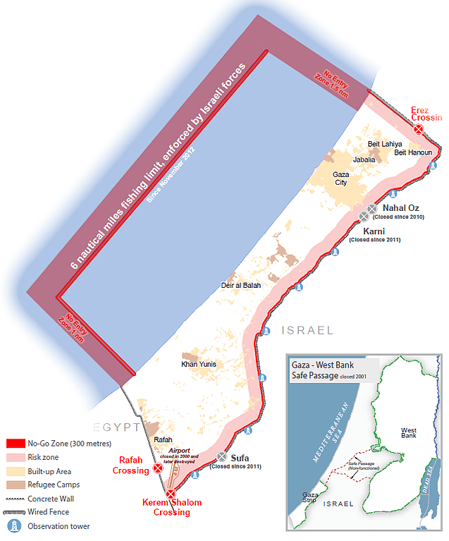
- On land, Israel controls the so-called “buffer zone” (or “no-go” or “risk” zone) which runs along the fence separating Gaza from Israel and policed by the ISF. It has restricted access to this area since the second intifada in 2000, citing security reasons related to attacks by Palestinian armed groups (including attempts to cross the fence by laying explosives or digging tunnels).
- The ARA’s width is not well-defined. Its scope is unclear, reportedly shifting between 150 m from the fence in 2000; to 300 m in 2009; back to 100 m but only permitted for farmers in 2012; and including an alleged ”no-go area” reaching up to 500 m from the fence in 2010. According to OCHA, “the Israeli authorities have refrained from officially announcing or demarcating the extent of the restricted area, generating uncertainty and increasing risks. In practice, the ‘Jakkar’ road, constructed by Hamas in mid-2015 at a distance of approximately 200-300 m from the fence, appears to be the closest point at which farmers feel relatively secure while working their lands.”
- At sea, Israel controls and unilaterally determines a so-called “fishing zone” which is just a fraction of Gaza’s actual territorial waters. The Oslo Accords agreed fishing area of 20 nautical miles (NM) has never exceeded 12 NM in practice and since 2006 has varied between 3 and 6 NM, only occasionally extending to 9 NM just for a few weeks. No boat can enter or exit Gaza, whether for fishing purposes or not – as illustrated by the failed attempts by humanitarian “flotillas” to access Gaza, e.g. in 2010 and in July 2018.
- In both of these areas, Israel employs enforcement measures against what it perceives as breaches of its directives, including the use of live fire, resulting in the death and injury of Gazans.
- On land, between 2010 and 2017, a total of 1,300 incidents of live fire by Israeli security forces on farmers, herders, scrap collectors, demonstrators and other Gaza residents were reported near the separation fence; at least 161 Palestinians were allegedly killed and more than 3,000 injured. The OHCHR-chaired Protection Cluster documented the killing of 389 people, amongst which 23 occurred in the context of protests, and the injury of 2,829 others by Israeli live fire in these areas between 2007 and 2017. An international doctor interviewed by the Commission who in May 2018 operated on hundreds of patients shot in the context of the demonstrations said:
After 14 May, it was basically ‘operate on one patient, move on to the next one’. I don’t remember many patients or names. I mainly remember a bloody mass of crushed bones. But I do remember one farmer who owned a field close to the protest site. He had been shot for the third time in his life.
- At sea, the Israeli restrictions of Palestinians’ access to the sea have been enforced through firing live ammunition, arresting fishermen and confiscating equipment. From 2010 to 2017, nearly 1,000 incidents of live fire by Israeli security forces were reported, including 107 injuries, five deaths, as well as 250 instances of confiscation of boats and other equipment.
- Beyond the threat to life, Israel’s control over Gaza’s land and sea areas has implications for the economy of the Strip and livelihoods dependent on safe and reliable access to these spaces. The areas closest to the separation fence are among Gaza’s most arable lands. Fishing has historically been one of the most important sectors for the coastal community of the Strip and once supported tens of thousands of people.
- The ARAs deprive producers of up to 35 per cent of Gaza’s agricultural land and as much as 85 per cent of its fishing waters. In 2010, OCHA estimated that thousands of farmers and fishermen still need to go and work in the ARAs since their livelihood and that of their families depend on it, and that 178,000 Palestinians are directly affected by ARAs on land and at sea.
- Throughout 2018, access to fishing areas and to farming lands near the fence inside Gaza remained restricted.
- Since 2014 Israel also regularly employs aerial spraying of herbicides in the ARA. According to media reports and accounts from Gaza residents, as recently as on 4 December 2018, the Israeli military sprayed herbicides from the air over areas inside the Gaza Strip and near the separation fence, damaging a variety of crops that Gazan farmers grow in fields near the fence. Many farmers avoid investing in high-value crops, despite potentially yielding greater profits, because they have no guarantee that their crops will not be ruined by the unexpected spraying. While Israeli farmers recently received compensation for resulting loss of crops by the Israeli Ministry of Defence, Palestinian farmers did not.
- The Israeli restrictions in these areas are particularly harmful to women working in fishing, farming and herding, now almost entirely pushed out of these sectors. Overall, women’s unemployment rate in Gaza increased from 35.1 per cent to 64.4 per cent between 2006 and 2016. One woman told the Commission:
I decided to participate in the demonstrations because of the blockade, they are killing us slowly, we want to lift the blockade, we want to let the international community see Gaza and see our suffering and we want to remind them that we are still here and we will keep protesting until the blockade is lifted, we don’t live in human conditions anymore.
- Israel also controls Gaza’s airspace, regularly flying its combat and intelligence-gathering aircraft and drones over Gaza – including during the demonstrations.
5. Impact on basic services and infrastructure in Gaza
- Since 2007, the blockade; the damage caused by the three escalations in hostilities; and the internal division between the de facto authorities in Gaza and the PA are impacting the delivery of basic services and infrastructure - such as electricity supply, water and sanitation, education and health care. Gazans’ realisation of a range of human rights have been set back to a level much worse than before the blockade.
- In 2012, the United Nations Country Team (UNCT) in the OPT concluded that the Gaza Strip would be uninhabitable by 2020. Only “herculean efforts” to improve energy, education, health, water and sanitation would avert this catastrophe. Despite this dire warning, the UNCT reported in 2017 that the situation was deteriorating even faster than anticipated. Harsh living conditions, when combined with prohibitions on leaving the Strip, had by June 2018 led to “growing frustration, anger and despair among the people of the Gaza Strip.”
- Electricity
- The electricity supply has been stagnant since 2006, following an Israeli bombardment of the Gaza power plant in retaliation for a Palestinian armed group attack in Gaza. At best, since then, barely half of the daily demand (estimated at 450 MW) has been covered – supplied partially from Egypt, partially from the Israeli Electricity Company paid for by the PA and partially from the Gaza power plant, operating with imported fuel. Internal disagreements between the PA and Hamas on funding and fuel taxes have in recent years exacerbated the lack of fuel for the power plant and electricity.
- During the first nine months of 2018, Gazans had on average only 5-6 hours of electricity per day. Following an agreement between Israel and Hamas brokered by Egypt and the UN, fuel from Qatar was supplied to the power plant and as of November, Gazans could finally benefit from 15 hours of electricity per day on average. Power outages impact every aspect of daily life in Gaza. Food preservation, cooking, heating and lighting, sanitation and other fundamentals of the right to housing are all jeopardized. Women, children, persons with disabilities have been disproportionately affected by the electricity crisis.
- Water and sewage
- Gaza’s water and sewage sector suffers from a chronic state of emergency, to the extent that a recent report predicted that an endemic disease outbreak or other public health crisis is imminent, with the risk of it spreading to Israel and Egypt. The main causes of the water and sanitation crisis are the depletion and poor quality of Gaza’s single coastal aquifer, which is the source of 95 per cent of all water in Gaza. Until the 1990s the aquifer provided Gaza Strip inhabitants with drinkable tap water. Today 97 per cent of this water is unfit for human consumption based on World Health Organization (WHO) standards. Residents in Gaza are aware that most tap water is unfit for human consumption and 9 out of 10 people rely on desalinated water, 81 per cent of which comes from the private sector. It is purchased in containers or tanks at prices 10-30 times more expensive than piped water, thus posing a heavy burden on already impoverished families.
- The electricity crisis, coupled with the blockade’s restrictions of entry of equipment and material enabling an upgrade of Gaza’s insufficient waste-water treatment facilities, have led to increasing amounts of untreated sewage being dumped into the Mediterranean - by 2017 at the rate of 43 Olympic-size swimming pools each day. This has significant environmental consequences, not only for the beaches of Gaza but also neighbouring areas in Israel and Egypt.
- Education
- While Gaza has traditionally had a high level of basic educational attainment, the infrastructure and the quality of learning in non-UNRWA schools have deteriorated over the past ten years as a result of the blockade, hostilities and the intra-Palestinian division. 181 kindergartens and 11 higher education institutions had yet to be repaired three years after being damaged in the 2014 hostilities. At least two thirds of schools operate on a double shift system, limiting student’s access to classrooms to only four hours per day, in crowded conditions with classes of around 40 students. Gaza students are prevented from enrolling in West Bank and East Jerusalem universities or other educational programmes since Israel does not grant any exit permits for studying there – despite having once represented 35 per cent of the West Bank student population.
- Health
- Due to the blockade’s restrictions on the movement of people and goods detailed above, Gaza’s health system suffers from a severe shortage of essential medical equipment and medicines as well as trained medical staff. The chronic electricity shortages described above, often force hospitals and clinics to rely on diesel-powered backup generators for up to twenty hours per day, which are very expensive to run. Shortages of diesel itself frequently lead to temporary closures of hospitals and clinics, thereby compromising life-saving services. In December 2018, WHO reported that the lack of reliable power sources for Gaza’s health sector threatens the life of over 1,500 patients who depend on electrical machines.
6. Relevance of the blockade for the demonstrations
- The UN Secretary General and the International Committee of the Red Cross, among others, have found that the blockade on Gaza contravenes international humanitarian law, as its restrictions target and impose hardship on the civilian population, effectively penalizing them for acts they have not committed, without regard to individual responsibility. The ICRC has urged Israel to put an end to this closure and called upon all those who have an influence on the situation, including Hamas, to do their utmost to help Gaza's civilian population, stating that “Israel's right to deal with its legitimate security concerns must be balanced against the Palestinians' right to live normal, dignified lives,” deeming the closure to constitute collective punishment imposed in clear violation of Israel's obligations under international humanitarian law.
- Ever since its imposition, the blockade has had a devastating impact on Gaza’s socio-economic situation and on the human rights of people living there, in particular their rights to life, freedom of movement and economic, social and cultural rights (in particular to health and family life, education, work, and an adequate standard of living). Israel’s continued imposition of the blockade on Gaza appears central to Palestinian peoples’ reasons for participating in the demonstrations. As a woman from El Bureij told the Commission: “…we Gazans are losing everything because of the blockade, lack of medical care, access to goods, unemployment, poverty, even you are alive you are dead. This is why people are participating… we’re trying to lift the blockade and to live in dignity.”
- In the current specific context, there are indications that the Israeli authorities intentionally tightened restrictions on movement of goods and people for all Gazans in response to actions of some demonstrators, particularly the use of burning kites and incendiary balloons (see the below section on 15 May – 11 October 2018).
C. “The Great March of Return and Breaking of the Siege”: background and principles
1. The origins
- On 7 January 2018, Ahmed Abu Artema, a 34-year-old Palestinian poet and journalist, posted on Facebook the idea of a non-violent march at the separation fence, to draw attention to General Assembly resolution 194 and to the dire humanitarian situation in Gaza. In the post, ending #GreatMarchofReturn, he wrote, “what if 200,000 demonstrators marched peacefully and broke through the fence east of Gaza and entered a few kilometres into the lands that are ours, holding the flags of Palestine and the keys to return, accompanied by international media, and then set up tents inside and established a city there.”
- The idea evolved into a movement of Palestinians. Abu Artema attributes the grim situation in Gaza as the prime factor that led people to support his idea: “The status quo is unbearable, no salaries, no job opportunity, no horizon for the youth. … We do not ask for much we just ask to live a normal life.”
- Abu Artema’s proposal of a non-violent march had already been proposed six years earlier. The suggestion, however, did not evolve into a mass movement until 2018, in light of the changing circumstances of the intervening years described above, and precipitated more directly by the above-mentioned United States’ December 2017 decision to move its embassy to Jerusalem.
- Abu Artema has been a key figure in the GMR since the protests began and attends the protests weekly. He believes the strategy of violence has failed and has reiterated the need for the protests to remain non-violent over the course of the demonstrations.
Abu Artema’s vision is for Palestinians and Israelis to live in one country as equal citizens. He believes this can be achieved by dialogue at a civil society level because there are people “on the other side that are calling for the Palestinian right of return too. It is important to strengthen this idea in order to seek to achieve peaceful coexistence based on equality”. A video with extracts from the Commission’s interview with Abu Artema can be viewed on the Commission’s website.
2. The principles of the Great March of Return
- Within weeks of his 7 January Facebook post, Abu Artema, civil society activists and other stakeholders drew up a charter of 12 “General Principles of the GMR”, envisaging a national march by Palestinians of all ages, genders, political and social groups:
- “General Principles of the Great Return March:
The issue of the Palestinian refugees is at the heart of the Palestinian question. Indeed, many Palestinians were terrorized and expelled from their land 70 years ago. They were replaced by another people that denied their sheer existence. They were disowned of their land under the fallacious pretext that “a land with no people should be given to a people with no land.”
Hundreds of thousands of Palestinians were forcibly displaced out of their homes and land into exile in the Arab countries and the rest of the world. Another entity, Israel, was created in lieu and instead of their society. Despite the recognition of the international community of the right of Palestinian refugees to return and compensation, as guaranteed by the principles of the International law and international conventions and treaties and relevant United Nation’s resolutions, the International community has failed to enforce the relevant resolutions on the return of refugees.
Despite the struggle of the Palestinian refugees to realize their rights, the State of the Israeli occupation continues to deny them the right of return to their homes from which they were expelled.
Therefore, the refugees decided to take the initiative through peaceful actions through the Great Return March. This comes as a continuation of the struggle of the Palestinian people for their right of return, the most important of which were the Return March in 2011, the Global March to Jerusalem (GMJ) in 2012 and the Palestinian rallies in the areas occupied in 1948 on the 19th of April each year.
Definition of the Great Return March:
It is an organised popular action, based on legitimate legal foundations and clear humanitarian principles, in which the masses of refugees embark on peaceful marches to implement paragraph 11 of UN Resolution 194 and to achieve the return of the refugees who were displaced in 1948 to their land, homes and properties. They are armed with their strong belief that rights are not lost if pursued and that rights do not diminish with time. They base their movement on the legitimacy of the UN resolution 194 and their right to its application as officially registered refugees in the international organisation.
- It is a sustained and cumulative struggle, not a seasonal or a one-day event. It will only end with the actual return of Palestinian refugees and the sit-in may last for weeks or months.
- It is a national march in which Palestinians of all ages and various political and social groups and their supporters from the free world meet around the universal issue of the return of refugees and their compensation as a national consensus.
- It is a humanitarian march calling for the human right of the return of refugees, failure to achieve that right is a justification to continue the march regardless of how long it takes. It has nothing to do with any political deals or offers from any side.
- It is a legal march based on international resolutions, most notably paragraph 11 from the UN Resolution 194, which explicitly calls for the return of Palestinian refugees as soon as possible to their villages and towns from which they were forcibly displaced and to be compensated.
- It includes the various locations of Palestinian refugees in the Gaza Strip, the West Bank, Jerusalem, the areas occupied in 1948, Lebanon, Syria, Jordan and other countries around the world. It aims to peacefully protest at the nearest points to their homes which they were forcibly displaced from.
- Participants will be from all components of the Palestinian civil society and all political parties or factions that believe in peaceful public resistance as an effective way to contribute to achieving peace and justice based on the restoration of the national rights of Palestinians, foremost of which is the right of return.
- It is a fully peaceful march from the beginning to the end. It adopts the style of open sit-ins, gradual progress, the construction of tents and the establishment of a normal life near the separation fence with their lands, homes and properties which they were forcibly removed from in 1948. The organisers are keen to invite international media to cover their message to all the world and are keen on the participation of international and human rights organisations to monitor and ensure the
march is peaceful.
- The organisers are keen to spread the culture of public resistance through the peaceful nature of the march and all accompanying events both inside and outside Palestine, and affirm that it is a new form of resistance different to confrontations and throwing stones. To ensure that the march does not deviate from its mission and to prevent any pretexts from stopping it, it is prohibited for the participating individuals and organisations to carry out any acts that violate the law. In Gaza Strip, as a central arena of the movement, it is preferable to start a sit-in 700 meters away from the separation fence to prevent the clash of young people with the occupation forces. Progress will be gradual and in accordance with the discretion of the committees and national bodies in charge, which can be done in stages to prolong the duration of internal and external mobilisation.
- The civilian bodies supervising the management of the march are decentralised units established in each location/country appropriately. The various units in all locations should coordinate to ensure the success of the project.
- The only flag to be raised during the march is the Palestinian flag with no partisan slogans, in addition to the UN General Assembly Resolution 194 and humanitarian slogans explaining the just cause of refugees in Arabic, English and Hebrew.
- Refugees are the responsibility of the United Nations. Therefore, human rights organisations have the task of contacting the United Nations and its international institutions to request their supervision for the marches and to send warning messages to the occupation not to target them.
- Communication should be made with various activists and solidarity organisations supporting Palestinian rights around the world to create global support for the initiative of the Great Return March. All media, political, legal and solidarity efforts should be mobilised to protect the march from the potential Israeli violence. “
3. Members of the Higher National Committee
- A Higher National Committee (HNC) and 12 subcommittees were subsequently established to organize and oversee the planning of the march, in accordance with the above-mentioned principles. Its members came from all sectors of Palestinian society, including civil society, cultural and social organizations, student unions, women’s groups, eminent persons and members of clans. Representatives of several political parties, including the Democratic Front for the Liberation of Palestine, Fatah, Hamas, the Popular Front for the Liberation of Palestine and Palestinian Islamic Jihad, were also members (the armed wings of these parties were not represented on the committee). While the members of the committee held diverse political views, they stated that their unifying element was the principle that the march was to be “fully peaceful from beginning to the end” and demonstrators would be unarmed. The Committee was composed of at least nine women, and repeatedly called on Palestinian women and girls to gather widely at the protest sites to demand their right to return.
4. Sub-Committees of the Higher National Committee
- The HNC also established twelve sub-committees: Media and Communication Sub-Committee; Elders and Honorable's Sub-Committee; Legal Sub-Committee; Students Sub-Committee; Popular Activity Sub-Committee; Women Sub-Committee; Health Sub-Committee; Refugees Sub-Committee; Requirements Sub-Committee; Legal and International Advocacy Sub-Committee; Youth Sub-Committee; Folklore Sub-Committee. The sub-committees had a diverse membership, ranging in size from four to 15 members.
5. Return camps
- The HNC established demonstration sites in open land along the separation fence in all five Gaza governorates: northern Gaza Strip (Abu Safia); east of Gaza City (Malaka); central Gaza Strip (El Bureij); east of Khan Younis (Khuzaa); and in the south in Rafah (Al-Shawkah). They are described in further detail in the section on legal assessment of the demonstrations below.
- Demonstrations were held at these sites every Friday and occasionally other weekdays between 30 March and 31 December 2018, and continued thereafter. Beginning in August, weekly demonstrations were also organized at the Zikim beach in North Gaza.
- Each site comprised a “return camp” – a group of tents named after villages from which Palestinians were displaced in 1948, positioned 700–1,000 m from the separation fence, near the Access Restricted Areas (ARA). In 2015, Hamas constructed and patrolled a road approximately 200-300 m. from the fence, known as Jakkar Road, informally demarcating the no go zone. The so-called return tents were erected by the HNC on the west side of Jakkar Road.
- These sites constituted the core of the weekly protests. Prayers were conducted in the tents, a field hospital was attached to each of the camps, and activities were run from them. Women were encouraged to attend and bring their entire families for day outings. The HNC organisers levelled the ground in the area of the sites, organised buses for participants to the protest sites, and provided financial support for activities.
- In accordance with the GMR principles, the activities set up at the return camps encouraged people to attend the GMR while remaining far away from the fence. The HNC also set up sand bags at a distance of 700 m from the fence to protect the tents (which the ISF subsequently bulldozed).
- The General Principles of the GMR, while calling for preferably preserving a 700 m distance from the fence, also suggested that the intention was for protestors to gradually move closer to the fence as the weeks progressed, at the discretion of the HNC. In April 2018, Khaled al-Batsh, coordinator of the HNC’s 12 sub-committees, announced moving the tents 50 m. closer as a first step, for the distance to become 650 m from the fence, which subsequently occurred at some of the protest sites.
6. Communication and social media
- The HNC decided that the best away to preserve the peaceful nature of the demonstrations was through an information campaign. They delivered lectures, information to schools, universities, mosques, churches, and publicised activities through the media. The message it disseminated was for people to preserve the peaceful nature of the protests and stay away from the fence. The HNC preferred this tactic over deploying armed police patrolling the protest sites because the latter would be seen as harming people’s right to peaceful assembly on their own land and would violate the principle of not carrying arms at the protest sites. These measures were seen as sufficient to preserve the peaceful nature of the demonstration and provided people with a framework to exercise their rights. The Commission was told that Hamas security officials checked the protesters for weapons at the entrance of some sites .
- The HNC communicates with the public through various media, including its Facebook page. The page informs people about events at the demonstration sites, calls on them to mobilize, and serves as a record, including videos and photos of protesters at the sites as well as the ISF actions. The page also reports on information about maritime activities and flotillas in support of the GMR. The posts reflect the diverse composition of the HNC, including messages and statements from its representatives. Posts also refer to activities of demonstrators, including throwing stones or assembling in different ‘units’ (tyre, kite, ‘baffle squads’) – see the below section on the Commission’s inquiry into specific incidents.
- Another Facebook page called the “Great March of Return” also provided updates. This page was not administered by the HNC, but was created by Abu Artema and other activists on 29 January 2018. By early 2019 it had over 35,000 followers. The page remained active as of January 2019, though since November 2018 its activity had diminished. It posted several articles and videos by Abu Artema. Its emphasis was to post the activity programs of the Return Camps and the times and locations of busses to the demonstrations. The posts reiterate the importance of preserving the peaceful nature of the GMR, while also calling on protesters to cross into Israel on 14 May and providing guidelines for doing so.
- In addition to social media, the HNC spreads its message through websites, pamphlets, radio, TV and newspaper announcements and Friday sermons calling on people to participate. There are many WhatsApp groups offering updates about the protests.
- From the many interviews conducted by the Commission, demonstrators were highly motivated to attend.
7. Participation of women and girls in the GMR
- The Return Camps gave women in Gaza access to a unique environment in which to participate visibly in public events, in contrast to their more traditional roles, and breaking norms on seclusion in Gazan society.
- Women participated with their families and children, on their own or with other groups of women, though in lesser numbers than men and boys. They played an important role in the GMR, as organisers, journalists, social media bloggers, demonstrators, medical paramedic volunteers, food and water distributors.
- Women-led activities held at the return camps were both spontaneous and coordinated with the HNC. Several women also became prominent activists in the protests and a women’s committee was formed. According to Dr. Kifah Al Ramli, a member of the Women’s Committee: “the Women’s Committee was formed among other committees for the lifting of the blockade (…) to acknowledge women’s presence through their activities and their valuable role in the Palestinian community.”
- Friday 20 April was labelled the Women’s March. It highlighted the active role of women in the GMR. Other women’s marches were held during the GMR, for example, on 3 July 2018 there was a demonstration called ‘Women under Siege.’ That day, the Chairperson of the Women’s Committee, Iktimal Hamad said: “This event came in the context of the support for Palestinian women who still stand up despite the siege, this event carries a clear message that no one can deny our rights, specifically the right of return, and our demands to lift the siege.”
D. Israel’s assessment of the demonstrations
- The preparations for the GMR were followed closely by Israeli officials and security forces. Central to Israel’s understanding of the GMR and the response of the ISF were, firstly, Israel’s ongoing armed conflict with Izzedin Al-Qassam Brigades (Hamas military wing) and Al-Quds Brigades (Palestinian Islamic Jihad military wing), and, secondly, the fact that the political parties of Hamas and Palestinian Islamic Jihad were both represented on the HNC.
- While the Commission did not benefit from cooperation with Israel, it gathered information concerning its government’s and security forces’ viewpoints through publicly available material, including its submission to the Supreme Court and material released by the IDF.
1. The conflict between Israel and Palestinian organized armed groups over the last decade
- Since 2007, Gaza and neighbouring Israel have experienced successive rounds of violent confrontations, including three major rounds involving massive land and air attacks from Israel on Gaza and shelling of Israel with rockets from Gaza by Palestinian armed groups. Nearly 1,400 Palestinians and 13 Israelis were killed during the 2008-09 three weeks of hostilities (Operation Cast Lead); 174 Palestinians and six Israelis were killed during the 2012 one week hostilities (Operation Pillar of Defense) and 2,251 Palestinians and 71 Israelis were killed during 51 days of hostilities in 2014 (Protective Edge).
- In between these major clashes, regular military activities included Hamas-led campaigns of rocket fire from Gaza towards Israel and continued constructions of sophisticated tunnels for operations inside Israel, and Israeli incursions and airstrikes. Most rockets and mortars fired from Gaza are by the Al-Qassam and Al-Quds Brigades.
- Over the past ten years, 12 Israeli civilians and 25 members of Israeli security force personnel were killed in attacks by rockets, mortars or live ammunition fired by Palestinian militants from Gaza into Israel (all but one before 27 August 2014). During the same period, 2,980 Palestinians were killed inside the Gaza Strip by Israeli security forces.
- Since the end of hostilities in August 2014 until 29 March 2018, the situation on the Israeli side of the fence had been relatively calm, with comparatively few rockets and mortars reportedly fired from Gaza and no fatalities occurring as a result:
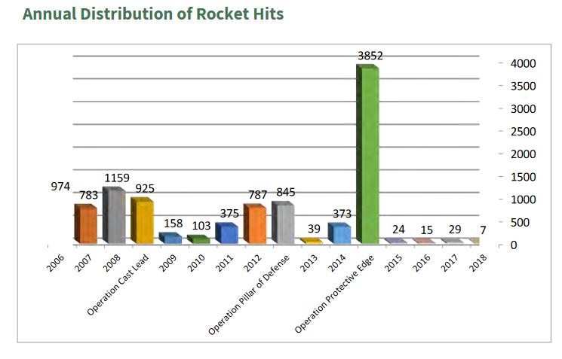
- This relative calm was the result of an informal agreement between Israel and Hamas of no hostilities (concluded after the 2012 escalation and reaffirmed after the 2014 escalation), mediated by Egypt.
- While both rockets and the threat posed by tunnels crossing into Israeli territory remained a source of anxiety for Israeli civilians in the Gaza envelope (see the below section on the impact on Southern Israel), as tunnels were discovered and destroyed by the IDF in 2017 and in 2018, the threat from such tunnels decreased as Israel continued building an underground barrier along the Green Line (separation fence), which it expects to finalize in 2019.
- Accordingly, the IDF deemed that “by the start of 2018, Hamas’ strategic military assets have had their effectiveness curbed by Israeli defences both in the aerial domain and underground”.
2. The GMR as a threat to Israel’s security
- Israeli officials and security forces however perceived a new security threat in the demonstrations, and saw them as closely linked with the operations of Palestinian armed groups.
- While the demonstrations were seen to have begun as a civilian initiative, the IDF saw them as having been “appropriated by Hamas in order to further its attacks against Israel, to create heightened security tensions in the Gaza arena and to increase political and diplomatic pressure on Israel, internally and internationally”. With Palestinian armed groups’ rockets and mortars intercepted by Israel’s Iron Dome defense system and with tunnels increasingly detected and thwarted by Israeli defences, the demonstrations were perceived as a new “operational opportunity for Hamas to obtain access to the Israeli homefront through another domain”.
- On the eve of the demonstrations, the IDF stated that it would not allow “mass infiltration” or tolerate damage to the separation fence during the protests – stating that it had deployed more than 100 snipers called up from military units, primarily from the special forces, with permission to open fire if lives of Israeli soldiers or civilians were to be in jeopardy. In warnings addressed to Gazans, Israel asserted that Hamas was pressuring them to perform provocative actions along the fence and advised that anyone approaching the fence would be endangering his or her life.
- The IDF made clear that it held Hamas responsible for all activities in Gaza, and that it would not allow Hamas to turn the area of the security fence into a “combat zone”. It saw the demonstrations as “fuelled by Hamas” in an attempt to mask “terror activities.”
- The Government of Israel’s assessment of the threat posed by the demonstrations was later presented publicly in three written submissions (of 29 April 2018, 6 May 2018 and 16 May 2018) to Israel’s Supreme Court in Cases HCJ 3003/18 and HCJ 3250/18 (see also the below section on legal assessment of the demonstrations).
- The Government there argued that the HNC was led by Hamas, which had developed a plan of action aiming to infiltrate Israel and to carry out attacks against the ISF under the cover of demonstrations. In parallel, it also argued that the risk of “mass infiltration”, by a large “incited” crowd that could attack Israeli soldiers or civilians residing only hundreds of meters from the Strip, posed a security threat. The possibility of a soldier being captured, as in 2006, was seen as a particularly realistic threat.
- Israel’s assessment was based on its long-standing conflict with Hamas, intelligence it claimed to hold, as well as its perceptions of media statements by some Palestinian leaders on the right of return and of crossing the fence.
- For instance, Issam Adwan, head of Hamas' Department of Palestinian Refugees, had on 16 January 2018 posted on his Facebook page: “As long as the Palestinians have the spirit of courage and daring, why not breach the border that was set up by the enemy in order to prevent them returning to their occupied lands? Wouldn’t the approaching of thousands of families towards the border confuse the enemy, attract the media to the causes of our people, expose our enemy, revive the region, and encourage our people to dare against the occupying enemy… What will our people lose from the attempt, except for the misery and poverty that they endured in the lands of the refuge?”
- Other public statements referred to “returning” to Israel or breaking the “walls of the blockade”. In a 9 April 2018 statement given at the Malaka protest site commemorating Martin Luther King’s assassination, Hamas’ Political Bureau Chairman Ismail Haniyeh stated the following about the GMR: “Here I am emphasizing more and more that the March is peaceful and I hope all the factions and our people understand the aim behind this March, we are leading this March with a lethal weapon, the weapon made of people and masses that we will use to knock over the doors of the occupation forces and open the doors of return and breaking the siege. Yes, at this time we emphasize the peacefulness of the March.” He underlined though that Hamas was still committed to armed resistance: “Our weapons are in our hands, our missiles in our hands, our tunnels are with us and the improvement of our resistance is ongoing by God’s will. This does not contradict that.” Later in the same speech Haniyeh said: “Yes we will break the walls of the blockade, we will remove the occupation entity, and we will return to all of Palestine’s land by God’s will.”
- The question of what the right of return means for Palestinian refugees and for the State of Israel is central to an understanding of the polarised views around the nature of the GMR. As indicated above, refugees “returning”, even if peacefully, is in Israel perceived as a near existential threat (see the above section on return of refugees).
- Israeli fears of demonstrators crossing the fence were heightened ahead of 14 May, dubbed by the HNC as “the return of a million”. Social media posts by demonstrators called for removing the separation fence, marching towards Israeli towns near the fence and staying there, while maintaining the campaign’s peaceful character. After the day’s events, Prime Minister Netanyahu declared: “Every State has the right to protect its borders. Hamas terrorist organisation declares its intention to destroy Israel and sends thousands to breach the border fence to fulfil this goal. We will continue to act firmly to protect our sovereignty and citizens.”
- This threat assessment underlay Israel’s subsequent decisions concerning the deployment of the ISF to prepare for the demonstrations (see the below section on Israeli forces’ preparations ahead of the demonstrations).
3. The Commission’s understanding regarding the role of Hamas in the GMR and the three phases of the demonstrations
- Israel’ assumption that Hamas controlled the protests merits further inquiry. Prior to the first protest on 30 March, various Palestinian parties represented on the HNC, including Hamas, publicly endorsed the GMR, its 12 general principles and its two stated goals of “return” and lifting the “siege”. Hamas’ representative on the HNC is particularly influential by virtue of Hamas’ power and the level of control it exerts within Gaza.
- As a HNC member, Hamas’ and the de facto authorities’ civilian and political entities provided support to return camp infrastructure, coordination, and technical and administrative support. According to one source, “the initiative did not come from Hamas, but without the full support of Hamas, it would not have lasted”.
- Hamas approval of the GMR was also necessary for the demonstrations to take place where they did. By virtue of an understanding with Israel, Hamas had since 2014 patrolled Jakkar Road to prevent people from reaching the ARAs - but ceased doing so in spring 2018, to enable the GMR to take place. Hamas and other HNC members also helped to provide buses and the carnival-like atmosphere.
- The role of Hamas in supporting the GMR shifted over time. The Commission could distinguish three phases of the demonstrations; a first phase (30 March – 14 May); a second phase (mid May – early October); and a third phase (early October – 31 December).
- These phases are described in depth below (see the section on the Commission’s inquiry into specific incidents), but in broad strokes, the first phase could be characterized as a genuine popular festive event, with tens of thousands of people from across Gazan society – refugees and original residents - gathering around traditional activities, concert, barbeques, cultural activities and sports games. Although the organizing committee and demonstrators messaged about “returning to their lands”, this was generally understood as symbolic, according to reliable sources present. There was not a sense that demonstrators had intended to break the fence and enter Israel en masse, but random and uncoordinated acts by demonstrators’ edging towards the fence and returning back.
- The large numbers of killings and casualties that occurred on 14 May changed the atmosphere, and the second phase saw fewer families attending. Instead, anger over killings and injuries drove groups of youth to engage in more violent actions – increasing their use of incendiary kites, slingshots, and incendiary balloons. From August towards October, nightly so-called “baffle squads” were established throughout the Gaza Strip. In general, while demonstrators threw stones, burned tyres and at times cut the barbed wire coils throughout the demonstrations, over time, the intensity appeared to increase, with more damage to, and breaching of, the separation fence. Demonstrators claimed their increasingly intense actions were in response to the severity of the ISF’s use of force. Similarly, Israel claimed that it escalated its use of force in response to the actions of the demonstrators, particularly to the use of incendiary kites and balloons (see the below sections on the Commission’s inquiry into specific incidents and the impact on Southern Israel).
- In the third phase, Hamas seemed to try to exert more control over the protest movement, seeking to capitalize on the negotiations with Israel facilitated by Egypt and UNSCO, on e.g. fuel deliveries from Qatar for increased electricity. Hamas was reportedly asked to “contain” the demonstrations in exchange for Israel minimizing use of firepower and allowing Qatari fuel to enter Gaza to supply the strip’s sole power plant.
- Hamas’ endorsement and support to the GMR served it well. Over the course of the GMR, Hamas’ popularity among Palestinians increased, both in the West Bank and Gaza. The fuel delivery by Qatar which in November brought 12 hours of electricity per day to Gazans, who had endured only 4 hours of electricity per day since April 2017, was undoubtedly a contributing factor.
- The success of the HNC, and of Hamas in particular, to mobilize such high numbers of people initially came as a surprise, in light of the prevailing deep public discontent with Hamas’ regime in Gaza. The months leading up to the GMR had been marked by a significant deterioration in the humanitarian situation, increased movement restrictions and falling purchasing power. On a number of occasions, Hamas had banned and forcibly dispersed peaceful assemblies that were held in protest against the prevailing humanitarian crisis. Activists had also been arrested and at times subject to ill-treatment and torture (see below section on freedom of assembly inside the Gaza Strip). The Hamas-led authorities' waning legitimacy had worsened following an attack on the PA Prime Minister Al-Hamdallah's convoy in Gaza on 13 March 2018, and the subsequent PA accusation of Hamas orchestrating the attack. By March 2018, most Gazans had lost confidence in any real progress for the national reconciliation process between Fatah and Hamas.
- So while Hamas indeed did play a role in supporting the GMR, the Commission understands that the thousands of people who responded to the calls to demonstrate did not do so prompted by Hamas, which was deeply unpopular at the time. Instead, as mentioned above, the lack of progress in peace negotiations; the deep economic crisis; and the impossibility to leave the Strip were among causes explaining how the GMR could become such a mass movement in Gaza - as was repeatedly communicated by demonstrators to the Commission.
- This is not to overlook the political benefit for Hamas. Additionally, as communicated by the HNC and demonstrators alike, the GMR was seen as an effective tool to bring the ‘Palestinian struggle’ back into the spotlight. Hamas also reportedly sought to use the demonstrations as a bargaining chip when seeking the lifting of certain restrictions of the blockade that Israel had imposed and tightened in response to incendiary devices used by demonstrators (see the below section on 15 May - 11 October 2018). In late November, an international Gaza-based observer told the Commission:
“It would be unfair to Gaza if this would be purely looked at from a lens of Hamas. The March is a genuinely non-violent expression of thousands of young people as to their rights and future prospects… There were perhaps violent acts such as throwing stones and letting fire kites fly. Here it is interesting to discuss what constitutes violence? Most Palestinians do not see kites as violence, they see kites as well as stones as a legitimate means and a proportionate response to occupation. There is a third phase, now. Over the past weeks we’ve seen fewer people injured and killed comparatively. In this third phase, Hamas has shown that they can control the situation, if they want to stop people from going closer to the fence, they can. Israel has made clear that they will facilitate entry of fuel if demonstrations quiet down. This phase started in early October coinciding with the negotiations on the entry of fuel etc, when Israel made clear they were willing to alleviate the situation. Israeli military has operated in the same way throughout the three phases, they use live ammunition and kill people, and they carefully control the impact of the blockade. They take up and down the fishing zone, permits to travel, visas to Israel etc. But even in the current phase when Hamas is perceived to be in more control than during early days, there are many people demonstrating who are not at all affiliated with Hamas.”
4. Conflict dynamics between 30 March – 31 December 2018, unrelated to the demonstrations
- Between 30 March and 31 December, in parallel with the demonstrations, the security situation in Gaza and the Gaza Envelope continued to be marked by episodes of military escalation between the ISF and Palestinian armed groups. These hostilities took place outside the context, time and location of the demonstrations. Although not directly linked to the GMR, several incidents may have been either culminating in tensions created by the protests or, in other cases, were aggravated by violence at the demonstration sites. In several instances, either Israel or a Palestinian armed group, would justify its military attacks as a retaliation to actions taken at the demonstrations.
- While the Commission did not investigate fatalities and injuries occurring as a result of hostilities outside the context, time and place of the GMR protests, it did track all fatalities for the purposes of establishing or ruling out any links to the GMR, thus determining whether they fall within its mandate. The Commission found that at least 67 Palestinians were killed by ISF in the Gaza Strip between 30 March and 31 December 2018, however not in the context of the GMR. It also found that one Israeli soldier and one Palestinian civilian in Ashkelon were killed by rockets, mortars or live ammunition fired by Palestinian militants from Gaza during the same period. One additional ISF member was killed inside Gaza, again outside the context of the demonstrations.
Hostilities taking place in Gaza
- The first significant military escalation after the GMR began, took place on 29 May 2018, when Palestinian armed groups launched nearly 200 rockets and mortar rounds from the Gaza Strip towards Israel, claiming the attack to be in retaliation for the ISF’s targeting of Qassam Brigades and Islamic Jihad positions by air strikes in the preceding two weeks (causing more than 10 casualties in their ranks), as well as for the use of live fire against demonstrators. The IDF, on its part, responded by striking 65 targets of Palestinian armed groups throughout the Gaza Strip.
- Two reported incidents in which Israeli soldiers near the fence were shot at (described in the section on impact on Southern Israel below) also triggered shelling and more than 200 airstrikes by the IDF in July and August 2018, killing nine Gaza militants.
- The last military escalation during the period under review was reportedly provoked by a botched ISF covert operation inside Gaza on 11 November 2018 in which seven Qassam Brigade militants and one ISF member were killed during a firefight with an Israeli commando unit. The incident led to the most intense exchange of shelling since the 2014 war in Gaza, and resulted in a number of casualties among both civilians and militants.
- Several incidents, outside the GMR context, resulted in the deaths of civilians, including children, at times raising questions regarding the military character of the attacked target. On two occasions a civilian was killed by a missile or a tank shell while present in agricultural field (incidents of 30 March 2018 and of 13 November 2018). On 14 July 2018 an Israeli air strike hit the Al-Kateeba building in Gaza city which according to Israeli sources was used by Hamas militants for urban warfare training. Two children who were sitting that evening on the roof of the building were killed and 23 persons were injured as a result of this attack. A video released by Hamas in March 2018 depicts military exercises inside the building and its vicinity, including the scenario of abducting an IDF soldier. On 9 August 2018 an air strike hit a residential house in Deir Al-Balah, killing a pregnant woman and her 2-year-old daughter, as well as injuring the father. Although hostilities were taking place in the area, it was unclear to the Commission what military objective had been attacked. On 28 October 2018 three children, aged between 13 and 15, were killed near the fence east of Khan Yunis allegedly by an Israeli aircraft. According to the IDF, the three were approaching the fence, crawling in the dark and holding an object suspected by an IDF observation point to be an IED. Palestinians reported that the three children were setting traps to catch birds.
Hostilities directed at Southern Israel
- The violence between Israel and Gaza-based Palestinian armed groups –unrelated to the demonstrations – often amounted to high-intensity hostilities. As noted, more than 1,100 rockets and mortar shells were fired from Gaza into Israel by Palestinian armed groups between 29 May 2018 and 31 December. The rockets initially hit the vicinity of the Envelope communities, and later reached more distant towns such as Ashqelon, Netivot and Beer Sheva. While most projectiles fired since May 2018 fell in open areas or were intercepted by the IDF ‘Iron Dome’ system, a number landed near schools and kindergartens, as well as close to a synagogue. Palestinian armed groups in Gaza claimed responsibility for these attacks against Israeli towns and military positions.
- Three Israeli soldiers and dozens of Israeli civilians, including at least two children, were lightly injured as a result of rocket attacks carried out in May, July and August 2018. On 12 November 2018, Palestinian armed groups fired more than 400 rockets at various localities in southern Israel. A 48-year-old civilian, Mahmoud Abu Asbah, from the town of Halhul in the West Bank, was killed and two other civilians were critically wounded after a rocket directly hit a residential building in Ashqelon. Dozens more were injured that day, mostly with minor injuries, and serious property damage occurred. A local kibbutz resident told the Commission: “this is a real and present danger to your life, you cannot belittle it… you don’t know where the rocket is aimed, you run for your life each time”.
- In addition to launching mortars and rockets, Palestinian armed groups fired heavy machine guns towards Israeli towns at least twice since May 2018, causing property damage in Sderot and Sha’ar HaNegev. According to Israeli sources, tunnels were discovered and destroyed in April, May and October 2018.
- In addition, the IDF reported at least 36 attempts to cross the fence into Israel which took place outside the context of the protests. At least on three occasions, open sources reported that Palestinians crossing the fence in southern Gaza tried to set an IDF post on fire. On 9 November 2018 an unarmed 25-year-old Palestinian man crossed the fence from Gaza, reached the Israeli village of Netiv Ha’aSara and set on fire a greenhouse, about 700 meters from the fence. This incident was the only one reported during the period under review which involved reaching the surroundings of a civilian community.
- Armed groups in Gaza also directed attacks against Israeli soldiers and military objectives located in southern Israel. On 29 May 2018, three soldiers were reportedly injured as a result of rocket attacks emanating from the Gaza Strip. On 11 November 2018, an Israeli officer was killed and another was injured east of Khan Yunis. As noted earlier, the clash broke out after an Israeli unit, carrying out a covert night operation inside the Gaza Strip, was exposed by a IQB unit. The incident resulted in the killing of seven Palestinian militants.
- The following day, Gaza militants fired an anti-tank missile at a bus that had been transporting IDF soldiers in the area of Sha’ar HaNegev Regional Council. Two soldiers were wounded, one critically. The military wing of Hamas assumed responsibility for the attack. These incidents triggered retaliatory attacks by both sides, including the launching of hundreds of projectiles from Gaza into Israel and IDF airstrikes in the Gaza Strip. An informal ceasefire was reached on 13 November 2018.
- Given its mandate, the Commission noted, but did not fully assess, the circumstances of the abovementioned incidents which occurred amidst hostilities between the parties, but outside the context of the demonstrations.
E. Israeli forces’ preparations ahead of and during the GMR
- Against this backdrop, the Commission examined the ISF’s preparations ahead of the GMR.
1. Deployment of Israeli security forces
- The ISF units charged with responding to the demonstrations comprised two territorial brigades, the Northern (known as the “Gefen Brigade”) and the Southern (known as “Katif Brigade”), both of which are subordinated to the Territorial Division Gaza (also known as the “143rd Fire Fox”) which, in turn, is subordinate to the Southern Regional Command.
- To discourage people from attending the demonstrations, the ISF dropped leaflets in Gaza:
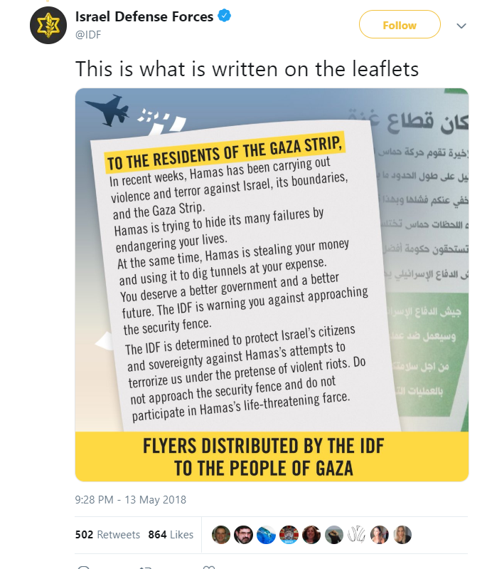
- Israeli authorities also sent letters to Palestinian transportation companies in the Gaza Strip warning them against aiding in the transport of “terrorists” and “violent rioters” to the protest sites.
- Access to certain areas on the Israeli side of the fence was closed off to Israeli civilians, with some farmers having to stop cultivating their fields as a result.
- Well before the GMR, the ISF had permanent military positions and surveillance electronic systems deployed along the separation fence, as well as around the kibbutzim in the Gaza envelope area (see the below section on the legal assessment of the demonstrations).
- Prior to the GMR, ISF military engineering units carried out significant infrastructure works on the ground including: reinforcing the separation fence, clearing vegetation on both sides, and digging deep trenches close to planned protests sites to “disrupt mass infiltration”. A number of earth mounds or berms were also built at each demonstration site, 30-70 m. east of the fence (depending on the site topography), so as to allow ISF to have a better viewpoint and ability to fire without risking ricochets off the fence.
- The ISF also carried out infrastructure work on the Palestinian side of the fence, such as placing barbed wire coils in the ARAs to stop people from reaching the separation fence - creating a new de-facto no-go zone of at least about 20-80 m. west of the separation fence at each site. The ISF could enter this area at will, and did so repeatedly, often at night, to replace the barbed wire coils where demonstrators had removed them. Throughout the demonstrations, the ISF regularly intervened along the fence on both sides to maintain the existing barriers and, whenever needed, repair any damage or breach caused by the protestors.
- On 28 March, IDF Chief of Staff, Gadi Eisenkot, to whom the Southern Regional Command (and the Gaza Division) is subordinated, stated that: “the IDF has deployed more than 100 sharpshooters” ahead of the demonstrations to prevent “mass infiltration” and damage to the separation fence during the protests.
- According to the IDF’s assessment that live ammunition may be required in light of the threats presented by events at the fence: “the IDF ordered that all use of live ammunition be restricted to specially-trained snipers, in order to ensure accurate and measured use of these means.”
- The snipers were coordinated by officers who were responsible for their deployment, training and conducting after-action reviews. The snipers generally operated in teams, typically consisting of two snipers and a spotter or observer. These teams were led by senior commanders, required to approve each use of live ammunition by the snipers, and typically positioned on top of the berms.
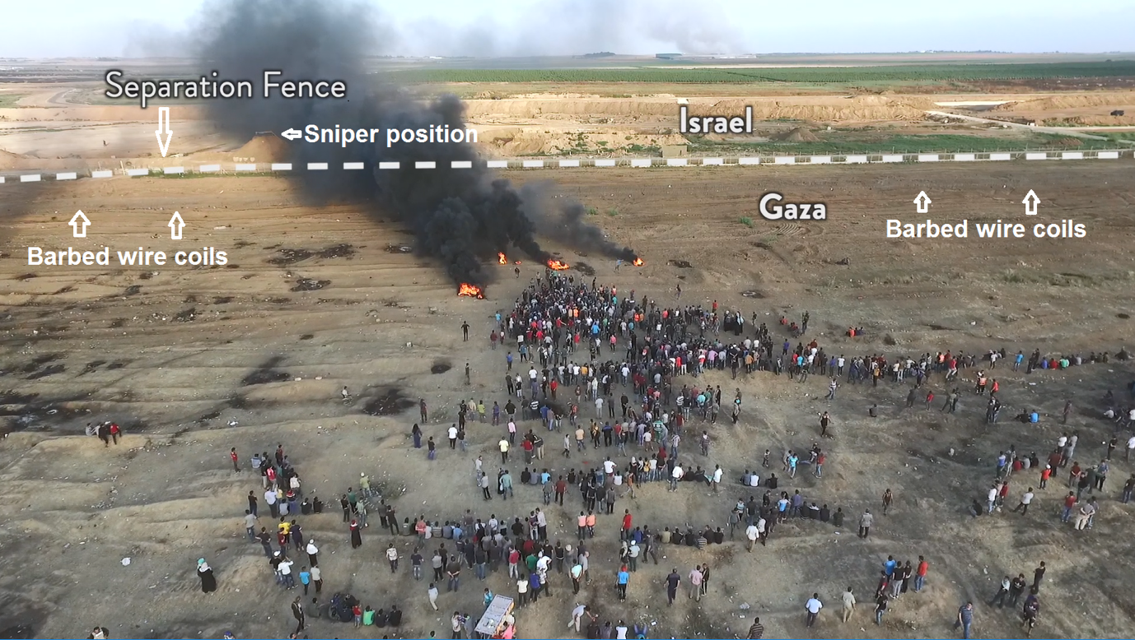
- Photos from a variety of sources over the protests period showed ISF soldiers armed with several types of assault and sniper rifles including variants of the Israeli-made Tavor rifle and the US-made SR25 and M24 sniper rifles. The snipers reportedly used 7.62 mm ammunition (see the below section on the use of high-velocity ammunition against demonstrators).
2. Less-lethal means
- The ISF was also equipped in advance of 30 March with a variety of crowd-control means, including public address and warning systems, and ‘less-lethal’ means to disperse demonstrations. Given their importance to the factual and legal findings, the Commission addresses these in more detail.
Less-lethal means available in other contexts
- The ISF has vast experience with riot control across both Israel and the OPT. The Commission recognizes that dealing with protests taking place during an armed conflict and along a separation fence presents additional risks and challenges to those arising when a State is dealing with protests within its own territory attended by its own citizens and residents. Nonetheless, the Commission found the Israeli Police’s ‘Rules of Engagement’ – which in contrast to the Rules of Engagement of the IDF have been made public in their entirety - relevant for a number of reasons. First, Israel stated that its use of force towards unarmed civilians during the GMR protests is in accordance with the law-enforcement paradigm. Second, the Israeli Police has extensive experience in handling violent demonstrations, including in East Jerusalem and the West Bank. Third, tactics used by the Police may shed light on, and in other cases may be suitable for, policing operations carried out by the ISF in the context of the protests.
- During riot-control operations in other contexts, the Israeli Police employ a number of less-lethal means. Under current Israeli legislation, when a protest poses a serious danger to public order and safety, the Police is authorized to disperse the crowd by force. However, and in line with IHRL, less harmful means must be used first. Only in exceptional circumstances can more severe means be employed immediately, without first exhausting less harmful means (as elaborated below).
- Protests classified by the Israeli Police as ‘Level D Riots’ appear most similar to the situation that prevails, at times, along the Gaza fence. Level D riots are described in the Police’s RoE as “severe riots”, where participants act violently and in a manner which can result in physical injuries to others and extensive damage to property; they may use ‘cold’ weapons such as stones, spikes and knives. To disperse a Level D riot, police regulations require that any force used be both proportionate and necessary. Permissible methods include loudspeakers generating extremely loud sound waves aimed in a particular direction, blinding flashlights, batons, water cannons, “skunk water”, tear gas launchers, grenades and bullets, stun (also called flash) grenades, paintball guns, and 40mm sponge grenades. Before deploying these methods, a warning must be given to demonstrators, and appropriate precautions adopted, taking into account, inter alia, the character of the crowd (for example the presence of children, or elderly).
Examples of less lethal means
- A description of less lethal means and, where applicable, their use during the demonstrations follows.
- Water cannons and use of “skunk water” are regularly used to disperse demonstrations in the West Bank. Skunk water is an extremely smelly and foul-looking liquid, composed of water, yeast and sodium bicarbonate (baking soda). It is typically sprayed from truck-mounted water cannons, with a maximum range of 30 to 40 m.
- The Commission saw limited use of this means during the GMR. The IDF noted that cannons are too focused, and would be required every few meters, with an effective range when stationary of approximately 60-70 meters. These are of limited effect where demonstrations last for hours, morning to evening, at sites sometimes extending for two kilometres. Mobile (vehicle-mounted) water cannons are more effective, and can address multiple locations, but have a shorter range and must be refilled periodically, causing them to be withdrawn from the area. Drones were reportedly also used for spraying skunk water.
- Stun grenades emit a bright light and a loud sound, meant to temporarily stun crowds. The Commission recorded at least one instance of such a grenade being lobbed from an armoured vehicle or tank at a crowd that had crossed the fence and then retreated. The loud explosion may damage the eardrum. The impact of this heavy metal object thrown at individuals may also lead to injury, especially as the stun grenade becomes very hot when it explodes.
- Tear gas is a chemical irritant, affecting the skin, eyes, respiratory system and the mucous membranes of the nose and throat. It causes a large variety of symptoms, mostly temporary. The long-term effects of repeated exposure are little understood, but many individuals affected by tear gas reported that symptoms persisted following initial exposure. Deaths due to intensive exposure to tear gas have also been documented, although not in the context of the GMR. In addition to the symptoms caused by exposure to tear gas, there are regular reports of injuries, sometimes severe, from tear gas canisters that are fired at demonstrators and bystanders.
- Tear gas use is restricted by Israeli military and police orders. For example, tear gas projectiles must not be fired directly at a person’s body. If a high fence or a wall blocks the grenade’s trajectory, throwing it is unsafe and therefore prohibited. Tear gas may only be used to disperse “serious disturbances that endanger public safety”, and may not be used indoors or in densely-populated areas. Under international law, use of tear gas is prohibited in hostilities but allowed for purposes of law enforcement.
- Tear gas was extensively used during the GMR, although the ISF reported challenges to this practice. For example - with the typical Gaza sea breeze blowing from the West to the East – tear gas tended to blow back in the ISF’s direction. Also, teargas fired from the berms lacked the range, or risked exposing ISF personnel if they moved closer. Teargas fired from vehicle-mounted launchers closer to the separation fence reached further into Gaza. The ISF also dropped tear gas canisters from drones allowing its deployment at greater distance, and throughout the demonstrations.
- The Commission received allegations related to excessive use of tear gas. It heard from several witnesses who believe that tear gas used at the demonstrations is causing more serious harm than usual. Among others, a humanitarian worker claimed that it appears more like a nerve agent:
people who experience it are severely suffering, it is not the usual gas they use at the demonstrations, it is something much more serious… The symptoms are serious convulsions, loss of control of the limbs, crying, really suffering, it is not the normal kind of tear gas.
- Some medical professionals believe that these unusually severe symptoms may be due to the strength of the tear gas used. Given its limited time and resources, the Commission did not investigate allegations regarding to tear gas inhalation, however it investigated several incidents entailing direct hits with tear gas canisters (see the below section on tear gas canisters).
- Sponge rounds or sponge grenades are projectiles composed of an aluminium base connected to a plastic body with a foam nose. While considered significantly less dangerous than rubber-coated metal bullets, they have led to fatal injuries when fired at very close range. Their maximum range is approximately 70 m, although firing them towards the upper body, within a 50 m range, may cause moderate to serious injury; if it hits the neck or head, grave injury may result. Accordingly, the Police’s regulations only permit aiming sponge bullets at a rioter’s lower body, and not against children, the elderly or pregnant women. Depending on the type, they may not be used at a range of less than 5 or 10 m.
- Exceptionally, Israeli Police operating in other contexts may use 37mm rubber-coated metal bullets. These have a metal core coated with either rubber or plastic, and are fired from launchers mounted on rifle-barrels. They can and have caused fatal injuries. Thus, their use must be approved by the Head of the Israeli Police. They are to be directed at the lower body and are only permitted when visibility is good - enabling target verification and proper range assessment. They are prohibited at a close range of less than 40 m and against children.
- Any use of sponge bullets or rubber-coated metal bullets must be followed by a detailed report of the circumstances in which these means were used.
- The Or Commission criticized the use of rubber-coated metal bullets within Israel’s borders and called for their prohibition. A recent large study concluded that rubber-coated metal bullets and those with composites of metal and plastic appear more lethal than purely plastic or rubber bullets. In East Jerusalem, since the prohibition, the Israeli Police has been using 40mm-caliber sponge rounds imported from the Unites States.
- The ISF used rubber and sponge coated bullets during the demonstrations (see the statistics section below), but not on a large scale – deeming their range of 70 meters to be insufficient: “These means can typically only be used when crowds are right at the fenceline or when they are present in Israeli territory, at which point the ability to repel the threats posed by the riots could require a considerable use of force… their short range means that IDF soldiers employing these means also have to come right up to the fenceline, endangering him or her…”
- “Ruger bullets” or 0.22 calibre live ammunition, fired by the so-called Ruger rifle, have in the past been used by the ISF as a crowd control measure, as they were considered less lethal than larger calibre ammunition. While their use was largely discontinued between 2001 and 2008 following criticism related to the Second intifada, in recent years it has been reported that Ruger bullets are more frequently used. According to the Israeli organization B’Tselem, their investigations reveal “a great deal of data indicating a steady erosion in the restrictions on firing, leading to ever greater use of this weapon, which is misleadingly portrayed as a non-lethal measure suitable as a means for dealing with disturbances.”
3. The use of firearms
- In the context of the GMR, the IDF decided against using 0.22 calibre live ammunition, opting instead for using 7.62 mm ammunition, with consequences that are detailed in the below section on permanent and life-changing injuries.
- The Israeli Police rules of engagement authorize the use of live fire – a single shot towards the legs – in order to arrest a person suspected of the commission of an offence posing a real danger to life or physical integrity of a person. This is provided that a prior warning (a verbal warning, shooting in the air) has been given and there is no other way to affect the arrest. Live fire can be used without warning only in case of self-defence, namely to counter an attack by an armed suspect (including with a cold weapon) which presents a real and immediate risk to the life or physical integrity of a person, provided there is no less harmful means to prevent the danger, and only to the extent necessary to remove the threat and prevent the completion of such an attack. Following the shooting, medical aid must be provided and the use of firearms must be reported promptly.
- In the context of the GMR, the IDF stated that “due to the limited effectiveness of [various non-lethal means] in negating the threats detailed above, the IDF has also been required to use potentially lethal force as a measure of last resort.”
- The Commission examines the legality of the ISF’s use of lethal force and its rules of engagement in that regard in the below section.
4. The rules of engagement applied by Israel in the context of the demonstrations
- In contrast with the said RoE used by the Israeli police, the RoE used by the IDF are not public. However, their contents have been described in great depth in the Israeli Government’s submissions to the Israeli Supreme Court and in several public IDF documents.
- The rules of engagement (also known as ‘standard operating procedures’) that the ISF used at the fence are based on rules reportedly in use for several years in the area. Although certain temporary adjustments were apparently made in specific circumstances, the Commission understands that the RoE were not specifically developed for dealing with the GMR. According to the IDF, the Rules, approved by both Israel’s Military Advocate General and Attorney General, “were thoroughly reviewed during the [ISF] preparation for the border events, and it was determined they adequately regulated the use of force in complex, life-threatening scenarios involving Palestinian civilians”.
- By default, the RoE treated the demonstrations as falling under the law enforcement paradigm. At the same time, Israel deemed the demonstrations to be linked to the ongoing armed conflict with Palestinian armed groups. The demonstrations were therefore not seen as “purely civilian”, meaning that any actions of combat/hostilities which might be integrated in the demonstrations would be seen as part of the ongoing armed conflict between Israel and Hamas. This approach appears to have underpinned the Government of Israel’s assertion before the Israeli Supreme Court that its use of force during the protests would be subject to the rules of law enforcement, with the IHL-based “conduct of hostilities” paradigm invoked only when the situation called for it. Provisions relevant to the “conduct of hostilities paradigm” would only be applicable “where there are reliable indications that a person is participating in the hostilities (for example, when a person is identified as a member of Hamas’ armed forces, or when a person is engaged in activities amounting to direct participation in hostilities, such as firing at Israeli soldiers)”.
- Accordingly, the Government of Israel claimed that the ISF’s RoE authorized soldiers to use lethal force against protestors only in the case of an imminent threat to the life or limb of Israeli soldiers or civilians, and only as a last resort, namely when less lethal means were insufficient to remove the imminent threat. Violent protestors who did not pose an imminent threat were to be dealt with by less lethal means.
- The Government of Israel further asserted to the Court and publicly, that the use of lethal force is permitted to prevent such imminent threat from arising. Thus, according to the Government, it is possible to use proportionate lethal force in order to prevent the mass crossing of the separation fence, as such crossing “may” constitute an imminent threat to soldiers or civilians. Notably, to avert such threats, the IDF’s RoE allow the use of firearms against a “key rioter” or a “key inciter” as a means to prevent a threat from materializing, provided that live fire is aimed at the person’s legs and following an escalation of force procedure (verbal warnings, exhausting non-lethal means).
- The ISF’s RoE allow the use of lethal force against two more categories of individuals. First, given the armed conflict and with it, the applicability of IHL, the RoE permit lethal force against those civilian protestors who take a direct part in hostilities. The Government emphasized that it does not consider the mere presence in the protests, nor getting closer to the fence, as direct participation in hostilities. According to the Government’s submission and public materials, (which the Court agreed with in its judgment), activities such as firing at Israeli soldiers or carrying an IED amount to direct participation in hostilities.
- The second scenario under IHL where lethal force can be employed is against members of organized armed groups. The RoE permit them to be targeted at any time based solely upon their membership of such a group, and by implication, also while attending the protests and even if they are not carrying out hostile acts during these protests. Further, the Government of Israel does not distinguish in this respect between members who have an actual combat role in the organized armed group and those members who do not possess such a role.
- Israeli and Palestinian non-governmental human rights organizations challenged in the Israel Supreme Court the ISF’s application of lethal force at the fence, contending that the RoE violated international law because they were too permissive or were being applied permissively. The Court disagreed and rejected the petitions, holding that “the use of potentially lethal force for the sake of dispersing a mass riot – from which an actual and imminent danger is posed to life or bodily integrity – is, in principle, permitted, subject to proving necessity and proportionality.” The Court did not see the RoE and formally did not approve them.
- The Court declined to examine how the rules were applied on the ground, deferring to the ISF’s internal investigations. The Court also declined to view videos of incidents presented by the petitioners.
- In reaching its conclusion, the Court relied on the government’s factual depiction of the GMR – and could not assess whether or not the RoE were also being applied in compliance with international law. The Commission sought to do so on a case-by-case basis in the below sections.
V. Legal assessment of the rules of engagement and the demonstrations
- Assessing the lawfulness of the use of lethal force against demonstrators was the Commission’s most important task when examining whether violations of IHRL or IHL had occurred. It conducted a thorough analysis of the ISF’s rules of engagement, and has significant concerns with both their content and how they were implemented on the ground – in particular regarding the use of the categories of “key inciter/instigator” and “key rioter”.
- The Commission agreed with the Government of Israel’s assertion that the two legal paradigms set out previously - the IHRL-based law enforcement paradigm and the IHL-based conduct of hostilities paradigm – applied in parallel to the demonstrations. Consequently, the applicable law needed to be determined in respect of each instance of use of force:
- Under the IHRL-based law enforcement paradigm, lethal force must not be used against an individual who does not pose an (i) imminent threat to life or serious injury, or if the force used was not pursuant to a (ii) legitimate law enforcement objective, or was not (iii) necessary or (iv) proportionate.
- Under the IHL-based conduct of hostilities paradigm, individuals must not be targeted unless they (i) were directly participating in hostilities, and only if the targeting complied with the principles of (ii) distinction, (iii) proportionality, and (iv) precautions in attack.
- The Commission next analyses the rules of engagement, and follows that with its assessment of the circumstances which inform the legality of the use of lethal force, under each paradigm.
A. Assessment of the ISF’s rules of engagement (including the categories “key instigators” and “key rioters”)
- In a document entitled “Gaza Border Events: Questions & Answers” released in February 2019, the IDF explains how the rules of engagement were implemented in practice. The document sheds light on the reasons that the IDF applied lethal force, eventually shooting 6,106 demonstrators with live ammunition, 4,903 of them in the legs (see the statistics section below). As expounded here, the rules of engagement seem to contradict international standards.
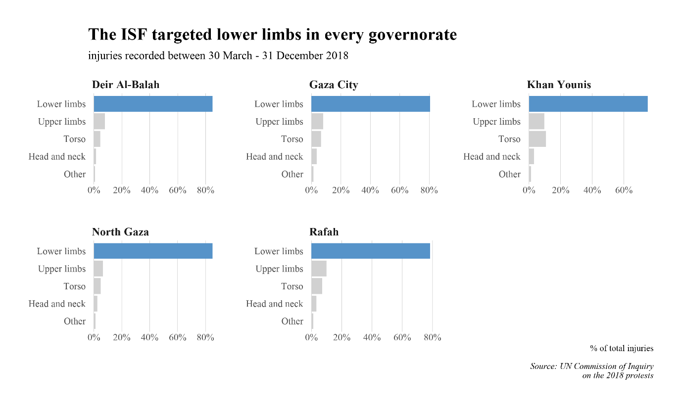
- In Court, the Government argued that its RoE “permit firing towards the legs of a key rioter or of a key inciter, but . . . only as a last resort, subject to strict requirements that derive from the principles of necessity and proportionality, and after all other means have been exhausted and failed.” The Court rightly treated this category with caution, noting that the status of ‘key inciter / key rioter’ does not exist in international human rights or humanitarian law, nor is there a legal foundation for targeting a person based on said status. However, relying on the facts described by the Government, the Court accepted that such primary rioters were the avant garde of the imminent threat to life.
- Where the applicable standard is imminent threat to life, the Commission finds the use of force against someone based on a status of key rioter/instigator highly problematic. In ‘ordinary’ crowd control scenarios, where security officers have access to the demonstrators, arresting a ‘key rioter or instigator’ may be lawful, and a necessary and proportionate response to the crowd becoming violent. Here, where arrest is not feasible, shooting that same person with potentially lethal force, however, is a severe escalation, one the Commission finds too-far removed from the imminent threat to life standard.
- The disconnect is evident prima facie. The Israeli Government does not in fact argue that the targeted ‘key rioter’ is directly posing an imminent threat to a person. Rather, the argument is that shooting a ‘key rioter’ - part of a threatening crowd - will cause the rest of the crowd to withdraw. The Commission notes that this was not entirely clear to the Court, as evidenced in the following observation, “This is due to the fact that we do not possess any concrete information regarding: the identity of the central instigators and inciters; the nature of their actions; their organizational affiliation and their involvement in terrorist activity, or in any other prohibited hostile activity; and whether and in what manner they posed an actual and imminent danger, which – as a last resort – necessitated fire” (emphasis added) These questions indicate that the Court believed that the ‘key rioter’ would him or herself pose the threat based on their individual conduct (as opposed to being based on a status of “key rioter” which does not exist in international law).
- Months after the Court’s review, the IDF Q&A, released in February 2019, shed further light on the particular category of key instigators and rioters, explaining that “where the commander assesses that the use of potentially lethal force is required to repel the real and imminent danger posed by a crowd, the commander will order such force only against ‘key instigators’ or ‘key rioters’”. The document then explained how ‘key instigators’ and ‘key rioters’ are identified, indicating that they “contribute centrally” to creating such threats, and listed examples of behaviour of such ‘instigators’ and ‘rioters’ who therefore could be shot:
- “Coordinating the tactical placement and setting on fire of tires”;
- “Coordinating people to contribute towards pulling back parts of the security infrastructure” (i.e., the barbed wire coils placed by the IDF inside Gaza);
- “Moving through the crowd while talking into a radio” and later seen to be “pulling wires attached to part of the security infrastructure [the barbed wire coils], together with a group of people”.
- “Incit[ing] the mob”;
- “Influenc[ing] their behaviour”;
- “Provid[ing] the conditions for which mass breach or infiltration may occur”;
- “Breach[ing] the security infrastructure” and “carr[ying] our attacks on IDF”;
- “Connect[ing] wires to the security infrastructure [i.e., barbed wire coils placed by the IDF inside Gaza] so that it may be pulled backwards”.
- In the law enforcement paradigm, none of the above listed activities can in themselves be lawfully met with lethal force – unless the person simultaneously poses an imminent threat to life or limb by, for instance, being armed and attacking.
- Further, determining exactly who “incites” and “influences” a large crowd is not straightforward. Such vague definitions as the basis for deciding upon the application of lethal force lead inevitably to arbitrary deprivation of life.
- As visible in the evidence reviewed by the Commission, some of which are public, but also in the hundreds of witness testimonies, in multiple cases where people were shot in the legs, the victim was merely standing in the vicinity of a crowd, or throwing/slinging rocks, lighting/moving tyres, or cutting the barbed wire coils placed by the IDF inside Gaza. Even accepting that this conduct meets the ISF-identified criteria of ‘key inciter’, the Commission found little or no evidence of the crowd itself bearing down on the fence and certainly not posing an imminent threat to someone’s life.
- In addition, were a certain individual able to incite a crowd of protestors to surge towards the separation fence, many steps would remain before an imminent threat to a person’s life materialized. The separation fence mostly remained in place. While the fence was cut, on occasion, by protestors during the GMR protests (as well as other times outside the protests), there were hundreds, even thousands, of occasions where ‘key inciters’ were targeted while the separation fence was fully intact. Even if the crowd were to cut it and cross, as happened on occasion, normally the crowd would be several dozens of meters away from the nearest IDF soldier and at least 800 meters away from the nearest civilian community. As indicated in the section below, IDF snipers are typically positioned at the top of sand berms or inside armoured personnel carriers, along with other soldiers, armed with automatic weapons and wearing personal protective equipment including body armour and ballistic helmets; the crowd is unarmed. The soldiers’ combined firepower, along with additional mobile forces in the vicinity, would be substantial protection. The ISF describe the crowd as if the threat is ‘real and imminent’ but appear to make no allowance in that assessment for the layers of significant (military) defences in place (see below).
- Another serious question is, once the “key rioter” status has been conferred on a protestor, whether and how it ends. If the crowd does not respond to the calls of the primary rioter (or does not manage to pull the fence away), does the person remain a ‘key rioter’ who can be targeted with lethal force? Similarly, if the sniper cannot get a good shot at the time, can the sniper hit the ‘inciter’ later? IDF public information indicates the answer is yes:
“Key instigators” and “key rioters” are often conducting activities within the violent riots for a lengthy period of time, and snipers face a challenge in identifying a time which provides the necessary circumstances for carrying out their fire while reducing the risk of hitting above the knee or hitting someone else. For example, snipers may act as a person temporarily moves away from the crowd or rests before continuing his activity.”
- The notion that a ‘key inciter’ can rest and then, presumably, continue their activity, prima facie undermines the notion that there is an imminent threat to life. How far away from a threatening crowd, temporally or physically, is one still considered a ‘key inciter’ and thus targetable?
- These are not rhetorical questions. The consequence of this policy has led to the application of lethal force against thousands of protestors well removed from an imminent threat to life.
- [Name removed], a 16-year-old boy, was confirmed by eye-witnesses interviewed by the Commission, as someone who had been near the front of the crowd of demonstrators and had attached a rope to the barbed wire. While tying the rope he was shot at, but he managed to escape and hide behind a near-by barrier. After a few minutes, he emerged from the barrier and was shot immediately. While the sniper may have been aiming for the legs, as the RoE would seem to have required, the boy was hit in the chest and died in hospital shortly thereafter. Clearly, at the time he was shot, he posed no imminent threat to anyone’s life, nor was he part of a crowd posing such a threat. Rather, he appears to have been targeted based on the status of ‘key rioter.’ The Commission confirmed that he was otherwise unaffiliated with any political faction or military organization.
- Overall, from the Commission’s analysis of the Government’s submissions to the Supreme Court and the IDF’s Q&A, it is clear that the “imminent threat to life” standard - as applied in the rules of engagement - was too far removed from the criteria as understood in international law.
- The jus cogens prohibition against the arbitrary deprivation of life does not permit ending one innocent’s life, to save another’s, let alone to stop another’s behaviour - a principle that applies a fortiori where an imminent threat to others has not yet materialized. To paraphrase the German Constitutional Court, if an innocent death would be used to save others, the innocent would be reduced to a mere “thing” to be used at the pleasure of the state.
- Considering the infinite value of all human life, States must stridently guard against any dilution of the threshold under which State agents justify taking life.
B. Assessment of when lethal force would lawfully be used under the law enforcement paradigm
- The Commission next analyses the circumstances under which the use of lethal force against demonstrators might have been lawful. As mentioned, under the IHRL-based law enforcement paradigm, lethal force must not be used against an individual who does not pose (i) an imminent threat to life or serious injury, or if the force used was not pursuant to a (ii) legitimate law enforcement objective, or was not (iii) necessary or not (iv) proportionate. The Commission hereinafter analyses each criteria.
1. Imminent threat to life or limb
- In making its assessment as to whether any protestor(s) posed an imminent threat to life, and the ‘reasonableness’ of that perceived threat as viewed from the perspective of the shooter, the Commission took into consideration several factors, among which were: the proximity of the victim to a person against whom the threat might be posed and the nature of any obstacles, defences, or barriers between the victim and the threatened person; the victim’s conduct at the time the potentially lethal force was applied; whether the victim possessed any weapon or explosive device capable of threatening human life and whether the weapon was prepared for use; whether the victim had responded to less-lethal measures, and the extent to which such measures, or any such additional measures, could effectively thwart the threat.
- In an effort to understand the proximity of the demonstrators to ISF soldiers or Israeli citizens, the Commission inquired into the lay of the land of each of the five GMR demonstration sites. It based the below determinations on a thorough review of Israeli and Palestinian testimonies and open sources, including considerable video and photographic material.
- Jakkar Road ran parallel to, and approximately 300-400 m from, the separation fence at all five demonstration sites.
Abu Safia Demonstration Site
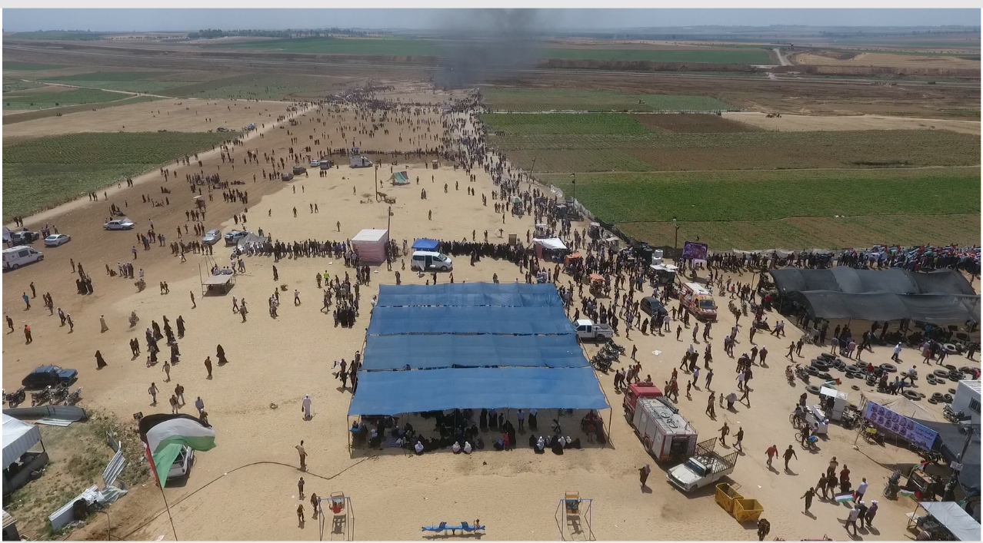
- The Abu Safia demonstration site in North Gaza was the main demonstration site in the North Gaza governorate, north-east of Jabalia town. The Camp of Return consisted of approximately 30 tents representing different families, clans and tribes. It was situated approximately 700 – 1000 m from the separation fence. To the east of Jakkar Road, rolls of barbed wire laid by the ISF ran parallel to the main separation fence on the Gazan side, approximately 50-150 m from the fence, depending on the location.
- The ISF built two gravel roads and laid more barbed wire just after the fence on the Israeli side. The ISF positions were located on a number of sand hills or berms. They were approximately 50 to 100 m behind the separation fence at a height of between 1.5 and 8 m. The separation fence itself is about three to four metres high and consists of about 20-25 horizontal wires, held together by vertical bars. In the space between the separation fence and the berms were two macadam roads, followed by barbed wire. On some of these berms, a military tent was erected, with individual soldiers positioned in front of the tents, facing the separation fence. Behind these berms, at a distance of approximately 50-100 m, a long earth wall was erected running parallel to the separation fence along the whole Abu Safia area. The positions of the Israeli military offer a clear view of the demonstration site, particularly since the terrain between Jakkar Road and the separation fence slopes slightly towards the fence.
- The terrain between the separation fence and Jakkar Road is flat and open and consists of uncultivated sandy areas and patches of vegetation. Israeli earth-moving equipment flattened some of the fields to improve line of sight for ISF soldiers and remove cover for demonstrators. Nevertheless, some of the terrain between the tents and the separation fence is rugged and provided spots for cover for individuals or small groups.
Malaka Demonstration Site
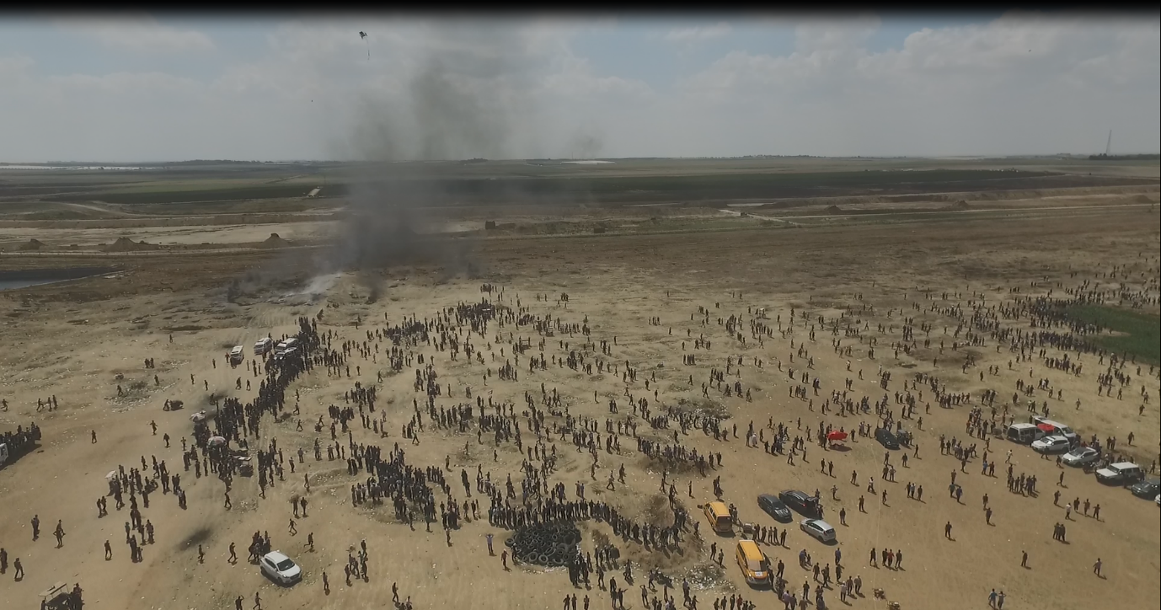
- The Malaka demonstration site lies south-east of Gaza City. It is bordered on the north by the Karni industrial estate and to the south by open agricultural plots. On the other side of the separation fence, the Nahal Oz Kibbutz is approximately two kilometres away.
- The tented camp at Malaka is approximately 500 m from the separation fence. There are earthen mounds between the tented camp and the separation fence at this site where some demonstrators gather for a better view of the activities near the fence.
- As with other sites, the ISF installed rolls of barbed wire on the Gazan side of the separation fence. The distance between the barbed wire and the separation fence was approximately 30 m. The ISF also erected a 1.5 metre high sand berm on the Israeli side of the fence, followed by a row of five earthen mounds, each approximately three m high. Typically, atop each mound were 7-10 ISF soldiers, including snipers and spotters.
El Bureij Demonstration Site
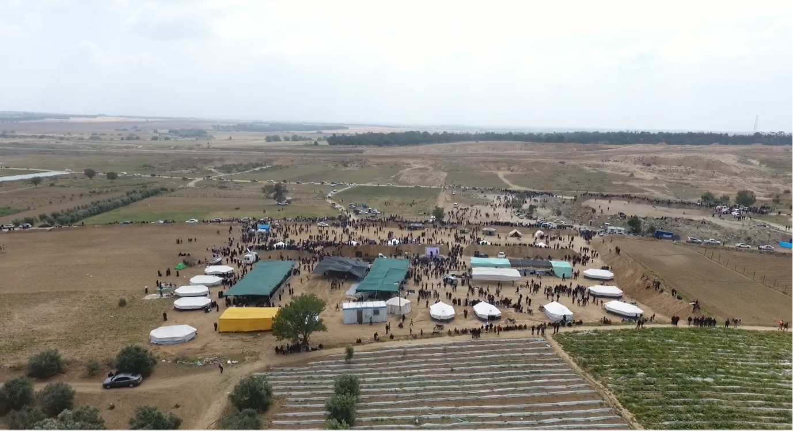I
- The demonstration site in central Gaza is located east of the El Bureij Refugee Camp. Approximately 15-20 tents, known as the “Camp of Return”, were set up approximately 700-1000 meters from the separation fence.
- The ISF fortified the separation fence with packed earth and placed barbed wire parallel to the separation fence approximately 30 to 50 m on the Gaza side of the fence. The ISF also built elevated sand berms approximately 20 to 30 m from the fence on the Israeli side, with each occupied by around five ISF soldiers, including snipers. Military utility vehicles patrolled the Israeli side of the fence.
Khan Younis Demonstration Site
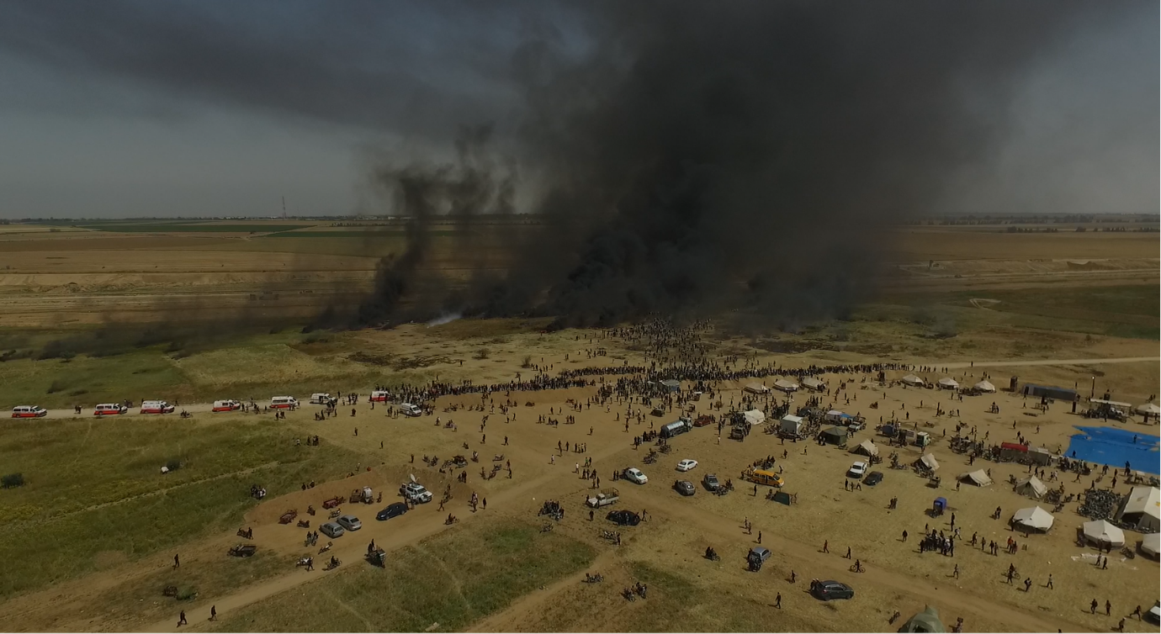
- The demonstration site in Khan Younis is located in the Al-Najjar neighbourhood, east of Khuzaa and Abasan Al-Jadidah villages. The Camp of Return is situated approximately 750 m from separation fence. The ISF laid rolls of barbed wire coils parallel to the separation fence on the Gazan side, approximately 50 m from the fence. Elevated sand berms were positioned 50 to 100 m from the fence on the Israeli side. ISF soldiers positioned themselves atop the berms and patrolled the area in military utility vehicles.
East Rafah Demonstration Site
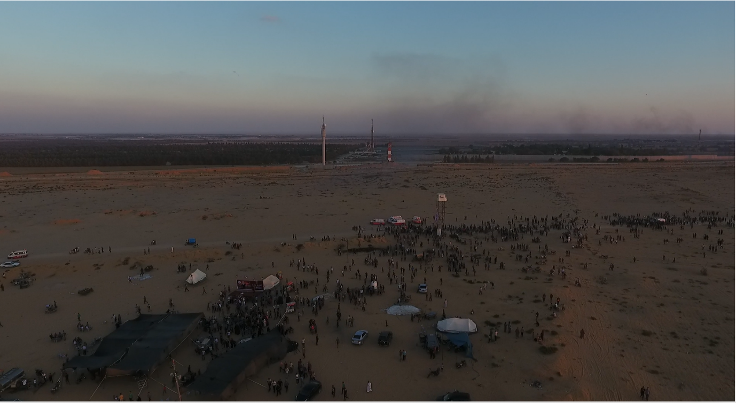
- The demonstration site in Rafah governorate is located near Al-Shawkah village, north of Gaza airport and about one kilometre northwest of the Kerem Shalom crossing with Israel. The tented camp at East Rafah has ranged from approximately 400-700 m from the separation fence at different times. Behind the separation fence are a series of sand berms at varying distances from the fence, depending on their location.
- Prior to the start of the demonstrations, local authorities erected a sand berm east of the camp to shield the demonstrators from ISF gunfire and observation.
- The ISF, including snipers, were positioned on three to four sand berms on the Israeli side of the separation fence.
Conduct and imminent threat
- During the course of its investigation, the Commission gained knowledge of various violent activities of demonstrators which, under certain conditions, may have posed an imminent threat to the lives or limbs of Israeli forces positioned near the separation fence – justifying the use of lethal force. Its assessment is set out below.
- Although the Commission noted the threat posed by burning kites or balloons (see the below section on impact on Southern Israel), in no case did the Commission detect that this threat was imminent to the lives or limbs of any Israeli civilian resulting from actions by demonstrators. The ISF had designated the Israeli lands in the immediate vicinity to the protest sites a no-go zone for Israeli civilians, in an effort to protect them from any potential threat emerging at the demonstrations. The Israeli civilian community which was closest to any of the five sites, kibbutz Nahal Oz, is located 800 m from the separation fence. In addition, kibbutzim neighbouring Gaza are protected with a range of security measures, including high smart perimeter fences, with barbed wire and electronic notification systems. In addition, Israel has substantial forces in the area (including military bases and battle tanks) that can be deployed to the kibbutzim within minutes, as well as fortified gun towers.
Throwing stones and other non-explosive objects
- It is clear from the information reviewed by the Commission that some demonstrators regularly threw and slung stones and other non-explosive objects at ISF soldiers on the other side of the main separation fence.
- Based on its assessment, the shortest possible distance between a demonstrator throwing an object and an ISF soldier, is approximately twenty metres, but usually considerably more. Twenty metres would be limited to situations where the demonstrator was able to reach the main separation fence directly in front of a sniper nest.
- While being struck with a stone or non-explosive object that was thrown by hand from a distance of twenty metres could certainly cause injury, the Commission does not consider that it would pose an imminent threat of death or serious bodily injury – especially taking into account the ISF’s protective equipment. Therefore, considering that twenty metres is the shortest possible distance from which a demonstrator could throw any object, the Commission finds that any demonstrator in the act of throwing a non-explosive object at the ISF from the Gazan side of the main separation fence usually does not pose an imminent threat of serious death or bodily injury to ISF soldiers on the other side.
Slinging stones
- Slinging stones and other non-explosive objects, however, requires a different analysis. Slings are crude weapons designed to increase the speed and distance of stones and other objects released towards a target. A skilled slinger can hurl a stone several hundred metres and strike a head-sized target from ten metres or more. It is clear that objects hurled from a sling are much more likely to seriously injure a target than objects that are thrown.
- That said, many factors must be considered when assessing the threat posed by a slinger. The slinger’s size and strength, as well as the length of the sling contribute to the force with which an object is hurled. The size and density of the object hurled also matters.
- A demonstrator in the act of slinging a stone or other non-explosive object may pose an imminent threat of serious bodily injury to an ISF soldier, however, not in every case. For example, a person hundreds of meters from the separation fence who is in the act of slinging a stone or other non-explosive object would not pose an imminent threat of serious bodily injury to an ISF soldier in personal protection equipment. Accordingly, the Commission finds that assessments of the threat posed by demonstrators who are in the act of slinging a stone or other non-explosive object must be carried out on a case-by-case basis.
Burning tyres
- Some groups of demonstrators regularly burned tyres near the separation fence to obstruct the view of ISF soldiers with thick black smoke. This was done with the intention of making it harder for ISF snipers and marksmen to identify and shoot demonstrators. In some instances, demonstrators burned tyres to provide cover for individuals who were hurling objects at the ISF or attempting to reach, breach, or damage the fence. Some demonstrators rolled burning tyres towards the separation fence.
- The Commission does not find that an individual in the act of burning tyres posed an imminent threat of death or serious bodily injury to ISF soldiers. Even if another individual uses the tyre smoke to conceal his or her attempt to kill or seriously injure ISF soldiers, the Commission concludes that it is the latter individual, and not the person who set the tyre alight, who poses an imminent threat of death or serious bodily injury to ISF soldiers.
- Noting the impossibility of a hand-rolled tyre breaching the various sections of the separation fence and rolling up several metres of loose earth, the Commission also finds that an individual in the act of rolling a burning tyre towards the separation fence does not pose an imminent threat of death or serious bodily injury to ISF soldiers
Incendiary kites
- The Commission is aware that some demonstrators flew incendiary kites across the separation fence in an effort to set fire to Israeli farmland. In some instances, demonstrators flew incendiary kites towards ISF positions on the other side of the separation fence. Most of the kites were constructed of plastic and sticks with burning rags or coals fixed to the tail.
- The Commission notes the considerable financial and psychological toll they have taken on Israeli citizens. With regard to the use of lethal force in response, however, the Commission finds that individuals in the act of flying incendiary kites towards open farmland do not pose an imminent threat of death or serious bodily injury to ISF soldiers or Israeli civilians.
- The potential for death and serious bodily injury may exist if individuals fly incendiary kites directly at ISF positions, albeit not in every case. For example, an incendiary kite flown into a confined space housing ISF soldiers is more likely to cause harm than one flown towards ISF soldiers who are out in the open. Starting a fire that sweeps across fields may pose a threat of death or serious injury, however, the threat is not imminent. Accordingly, the Commission finds that an assessment of the threat posed by demonstrators who are in the act of flying an incendiary kite directly at ISF positions must be carried out on a case-by-case basis.
Incendiary balloons
- It is also clear from the information collected that some demonstrators released incendiary balloons, so they would float over the separation fence and set fire to Israeli property. Most have consisted of burning rags or coals carried by balloons or condoms inflated with helium gas. Others have allegedly had a sort of IED attached, intended to cause a small explosion upon impact.
- Concerning the use of lethal force in response, however, the Commission finds that individuals in the act of releasing an unguided, indiscriminate incendiary balloon are engaging in dangerous, even threatening behaviour. However they do not pose an ‘imminent threat to life’ or serious bodily injury to ISF soldiers or Israeli civilians.
Damage/cutting to barbed wire coils or the separation fence
- Considerable evidence indicates that small groups of demonstrators managed to pull back sections of the barbed wire coils placed inside Gaza and, in some instances, cut wires on the main separation fence.
- The Commission acknowledges the genuine fear among the ISF and Israeli citizens that a breach of the separation fence would lead to physical attacks against Israeli soldiers or citizens residing in nearby kibbutzim. The Commission also recognizes that in some instances, individuals who damaged the fence have crossed, or intended to cross, the fence into Israel.
- Nevertheless, damage to a static barrier, bordering largely agricultural land, simultaneously does not create a threat of death or serious injury to individuals on the other side. Moreover, while a breach to the fence could lead to additional threats to the ISF and Israeli civilians, these additional threats are distinct and must be addressed separately. Consequently, the Commission finds that an individual in the act of damaging the separation fence does not necessarily pose an imminent threat of death or serious injury to the ISF or Israeli civilians.
Crossing the separation fence into Israel
- The Commission is aware that small groups of demonstrators, at demonstration sites and during demonstration times, have crossed the separation fence and briefly entered Israeli territory. In one case the group consisted of as many as 20 people. The Commission also recognizes the genuine fear among the ISF and Israeli citizens that demonstrators crossing into Israel would physically harm ISF soldiers or residents of nearby kibbutzim.
- As set forth above, the nearest ISF soldiers to the separation fence were usually positioned on sand berms, approximately three to four metres above ground. The nearest kibbutz to the separation fence is Nahal Oz, roughly 800 m away over open farmland. The second closest kibbutz, Mefalsim, is roughly 1,200 m away from the separation fence, again over open farmland.
- Noting these distances, and considering that the threat to ISF soldiers and Israeli citizens derives from the actions of the demonstrators once they are on Israeli soil, the Commission finds that the mere act of crossing the separation fence into Israel does not, in itself, pose an imminent threat to life or serious bodily injury to ISF soldiers or Israeli civilians.
Possession of hand-held cutting weapons and tools
- Several demonstrators carried hand-held cutting weapons, primarily so called wire-cutters and other sharp tools during the protests. Many of these individuals used the weapons and tools to damage the separation fence and cut the barbed wire coils described above. The Commission recognizes that hand-held cutting weapons and tools can be used to kill or cause serious bodily harm to others; however, it also acknowledges that this threat arises once the individual in possession actually attacks someone. Mere possession of hand-held cutting weapons and tools, even by individuals who have crossed the fence into Israel, does not pose an imminent threat to life or serious bodily harm to ISF soldiers or Israeli citizens. The Commission accordingly finds that assessments of the threat posed by demonstrators who are in possession of hand-held cutting weapons and tools must be carried out on a case-by-case basis.
Molotov Cocktails
- The Commission is aware of claims that some demonstrators at the GMR used Molotov cocktails against ISF soldiers. The Commission asked Israel for information about these alleged incidents but did not receive a response. Although the Commission has not been able to verify these claims, it distinguishes Molotov cocktails from other ‘improvised incendiary devices’ (IIDs) used by some GMR demonstrators.
- Molotov cocktails are a specific type of IID, not a general term for all IIDs. This distinction is important because Molotov cocktails are much more dangerous than other IIDs such as lit coals or cloth balls soaked in fuel that simply burn – in that the burning liquid of a Molotov can spread instantly.
- From video footage and photographs viewed by the Commission, the incendiary kites and balloons used by small groups of demonstrators carried burning coals or cloth balls soaked in fuel.
- The Commission could not corroborate claims of the use of Molotov cocktails during the demonstrations. It saw some video material of individuals and groups outside the protest site/times, throwing them. Were demonstrators to throw Molotov cocktails at ISF soldiers at short-range, this might pose an imminent threat of death or serious injury.
Grenades
- The Commission is aware of claims that some demonstrators threw grenades at ISF soldiers. A grenade is a small explosive weapon typically thrown by hand or by launcher. Stones and other non-explosive objects thrown or slung at ISF soldiers are not grenades. IIDs, such as burning coals and cloth balls soaked in fuel are not grenades either because they are incendiary rather than explosive. The ISF have reported that soldiers were injured by grenades on 13 July and 21 September. The Commission asked Israel for information about these alleged incidents but did not receive a response. The Commission has not been able to verify claims, nor has it seen evidence that demonstrators carried or threw actual grenades at the demonstration sites during demonstration times.
- A grenade thrown at short range could pose an imminent threat of death or serious injury.
Firearms
- The Commission is aware of claims that some demonstrators carried firearms. However, during the course of its inquiry into nine months of large-scale demonstrations, it identified two instances of people carrying arms at the demonstration sites: one pistol (visible in a video depicting an Israeli drone being shot down) and one rifle (see the section on 14 May and the description of an incident that may have amounted to hostilities).
- Were a demonstrator to use firearms against the ISF or Israeli citizens, the ISF’s use of lethal force in response to such an imminent threat would be lawful, so long as it was necessary and proportionate.
Conclusion
- The Commission notes that while the above-listed conduct may not in all cases entail an imminent threat to life, they are also not ‘peaceful’. Action short of lethal force may be justified against those demonstrators who, by resorting to violence, may have temporarily waived their right to ‘peaceful assembly.’
- Before turning to the tests of legitimate aim, necessity and proportionality, the Commission examines the question of threats emanating from a group or crowd.
- The Basic Principles on the Use of Force and Firearms as well as other interpretations of IHRL are clear that, when the conditions are met for the use of force, it is to be applied to the person posing the imminent threat. In certain extreme cases where a hostile crowd itself poses an imminent threat to life, and where all other measures have been exhausted or are not feasible to avert the threat, firearms may be permitted if proportionate and necessary, as a last resort to save a life. Indiscriminate fire at a crowd, however, is never allowed. Fire must be aimed specifically at those comprising the imminent threat - to the extent this can be determined. If it cannot be determined, one expert opines:
“[I]t must be recognised that violent assemblies differ in the numbers of people involved, in the degree of violence manifested and in the imminence of gravity of the threat to life posed by the actions of the participants. In an extreme case where there is a tumultuous and chaotic disturbance created by an assembly of people exhibiting a ferocious degree of violence; where it is genuinely believed that the actions of a large proportion of the people forming the assembly pose an imminent or grave threat to life; and where it is not possible to distinguish between those who do pose that threat and those who do not, it could be argued that the only way to reduce the threat is to disperse the assembly, and that the only way to disperse the assembly is to use firearms.
“On such an occasion it is probable that a number of individuals within the assembly, who are not themselves presenting an imminent or grave threat to life, and who, because of the circumstances cannot be distinguished from those who are posing the threat, would be killed or injured by firearms discharged to disperse the assembly. Furthermore, apart from the impossibility of distinguishing between people who themselves do or do not present the necessary threat to life at any specific instant, the fact of participation in an assembly of people which, collectively, present the threat could be seen as justification under the basic principles, for the use of firearms against them as individuals.”
- The Commission acknowledges this perspective, but did not find such extreme circumstances or “ferocious degree of violence” present.
- The IDF spokesperson and the judgment of the Supreme Court both refer to groups as large as 25 having been arrested within Israel, upon breaching the fence. Videos reviewed by the Commission shows groups of protestors, having cut through the fence, dancing, chanting, praying, shouting slogans, throwing rocks, kissing the ground, and planting flags. In each instance viewed by the Commission, those breaching returned to Gaza upon the approach of the ISF. In some instances the ISF deployed lethal force nevertheless.
- The Commission also reviewed videos of some individuals and small groups crossing into Israel and damaging property or committing acts of vandalism. In one video a person who has breached the fence set fire to an empty IDF sniper position located across from a protest site. In another video, a section of the fence called Tiger Gate is blown up; in a third, installations at the Kerem Shalom crossing burned. These acts did not seem to occur during the protests themselves but at other locations along the separation fence, or if at a protest site, then outside the times of the ‘GMR’ protests forming part of the Commission’s mandate. The incidents were therefore not assessed by the Commission and do not form part of its findings. However the seriousness of these acts was taken into consideration and informed the Commission’s understanding of the context (see also the below section on the impact on Southern Israel). These examples demonstrate the diversity of the circumstances and the challenge of predicting the intent of those who may cross. The Commission did not ignore the possibility that any individual, or group, may in fact seek to harm, kidnap or even kill an ISF soldier or Israeli citizens beyond. Against the weaponry and defences faced, there was little likelihood of success, but given the history and context, the possibility had to be taken seriously.
2. Legitimate law enforcement objective
- The Commission finds that defending the ISF soldiers or Israeli civilians against threats to their life is a “legitimate law enforcement objective.” It also finds that defending the separation fence from damage, prohibiting acts of vandalism within Israel and against its land, equipment and infrastructure is a legitimate objective.
3. Necessity
- Using force is permitted only where no other way exists to achieve a legitimate law enforcement objective - making the use of force ‘necessary’. Potentially lethal force is necessary only when the person deploying or authorizing the force reasonably believes that lethal force is necessary to save life. In short, it must have been reasonable to believe that the next thing to happen, were the bullet not fired, was a lethal attack against a person or group.
- For its assessment of necessity, the Commission considered whether alternatives were available and their implementation feasible, to stave off a threat, or whether the situation was such that the use of lethal force was indeed the last resort, necessary to save life.
- The Commission noted, in the incidents it studied, that where the ISF responded to the crowd of demonstrators approaching the fence with less-lethal measures, such as sponge-tipped bullets and tear gas, it averted whatever threat may have existed. This happened repeatedly. On those occasions where a portion of the crowd remained at the fence, or crossed into Israel, the ISF forces, and accompanying defences, were sufficient to avert whatever threat they posed without the resort to lethal force. If killing those breaching the fence was unlawful, it is a fortiori unlawful to shoot the ‘main rioter’ who may have emboldened them to do so.
- Similarly, lethal force against key inciters cannot, as a matter of fact, be a ‘last resort.’ As acknowledged by the ISF, the person being targeted does not themselves pose an imminent threat to someone’s life, but is apparently encouraging someone else, who may or may not respond. Life taken in such circumstances, disconnected from an imminent threat, violates international human rights law as not being necessary to save a life.
- A final point on necessity relates to the separation fence. Defending the fence is a legitimate law enforcement objective. Deploying non-lethal, but escalated force to protect it is foreseen in IHRL. Deploying potentially lethal force in order to protect the fence as such, however, is per se excessive, as it does not avert an imminent threat to someone’s life.
4. Proportionality
- For its assessment of proportionality, the Commission considered whether the quantity and nature of the force used stood in reasonable relation to the threat being averted. States must choose the least intrusive means to achieve the law enforcement objective. Even when such force is the minimum necessary, its use may not cause harm that would be disproportionate to the aim sought to be achieved; indeed the proportionality threshold “sets a maximum on the force that might be used to achieve a specific legitimate objective”.
- High velocity munitions at close range
- The IDF has stated that 7.62 sniper bullets were required because smaller calibre bullets do not have the accuracy at the necessary distances or are more easily deflected. Experts agree that the smaller bullet available to the IDF (5.56m/.22 gauge) is less effective at distances over 250 meters, whereas the 7.62, has a much greater effective range.
- In light of the devastating effect to the human body of the 7.62 bullet, and the specific circumstances of these protests, the Commission expressed its concern with respect to proportionality. This issue also cuts to the core of the threat assessment. For a threat to be imminent, as noted above and by international experts, an attack must be moments away and there should not be any remaining, intervening steps necessary. The attacker should also be in sufficient proximity to carry out the attack. If the IDF finds it necessary to shoot a ‘key inciter’ at more than 250 m away, the concept of “imminence” is arguably being misapplied. Conversely, shooting someone who is closer to, or at, the fence, (i.e., less than 100 m from the soldiers), the 5.56 is arguably effective, while the 7.62 is disproportionate – for all the reasons set out in the below section on permanent and life-changing injuries.
- The same argument is to be made for ‘less-lethal force’ (i.e., tear gas, rubber and rubber-coated bullets, water cannons etc.). Experts told the Commission that sponge bullets and water cannons are not effective at distances beyond 80 meters (with drone technology and other launchers, the ISF was able to deliver tear gas at much further distances), justifying in part the use of live ammunition. Beyond 80 m however, one must ask whether the threat to someone’s life meets the requirement of ‘imminence’. Of course the use of less-lethal measures do not require an imminent threat, but an escalation of force. Still, those measures cannot be abandoned in favour of live ammunition until an imminent threat is posed.
- Weighing a lifetime of harm to the victim against averting a speculative threat
- The Commission is further concerned that the proportionality calculation has been misapplied by the ISF, with devastating effects to the victims (see the below section on permanent and life-changing injuries). As set out in this report, the Commission views the ISF as having applied lethal force to prevent a threat from becoming imminent - as opposed to using lethal force to avert an existing threat. The proportionality calculation, as the ISF applies it, thus weighs the concrete harm of life-long disfigurement and immobility, against a speculative threat. This approach risks violating the requirement that the use of potentially lethal force be proportionate.
C. IHL-based conduct of hostilities paradigm
- As mentioned, the IHL-based conduct of hostilities paradigm was also potentially applicable in parallel to the law enforcement paradigm - to the extent that the threshold of violence necessary for being considered “active hostilities” was met during the demonstrations. Under the conduct of hostilities paradigm, lethal force may only be used against an individual who is (i) directly participating in hostilities, so long as the targeting complied with the principles of (ii) distinction, (iii) proportionality, and (iv) precautions in attack.
1. Direct participation in hostilities
- The Israeli Supreme Court noted that “some of the demonstrators can be classified as direct participants in the armed conflict that exists between Israel and the Hamas (this is certainly the case with respect to the terrorists and the armed persons among them; two close categories also includes both members of the terrorist organizations who disguise themselves as demonstrators and also participants in the protest who agree to serve as “human shields” for the terrorists hiding behind them).”
- Following this quote, the Court set out the ICRC’s three-element test for “direct participation in hostilities” – as the Commission has done above. The Court did not, however, undertake an application of the test to the facts, a step that was presumably justifiable in light of the undeveloped factual record.
- The Commission observes two points, first that ‘directly participating in the armed conflict’ (Court’s language), is not synonymous with ‘directly participating in hostilities’ (language of AP I, para. 51(3)), the latter reflecting the more concrete, activity-based requirement for the DPH threshold. Second, using the label ‘terrorist’ suggests that DPH can be status-based, which it is not. Nor does being associated with or affiliated to a ‘terrorist group’ qualify as DPH, without more. Being an ‘armed person’ (Court’s language) is also insufficient for DPH. Civilian police at a demonstration, for example, will regularly be armed and even a private person might lawfully carry a weapon. Neither of these alone amounts to direct participation in hostilities.
- Rather, as the ICRC’s Interpretive Guidance makes clear, the person’s conduct must harm in sufficient measure the military operations or capacity of the opposing force, or inflict death, injury, or destruction on protected persons or objects; and the conduct must be specifically designed to cause the harm in support of a party to the conflict and to the detriment of another (i.e., ‘belligerent nexus’).
- As noted, the Commission found one instance where this threshold was arguably met, on 14 May in North Gaza. There may have been other instances, some of which were outside the context of the GMR and not investigated by the Commission. In most cases, however, the IDF applied lethal force against individual protestors in circumstances where, in the view of the Commission, these thresholds were not met. Unarmed civilian protestors, even if violent and undertaking acts of vandalism, cannot be said to inflict sufficient harm on military operations or military capacity or said to inflict that harm in support of a party to the conflict. The Commission also notes that 4,903 people among the 6,106 people who were shot, were hit in the lower limbs; an indication – as per the RoE – that the IDF considered them ‘key inciters,’ rather than civilians directly participating in hostilities.
2. Principles of distinction, proportionality and precautions in attack
- Military operations to which the conduct of hostilities paradigm applies must also comply with the principles of distinction, proportionality and precautions in attack. These principles apply when targeting persons who are directly participating in hostilities, as well as when targeting persons based on their membership in organized armed groups parties to the conflict.
- Targeting unarmed demonstrators purely on the basis of their current or former political views, or their current or former membership of an armed group – and not on their conduct at the time – is impermissible in the view of the Commission.
- Even if it can be argued that persons with a “continuous combat function” in an organized armed group party to the conflict could be, under the conduct of hostilities paradigm, legitimately targeted at any time, in this specific context the risk to bystanders is unacceptably high. Firing live ammunition at such an individual, standing in the midst of a civilian crowd, with the foreseeable risks of mistakes, ricochets, bullet fragmentation or shrapnel, or of high-velocity ammunition going through one body and hitting another, directly implicates the principles of proportionality and precautions in attack. These risks are illustrated by the fact that, as set out below, not only were 6,106 persons shot by live ammunition, but a further 1,576 persons (including 345 children and 59 women) - probably not the intended targets - were injured by bullet fragmentation or shrapnel.
- Largely for these reasons, international jurisprudence and expertise have long since come to the view that firing into crowds of demonstrators – even in areas where there is an ongoing armed conflict, violent riots or frequent terrorist attacks – will nearly always be unlawful.
VI. Statistics
A. Overall fatalities and injuries occurring in the context of the demonstrations
- The Commission focused its investigation on fatalities and physical injuries occurring in the context of the demonstrations between 30 March and 31 December 2018. See the table below.
Fatalities and injuries between 30 March and 31 December 2018
Category | Total | Women | Children | Body part targeted |  |  |  | Presse | Health  workersf
 |  |  |  | Head/neck | Torso | Upper limb | Lower limb
Gaza:
Fatalities by live ammunitiona | 183 | 1 | 32 | 70 | 101 | 0 | 12 | 2 | 3
Injuries by live ammunitionb | 6 106 | 159 | 940 | 175 | 401 | 493 | 4 903 | 39 | 39
Injuries by bullet fragmentation/shrapnelc | 1 576 | 59 | 345 | - | - | - | - | 5 | 34
Injuries by rubber-coated metal bullet | 438 | 36 | 124 | - | - | - | - | 4 | 34
Injuries by direct tear-gas canister hit | 1 084 | 60 | 233 | - | - | - | - | 32 | 85
Israel:
Fatalitiesd | 0 | 0 | 0 | - | - | - | - | - | -
Injuries by stones, explosives | 4 | 0 | 0 | - | - | - | - | - | -
a The Commission found that at least 189 Palestinians were killed at demonstration sites, including 35 children. 183 of those killed were shot by live ammunition used by Israeli security forces; 4 by direct hits of tear gas canisters used by Israeli security forces; one likely by a stone thrown by another Palestinian and one by shrapnel of unidentified origin.
b The Commission’s estimate of 6,103 persons wounded by live ammunition at demonstration sites is based on its analysis of detailed data sets and electronic patient registry extracts collected separately from a range of health-care providers in Gaza (including eight hospitals run by the Ministry of Health, six other hospitals, and several health-care and rehabilitation centres run by international non-governmental entities and organizations). Of these, the Commission tracked and corroborated more than 300 incidents in which demonstrators were wounded by live ammunition. Some 134 of those shot were hit in multiple or other parts of the body.
c Most injuries by shrapnel were the result of bullet fragmentation from live ammunition. A small number may also have been caused by metal fragments stemming from direct tear-gas canister hits.
d One Israeli soldier was killed on a Friday while demonstrations were ongoing but outside the protest sites; see the section on impact on Southern Israel.
e Incidents affecting journalists or other media workers investigated or corroborated by the Commission. The total number is likely higher. See section on journalists.
^{f} World Health Organization, Attacks on health care in the Gaza Strip, January–December 2018. See section on medical personnel.
- The Office for the Coordination of Humanitarian Affairs (OCHA) has estimated that 23,313 Palestinians were injured by Israeli forces in the context of the demonstrations in 2018, including by tear-gas inhalation and canisters, contributing to the highest toll of injuries recorded in the Occupied Palestinian Territory since 2005.
- The Commission focused on investigating incidents entailing the use of live ammunition. Charts and graphs are presented below.
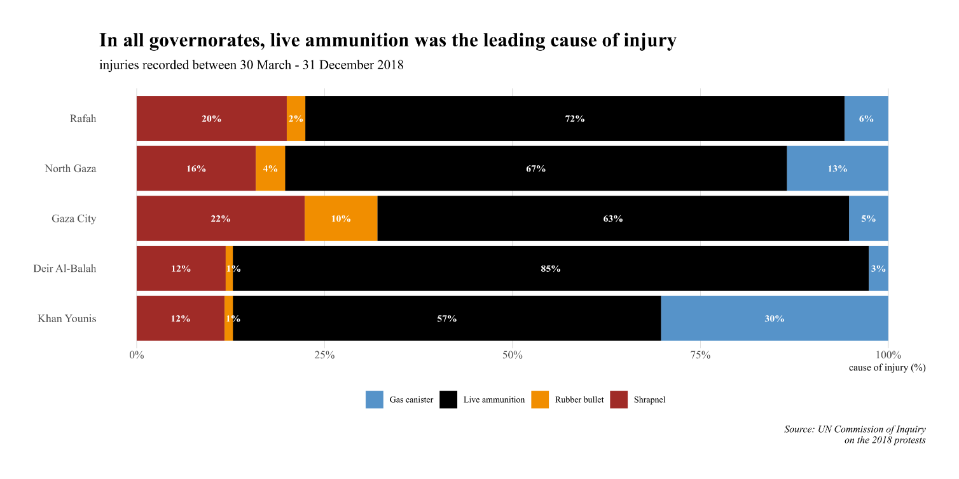
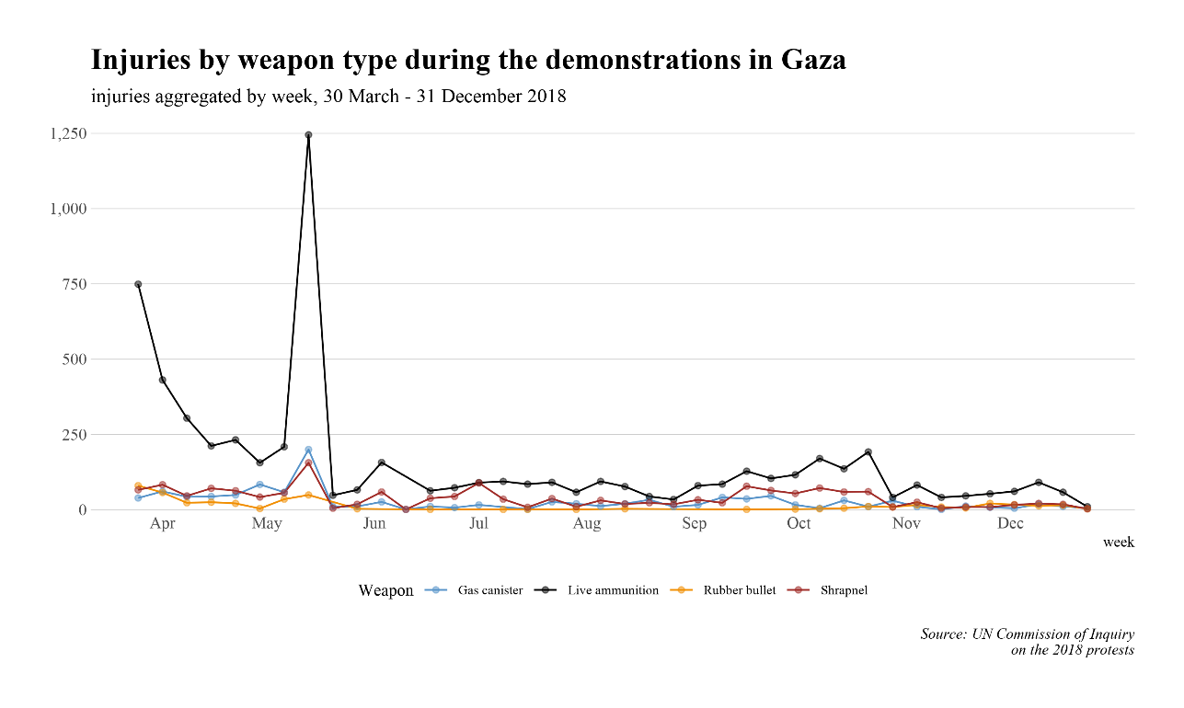

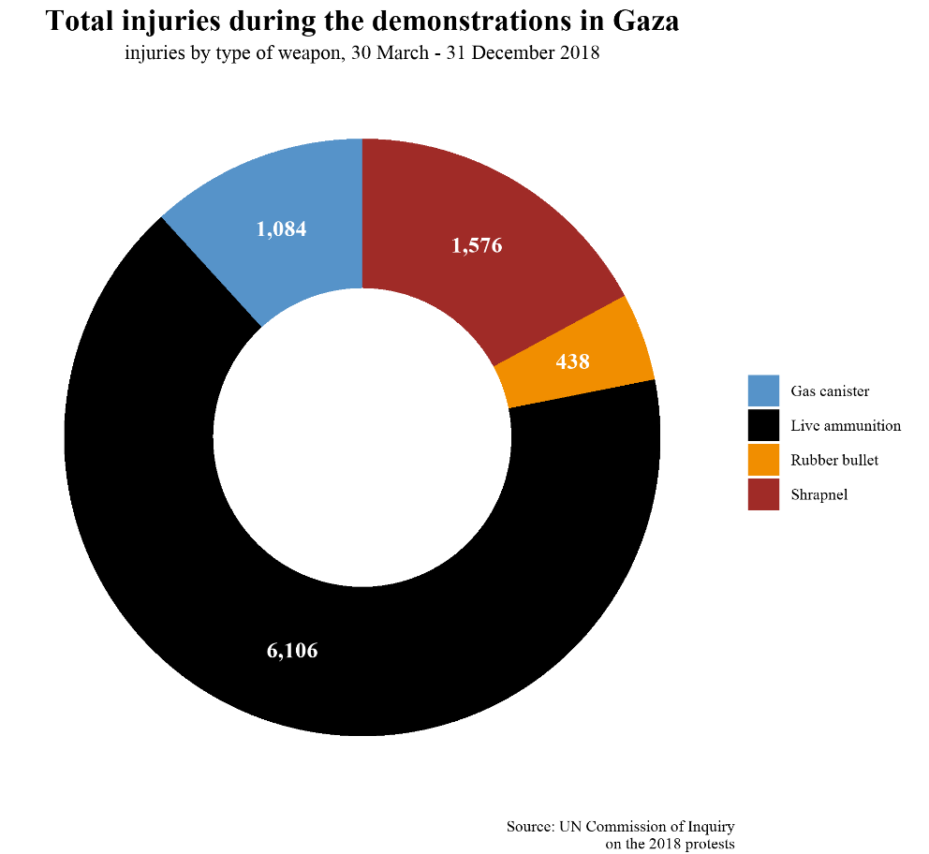
B. Fatalities among members of armed groups
- A substantial majority of those killed in the GMR were civilians, unaffiliated to any armed group. The Commission has found, however, that 29 of those killed in the context of the GMR demonstrations were current or former members of Palestinian armed groups party to the conflict with Israel. Of the 29, one was killed by a tear-gas canister, and 22 were shot on the same day, 14 May. The Commission had insufficient information to render a finding on the potential affiliations of 18 of the other persons killed.
- The Commission did not find indications that these armed groups were involved in the organization or staging of violent incidents at the protests, with the possible exception of a 14 May North Gaza incident (described in the below section on 14 May 2018). Public statements by some of the armed factions indicated that their members have been killed while demonstrating.
- Where the Commission found that an individual demonstrator was or may have been a member of Al Qassam Brigades or Al Quds Brigades, it represented that finding in its overall statistics. It did not include their affiliation in individual case descriptions for reasons of witness protection and risks of reprisals. The Commission also identified incidents in which persons were shot and killed who currently or in the past may have belonged to smaller armed factions.
- The Commission notes that there have been attempts by Israeli think tanks and commentators to rely on alleged support, or alleged family members’ support, for political parties, namely Hamas and Fatah, as justification for the killing of demonstrators, including children as young as 13. Most commonly, GMR demonstrators have been described as “Hamas terrorists”, “Hamas operatives” and “Hamas families” rather than people exercising their basic right to protest – including against 51 years of occupation and an ever-deepening humanitarian crisis.
- The Commission underscores that the political affiliations of demonstrators and that of their family members is irrelevant to the consideration of whether the circumstances of their killing are lawful.
- The Commission found that, in keeping with the stated aims and character of the GMR as a peaceful civilian demonstration, individuals associated with armed groups attended the GMR demonstrations unarmed and in civilian clothes, in some cases with their families. In a small number of cases, the Commission was unable to collect sufficient information about the exact circumstances of their deaths. As noted, the Commission found only one incident in which members of an armed group may have been armed and engaged in hostilities at a protest site and at a protest time (see the below section on 14 May 2018).
- The Commission recalls its view that in the specific circumstances of the GMR, it was impermissible to invoke the doctrine of continuous combat function as a justification for killing such individuals (see the above sections on applicable law and legal assessment of the demonstrations).
VII. Inquiry into specific incidents
- As mentioned, the Commission focused its inquiry on assessing the lawfulness of the use of lethal force at the demonstrations – seeking to determine whether each instance of use of live ammunition was lawful under the IHRL-based law enforcement paradigm or, in the rare case of active hostilities occurring at the protest sites, under the IHL-based conduct of hostilities paradigm.
- The Commission below presents a selection of the specific incidents it investigated, focusing on three key demonstration days (30 March, 14 May and 12 October) and incidents that are illustrative of patterns, such as targeting of “key inciters”. Incidents investigated by the Commission affecting protected groups are presented in the next section. For each incident, the Commission sets out whether it found reasonable grounds to believe that the use of force was lawful under the law enforcement paradigm. It also describes the one incident - during demonstration sites and times - in which it found reasonable grounds to believe that the threshold for active hostilities was met.
- For each of the cases investigated by the Commission, it has prepared a case file typically containing eyewitness testimony collected through interviews and affidavits; photographic evidence of the incident or of events just before or after; medical reports; hospital registration data; open source material and analysis; and any other relevant information gathered including through submissions it received.
A. 30 March 2018
- The demonstrations began on 30 March 2018 and were reportedly attended that day by between 40,000 and 50,000 Palestinian men, women, children, elders, civil society and political activists, and public figures. The Higher National Committee‘s calls for participation were initially made through media outlets and social media, and then widely relayed to the public by activists, including during prayers in mosques.
- Demonstrators congregated at five main demonstration sites. The atmosphere was festive, with activities in tents including poetry readings, seminars, lectures and cultural and sporting activities.
- Most gathered at “Camps of Return” located along Jakkar Road, which runs parallel to and is approximately 300 m from the separation fence. Smaller numbers of demonstrators moved closer to the fence, and stood, sat or lay on the ground. Some demonstrators near the fence threw stones, burned tyres and waved Palestinian flags. The Commission did not find that demonstrators were armed.
- As early as 9 a.m., the ISF responded to the demonstrations with live ammunition.
1. Deaths and injuries
- Overall, at the demonstrations held on 30 March, the ISF killed 18 people and wounded 703 with live ammunition; another 62 people were wounded by bullet fragmentation or shrapnel. The youngest casualty was a two-year-old, wounded in the head; the oldest, a 71-year-old woman shot in the leg.

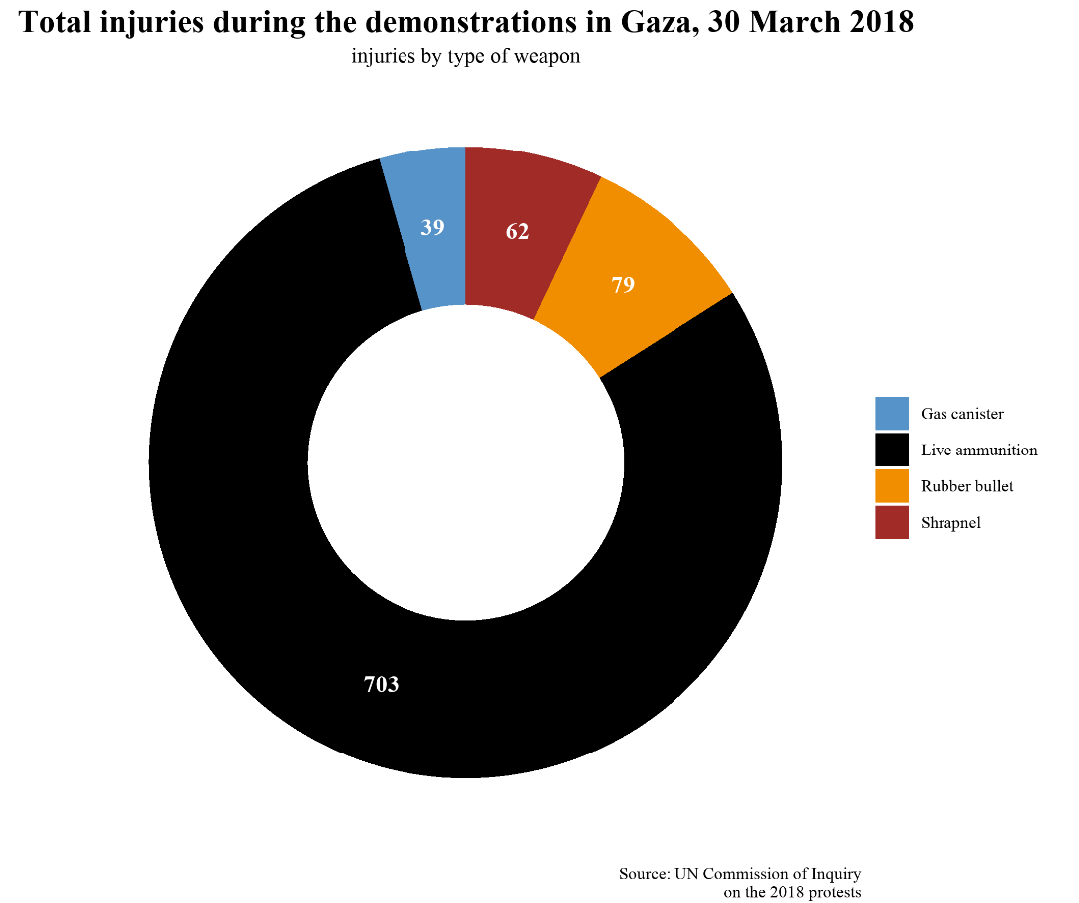

Demonstration site East of El Bureij Refugee Camp, Central Gaza Strip
- Eyewitnesses estimate that between 7,000 and 14,000 people attended the demonstrations at the site east of El Bureij on 30 March. Families were picnicking, cooking and congregating on plastic chairs in front of the tents at the Camp of Return along Jakkar Road, approximately 300 m west of the separation fence. Smaller numbers of demonstrators got closer to the fence, and stood, sat and lay on the sand dunes. The Commission did not find evidence of weapons present at the demonstration site on 30 March, nor were any attempts made to cross the separation fence. Actions by demonstrators near the fence were limited to throwing stones and waving Palestinian flags.
- The Commission considers that the following cases were emblematic of the ISF’s response to the demonstrations east of El Bureij refugee camp on 30 March.
- 9 a.m., Mohammad Obeid (24) shot in both legs
At approximately 9 a.m. Mohammad Obeid, a 24-year-old footballer for the Al-Salah Sports Club arrived at the demonstration site with his friend. Mohammad took out his telephone and began recording a “selfie” video. An ISF sniper shot him in the right side of his right leg as he filmed himself approximately 150 m from the separation fence. The bullet passed through his right leg and hit his left leg just above the knee, shattering the base of his femur. It is clear from eyewitness testimony and video footage that at the time that he was shot he was standing alone. The area was quiet and calm, there was no shooting from the Israeli side, no tear gas, no stone throwing from the Palestinian side, no one had set fire to tyres.
Mohammad was speaking calmly and filming himself when the ISF sniper shot him. He was neither advancing towards the separation fence nor encouraging anyone to advance towards it. He alternated between having his back to the ISF soldiers and having his back to the demonstrators as he filmed. The ISF sniper shot Mohammad as he turned to his right and stood perpendicular to the separation fence. The bullet’s penetratration of both
Mohammad’s legs increased the impact of the injury and subsequent disability.
The Commission finds that Mohammad did not pose an imminent threat of death or serious injury to ISF soldiers when he was shot.
- 12.45 p.m., student (21), shot in both legs
The ISF shot a 21-year-old student from El Nusseirat Refugee Camp in both legs with live ammunition around 12.45 p.m. He had just arrived at the demonstrations and got out of a car, approximately one kilometre from the separation fence. The ISF first shot him in the left leg. A few seconds later, ISF soldiers shot him in his right leg. The gunshot to his left leg severed a nerve. The gunshot to his right leg caused catastrophic tissue and bone damage, requiring seven surgeries, including a bone transplant, to avoid amputation.
The Commission finds that he did not pose an imminent threat of death or serious injury to ISF soldiers when he was shot.
- 3 p.m., Yousef Kronz (19), shot in both legs, led to amputation
Yousef Kronz was a 19-year-old student journalist when he attended the demonstration site east of El Bureij on 30 March. He wore a blue “PRESS” vest and carried his photography equipment, including a camera and a tripod. He sat cross-legged on top of a sand dune to take photographs of the demonstrators, at least 800 m from the separation fence. After approximately 40 minutes he stood up. As he stood up, the ISF shot him with two bullets in immediate succession which hit him in the right knee and the left knee. He collapsed on the ground. Yousef’s right leg was later amputated.
The Commission finds that Yousef did not pose an imminent threat of death or serious injury to ISF soldiers when he was shot.
- 3.30 p.m., killing of Abed Hawajri (41)
Abed Hawajri was a 41-year-old man from El Nusseirat Refugee Camp. At approximately 3.30 p.m. on 30 March, the ISF shot him in the abdomen. According to information collected, Abed was standing near the back of a crowd when shot, with nothing in his hands, wearing jeans and a jumper, approximately 150 m from the fence. He was taken to hospital and died the same day.
The Commission finds that Abed did not pose an imminent threat of death or serious injury to the ISF soldiers when he was shot.
- 4 p.m., schoolboy (16), shot in the face
At approximately 4 p.m., a 16-year-old boy climbed onto high ground near the School Gate, approximately 300 m from the separation fence. He was distributing sandwiches to demonstrators. The ISF then shot him in the face with a single bullet, which entered his nose and exited his skull. As a result of his injuries, he had a fractured jaw, is deaf in one ear and is unable to taste or smell.
The Commission finds that he did not pose a threat of death or serious injury to the ISF soldiers at the time that he was shot.
- 5 p.m., killing of Naji Abu Hojayeer (25)
Naji Abu Hojayeer was a 25-year-old mechanic from El Bureij Refugee Camp. An ISF soldier shot him in the abdomen shortly after 5 p.m. He died the same day. According to information collected, Naji was standing 300 m from the separation fence when he was shot. He was wrapped in a Palestinian flag, surrounded by hundreds of people.
The Commission finds that Naji did not pose an imminent threat of death or serious injury to the ISF soldiers when he was shot.
Abu Safia Demonstration Site in North Gaza
- On 30 March, thousands of people gathered at the Abu Safia demonstration site in North Gaza, primarily around the Camp of Return. The demonstrations started at approximately 7.30 a.m. and lasted until approximately 7 p.m. The demonstrations had a generally calm character. People of all ages walked in small groups and sat on the ground, waving Palestinian flags. Women and men were usually separate. Local television crews filmed the scene. The Commission did not find any evidence of weapons at the demonstration site.
- At around 10 a.m. a group of youths approached the separation fence and threw stones towards the ISF. Some young men burned tyres. The ISF responded with live ammunition and tear gas.
- The Commission considers that the following cases were emblematic of the ISF’s response to the demonstrations at the Abu Safia site on 30 March.
- 11 a.m., Mohammad Ajouri (17), shot in the leg, led to amputation
At approximately 11 a.m., Mohammad Ajouri, a 17-year-old boy from the Jabalia Refugee Camp and a member of the Palestinian Athletics Organization, went to the demonstration site with his friends. He handed out onions and water to protestors to relieve symptoms of teargas inhalation. When he was approximately 300 m away from the fence, ISF soldiers shot Mohammad in the back of his right leg. Doctors had to amputate his leg as a result (see section on denial of medical exit permits).
The Commission finds that Mohammad did not pose an imminent of death or serious injury to ISF soldiers at the time he was shot.
- 11.30 a.m., killing of Mohammad Kamal Najjar (25)
Mohammad Kamal Najjar, a 25-year-old unemployed demonstrator, was the first fatality at the Abu Safia protest site on 30 March. Mohammad and his friends joined a group of about 100 demonstrators and threw stones at the ISF soldiers. In response, the Israeli forces shot Mohammad’s friend in both legs with live ammunition. As Mohammad approached his friend to assist him, the ISF soldiers shot Mohammed as well. He was approximately 50 m from the fence at the time. According to an eyewitness:
When Mohammad went towards the injured person to help him, he was shot in the left side of his abdomen. I heard an eruption coming from his body... I was 20 m away... Mohammad died on the spot.
The Commission finds that Mohammad did not pose an imminent threat of death or serious injury to the ISF soldiers when he was shot.
- 11.45 a.m., killing of Tha’ier Rabaa (30)
Tha’ier Rabaa was a 30-year-old from Jabalia town. The ISF shot him in the thigh, severing his femoral artery. According to information collected, Tha’ier had thrown stones at the ISF and tried to rescue injured people. He was shot as he sought cover from heavy gunfire, approximately 30 m from the barbed wire coils. He died of his injuries on 6 April.
The Commission finds that Tha’ier did not pose an imminent threat of death or serious injury to the ISF soldiers when he was shot.
- 12.30 p.m., female teacher (64) shot in the leg
At approximately 12.30 p.m., the ISF shot a 64-year-old female teacher in the leg. She was 130 - 150 m from the separation fence approaching three injured youths who had been burning tyres before they were shot. According to her, she assumed that, as an older woman, she would not be shot by the soldiers. She removed the veil which covered her face so the ISF could see that she was a woman and not a man in disguise. As she was about to approach the injured demonstrators the ISF shot her in her left leg, just above the knee.
The Commission finds that the teacher did not pose an imminent threat of death or serious injury to ISF soldiers at the time she was shot.
- 3.20 p.m., killing of Abed El Fatah Nabi (18)
Abed El Fatah Nabi was an 18-year-old from Beit Lahia. At around 3.20 p.m., Abed and three others joined a crowd of demonstrators, approximately 400 m from the fence. Abed’s killing was captured on multiple videos and circulated widely on social media. As evidenced by the video footage, a demonstrator in a white shirt picked up a tyre and was running away from the separation fence towards the crowd of demonstrators. As he was running, the ISF fired at him. Abed ran to help him, taking the tyre and continuing to run away from the fence. The ISF shot him in the back of the head with live ammunition. He was pronounced dead on arrival at the hospital. A video of the incident can be viewed on the Commission’s website.
The Commission finds that Abed did not pose an imminent threat of death or serious injury to ISF soldiers at the time he was shot. In August, the MAG announced an investigation into Abed’s killing. The Commission requested, but did not receive information regarding the status of the investigation.
- 3.45 p.m., killing of Bader Sabagh (19)
Bader Sabagh was a 19-year-old from Jabalia. At approximately 3.45 p.m. Bader joined some friends and relatives on Jakkar Road. ISF soldiers shot him in the left side of his head as he was standing and smoking, approximately 300 m from the separation fence. An eyewitness recounted:
Bader was standing about two metres in front of me. I suddenly saw something hit him in the left side of his head and exit from the right side. Then, I saw [him] fall to the ground in front of me, bleeding heavily from his head. I ran towards him and saw that a bullet had entered his head from the left side and exited from the right side.
Bader died that same day on the operating table at hospital.
The Commission finds that Bader did not pose an imminent threat of death or serious injury to ISF soldiers at the time he was shot.
- 4.30 p.m., student (22), shot in the leg
At approximately 4.30 p.m., the ISF shot a 22-year-old student from Beit Lahiya in the leg. He was standing approximately 30 m from the separation fence watching demonstrators nearby throwing stones. He had nothing in his hands and began to run away from the fence once the ISF began firing at the demonstrators. As he ran away, the ISF shot him in his right leg, nearly severing it. Fragments from the bullet impacted his left leg. As a result of his injury, he has dropped out of university and fears that he will be permanently disabled.
The Commission finds that the student did not pose an imminent threat of death or serious injury to ISF soldiers at the time he was shot.
Demonstration site Malaka, Gaza City
- Several thousand people attended the Malaka demonstration site on 30 March. The demonstration was mostly peaceful, featuring musical, cultural and political events. By 10 a.m., a few protesters lit tyres and threw stones. The Commission did not find evidence that demonstrators carried weapons or that the separation fence was breached or damaged on 30 March.
- The Commission considers that the following cases were emblematic of the ISF’s response to the demonstrations at the Malaka site on 30 March.
- 10 a.m., schoolboy (13), shot in the leg
ISF soldiers shot a 13-year-old boy in the leg at approximately 10 a.m., as he was 300 m from the separation fence. He had been standing among a crowd of people on Jakkar Road looking towards the separation fence when a young man nearby was shot in the leg. As he turned to leave the demonstration site, he too was shot in the leg and fell to the ground. He spent 13 days in hospital and underwent five surgeries on his leg to repair nerve damage. As a result of his injury, he missed three months of school and has nightmares about what happened.
The Commission finds that he did not pose an imminent threat of death or serious injury to ISF soldiers at the time he was shot.
- 3 p.m., killing of Mahmoud Rahmi (33)
Mahmoud Rahmi was a 33-year-old man from Gaza City. ISF soldiers killed him at approximately 3 p.m. He had thrown stones at the ISF while standing over 30 m from the separation fence. Friends nearby heard a shot and saw blood coming from the left side of Mahmoud’s body. The bullet entered the lower part of his chest, lacerating his organs and causing him to bleed to death.
The Commission finds that Mahmoud did not pose an imminent threat of death or serious injury to ISF at the time that he was shot.
Demonstration site east of Khan Younis
- Thousands of people gathered at the Khuzaa protest site east of Khan Younis on 30 March, some as early as 7 a.m. The majority stood facing the separation fence and waved Palestinian flags approximately 300 m from the fence. Later in the day, some demonstrators burned piles of tyres near the fence, threw stones, and attempted to approach the separation fence.
- The Commission considers that the following cases were emblematic of the ISF’s response to the demonstrations east of Khan Younis on 30 March.
- 2.30-4 p.m., killing of Fares Al-Raqab (26)
Fares Al-Raqab was a 26-year-old resident of Bani Suheila. The ISF shot and killed him between 2.30 and 4 p.m. Material viewed by the Commission indicate that he was running away from the separation fence, at about 150 to 200 m, when he was shot in the back. The bullet entered his abdomen and he died of his injuries on 2 April.
The Commission finds that Fares did not pose an imminent threat of death or serious injury to ISF soldiers at the time that he was shot.
- 3 p.m., girl (13), injured by bullet fragmentation
At 3 p.m., a 13-year-old girl was injured by bullet fragments as the ISF opened fire on demonstrators near the barbed wire coils. The ISF soldiers fired tear gas in the area as she lay on the ground and while others came to evacuate her, three of whom were then shot (below).
The Commission finds that she did not pose an imminent threat of death or serious injury to ISF soldiers at the time that she was hit.
- 3 p.m., killing of Marwan Qudieh (45)
Marwan Qudieh was from Khuzaa village. The ISF shot him with two live bullets in the lower legs at approximately 3 p.m. at the Khuzaa protest site. According to information available, he was shot while assisting the injured girl (above). Marwan died on 9 April from septic complications.
The Commission finds that Marwan did not pose an imminent threat of death or serious injury to ISF soliders at the time that he was shot.
- 3.30 p.m., man (30), shot in the leg
The ISF shot a 30-year-old potato seller in the ankle approximately 14-15 m from the separation fence. He had been rescuing injured demonstrators and had just finished evacuating the injured girl (above).
The Commission finds that he did not pose an imminent threat of death or serious bodily injury to the ISF soldiers when he was shot.
- 3.30 p.m., man (32) shot in the leg, led to amputation
At approximately 4 p.m., ISF soldiers shot a 32-year-old construction worker with live ammunition in both legs. He had been rescuing injured demonstrators and, at the time he was shot, was assisting the injured girl (above). His right leg was amputated above the knee on 11 April.
The Commission finds that he did not pose an imminent threat of death or serious injury to ISF soldiers when he was shot.
- 4 p.m., killing of Jihad Abu Jamous (30)
Jihad Abu Jamous was a 30-year-old man from Bani Suheila. At around 4 p.m, ISF soldiers shot him in the head with live ammunition when he was approximately 250 to 300 m from the fence. He died immediately.
The Commission finds that Jihad did not pose an imminent threat of death or serious bodily injury to the ISF soldiers when he was shot.
- Afternoon: woman (41), injured by live ammunition
The ISF soldiers shot a mother of two daughters in the leg with live ammunition. She was standing 200 - 300 m away from the fence, talking to a journalist when she was shot.
The Commission finds that she did not pose an imminent threat of death or serious bodily injury to the ISF soldiers when he was shot.
Demonstration site East of Rafah, Southern Gaza Strip
- On 30 March, thousands of demonstrators began to arrive early in the morning on foot and in vehicles. No checkpoints were seen at access points to the Camp of Return.
- The demonstration was largely peaceful on 30 March, and actions by demonstrators near the fence were limited to throwing stones, burning tyres and waving Palestinian flags. The Commission did not find evidence that any demonstrators carried firearms.
- The Commission considers that the following cases were emblematic of the ISF’s response to the demonstrations east of Rafah on 30 March.
- 11 a.m., Maryam Abu Matar (16), shot in the leg
The ISF shot a 16-year-old girl from in the lower leg with live ammunition around 11 a.m. She was approximately 50 m from the separation fence when shot. She had approached the separation fence with her sister and a small group of girls to plant Palestinian flags in the ground. She had been carrying the largest flag. After planting her flag, she sat on the ground facing the ISF soldiers and drew her finger across her throat. Owing to the severity of her injury, she was still fitted with an external fixator to mend the bone in her leg, nine months after she was shot. A video with extracts from the Commission’s interview with Maryam can be viewed on the Commission’s website.
- The Commission finds that Maryam did not pose an imminent threat of death or serious injury to ISF soldiers when she was shot.
- 12 p.m., killing of Ameen Abu Mo’amar (25)
Ameen Abu Mo’amar was a 25-year-old from Al-Soufi neighborhood. ISF soldiers shot him in the abdomen with live ammunition around 12 p.m. as he stood in a large crowd of demonstrators about 60 m from the separation fence. The bullet caused severe lacerations to Ameen’s liver and led to catastrophic bleeding. He died shortly after arriving at hospital.
The Commission finds that Ameen did not pose an imminent threat of death or serious injury to ISF soldiers when he was shot.
- 2 p.m., Alaa Dali (21), shot in the leg, led to amputation
Alaa Dali is a 21-year-old cyclist for the Palestinian Cycling Team. He had earned a slot to participate in the Asian Games in the summer of 2018. According to corroborated accounts, an ISF sniper shot him in his right leg on 30 March, at around 2 p.m., as he stood alone watching the demonstration approximately 300 m from the separation fence east of Rafah. Alaa was shot as he stood on a raised pile of sand while wearing his cycling gear and holding his bicycle. The nearest demonstrator was approximately 15 m in front of him.
The bullet nearly severed his right leg just below the knee, destroying the bone and a considerable amount of muscle tissue and blood vessels. Doctors amputated Alaa’s leg above the knee in order to save his life. He will be unable to resume his cycling career.
The Commission finds that Alaa did not pose an imminent threat of death or serious injury to ISF soldiers when he was shot.
B. 31 March – 13 May 2018
- Over the following weeks, demonstrations were held each Friday at the five main sites in Gaza: on 6 April, 13 April, 20 April, 27 April, 4 May and 11 May. The ISF continued to employ live ammunition against demonstrators. Children, journalists, paramedics and persons with disabilities were among those killed and injured (see sections on children, journalists and paramedics).
- From April, demonstrators began to send kites and balloons carrying burning rags or coals wrapped in chicken wire (see tyre, kites and balloons “units” below) to the Israeli side of the fence, which caused fear among the civilian population and damage to their property (see section on impact of demonstrations on Southern Israel). Israeli authorities attributed deployment of the kites to Hamas and launched a number of attacks targeted at associated infrastructure. On 11 May, Palestinians inside the Gaza Strip set fire to the Kerem Shalom humanitarian crossing, damaging fuel and gas pipes.
- In addition to slinging stones and throwing tear gas canisters back at the ISF, protesters regularly removed the coils of barbed wire on the Gaza side of the separation fence that the ISF then regularly replaced. Groups of demonstrators burned tyres and adjusted their locations to the prevailing winds in order for the smoke to better screen them from ISF snipers.
- On occasion, a handful of individuals cut through the separation fence, but outside of demonstration hours and in areas outside of the demonstration sites, before being repelled, or shot, by ISF.
Tyre, kite or balloon “units”
- Some activities, such as the launching of incendiary kites, cutting barbed wire or tyre burning, began to be organized by self-declared “units”, some of them through their own Facebook pages.
- In early April, demonstrators, mainly young men, set up ‘tyre units’ (‘Kushuk/Koushuk units’) at each of the five sites with the stated aim of protecting demonstrators from ISF gunfire. They would place the burning tyres so that the thick black smoke they produced blew in the direction of ISF sniper positions. Over time, the units became more and more organized, with tyres brought in by trucks in advance of each Friday’s demonstration. The activities appeared to be condoned by the HNC.
- The incendiary kites began already on the second Friday of the GMR with balloons following later. Those involved formed themselves into ‘kites and balloons units’ (e.g. ‘Sons of Zouari’) and claimed to be unaffiliated with any organisation. The presence of these units at the various sites dropped off during the summer months, but from information available to the Commission, appeared to remain active outside protest sites and times.
- The Commission found conflicting information regarding whether these units were directed or controlled by the HNC. According to one HNC member, the units acted separately from the GMR, and the HNC had no control or influence over their activities. A Kites and Balloons Unit Facebook page mentioned the GMR only on a few occasions in 2018. A member of one unit told the Commission, however, that the HNC supported them with money and even told them when to fly kites and when not, and how many.
- The Commission found that these units’ activities were at times sanctioned or encouraged by the HNC. While members of armed groups appeared to be involved at times, the Commission did not find that armed groups initiated or directed these activities during the times and sites of GMR demonstrations.
ISF response
- The ISF also adjusted its tactics. Berms were raised and fortified, increasing their height to give a better vantage point and to avoid bullets ricocheting off the fence. The ISF installed covers at the top of the snipers’ nests for protection. They began to drop tear gas on demonstrators near the tented camps by drone, so that it would blow eastwards into the crowd. The ISF’s other responses to the protestors activities remained - live ammunition, tear gas fired from rifles and military vehicles, and rubber bullets.

1. Deaths and injuries
- 12 April 2018, killing of Abdullah Al-Shuhri (28), Khan Younis
At approximately 5.30 p.m on 12 April the ISF shot Abdullah Al-Shuhri in the chest with live ammunition. A 28-year-old resident of Zurab neighborhood in Khan Younis District Abdullah was standing approximately 100 m from the separation fence when he was hit. He was seeking shelter from the shooting behind a tree with a friend and was shouting to the ISF soldiers “I will be back”. He was hit in the right side of the chest and died at hospital after resuscitation attempts failed.
The Commission has reasonable grounds to believe that he did not pose an imminent threat of death or serious injury to ISF soldiers when he was shot.
- 13 April 2018, killing of Islam Herzallah (28), Gaza city
Islam Herzallah was shot as he was throwing stones at the ISF approximately 15 m from the fence. The bullet entered his waist area, lacerating his organs and causing him to bleed to death. Islam was married and was the father of three, a vegetable salesman.
The Commission found reasonable grounds to believe that he did not pose an imminent threat of death or serious injury to ISF soldiers when he was shot.
- 20 April 2018, killing of Sa'd Abu Taha (31), Khan Younis
On 20 April, at 6 p.m., ISF soldiers shot Sa'd Abu Taha, a 31-year-old carpenter, in the neck. A resident of Al- Qarara town of Khan Younis District, he was killed while standing with a dozen demonstrators approximately 100 m from the separation fence at the Khuzaa protest site.
The Commission found reasonable grounds to believe that he did not represent an imminent threat of death or serious injury to ISF soldiers when he was shot.
- 27 April 2018, killing of Abed El Salam Bakr (32), Khan Younis
On 27 April, at 6 p.m., ISF soldiers shot Abed El Salam Bakr in the abdomen with live ammunition. Abed was a 32-year-old resident of Khan Younis District and father of two children. He was filming with his mobile phone and standing among the crowd of protestors at the moment he was shot. Paramedics transferred him to hospital, but he bled to death before arriving.
The Commission found reasonable grounds to believe that he did not represent an imminent threat of death or serious injury to ISF soldiers when he was shot.
- 27 April 2018, killing of Mohammad El Maqayid (21), Gaza city
Mohammad El Maqayid was shot with live ammunition in the head at approximately 5.30 p.m. Along with a handful of other demonstrators he had reportedly cut through the barbed wire, which was 30 m from the separation fence. Some information indicates Mohammad reached the separation fence. He was throwing stones at the ISF, located on the berms 30-40 m away. The ISF shot live ammunition and fired tear gas at the group and Mohammad was shot dead, while others were injured.
The Commission has reasonable grounds to believe that Mohammad did not represent an imminent threat of death or serious injury to ISF soldiers when he was shot.
C. 14 May 2018
- Prior to the 14 May demonstrations some people on social media called for demonstrators to breach the separation fence on 14 May and reach Israeli communities. The HNC were simultaneously clear that all demonstration activities, including any crossing into Israel, were to be non-violent and unarmed.
- Meanwhile, Israeli authorities alleged that Hamas, under the cover of the civilian demonstrations, was planning to breach the Gaza fence, carry out terror attacks and “massacre” Israelis, and that it would stop a possible breach of the fence at all costs, warning protesters that they were putting their own lives in peril.
“On Monday May 14th, the Hamas terrorist organization plans to send armed terrorists, among 250,000 violent rioters to swarm and breach Israel’s border with Gaza and enter Israeli communities,” the IDF warned in an English language video. “Hamas plans to carry out a massacre in Israel. The Israel Defense Forces will not let them.”
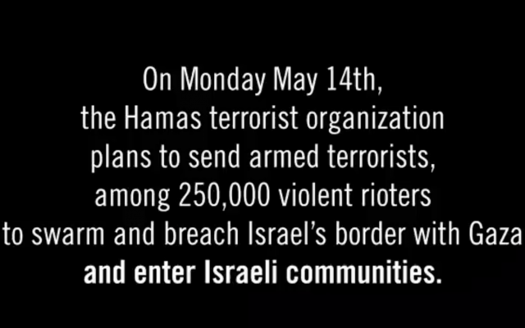
Screenshot from IDF video issued on May 13, 2018 (IDF video)
- On the Israeli side of the fence, soldiers from 11 battalions, including from the Nahal and Givati brigades, special forces, intelligence-gathering units, Armoured Corps, snipers, and drones were deployed to reinforce existing troops in the area.
- On Monday 14 May, the Great March of Return demonstration was scheduled to coincide with the opening of the U.S. Embassy in Jerusalem and the 70th anniversary of the Nakba. The demonstrations were labelled “The Return of a Million.” An estimated 35,000-40,000 people attended the demonstrations on 14 May, the highest number of demonstrators since 30 March.
- Prior to the demonstrations, at around 3 a.m., the ISF entered Gaza territory and used bulldozers to level the ground at the demonstration sites East of Jabalia, East of Gaza City, East of Al Bureij camp, East of Khuzaa, South East of Khan Younis, and East of Rafah.
- At all sites, large crowds of unarmed demonstrators congregated around the tents and in the open space between Jakkar Road and the separation fence.
- 14 May was marked by an increase in violence by the ISF and demonstrators. Many primarily young and middle-aged men slung or threw stones, shouted slogans and burned tyres, which created a wall of smoke. Some demonstrators cut or pulled away the barbed wire coils or approached the separation fence. In the afternoon, two demonstrators from El Bureij crossed the separation fence and set fire to an empty ISF berm. The ISF shot them as they ran back to the Gaza side of the fence, killing one and injuring another in the leg.
- The ISF released pictures of grenades and other improvised explosives that it claimed had been thrown or launched by slingshot across the separation fence at the ISF. While the Commission saw video of demonstrators slinging and throwing stones and empty tear gas canisters, it could not confirm that demonstrators threw or launched explosive devices towards ISF soldiers during the protests. The ISF also described being shot at (see also the incident description from the Al-Shuhada cemetery below). In the course of its investigation, the Commission sought information from the IDF regarding alleged shooting incidents but did not receive a response (see Annex with correspondence).
- Throughout the day, Israeli forces responded to the demonstrations with live ammunition and tear gas.
1. Deaths and injuries
- In total, Israeli security forces shot at least 1,162 people with live ammunition; some 141 were wounded by bullet fragmentation or shrapnel, marking the “highest one-day death toll in Gaza” since Israel’s 2014 military operation in Gaza.
- The ISF shot and killed seven children on 14 May: one girl: Wisal Khalil (14); and six boys: Izzedine Samak (13); Said al-Kheir (15); Ahmad al-Sha’ar (15); Talal Matar (16); Saadi Abu Salah (16); and Ibrahim al-Zarqa (17) (see also section on children). Five of them, including Wisal, were killed by live ammunition fired by ISF snipers at their heads and necks, and the two remaining boys were killed by live ammunition fired by ISF snipers into their abdomens.
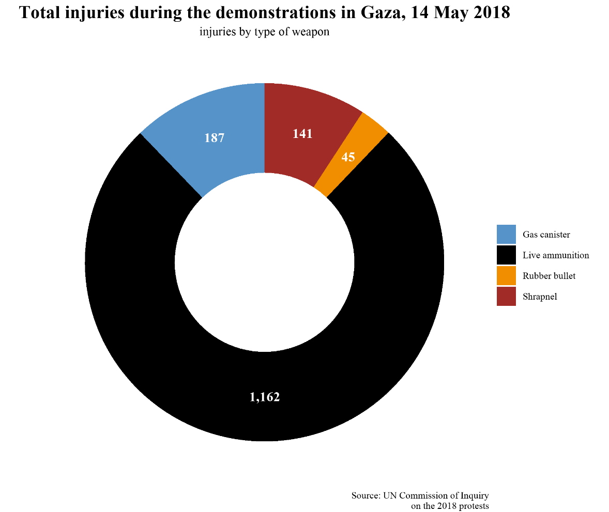
- The ISF also killed a paramedic, Musa Abu Hasaneen, with a shot to the chest (see section on medical personnel) and injured 15 health workers from the Palestinian Civil Defence and Palestinian Red Crescent Society (PRCS) field medical teams.
- On the Israeli side, one soldier was lightly wounded, reportedly by a stone.
- According to one medical organisation providing first aid to demonstrators, they treated more than 3000 people in three hours.
Demonstration sites at Gaza City
- In the lead up to 14 May, three additional demonstration sites were set up east of Gaza City – one to the north, near Karni Crossing, and another to the south, in an open field.
- Later that day, as crowds of demonstrators congregated at the tents and in the land between Jakkar Road, approximately 200 people, primarily young and middle-aged men shouted, chanted slogans and slowly approached the fence amid heavy smoke. They were not armed. They occasionally slung stones and periodically brought tyres to the front to burn. Shots fired by the ISF rang out every few minutes, causing the crowd to crouch or lay behind sand hills. The scene was chaotic.
- The Commission considers that the following cases were emblematic of the ISF’s response to the demonstrations at Gaza City on 14 May.
- 10.30 a.m., killing of Yasser Habeeb (24)
Yasser Habeeb was a 24-year-old from Gaza City. The ISF shot him in the neck around 10.30 a.m. According the Commission’s investigation, he was approximately 100 m from the fence. He had been throwing stones at the ISF and burning tyres. He died on 25 May 2018.
The Commission finds that Yasser did not pose an imminent threat of death or serious injury to ISF soldiers when he was shot.
- Mid-morning, killing of Husein Abu Aweida (41)
The ISF shot 41-year old Husein Abu Aweida, a food and beverage seller, in the back. According to eyewitnesses he was approximately 150 m from the separation fence when he was shot. A surgeon told the media that his spine had been severed and that fragmentation had caused damage to his liver and lungs. He survived for several days, finally succumbing to his injuries on 26 May 2018.
The Commission finds that Husein did not pose an imminent threat of death or serious injury to ISF soldiers when he was shot.
- 11.30 a.m., killing of Ala’a Khteeb (27)
Ala’a Khteeb was a 27-year old from Al-Sajaiya, Eastern Gaza City. He was among a group of young women and men who cut through the barbed wire coils and approached the separation fence shouting “Allahu Akbar (God is great).” The ISF responded with live ammunition, shooting Ala’a in the head. He was pronounced dead at 2 p.m. the same day.
The Commission finds that Ala’a did not pose an imminent threat of death or serious injury to ISF soldiers when he was shot.
- 12 p.m., killing of Taher Mahdi (24)
Taher Madhi was a 24-year-old from Al-Shati Refugee Camp. The ISF shot him in the torso at approximately 12 p.m. when he was roughly 300 m from the separation fence. Mahdi had been walking away from the fence towards the Camp of Return when he was shot. He died of lacerations to his internal organs.
The Commission finds that Taher did not pose a threat of imminent death or serious injury to ISF soldiers when he was shot.
- 12.30 p.m., schoolboy (16), shot in the leg, led to amputation
ISF soldiers shot the boy in the leg at approximately 12.30 p.m. He was standing in a crowd of people approximately 80 m from the separation fence. Three days prior, on 11 May and at the same site, he had been pulling on the barbed wire. According to the boy, the ISF targeted him because they recognised him from his previous activities. Video of the incident, however, suggests that a man near him, seemingly exhorting the crowd, may have been the intended target.
Owing to the severity of his injury and subsequent infection, doctors were forced to amputate his left leg on three different occasions. The last amputation was six centimeters above his left knee.
The Commission finds that he did not pose an imminent threat of death or serious injury to ISF soldiers when he was shot.
- 12.30 p.m., carpenter (58), shot in the leg, led to amputation
At approximately 12.30 p.m., the ISF shot a 58-year-old carpenter in the leg at the Malaka demonstration site when he was standing unarmed, 300 m from the separation fence. He was hit with a single shot. As a result of his injuries, his leg had to be amputated below the knee.
The Commission finds that he did not pose an imminent threat of death or serious injury to ISF soldiers when he was shot.
- Graphic designer (26), shot in the abdomen
The ISF shot a 26-year-old graphic designer from Gaza City when he was approximately 150 m from the separation fence. He was with a group of demonstrators who had been pinned down by heavy ISF gunfire. The ISF shot him in the abdomen as soon as he stood up. As a result of his injuries, he will not be able to have children.
The Commission does not consider that he posed an imminent threat of death or serious injury to ISF soldiers when he was shot.
- 3 p.m., killing of Mahmoud Jundya (20)
Mahmoud Jundya was a 20-year-old journalism student from Gaza City. The ISF shot him in the leg when he was filming the demonstrations on his mobile phone, 50 m from the separation fence. When gunfire broke out he crouched down behind an earth mound. The ISF shot him in the back as he lay lay there, seeking cover. He died at hospital.
The Commission finds that Mahmoud did not pose an imminent threat to life or serious injury to ISF soldiers when he was shot.
- 3 p.m., killing of Mahmoud Al Gharabli (16)
Mahmoud Al Gharabli was a 16-year-old from Al Shoja'yaa. The ISF shot him in the head as he was approaching the separation fence. Visibility was poor and according to those with him at the time, the soldiers were not visible from his position. The ISF began shooting towards burning tyres close to Mahmoud, striking other demonstrators in the legs and Mahmoud in the head.
The bullet caused multiple skull fractures, cerebral hemorrhage and brain lacerations. After surviving for several weeks in a coma, he died on 4 July.
The Commission finds that Mahmoud did not pose an imminent threat to life or serious injury to ISF soldiers when he was shot.
- According to a foreign journalist who covered the events in Gaza City that day:
What was notable was the number of injured people. And the slow, methodical shooting. Every few minutes … you would hear a shot ring out and you would see someone fall. And then another shot and another person fell. It went on for hours…
I saw a man who had been shot in the throat, I didn’t see it happen but I saw the immediate aftermath. He was covered in blood. I saw a man who had been shot in the head…
There was a constant stream of bloody bodies being carried back towards the ambulances. It was surreal and endless. It became almost normal, it was happening so often. A shot, a person falling, people carrying the body away.
The number of wounded was astonishing. I couldn’t say how many people I saw who were shot because it was so high. I have covered wars in Syria, Yemen, Libya. I have never seen anything like this. The slow methodical shooting. It was just shocking….

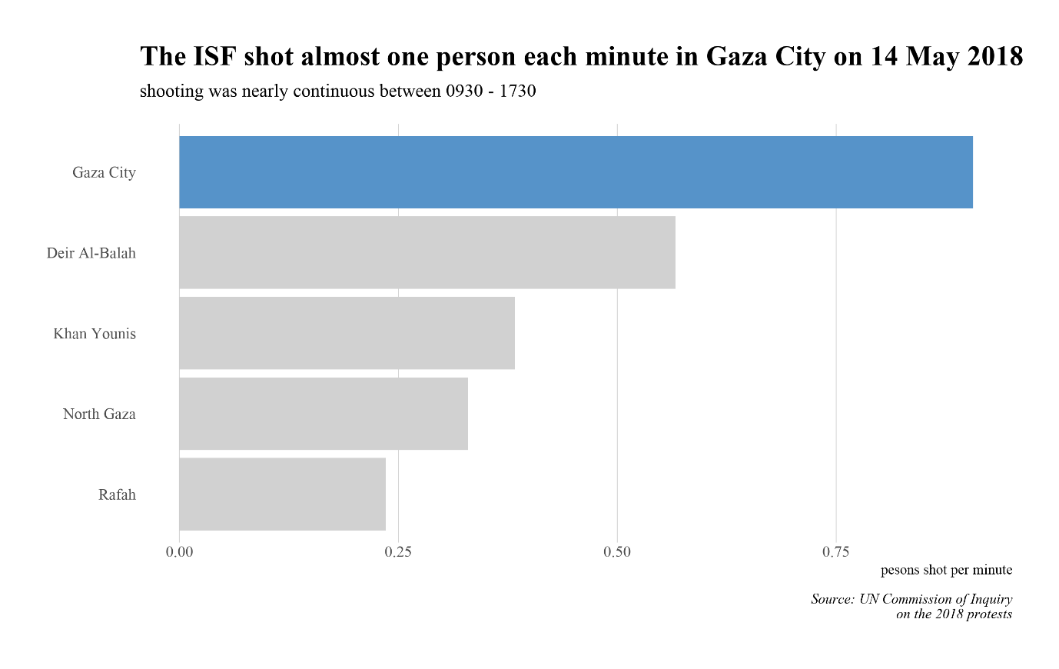
North Gaza Demonstration Sites
- On 14 May, demonstrations were held at Abu Safia, as well as east of the Al-Shuhada cemetery, east of Beit Hanoun, on the Erez crossing and north of Beit Lahyia.
- From a review of the interviews of witnesses who were present at the demonstrations in North Gaza that day, as well as photographs and video footage from the day, the Commission did not find any evidence that demonstrators carried firearms. However the Commission investigated one attack on ISF positions which took place only a few hundred meters southeast of the Al-Shuhada cemetery, see below.
- An international observer described the crowds at the protest site on the morning of 14 May:
The first layer was like a carnival, people celebrating the protest movement… It felt like a music festival. As I kept going forward I began to hear gunshots. In the layers closest to the fence the atmosphere was completely different...
- He also described the scene 50 - 75 m from the separation fence:
The bullet fire was so extensive that things like the tyre fires that were meant to be protective of the crowd, the guys doing that couldn’t even get it going. There was no opportunity for them to gather and light tyres. Groups of protestors were pinned down by gunfire and if they got up they would be shot.
- The Commission considers that the following cases were emblematic of the ISF’s response to the demonstrations at the Abu Safia demonstration site on 14 May.
- 10.30 a.m. Accountancy student (23), shot in the leg, led to amputation
At approximately 10.30 a.m., the ISF shot a 23-year-old accountancy student in the leg as he stood with friends at least 200 m from the separation fence, holding a flag.
Suddenly I felt myself flying a few metres. One exploding bullet hit my left leg. I was standing in an area with friends and where there was nothing going on and I was only carrying a flag.
His leg was later amputated.
The Commission finds that he did not pose an imminent threat of death or serious injury to ISF soldiers when he was shot.
- 4 p.m., killing of Mohammad Najjar (33)
Mohammad Najjar was a 33-year-old Naval Police Officer. The ISF killed him with a shot to the chest. At the time he was shot, he was sitting on a hill with his friend, around 500 m from the separation fence at the demonstration site in Abu Safia. His friend heard two shots and then saw Mohammad lying on the ground with his hands on his chest. Mohammad died almost immediately.
The Commission finds that Mohammad did not pose an imminent threat of death or serious injury to ISF soldiers when he was shot.
- The Commission considers that the following cases were emblematic of the ISF’s response to the demonstrations east of Beit Hanoun on 14 May.
- 10.15 a.m., killing of Mohammad Abu Setta (25)
Mohammad Abu Setta was a 25-year-old from Beit Hanoun. ISF soldiers killed him with a shot to the chest at around 10.15 a.m. He died of his injuries the same day.
According to one source, Mohammad had not been throwing stones or burning tyres and was approximately 150 m from the separation fence. Another eyewitness reported, however, that a few minutes prior to being shot, Mohammad had been closer to the fencing and joined other youths in throwing stones at the ISF. A third witness indicated that this group had cut the barbed wire coils on the Gaza side of the fence and moved closer to the separation fence. According to the same witness, Mohammad was approximately three metres from the separation fence when he was shot.
The Commission gathered conflicting accounts eyewitnesses as to the exact distance Mohammad was from the fence at the time he was killed – ranging from just a few to over 100 m. The Commission considered that even if Mohammad had cut the barbed wire and moved to a position three metres from the separation fence, he did not pose an imminent threat of death or serious injury to the ISF at the time he was killed.
- 2.30 p.m., shooting of a university student (22), led to amputation
The ISF shot a 22-year-old university student from northern Gaza in the right hip around 2.30 p.m. as he stood 100 m from the separation fence. He wore a Palestinian flag around his neck and held another flag in his hands. He was standing alone when the ISF soldiers shot him. The bullet entered his right hip and exited through his lower right leg. Due to the severity of his injury doctors were forced to amputate his right leg ten centimetres below the hip.
The Commission finds that the student did not pose an imminent threat of death or serious injury to the ISF when he was shot.
- 3 p.m., killing of Saadi Abu Salah (16)
Saadi Abu Salah was a 16-year-old boy from Beit Hanoun. At around 2.30 p.m. he moved towards the fence with a group of approximately 40-50 young people, some of whom burned tyres and waved Palestinian flags. Shortly after burning a tyre and rolling it towards the fence, he came under fire, causing him to take shelter on the ground. Saadi and the others in his group then continued to throw stones at ISF soldiers. The ISF then shot Saadi in the abdomen.
The Commission finds that Saadi did not pose an imminent threat of death or serious injury to the ISF when he was shot.
- The Commission considers that the following cases were emblematic of the ISF’s response to the demonstrations east of of the Al-Shuhada cemetery on 14 May.
- The Commission investigated an incident that occurred during the demonstrations in the early afternoon of 14 May that may have amounted to “direct participation in hostilities”. In the morning of that day, hundreds of people gathered in the area 50–300 m from the fence at a new demonstarion site east of the Al-Shuhada cemetery. They chanted slogans, waved flags, and slung and threw stones towards the ISF soldiers. Young men were burning tyres, creating a thick cloud of smoke. They also tried to reach the barbed wire coils. Some of the demonstrators approached the area up to 50-100 m from the separation fence. According to a witness, at aproximately 12.50 p.m., heavy and indiscriminate shooting started from the ISF, targeting the young men approaching the fence and also those who were on Jakkar road. The Commission viewed a video in which a person in civilian clothes, metres away from a sizeable group of demonstrators and cheered on by them, fired a rifle towards the Israeli side of the separation fence at a distance of between 50 and 70 m from the fence, amid the thick smoke of the burning tyres. It is unclear whether he was part of a group of militants. Israeli forces responded to the attack with tank and gunfire for about 40 minutes, killing 21 people, including eight alleged members of armed groups, a paramedic and two children: Said Mohammad Abu Al-Kheir (15) and Ibrahim Ahmad Ali Al Zarqa (17).
- Approximately 1.30 p.m., killing of Said al-Kheir (15)
Said al-Kheir was from Al Shatee’ neighborhood in Gaza City. The ISF shot him in his neck. According to an eyewitness who accompanied Said that day, they had gone to the demonstration near the Al-Shuhada cemetery, east of Jabalia and they stood on a sand hill hundreds of metres from the separation watching the demonstrations. Said was approximately 500 m from the fence when he was last seen by the eyewitness. Visibility was good because there were no tyres burning.
The eyewitness told the Commission that at approximately 1.30 p.m., the ISF started shooting at the demonstrators and people started falling. The witness was hit in his right arm. When he was evacuated he found Said already in the ambulance along with another dead person. Said had been shot in the neck.
The Commission finds that Said did not pose an imminent threat of death or serious injury to the ISF when he was shot. To the extent that Said’s death was related to the above incident, IHL’s principles of distinction, proportionality and precautions are implicated – for the parties on both sides of the separation fence. The same applies for all others killed in this incident.
- Approximately 1.30 p.m., killing of Ibrahim Al Zarqah (17)
Ibrahim Al Zarqah was from Al Tufah neighbourhood. The ISF shot him in the head with live ammunition near the Al-Shuhada cemetery, during the above incident. Bullets were being fired in quick succession and there were dozens of injuries in a matter of seconds. When hit, Ibrahim was 300 m from the separation fence with a group of protestors.
The Commission finds that Ibrahim did not pose an imminent threat of death or serious injury to the ISF when he was shot. To the extent that Ibrahim’s death was related to the above incident, IHL’s principles of distinction, proportionality and precautions are implicated – for the parties on both sides of the separation fence.
- The Commission did not receive any reports of ISF soldiers being injured during this incident.
Demonstration site East of El Bureij Refugee Camp, 14 May 2018
- People began arriving at the demonstration site from around 6 a.m. on 14 May. By approximately 8.30 a.m., hundreds of men, women and children had gathered at the Camp of Return. Young men burned tyres and threw stones at the ISF.
- Within the next hour, ISF soldiers positioned behind the separation fence fired live ammunition, rubber coated steel bullets and tear gas canisters towards demonstrators. The Commission did not find any indications of any demonstrator being armed at the El Bureij demonstration site.
- The following cases are emblematic of the ISF’s response to the demonstrations east of El Bureij refugee camp on 14 May.
- Approximately 2 p.m., killing of Ahmed Al Odeini (36)
Ahmed Al Odeini was a 36-year-old political and social activist from Deir Al Balah. The ISF shot him at approximately 2 p.m. on 14 May as he stood 50 - 100 m from the separation fence. Ahmed had joined a group of demonstrators that was throwing stones at the soldiers and burning tyres. Shortly after the smoke dispersed and visibility improved, ISF soldiers positioned on sand banks on the Israeli side of the separation fence opened fire at Ahmed’s group. Ahmed had not been holding anything in his hands before he was shot by the ISF. The bullet entered his right buttock and exited through his lower abdomen. He died on a hospital operating table.
The Commission finds that Ahmed did not pose an imminent threat of death or serious injury to ISF soldiers at the time that he was shot.
- Approximately 2 p.m., killing of Talal Matar (16)
Talal Matar was a 16-year-old resident of El Nusseirat Refugee Camp. Based on the Commission’s investigation, ISF soldiers shot him in the head sometime around 2 p.m. on 14 May as he was standing on a sand hill approximately 300 m from the separation fence. Talal stood alongside other demonstrators to observe ISF soldiers and participate in the protests. ISF soldiers fired live ammunition and tear gas at the crowd gathered there, while drones dropped tear gas.
An eyewitness told the Commission that Talal decided to stay on the hill while he and others retreated from ISF gunfire. The eyewitness could not find Talal when he returned to the hill approximately five minutes later. The following day, a source discovered Talal’s body at the Shifa Hospital morgue. Talal had arrived at the hospital with a gunshot wound to the head and died before being admitted to the operating room.
The Commission finds that Talal did not pose an imminent threat of death or serious injury to ISF soldiers at the time that he was shot.
- Approximately 2-3 p.m., killing of Mokhtar Abu Khammash (23)
Mokhtar Abu Khammash was a 23-year-old man from Al Eker area in Central Gaza. According to an eyewitness, Mokhtar and a friend cut through the separation fence with wire cutters and crossed into a deserted area on the Israeli side between 2 and 3 p.m. They carried a wire cutter, kerosene and a lighter. Once on the Israeli side they set fire to an empty berm. As they were on their way to another empty berm, they saw an ISF soldier approximately 30 m away. According to the eye witness, Mokhtar and his companion were shot as they were running back towards the Gaza side of the fence. The ISF soldier shot Mokhtar in the side of the chest and his friend in the hip. Mokhtar was pronounced dead on arrival at the hospital.
The Commission finds that Mokhtar did not pose an imminent threat of death or serious injury to ISF soldiers at the time that he was shot. The Commission finds that his conduct did not meet the threshold of ‘direct participation in hostilities’ due to a lack of belligerent nexus, and that his killing was therefore unlawful.
- 3 p.m., shooting of a volunteer journalist (25) in the thigh
The ISF shot a 25-year-old volunteer journalist at approximately 3 p.m. Due to the gunfire, he was lying on the ground among a large group of demonstrators approximately 150 m from the separation fence. The ISF shot him once he stood up, shattering the bones in his right thigh.
- The Commission finds that the volunteer journalist did not pose an imminent threat of death or serious injury to ISF soldiers when he was shot.
Demonstration site at Khan Younis
- In preparation for the large crowds expected to attend the demonstrations in Khan Younis, the HNC established two additional sites: in Abasan Al-Jadidah located north of the main Khuzaa protest site and a one-day protest site east of Abu Reidah neighbourhood, southeast of the main protest site.
- Thousands of demonstrators including men, women, children, elders and entire families were gathered at the demonstration sites. They arrived by foot, bus, car, or bike from nearby villages and neighbourhoods. Some members of armed groups were among the participants, but were unarmed. Tents in all three sites in Khan Younis held events such as dancing, bread baking, sports and cultural activities.
- Hundreds of demonstrators got close to the barbed wire coils, burned tyres and threw stones at the ISF. ISF fired live ammunition and tear gas canisters at the demonstrators. ISF used drones to drop gas canisters on the protesters. Demonstrators attempted to cross the fence, and were repelled by ISF gunfire.
- The Commission considers that the following cases are emblematic of the ISF’s response to the demonstrations at Khan Younis on 14 May.
- 12.30 p.m., killing of Jihad Al-Faraa (29)
Jihad Al-Faraa was a 29-year-old from Al-Qararah. The ISF soldiers shot him in the neck at the Abasan al-Jadidah protest site. His death was declared at hospital. He was shot after standing for noon prayers in the courtyard of the Camp of Return, about 300 meters from the separation fence.
The Commission finds that he did not present an imminent threat of death or injury to ISF soldiers when he was shot.
- 12.30 p.m., killing of Ahmad Hamdan (27)
Ahmad Hamdan was a 27-year-old from al-Amal neighbourhood in Khan Younis. The ISF shot him multiple times in the chest and abdomen with live ammunition. Video footage of him seconds before he was killed shows that he was standing among a crowd of protestors with thick clouds of smoke around them. He was pronounced dead on arrival at the hospital.
The Commission finds that he did not pose an imminent threat of death or serious injury to the ISF when he was shot.
- Approximately 1.30 p.m., killing of Ahmed Al-Shaer (15)
ISF soldiers shot 15-year-old Ahmed Al-Shaer in the back of his head with live ammunition. Ahmad was throwing tyres at the time.
The Commission finds that Ahmed did not pose an imminent threat of death or serious injury to the ISF when he was shot.
- 12.30 p.m., shooting of a taxi driver (22)
The ISF shot a 22-year-old taxi driver from the Khan Younis area in the legs at approximately 12:30 p.m. While approximately 50 m from the separation fence and taking cover from gunfire, he had picked up a tear gas canister to throw it back at the ISF when hit. He had been throwing stones at the ISF before that. The bullet passed through both legs. Although there were many demonstrators at the site that day, the nearest person to him when he was shot was approximately 30-40 m away.
The Commission finds that he did not pose an imminent threat of death or serious injury to ISF soldiers at the time he was shot.
- 2.30-2.45 pm., killing of Mahmoud Abu Taima (23)
Mahmoud Abu Taima was a 23-year-old from Khan Younis. Between 2.30 and 2.45 p.m., the ISF shot him in the head with live ammunition. Mahmoud was approximately 150 m from the separation fence when he was shot. He was declared dead on admission to hospital.
The Commission finds that Mahmoud did not present an imminent threat of death or injury to ISF soldiers when he was shot.
Demonstration site at Rafah
- The demonstrations in Rafah on 14 May were particularly large and intense. In addition to the usual activities, such as speeches, art performances and distribution of food, some demonstrators also burned tyres near the fence to create a smoke screen; cut and pulled the barbed wire in an attempt to reach the separation fence; and threw stones towards ISF positions.
- The ISF deployed in larger numbers that previously, including snipers and tank crews. In addition to live ammunition, the ISF also fired heavy amounts of tear gas at demonstrators from vehicle-mounted multiple launchers and released tear gas from drones.
- The Commission considers that the following cases are emblematic of the ISF’s response to the demonstrations at Rafah on 14 May.
- 10.45 a.m., killing of Ali Khafajah (21)
- Ali Khafajah was a university student from Tal Al-Sultan neighbourhood in Rafah. ISF soldiers shot him in the head with live ammunition around 10.45 a.m. Ali was talking on his phone while standing in a crowd about 150 m from the separation fence when he was shot. The bullet caused severe brain lacerations and catastrophic bleeding. He died at hospital.
- The Commission has not found evidence indicating that Ali posed an imminent threat of death or serious injury to ISF soldiers when he was shot.
- 11 a.m., killing of Mo’tassim Abu Loli (20)
Mo’tassim Abu Loli was a 20-year-old janitor from Rafah. ISF soldiers shot him in the head with live ammunition around 11 a.m. The bullet caused multiple skull fractures and severe brain laceration. Mo’tassim died at the hospital shortly thereafter. The night before he was shot, he left his home for the demonstration site carrying a toolbox with fence-cutting tools. Before the ISF killed him, Mo’tassim had been injured several times during his participation in the demonstrations, including once with rubber bullet in the leg.
Despite the fence-cutting tools, the Commission did not find that Mo’tassim posed an imminent threat of death or serious injury to ISF soldiers when he was shot.
- Due to the large numbers of deaths and injuries, the HNC called for the demonstrations to end early on 14 May. According to a journalist:
At 5 p.m. the entire perimeter area was evacuated of demonstrators because the hospitals were overwhelmed and overstretched. Field hospitals and journalists working at the demonstration sites were told to tell people to leave… [W]e were told to tell people that it was enough and that they should go home.
2. Perspective from Gaza Hospitals during 14 May demonstrations
- Meanwhile, hospitals across the Gaza Strip were in chaos, as doctors and medical professionals struggled to treat those wounded. According to doctors treating the injured, the injuries resembled those that would typically be seen during a war.
- According to a doctor at one hospital, “[I]t was a slaughter that day.” Despite having worked in a number of war zones over the course of his career, he told the Commission that he had never seen anything like the “absolutely horrific” scenes at the hospital. According to him, “The day started calmly, but at around 11 a.m. it got going. One after the other, ambulances began arriving 10 seconds after each other with one to four patients in each. Casualty and triage were completely overwhelmed, at one point there was total chaos… There was one horrific injury after another.”
- According to him, the injuries were particularly striking:
“These cases were very similar, massive open wounds in the lower limbs, which means skin and muscles were ‘blown out’, bones smashed into a lot of pieces, whereas in a normal car accident a bone was broken into 2-3 pieces, and damage to blood vessels which leads to vascular injury so the limb is in danger… With head and chest injuries, either you die from it or you survive. With limb injuries, the story is much more complex. A lot of skin and underlying tissue has been blown out with the force of the bullet, the bone has been smashed. It is like breaking a stick, there are areas where the bone has been shattered. Big holes, damage to blood vessels - vascular injuries and nerve injuries that are very difficult to repair. That was the most poignant thing, the number of extremely similar injuries.”
- Al Aqsa Hospital in central Gaza was similarly overwhelmed as patient after patient was admitted with gunshot wounds. On being asked if any particular cases stood out for him from that day, one international doctor told the Commission, “I don’t remember many patients or names. I mainly remember a bloody mass of crushed bones.”
- Describing the scenes that day, Dr. Mohammad Abu Mughaiseeb told Al Jazeera:
I will never forget Monday, May 14. In the span of 24 hours, the local health authorities recorded a total of 2,271 wounded, including 1,359 people injured by live ammunition... At 3 p.m. we started receiving the first wounded from the demonstration. More than 300 arrived though the doors in less than four hours. I had never seen so many patients in my life. Hundreds were lining up to get into the operating theatre; the corridors were full; everyone was crying, shouting and bleeding. No matter how hard we worked, we could not cope with the huge number of injured. It was too much. Gunshot after gunshot, our team worked for 50 hours straight trying to save lives. . . It brought back the memories of the 2014 war. But really, nothing could have prepared us for what we saw on May 14. And what we are still seeing today.
- Meanwhile, in Gaza City, Dr. Andy Ferguson, a British doctor who works for Medical Aid for Palestinians (MAP) was at Gaza’s largest hospital, Al Shifa on 14 May. He described what he witnessed:
On Monday 14 May, despite 12 theatres working flat out throughout the afternoon and evening, at 10 p.m. there were still 70 major orthopaedic cases waiting for surgery – most of those with gunshot wounds. By 8 a.m. the following morning, 40 of these were still waiting, many in agony due to the unavailability of sufficient pain medications. Even basic supplies – gauze, syringes, surgical gowns – were running out.
- Another doctor described the scenes at Al Shifa that day in vivid detail:
For a civilian population anywhere in the world [the number of patients was] overwhelming. I have never witnessed anything like that on that scale, even in Gaza in 2014... We were expecting gunshot wounds but over nine hours, from midday to 9 p.m. it was like nothing we had seen before. [F]rom about 2 p.m. there was a solid wall of noise from the sounds of the ambulances arriving, unloading patients, each of those was carrying five or six patients, the triage areas outside emergency department set up was full… Every square inch of the hospital was absolutely full of patients. It was quite overwhelming, patients were screaming in pain and we couldn’t offer them a decent analgesia. Despite efforts… to keep family members out of the triage area, it was pandemonium with an overflow of extremely concerned family members who… were understandably wanting their own family member to be treated first. The priority was patients with vascular injuries because they have about six hours before they will either die or lose their limbs. Soon all 12 theatres were full and there were too many patients for the surgeons to see too. Therefore in some cases there were amputations because there wasn’t an alternative. Vascular repair was a big issue but there were not enough surgeons to do the repairs...
- A senior health official told the Commission that Gaza’s health system nearly collapsed on 14 May. He compared the burden on Gaza’s hospitals to the 2014 hostilities:
Most victims in 2014 were from bombings, aerial drones, F16s. In 2014, the situation was clear, the injuries were simple, or deaths. Rarely did we have serious injuries. Nowadays the situation is completely different. There was a bloodbath on 14 May… If the situation continued for even half an hour more the whole health system in Gaza would have collapsed… I think the event was much greater than anyone can imagine.
D. 15 May - 11 October 2018
- Between mid-May and October, demonstrations were held each Friday at the five main protest sites, and from August 2018 at a new, maritime demonstration site in Zikim, in north Gaza. There were periods of relative de-escalation, including during ongoing external negotiation efforts and religious holidays, for example, during the period between Nakba day and the end of the month of Ramadan (18 May-15 June).
- In addition, from August 2018 onwards, several so-called “baffle squads” or “night disruption units” were established throughout the Gaza Strip. Participants’ activities along the separation fence at night included chanting slogans, shouting, and blowing whistles into loudspeakers, burning tyres, damaging the fence, launching homemade fireworks and firecrackers. The intention was clearly to harass the ISF stationed on the Israeli side of the separation fence. The Commission could not establish whether these groups were organized or directed by any political faction or militant group. These activities occurred outside the demonstration times, at night.
- At the demonstration sites meanwhile, demonstrators continued to sling and throw stones, burn tyres, cut the barbed wire and approach the separation fence. The ISF continued responding to protests with live ammunition and tear gas. Over time the intensity increased again, with more IIDs thrown and more damage to and breaching of the separation fence. Demonstrators claimed that the increased intensity of their actions was in response to the severity of the ISF use of force against demonstrators. The IDF reported at least 15 attempts by Palestinians to cross the separation fence, as well as 24 incidents involving incendiary balloons and kites.
- Israel claimed that it escalated its use of force in response to the actions of the demonstrators, particularly to the use of incendiary kites and balloons. Israeli authorities attributed deployment use of such kites to Hamas, and launched a number of attacks targeted at infrastructure it claimed to be associated with the launching of kites.
- Also in response to the incendiary kites, Israel temporarily closed its crossings with Gaza halting import of fuel and gas, and reduced the limit for fishing in the sea off the Strip. The Israeli Minister of Defense’s tweeted on 13 October 2018: “As long as the violent protests continue on the Gaza border, including the launching of incendiary balloons and kites and the burning of tyres near Israeli towns, the fuel and gas for the Gaza Strip will not be renewed.”
- Similarly, text messages were shared with the international community from Israel’s Coordination and Liaison Administration (CLA) confirming that the closures were in response to incidents at the fence. A message to the international community from CLA in July 2018 read:
“The fishing zone has been reduced back to 6 nautical miles effective immediately. 2. Export from the Gaza Strip has been frozen until further notice. 3. Import to the Gaza Strip is approved only for medical supplies, drugs, food, gas and petroleum. There is no import to Gaza of construction materials. This is because over the past few weeks, Hamas has sent hundreds of incendiary terror kites and balloons sparking fires which burnt hundreds of acres of agricultural land. Israel will no longer allow Hamas to terrorize Israeli citizens by damaging their source of livelihood.”
1. Deaths and injuries
- The Commission considers that the following cases are emblematic of the ISF’s response to the demonstrations in different areas of the Gaza Strip that the Commission investigated during the time period (May-October 2018).
- 8 June, killing of Imad Abu Drabi (20), North Gaza
Imad Abu Drabi was from Beit Lahia. He was shot in the head while at the protest site in east Jabalia. An eyewitness who was with Imad and other protestors that day told the Commission that on Friday 8 June they arrived at around 1 p.m. at Abu Safia. At around 4.30 p.m., while they were standing at a distance of approximately 100 meters from the barbed wire coils, a shot range out and Imad fell to the ground, blood dripping from his head. A number of young men carried Imad to an ambulance. He died at hospital.
The Commission finds that Imad did not pose an imminent threat of death or serious injury to ISF soldiers at the time he was shot.
- 22 June, killing of Osama Abu Khater (27), Khan Younis
ISF soldiers shot 27-year-old Osama Abu Khater between the chest and abdomen with live ammunition during his participation in the protests. He died at hospital two days later. The Commission analysed videos showing Osama and other protestors close to the barbed wire coils, at around 7 p.m on June 22nd. In one video, a single gunshot is heard and Osama is then seen lying on the ground while paramedics rush to him. Osama and other protestors had been cutting the barbed wire coils when he was shot.
The Commission finds that he did not pose an imminent threat of death or serious injury to ISF soldiers at the time he was shot.
- 29 June, killing of Mohammad El Hamaydah (24), Rafah
Mohammad El Hamaydah was a policeman from al-Shaburah Refugee Camp. At around 5.30 p.m. on 29 June, Mohammad and others started moved north, closer to the separation fence, and the ISF started shooting. Mohammad fell to the ground. Video footage indicates that Mohammad was shot while pulling the barbed wire. He was transferred to hospital having been hit by a bullet in his abdomen and another in his left thigh. He died from haemorrhagic shock and abdominal organs lacerations.
The Commission finds that Mohammad did not pose an imminent threat of death or serious injury to ISF soldiers at the time he was shot.
- 13 July, killing of Amjad Hamdonah (19), North Gaza
At 7 p.m. on 13 July, ISF soldiers shot with live ammunition Amjad Hamdonah from Jabalia in his right knee while he was protesting at the Abu Safia site and standing 50 m from the separation fence. He suffered from bone fragmentation and vein damage. As a result, Amjad went through several surgical operations and remained in hospital until he was transferred to Makassed Hospital in Jerusalem for about two weeks until he died on 7 September 2018.
The Commission finds that Amjad did not pose an imminent threat of death or serious injury to ISF soldiers at the time he was shot.
- 20 July, killing of Mohammad Badwan (26), Gaza city
On 20 July at 7 p.m., Mohammad Badwan was among a crowd of men hurling stones at a gap in the white walls at Karni crossing. ISF soldiers shot him in the chest, and he was pronounced dead on arrival at the hospital.
The Commission finds that Mohammad did not pose an imminent threat of death or serious injury to ISF soldiers at the time he was shot.
- 27 July, killing of Ghazi Abu Mustafa (43), Khan Younis
On 27 July, ISF soldiers shot Ghazi Abu Mustafa, father of six children and mechanic from Khan Younis District in the head with live ammunition. He had previously been shot in the left knee in June 2018, while he was standing some 500 meters from the separation fence. Since that injury he walked on crutches. Ghazi was with his crutches when he was hit on 27 July, sitting under an olive tree approximately 100-200 meters from the separation fence. He was transferred to the Gaza European Hospital and declared dead 30 minutes after his admission. The Commission reviewed a video documenting the moment Ghazi was shot: Another protestor is seen rolling a tyre and that protestor is shot in the foot. The bullet ricochets off the ground and hits Ghazi.
The Commission finds that Ghazi did not represent an imminent threat of death or serious injury to ISF soldiers.
- 3 August, killing of Ahmad Yaghi (26),Gaza City
At approximately 7.40 p.m., ISF soldiers shot Ahmad Yaghi in the chest as he was protesting approximately 100 m from the fence. The bullet penetrated his chest and exited through his back. Ahmad had on previous occasions been involved in burning tyres, throwing stones and cutting the barbed wire coils.
The Commission has reasonable grounds to believe that Ahmad did not pose an imminent threat of death or serious injury to ISF soldiers.
- 10 August 2018, killing of Ali al-Aloul (55), Rafah
Ali al-Aloul was from Shaboura Refugee Camp and a father of seven children. Ali attended the protests east of al-Shawkah village, east of Rafah, on a weekly basis and often led the afternoon prayer. On 10 August, ISF soldiers shot him with live ammunition to the chest while he was protesting 100 m from the separation fence. He was transferred to the European Hospital and died from haemorrhagic shock and organ lacerations.
The Commission has reasonable grounds to believe that Mohammad did not represent an imminent threat of death or serious injury to ISF soldiers at the time he was shot.
- 18 September, killing of Mohammad Abu Naji (33), North Gaza
ISF soldiers shot Mohammad Abu Naji, resident of Beit Lahia, with live ammunition in the chest. He was married and a father of two children. At around 4.00 p.m, he went with his colleages to the Erez crossing. Mohammad was sitting under an iron column, 300 m away from the separation fence, in the corridor leading to the crossing. A source told the Commission that he heard a gunshot and then saw Mohammad, who was seven meters away from him, putting his hands on his chest, to stop bleeding emanating from his chest. Mohammad was transferred to the hospital where he died.
The Commission has reasonable grounds to believe that Mohammad did not represent an imminent threat of death or serious injury to ISF soldiers.
- 24 September, killing of Mohammad Abu Sadiq (22), North Gaza
ISF soldiers shot Mohammad Abu Sadiq from Al Shatee’ in Gaza City during the Zikim maritime protest site. Mohammad was burning tyres and throwing stones at the soldiers. At around 5.50 pm, Mohammad and other protestors backed away due to tear gas and stood about 150 m away from the separation fence. Mohammad was then hit in the back of his head and fell on the ground. Young men carried him, took him to an ambulance and from there to the hospital where he died.
The Commission has reasonable grounds to believe that Mohammad did not represent an imminent threat of death or serious injury to ISF soldiers.
- 28 September, killing of Mohammad Inshasi (18), Khan Younis
On 28 September 2018, ISF soldiers shot 18-year-old Mohammad Inshasi in the abdomen during his participation in the protests in Khuzaa. He was pronounced dead in the European Hospital an hour later. Mohammad was approximately 50–70 m away from the separation fence when he was shot. He was chanting slogans and approaching the fence, among tens of other protestors.
The Commission has reasonable grounds to believe that Mohammad did not represent an imminent threat of death or serious injury to ISF soldiers.
E. 12 October 2018
- About 15,000 people attended the demonstrations of 12 October, marking the twenty-ninth week of demonstrations, and participated in activities at the tents and flying Palestinian flags. At all five sites, a minority of demonstrators burned tyres close to the fence, threw stones, flew incendiary kites and balloons and cut through barbed wire coils. Demonstrators breached the separation fence east of Al Bureij, central Gaza Strip, and the Malaka area, east of Gaza City.
- The ISF claimed that demonstrators also planted explosive devices at the fence. The Commission viewed some related videos, including of explosions, but did not find them to be during protest times or at protest sites.
1. Deaths and injuries
- Across all sites that day, Israeli forces used live ammunition, rubber-coated bullets and tear gas, killing seven demonstrators. At least 136 others were wounded by live ammunition, and another 50 by bullet fragmentation or shrapnel. Two were injured by rubber bullets and another 5 by gas canisters.
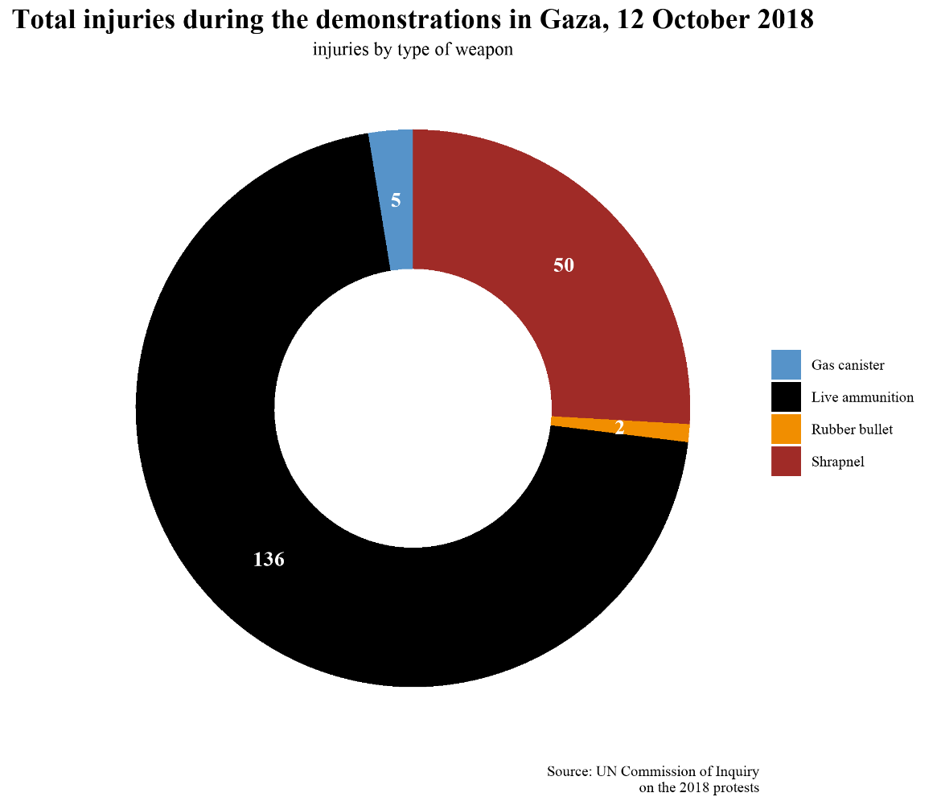
Demonstration site East of El Bureij Refugee Camp, Central Gaza
- At the demonstration site east of El Bureij Refugee Camp, between 4.30 and 5.15 p.m., a group of demonstrators made a hole in the separation fence. The ISF claimed that the demonstrators detonated an IED at the fence, setting part of the fence on fire and enabling a group of demonstrators to approach an ISF sniper post in Israeli territory. The Commission has not found information to suggest that demonstrators detonated an IED at the fence on 12 October 2018. However, multiple videos reviewed by the Commission show demonstrators cutting the security fence with what appear to be axes, machetes, and other tools. Numerous demonstrators crossed into the Israeli side, with some also heading in the direction of the sand berms. Approximately 20 demonstrators climbed through the fence onto the Israeli side near cement cubes and ISF positioned on berms. ISF responded with live fire, causing most of the group to retreat back to Gaza territory.
- The Commission considers that the following cases are emblematic of the ISF’s response to the demonstrations east of El Bureij Refugee Camp on 12 October.
- 5.25 p.m., killing of Ahmad Abu Na’im (17)
Ahmad Abu Na’im was among the group of demonstrators from the incident described above who cut the separation fence. While most retreated to the Gaza side once the ISF responded, Ahmad, from the Nuseirat refugee camp, remained on the Israeli side with at least one other demonstrator. Israeli forces allege that Ahmad approached an Israeli soldier with a knife, and was then shot by Israeli forces at point-blank range. Eyewitness accounts taken by the Commission are contradictory. According to one, a group of armed Israeli soldiers approached Ahmad, who was on the ground, unarmed; when he reached up to an Israeli soldier’s arm, the soldier shot him multiple times in the chest and a female witness who was nearby was shot in the leg. Another witness alleged that Ahmad was shot while he was running away. Yet another witness told the Commission that Ahmad had his hands raised in the air when an ISF soldier shot him, causing him to fall down. According to this witness, two other soldiers appeared and shot Ahmad multiple times while he lay on the ground.
Given these different accounts, the Commission was unable to make a finding as to whether Ahmed constituted an imminent threat to life or serious injury to Israeli forces when he was shot.
- Following Ahmed’s killing, dozens of demonstrators tried to breach the security fence and the ISF responded with heavy gunfire, killing the following three Palestinians, and injuring many others.
- 5.25 p.m., killing of Ahmad El Taweel (22)
Ahmad El Taweel was a day labourer from El Nusseirat Refugee Camp. He had previously been shot in the right leg on 30 March at the demonstration site east of El Bureij. He attended the demonstration again on 12 October, with his 14-year-old nephew. The ISF killed him with a shot to the chest. He died instantly.
The Commission finds that Ahmad did not pose an imminent threat of death or serious injury to ISF soldiers at the time he was shot.
- 5.25 p.m., killing of Mohammad Ismail (29)
Mohammad Ismail was among those killed when the group crossed the separation fence and were fired upon by the ISF while on the Israeli side. According to an eyewitness, he had run back to the Gaza side of the fence when he was shot. He was killed about 50 m from the fence as he lay on the ground among a group of people. He was lying down, the bullet entered his back lower side and exited near his shoulder. He died the same day.
The Commission finds that Mohammad did not pose an imminent threat of death or serious injury to ISF soldiers at the time he was shot.
- 5.25 p.m., killing of Abdullah El Daghmah (25)
According to an eyewitness who crossed the separation fence with Abdullah, he had pushed a tyre through the hole in the fence. Demonstrators set fire to tyres on the Israeli side, creating thick black smoke. Abdullah was taking selfie photographs of himself on his telephone. The witness lost sight of him and a few minutes later heard a series of gunshots. Immediately he saw some men shouting “martyr!” and carrying Abdullah’s body towards an ambulance. According to another eyewitness, an Israeli soldier had ordered Abdullah to return to the Gaza side of the fence and he had refused. The soldier then shot Abdullah as he turned towards the fence. Abdullah was shot in the abdomen at approximately 5.25 p.m. He was pronounced dead at Al Aqsa hosptial the same day.
The Commission finds that, despite minor discrepancies in accounts of the incident, Abdullah did not pose an imminent threat of death or serious injury to ISF soldiers at the time he was shot.
- In addition to the four demonstrators killed east of Al Bureij, three others were killed east of Gaza city and east of Rafah southern Gaza Strip on 12 October. That day some 154 demonstrators were injured with live ammunition, including a number of children.
Demonstration site Abu Safia, North Gaza
- In North Gaza, the demonstrations were held at the main site, the Abu Safia area, east of Jabalia. Eyewitnesses and video footage posted on the official website of the HNC show scores of civilians walking calmly towards the demonstration site. Most people gathered either in the tent area or stood or sat on high ground area around 700 meters from the separation fence. A third group of demonstrators assembled closer to the separation fence. On occasion, the smoke from burning tyres was so thick that the separation fence could not be seen.
- Numerous young Palestinians slung stones at ISF positions with slingshots. Some managed to breach the barbed wire coils and walked triumphantly but calmly through the opening towards the main fence. The ISF used live fire and tear gas against the demonstrators. A large group of young people managed to reach the main fence, and one managed to climb part of it.
Demonstration site Makala, Gaza City
- At the demonstration site in Gaza City, the ISF shot and killed two people and injured dozens with live ammunition, among them four women and a 6-year-old boy and two 14-year old boys.
- The Commission considers that the following cases are emblematic of the ISF’s response to the demonstrations in Malaka on 12 October.
- 5.50 p.m., killing of Afifi Mahmoud Afifi (18)
Afifi Mahmoud Afifi was an 18-year-old resident of Gaza City. The ISF shot him in the chest while he was with dozens of young people near the barbed wire coils, some setting fire to tyres, others throwing stones at Israeli soldiers. Together with a friend, Afifi walked towards the barbed wire coils. Around 6 p.m., Afifi’s friend saw five men falling to the ground. Shortly thereafter, he heard another shot and saw Afifi falling down next to him. The Commission’s investigation found that at the time of his death, Afifi was standing in the midst of a crowd of protestors approximately 30 m from the separation fence. Smoke from burning tyres was thick. On the stretcher, a bullet hole was visible in his upper chest.
The Commission finds that Afifi did not pose an imminent threat of death or serious injury to the ISF at the moment he was shot.
Demonstration site Rafah
- At the demonstration site in Rafah, 27 Palestinians were injured with shrapnel or live ammunition, among them two women and a 6-year-old boy. A video reviewed by the Commission showed a group of young Palestinians sitting on a small earth hill near the separation fence shouting, waving a Palestinian flag, surrounded by smoke from burning tyres. Sizable numbers of people are seen close to the separation fence. In another sequence, demonstrators pulled away a section of barbed wire.
- The Commission considers that the following cases are emblematic of the ISF’s response to the demonstrations in Rafah on 12 October.
- 5.35 p.m., killing of Tamer Abu Armana (21)
Tamer Abu Armana was a 21-year-old from Rafah. The ISF shot him in the neck with live ammunition. Just before Tamer was shot, he was helping drag a burning old refrigerator that was releasing dark smoke. Visibility around Tamer was not good due to the smoke. Corroborated video of the moment after he was hit shows him unconscious with blood all over his head immediately after he is shot. Tamer was pronounced dead on arrival at hospital.
According to his medical report, the cause of death was complication of lacerations of neck structures resulting in haemorrhagic shock, due to a bullet shot to his neck.
The Commission finds that Tamer did not pose an imminent threat of death or serious injury to ISF soldiers when he was shot.
- Afternoon, injured woman (36)
In the late afternoon, the ISF soldiers shot a 36-year-old woman in her right hand at the Rafah protest site, while she was burning tyres with a group of men and women close to the fence. At the time she was shot, heavy smoke was emanating from the tyres. The woman told the Commission that she burned tyres to protect men who were trying to cut the fences.
The Commission finds that she did not pose an imminent threat of death or serious injury to ISF soldiers when she was shot.
F. 13 October – 31 December 2018
- The demonstrations continued each Friday at the five demonstration sites throughout 2018, as well on other days at the Zikim beach site in North Gaza, during this third phase of the demonstrations (see context section).
- 15 October, killing of Sadam Shlash (28), North Gaza
Sadam Shlash from Jabalia camp, was shot and killed during the Maritime demonstrations in North Gaza, near the Zikim area. At around 3.30 p.m. on 15 October, he went to the sea shore of Beit Lahia, opposite of the Israeli military site of Zikim, to participate in the protests. At around 5.15 p.m., Sadam and other demonstrators were throwing stones at the soldiers from the beach, while live bullets were fired at them. Sadam fell to the ground. Some of the young men immediately carried him away. Sadam was bleeding from his upper right thigh and the pelvic area, and he said, "Help me, my injury is serious". He was carried with the help of some young men and a paramedic on stretchers to the ambulance where they transferred him to the hospital where he died later that evening.
The Commission finds that Sadam did not pose an imminent threat of death or serious injury to ISF soldiers when she was shot.

VIII. Protected Groups
A. Children
- Between 30 March and 31 December 2018, the ISF killed 47 children, of whom 34 were killed in the course of the Great March of Return demonstrations in Gaza.
- 32 of these children were killed by live ammunition. In addition, two children, 15-year-old Jamal Afana and 15-year-old Ahmad Abu Habel died after being hit in the head with gas canisters.
- The youngest child who was killed during the demonstrations, Ahmad Yasser Sabri Abu Abed, was four years old. On 7 December, he died as a result of injuries caused by fragmentation from live ammunition fired into a crowd of demonstrators approximately 250 m from the separation fence.
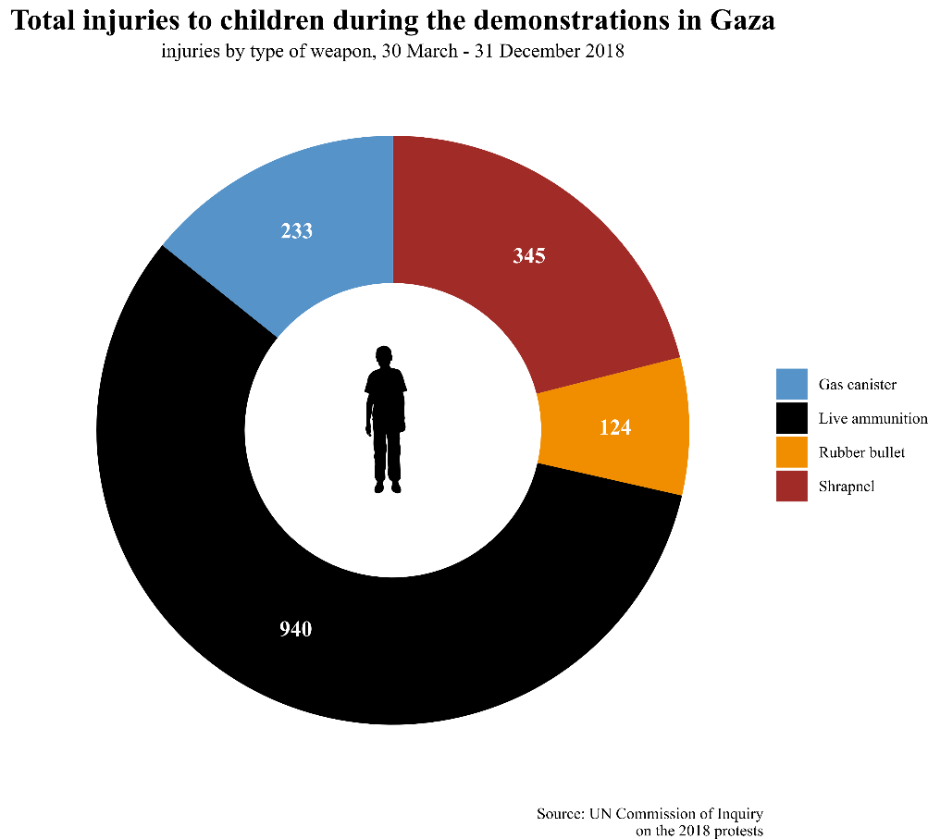
- The Commission investigated the following emblematic cases of children killed during the demonstrations:
- Ibrahim Abu Shaar (17)
On 30 March, at approximately 3 p.m., the ISF shot Ibrahim in the back of the head as he walked away from the barbed wire coils towards the Camp of Return, south of the Red Tower in Rafah. Ibrahim was approximately 70 - 100 m from the separation fence. Due to his large head wound Ibrahim died almost instantly. Prior to being shot, Ibrahim and his companion had been throwing stones at ISF soldiers on the Israeli side of the fence. According to an eyewitness, ISF soldiers had spoken to the boys in Arabic over a loudspeaker, saying: “Go home, don’t listen to Hamas.” At the time that he was shot, visibility was good.
The Commission finds that Ibrahim did not pose an imminent threat of death or serious injury to ISF soldiers when he was shot.
- Ahmad Al Aayidi (17)
Also on 30 March, the ISF shot 17-year-old Ahmad Al Aayidi in the head as he walked away from the separation fence towards the Camp of Return at the demonstration site east of El Bureij in central Gaza. According to an eye witness, Ahmad and his friend arrived at the demonstration site at approximately 12.30 p.m. Six Israeli soldiers were positioned on the other side of the fence, as well as a military utility vehicle that was firing tear gas at demonstrators. At one point, Ahmad and the witness stopped on Jakkar Road, next to the ambulances and 300 m away from the separation fence. By around 12.45 p.m., the witness and Ahmad began to walk away from the fence towards the Camp of Return. The ISF then shot Ahmad when he was 400-500 m from the fence. According to the eye witness, Ahmad was holding his hand and was shot while mid-sentence talking to him. Ahmad was evacuated to Al Aqsa, then Al Shifa Hospital, then 12 days later transferred to hospital in Ramallah. He died of his injuries on 5 August.
The Commission finds that Ahmad did not pose an imminent threat of death or serious injury to ISF soldiers when he was shot.
- Hussein Madi (13)
The following week, on 6 April, the ISF shot 13-year-old Hussein Madi in the abdomen at the Malaka demonstration site east of Gaza City. According to an eyewitness, at approximately 2-3 p.m., Hussein had crawled on his stomach up to the rolls of barbed wire, which had been cut. He had a rope with him, and he tied the rope onto the barbed wire, then fled back behind a tree near the water reservoir. Although he was shot at while he ran, he was not hit. He reportedly waited behind the tree for a few minutes, and when he came out, he was shot immediately with a single bullet. According to testimony, there was no warning before the shots came.
The Commission finds that Hussein did not pose an imminent threat of death or serious injury to ISF soldiers when he was shot.
- Alaa El Zamli (15)
Also on 6 April, at approximately 6.30 p.m., the ISF shot 15-year-old Alaa Yihya Ismael El Zamli from Al Shaboura camp in Rafah in the neck with live ammunition as he stood among a crowd approximately 80 m from the separation fence. According to an eyewitness, the ISF used a laser sight to locate and target Alaa because of dense smoke and limited visibility.

The Commission finds that Alaa did not pose an imminent threat of death or serious injury to ISF soldiers when he was shot.
- Mohammad Ayoub (14)
On 20 April, the ISF shot 14-year-old Mohammad Ayoub from Jabalia Refugee Camp in the head at the demonstration site east of Jabalia. Mohammad was at least 200 m from the separation fence when the ISF shot him. A video of Mohammad’s killing circulated on social media, leading the UN Special Coordinator for the Middle East Peace Process, Nickolay Mladenov, and the European Union to call for the Israeli authorities to investigate the shooting.

In response, the ISF stated that Mohammad was killed while trying to damage the security fence; however, it is clear from the video that he was far from the separation fence when he was shot. Even if Mohammad had been previously trying to damage the security fence, that act alone would not pose an imminent threat to life or serious injury to ISF soldiers.

The Commission finds that Mohammad did not pose an imminent threat of death or serious injury to ISF soldiers when he was shot.
- Izzedine Samak (13)
Izzedine Samak was a 13-year-old from El Bureij Refugee Camp. He died after the ISF shot him in the abdomen on 14 May, around 10 a.m. According to an eye witness, Izzedine and some friends had been throwing stones, including by sling, at a group of around ten ISF soldiers 150 m away, on the other side of the separation fence. Once they ran out of stones, Izzedine and his companions went back towards Jakkar Road and filled a sack with more stones from a quarry. On their way back to the demonstration area, they stopped to rest about 150 m from the fence and 30 - 40 m from Jakkar Road. The ISF soldiers shot Izzedine as he sat on the sack with his back to the fence. Izzedine slumped over and fell off the sack, bleeding profusely. He was admitted to the hospital in a critical condition and died during emergency surgery.
The Commission finds that Izzedine did not pose an imminent threat of death or serious injury to the ISF soldiers when he was shot.
- Wisal Sheikh-Khalil (14)
Wisal Sheikh-Khalil was a 14-year-old girl from Al Maghazi Refugee Camp. The ISF shot her in the head in the early afternoon of 14 May when she was approximately 100 m from the separation fence. The gunshot entered the right side of her skull and exited from the left side of her skull. She died instantly.
According to an eyewitness, Wisal had approached the separation fence several times. On one occasion, she laid a Palestinian flag on the ground in front of the fence and knelt to pray before hanging the flag on the fence. She carried on with this activity even though soldiers told her to retreat over a loudspeaker and fired warning shots. On another occasion on the same day, she approached the fence with wire cutters before retreating as a result of tear gas and more warning shots from ISF soldiers.
Immediately before she was shot, Wisal had requested her companion’s wire cutters because she wanted to cut the fence. Wisal and her companion had frequently approached the fence together in the past, throwing stones at ISF soldiers and burning tyres.
On the day the ISF shot Wisal, she was at the front of a group of approximately 100 young people, mostly male, who were throwing stones at soldiers, taunting them with slogans and burning tyres to obstruct their field of view. Before shooting Wisal in the head, the soldiers had been consistently firing tear gas and live ammunition aimed at the demonstrators’ lower limbs in an effort to deter them from approaching the fence. Although the protesters would retreat on occasion, they continued approaching the fence throughout the day.
The Commission finds that Wisal did not pose an imminent threat of death or serious injury to ISF soldiers at the time that she was shot.
- On 14 May, the ISF also killed:
- Said al-Kheir (15), gunshot to the head
- Saadi Abu Salah (16), gunshot to the abdomen
- Ibrahim al-Zarqa (17), gunshot to the head
- Talal Matar (16), gunshot to the head
- Mahmoud al-Gharabli (15), gunshot to the head
- The Commission investigated each of these cases and found that none of these children posed an imminent threat of death or injury to ISF soldiers when they were shot (see section on 14 May).
- Bilal Ashram (17)
On 15 May, the ISF shot 17-year-old Bilal Ashram from El Nusseirat Refugee Camp twice as he was running away from the separation fence towards the Camp of Return at the demonstration site east of El Bureij. According to an eyewitness, the first shot hit Bilal in the leg, causing him to fall forward. As he struggled on the ground, ISF soldiers shot him a second time in the chest. Bilal was pronounced dead on arrival at the hospital. Prior to being shot, Bilal had been throwing stones at ISF soldiers. The ISF soldiers who shot Bilal were positioned on berms overlooking the demonstration area. Bilal was easily visible as he was running away from the separation fence.

The Commission finds that Bilal did not pose an imminent threat of death or serious injury to ISF soldiers when he was shot.
- Haytham Jamal (14)
On 8 June, the ISF shot 14-year-old Haytham Jamal in the abdomen at the demonstration site in east Rafah. He was killed with a single shot as he stood in a crowd watching the ISF fire tear gas at another group of demonstrators.
The Commission finds that Haytham did not pose an imminent threat of death or serious injury to ISF soldiers when he was shot.
- Yasser Abu Naja (11)
On 29 June, the ISF killed 11-year-old Yasser Abu Naja with a shot to the head in Khuzaa, Khan Younis District at around 6.30 p.m. At the time of the shooting, he was hiding with his two friends behind a damaged bin approximately 100 - 200 m from the separation fence and 70 m away from Jakkar Road. The children had been chanting slogans at the ISF. According to one source, visibility was clear. Forensic analysis conducted by the Commission suggests that the victim was shot with one high-velocity bullet from a near distance.
One source reported that Yasser was shot during an “attempt to sabotage the barbed wire coils”. The source cites photographs of a young boy near the wired fence, but the Commission is not satisfied that the photographs are of Yasser Abu Al-Naja as his face cannot be recognizable and the clothing worn by the child do not match the ones seen on his resuscitation table. Other eyewitnesses interviewed by the Commission mentioned that the child was hiding with his friends behind an old bin and not attempting to cut the fence.
The Commission finds that even if Yasser had been causing damage to the barbed wire coils that would not have in itself posed an imminent threat of death or serious injury to the ISF at the time that he was shot.
- Othman Hilles (14)
On 13 July, the ISF killed 14-year-old Othman Hilles from Shuja’iya with a shot to the chest as he attempted to climb the separation fence at the Malaka demonstration east of Gaza City.
A video of the incident showed a group of girls and one other boy waving Palestinian flags. No one visible in the video is slinging rocks or burning tyres, indeed no one is holding anything apart from the flags. Visibility was generally good, although with some smoke on occasion. Othman was unarmed and not carrying anything. He was clearly visible in a white shirt and had been walking back and forth in front of the fence, touching it on occasion. At one point, he took a step up onto the fence. When he took a second step up, he was shot in the chest and fell back off the fence. He died shortly thereafter in hospital. A video of the incident can be viewed on the Commission’s website.

The Commission finds that Othman did not pose an imminent threat of death or serious injury to ISF soldiers when he was shot. The Israeli Military Attorney General (MAG) ordered a criminal investigation into Othman’s death in light of an apparent breach of the Israeli Rules of Engagement. The Commission asked for, but did not receive, an answer regarding the outcome of the investigation.
- Majdi al-Satari (11)
Majdi al-Satari was an 11-year-old child from Al-Shabourah Refugee Camp, southern Gaza Strip. On 27 July, he was shot in the head by live ammunition by an ISF sharpshooter while attending the protest east of al-Shawkah village, east of Rafah.
Majdi died of severe brain lacerations while he was in the ambulance that transferred him to the hospital. According to one witness, it was the first time Majdi participated in the demonstrations.
On the evening that Majdi was shot, thousands took part in the protests. On the Israeli side of the security fence there were small sand berms on which ISF soldiers were posted and a number of military vehicles. On the Palestinian side there were young men setting tyres on fire and throwing stones, some of them were close to the fence. According to one eyewitness, at approximately 6.30 p.m., young men approached the fence, and began cutting part of it and pulling it away. The ISF started shooting. A source said that there were two sniper shots, one hit the leg of one of the persons cutting the fence, and the other shot hit Majdi’s head. Majdi was shot while standing and observing these events about 100 m away from the security fence.
The Commission finds that Majdi did not pose an imminent threat of death or serious injury to ISF soldiers when he was shot.
- Mo’min Hams (16)
On 27 July, Mo’min Hams, a 16-year-old resident of Rafah, went to the protest site with some relatives. Some demonstrators approached the fence, burning tyres and throwing stones and according to one source, cutting and pulling the fence. On the Israeli side, the ISF were stationed near the communications tower and one or two army utility vehicles were visible near the separation fence. At approximately 5.30 p.m., the ISF began firing live ammunition at this group of protestors, as they approached the fence and then moved away. Mo’min was standing amongst this group.
According to one eyewitness, Mo’min stayed in his position holding a Palestinian flag. According to other sources, Mo’min was with a number of young men cutting the barbed wire coils and burning tyres. The ISF opened fire towards the men and boys and Mo’min fell to the ground. The ISF shot Mo’min with live ammunition in the upper part of the chest near his right shoulder. He died the following day, after haemorrhaging and damage to internal organs of the chest.
The Commission has not been able to determine whether Mo’min was merely standing in place, holding a Palestinian flag, or cutting the barbed wire coils at the time he was shot. However, even if Mo’min had been cutting the barbed wire coils when he was shot, this act in itself would not have entailed that Mo’min posed a threat of death or serious injury to the ISF at that time.
The Commission finds that Mo’min did not pose an imminent threat of death or serious injury to ISF soldiers when he was shot.
- Muath Souri (15)
Muath Souri was a 15-year-old from El Nuseirat Refugee Camp. In the early evening of 3 August, ISF fired live ammunition towards demonstrators who had congregated at Um Husniya hill, approximately 300 m south of the main demonstration site east of El Bureij. According to an eyewitness, demonstrators had cut the barbed wire coils and moved several metres towards the separation fence. An Israeli armoured vehicle arrived and fired shots at them. At around 7.25 p.m. the eyewitness saw Muath lying injured on the ground at the foot of the hill, approximately 150 m from the separation fence. The witness evacuated him along with others. Muath had been shot in the lower abdomen with live ammunition. He was taken to Al Aqsa Hospital and died of his injuries on 4 August.
The Commission has not been able to determine whether Muath was involved with efforts to cut the barbed wire coils. Even so, the Commission does not find that Muath posed an imminent threat of death or serious injury to the ISF at the moment he was shot.
- Suhaib Abu Kashef (16)
The ISF shot 16-year-old Suhaib Abu Kashef in the neck with live ammunition at the demonstrations site in Khan Younis on 3 August where he had crossed the barbed wire together with other youths. He was hurling stones at the ISF from a distance of approximately 20 m from the separation fence. The ISF opened heavy fire on the group, striking Suhaib. Suhaib was transferred to Al-Ahli hospital in Hebron where he remained for two weeks. He returned to Gaza and was admitted to the intensive care unit at the European hospital, but was pronounced dead on 15 September.

The Commission finds that Suhaib did not pose an imminent threat of death or serious injury to ISF soldiers when he was shot.
- Bilal Khafaja (16)
At around 5 p.m. on 7 September, at the demonstration site east of Rafah, the ISF shot 16-year-old Bilal Khafaja in the chest as he was approximately 300 m from the separation fence, walking towards it. He died from his injuries the same day.
According to an eyewitness, there was a heavy presence of ISF on the Israeli side of the fence on the afternoon that Bilal was shot. A group of protestors had been burning tyres, throwing rocks and launching incendiary kites near the fence, which started a fire in an ISF communication tower. ISF vehicles responded by firing live ammunition and tear gas towards the demonstrators. Photographs show heavy smoke fire and tear gas that afternoon.
While the demonstrations were certainly chaotic and threatening on the afternoon of 7 September, the Commission does not find that Bilal posed an imminent threat of death or serious injury to ISF soldiers when he was shot.
- Ahmad Abu Tyoor (16)
On 7 September, ISF soldiers shot 16-year-old Ahmad Abu Tyoor in the thigh as he danced a traditional Palestinian dance alone with his hands in the air, around 10-15 m from the separation fence. The bullet severed his femoral artery and he died of his wounds the following day. A video of the incident can be viewed on the Commission’s website.
According to an eyewitness, Ahmad was well-known to the ISF soldiers since he regularly attended the demonstrations and burned tyres. According to the same eyewitness, prior to dancing in front of them, Ahmad had thrown stones at the ISF, although none had reached the ISF position.
The Commission finds that Ahmad did not pose an imminent threat of death or serious injury to ISF at the time he was shot.
In September, the Israeli authorities stated that an investigation into the killings of Bilal and Ahmad would be conducted (see the below section on accountability).
- Mohammad Hoom (14)
On 28 September, ISF soldiers shot Mohammad Hoom, a 14-year-old boy from El Bureij camp, in the side of his chest as he was running away from the separation fence. The bullet impacted his heart and he died on the way to the hospital.
According to an eyewitness, Mohammad had earlier joined a large group of demonstrators that was trying to rescue a smaller group of demonstrators pinned down by heavy ISF gunfire about ten metres from the separation fence near Wadi Abu Qatroon. ISF soldiers opened fire on Mohammad’s group as it approached the fence. An ISF vehicle mounted with a machine gun also came towards Mohammad’s group and began to fire at them indiscriminately. In addition, approximately ten ISF snipers positioned themselves facing Mohammad’s group. Mohammad and others began to run away from the fence in an attempt to escape the heavy ISF gunfire.
Mohammad was approximately 250 m from the fence, fleeing towards Jakkar Road, when ISF soldiers shot him. Mohammad had been carrying a bag of seeds when the ISF shot him.
The Commission finds that Mohammad did not pose an imminent threat of death or serious injury to ISF soldiers when he was shot.
- Nasser Mosabeh (11)
On 28 September at approximately 5 p.m., the ISF shot 11-year-old Nasser Mosabeh in the back of the head with live ammunition at the demonstration site in Khan Younis. Nasser was transferred to the Gaza European Hospital where he was declared dead.
On that day, Nasser had been helping his two volunteer paramedic sisters treating injured people at the protest site towards Jakkar Road. He would bring saline water bottles to paramedics and would keep his distance to 150 m from the fence. Protestors burned tyres approximately 70-100 m from the fence impairing visibility for the ISF soldiers. When the victim was shot, he was under a tree, 250 m from the fence near Jakkar Road. ISF soldiers fired two gunshots and the child was found lying on the ground seconds after the gunshots were heard. Nasser was lying three meters away from another injured man. The bullet entered the right side of his head behind his ear and parts of his skull and brain were found close to his body. The Commission analysed video and photographic footage showing Nasser’s injury at the back left side of his head as he was surrounded by paramedics attempting resuscitation.
The Commission finds that Nasser did not pose an imminent threat of death or serious injury to ISF soldiers when he was shot.
- Fares Sirsawi (13)
Fares Sirsawi was a 13-year-old resident of Gaza City. He was shot in the chest on 5 October while at the demonstration in the east of Gaza City. The Commission found that the boy was with other youth bringing tyres to the fence. While dragging a tyre to a point approximately 10 m from the fence he was hit with a single bullet in the upper chest. He died from a severe haemorrhage the same day at the Al-Shifa hospital.
The Commission finds that Fares did not pose an imminent threat of death or serious injury to ISF soldiers when he was shot.
- Mohammad Jahjouh (16)
On 21 December, 16-year-old Mohammad was standing in a large group of demonstrators between 100 and 300 m from the barbed wire coils at the protest site in Gaza City. Other demonstrators were throwing stones. The ISF launched tear gas canisters towards the demonstrators and occasionally shot at them. At approximately 4 p.m., the ISF shot Mohammad in the back while he was standing 150 m from the fence and 80 m from the group throwing stones.
The Commission finds that Mohammad did not pose an imminent threat of death or serious injury to ISF soldiers when he was shot.
- The Commission found that Israeli security forces used lethal force against children who did not pose an imminent threat of death or serious injury to its soldiers. Four of the children were shot as they walked or ran away from the fence.
- Several children were recognizable as such when they were shot. The Commission finds reasonable grounds to believe that Israeli snipers shot them intentionally, knowing that they were children.
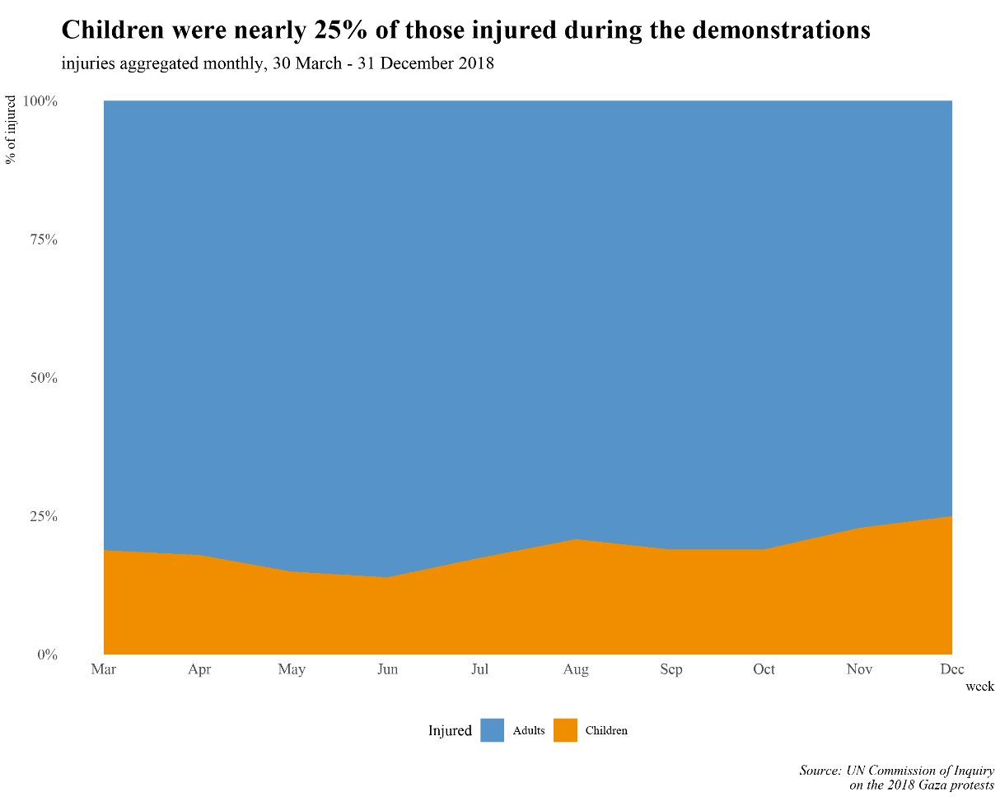
B. Medical personnel
- The Occupied Palestinian Territory is one of the most dangerous places in the world for healthcare workers. According to WHO, between 30 March and 31 December, the ISF killed three health workers and injured 560 in 357 recorded incidents against health staff and facilities. WHO data also shows that 84 ambulances and five other health vehicles were damaged, as well as three health facilities.
- On average over the course of the demonstrations, ISF forces have injured more than two healthcare workers per day and damaged nearly eleven ambulances and health care vehicles per month.

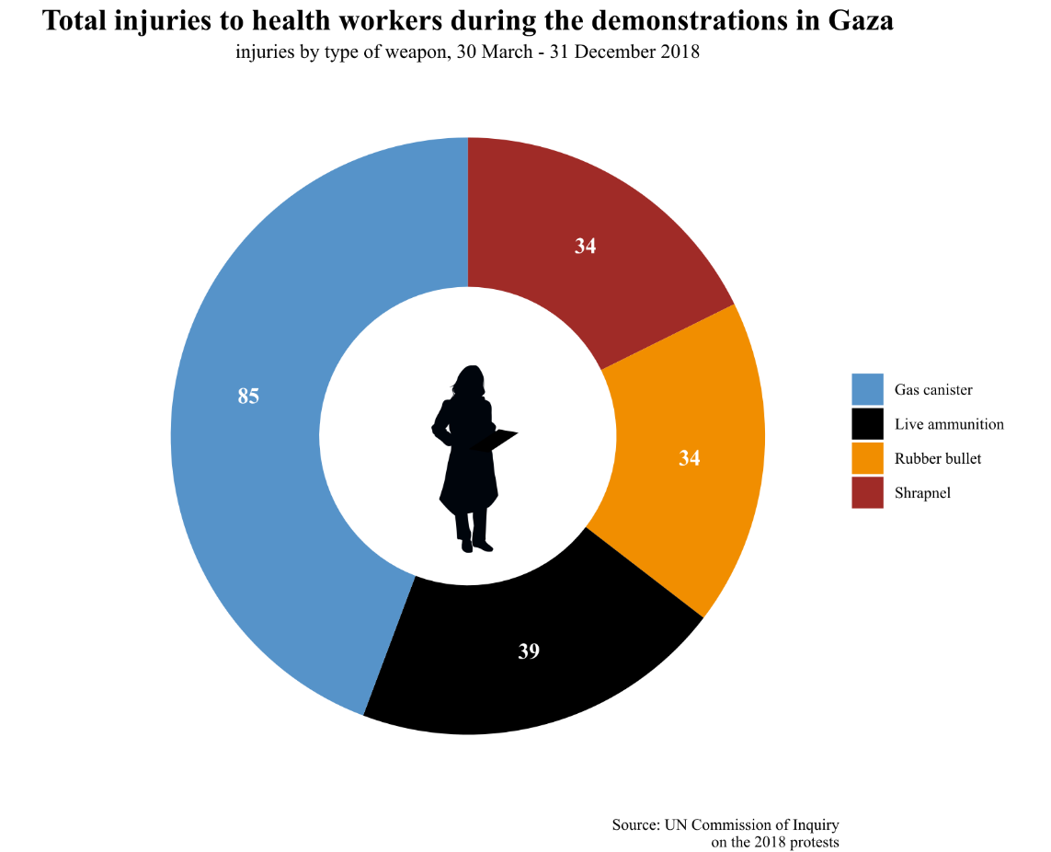
- A study conducted by Médecins du Monde (MdM) indicates at the very least a disregard for the protection of health workers in Gaza. 95 per cent of healthcare workers interviewed by MdM who had been working at the demonstrations between 30 March and 15 May felt they had been working in a wholly unsafe environment. 70 per cent of health workers interviewed by MdM who were at the demonstration sites between 30 March and 15 May indicated that they had been the direct victim of an attack during this ten-week period; 93 per cent had either been a direct or indirect victim or witness to an attack on other healthcare workers. Although many healthcare workers were injured within 100 m of the fence, at least four were injured 700 m from the fence.
- The Commission interviewed several healthcare workers who witnessed the killing of paramedics or were injured themselves by live ammunition, tear gas canisters and bullet fragmentation during the demonstrations between 30 March and 31 December. They repeatedly expressed their incomprehension at being injured in the course of their duties.
- The Commission interviewed witnesses to the killings of three clearly-marked health workers:
- Musa Abu Hassainen (35)
Musa Abu Hassainen was a 35-year-old Civil Defense paramedic. ISF soldiers killed him with a shot to the chest at approximately 1 p.m. on 14 May while he was wearing a high-visibility Civil Defense vest. Shortly before he was shot, he had been treating injured demonstrators north of the Al-Shuhada cemetery, behind the sewage treatment plant east of Jabalia town. He was approximately 250-300 m from the fence when ISF soldiers shot him.
ISF soldiers shot Musa when they directed heavy gunfire and shelling towards the demonstrators Musa and his colleagues were accompanying. The soldiers were positioned behind sand hills on the other side of the separation fence. The firing was so intense that surviving demonstrators and other members of Musa’s medical team were unable to promptly evacuate several of the deceased and wounded. Musa died on the way the hospital.
Musa was clearly marked as a Civil Defense paramedic when he was shot. The Commission finds that Musa did not pose an imminent threat of death or serious injury to ISF soldiers when he was shot.
- Razan Najjar (20)
Razan Najjar was a 20-year-old volunteer paramedic with the Palestinian Medical Relief Society (PMRS) from Khan Younis. She was shot in the chest on 1 June at approximately 6.30 p.m. at the Khuzaa protest site east of Khan Younis. On 1 June from 3 p.m., hundreds of people were present at a considerable distance from the separation fence. At around 3:30 p.m., the ISF began firing tear gas canisters and rubber bullets to disperse demonstrators. A number of demonstrators were reportedly injured, including one rescued by Razan. The demonstrations intensified with demonstrators throwing stones, including by using slingshots.
Shortly before she was shot, Razan had gone closer to the fence with three other paramedic colleagues to provide medical assistance to two injured protestors. They held their hands up in the air to show the ISF they meant no harm. The soldiers did not lower their weapons.
At the time she was shot, Razan was wearing a white vest clearly marking her as a paramedic. She was standing along with other volunteer paramedics approximately 20 to 50 meters from the barbed wire coils or 110 m from where the ISF soldiers were stationed on the other side when she was hit. Visibility was good when she was shot. The bullet hit her in the chest and exited from her back. A New York Times investigation found that one bullet fragmented into pieces, killing her and injuring two other paramedics. Eyewitnesses interviewed by the Commission stated that she was killed by a single shot. The Forensic Report issued by the Palestinian National Authority also indicated she was shot by a single bullet.
On 28 October, the Israeli Military Attorney General (MAG) announced that it launched an investigation into the incident (see the section on accountability).
The Commission finds that Razan did not pose an imminent threat of death or serious injury to the ISF when she was shot.
- Abed Abdullah Al Qotati (22)
Abed Abdullah Al Qotati was a 22-year-old volunteer paramedic from Tal El Sultan in the southern Gaza Strip. ISF soldiers shot him in the chest in Rafah during the afternoon of 10 August as he was tending to an injured demonstrator near the separation fence. Abdullah was wearing a white paramedic jacket and carrying a red first-aid kit when the ISF soldiers shot him. According to one witness, he had his hand in the air when he was shot. He died of bleeding and lacerations to his thoracic organs.
Although there was some smoke from the burning tyres, visibility around Abdullah was good. According to the eye witnesses closest to him at the time, Abdullah was 20-30 m away from the fence when he was shot.
Abdullah was clearly marked as a paramedic, and was administering first aid to an injured demonstrator. The Commission finds that Abdullah did not pose an imminent threat of death or serious injury to the ISF when he was shot.
- The Commission interviewed a number of health workers and paramedics who were injured by live ammunition in the course of their duties.
- Female paramedic (21)
In one notable case, the ISF shot a 21-year-old female volunteer paramedic in the chest while she was wearing her white medical vest, clearly identifying her as a paramedic. The ISF shot her in Rafah in August 2018.
She described being shot in the chest by the ISF as she and other paramedics ran towards a group of injured demonstrators in Rafah:
…we were moving towards the area where people had been shot, closer to the fence. At that moment I saw the Red Tower and there were about 6-7 armed soldiers on the tower. I was still moving forward and from time to time I would look up at them. Then I heard a gunshot. I continued to run… I felt dizzy and I fell on my knees… I had been shot in the chest.
An ambulance driver witnessed her shooting. He told the Commission:
S[he] was wearing her white paramedic robe and carrying a first aid kit bag. There was continuous shooting at the fence area. We were in a clear area with no demonstrators around. Suddenly [she] fell on the ground… she was bleeding heavily. I put her in the ambulance and I saw the bullet entry point in the chest. I realized she was shot.
The victim was clearly marked as a paramedic and was approaching injured demonstrators so that she could assist them when she was shot. The Commission finds that she did not pose an imminent threat of death or serious injury to ISF soldiers when she was shot.
- Volunteer paramedic (35)
On 6 April, the ISF shot a volunteer paramedic in the back of the leg with live ammunition, approximately 400 m from the fence in Rafah. He described the situation:
I evacuated the wounded person who was convulsing from gas inhalation. We were carrying him on the stretcher, I had my back to the fence, we were walking towards the ambulance… the soldiers can see that I am no threat, that I am in my paramedic vest, helping the injured. The back of my vest has the logo on it. I was clearly visible. My colleague entered the ambulance and was pulling the stretcher, I was outside the ambulance pushing the stretcher into the ambulance when I was shot. As far as I know it was a direct shot to my leg, not a ricochet... There was no smoke at the time that I was shot, I was clearly visible.
The injured health worker was clearly marked as a paramedic and was loading an injured demonstrator into an ambulance when he was shot. The Commission finds that he did not pose an imminent threat of death or serious injury to ISF soldiers when he was shot.
- Volunteer paramedic (38)
A week later, the ISF shot another paramedic and ambulance driver in the back of his leg as he carried an empty stretcher at the demonstration site in Rafah on 13 April. At the time that he was shot he was walking alone, approximately 200 m from the separation fence. He was clearly marked in his paramedic uniform and visibility was clear.
The Commission finds that he did not pose an imminent threat of death or serious injury to ISF soldiers when he was shot.
- Dr. Tarek Loubani (37)
Tarek Loubani is a Canadian-Palestinian physician. At approximately 12 p.m. on 14 May at the protest site east of Gaza City, the ISF shot him as he stood among a group of paramedics wearing his hospital uniform. He was shot with one bullet that passed through both legs. Visibility was clear. There were no demonstrators near the group of medics and there was no shooting from the ISF either immediately before or after he was shot. In an interview to CBC Radio he stated:
It's unfortunate because we, as a medical team, always hope for and expect some protection. We're not there politically. We just want to make sure that if people get into trouble, we're there to help them… My observation is that I was clearly marked and I was shot… I don't feel I was caught in crossfire, but I can't speak to the intentions of the sniper who shot me.
The Commission finds that Dr. Loubani did not pose an imminent threat of death or serious injury to ISF soldiers when he was shot.
- Paramedic (41)
On 19 October, the ISF shot a paramedic at the demonstration site in Khuzaa, Khan Younis. He was shot in the back of his leg as he treated an injured demonstrator near to Jakkar Road. He was standing side-on to the fence and the bullet passed through his right leg: “I saw my right leg explode. I fell on the ground.” According to him, an ISF sniper stationed on a berm shot him. Visibility was good and he was clearly marked as a paramedic, wearing a white coat and a high-visibility vest with a medical logo. His leg bone became infected and is at risk of amputation.
The paramedic was treating an injured demonstrator when he was shot. The Commission finds that he did not pose an imminent threat of death or serious injury to ISF soldiers when he was shot.
- Based on numerous interviews with victims and witnesses and corroboration of video footage in a number of instances, the Commission found reasonable grounds to believe that Israeli snipers intentionally shot health workers, despite seeing that they were clearly marked as such.
C. Journalists
- The Great March of Return has received prominent and extensive coverage in international media. Reports by major Western and Arab media organisations headlined news broadcasts and TV broadcasts at critical periods during the demonstrations, in particular on the days when high numbers of casualties were recorded. The coverage of the demonstrations of 14 May, juxtaposed with the reporting on the opening of the US Embassy in Jerusalem on the same day, was leading news all over the world.
- For 40 weeks, international and local journalists alike beamed reports, video footage and photographs from the Great March of Return demonstrations across the world. The majority of the persons working with cameras on the protest sites were freelancers, with various degrees of connection to media outlets. The Commission focused its investigations of journalist cases on those who were established professionals with proven track records of continuous production for recognised media organisations, the UN or NGOs, or who were prominent on social media with large followings, and who legitimately wore blue vests marked with the letters “PRESS” at the protest sites.
- Between 30 March and 31 December, the ISF killed two journalists, injured 39 with live ammunition, 5 with shrapnel, 32 with tear gas canisters direct hits, and 4 with rubber-coated bullets as they covered the Great March of Return demonstrations.
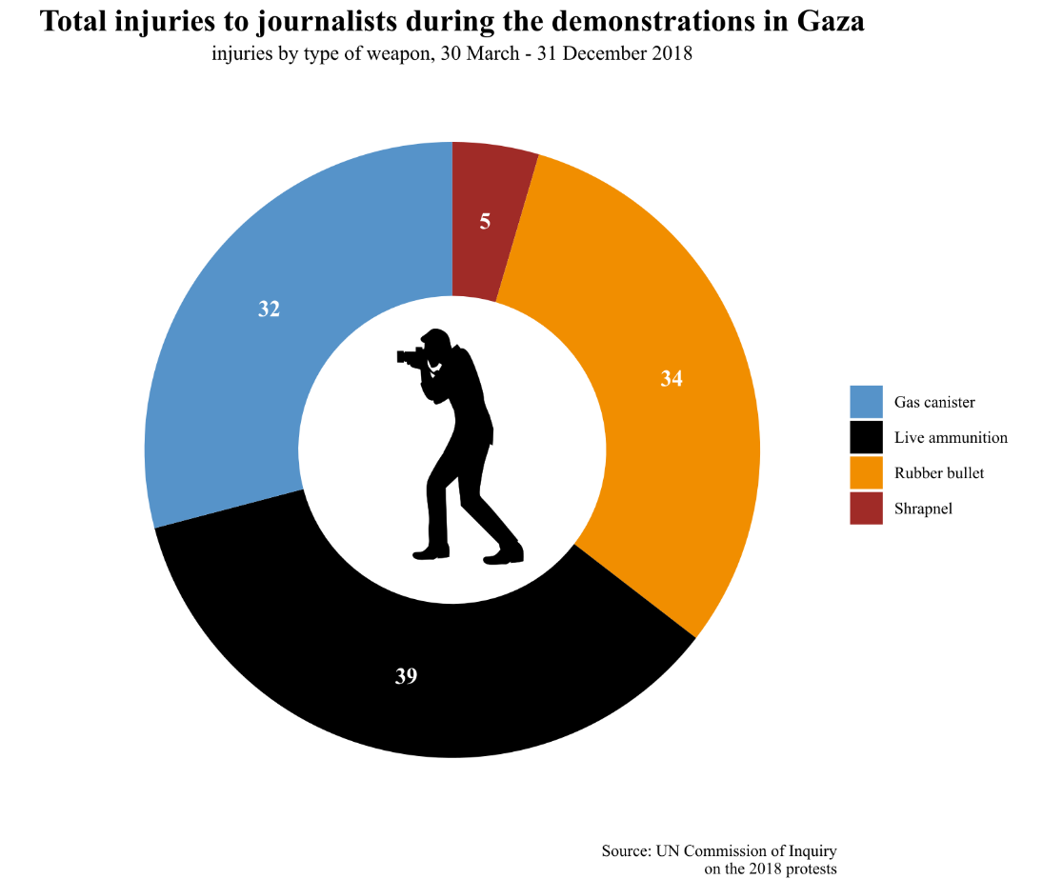
- This has led to speculation among local journalists that the ISF has deliberately targeted Gazan journalists at the demonstrations. Gazan journalists certainly feared for their lives at the demonstrations. One told the Commission that he always bids farewell to his parents as if he will not return. He told the Commission:
As journalists we are always standing in a group of our own and away from other protestors so we would be clearly identifiable. T[he ISF] would at times shoot live ammunition right under our feet to separate us from each other and to prevent us from taking photos and doing our jobs.
- Another told the Commission that journalists working at the demonstrations consider themselves so at risk that they say goodbye to each other as they leave the press tents and head out to cover the protests.
- Moreover, a number of international and local journalists told the Commission that they kept a distance from the demonstrators, and tended to congregate together with others wearing blue “PRESS” vests. Journalists told the Commission that only a small number of Gaza journalists, mostly those who work for major news organisations, own or have access to vests that actually have ballistic armour, as these are difficult to import into Gaza since they are banned under the “dual use” list.
- As one journalist told the Commission:
Why are journalists not protected by international law? Where are our rights? Even our vests are not bulletproof. I do not even own my vest and helmet. I borrowed them from a friend. Please tell the international community that journalists should be protected. It is our right!
- A journalist whom the ISF shot twice with live ammunition during the demonstrations told the Commission:
I was hit in the abdomen in the area where the vest ends, in an unprotected area. My vest is not a protective or bulletproof vest. The protective vest is not allowed to be imported to Gaza, Israel bans it. Most people in Gaza do not have it, not even the journalists’ union. All journalists wear a vest that is not protected, unless they bring one from outside. I was visited by a journalist from abroad, she showed me her vest and it was completely different from the ones we have. Even if I was wearing a vest, the bullet was under the vest, right after it ends. [An international news agency] for example has a [few] of these protective vests, when foreigners come they ask them to bring a few. All we photojournalists know each other. Nobody owns one.
- The Commission has interviewed several eye witnesses to the killings of journalists, as well as several journalists who were injured during the demonstrations.
- Freelance journalist (24)
At approximately 2 p.m. on 30 March, the ISF shot a 24-year-old freelance photojournalist from Khan Younis in the abdomen with live ammunition. He was standing with his back to the separation fence, around 300 m away. When he was shot he was taking a break from photographing along with two other photojournalists from international news agencies. He was wearing a blue vest marked “PRESS” and the bullet entered his mid-section just below the vest.
The injured journalist was evacuated to Nasser Hospital in Khan Younis where doctors removed 30 centimetres of intestines and 16 pieces of shrapnel after several hours of surgery. Three months later, he discovered that the bullet remained lodged between his spine and pelvis. Doctors told him that it can only be removed with surgical intervention outside Gaza.
The Commission concludes that the journalist did not pose an imminent threat of death or serious injury to the ISF at the time that he was shot.
- Yasser Murtaja (30)
The ISF shot 30-year-old journalist Yasser Murtaja with live ammunition in the lower abdomen as he covered the demonstration site east of Khuzaa village in Khan Younis on 6 April. Yasser was wearing a dark blue bulletproof vest clearly marked with the word “PRESS”, and a blue helmet. He was shot at approximately 1.30 p.m. as he filmed the demonstrations with a video camera for a documentary about the GMR. He was standing approximately 300 m from the separation fence, behind a large group of demonstrators. Visibility was good, and there were no other shots fired in the vicinity at the time. The gunshot hit him in the abdomen, causing a rupture in the main artery of the intestines, as the bullet entered between the protective blocks of his vest. He was evacuated to Nasser Hospital in Khan Younis and died of his injuries the following morning on 7 April.
One day later, Israel’s Defense Minister Avigdor Lieberman suggested that Yasser had been killed because he had been operating a drone, stating: “I don’t know who he is, a photographer, not a photographer. Whoever operates drones above [Israeli] soldiers needs to understand that he is endangering himself.” The Israeli media then contradicted Lieberman’s claim that Yasser had been operating a drone when he was shot by relaying an IDF statement that it was not aware of any use of drones by Palestinians during the demonstration near the fence along the Gaza on 6 April. Despite this, false allegations that he was operating a drone and that he was “a longstanding Hamas operative” continued to be reported despite lack of evidence (see the below section on misinformation).
The Commission finds that Yasser did not pose an imminent threat of death or serious injury to the ISF when he was shot.
- Freelance photojournalist (22)
Also on 6 April, at the demonstration site in North Gaza, the ISF shot a freelance photojournalist in the arm as he went to photograph an injured demonstrator. According to the injured photojournalist, he was standing around 300 m away from the fence when the ISF shot him.
At the time that he was shot, he was wearing a band on his leg marked “PRESS.” Many months after being injured he has not regained feeling in his right arm and is still undergoing medical treatment.
The Commission concludes that he did not pose an imminent threat of death or serious injury to the ISF at the time that he was shot.
- Ahmed Abu Hussein (24)
A week later, the ISF killed Ahmed Abu Hussein, a 24-year-old journalist from the Jabalia Refugee Camp. The ISF shot him with live ammunition on 13 April shortly after 2.30 p.m. at the Abu Safia protest site in North Gaza.
Ahmed worked for the Palestinian news agency Bisan News Network and as a radio reporter with the local radio station Sawt al Shaab (the Peoples’ Voice). Publicly available video footage of Ahmed’s shooting, verified by the Commission, clearly shows him standing still taking photographs of demonstrators far from the separation fence. At the moment he was shot, Abu Hussein was approximately 250-300 m from the fence. He was clearly marked as a journalist, wearing a blue helmet and a blue vest marked “PRESS” as he took photographs of the demonstrations. A video of the incident can be viewed on the Commission’s website.

Medical analysis conducted by the Commission concludes that Ahmed was shot in the left side of the abdomen, injuring his spleen, kidney, pancreas, colon, diaphragm and spinal cord. He died of his injuries twelve days later, on 25 April.
The Commission finds that Ahmed did not pose an imminent threat of death or serious injury to the ISF when he was shot.
- Journalist (age withheld)
On 14 May at approximately 11 a.m., the ISF shot a journalist in the abdomen at the Malaka demonstration site. He was approximately 150 m from the separation fence. He was wearing a blue helmet and a blue vest clearly marked “PRESS”. After being evacuated, he was transferred to hospital in Jerusalem where he received intensive medical treatment that saved his life.
The Commission finds that the journalist did not pose an imminent threat of death or serious injury to the ISF when he was shot.
- Journalist (49)
On 10 June, the ISF shot a journalist from Gaza City in the foot at the Abu Safia demonstration site in North Gaza. He was clearly marked as a journalist, wearing a vest marked “PRESS”. He also wore a helmet and carried a camera and gas mask.
He was shot at approximately 2.45 p.m. in the afternoon in an area apart from the demonstrators, approximately 200-300 m from the separation fence. The only people nearby were a group of five health workers about three to four metres away who were marked with high visibility vests bearing the Red Crescent insignia. Visibility was good, there was no smoke from burning tyres. Before the journalist was shot, ISF gunfire directed at the demonstrators had been sporadic rather than continuous. He has been unable to work since he was injured.
The Commission finds that this journalist did not pose an imminent threat of death or serious injury to the ISF when he was shot.
- Female journalist (25)
The ISF shot a female journalist in the leg towards the end of 2018, in the early evening, as she was walking away from the separation fence, approximately 300-400 m from the fence in Khuzaa, Khan Younis. Photographs and videos show that she was wearing a blue vest marked “PRESS” at the time of her injury, clearly indicating that she was a member of the media.
According to eyewitnesses, two gunshots were fired in quick succession. The first hit the journalist, the second hit a man behind her, reportedly in his leg. She told the Commission that she was about to leave the demonstration site and was walking away from the fence towards Jakkar Road when she was shot in the leg. Visibility was very good at the time she was shot. Her injury has had a major impact on her life, as she cannot walk without crutches and her right foot is completely paralysed.
The Commission finds that the female journalist did not pose an imminent threat of death or serious injury to the ISF when she was shot.
- As civilians, members of the press - journalists, photojournalists and photographers - are protected under international law. Despite this, based on its analysis, the Commission found reasonable grounds to believe that Israeli snipers shot journalists intentionally, despite seeing that they were clearly marked as such.
D. Persons with disabilities
- Persons with disabilities are entitled to special protection under international law. The Commission investigated several emblematic cases of persons with disabilities who were killed by the Israeli forces.
- Fadi Abu Salmi (29), double amputee
Fadi Abu Salmi was a 29-year-old double amputee from Khan Younis. On 14 May, the ISF shot him in the chest at the Abasan Al Jadidah protest site at approximately 1.25 p.m. He died immediately. The ISF shot him in the chest with live ammunition as he sat in his wheelchair under a tree approximately 250-300 m from the separation fence with two friends.
Fadi had lost both his legs during an airstrike in 2008, when he was 20-years old. Reports indicate that prior to the airstrike he had been a member of Al-Quds Brigades. According to a witness, Fadi was no longer a militant, and he supported the peaceful aims of the GMR. According to the same witness, Fadi was known to the ISF due to his past and distinctive disability.
The Commission finds that Fadi did not pose an imminent threat of life or injury to ISF soldiers at the time he was killed.
- Ahmad Abu Aqel (24), walked with crutches
Ahmad Abu Aqel was a 24-year-old from the Jabalia refugee camp. He walked with crutches, having been previously injured by the ISF during a demonstration on 8 December 2017.
On the morning of 20 April, after having his bandages changed at the medical tent, he sat down alone on a small sand hill near Jakkar Road approximately 150 m from the separation fence of Abu Safia, with his back towards the fence. The ISF shot him in the back of the head as he sat on the sand hill at approximately 11.15 a.m. He died the same day.
The Commission finds that Ahmad did not appear to pose an imminent threat of death or serious injury to the ISF when he was shot.
- Mohammad Abdulnaby (27), walked with crutches
Mohammad Abdulnaby was a 27-year-old man from the Jabalia refugee camp. He had to walk on crutches after being injured a few months previously. On 26 October, together with friends, he went to the Abu Safia demonstration site. Soon after 3 p.m. an eyewitness saw Mohammad walking towards the fence. The ISF shot him in the head when he was still close to Jakkar Road and far from the separation fence.
The Commission finds that Mohammad did not appear to pose an imminent threat or serious injury to the ISF when he was shot.
The Commission found reasonable grounds to believe that Israeli snipers shot these demonstrators intentionally, despite seeing that they had visible disabilities.
The Israeli forces also unlawfully shot other demonstrators with disabilities, whose disability may not have been apparent.
- Tahrir Wahba (18), hearing disability
18-year-old Tahrir Wahba was deaf. On 1 April, the ISF shot him in the back of his head with a single bullet at the Khuzaa demonstration site in Khan Younis. He died three weeks later. The Commission reviewed and verified video footage of his killing. He was approximately 150 or 200 m away from the separation fence when he was shot. In a video authenticated by the Commission, Tahrir is seen adding a tyre to a burning pile, turn his back to the fence, and wave his arms in the air. A second later he is shot in the back of the head. His head wound is clearly visible.
The Commission finds that Tahrir did not pose an imminent threat of death or serious injury to the ISF when he was shot.
- Shadi Kashef (23), hearing disability
23-year-old Shadi Kashef was deaf. He was a day labourer from Rafah. At approximately 3.30 p.m. on 30 March, the ISF shot him in the head during the demonstrations east of Rafah. According to a witness, he was standing about 150 m from the separation fence. He died of his injuries on 5 April.

The Commission finds that Shadi did not pose an imminent threat of death or serious injury to the ISF when he was shot.
- Karam Faiyad (26), intellectual disability
On 28 December, the ISF soldiers shot in the head with live ammunition Karam Faiyad, a 26-year-old with an intellectual disability and resident of Khan Younis District. He was standing 150 m from the parameter fence among a crowd of protestors when he was hit.
The Commission has reasonable grounds to believe that he did not represent an imminent threat of death or serious injury to ISF soldiers.
IX. Permanent, life-changing injuries: a generation wounded
A. Testimony from injured demonstrators and medical workers
- The injuries from gunshot wounds with live ammunition are life-changing. Médecins Sans Frontières described a pattern of demonstration injuries “where the bullet has literally destroyed tissue after having pulverized the bone”. The Commission has received multiple accounts of injuries from demonstrators and health workers.
- A 21-year-old man, shot in the leg on 30 March in Rafah told the Commission:
I was shot right below my right knee. The bullet exploded… My leg was almost severed. My leg was later amputated from above the knee because of the gravity of the wound… The bullet was like a bomb that shattered my leg… The arteries and veins were completely destroyed… It was the shock of my life when the doctors decided to amputate my leg.
- Another young man from El Bureij described his injury in similar terms:
I was shot with one bullet in my right knee. The bullet went through my left leg and entered my left kneecap, smashing it to pieces and causing multiple fractures to my left femur…
- He overheard the health workers who rescued him describing his injuries:
They were saying to each other: "Look at his legs, they have been totally smashed. He will never walk again. They will need to be amputated.” I was nearly passing out and I lost even the faintest hope of being able to walk again.
- A volunteer paramedic who treated a young man injured on 6 April in Khan Younis described the victim’s injury:
He was shot right below the knee… his leg was probably amputated because [it] was shattered. I believe that it was an exploding bullet because only a thread of flesh held the leg together, the bone was completely destroyed.
- One international doctor who has worked in a number of war zones described the pattern of injuries that he saw:
The types of injuries were extremely similar, not normal in any situation: massive open wounds in the lower limbs, skin and muscles “blown out”, bones smashed into lots of pieces and damage to blood vessels [putting]… the limb in danger.
- Another international doctor described the typical injuries he treated in similar terms:
[e]xplosive injuries on muscles, nerves, bones, veins, in the area of the body that was hit, it looks like an explosion, because of the high velocity of the bullets.
- According to one surgeon responsible for treating a large volume of such cases:
[t]he exit wound is disproportionately wider. It can be the size of a fist, or even of an open hand. […] In half of the injured we’ve received, the bullet has reached the bone, causing multi-fragment fractures, which means the bone has literally been turned into dust.
B. Use of high-velocity ammunition against demonstrators
- On 30 March, it became widely known that the ISF was injuring demonstrators with high-velocity ammunition fired at relatively close range, resulting in life-changing, permanent disabilities including amputations. Nevertheless, the ISF has continued to shoot demonstrators with high-velocity ammunition at relatively close range.
- The extensive bullet damage described above has led many international medical experts, media outlets and victims to believe that the ISF may have shot protesters with “exploding bullets”. Indeed, a number of victims and witnesses told the Commission that they believed “exploding bullets” were causing these devastating injuries.

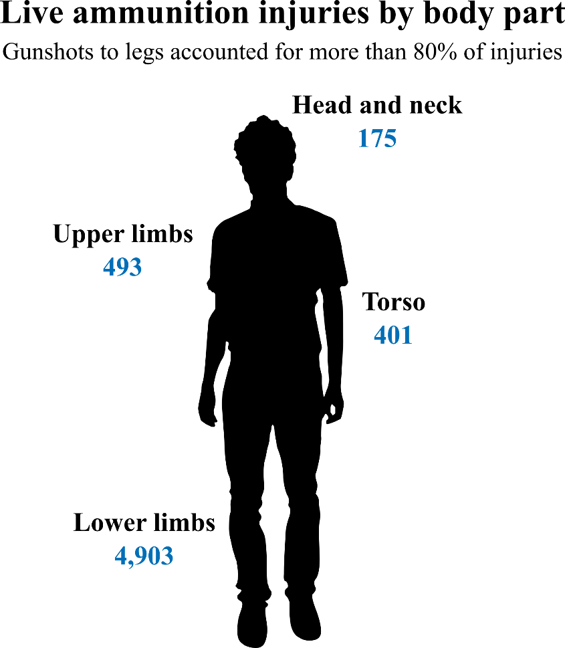
- Claims of explosive bullets being used against protesters during the Great March of Return arise from the assumption that large exit wounds and extensive tissue and bone damage could only have been caused by a bullet that explodes upon impact. However, standard, high-velocity ammunition can also cause these effects.
- Upon impact, a high-velocity bullet transfers much more kinetic energy to its target than a low-velocity bullet, such as one fired from a 9 mm handgun. This creates a much larger wound channel and exit wound, especially when the high-velocity bullet impacts bone at close range. In addition, high velocity bullets often fragment or tumble end over end upon entering their target, creating devastating injuries to tissue, organs and bone.
- ISF troops operating along the Gaza fence were seen in open source media with three standard-issue small arms that fire high-velocity ammunition: Israeli-made Tavor assault rifles and their variants, which use 5.56 x 45 mm. ammunition, and both M24 and SR25 sniper rifles manufactured in the United States, which use 7.62 x 51 mm. ammunition.
- Civilian trauma surgeons in the United States are becoming familiar with the effects of high-velocity rounds on the human body, owing to multiple shootings with rifles that fire the same high-velocity 5.56 x 45 mm. ammunition as the Tavor assault rifle, which can leave exit wounds as large as a grapefruit. With this in mind, it is worth noting that the bullet fired by the Tavor assault rifle is the smallest and least powerful of the bullets fired from the three weapons listed above.
- Therefore, if ISF forces fired upon demonstrators with Tavor assault rifles or M24 and SR25 sniper rifles, it is highly likely that the victims would have suffered gunshots with large exit wounds that caused catastrophic damage to tissue, organs and bone.
- Indeed, the Commission’s military and forensic experts asserted, based on photos of injuries submitted to and verified by the Commission, that many of the gunshot wounds observed in Gaza are consistent with those that can be caused by high-velocity ammunition fired by sniper rifles.
- A number of international doctors with experience in conflict zones who worked in Gaza’s hospitals between 30 March and 31 December 2018 concurred, asserting that the gunshot wounds from the demonstrations were caused by high-velocity bullets fired at relatively close range. They agreed that “absolutely horrific” injuries featuring complex tissue and bone damage are entirely predictable when high-velocity ammunition is fired into human bodies by snipers. As the doctors explained: “that is what a sniper bullet does. It is what it is designed to do.” In the view of one doctor the Commission spoke to: “…using high velocity bullets on a population that are 100 metres away doesn’t make sense, it is like using a tank to kill a fly.”
C. Amputations
- According to the OCHA and WHO, ISF snipers wounded 122 demonstrators (being shot during the time period in question) who had to undergo amputations, including 21 children. More people have lost their limbs during the GMR than during the entire 2014 Israel-Gaza conflict. The Commission had investigated the below cases:
- Abed Nofal (11)
Abed is a schoolboy from El Bureij refugee camp. On 17 April, at around 4.30 pm, the ISF shot him with live ammunition in his left leg. He was approximately ten metres from the fence, east of Al Bureij, central Gaza Strip. He was playing football with friends and was shot as he ran to pick up the ball. According to doctors, the bullet caused multiple fractures and severe tissue damage to his leg. As a result, his leg was amputated below the knee.
- Student (17)
On 14 May, the ISF shot a 17-year-old student from Shujiriah, Gaza City in the leg. He was standing in a crowd of people approximately 80 m from the separation fence. Owing to the severity of his injury and subsequent infection, doctors were forced to conduct three separate amputations of his left leg. The last amputation was six centimetres above his knee.
- University student (23)
A university student from Jabalia Al-Balad was shot in his left leg on 14 May while with his friends at the demonstration site in Abu Safia, east of Jabalia. He told the Commission that at around 10.30 a.m. he was near Jakkar Road and was holding a flag when he was shot. The student stayed at Al Shifa hospital 12-13 days where the doctors decided finally to amputate his leg. He did not return back to the faculty after his injury.
- Bricklayer (26)
On 6 April, the ISF shot a 26-year-old bricklayer from Rafah in the leg. He was 300 m from the fence, in an area that he considered safe. The bullet shattered the left side of his pelvis, forcing doctors to amputate his left leg from the waist down. Prior to his injury, he was the main breadwinner in his family. Now he is unable to work.
- Farmer and construction worker from same family (38 and 31)
The ISF shot two wage-earning siblings, aged 38 and 31 respectively, on two different dates at the same demonstration site. Both had their legs amputated with devastating consequences for the family’s livelihood.
The ISF shot the younger sibling, on 30 March, in both legs as he tried to evacuate an injured demonstrator approximately 20 m from the separation fence. His right leg was initially amputated 20 cm above the knee. He has undergone two further surgeries where doctors removed additional parts of his right leg, and he has a bone fixator on his left leg.
Weeks later, the ISF shot his older sibling in the leg as the victim handed out water bottles to protestors approximately 50 m from the fence. According to an eyewitness, the victim’s leg was almost completely severed. It was amputated below the knee the same day. As a result neither is able to work to support their families.
- Mobile phone seller (47)
A resident of Abraj Al-Nada in Beit Lahia, who performed odd jobs for a living such as selling mobile phones, was injured on 14 May 2018. That day he went to the demonstration site in Abu Safia, east of Jabalia, to watch the demonstrations. At around 12.50 p.m., while standing alone in an area more than 400 m from the separation fence and smoking a cigarette, he was hit by a sniper bullet that tore through his right leg. Doctors in Al-Shifa hospital were forced to amputate his leg three days later to save his life. He is no longer able to work.
- Retired teacher (63)
On 13 April, the ISF shot a 63-year-old retired teacher in his lower leg at the demonstration site east of El Bureij. He told the Commission that when he was shot he was approximately 400 m from the separation fence watching people set fire to tyres.
His injury was so severe that doctors amputated his leg the same day. Nine months after his injury he has been unable to access a suitable prosthesis.
D. Life in Gaza after amputation
- The Commission heard from many amputees who expressed frustration, anger and deep-seated despair at being injured in such a fundamental way. According to a psychiatrist:
[O]ne of the major causes of frustration of those who were injured in the GMR was that the system could not really support them... We are talking about people whose arms and legs could have been saved from amputation, but they were not able to get out of Gaza in time. Th[ey] present anger, aggression, hopelessness, we are seeing an increase in domestic violence and severe depression. These are the main things that result from these traumatic events.
- For children, the long-term psychological effects are particularly acute. A teacher told the Commission about the children at his school:
The injuries in the GMR have had a hugely negative impact on the lives of our students, especially those injured in their legs and hands who can no longer live normal lives because they are permanently disabled. They cannot concentrate and their grades are suffering, they experience social isolation, becoming withdrawn, no longer able to focus during classes and no concentration. They have nightmares about what happened.”
E. Internal injuries and nerve damage
- The Commission had heard from several injured people who had suffered internal and nerve damage, including:
- Ahmed Ghanem (15), shot in the arm and chest
On 1 June, the ISF shot Ahmed, a 15-year-old middle school student from the El Bureij refugee camp. He was shot in the torso as he socialised with other demonstrators approximately 280 m from the separation fence. The bullet entered his right arm and continued into his chest, fracturing several ribs, impacting his lungs, diaphragm and liver before lodging itself in his left hip. Because of the gunshot, doctors had to remove half of a lung and half of his liver. Doctors have informed him that he only has a 30 per cent chance of recovering the use of his right hand since the bullet damaged three main nerves in his arm. A video with extracts from the Commission’s interview with Ahmed and his father can be viewed on the Commission’s website.
- The Commission observes that the ISF has shot a number of male and female demonstrators in the lower abdomen and groin area.
- Former schoolboy (15), shot in the groin
In one case, the ISF shot a 15-year-old boy in the groin at the maritime demonstration site in North Gaza on 15 October 2018. According to him, he was standing 120 m from the fence when the ISF shot a single bullet in his testicles. As a result of his injury he is unable to walk more than 30 m and has dropped out of school.
- Other victims who were shot in the groin have told the Commission that their injuries make it unlikely that they will be able to have children.
F. Injuries caused by tear gas canisters
- Although tear gas is considered a non-lethal crowd control measure, its deployment can cause serious injury or death if undertaken outside of non-lethal parameters. For example, firing a tear gas canister at a human being can cause serious injuries, including bone fractures and burns. The Commission found instances in which the ISF appeared to fire tear gas canisters recklessly, at times with lethal results, towards children, health workers and journalists, as well as other demonstrators.
- Jamal Afana (15)
Jamal was a 15-year-old from Shaboura refugee camp, southern Gaza Strip. He was hit in the head by a tear gas canister while attending a demonstration east of Rafah on 11 May. According to one witness, Jamal was standing with his friends 50 m from the separation fence. Tear gas canisters were being fired by multiple launchers mounted on military vehicles, by drones and by rifles. Jamal moved away from his friends, closer to the security fence near Kerem Shalom (Karim Abu Salem) crossing, when he was hit with a tear gas canister in the back of his head. He died the following day at the European Hospital.
- Ahmad Al Assi (22)
ISF soldiers hit 22-year-old Ahmad Al Assi in the head with a gas canister on 8 June at the Khuza’a protest site. He succumbed to his wounds on 14 June at the Gaza European Hospital. The moment of his injury is documented in a video which shows Ahmad pulling on a rope with a group of other protestors. Seconds later, he was hit in the back of the head with a gas canister emitting smoke; he fell to the ground and was immediately carried and removed from the scene by other protestors. Visibility conditions were poor as seen in the video as the group of protestors are concealed by clouds of thick black smoke, possibly from burning tyres, between them and the separation fence.
- Ahmad Abu Habl (15)
15-year-old Ahmad Abu Habl from Beit Hanoun was killed by a tear gas canister at around 2.30-3 p.m. on 3 October. According to an eyewitness, he and Ahmad were sitting and talking approximately 200 m from the fence, near Erez crossing area, when Ahmad was hit in the head with a tear gas canister. The tear gas canister fractured his skull. Video footage reviewed by the Commission shows Ahmad on the ground with the tear gas canister lodged in his head. He was pronounced dead on arrival at hospital.
- Journalist (31)
On 14 December, a journalist was hit in the face with a tear gas canister when he was 350 m from the fence, east of Gaza city. According to an eye witness, that day was calmer compared to previous demonstrations. The eye witness told the Commission that the journalist was standing in a group of journalists, talking amongst themselves when a journalist in their group was shot in the leg with live ammunition and another was hit with a tear gas canister. According to the eyewitness, the journalists were all wearing blue “PRESS” vests and helmets. Ten minutes later, after the journalists had helped to evacuate the injured, a third journalist was shot with a rubber bullet in his hand. Approximately three minutes later, the same journalist was hit in the face with a gas canister. His helmet flew off and he fell to the ground.
- Female freelancer journalist (age withheld)
A female freelance journalist injured on 14 May with a tear gas canister, told the Commission that over the course of the demonstrations she had been injured by gas canisters ten or more times. She also reported that her camera had been damaged on three occasions, including on 14 May.
- Female paramedic (21)
A female paramedic shot in the chest with live ammunition, was also injured twice with tear gas canisters in the leg as she treated injured demonstrators in Khan Younis on 6 April and again in August 2018.
She told the Commission about her experience, at the Khuza demonstration site in Khan Younis on 6 April:
I was shot with a gas canister to my right ankle. This gas canister was shot from a rifle, it was shot directly at me. It was shot at me when I was providing treatment to a wounded person. I am sure because the smoke had dwindled and you could see the soldiers, they got off the jeep and they were shooting gas canisters at demonstrators from the other side of the fence. I was providing first aid to an injured person when [the soldier] shot me… I am sure the soldiers saw what I was doing when I was shot, the visibility was good.
Four months later, she was injured again with a tear gas canister at the same demonstration site:
I was standing alone, there were no burning tyres and the soldiers could certainly see me. I was alone, no one was near me. I was shot with a gas canister [in the leg] and I collapsed... I couldn’t dare look at my leg because I thought it was severed. I was wearing my white paramedic coat and I was holding my first aid bag when it happened.
She expressed a commonly-held belief among health workers that they are deliberately targeted by the ISF with tear gas canisters:
We are just doing our job peacefully and we see no reason to be targeted. What we do as health workers, whenever we see an injured person, we drop our tools, we put our hands in the air and we proceed slowly to signal to the soldiers that we are peaceful, we are unarmed, that we pose no threat, but yet we are targeted.
- Nurse student (21)
On 13 April in Khan Yunis, another female paramedic was injured by a gas canister, fracturing her ankle in multiple places. As a result of her injury, she uses crutches to walk.
- On the same day in a separate incident in Khan Yunis, an ISF drone dropped tear gas canisters on a field hospital which was clearly marked with medical insignia. According to a doctor working there that day:
Tear gas canisters penetrated the roof, all the medical workers there inhaled the gas, we all evacuated the tent, we treated ourselves outside the tent… Every person in that tent, both medical workers and patients, was affected, [there were] about 40 medical workers, all categories of staff and also patients, about 10 of them.
- Another eye-witness recounted the ISF tear gas attack on the field hospital:
I saw it happen. The drones, there were many of them coming one after another, hovering over us, over the tents, and then they would release tear gas canisters which would unload the canisters [sic] on and around the big medical tent, the field hospital. Tear gas canisters were being dropped at the door of the tent and around the tent and then they exploded. There are two types of canisters, those that explode on impact and those that explode in the air. I saw some explode as they hit the ground and others let out gas before touching anything. Many health workers fainted.
X. Impact of high volume of GMR injuries on Gaza’s health sector
- Gaza’s healthcare system is under unprecedented strain as it struggles to cope with the massive influx of deaths and injuries from the GMR demonstrations.
- Due to the huge numbers of injured, hospitals have been forced to divert resources from ordinary medical needs, such as births, routine operations, cancer treatments and burn treatments with far-reaching effects. 8,000 elective surgeries alone have been cancelled or postponed, resulting in a backlog that will take years to address.
- As an international doctor observed: “Gaza faces a medical crisis… the number of the injuries, as well as their consequences [are] catastrophic.”
- According to the Spokesman of the Ministry of Health, Dr. Ashraf Al Qedra:
Challenges facing the health sector exceed the medical capabilities of any health system in the world… on Fridays, hospitals in the Gaza strip received 280 case per hour which surpassed the 2014 Israeli offensive, where hospitals received only 9 cases per hour.
- The number of injuries from the demonstrations is so overwhelming that doctors have been forced into a cycle of prematurely discharging patients to make room for the next wave of injuries that is expected to arrive. Patients who have been prematurely discharged then seek treatment at primary healthcare clinics that are wholly unprepared and under-resourced to cope with the high volume of complicated injuries requiring long-term monitoring and care.
- One primary healthcare clinic reported that since 30 March, there has been a 50 per cent increase in the number of patients being seen by their clinic’s doctors. Another primary healthcare clinic reported that since the demonstrations started, the clinic’s nurse in charge of wound care has been treating 15 additional patients a day. An experienced nurse working in a primary care clinic told the Commission:
I have had to treat injured of different types which I had not seen before which makes the whole situation much more challenging. [T]he numbers have increased tremendously and the kinds of injuries are dramatically different. Now I am treating serious, and very serious injuries. The majority of injuries [are] people who had been shot in the chest, in vital parts of the bodies. A number of injured had limbs amputated so we have been providing follow up care.
A. Challenges to recovery and long-term disability for injured demonstrators
- With over six thousand people living with gunshot wounds from live ammunition, mostly to the lower limbs, Gaza faces what Médecins Sans Frontières has termed a “slow-motion healthcare emergency.”
- A number of medical professionals observed that Gaza’s healthcare system has not experienced anything like it, even in the recent wars of 2008/2009, 2012 and 2014. Unlike those wars where the nature of injuries was relatively diverse, the current volume of severe gunshot injuries to the lower limbs requires a mass amount of specialised, long-term medical care focusing on orthopaedic, vascular and plastic surgery. Gaza’s healthcare system cannot cope with these demands.
- As WHO observes:
The grave injuries suffered are merely the first chapter in a prolonged ordeal. Even a superbly functioning healthcare system would be sorely tried when faced with such a large number of casualties. Yet in Gaza, even before the protests began, the healthcare system was already on the brink of collapse.
- Medical professionals estimate that around half of those with gunshot wounds to the legs will require reconstructive, orthopedic surgery. According to Shifa Hospital and Medical Aid for Palestinians (MAP), in early December 2018, 700 patients were awaiting complex limb reconstruction surgery.
- However, limb reconstruction treatment requires multiple operations. Each surgery is complex and requires approximately two to three hours of operating time. Recovery is long, costly and uncertain. Hospitals lack dedicated operating rooms, patient beds and essential medical equipment. Furthermore, patients need regular outpatient care including x-rays, blood tests, dressing changes, pain management, and up to thirty physiotherapy appointments. There are currently long waiting times for prosthetic limbs in Gaza due to shortage of materials, high demand and the continued blockade. As MAP has pointed out:
If the[se injuries] are untreated... most people will be unable to work or support themselves. While the treatment is extremely expensive, it is much cheaper than the alternative, which is a whole generation of young men and women who would be unable to work.
- Patients who have been lucky enough to secure limb reconstruction surgery are faced with a long and challenging recovery period. A physiotherapist shared some of these challenges with the Commission:
The treatment is very long and intensive, in some cases it will take more than a year of intensive rehabilitation until they make a full recovery. What I have noticed in the cases that I treat is that after two to three sessions you are hoping that the patient is starting to see some improvement and some pain relief, but you discover that the patient is still suffering because there is still shrapnel in the body… This is extremely painful, the patients are in severe pain, they cannot sleep for six months. The recovery is very long and very painful.
- In addition, injured demonstrators must guard against the threat of serious infection throughout the entirety of their treatment and recovery. The lack of appropriate treatment and sanitation in Gaza’s health system means that infection is a high risk, especially for patients with open fractures, a risk heightened by the hospitals’ need to discharge the patients prematurely. Doctors report treating patients whose open fractures have not properly healed, risking osteomyelitis, a deep bone infection which Gaza health facilities currently lack the ability to diagnose and which requires lengthy treatment and repeated surgical intervention.
- The challenges to proper treatment and recovery mean that injured demonstrators are at very high risk of chronic infection, loss of function, amputation and lifelong disability.
B. Long-term financial and psychological impact of GMR injuries on families and communities
- The majority of injured demonstrators are young men, and in a number of instances, the family’s only breadwinner. It is hard to overstate the impact of these incapacitating injuries. According to one international doctor:
With the resources that hospitals and doctors have in Gaza, it is clear that a huge part of those injured will remain disabled for life. Had Gaza had better resources, they may have had better chances. Many injuries will never heal. Many will result in amputations later on… It is very clear that many legs will never be walked on again, with or without an amputation.
- Amputations and the loss of use of limbs place a substantial burden on individuals, families and communities, reducing livelihood opportunities and increasing poverty. In the context of Gaza, which is experiencing unprecedented poverty and food insecurity, the loss of a wage-earner, who becomes instead an additional burden on the family, can result in serious financial and psychological problems for families and communities.
- According to a nurse who has treated hundreds of people injured during the demonstrations:
Most of the patients express post traumatic psychological effects stemming from the fact that they are unable to work. The majority of the injuries were incapacitating, they are preventing people from going about their daily needs, let alone the fact that in many instances they were the main breadwinner in the family. In these cases they are often laid off by their employers.”
- A senior doctor added: “limb injuries impose a massive physical and psychological burden on the victim, his family and the wider community. Lives will never be the same again.”
- According to WHO, the current crisis in Gaza will lead approximately 10,400 people to develop severe mental health problems and 41,700 will have mild to moderate problems, including 26,000 children. These numbers are expected to increase.
C. Israeli authorities’ reluctance to issue medical exit permits resulting in life-changing injury and death
- In cases that require specialised medical and surgical attention not available in Gaza, doctors are forced to refer patients for medical treatment to hospitals in East Jerusalem, the West Bank and abroad. To access such treatment, a patient must go through a lengthy, complicated bureaucratic process, fraught with risk and uncertainty. Israeli and Egyptian authorities often deny, delay or do not respond to requests to exit Gaza for medical treatment. For example, in 2017, the Coordinator of Government Activities in the Territories (COGAT), the military authority responsible for administering Israel’s permit system in Gaza, approved just 54 per cent of exit permits through the Erez Crossing for patients seeking treatment outside of Gaza. This is the lowest rate documented since WHO began collecting statistics in 2008.
- Male patients aged 18 to 40 had the lowest permit approval rating with less than a third (29 per cent) approved. This can have fatal consequences. As many as 54 people in Gaza are known to have died in 2017 after denial or delay regarding issuance of their permits and consequently missed appointments, 46 of whom were cancer patients.
- In early April 2018, COGAT denied medical exit permits for injured demonstrators primarily because the Israeli Defence Minister had issued a policy categorically denying passage to any person injured during the 30 March demonstrations. (See Al Kronz and Al Ajouri case below). Although the Israeli Supreme Court rejected this blanket policy, those injured in the demonstrations continue to face significant challenges in accessing medical treatment outside Gaza.
- According to WHO, Israel’s approval rate for medical exit permits accorded to Gazans injured in demonstrations near the fence was significantly lower than the overall approval rate. As of 31 December 2018, according to Gaza’s Coordination and Liaison Office, there had been 435 applications by those injured in the demonstrations to exit Gaza via Erez crossing to access health care. Of those applications, 82 (19 per cent) were approved, 130 (30 per cent) were denied and 223 (51 per cent) were delayed. The numbers suggest that Israeli authorities singled out Gazans who attended the demonstrations at the fence.
- At the heart of these statistics are a series of opaque policies which restrict Gazans from leaving the Strip for specialist medical treatment. For example, COGAT does not consider demonstrators with severe injuries to lower limbs resulting from gunshot wounds to be patients “requiring lifesaving treatment”. Rather, it categorizes them as persons “who could benefit from a drastic improvement in their quality of life.” In practice, this distinction means that the Israeli military authority may deny permit requests from the injured demonstrators under its exit permit rules, even if those requests are premised on the need to save limbs from amputation.

- The following cases illustrate the life-changing and sometime fatal impacts of this policy and practice.

- Yousef Kronz (19) and Mohammad Ajouri (17)
On 30 March, Yousef, 19, was shot in both knees as he took photographs of the demonstrations in El Bureij. On the same day, Mohammad, 17, was shot in one of his legs at the demonstration site in North Gaza.
Both Yousef and Mohammad were taken to Al Shifa Hospital in Gaza City which did not have the resources to save their legs. The hospital made an urgent request to COGAT that they be permitted to leave Gaza for urgent medical treatment at Al Istishari Hospital in Ramallah. Medical documentation attached to their requests stated that without proper treatment their legs were at risk of amputation. COGAT did not respond. Two human rights organisations, Al Mezan and Adalah, filed a follow-up request which was denied on 5 April.
In its response, COGAT stated that their request to leave Gaza was rejected due to the Israeli Defense Minister’s policy that any person injured during the 30 March demonstrations would be denied passage through Israel to medical facilities in the West Bank, on account of their participation in the protests, and the fact that neither patients’ life was in immediate danger. On 8 April, Al Mezan and Adalah filed a petition to the Israeli Supreme Court challenging the decision. In the meantime, by 11 April six permits for people injured during the demonstrations to travel for medical treatment had been submitted, and all had been denied.
While the court awaited the State’s response, the deterioration in the patients’ conditions forced doctors at Al Shifa Hospital to amputate one of Yousef’s legs and Mohammad’s injured leg. Mohammad was discharged from hospital three days later. Yousef’s other leg remained at risk of amputation.
On 16 April, the Israeli Supreme Court ruled that Yousef posed no security risk and he received exceptional authorization to leave Gaza. Yousef’s parents, siblings or uncles were not allowed to travel with him, so his 85-year-old grandfather accompanied him. At the Erez Crossing he was kept in the ambulance for hours and searched before being transferred to another ambulance on the Israeli side. Yousef spent three months in hospital in Ramallah where he underwent three surgeries to save his right leg.
- Zakaria Bishbish (14)
Zakaria was a 14-year-old from Al Maghazi refugee camp. ISF soldiers shot him in the back around 6 p.m. on 30 May, a day when demonstrators were taking part in cultural activities. Zakaria had been playing, along with three other boys. Zakaria was approximately 100 m from the separation fence when he was shot. The ISF soldiers who shot Zakaria had taken positions on high ground overlooking the protest site.
The ISF gunshot that hit Zakaria perforated his stomach and colon; splintered his vertebrae; and bruised his kidney. His injuries resulted in sepsis – a life-threatening condition that arises when the body's response to infection causes injury to its own tissues and organs.
Zakaria’s family applied on his behalf for a two week medical exit permit to enable him seek lifesaving treatment at St Joseph Hospital in East Jerusalem. A medical appointment was scheduled for him on 4 June. However, COGAT denied his request to travel through the Erez Crossing. No reasons were given for the decision. His family then tried to secure appointments for him in Egypt and the West Bank. The Israeli military authority did not respond to his second exit request. Zakaria died of sepsis on 18 June.
XI. Impact of the demonstrations on women and girls
- The Commission inquired into the impact of the demonstrations on women and girls in Gaza.
A. Women and girls injured during the demonstrations
- During the Commission’s reporting period, ISF soldiers killed one woman and one girl: a 20-year-old female paramedic, Razan Al-Najjar in Khan Younis and a 14-year-old girl, Wisal Sheikh-Khalil from Al Maghazi Refugee Camp (see the sections on medical personnel and children respectively.
- The Commission’s investigation found that 159 women were shot with live ammunition, 59 were injured with bullet fragmentation, 36 by rubber coated metal bullets and 60 by direct tear gas canister hits.
B. Participation of women and girls in the demonstrations
- The low proportion of women and girls injured and killed compared to men and boys should be understood within the prevalent social context in Gaza. Despite encouragement by the HNC, women and girls participated in the demonstrations in lower numbers than men and boys.
- In many families, women and girls cannot leave the house unaccompanied and women rarely hold social gatherings in public. Several women interviewed by the Commission mentioned that their husbands or the male head of household had to provide their consent for them to participate in the demonstrations. Despite this women participated, including without their relatives’ consent. A woman told the Commission that her family had refused to let her participate in the protest after she was injured a first time, but she repeatedly returned anyway. One of the organisers of the GMR told the Commission: “When a woman participates [in] the protests, she tells Palestinian society that she exists and that she should have a place in the political process.”
- Women and girls also gathered at the protest sites as a venue to conduct social and cultural activities because of the lack of accessible public spaces for women and girls in Gaza. For example, one injured 16-year-old girl told the Commission that she participated regularly at the tented camps to sew and knit in the tents with her friends because their home is overcrowded and they do not have electricity. On 13 May 2018, the ISF shot her in the abdomen with live ammunition as she was walking away from the tents, approximately 800 m from the separation fence at the protest site, east of Gaza city.
- According to a survey conducted by UNFPA, consistent with accounts received by the Commission, women’s participation in the demonstrations was generally encouraged despite the conservative patriarchal social and cultural norms dominating in Gaza.
- Women have also told the Commission that they perceived that they were less likely than men and boys to be shot by the ISF. A 26-year-old woman told the Commission:
Women do not usually go close to the fence like I do. I burn tyres and throw stones, usually women do not do that. When the men want to cut the fence, I help them. For example, I walk in front of them to cover them when approaching the fence. Soldiers do not kill women usually – men on the other hand are hunted by Israelis like birds.
- Throughout the demonstrations, some women and girls burned tyres, cut the fence, threw stones at ISF soldiers, crossed the barbed wire coils, planted Palestinian flags, and, in one reported case, launched burning balloons towards neighbour Israeli settlements.
- Women also rescued injured men and boys close to the separation fence. One woman told the Commission how on 30 March 2018, at the North Gaza protest site, she rescued men and boys trapped behind the barbed wire coils while the ISF soldiers were firing live ammunition in their direction:
[T]hey were trapped and very close to the fence. I wanted to go rescue them because I am a woman. (…) There were about 15 men including four boys at 5 to 10 m from the fence. There were doing nothing, they had no weapons, they were just getting closer to the fence. I was concerned they would be captured by the Israelis. I told a woman next to me “I am going to get them, I am a mother, I can carry children”. I decided to go rescue the men and children because I am a woman. As a woman, they would not shoot at me.
C. Motivations of women and girls
- Women interviewed by the Commission and reports received suggest that women wanted to challenge prevailing gender norms. A 22-year-old woman told the Commission: “I participate like the young men. We participate as equals because of the bad economic situation and the blockade. I am very upset that I cannot find work and cannot sustain myself. I am a skilled woman.” It was reported that women in Gaza were educated with the notion that women are the symbol of resistance: “Our grandmothers always helped our grandfathers and fought with them during the Nakba and the first Intifada.” One female demonstrator told the Commission:
I have always struggled for the liberation of my people so that is why I participate in the demonstrations. I was very active and I would go as close as I could to the fence, to the point that I was face to face with the soldiers and I would talk to them. I was the bravest of all of the women and braver than most of the men. (…) I would carry and burn tyres and evacuate the wounded.
- Women and girls who participated in the protests expressed a high level of support for the GMR and its underlying causes, including the right to return for Palestinian refugees, and to end the longstanding blockade with its adverse impact on the life and livelihoods of Gazans. A 64-year-old woman told the Commission that the importance of the demonstration’s aims outweighed the usual social norms governing women’s participation in public events:
The reasons why we demonstrate are obvious! (…) It is an awful situation in Gaza. The number of women participating in the demonstrations is not high. (…). This is because it is still a patriarchal society and religion plays an important role. Because of the importance of the issue at stake, we do things against this “culture” and go out to demonstrate.
- More specifically, numerous women told the Commission that they participated in the GMR with the objective of informing the outside world that women and children in Gaza live in extremely dire conditions without adequate medicines and health facilities and employment opportunities outside the home. They shared a sense of hopelessness and despair about the future because of the occupation and the blockade. Women’s reasons for attending the demonstrations should be understood in the context of intersecting forms of discrimination and violence affecting women and girls in Gaza.
- Many women expressed fear of injury, violence and death at the demonstrations. Some also described despair and even suicidal thoughts stemming from often pre-existing discriminatory situations, including patriarchal societal norms, deep poverty and living as refugees under occupation. In three instances reported to the Commission this led to women expressing indifference to the risk of injury or even death at the protests. According to one of them: “When I go to the protest sometimes, I just want to end it. I go to the protest to either die or to feel an escape, I don't want to be injured, I just want to disappear.” Highlighting the desperate economic situations among Gazan families, these women told the Commission that if they were killed, at least they would leave a financial legacy to their children or other family members and would no longer be “burdens” their families.
D. Women becoming primary breadwinners and primary caregivers
- The social impact of the GMR demonstrations has had a disproportionate effect on women and girls in Gaza. It increased the burden on women and girls who became primary breadwinners as well as caregivers for the wounded.
- The death of a primary breadwinner, either a son or spouse, has a direct and immediate impact on the living conditions of the mother, or widow and her children. The opportunities for women to fill the income gap are minimal given the socio-economic situation in Gaza. According to UNFPA, in the third quarter of 2018, less than 26 per cent of women in Gaza were participating in the labour force (i.e. working or looking for a job) and 78 per cent of those were unemployed (versus 46 per cent of men). In this context, women told the Commission that it was extremely difficult for them to seek outside employment when their sons or husband as breadwinners were incapacitated or killed – it is especially difficult for women who were married at a young age as they have never worked outside the household.
- It was also reported that women inherited debt from their deceased husbands which added to the challenges widows faced. However, in one case reported, charities and organizations were able to raise the money to reimburse such debt.
- In Gaza, the lack of employment opportunities for women, and discriminatory laws regarding child custody have previously forced some women to marry the brother of their deceased husband. A woman from the southern part of Gaza told the Commission that after the ISF killed her husband at the demonstrations in July 2018, she had no choice but to move with her six children into her brother-in-law’s home. She received $3000 from a Qatari donation for the death of her husband in addition to a monthly pension of approximately $400 from the authorities. She was forced to marry her brother-in-law under threat of eviction:
My brother in law lives in the house and is pressuring me to marry him otherwise he will take over the house with my children, and I will be removed from the household if I do not marry him. I am trying to get money to rent my own home so I can live away with my children.
- In the customary division of labour in the household in Gaza, the treatment and care of an injured family member is mainly the responsibility of the mother or wife. The high number of injured people since 30 March 2018 compounded by shortages of electricity, medicines and equipment, has forced hospitals to release patients prematurely and hand over the treatment to the families. As one woman told the Commission: “women, mothers, they are the ones who take care of the amputees and their injured children (…). Women always carry the heaviest burden in Gazan society.”
- The mother of a 16-year-old girl shot in the leg on 30 March 2018 in Rafah explained to the Commission the difficult burden she carries as the main carer for her daughter and the psychosocial consequences on her and her children:
The injury have had a huge impact on all of my children, economically, educationally, psychologically. (…) My daughter needs a huge amount of support, both physical and mental. I have to go with her to the bathroom to help her. My other children get really upset. They don’t understand why she gets all of the attention. It is so hard to explain it every time. On two occasions now I have had to go out of the house and be away from them, on my own, to feel like I have a moment to calm down, a moment to myself. My husband was killed and I am doing this alone. I don’t know how I can do this on my own.
- Despite the relatively low proportion of injuries among women and girls, the consequences of an injury are often more severe for women, especially when the injured woman is a mother. A few women told the Commission that they are expected to continue fulfilling their home duties despite an injury. Some women also said they sought assistance from their sisters, mothers or female friends to support them in their house chores and caring for their children while they are in convalescence. One injured woman however mentioned that her husband had to “take care of himself” while her sisters assisted her.”
- Injured women often rely on other family members to access medical treatment because of the social norm that prevents women in some families from leaving their homes unaccompanied. UNFPA reported that women who have participated in the GMR without the consent of their male heads of household have sometime not sought medical assistance outside the field hospitals. Women often refrained from registering their personal information at the field hospitals to avoid future disputes in the household. Women reported that they refrained from receiving medical treatment following severe tear gas inhalation during a demonstration to avoid possible tension with their husbands.
E. Domestic violence prevalence and its link to the GMR
- According to mental health professionals in Gaza, injured demonstrators, predominantly young and middle-aged men, exhibit anger, aggression and hopelessness resulting from severe depression caused by the traumatic events of the 2018 demonstrations. This has led to an increase in domestic violence, among a community where even before the demonstrations over half of married women reported at least one form of violence in the home. While approximately 51.1 per cent of married women have been exposed to at least one form of violence by a family member in Gaza, less than 1 percent sought assistance. Domestic violence is not prohibited by law in Palestine. The Special Rapporteur on Violence against Women reported that the economic situation, the level of unemployment and the pressure of the occupation have a greater impact on women’s and children’s lives, making them subject to domestic violence, in particular in Gaza, due to the constant pressure felt by the blockade and the recurring cycles of conflict, and the overcrowding that limits their mobility and privacy. UNFPA similarly reported that factors enabling situations of gender-based violence included the fact that perpetrators rarely face legal, criminal or social penalties for their abusive behaviour. In addition, while divorce is legally permissible in Gaza, dominant social norms prioritize the preservation of a marriage regardless of the cost to victims of gender-based violence.
- Some women reported that domestic violence is a factor pushing them to attend the demonstrations to “escape” from pre-existing situations of violence. For example, one woman suffering from domestic violence told the Commission:
I don’t care if I get martyred, I want to die if my kids are to get money from my life. If I want to divorce my husband and be free, my parents will never accept, they prefer that I die than obtain a divorce. I went to protest as an expression of freedom, freedom from the violence at home, the fact that I cannot divorce my violent husband, that I want my kids to live in dignity. (…)If I divorce my husband I will lose my children.
- Other women reported being victims of psycho-social and physical abuse by their husbands or other head of household, who accuse them of responsibility for the injury of a son or daughter, or sustained by their husband at the protest site. For example, one woman explained that since her husband inhaled gas at the north Gaza protest site on 14 May which created chronic brain seizures, “he cannot sleep, he becomes very angry towards me in the house and towards the children. He screams and he breaks things. He is very frustrated. We live in very bad conditions. He hits the children. When he becomes violent, I leave the house”.
- Some women also told the Commission that their husbands or fathers blamed them for the women’s own injuries. For example, one woman said that her father hit her because she was wounded on 14 May by gas canisters at the Khan Younis protest site. Another woman said:
My husband was very angry that I went to protest, I escaped the house to go participate that day. He started shouting at me when I got injured “why did you particpate!” He did not speak to me for an entire month. He expressed his anger towards me only with words, he said “if you go out again I will divorce you”.
XII. Impact of the demonstrations on Southern Israel
- As part of its mandate, the Commission sought to assess the impact of the large-scale protests that began on 30 March 2018 on southern Israel, and in particular on Israeli civilians. The Commission requested, received and analysed information from various sources pertaining to the situation of Israeli communities living in close proximity to the fence, the closest community being only hundreds of metres from the fence. A video with extracts from the Commission’s interview with one of the residents of these communities can be viewed on the Commission’s website.
- The Government of Israel refers to the Israeli communities located near the fence as the Gaza ‘Envelope’. About 55,000 civilians live in this Envelope which includes about 50 communities – towns, villages and Kibbutzim – all within seven kilometers of the fence. Sderot is the biggest town with 25,000 residents. The remaining communities are part of three main Regional Councils: Eshkol, Sha’ar HaNegev and Sdot Negev.
A. Killings and injures
- During the period under review, no Israeli civilian deaths or injuries were reported in the context of, or as a result of, the demonstrations. The impact on the civilian communities of southern Israel during the protests – especially the impact of incendiary devices and attempts to cross the fence into Israel – primarily concerns damage to property and livelihood, disruption of daily life and access to services, as well as serious psychosocial trauma.
- Before discussing the effect on the civilian population, it is important to note that violent incidents during the protests caused one death and four injuries among Israeli soldiers. On Friday, 20 July 2018, a protest day, a Palestinian sniper shot Staff Sergeant Aviv Levi of the Givati Brigade while he was near the fence opposite of Kibbutz Kissufim. According to Israeli sources, he was shot from the first line of houses in Gaza, located a few hundred meters from the fence. On 25 July 2018, also near Kissufim, another soldier from the same unit was injured by live fire. In both cases the IDF maintained that the sniper had taken advantage of the fact that the soldiers were distracted while dealing with civilian demonstrators, thus exposing themselves to enemy militants. The IDF also claimed that this may have been a deliberate plan, using the demonstrations to attract the soldiers to a specific different location near the fence.
- On numerous other occasions during the demonstrations, Palestinians burned tyres and threw and slung stones at IDF soldiers. According to Israeli sources, grenades and IEDs were thrown as well, however the Commission could not confirm that they were thrown during the protests, and therefore not necessarily falling into the mandate of the Commission.
- Regarding the injuries of IDF soldiers during the protests, on 14 May 2018, an Israeli soldier was lightly injured by a stone thrown by protestors. On 13 July 2018, a soldier was moderately injured, reportedly by a grenade. According to the IDF, a soldier was injured as Palestinians reportedly threw a number of “Molotov cocktails” and two hand grenades at Israeli forces deployed at the fence east of Jabalia on 14 September 2018. The IDF also reported that a soldier was injured during the demonstrations by grenade fragmentation a few days later, on 21 September 2018.
- The Commission is aware of similar incidents which occurred during the protests, which however did not result in casualties among IDF soldiers. These include the North Gaza 14 May incident (see the 14 May 2018 section). Reportedly, an IDF vehicle was fired upon during the protests on 1 June 2018. On 6 July 2018 an explosive device thrown from the Palestinian side, bounced off the fence and hit protestors attempting to breach the fence. Photos and videos released by the IDF depict Molotov cocktails, grenades and IEDs allegedly used, or intended to be used, as part of the Friday protests on 30 March 2018, 6 April 2018, 1 June 2018 and 28 September 2018. As indicated in above sections, the Commission observed a considerable number of photos and videos in which protestors are seen throwing stones and flying incendiary kites and balloons during the protests, and in one case shooting down an IDF drone.
B. Incendiary kites and balloons
- The launching of incendiary balloons and kites into Israeli territory has been part of the demonstrations at the Gaza fence since April 2018. Most have consisted of burning rags or coals carried by a simple kite constructed of plastic and sticks, or by balloons or condoms inflated with helium gas. While most of these balloons and kites landed within the Envelope area, some reached locations dozens of miles away from the Gaza Strip. In several cases, they landed in empty educational institutions and in private houses, causing property damage. Residents of Israeli kibbutzim indicated that, in some cases, the balloons and kites posed a grave risk for children as they seem ‘innocent’, but might explode or ignite upon landing or being touched. This was particularly the case with balloon-based devices that would be attractive to a child. In November 2018 a vehicle went up in flames near kibbutz Alumim after it drove over such an incendiary device.
- Information gathered from multiple sources confirms that hundreds of incendiary kites and balloons were launched from the Gaza Strip towards Israel during the demonstrations. More than 1,600 fires were recorded in southern Israel between April-October 2018, burning about 7,000 acres of land (almost 30 square kilometres), with damage estimated in millions of dollars. Extensive damage was also caused to agricultural land and crops in southern Israel, including approximately 1,200 acres of burned cultivated land. Local residents told the Commission about the serious loss of livelihood caused by these fires, as farmers have lost everything they worked for in the past year. The Commission heard from a local resident who specializes in insurance and risk management that the direct damage caused by the fires and the difficulty to access and cultivate the land due to security reasons may reach more than 20 million US dollars.
- It should be noted that a significant decrease in the launching of incendiary kites and balloons was reported as a result of ceasefires reached since April 2018, the last one was agreed between the parties in November 2018. Following this ceasefire, no incendiary kites or balloons were launched for six weeks.
- Local Israeli residents also told the Commission that the heavy smoke caused by the fires and burning tyres forced them to use masks and to stay indoors. It was mentioned that as a result of the high level of air pollution, members of the community are required to use medication, and that the evacuation of vulnerable persons (e.g., elderly or sick) from the Envelope area was considered, at least on the days of the protests.
- The psychological effect of the fires caused by incendiary devices was repeatedly highlighted. According to the IDF Spokesperson, an incendiary kite marked with a swastika was flown into Israel on 20 April 2018. One witness told the Commission that another kite launched from Gaza carried a photo of an Israeli minister who resides in southern Israel and the words “we are going to get your home”. She added “there’s a lot of psychology. A lot of people are talking about the ongoing stress”. The Commission observed photos and videos depicting kites and balloons with slogans such as “they are coming to you” and “we will not suffer alone”. Moreover, various open source material covered the activity of the Balloons and Kites Unit which has stated its aims as flying incendiary devices over the fence to set Israeli fields on fire. During an April 2018 media interview, a unit member threatened: “not dozens but hundreds of kites will be flown toward the enemies, burning their crops, and causing them confusion and panic”.
C. Attempts to cross the fence into Israel
- Israeli civilians repeatedly raised the fear that protestors will cross the security fence and harm individuals in nearby Israeli communities. As noted in the above section on Israel’s assessment of the demonstrations, this fear seems to have shaped Israel’s position towards the protests, including the protective measures taken by the ISF, as well as its use of force vis-à-vis protestors. Members of the local community provided some details on the protective arrangements adopted in their Kibbutzim, addressing the risk of infiltration. Apart from a high electronic fence and the surrounding barbed wire, a team of guards is actively patrolling the area. There is also a team of trained first responders in the Kibbutz, as well as arms under lock and key. Most importantly, the witness stressed, “the IDF can be with us in a matter of minutes”.
- Notwithstanding these arrangements, a witness told the Commission that “it is scary to think about the threat. They [Palestinian demonstrators] go through the fence and then what?!”. Another witness, a resident of a Kibbutz close to the Karni crossing, observed that “the objective of the protests is ‘return’. The Palestinians in Gaza want to conquer Israel and to deport us”. She added that “the risk of infiltration is real. Once someone crosses the fence, they are in the centre of the Kibbutz within two minutes and they do not come in peace”. One local resident referred to a statement made by Hamas leader Yahya Sinwar, announcing in a Gaza mosque that he would soon deliver a speech from Kibbutz Nahal Oz. According to this witness, “even if he [Sinwar] is not actually going to do it, he has enough people over there following his wishes”.
- Since the beginning of the protests on 30 March 2018, the IDF reported at least 63 incidents in which Palestinians crossed the security fence, or attempted to do so. According to the IDF, at least 27 incidents took place during the demonstrations. In most cases, Palestinians returned to the Gaza Strip after cutting the fence and crossing into Israeli territory. In a number of instances, related or not to protests, the persons attempting to cross into Israel were shot or apprehended by the IDF, and the IDF reported that some of these persons were armed. The IDF killed four Palestinians in what was reported in Israeli media as an attempt to abduct an Israeli soldier.
- In light of these incidents and the perceived threat to the civilian population in southern Israel, the Commission notes that the demonstrations’ organizers and the political leadership in Gaza emphasized, on many occasions, that the demonstrations are – and should remain – peaceful. The General Principles of the GMR stressed that “it is a fully peaceful march from the beginning to the end” and urged participants to sit 700 m from the fence “to prevent the clash of young people with the occupation forces”. Statements of this nature were also made, for example, by the GMR Higher National Committee and by Hamas spokesperson Fawzi Barhoum.
- However, the statements leading up to the protests on 14 May 2018, which had been marked as “The Return of a Million”, called for the removing of the fence and marching towards Israeli towns near the border and staying there, while maintaining the peaceful character of the campaign. Some public statements were ambiguous, while others explicitly urged protestors to cross into Israel by force, see e.g. the section on the Commission’s understanding regarding the role of Hamas in the GMR. Similarly, an official statement by Hamas, delivered on 14 May 2018, praised the Palestinian unity “in the struggle to reach the fence, which will be removed”.
- In addition to the above mentioned statements, a senior official of the Palestinian Islamic Jihad, Khaled Al-Batsh, stated an intention to use the protests, the kites and wire cutting units to make the situation of the Gaza Envelope similar to that of the Israeli settlements within the Gaza Strip before they were dismantled, implying that Palestinian attacks against these settlements eventually forced Israel to evacuate them. On another occasion he warned that if the blockade is not completely lifted, Israeli residents of the Gaza Envelope will pay the price. Additional public statements and comments on social media indicate that some protestors, as well as members of the Palestinian armed groups, supported spreading fear among Israeli civilians. For example, members of the “Kites and Balloons Unit” vowed to rain hundreds of incendiary and explosive balloons on Israeli communities. Following the suspension of its operation amid attempts to reach a ceasefire, the Unit stated, in December 2018, that this suspension was a mistake, arguing that it would be better to negotiate while the Unit was still active in making the situation in the Gaza Envelope unbearable. Similarly, a member of the so-called “Night Harassment Unit” urged Israeli residents near the fence to leave their homes. He added that the Unit was planning to escalate the violence against them, including to throw stink bombs and spray the fields and trees in Israel with poison, and to launch balloons every day carrying stun grenades. A press statement from Islamic Jihad described new missiles that could turn Israeli towns around the Gaza Strip into a place where no one could live.
- Attempts to cross the fence, statements from Palestinian leaders inciting hatred and violence, past experiences of Palestinian aggression and ongoing violence by Palestinians against Israelis – whether related to the demonstrations or not – contribute to a constant feeling of fear among Israeli civilians and soldiers. It is clear to the Commission that many Israeli civilians genuinely believe that they will be in serious danger if the fence is breached, and Palestinians from Gaza cross into Israeli territory and reach their communities. Despite the fact that the IDF can respond and come to their rescue within minutes, the account provided by local residents demonstrates their fear of such a violent scenario playing out, stressing their proximity to the fence. Indeed, local residents highlighted the psychosocial effects of the ongoing conflict. A local resident stated that: “when you live close to the border you get totally different fears and perspectives”. Another witness said that: “most of the Kibbutz members, and all the children, are receiving psycho-social support”. Between March 2018 and November 2018, the Resilience Centres operated by the Ministry of Welfare Affairs and the Regional Councils received 2.5 times more calls in comparison to the same period last year.
- In the course if its inquiry into the threat posed to Israeli civilians, the Commission carefully assessed the claim that Hamas organized the demonstrations in order to enter Israeli territory and cause harm to Israeli civilians. Senior Israeli authorities often repeated this narrative on the international stage. By way of example, in an interview with The New York Times, IDF’s Head of International Media, Lt. Col. Jonathan Conricus displayed a printout of a Google map with directions from Palestinian territory to the nearest Israeli village, Nahal Oz, implying without more that demonstrators wanted to descend on the village to cause harm. In another case, Israel’s Ministry of Foreign Affairs published a video also displaying a Google maps image with arrows and directions from Palestinian territory to nearby Israeli villages, alleging that “Hamas organized the riots with the goal of kidnapping or killing Israelis.”
- The Commission has verified that the map in question originated from a post on the Facebook page, “The Great March of Return,” which was setup in January 2018 by the activist, Ahmed Abu Artema (see the above section on the origins of the demonstrations). Abu Artema and a number of other activists are administrators of the Facebook page, which was the first source of information for demonstrators and has since amassed 35,808 followers. In the absence of an “official” Facebook page for the Great March of Return – until the end of April, when the Higher National Committee created a page – this page essentially functioned as the de facto source of information for the movement.
- However, the image, which was posted on the page on 12 May 2018, only depicts the walking distance to the nearest Israeli villages, and other maps show similar walking distances from other areas along the border fence. In these posts, the Commission found no calls for violence or to cause harm to Israeli civilians, and in earlier posts the page consistently called for peaceful assembly. On 13 May 2018, the page also posted another message, which urged demonstrators to, “Always remember: our march is peaceful and only peaceful means are used… Our march is peaceful and it must remain peaceful and our goal is to return home only.” Another post, also shared on 13 May 2018, told demonstrators that “they should not kill anyone or destroy any houses except military sites, and not to uproot trees, even if the army uses fire and snipers. We will not kill anyone. We will preserve the peace and mobilize our people.”
- The ISF and other organizations also drew an association between this Facebook post and some social media posts by Palestinians who called for explicit violence once in Israeli villages. The Commission reviewed the separate posts inciting violence, but found that the individuals who made these posts were not affiliated with the Great March of Return organizers.
- In May, the head of Hamas Political Bureau in Gaza Yahya al-Sinwar was widely quoted, including by the Israeli Supreme Court, in a UN Secretary-General report and in a Washington Post opinion piece by Israel’s Ambassador to the US, as having said, in April, to a crowd of demonstrators, “we will take down the border and tear out their hearts from their bodies.” This statement received much attention and was often referred to by the Commission’s interlocutors as indicative of the threat potentially posed by demonstrators crossing the fence. When the Commission sought to verify this statement, it reviewed several short videos with English translations of the speech that were widely circulated on the internet, in which this often-quoted part of Sinwar’s speech appear to have been cut mid-sentence. The Commission reviewed the original entire clip in Arabic and could confirm that Sinwar’s words had indeed been deliberately cut mid-sentence in the videos with English translations. The full sentence makes clear that Sinwar was speaking of instilling fear (a fear so great it would take hearts out), and not of literally tearing hearts out of bodies.
D. Risk of displacement and prospects for improvement
- Previous fact-finding mandates already pointed out that the repeated cycles of violence affecting the Envelope area may result in the displacement of individuals and groups, pushing them to leave their homes in southern Israel. Indeed, local residents told the Commission that during previous rounds of violence they, or their neighbours, had to be evacuated to other areas of Israel which were considered safer. With respect to the GMR, a local resident noted that “many families leave the area for the entire weekend in order to avoid the Friday ‘madness’”. She expressed her concern that if the situation persists, “people will decide to leave the area altogether”. She also mentioned that a family relative has recently decided to leave the Kibbutz, as he “no longer wishes to live in a war zone”.
- Notably, some members of local communities near the fence acknowledged the suffering of the civilian population in Gaza and the strong link between the dire humanitarian situation in Gaza and the escalation of violence. One resident stated that “a desperate neighbour is a dangerous neighbour. Unless they find something to live for they will find something to die for”. Despite this grim reality, witnesses mentioned that for many years, they had good neighbouring relationships with Gaza residents. Some local residents expressed their hope that the conflict can be resolved in non-violent means in order to improve the living conditions on both sides of the fence. This was reiterated by another witness, stating that “I grew up at a time when the Palestinians were not my enemy… many people in our community still hold on to the idea that we can have a normal relationship or ‘peace’ if that’s the right word”. She concluded by saying that “we want them [Palestinians in Gaza] to have a better life because the moment they have a better life, we will have a better life. This is the side of the story that most people don’t hear enough”.
XIII. Freedom of assembly in the Gaza Strip, West Bank and Israel (in parallel to the GMR)
- The Commission was mandated to investigate alleged violations and abuses committed in the context of the large-scale protests that began on 30 March 2018, regardless of duty-bearer. While focusing on the protests along the Gaza-Israel fence, the Commission interpreted its mandate to comprise also the manner in which the parties and their respective security forces handled civilian demonstrations which took place in Gaza, in the West Bank including East Jerusalem, and within Israel, in parallel to the GMR.
- The ongoing political division between Hamas and Fatah triggered most violations of the right to peaceful assembly committed by Palestinian security services since June 2007 in Gaza and the West Bank. For example, the annual commemorations of Fatah’s founding were suppressed in Gaza, while the annual commemorations of Hamas’ founding were banned in the West Bank. In its 2017 annual report, the Independent Commission for Human Rights reported that the most common violations of the right to peaceful assembly in the West Bank concerned assemblies of political nature, while most of the complaints regarding a violation of this right in the Gaza Strip related to economic or social grievances.
A. Freedom of assembly inside the Gaza Strip
- In the months leading up to 30 March 2018, the Hamas-led security services banned and forcibly dispersed several peaceful assemblies held to protest the prevailing humanitarian crisis in Gaza. The de facto authorities’ suppression of peaceful protests in recent years has led to a general understanding among Gazans that voicing dissent can entail a heavy-handed response by Hamas’ security agencies. Against this background, it is perhaps not surprising that few demonstrations take place inside the Gaza Strip, let alone demonstrations that could qualify as “large-scale”.
- On 18 June 2018, a sit-in was organized, with permission by the Ministry of Interior, in the Al Saraya Square in Gaza City, to call for the end of sanctions on Gaza and of the internal division. After its initiation, reportedly, about 50 Hamas security officers in plainclothes arrived at the sit-in and violence ensued. Participants were beaten with batons and people who photographed the events were pursued and forced to delete all images on their phones. Gaza’s Ministry of Interior denied this account of events, including that participants had been arrested.
B. Freedom of assembly in the West Bank, including East Jerusalem, in relation to the GMR
- Restrictions on the rights to freedom of expression and freedom of assembly have been imposed also by the West Bank authorities. The PA tends to prevent dissent, while allowing the enjoyment of these rights to the extent it supports the local authorities and their policies. Protests in solidarity with Gaza are often perceived as expressing frustration with the PA or directly in support of Hamas.
- A demonstration took place in the West Bank on 13 June 2018 as part of the “Lift the Sanctions” campaign, organized by various Palestinian civil society actors calling for the lifting of the Palestinian Authority’s punitive measures on Gaza. These punitive measures date back to April 2017 and include the reduction of salaries and early retirement of public sector employees based in Gaza, as well as budget cuts affecting electricity supply and medical services in Gaza. On the morning of 13 June, the PA banned this protest, while permitting a Fatah-organised protest the same day in Nablus. Despite the ban, the protest went ahead as scheduled, with a crowd of around 150 to 200 protestors gathering at Al-Manara Square in Ramallah.
- According to information reviewed by the Commission, the protest on 13 June 2018 was largely peaceful, and the violence employed by Palestinian security forces’ violence was for the large part unnecessary and excessive. Palestinian security forces dispersed the crowd almost immediately, and without warning launched stun grenades, pepper spray and tear gas. At least one person was reportedly injured when a gas canister exploded between her legs. Numerous others were beaten by individuals wearing white caps. One witness described that:
“The Baltagiya [“thugs”] were all wearing white caps, so they were very distinguishable. They were particularly violent, pushing people. They also verbally and sexually harass[ed] women.”
- According to MADA, the Palestinian Centre for Development and Media Freedoms, at least 17 journalists from different media outlets were threatened or impeded from covering the protest. Dozens of arrests were carried out during the protest and on the following days. The Commission learned that most of those arrested were released after a few hours and forced to remove any footage or photos taken during the protest from their phones. Several individuals were made to sign documents committing not to protest in the future before being released. Some were questioned on their political affiliation and that of their families.
- A number of arrested protestors were severely beaten by civilians acting in cooperation with Palestinian security forces or potentially, by members of the security forces wearing civilian clothing. One protestor told the Commission:
“I was literally suffocating and couldn’t breathe. […] The same guy, and another police officer started beating me. The second one was in uniform. They put me in front of the police car and were kicking and punching me […] He took my phone from my pocket and he asked me to delete what I filmed. He kept beating me especially on my face. The next day my jaw was very painful and my back.”
- Another person described his experience after he was taken to a detention facility:
“They took me to the interrogation room. When we got to the room, they threw me against the window of the room. They beat me all over my body. My face, my legs, my torso […]. They tied my hands and my legs with a rope. They tied the rope to the window, and then they lifted me a little bit off the floor, by my arms. Later, I had my hands handcuffed behind my back, while sitting on a chair”.
- Demonstrators and supporters of the Lift the Sanctions campaign also reported incitement and intimidation by PA officials and on social media. The Palestinian Cybercrimes Law was referenced by several civil society organisations as the basis for arbitrary restrictions on the freedom of expression, including in the context of the Lift the Sanctions campaign.
- It is noteworthy that following local and international criticism of the authorities’ clampdown on the 13 June protest, subsequent events, for example similar protests in Bethlehem, were able to proceed by the Palestinian authorities without such a level of violent repression.
C. Freedom of assembly in Israel, in relation to the GMR
- Several protests in support of the GMR and against the ensuing ISF response were held inside Israel. A prominent protest took place on 18 May 2018 in Haifa, attended by about 300 people, who were dispersed by the Israeli Police. At least 19 protestors were arrested during this protest after they allegedly, acted violently and attempted to assault police officers. All of them were released within 72 hours by an Israeli judge.
- According to open source material, Israeli Police dispersed the protests using unnecessary force, and at least eight protestors were physically and verbally assaulted by police officers. Footage seen by the Commission shows police officers aggressively pushing demonstrators, punching several demonstrators while affecting an arrest, knocking them to the ground, without the demonstrators resist the arrest. The Israeli Police maintained that the arrested demonstrators disturbed public order and caused damage to property. The Head of Israeli Police noted that following an investigation of the complaints made by protestors, disciplinary action may be taken against police officers who used force excessively. It should be noted that such violence did not occur during similar protests in Haifa on 20 May 2018 and 1 June 2018.
XVI. Misinformation amid the Great March of Return
- Online dis- and misinformation have long been prominent features of the conflict in Gaza, with both Hamas and the IDF attempting to use social networks to shape public discussions and narratives in their favour.
- This created challenges for the Commission during its investigation. It also affected the credibility of information reaching the international community, potentially impacting also both the demonstrations and the response thereto.
- Misinformation and disinformation can, under certain conditions, amount to violations of international law – e.g. to incitement to hatred or hate speech. The Commission did not have sufficient time to investigate such allegations.
- It did, however, in the course of its inquiry on individual cases, encounter examples of misinformation that it presents below. It reviewed a number of reports by independent think tanks and organizations alleging that demonstrators were affiliated with violent extremist groups. However, these reports frequently lacked methodological rigour, misidentifying victims and setting forth unconfirmed claims that the victims were affiliated with violent extremist groups or where the affiliation was immaterial to the circumstances, and the legality, of the victim’s killing. In some cases, these reports wrongly identified the victims as individuals in stock photos found online or taken from social media. Three specific instances of Israeli and Palestinian misinformation that occurred during the Commission’s fact-finding period are set out below, to illustrate how dis- and misinformation negatively affected the public debate regarding the demonstrations in Gaza. The Commission based its analysis on publicly available information, including media reports, data from social media, and primary research conducted by the Commission.
A. Razan al-Najjar
- When an ISF bullet killed a young volunteer paramedic, Razan al-Najjar, on 1 June, the event galvanized demonstrators in Gaza and prompted the Israel Defense Forces to open an investigation into her death.
- By 5 June 2018, the IDF official Twitter account tweeted:
During an initial examination of the incident that took place on June 1st, 2018, in which a 22-year-old Palestinian woman was killed, it was found that a small number of bullets were fired during the incident, and that no shots were deliberately or directly aimed towards her.
The examination is ongoing. In addition, the incident will be examined by the General Staff Fact Finding Assessment Mechanism, and the findings will be passed to the Military Advocate General.
- Later, the Israel Defense Forces published a tweet that read:
“Hamas’ use of human shields must stop.”
- Below the text of this tweet, a video allegedly shows Razan throwing a gas canister with a subtitle that reads:
“This medic was incited by Hamas to give up her life for their goals.”
- The video then shows an interview of Razan in which she appears to admit to acting as a human shield for Hamas. At the time of writing, the video had been viewed 231,000 times and had 1,812 retweets and 2,072 likes.
- The Commission has found, however, that this excerpt from Razan’s interview was edited from the original interview that she gave to a Lebanese broadcaster, Al Mayadeen News. In the original interview, Razan actually stated that she was acting as a “human shield for injured demonstrators.” Al Mayadeen News uploaded the full interview to its website on 2 June 2018 and to its YouTube channel on 3 June 2018.
- Ofir Gendelman, the spokesperson for Benjamin Netanyahu, sent a similarly edited video in a tweet published on 7 June 2018, accompanied by the following message:
This is #RazanNajjar, who came to the Gaza border last week to "serve as a medic" & unfortunately lost her life there. But, do medics participate in riots & say thay [sic] are human shields for terrorists? Hamas used her as a human shield for its terrorists who stormed our border.
- The video has been viewed 44,300 times and has 230 retweets and 267 likes. Gendelman posted the same video on his YouTube account with the caption:
Hamas used Razan Al-Najjar as a human shield to cover its terrorists.
- At the time of writing, Gendelman’s YouTube video had 8,564 views. Other senior government officials, including the Israeli Ambassador to the United Kingdom and members of the Israeli Ministry of Foreign Affairs, also shared the videos. Both versions of these videos also circulated on Facebook, where one video was shared by a page with over 5.5 million fans. The video was viewed 65,068 times and shared another 1,200 times.
- The spread of such altered videos, shared by senior Israeli government officials, illustrates how disinformation can move rapidly in social media and achieve wide reach. The Commission observed how such posts provoked hate speech and dehumanizing language, directed at demonstrators in the GMR, including then-deceased al-Najjar.
- Palestinian activists also spread misinformation and hate speech online shortly after Razan’s death and harassed a woman that they alleged was the sniper responsible for shooting Razan. The Commission has found no evidence that the woman is responsible for Razan’s death, as she is reportedly a former soldier who served in the IDF more than two years ago. Nevertheless, some pro-Palestinian Facebook pages and activists on Twitter shared posts with more than 300,000 followers, blaming the woman for Razan’s death.
- Other activists from Gaza also frequently referred to the woman as al-Najjar’s killer and included her photo in videos about al-Najjar when vowing revenge. As a result, the woman received numerous death threats and messages with hateful content. She subsequently closed her Facebook profile out of fear for her safety and issued a public statement on Facebook denying the allegations against her.
B. Yasser Murtaja and Ahmed Abu Hussein
- On 6 and 13 April, the ISF shot two journalists, Yasser Murtaja and Ahmed Abu Hussein, at demonstrations in North Gaza and Khan Younis. Both journalists wore blue helmets and dark blue vests clearly marked “PRESS” as they filmed or photographed demonstrations, and both journalists stood at a distance of 200-300 meters from the security fence.
- After the shooting of Yasser, the IDF released a statement to media, stating that:
The IDF does not deliberately target journalists. The circumstances in which the journalist was supposedly hit by IDF fire are not known and they are being investigated.
- However, on 7 April, when asked to comment on the killing of Yasser, Israel’s then Minister of Defense, Avigdor Lieberman, said:
I don’t know to who he is, a photographer, not a photographer – whoever operates drones above IDF soldiers needs understand that he is endangering himself.
- On 10 April, Avigdor Lieberman then claimed that Yasser was an operative with Hamas, stating:
This is a member of the military arm of Hamas who holds a rank parallel to that of captain, who was active in Hamas for many years.
- Several senior Israeli officials repeated this claim in social media, and others later asserted that Hamas operatives wore “PRESS” jackets as they attempted to breach the security fence. The Commission interviewed multiple witnesses and reviewed photographic and video evidence, confirming that Yasser was not operating a drone at any time on 6 April; furthermore, the Commission found no evidence to substantiate the claim that Yasser was a Hamas operative. False allegations that Yasser was operating a drone and that he was “a longstanding Hamas operative” continued to be reported despite lack of evidence.
- When Ahmed Abu Hussein was shot on 13 April, the IDF again released information intended to discredit journalists. A photo, made available by the IDF, showed a journalist standing behind, and filming, a demonstrator attempting to light a firework at the demonstration site east of Gaza City.
- The IDF official Twitter account tweeted the photo with a statement that read:
This terrorist wielding an item suspected of being an explosive device used for terror purposes while journalists & a handicapped person stand closely behind him.
- The IDF’s Arabic-language spokesperson, Avichay Adraee, then tweeted a modified version of the photo that suggested that journalists were acting as human shields for Hamas.
- An Israeli think tank later reported that in addition to being a journalist, Ahmed Abu Hussein was a member of the Popular Front for the Liberation of Palestine (PLFP). To bolster these claims, the think tank provided screenshots of Ahmed’s Facebook page, in which he shared a post in 2018 of the PLFP’s information bureau, and a post from 2014 of an image of a hand and a Molotov cocktail.
- The Commission reviewed this information, but it found no evidence to suggest that Ahmed was an active member of the PLFP.
3. Layla Al-Ghandour
- On 14 May, the death of an 8-month-old baby, Layla Al-Ghandour, prompted global outcry about the ISF’s indiscriminate tactics against demonstrators. Initial reports indicated that Layla had died after inhaling ISF tear gas at the demonstration site east of Gaza City. Layla’s uncle had reportedly taken her to the demonstration, believing that Layla’s mother was also at the protest site; when he could not calm the crying baby, Layla’s uncle reportedly passed her into the care of her grandmother. Shortly after, a gas canister fell nearby Layla and her grandmother. An hour later, Layla allegedly stopped breathing.
- More than 200 media articles covered the death. However, media reports shortly after also suggested that Layla’s death may have been caused by a pre-existing medical condition. By 24 May, Gaza’s Ministry of Health had removed Layla’s name from the list of fatalities, pending further investigation. One month later, the IDF told media that a relative of Layla, who was in their custody, confessed that Hamas had paid the Ghandour family to attribute Layla’s death to tear gas at the demonstrations.
- The Commission sought, but could not obtain, the medical report and forensic analysis for Layla’s death. Thus, it could not verify the cause of death. Nor could the Commission corroborate the IDF’s claim that Hamas paid the Ghandour family to misrepresent the cause of Layla’s death.
XV. Human rights defenders: silencing critical voices
- In the course of its mandate, the Commission collected a large amount of information, including material from Israeli and Palestinian civil society and human rights activists. Given that the Commission did not have access to the Gaza Strip, nor to southern Israel, the information received was crucial to the Commission’s understanding of the issues at hand and of the circumstances of specific incidents. Importantly, the information gathered does not speak in ‘one voice’, but rather represents diverse sources and different perspectives.
- The Commission, however, observes that some individuals and groups that seemed to possess valuable information relevant to its mandate, chose to limit their cooperation with the Commission, and in other cases refrained from engaging with the Commission altogether – against a background of alarming reports of measures taken by both Israeli and Palestinian authorities to silence critical views and to limit independent scrutiny of their actions.
- The pressure on human rights defenders and civil society in Israel was already noted by the Fact Finding Mission which examined the December 2008-January 2009 Gaza hostilities. It was pointed out that “Israel, in its actions against political activists, NGOs and the media, has attempted to minimise public scrutiny of its conduct both during its military operations in Gaza and the consequences that these operations have had for the residents of Gaza”. Regrettably, the campaign to delegitimize human rights defenders and to undermine their work remains ongoing. In recent years, the Government of Israel adopted various measures which apply to individuals and groups challenging the government’s policies in the West Bank and Gaza. These measures include, for example, enhanced reporting obligations on their sources of funding, establishing civil liability for certain critical expressions concerning the occupation, taxing donations and lobbying donors to terminate funding, restrictions on outreach activities and inflammatory statements by senior politicians.
- Soon after the large-scale protests near the Gaza fence began, Israeli human rights NGOs called on the Government of Israel to stop using lethal force against unarmed demonstrators, and further petitioned the Israeli Supreme Court challenging the legality of the rules of engagements employed by the IDF during the demonstrations. This move was strongly condemned by senior Israeli officials. In April 2018, the Israeli NGO, B’Tselem, called IDF soldiers to refuse orders instructing the use of lethal force against unarmed demonstrators who do not pose an imminent threat. Shortly thereafter, Israeli Defence Minister, Avigdor Lieberman, accused the organization of cooperating with Israel’s enemies and delegitimizing IDF soldiers. He further requested the Israeli Attorney General to open a criminal investigation against B’Tselem for incitement. His call was reiterated by the Minister of Public Security Gilad Erdan, adding that such groups “are stabbing the residents of southern Israel in the back”. During an October 2018 meeting at the UN Security Council, to which B’Tselem’s Director was invited, the organization criticized Israeli practices in Gaza and the West Bank, including the use of live gunfire during the demonstrations. Israel’s permanent representative to the United Nations, Danny Danon, while presenting his position to Council’s members, turned to the B’Tselem Director in Hebrew, calling him “a collaborator” and castigated him for aiding Israel’s enemies. Prime Minister Benjamin Netanyahu later said that B’Tselem’s speech was “full of lies” and “an attempt to help Israel’s enemies”.
- Against this background, it is a matter of little surprise that some individuals and groups were reluctant – for fear of reprisals – to discuss certain aspects of the demonstrations with the Commission, in particular the scope of violence or the presence of armed elements during the protests.
- In light of the foregoing, the Commission is gravely concerned by the measures taken by all parties to intimidate and delegitimize individuals and groups in order to prevent them from expressing their concerns and reservations regarding the authorities’ conduct or from reporting human rights violations, including in the context of the demonstrations. The Commission also notes the negative role of statements made by senior officials, leading to a hostile climate and further actions against human rights defenders and civil society. The Commission regrets that the status and public influence of senior figures had not been used to promote a safe and conducive environment for expressing dissent and different views.
- As noted, in the absence of access to the Gaza Strip and to southern Israel, human rights defenders and civil society activists have played a key role in assisting the Commission to fulfil its mandate. However, the hostile climate against such individuals and groups, and the resultant chilling effect, may ultimately have undermined the Commission’s work. The Commission therefore reiterates the important contribution of human rights defenders to an open and healthy society. It further notes with appreciation their indispensable work in standing against abuse of power and in protecting human rights, especially of those most vulnerable.
XVI. Findings
- The Commission investigated all 189 fatalities and tracked more than 700 injuries caused by the Israeli security forces at the demonstration sites and during the demonstrations.
- The Commission found that demonstrators who were hundreds of metres away from the Israeli forces and visibly engaged in civilian activities were intentionally shot. Journalists and health workers who were clearly marked as such were shot, as were children, women and persons with disabilities.
- With the exception of one incident in North Gaza on 14 May that may have amounted to “direct participation in hostilities” and one incident in Central Gaza on 12 October that may have constituted an “imminent threat to life or serious injury” to the Israeli security forces, the Commission found reasonable grounds to believe that, in all other cases it investigated, the use of live ammunition by Israeli security forces against demonstrators was unlawful.
- The Commission found reasonable grounds to believe that the Israeli security forces killed and maimed Palestinian demonstrators who did not pose an imminent threat of death or serious injury to others when they were shot, and where there shooting did not thwart any such threat. Less lethal alternatives remained available and substantial defences were in place, rendering the use of lethal force neither necessary nor proportionate. The Commission therefore found reasonable grounds to believe that demonstrators were shot in violation of their right to life. The Commission did not find that those targeted were ‘directly participating in hostilities’, with the noted exception of the 14 May incident. Some demonstrators engaged in violent acts, including vandalism, hurling stones, large firecrackers and other light explosives, and damaging fences and equipment. These acts, however, could not reasonably be expected to meet the required threshold of harm to the ISF forces, as is required under existing IHL standards for ‘direct participation’ in hostilities. Nor was it clear that the acts were specifically designed to cause such harm in support of the war effort. Therefore, in finding that the victims were not ‘directly participating in hostilities’, the Commission has reasonable grounds to believe that they were killed and injured in violation of the principle of distinction under international humanitarian law.
- The Commission found that at least 29 of those killed at the demonstration sites were members of Palestinian organized armed groups. The Commission observed above see section on applicable law) that the international legal community holds divergent views on whether organized armed group members may be targeted at any time, or only when directly participating in hostilities. In accordance with the law enforcement paradigm as informed by international human rights law, and in the absence of arms and active hostilities, the Commission took the legal position that is most reflective of the convergence of IHL and IHRL concerning protection of the individual. In this specific context, targeting individuals purely on the basis of their membership in an armed group, and not on their conduct at the time, was unlawful in the Commission’s view. The applicable tests remain whether an individual, at the time targeted, was directly participating in hostilities or posed an imminent threat to life.
- Even if the Commission were to have accepted in this context the ‘continuous combat function’ - with its permissive approach to targeting members of armed groups - it notes the difficulty ISF forces would have in complying with the principle of precaution (all feasible measures to avoid and in any event to minimize incidental loss of civilian life, injury to civilians and damage to civilian objects) and of proportionality (prohibition on attacks that are expected to cause incidental loss of life or injury to civilians or damage to civilian objects, which would be excessive in relation to the concrete and direct military advantage anticipated). Given the proximity, even intermingling, of armed group members with the demonstrating civilian crowd, harm to civilians is not only foreseeable, but nearly impossible to avoid. Indeed the more than 1,500 demonstrators wounded by shrapnel attest to the danger of civilians being injured by mistake, by ricochets, by bullet fragmentation and by shots going through one body to enter another, when snipers fire high-velocity live ammunition into a demonstrating crowd.
- The Commission found reasonable grounds to believe that, on 14 May, at least one gunman fired a weapon at the Israeli forces from within or near the demonstrations at a temporary demonstration site in North Gaza. The Commission noted that 21 people were killed in the incident, of whom eight were allegedly members of the IQB. The Commission was unable to undertake as thorough an investigation into this incident as it could with others, in light of some witness’ unwillingness to speak of the events. The Commission expresses concern at the number of civilians, including children and a paramedic, who were killed in the clash and the apparent use of tank fire in such a context. The IDF’s investigation of this incident should examine carefully whether the principles of proportionality and precautions in attack were respected. The Commission notes that firing from the vicinity of a crowd of unarmed demonstrators endangers civilian lives and risks violating the principle of distinction under international humanitarian law. To the extent IQB members either launched an attack from within a crowd of civilians, or retreated into the crowd after the attack, they violated the principle of distinction.
- The significant number of people killed in this incident warrants further, in-depth investigation.
- The shooting by Israeli security forces of Palestinian demonstrators with high-velocity weaponry at distances under 200 meters resulted in killings and long-term, life-altering and life threatening injuries, including paralysis and amputations. Although this was well known as early as April 2018, Israeli forces continued this practice throughout the period under review. Using such weaponry at short range, and justifying it by the need for accuracy at long range, indicates a disproportionate use of force.
- IHRL obliges duty-bearers to provide a remedy for violations, in this case for the excessive force used against those killed and injured. To date, the Government of Israel has consistently failed to meaningfully investigate and prosecute commanders and soldiers for crimes and violations committed against Palestinians or to provide reparation to victims in accordance with international norms. While it is still early at the time of writing, paltry accountability measures arising out of Operations Cast Lead and Protective Edge, and public comments by high-ranking public officials, cast doubt over the State’s willingness to scrutinize the actions of its military and civilian leadership, including those who drafted, approved and supervised the implementation of the rules of engagement and other policies implemented by ISF in their response to the demonstrations. Further details is provided below in the section on accountability.
- The right to life includes the right to a life with dignity. As the occupying Power, Israel has obligations under international law to ensure the health and welfare of the Palestinian population. The Commission found that the ongoing blockade of Gaza and its impact on the health-care system in Gaza, and the ensuing deprivation of essential goods and services necessary for a dignified life, including basic medical supplies, safe drinking water, electricity and sanitation, constitute violations of the fundamental rights to life and health, in particular of wounded demonstrators.
- International human rights law protects those who participate in demonstrations under the freedoms of expression and peaceful assembly. While not all demonstrators were peaceful, the Commission found reasonable grounds to believe that the excessive force used by Israeli security forces violated the right of peaceful assembly of the thousands of demonstrators who were.
- The Convention on the Rights of the Child protects children’s rights to life, peaceful assembly, expression and the highest attainable standard of health, among other rights. The Commission found reasonable grounds to believe that Israel violated those rights when its forces used lethal force against children who did not pose an imminent threat of death or serious injury to others at the time they were shot.
- Customary and conventional international humanitarian law requires that health workers be respected and protected. Similar protection is afforded to journalists and children who do not take part in hostilities. The Commission found that the Israeli security forces shot health workers, journalists and children who had not lost their protected status; Israel is thus in violation of international humanitarian law.
- The Commission has reasonable grounds to believe that some members of the Higher National Committee, including Hamas, encouraged or defended demonstrators’ use of incendiary kites and balloons, causing fear and significant material damage in southern Israel. The de facto authorities in Gaza failed in their due diligence obligations to prevent and stop the use of these indiscriminate devices. Similarly, the police force failed to prevent or take action against those demonstrators who injured Israeli soldiers. Both the PA - to the extent of their effective control, see Accountability section - and Gaza’s de facto authorities are obliged to investigate these failures to uphold IHRL and take measures to rectify them, including by punishing those responsible where appropriate.
- The Palestinian Authority and the Gaza de facto authorities also bear responsibility for failing to uphold the right to peaceful assembly in connection with demonstrations policed by their respective security forces in Ramallah on 13 June and in Gaza city’s Suraya square on 21 June 2018.
XVII. Accountability
- Violations of international humanitarian law and violations of international human rights law give rise to State responsibility. Victims of human rights violations are entitled to remedies, including equal and effective access to justice, adequate, effective and prompt reparation, including compensation, and guarantees of non-repetition. This section examines the issue of where accountability lies for the violations that occurred during the period under examination by the Commission.
A. International legal framework
- Israeli and Palestinian authorities - both the de facto authorities in Gaza and the Palestinian Authority - have an obligation to investigate alleged violations of international human rights law and international humanitarian law. In order to meet this obligation and hold those responsible to account, Authorities should initiate a range of accountability mechanisms, including disciplinary measures; criminal proceedings; and commissions of inquiry.
1. IHRL – duty to investigate
- The Commission has found that law enforcement rules are applicable to regulating the conduct at the Israel-Gaza security fence, thus making the duty to investigate alleged violations under IHRL relevant. The most significant difference between the duties to investigate under IHRL and IHL concerns the grounds for triggering an investigation. Under IHL, a ‘reasonable suspicion’ that a war crime was committed requires an investigation to be opened, whereas under IHRL, the range of conduct or events requiring an investigation is much wider, thus making the threshold lower than the framework of IHL. The obligation to investigate violations of human rights law derives from the general obligation on states and in some cases non-state actors ‘to uphold and guarantee’ human rights and from the right of individuals to secure ‘effective remedy’ from a competent authority. Various human rights sources have interpreted the substantive rights and the general obligation to ensure the realisation of human rights to include the obligation to investigate human rights violations. A failure to do so constitutes a separate violation.
The Right to Life
- The right to life has been interpreted to require an investigation immediately following the use of lethal force in a law enforcement context. The IHRL duty to investigate is concerned with suspicious deaths, especially where States authorities bear responsibility, either through acts (its organs or agents may have caused such a death) or omissions (the state failed to protect the victim from others). This derives from the right to life and therefore places a human rights obligation to investigate deaths that occurred in the context of the GMR both on Israeli authorities and Palestinian authorities. The Minnesota Protocol on the Investigation of Potentially Unlawful Death (2016) sets out the international standards for the investigation of suspicious deaths, potentially unlawful deaths of individuals or suspected enforced disappearances. It restates that investigations are a central part of the protection of the right to life. The Minnesota Protocol articulates the IHRL grounds for triggering an investigation as follows:
‘A State’s duty to investigate is triggered where it knows or should have known of any potentially unlawful death, including where reasonable allegations of a potentially unlawful death are made’.
- This definition extends the obligation to deaths connected to a possible state failure ‘to exercise due diligence to protect an individual or individuals from foreseeable external threats or violence by non-State actors’.
2. IHL - duty to Investigate
- Treaty provisions on the duty to investigate under IHL are sparse. According to Article 146 GCIV Parties have a duty to actively pursue prosecution of grave breaches of the Convention. The relevant grave breaches are ‘wilful killing’ and ‘wilfully causing great suffering or serious injury to body or health’. The most potent way in which IHL deals with accountability is through criminal responsibility, although other means are available, such as demotion, dismissal, or administrative sanction. Criminal responsibility includes command responsibility, superior orders and the obligation not to follow illegal orders. The duty to investigate grave breaches, as laid down in GCIV, is further developed in Articles 85-87 API. The Commentary on the Additional Protocols confirms the importance of commanders in the implementation of this duty. Moreover, the Commentary interprets the concept of a commander broadly to include all members of the military exercising command function, no matter how junior. Although Israel is not a party to API, there is support for the position that Article 87 reflects customary international law. Notably, there is no express obligation to investigate during a NIAC. However, it is widely accepted that the obligation applies to both IAC/Occupation and NIAC.
- War crimes require investigation when there is a reasonable suspicion that they have occurred. An investigation would be required according to IHL during an armed conflict if the targeted individual was not a legitimate target according to the definition of ‘combatant’ or a ‘civilian directly participating in hostilities’(‘DPH’); or if civilians killed and injured in the course of the operation render the killing a breach of the principle of proportionality because the extent of the expected collateral damage is excessive relative to the military value of the targets.
3. Grounds for triggering an investigation under IHL and IHRL
- Whether the conduct is characterised as occurring during active combat or as law enforcement will influence the determination of whether a reasonable suspicion of criminality has been reached that triggers an investigation. This can be difficult when the fluid nature of a conflict causes some operations to fall under the IHL framework and others under the IHRL framework; such is the case at the Gaza fence. The Targeted Killing case addresses this challenge by requiring an investigation after every such operation even where governed by IHL.
- There is a growing trend to accept that a minimum inquiry into deaths is required that goes beyond the strict IHL treaty law. The Turkel Commission, a public commission of inquiry appointed by the Government of Israel that assessed Israel’s investigative system according to international law, found that not only suspected war crimes, but also ‘exceptional incidents’ should be investigated. The Minnesota Protocol goes further by calling for systematic assessment of all battlefield casualties.
4. Standards for an investigation
- Once triggered, an investigation must comport with international principles of ‘effective investigation.’ The principles: independence, impartiality, thoroughness and effectiveness, promptness and transparency, are widely recognised. The Minnesota Protocol reaffirms these principles by providing the most comprehensive guidelines and good practices during investigations into deaths, including guidance on the actions of crime scene investigators and standards for investigations by medical practitioners. The Turkel Report recognises and explains the principles and applies them to armed conflict.
5. Effective remedies
- International human rights law requires that victims of violations have accessible and effective remedies, including compensation. Other remedies include the victim’s right to: (a) equal and effective access to justice; (b) adequate, effective and prompt reparation for harm suffered; and (c) access to relevant information concerning violations and reparation mechanisms. Reparations include: restitution, compensation, rehabilitation, satisfaction and guarantees of non-repetition. Satisfaction includes a range of measures, inter alia: measures aimed at the cessation of continuing violations; verification of the facts and full and public disclosure of the truth; a public apology; and legal reform.
B. Israel
1. The State of Israel’s accountability mechanisms
- The legal institution responsible for deterring potential violations of the laws of war committed by the armed forces and for holding soldiers accountable is based almost entirely within the IDF. A central figure in the Israeli military justice system is the Military Advocate General (MAG), who serves as the commander of the MAG Corps. The MAG is the legal advisor to the Chief of Staff of the Israeli Army and at the same time enforces law and order in the Army, mainly through the Military Prosecution Service, with the aid of the Military Police Criminal Investigative Division (MPCID). The MPCID carries out criminal investigations which since 2017 have been with the aid of the Military Police Criminal Investigative Unit for Operational Affairs (CIUO). The MAG provides directives according to the circumstances in which an MPCID investigation is opened into operational activities in the West Bank and Gaza. Israeli and Palestinian human rights organisations provide legal aid to Palestinians who are victims of alleged violations by IDF soldiers. These organisations file complaints on behalf of Palestinians with the MAG Corps.
2. Background of accountability framework vis-a-vis Gaza
- In recent years, public debate has developed about the nature and scope of the duty to investigate military incidents by the IDF, in particular in relation to their conduct during military operations in Gaza. The scale of Operations Cast Lead (2008-9), Pillar of Defence (2012) and Protective Edge (2014), and the number of civilian casualties in these operations, precipitated questions concerning accountability measures. The most notable international development was the Goldstone Report. Among other matters, the report criticised Israel’s handling of investigations into that military operation. Also significant are the follow-up UN reports to the Goldstone Report – the Tomuschat Report and the McGowan Davis Report. Similar inquiries were commissioned by the UN following subsequent operations in Gaza. Domestically, the Israeli military justice system has come under the review by the Israeli Supreme Court and more significantly by the government’s decision to establish the Turkel Commission and the recommendations that Report set out in terms of reforms to the investigative system. The Turkel Commission’s findings and the Israeli Government’s response to them, in principle and in deed, are important for an understanding of Israel’s conception of its responsibilities to investigate under international law.
3. Turkel Commission recommendations and implementation
- The Turkel Commission made 18 recommendations, which proposed dramatic changes to the way in which investigations are conducted in Israel’s military justice system. One of the Commission’s significant recommendations concerned the ‘operational debrief’ – the mechanism used by the IDF for deciding whether to open an investigation. Judge Turkel concluded that the operational debrief as a trigger for investigations failed to adhere to international standards, noting that other countries did not utilise such debriefs in a similar manner. The Commission recommended the ‘fact-finding assessment’ (‘FFA’) as the alternative mechanism to ensure that the initial information about an alleged violation is gathered by a unique team that, importantly, lay outside the chain of command – as opposed to the commander of the unit whose activity is under consideration. The FFA was recommended for situations where more information is required to establish whether there is a reasonable suspicion of criminal activity within a specified time frame.
- Although the government implemented the proposal and employed it during the investigative process into Operation Pillar of Defence allegations, the move did not appear to improve the incidence of opening of criminal investigations. During the next round of hostilities, Operation Protective Edge, Israel announced that it had established a permanent fact-finding assessment mechanism outside the chain of command and with relevant legal, operational and investigative expertise.
- Currently, Israel’s internal investigations into alleged wrongdoing by ISF can be triggered via a ‘complaint’ to the MAG, for example by family or counsel of victims. Investigations are also triggered automatically into every Palestinian death involving the IDF, except in situations of a ‘genuine combat nature.’ The IDF does not appear to have invoked this exception for the events at the GMR, but it has interpreted the phrase ‘genuine combat nature’ broadly elsewhere, a practice that arguably serves to undermine the distinction between law enforcement and conducting hostilities during armed conflict (see also the section on the interaction of the legal frameworks above). Consequently there have been very few automatic investigations opened into the killing of Palestinians by IDF soldiers, in 2016, for example, the MAG determined that 79% of incidents in which Palestinians were killed by IDF gunfire were of a ‘genuine combat nature’.
- The Commission notes the reforms undertaken to improve the investigation process within the IDF. Despite the reforms, the system remains an internal oversight body - one whereby the military is examining its own conduct. While perhaps the FFA is outside the chain of command of the incident under examination, which is an improvement, it is not entirely outside the military chain of command. Thus, concerns remain as to the principles of independence, impartiality and effectiveness.
4. Prima facie suspicion of criminal conduct
- In addition to the investigative work of the MAG Corps on cases referred by the FFA mechanism, events where there was a prima facie suspicion of criminal responsibility were referred directly by the MAG to the MPCID for a criminal investigation. For example, the MAG ordered the immediate opening of a criminal investigation into 24 exceptional incidents after Protective Edge. Of these criminal investigations, the MAG decided to issue indictments against three soldiers who were accused of looting and of aiding and abetting looting. A Military Court convicted the soldiers for theft and aiding and abetting theft, and sentenced them accordingly. No indictment has been issued in relation to an incident that involved significant civilian casualties. By 2018, the MAG had closed all remaining 21 criminal investigations, without undertaking any criminal or disciplinary proceedings. Of the seven incidents from Protective Edge referred to the MAG from the FFA, and that the MAG then referred for criminal investigation, the MAG issued decisions in five of these incidents – closing them; two cases remain under investigation. The MAG’s decision to close the cases can be appealed to the Attorney General, and the COI understands that appeals have been filed in some cases. The Attorney General is yet to issue his findings.
- In March 2018, almost four years after Operation Protective Edge, the State Comptroller (the equivalent of an Ombudsman) published his report on whether the IDF’s conduct during the 2014 conflict conformed to international law, with a focus on the mechanisms for investigating alleged violations by the IDF. He was critical of the IDF’s investigative methods and concluded that they did not comply with the Turkel recommendations. He emphasised the considerable delays in completing the outstanding preliminary examinations by the FFA mechanism and criminal investigations by the MAG. The report found that the FFA mechanism carried out its examination without proper preparation or an orderly work procedure, casting doubt on its effectiveness. The Comptroller found that the deadline set by the IDF’s Operations Division of 30 days for the FFA mechanism to conduct an investigation was not respected in more than 80% of the cases. Further, the MAG Corps apparently continues to use information from the operational debriefing systematically as part of its preliminary factual inquiry of complaints, particularly concerning shooting incidents. To the extent this practice returns the operational debrief back to the center of the investigation, it undermines a core Turkel Commission recommendation. It also appears that Fact-Finding Assessments risk replacing criminal investigations. This brings into serious question whether the current Israeli system meets international investigation standards.
- Based on the above, the Commission shares the view that the investigative process into incidents arising out of Operation Protective Edge, and the meagre results when viewed from the outside, together with the expansive approach to classifying incidents as being of a ‘genuine combat nature’ and the lack of results from the recently created FFA mechanism, all seem to justify the lack of confidence in the system and make it difficult to avoid the conclusion that the MAG Corps has yet to accept the implications of accountability. The principles of promptness, independence and impartiality, and effectiveness appear to be compromised.
5. Investigations into incidents arising out of the GMR
- Palestinian and Israeli human rights organisations have worked in real time to submit complaints to the MAG Corps on behalf of Palestinian victims. Based on information available to the Commission, these organisations have filed over 100 complaints to the MAG Corp relating to deaths and injuries in the context of the GMR.
- The Commission understands that the IDF is undertaking three investigative tracks simultaneously, some automatically by operation of the investigation policy and others based on the complaints received.
6. Internal panel
- Then-IDF Chief of Staff Gadi Eisenkot initiated an internal probe soon after the April 7 death of 30 year old Palestinian journalist Yasser Murtaja. The journalist was reportedly shot by IDF soldiers while wearing a navy-blue protective vest marked ‘PRESS’ (see the journalist section). His death sparked international and national criticism of the army’s open-fire policy. The ‘internal panel’ was tasked with examining and investigating the events at the Gaza fence. It was led by Brigadier General Motti Baruch, head of the Operations Directorate’s Instruction and Doctrine Division, with the support of the MAG, Brigadier General Sharon Afek. The investigation spanned the period from the start of the protests until 14 July. It examined 153 deaths that occurred during this period. Other known cases examined by the panel include those of the volunteer paramedic, Razan Al-Najjar, shot on 1 June while tending to wounded at the Khan Younis protest site, and Mohammad Ayoub, a 14-year-old boy who was shot on 20 April 2018 in the Northern Gaza protest site (see the sections on medical personnel and children).
- On 26 July, Haaretz reported the findings of the panel.
“The investigators obtained details on each case in which demonstrators were killed, including the log entries of the army snipers involved, the reason for opening fire and who approved the order. . . The team found that in each incident, weapons fired were carried out in accordance with open-fire orders and none of the Israeli army sharpshooters had deliberately targeted ‘uninvolved’ Palestinian bystanders. The panel noted several reasons for what they termed ‘operational mishaps’ that resulted in the deaths of ‘innocent’ people, including cases in which bullets had hit border fence installations or the ground, cases in which demonstrators intruded into the line of fire after troops had opened fire and incidents in which bullets ricocheted, subsequently hitting Palestinians. In the course of the investigation, the Israeli army raised the height of some of its sniper positions to minimize the risk of hitting Palestinians unintentionally.
- The internal probe found that none of the reported killings fell outside of the RoE. As set out in the above section assessing the ISF’s rules of engagement, the rules are problematic, however, and thus, even if the killings complied, they were still unlawful in the Commission’s view. In most deaths, and injuries, the choice to use live fire was not as a last resort to stave off an imminent threat to life, as both IHRL and the RoE require, but on the basis of a person having been identified as a ‘primary inciter’ – clearly not the legal equivalent. Other casualties were the result, as the article above also notes, of ricochets or mistakes. The ‘internal probe’ appeared not to examine responsibility for decisions made higher in the military echelons than the actual sniper, which the Commission finds to be a significant gap.
- The status of the ‘internal panel’ and the authority of its findings are unclear. However, other investigative processes are ongoing, such as the FFA.
7. Fact-Finding assessment mechanism
- The Government of Israel, in its submissions to the Supreme Court in the petition concerning the RoE for the GMR protests, stated that certain incidents, in which it was alleged that the death of a person was caused by IDF shooting in violation of orders and of the RoE, were referred to the IDF Independent Mechanism for the Investigation of Suspicious Incidents (FFA). Subsequently, the IDF has stated that it has referred all cases of death in the context of the protests to the FFA, setting up “a dedicated team . . . tasked with examining these events. This team . . . has been headed by a Brigadier General in the reserves with extensive experience in fact-finding in operational circumstances.”
- For example, despite the internal probe finding that the IDF did not fire directly at Razan Al-Najjar, the case was sent to the FFA. On 5 June 2018, the IDF stated: “During an initial examination of the incident that took place on June 1st, 2018, in which a 22-year-old Palestinian woman was killed, it was found that a small number of bullets were fired during the incident, and that no shots were deliberately or directly aimed towards her. The examination is ongoing. In addition, the incident will be examined by the General Staff Fact Finding Assessment Mechanism and the findings passed to the Military Advocate General.”
- Two specific incidents referred to the FFA Mechanisms involved the death of minors, Bilal Khafaja and Ahmad Abu Tyour. Both were shot in Rafah on 7 September. The IDF Spokesperson issued a statement on 8 September: “Reports regarding the death of two Palestinians who participated in the riots yesterday have been brought to our attention. The incidents in question may also be reviewed by the General Staff Fact-Finding Assessment Mechanism.”
- No other information is publicly available about these two investigations into the deaths of minors from Rafah in September, and they do not appear to have been among those the IDF acknowledged to be under criminal investigation (see below). Nor has the Government of Israel provided information on these or indeed any cases to the Commission.
8. Criminal investigations opened by the MAG
- According to the MAG spokesperson, ‘The rules of engagement are a cornerstone of the IDF, and where there is reasonable suspicion that they violate them - we must investigate’. In August, the MAG announced it was opening criminal investigations into two cases. One was in relation to the death of Abed Nabi an 18-year-old killed running away from the fence on 30 March. The other was in relation to the death of Othman Hilles a 15-year-old boy, who on 13 July, was shot in the chest when he stepped up on the separation fence at the Gaza City protest site. He later succumbed to his wounds. (See the sections above on children).
- In October 2018, the MAG opened a third criminal investigation into the death of the paramedic Razan Al-Najjar (see the medical personnel section above). In doing so it rejected the findings of the “internal probe” which had found that Israeli soldiers did not fire directly at her (above). That investigation is ongoing. This is the only known case that has passed through all three investigative mechanisms, and at the time of this report, it is yet to be decided.
- In March 2019, the Israeli media reported that “the IDF legal division has five criminal investigations into the deaths of 11 Palestinians” underway.
9. Supreme Court judgment
- Serious misgivings were occasioned by the record of the internal investigation into incidents arising out of Operation Protective Edge. In its judgment on the RoE, the Israeli Supreme Court nevertheless praised the system and deferred to it. Justice Melcer and Chief Justice Hayut were both of the view that this kind of review can only occur after the fact and that it is not the place of the Court to make an assessment of the application of the RoE in the midst of fighting, without a developed factual record. While the Court rejected the government’s argument that the issue at hand was non-justiciable per se, it adopted the position that the Court’s authority to intervene on operational matters is limited. The Court nonetheless emphasised the importance of reviewing the nature of the incidents that occurred at the protests at the Gaza fence:
“[W]e assume that the large number of killed and wounded to date, and the fact that according to the Petitioners’ claims, many of the casualties received upper-body wounds, and others were wounded in the back – will lead, on the one hand to lessons learned regarding the possibility of using alternative non-lethal means to the extent possible, and on the other hand, to an in-depth inquiry via the mechanisms mentioned here, regarding what transpired.”
- Based on the findings publicly released to date, it is difficult to conclude that the few cases currently under review by the MAG Corps reflect the ‘in-depth inquiry’ that the Court assumed the IDF would undertake into the casualties resulting from its soldiers’ actions.
10. Assessment
Trigger threshold
- At the time of this report, five cases involving 11 individual victims were apparently under criminal examination by the MAG Corps. While the Commission welcomes the opening of these cases, it is difficult to determine, based on the Commission’s investigation, why these five were chosen. For example, in relation to the deaths of the four children, what circumstances indicate a reasonable suspicion of a violation of international law, more so in these than the 30 other cases of children killed? The same may be said of health workers and journalists, especially in light of their role and clear markings.
- Official statements by Israeli authorities make clear that Israel had necessary information about the circumstances of each death. It ‘collected information about each incident that led to the killing of a Palestinian, including the reason for opening fire, who gave the order and which snipers were involved’. Following the 30 March protests, the IDF announced that “[n]othing was carried out uncontrolled; everything was accurate and measured, and we know where every bullet landed”.
- The large number of people killed and seriously wounded created significant discussion, not only within civil society, political figures and the media, but also among the security forces, especially as there was discussion alongside calls by human rights defenders, for soldiers not to follow the (allegedly illegal) rules of engagement. Significantly, the Or Commission of Inquiry established by Israel in 2003 determined that “it should be made unequivocally clear that firing live ammunition, including sniper fire, is not a means to disperse crowds… This is a means to be used only in special circumstances, such as when there is a real and imminent to life…”
International standards of investigation
- The Commission has significant concerns as to whether current investigative routes adhere to the international standards for investigation. An ‘effective’ investigation is one where extensive, probing efforts are made, including identifying and interviewing eye-witnesses, gathering medical files, and securing forensic and photographic materials. On the basis of information available to the Commission from human rights organisations that have filed complaints on behalf of Gazan victims, who show evidence that they have furnished information, and state their readiness to facilitate further information collection, there appears to be a gap between the investigation mechanisms and those filing complaints.
- Questions also arise about whether the examinations and investigations will meet the international standard of independence and impartiality, not only for structural reasons, which were addressed above, but because of statements made in the course of those inquiries by the civilian and military echelon. For example, in April the then Defence Minister Avigdor Lieberman said on Army Radio: “Israeli soldiers did what was necessary. I think all our soldiers deserve a medal. … As for a commission of inquiry – there won’t be one.” Concerning the internal probe, an IDF officer explained to the press that the point of the probe was to meet complementarity concerns at the ICC, and stated that “the investigation will work to back the troops”. In response to this comment, six UN Special Rapporteurs stated that “we are concerned that the planned probe may lack the independence, impartiality and effectiveness required by the international law.” Shortly thereafter, the Minister of Justice proffered her view on compliance in an interview with Army Radio, “IDF soldiers are performing well, in accordance with open-fire orders.”
- The standards of impartiality are also jeopardised with respect to specific criminal investigations, such as the inquiry into Razan Najjar’s killing. Public speculation by the IDF and the Prime Minister concerning her protected status as a medic was aired while the investigation into her case was active.
- The IDF’s internal mechanisms do not appear transparent. Following Operation Protective Edge, the MAG Corps stated that in order to ensure transparency, the MAG’s decisions were to be publicised periodically. Six updates have been released online since then (in English and Hebrew). Regrettably, no similar updates have been issued in relation to the investigative steps taken by the MAG Corps in relation to specific GMR related incidents. This is also unlikely to satisfy the Special Rapporteur on counter-terrorism and human rights, for example, who promoted the need for full transparency into such preliminary investigations.
- Investigations should focus also on the operational planning, and the role of superior officers in operational decision-making. The Commission shares the view of the Office of the Prosecutor of the ICC on this question in that responsibility lies not only with those pulling the trigger, but also those senior within the structures who deliver the orders. Recommendation 2 of the Turkel Commission supported holding commanders and superiors to account as ‘one of the most significant obligations codified in international humanitarian law and international criminal law.’ Ordinary soldiers are obliged not to follow manifestly illegal orders. Any (illegal) order to kill or wound a civilian who is not posing an imminent threat or not ‘directly participating in hostilities’ invokes individual criminal responsibility of the superior delivering it.
- According to the Supreme Court:
‘[I]mmediately after the violent incidents that took place on March 30, 2018, and consistently since then, an ordered process of inquiry and the learning of operational lessons and their integration has taken place. In this context, new emphases were given to the security forces, which were intended to further limit the extent of casualties.’
- It is unclear from the judgment, or from the Commission’s investigation, what these ‘new emphases’ were and whether they had meaningful impact in minimising the loss of life. The Commission noted changes to the height of the berms where the sniper nests were positioned and differences in the deployment of less-lethal force. The incidence of loss of life decreased after 14 May (see the statistics section). While the Commission believes these operational changes may have helped decrease the accidental injuries or fatalities – in particular as the RoE did not change, nor did the behaviour of the protestors – their numbers remained disturbingly high and in apparent disproportion to the (violent) circumstances facing the IDF.
- The Commission notes that the examination of alleged violations of international law during Operation Protective Edge did not include an examination of the responsibility of decision makers – those who issued orders or designed policy. Nor did any of the current mechanisms examine issues pertaining to leadership, for example the decision to have located the berms too low initially; having deployed snipers as a primary means of defense; having used higher velocity bullets than was necessary; having apparently failed to (re)deploy available, less-lethal means (e.g., mobile water cannons) if a crowd approached the separation fence; having implemented RoEs that permit lethal force against unarmed civilians who do not themselves pose an imminent threat to life; and failing to change that approach - even when it became clear that the demonstrators were not planning to enter Israel en masse and commit murder. This casts doubt over the ability of existing mechanisms within the IDF to scrutinize effectively the responsibility of commanders and decision makers involved in the IDF’s response to the GMR.
- In this same vein the Commission notes that the Comptroller’s Report did not conduct a criminal investigation, but did address structural issues, including those implicating higher-ups in the civilian and political echelons. Its recommendations concerning transparency, independence, the issuance of directives and respect for timelines should be carefully considered.
Palestinian access to remedies through Israeli Courts
- Human rights law requires States to ensure that effective remedies, including reparation, are available to victims of violations. This obligation does not depend on where the victim resides. The Commission found that recent developments in the Israeli legal system severely hamper Gazan residents’ capacity to pursue domestic recourse. For example, in November 2018, the District Court of Be’er Sheva rejected the compensation claim of a Gazan resident, 15 year old Atiyeh Nabaheen. Atiyeh was shot in November 2014 by the IDF while he was on his family’s property near Al-Bureij, 500 meters from the fence between Israel and the Gaza Strip. As a result of the shooting, Atiyeh is a quadriplegic.
- The Civil Wrongs (State Liability) Law, 5712-1952 stipulates that Israel will not be liable in torts for damages caused to a non-Israeli resident residing in a territory located outside Israel which was declared by a government order as ‘enemy territory’. Since 2007, when it came under Hamas rule, Gaza is considered to be such territory. The Court thus ruled that Atiyeh is not entitled to seek compensation from Israel because he lives in ‘enemy territory’. The Court stated that in the West Bank, the Israeli Military Commander is the ‘sovereign’ and hostilities are no longer taking place there. In Gaza, however, the enemy is the ‘sovereign’ and therefore there is a presumption that IDF activity there constitutes combat activity. The Court dismissed the petitioner’s claim without an examination of the merits, avoiding claims that the law is unconstitutional and violates international law. This is the first time of which the Commission is aware that Israeli courts relied solely on that ground to deny a claim. The Court nonetheless suggested alternative avenues for granting compensation including internal mechanisms from the enemy government, international judicial mechanisms for inter-State litigation, and administrative mechanisms subject to judicial review in accordance with Israeli administrative law.
- The ruling, and the law on which it is based, excludes Gazan residents from eligibility for compensation under the law, without examining the harm itself. In doing so, Gazan victims of violations are denied the main avenue to fulfil their right to ‘effective legal remedy’ from Israel that is guaranteed to them under international law. The Commission is unaware of any alternative mechanism employed by Israel to compensate Palestinian victims for damage caused unlawfully by the security forces. The importance of this ruling is thus difficult to overstate. Even though in its submission to the Supreme Court the Government of Israel does not classify the GMR as ‘combat activity’ (see supra), but rather law enforcement, the thousands wounded in this context will be excluded from Israeli courts in seeking compensation for their lifelong injuries if the view taken by the Court prevails.
- Also in 2018, additional announced legal developments in Israel risked further impeding the chances for those injured to receive financial support. The Government of Israel announced new measures withholding Palestinian clearance tax revenue to an amount equal to that of payments made by the Palestinian Authority to those injured or to the families of those killed. The government also expressed its intention to increase the sum of withheld funds in the light of the damage caused by incendiary kites and balloons to the crops of Israeli farmers.
General conclusions on Israel’s investigations in Gaza and the West Bank
- Israel’s record for investigating deaths of Palestinians in Gaza and the West Bank is dismal. Between 2011 and 2016, only 3.4% (32 out of 948) of the investigation files opened by the MPCID regarding soldiers’ suspected offenses against Palestinians or their property led to indictments. Moreover, the investigative process into incidents arising out of Operation Protective Edge have fallen below international the standards, as set out above. Though it is too early to assess the adequacy of investigations currently underway, and the State of Israel still has time to open investigations, the concerns of transparency, independence, information collection, delay and narrow scope – in addition to the exclusion from judicial remedies – provides little confidence that accountability for the deaths and serious injuries in violation of IHL and IHRL that occurred in the context of the GMR will be different.
C. Palestine
- In recent years Palestine has acceded to a range of international treaties which require it to uphold obligations and to ensure accountability when its officials violate treaty provisions. The treaties apply to the entire OPT and the Commission considers Hamas to be obliged to respect, protect and fulfill human rights in light of its government-like functions in Gaza (as set out in the section on applicable law). Palestine’s accession to the ICCPR includes an obligation to investigate violations
1. Accountability mechanisms in the West Bank and Gaza Strip
- Since 2007, security forces in the West Bank, including East Jerusalem, and Gaza are governed respectively by the Palestinian Authority and Hamas along separate but parallel lines. Each security service has an internal mechanism for receiving complaints directly from citizens and human rights organisations. The system is complex because the mandates, roles and responsibilities of these mechanisms within the different Palestinian institutions often overlap. Consequently, there has reportedly been inefficient coordination between them and poor outcomes in terms of accountability. The oversight mechanism in Palestine is the Independent Commission for Human Rights (ICHR), a statutory watchdog which was foreseen in the Basic Law (provision 31). ICHR deals with human rights complaints submitted by citizens. Its mandate reaches also to protests related to the GMR that took place in the West Bank. The Commission found that Palestinians were injured and ill-treated during these protests (see section on freedom of assembly in the West Bank). Because it was Palestinian security forces who policed them, the authorities in the OPT bear responsibility to investigate that treatment and punish culpable parties, throughout the chain of command.
- A range of internal mechanisms to handle complaints are available in the West Bank. Mechanisms that exist within the executive are the Directorate General of Complaints at the Council of Ministers and the Complaints Unit at the Ministry of Interior. While in theory there is coordination and cooperation between the two mechanisms, it is difficult to ascertain what those coordination channels are in practice. An internal complaints investigation mechanism also exists within the General Intelligence (Complaints Department), and there are a number within the Palestinian Civil Police (the Inspector-General’s Office, Bureau of Grievances and Human rights, Police Security and Disciplinary Department, and the Department of Police Discipline).
- The executive authorities and the security authorities do not appear to share important information on complaints filed and cooperation between them appears weak. For example, “when the Complaints Unit at the Ministry of Interior receives a complaint against a member of the security forces, it refers it to the commander of the force rather than to its internal complaint unit.” The Ministry of Interior appears to view the commander, rather than the complaints bureau, as primary means of communication on matters of discipline and investigation within the security forces, a practice that undermines the independence required for accountability within international standards. The process of handling complaints risks becoming tangled in bureaucracy as formal letters among agencies go through official channels rather than a practice of direct information sharing and cooperation at the working level. The investigation system becomes even more difficult and less efficient in such a multi-player system.
- There is also no regulated coordination between the ICHR and the executive authorities or the security forces. Practice seems to vary by agency. For example the ICHR communicates with the General Intelligence through its legal department which in turn passes complaints on to the Complaints Unit, while with the civil police the ICHR can work directly with the Bureau of Grievances and Human Rights.
- In Gaza, complaints about the conduct of security forces and police can be submitted to oversight bodies in the Ministry of Interior or Security Department of the Police, or in some cases to the Ministry of Justice.
- Few complaints filed through internal oversight mechanisms in Gaza or the West Bank are referred to criminal prosecution. This brings into question whether there is real accountability for serious violations. In the West Bank, the Office of the Military Prosecution is responsible for investigating and prosecuting crimes committed by members of the security forces regardless of their rank. According to information submitted to the Commission, in 2018 judicial backing was given to the Palestinian authorities to consider the police in the West Bank as a military institution rather than a civilian one. As a consequence, police officers accused of violations can only be tried in military courts, making it more difficult for alleged victims of police abuse to access justice. However, the ICHR also reported on a case “where a magistrate of Ramallah Court referred a number of military officers to the Military Public Prosecution because they were suspected to torture defendants who were brought before the court. . .”
- Playing a similar role in Gaza, the Military Prosecution there told the ICHR that in all of 2016 not a single security force member had been held criminally accountable.
- In addition to the above internal measures, external oversight is available through the ICHR where victims can also direct their complaints. ICHR investigates these claims and, where it finds potential wrongdoing, it intervenes with the relevant authority. In 2017, the ICHR received 2656 complaints, 1551 from the West Bank and 1105 from Gaza, 72% of which pertained to the security services.
- It concluded that some of those cases were handled satisfactorily. While noting that cooperation between the ICHR and security agencies is taking place, some security agencies regularly ignore or provide only perfunctory responses to many complaints. For example, the ICHR observed a response rate in 2017 of more than 60% for West Bank-based security agencies. Gazan authorities only responded to 16 of the 1210 letters sent, a meagre 1.3% response rate. While the Commission acknowledges the political-level dispute between the de facto authorities in Gaza and the Palestinian Authority, those differences do not justify the paltry cooperation between Gaza-based security services and the ICHR. The Commission finds this failure unacceptable and recommends the de facto authorities to immediately rectify it and start cooperating with the ICHR.
2. Investigations into violations of freedom of assembly during the reporting period
- As discussed in the section on freedom of assembly in the West Bank of this report, those protesting on 13 June in solidarity with the GMR - and also because they alleged that the PA had been complicit in the blockade - were allegedly met with excessive force. To the Commission’s knowledge, no investigations have been opened in relation to the actions of the PA security forces against the protestors.
- In regard to the PA’s accountability responsibilities for activities that occur in the Gaza Strip, the PA has stated in the past, and repeated to the Commission in this context, that it is unable to investigate allegations against Palestinian armed groups in ‘a territory over which it has yet to re-establish unified control’.
- In relation to the 18 June sit-in in the Al Saraya Square in Gaza, the excessive force used was reportedly carried out by 50 security officers in plainclothes, linked with the de facto authorities. To the Commission’s knowledge, no investigations have been opened in relation to the behaviour of the security forces against the protestors.
- On the whole, the Commission found little information indicating that accountability mechanisms within the West Bank or Gaza were functioning properly, nor did it find specific cases where the conduct of the security officials had been adequately investigated. The paucity of information and (presumably) action is cause for concern and shows a lack of willingness of the relevant authorities to hold to account those responsible for violations.
- In assessing Palestine’s approach to accountability, consideration must be given to the fact that it has been under prolonged occupation by Israel for over 50 years and is a place where human rights norms are under significant threat. Elections have not been held since 2006. In this environment, an active and critical media in the OPT plays an important role, as does civil society, elements of which have voiced sharp criticism of President Abbas and the PA. While the bravery of such human rights defenders should be applauded, it must be accompanied by genuine and concrete accountability by civilian and military officials and superiors.
- Palestine has acceded to international treaties and sees itself as part of the international community. Together with the demands of that community come the obligations that the Palestinian authorities must fulfil to their population to the extent possible in light of the occupation. Despite the findings of the UN Committee of Experts in 2010 concerning investigations into violations allegedly committed by Palestinian actors before and after the 2008-09 hostilities, there appears to be no real progress on creating institutional improvements to ensure accountability.
D. Third State obligations
- In addition to the primary obligations for accountability that fall on Israel and Palestine, third states also bear such obligations. High Contracting Parties of the Geneva Conventions have undertaken ‘to respect and ensure respect’ for the Conventions in all circumstances. The grounds for triggering this obligation include deterring the commission of any violation of the four treaties, though practice generally deals only with grave instances, for example serious breaches of the Geneva Conventions. The obligation has traditionally been understood to encompass a negative duty not to encourage, aid or assist other parties to the Convention to commit violations. States that substantially support a party to a conflict have a heightened obligation. More recently, the ICRC has interpreted an external component of the obligation on the assisting state to ‘ensure respect’ for the rules of IHL by all other states. This positive duty includes an obligation to prevent violations when there is a foreseeable risk that they will be committed, and to prevent further violations in the event they have already occurred. This requires all states that have ratified the Conventions to use their influence to compel fellow State Parties to the Conventions that are at the time involved in an armed conflict or occupation– whether against states or non-state actors – to respect the Conventions (i.e., obligations erga omnes partes). The obligation holds irrespective of the duty bearing states’ connection to the armed conflict or occupation, either through its actions or proximity. Third states have a duty to take action to safeguard compliance with the Conventions. The High Contracting Parties are not responsible for a possible failure of their efforts as long as they have done everything reasonably in their power to bring the violations to an end. Accordingly, the ICRC interprets Common Article 1 to potentially involve a duty of due diligence.
- This obligation has been repeatedly employed in the context of the conflict between Israel and Palestine. There are numerous pronouncements, including Security Council and General Assembly resolutions, that appeal to High Contracting Parties to the Conventions to ensure respect by Israel – the Occupying Power – for its obligations under the GCIV in accordance with Article 1. The UN has cautioned its members in the context of the GMR to ensure accountability: ‘If Israel will not take credible and effective steps to investigate, and indeed, where it has congratulated its military forces for their use of force, then the international community must fill the investigatory void to ensure respect for international law.’
- Upholding this obligation may include a range of measures such as withholding financial and arms support that may contribute to the allegedly unlawful conduct, or diplomatic intervention.
- The underlying purpose of Common Article 1 is to encourage and generate greater respect for IHL. This broader obligation for accountability strengthens the legal provisions on the duty to investigate by extending the reach to states’ indirect involvement and their liability for secondary violations. Prevention is embedded in the duty to ensure respect; and the duty to ensure respect is a general principle that informs the implementation of IHL. Therefore, in relation to the events along the Gaza fence, High Contracting Parties to the Geneva Convention should be mindful of their duty to ensure compliance with the Convention.
E. International mechanisms
- In January 2015, Palestine accepted the jurisdiction of the International Criminal Court (‘ICC’) and the United Nations Secretary General accepted its accession to the Rome Statute, thereby making Palestine the 123rd State Party to the ICC. The declaration lodged by Palestine accepted the jurisdiction of the ICC over alleged crimes committed ‘in the Occupied Palestinian territory, including East Jerusalem, since June 13, 2014’. In the same month, after the ICC Registrar accepted Palestine’s declaration and transmitted it to the Prosecutor for her consideration, the Office of the Prosecutor opened a preliminary examination of the situation in Palestine, which is ongoing. The focus is alleged crimes committed in the OPT in order to reach a decision on whether there is a reasonable basis to proceed with an investigation based on the Rome Statute criteria. Therefore, although Israel is not a party to the Rome Statute, the conduct alleged against it may be examined if it took place inside the OPT.
- In the context of the GMR in Gaza and the violence that ensued, in April 2018, the Prosecutor of the ICC observed that ‘[v]iolence against civilians - in a situation such as the one prevailing in Gaza – could constitute crimes under the Rome Statute’. In May 2018, Palestine submitted a referral pursuant to article 14 of the Rome Statute specifically requesting the Prosecutor to investigate past, ongoing and future crimes within the Court’s jurisdiction, including “Crimes involving murders and unlawful attacks on civilians, including through excessive use of force and unlawful killings of Palestinians, including demonstrators exercising their right to protest.” The Prosecutor acknowledged receipt of the referral and stated that she is continuing with her preliminary examination into the situation in order to determine whether the criteria for opening an investigation are met. In her Report on Preliminary Examination Activities 2018, the Prosecutor discussed the protests, stating their relevance to her preliminary examination:
‘The Office has gathered information regarding other crimes allegedly committed by both sides in relation to the violence that has occurred in the context of the protests held along the Israel-Gaza border since 30 March 2018. These and any other alleged crimes that may occur require further assessment.’
- In accordance with the principle of complementarity, relevant to the Prosecutor’s assessment will be the existing domestic mechanisms, and whether the state authorities have properly conducted investigations into alleged violations of international law in the context of the GMR.
F. Conclusion on accountability
- Since the end of March until 31 December 2018, over 6,106 Palestinians who participated in the GMR along the separation fence were shot, with 183 killed. During that same period, smaller scale demonstrations in the West Bank and inside the Gaza Strip were violently dispersed. The conduct of Israel, the Palestinian Authority and the Gaza de facto authorities differ in severity insofar as their conduct has allegedly violated different aspects of international law. Nonetheless all are obliged to investigate the allegations of unlawful conduct by their security forces, and to do so in a manner that complies with international standards. A review of the investigative mechanisms of these parties does not give grounds for confidence that has or will happen.
XVIII. Identification of those responsible
- The Commission was mandated to identify those it deemed responsible for the violations it refers to in the present report. It does so by placing the relevant information in a confidential file to be handed over to the United Nations High Commissioner for Human Rights. The Commission authorizes the High Commissioner to provide access to that information to the International Criminal Court and national authorities that are conducting credible investigations for the purposes of ensuring accountability for crimes and other serious violations committed in this context, establishing the truth about violations or implementing United Nations-mandated targeted sanctions against particular individuals or institutions responsible for the crimes and violation set out here. The Commission requests the High Commissioner to grant access only to the extent that witnesses or other sources of information concerned have given their informed consent and that any protection concerns are duly addressed.
- Inside this dossier are references to relevant military and civilian structures in Israel which bear primary responsibility for the conduct of the security forces and their use of lethal force on Palestinians attending the GMR. Responsibility also lies with those who fail to conduct investigations that meet international standards into the deaths and injuries in violation of IHRL and IHL as alleged in this report. As noted, individuals who committed the violations directly, or who aided or ordered them to be committed, are also responsible.
- The Palestinian Authority and the Gaza de facto authorities bear responsibility for failing to uphold the right to peaceful assembly in connection with the demonstrations in Ramallah and inside the Gaza Strip into which the Commission inquired. To the extent they fail to conduct investigations into the conduct of their respective security forces in their dealings with these demonstrations, and fail to hold those responsible to account, they also carry responsibility.
- The de facto authorities in Gaza bear additional responsibility for not having taken sufficient measures against those launching indiscriminate, incendiary kites and balloons into Israel.
XIX. Individual criminal responsibility
- Certain violations of international law attract individual criminal responsibility and are prosecutable in both domestic and international courts.
- During armed conflict or occupation, international humanitarian law prohibits, inter alia, wilful killing and wilfully causing great suffering. Unless undertaken lawfully in self-defence, intentionally killing a civilian not directly participating in hostilities is a war crime. The Commission found reasonable grounds to believe that individual members of the Israeli security forces, in the course of their response to the demonstrations, killed and gravely injured civilians who were neither directly participating in hostilities nor posing an imminent threat.
- If committed in the context of a widespread or systematic attack directed against a civilian population pursuant to or in furtherance of a State or organizational policy, serious human rights violations may also constitute crimes against humanity. Murder and “other inhumane acts” that cause great suffering or serious injury qualify as such violations. In the course of the investigation, the Commission found serious human rights violations that may constitute crimes against humanity.
- Civilian and military leaders bear responsibility for international crimes they commit directly, but also as commanders where they exert effective control over subordinates, knew or should have known about subordinates’ crimes, and failed to prevent or repress their commission or to submit them for investigation and prosecution.
- The Commission is aware of an ongoing preliminary examination by the International Criminal Court of alleged crimes committed in the Occupied Palestinian Territory, including East Jerusalem, since 13 June 2014, and requests the High Commissioner to refer the present report and relevant information upon which it is based to the Office of the Prosecutor.

XX. Recommendations
A. Realization of the human rights of civilians on both sides
- The Commission calls upon all duty bearers to implement fully previous recommendations made by United Nations human rights and fact-finding bodies. It also calls upon States Members of the United Nations to promote compliance with human rights obligations and to ensure respect for international humanitarian law in the Occupied Palestinian Territory and Israel, in accordance with article 1 common to the Geneva Conventions.
B. Prevention of future violations during demonstrations and protection of civilians on both sides
- The Commission recommends that the Government of Israel:
(a) Refrain from using lethal force against civilians, including children, journalists, health workers and persons with disabilities, who pose no imminent threat to life;
(b) Ensure that the rules of engagement:
(i) Do not authorize lethal force against “main inciters” as a status; and ensure that the rules permit such force only as a last resort, where the person targeted poses an imminent threat to life or directly participates in hostilities;
(ii) Prohibit targeting persons based solely on their actual or alleged affiliation to any group, rather than their conduct.
- The Commission recommends that the de facto authorities in Gaza stop the use of incendiary kites and balloons.
- The Commission also recommends that the Palestinian Authority and the de facto authorities in Gaza ensure that their respective security agencies respect freedom of assembly and refrain from excessive use of force when policing demonstrations in the West Bank and inside Gaza; that they support and facilitate the work of the ICHR in this respect; and hold those responsible to account.
- The Commission recommends that States Members of the United Nations employ every means to prevent further use of lethal force against civilians at demonstrations, including by demarches and by ensuring protective monitoring of the demonstrations by independent entities (United Nations entities or non-United Nations).
C. Ensuring access to medical services and the fulfilment of the right to health of injured persons
- The Commission recommends that the Government of Israel:
(a) Lift the blockade on Gaza with immediate effect;
(b) Ensure that all those injured at demonstrations are permitted prompt access to hospitals elsewhere in the Occupied Palestinian Territory, in Israel or abroad;
(c) Ensure timely access of medical and all other humanitarian workers to Gaza, including to provide treatment to those injured in the context of demonstrations;
(d) Ensure efficient coordination for entry of medical items and equipment into Gaza, and remove the prohibition of entry applied to items with legitimate protective and medical uses, including carbon fibre components for the treatment of limb injuries.
- The Commission recommends that the de facto authorities in Gaza and the Palestinian Authority ensure timely and efficient coordination for the entry of medical supplies and equipment into Gaza.
- The Commission recommends that States Members of the United Nations and civil society support the health-care system in Gaza, particularly with the resources necessary to treat injuries incurred at the protests.
D. Ensuring accountability and reparations for violations committed
- The Commission recommends that the Government of Israel:
(a) Investigate promptly, impartially and independently every protest-related killing and injury in accordance with international standards, to determine whether war crimes or crimes against humanity have been committed with a view to holding those found to be responsible accountable;
(b) In accordance with General Assembly resolution 60/147, ensure prompt, adequate and effective remedies for those killed or injured unlawfully, including timely rehabilitation, compensation, satisfaction and guarantees of non-repetition;
(c) Amend the law on civil liability to provide a remedy to Gazans through Israeli courts for breaches of international human rights law or international humanitarian law by the Israeli security forces.
- The Commission recommends that the United Nations High Commissioner for Human Rights manage the dossiers on alleged perpetrators, to be provided to national and international justice mechanisms, including the International Criminal Court, undertaking credible and independent investigations into alleged international crimes and violations.
- The Commission recommends that States Members of the United Nations consider imposing individual sanctions, such as a travel ban or an assets freeze, on those identified by the Commission as responsible for violations.
- The Commission recommends that States parties to the Geneva Conventions and/or to the Rome Statute carry out their duty to exercise criminal jurisdiction and arrest persons alleged to have committed, or who ordered to have committed, the international crimes described in the present report, and either to try or to extradite them.

Annexes
A. Correspondence

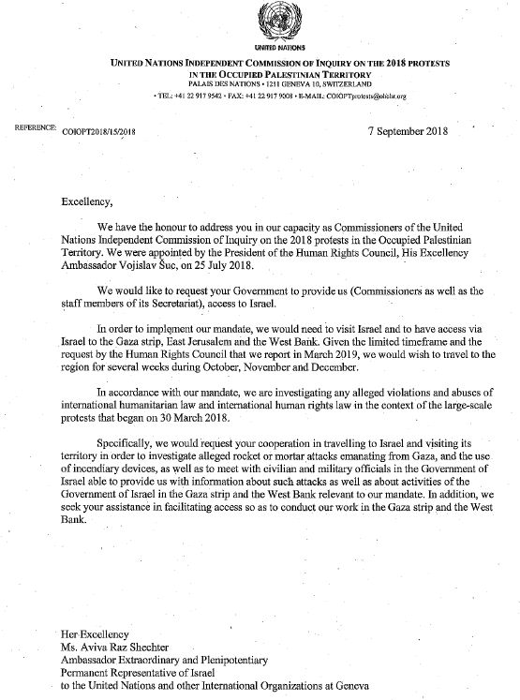

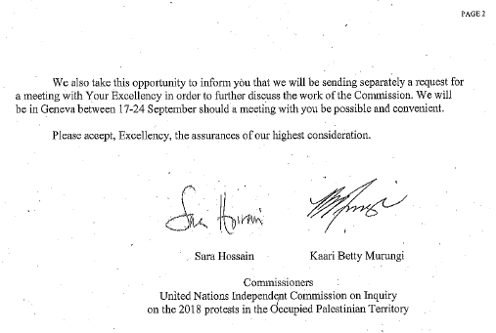

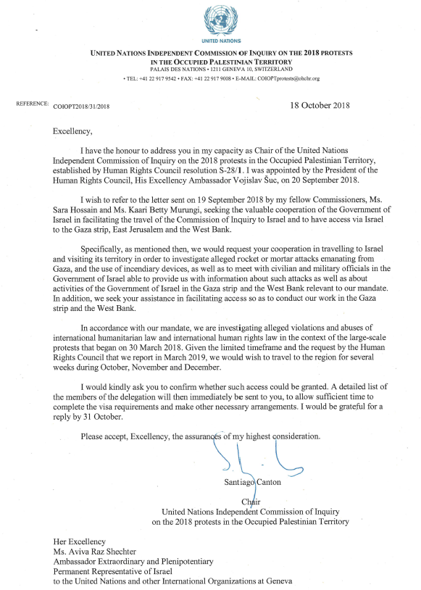

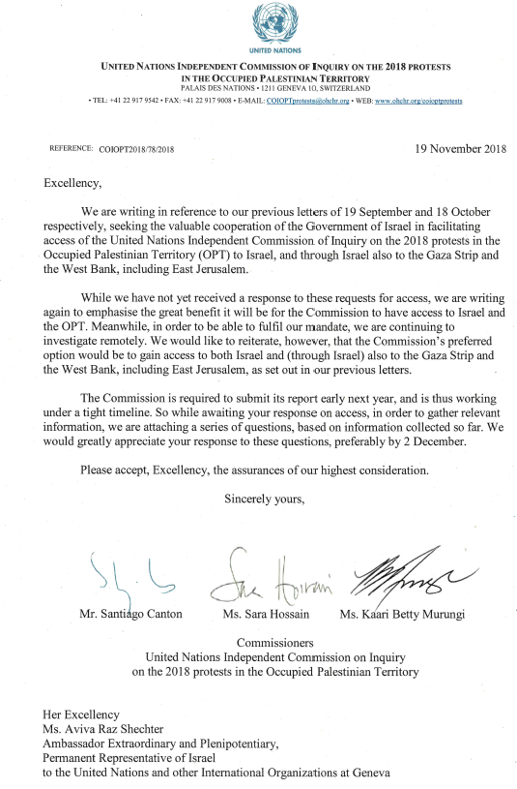

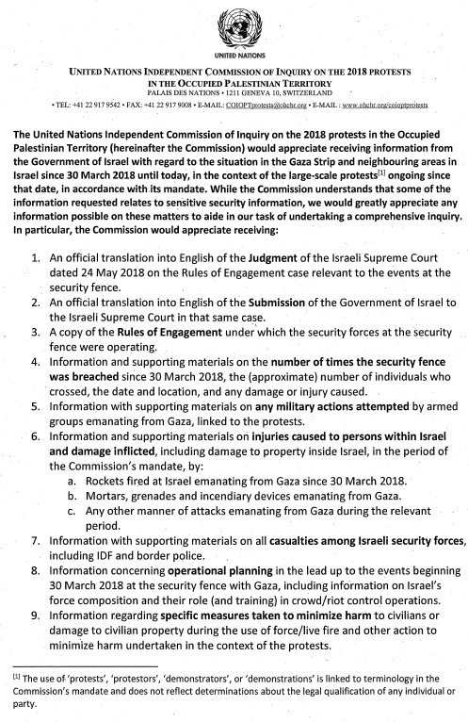

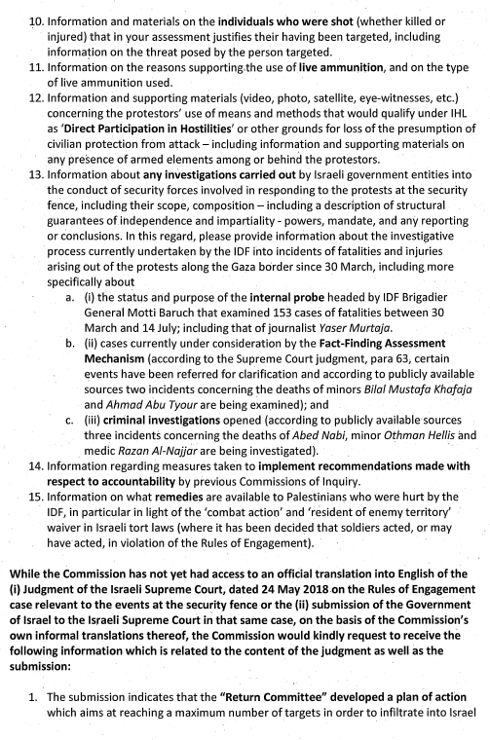

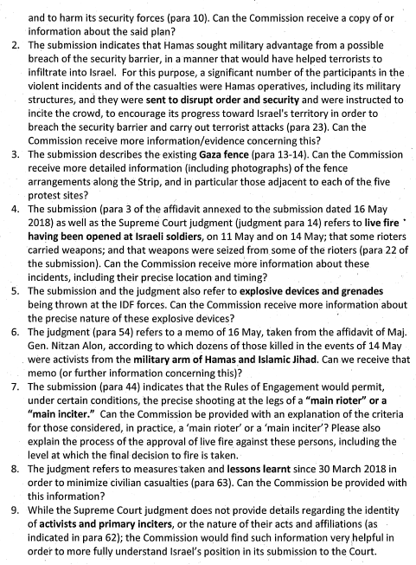

- Correspondence – Egypt

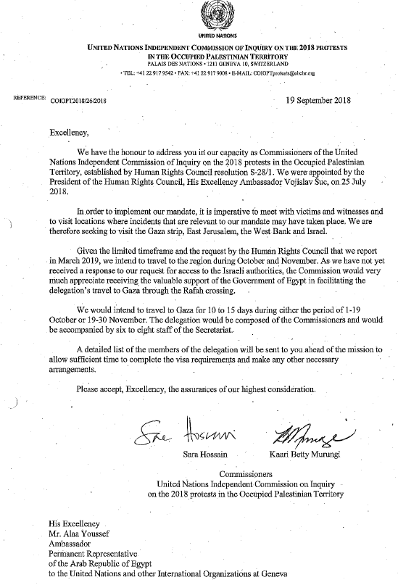

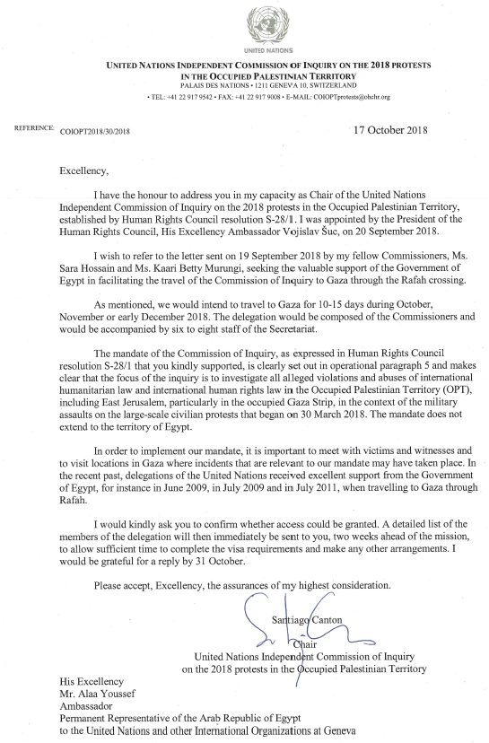

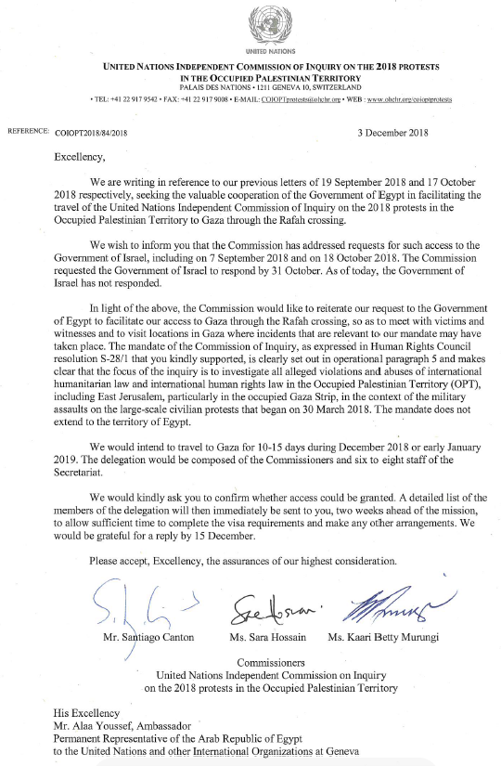

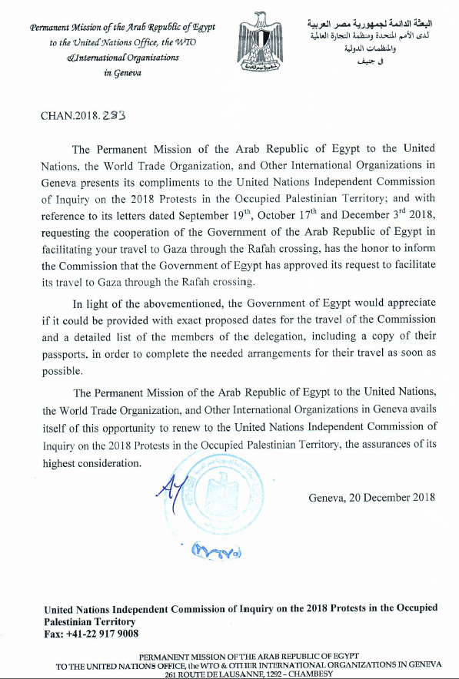

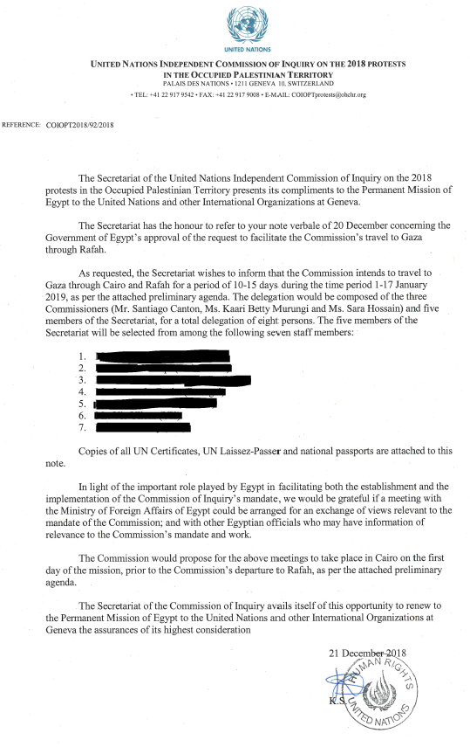

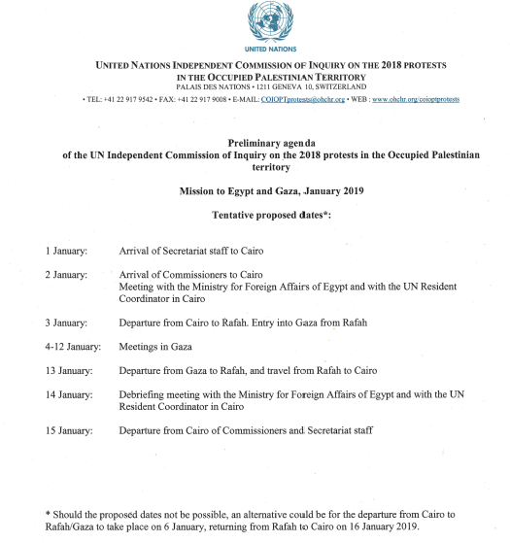

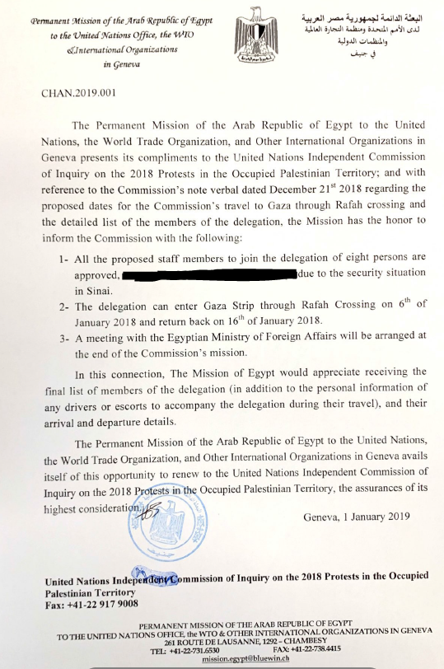

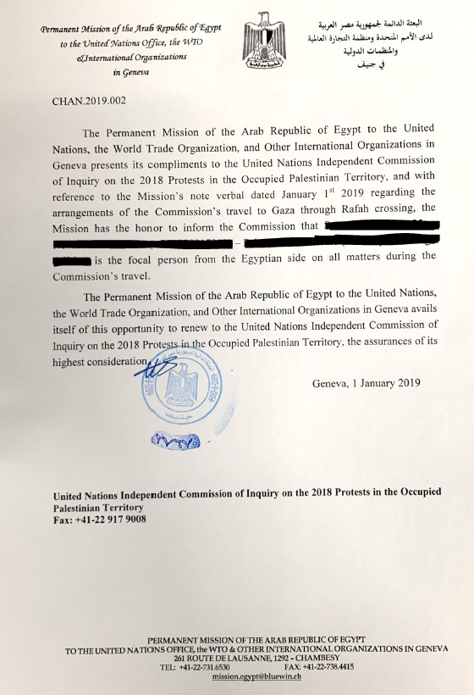

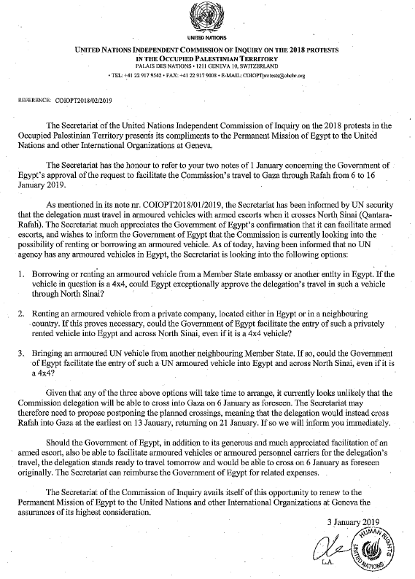

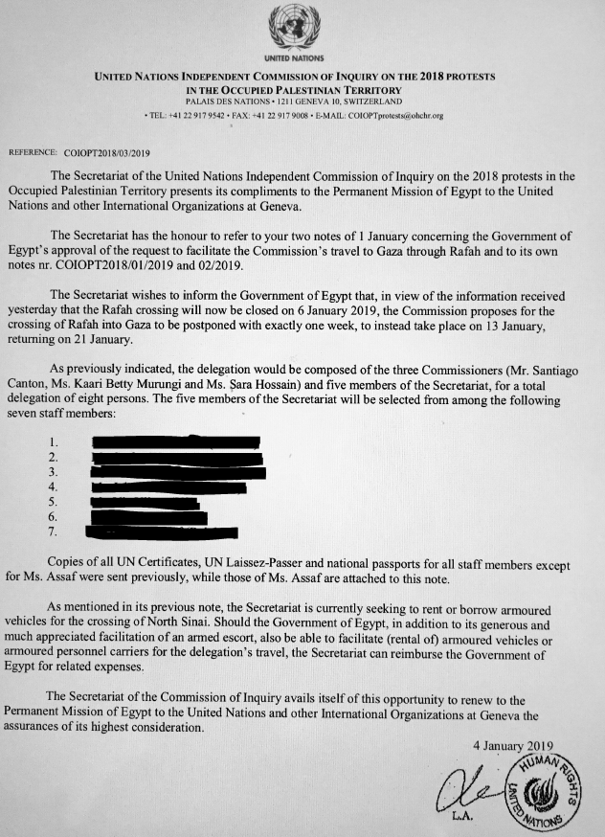

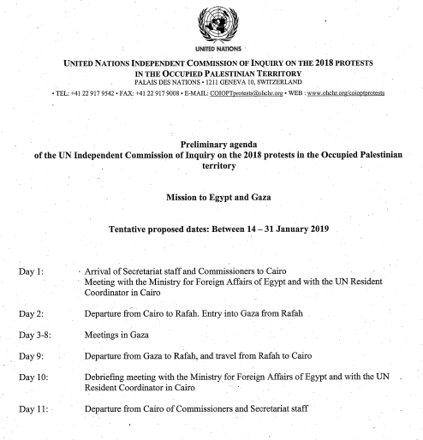
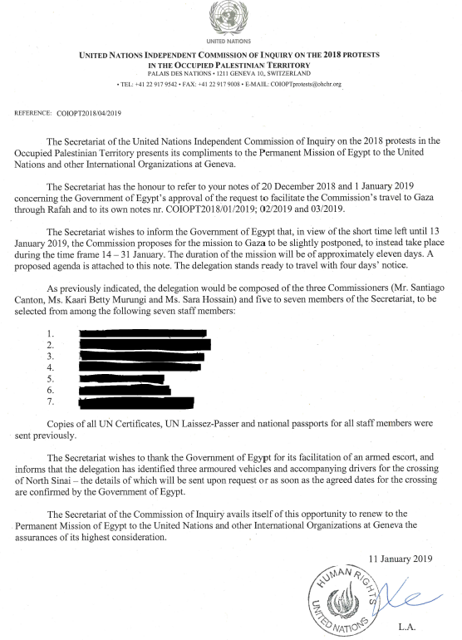
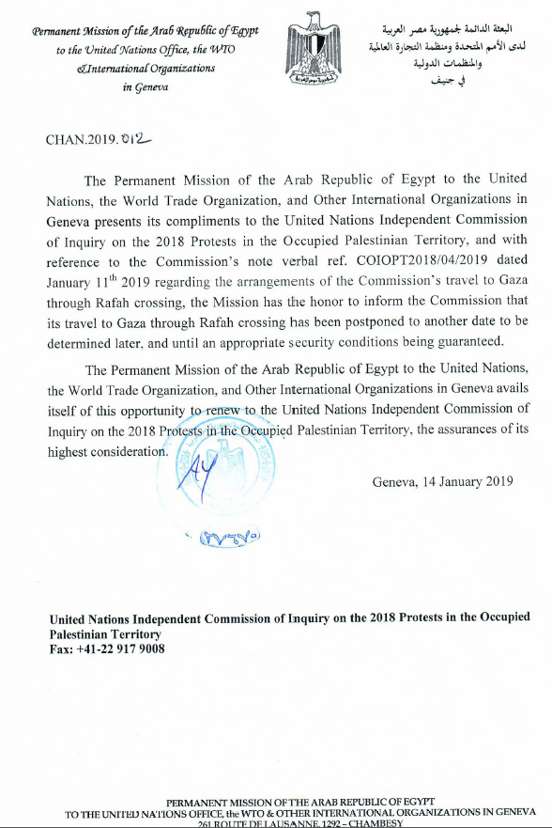

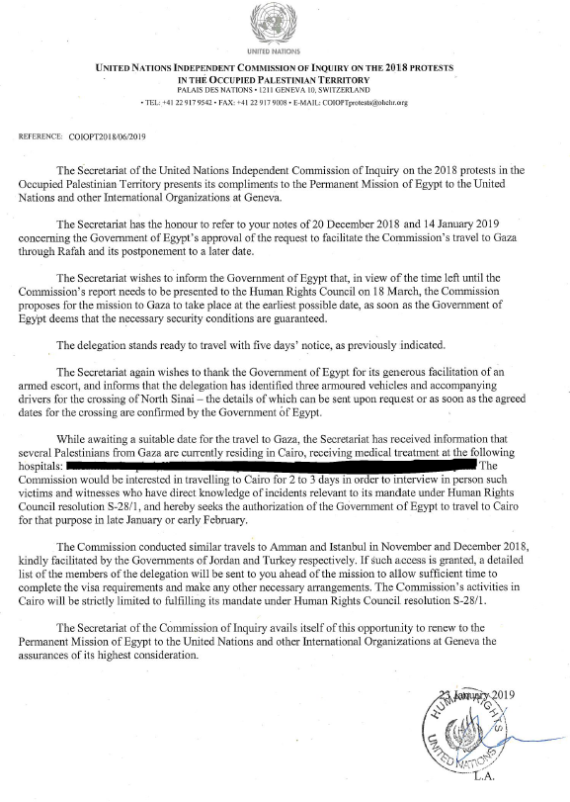

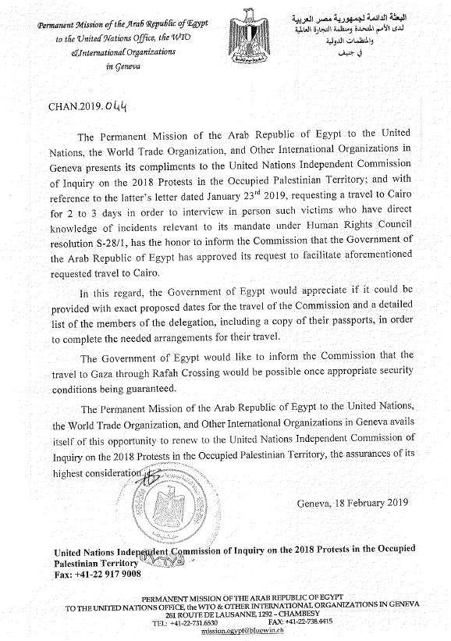

B. Submissions to the Commission of inquiry*

Adalah
Addameer
Al Mezan
Al Haq
Amnesty International
Badil
Colonel (ret.) Richard Kemp on behalf of the High Level Military Group
CUNY
Defense for Children International Palestine
Euro-Med Monitor
Gazan Doctors
Gisha
High Committee of GMR
HNC
HRIA
HRW
ICSPR
Jamie Stern-Weiner
LPHR
Médecins du Monde
Medical Aid for Palestinians
MoH
National Return
NGO Monitor
NRC
OCHA
OHCHR
PCHR
PMRS
POM Palestine Geneva
PRC - Palestinian Return Center
PRCS Palestine Red Crescent Society
PWWSD
Stop the Wall

Special Rapporteur on the rights to freedom of peaceful assembly and of association
Special Rapporteur on extrajudicial, summary or arbitrary executions

Special Rapporteur on the right of everyone to the enjoyment of the highest attainable standard of

physical and mental health
Special Rapporteur on the rights of persons with disabilities

Special Rapporteur on Torture and Other Cruel, Inhuman or Degrading Treatment or Punishment
UK Lawyers for Israel
UN Watch
UNICEF
UNRWA
WCLAC
WHO
Yesh Din

On 25 July 2018, the President of the Council appointed Ms. Hossain, Ms. Murungi and Mr. David Crane (United States), who subsequently resigned on 22 August 2018, and was replaced by Mr. Canton on 20 September 2018.
For the period 30 March – 31 December, the Commission tracked killings and injuries of Palestinian civilians, members of Palestinian organized armed groups, Israeli soldiers and civilians that did not take place at protest sites at protest times, but occurred in the broader context of the ongoing hostilities between Israel and organized armed groups in Gaza. The Commission did not investigate these individual cases since they fell outside its mandate. See the section on “Hostilities outside the GMR” below.
See for example OHCHR, International Commissions of Inquiry and Fact-Finding Missions on International Human Rights Law and International Humanitarian Law - Guidance and Practice (2015).
Secretary-General’s bulletin on information sensitivity, classification and handling, ST/SGB/2007/6.
COIOPT2018/78/2018.
https://www.ohchr.org/coioptprotests
Statute of the International Court of Justice, art 38(1) (“1. The Court, whose function is to decide in accordance with international law such disputes as are submitted to it, shall apply: international conventions, . . .; international custom, . . .; the general principles of law recognized by civilized nations; . . . judicial decisions and the teachings of the most highly qualified publicists of the various nations, as subsidiary means for the determination of rules of law.”).
Both States are parties to CERD, CEDAW, CAT, CESCR, CRPD and CRC, including the CRC’s Optional Protocol on the Involvement of Children in armed conflict (CRC-OPAC). Israel is also party to the CRC-OPSC.
See, for example, ICCPR, art. 2(1); ICESCR, art. 2(1).
Human Rights Committee, General Comment No. 31, para. 7 (“Article 2 requires that States Parties adopt legislative, judicial, administrative, educative and other appropriate measures in order to fulfil their legal obligations.”).
For example, the ICCPR permits a State party to restrict the right “to liberty of movement and freedom to choose his residence,” in article 12(1). Permissible restrictions are delimited in article 12(3).
For example, with respect to the right to privacy, see Human Rights Committee, General Comment No. 31, para. 6 (“Where such restrictions are made, States must demonstrate their necessity and only take such measures as are proportionate to the pursuance of legitimate aims in order to ensure continuous and effective protection of Covenant rights.”).
ICCPR, art. 4(1) (“In time of public emergency which threatens the life of the nation . . . States Parties to the present Covenant may take measures derogating from their obligations . . . to the extent strictly required by the exigencies of the situation.”).
ICESCR art. 12.
Multilateral Treaties Deposited with the Secretary-General: Status as at 31 December 1991, UN Doc. ST/LEG/SER.E/10 (1992) p. 149.
Haaretz, “Knesset Panel Votes to Extend Israel’s State of Emergency,” (12 July 2018). Israel’s declaration does not allow derogation from the freedom of peaceful assembly and could not allow derogation from the right to health.
ICCPR, art. 2. The text continues, “without distinction of any kind, such as race, colour, sex, language, religion, political or other opinion, national or social origin, property, birth or other status.” The Human Rights Committee has interpreted this jurisdictional statement to include activities by state agents also outside the territory, see Communication No. 52/1979, Lopez Burgos v Uruguay, Views of the Human Rights Committee adopted on 29 July 1981, para. 12(3). Another example of territorial reach is in the European Convention on Human Rights as follows, “The High Contracting Parties shall secure to everyone within their jurisdiction the rights and freedoms defined in Section I of this Convention.” (emphasis added), ECHR art. 1.
International Court of Justice (ICJ), Armed Activities on the Territory of the Congo (Democratic Republic of the Congo v. Uganda), Judgment, ICJ Reports 2005, para. 216 (finding international human rights law applicable to State conduct in the exercise of its jurisdiction outside its own territory, particularly in occupied territories) (Hereafter ‘Armed Activities Case’); ICJ, Legal Consequences of the Construction of a Wall in the Occupied Palestinian Territory, Advisory Opinion of 9 July 2004, [2004] ICJ Reports, p. 136, para. 106 (“Wall case”). See Human Rights Committee, General Comment No. 31 on the nature of the legal obligations of States Parties, para. 10 (“States Parties are required by article 2, para. 1, to respect and to ensure the Covenant rights to all persons who may be within their territory and to all persons subject to their jurisdiction. This means that a State party must respect and ensure the rights laid down in the Covenant to anyone within the power or effective control of that State Party, even if not situated within the territory of the State Party.”).
ICJ, Armed Activities Case, paras. 179, 216; ICJ, Wall Case, para. 106; Human Rights Committee, General Comment No. 36, para. 63 (“Furthermore, States Parties must respect and protect the lives of individuals located in territories, which are under their effective control, such as occupied territories, and in territories over which they have assumed an international obligation to apply the Covenant.”). See also Communication No. 1539/2006, Munaf v. Romania, Views of the Human Rights Committee on July 31, 2009, para. 14.2 (“[T]he risk of an extra-territorial violation must be a necessary and foreseeable consequence and must be judged on the knowledge the State party had at the time.”). Where jurisdiction results by the extraterritorial State’s control over citizens of the territorial State, the extent and nature of the obligations is determined by the extent and nature of control exercised. See also European Court of Human Rights, Al Skeini and Others v. The United Kingdom, 7 July 2011, para. 137.
Human Rights Committee, General Comment No. 36, para. 63.
ICJ, Wall Case, pp. 178-181, paras. 107-113 (concluding that international human rights instruments are applicable “in respect of acts done by a State in the exercise of its jurisdiction outside its own territory. . .”). The ICJ referred specifically to the ICCPR and the CRC (and its protocols) in that context. Ibid. para. 217. Similarly, ICJ, Advisory Opinion on the Legality of the Threat or Use of Nuclear Weapons, (1996), para. 25 (“Nuclear Weapons Case”); ICJ, Armed Activities Case, para. 216. Regional human rights courts have also held that States Parties’ obligations may apply outside the borders of its member States, although their jurisdictional statements are different. Both the American Convention and the European Convention of Human Rights apply “to all persons subject to their jurisdiction,” with no mention of territory. For example, the Inter-American Commission on Human Rights, Morales v. Cuba, 29 September 1999, para. 23; para. 25 (“[I]n fact, the Commission would point out that, in certain cases, the exercise of its jurisdiction over extraterritorial events is not only consistent with but required by the applicable rules.”); Coard et al. v the United States, 29 September 1999, para. 37 (same). The European Court of Human Rights too has regularly found the ECHR to apply extraterritorially, see Al-Skeini and Others v. the United Kingdom, 7 July 2011, para. 149; para. 177 (“[I]n these exceptional circumstances, the Court considers that the United Kingdom, through its soldiers engaged in security operations in Basra during the period in question, exercised authority and control over individuals killed in the course of such security operations, so as to establish a jurisdictional link between the deceased and the United Kingdom for the purposes of Article 1 of the Convention.”); Drozd v. France, European Court of Human Rights, 26 June 1992, para. 91 (“[t]he term ‘jurisdiction’ is not limited to the national territory of the High Contracting Parties; their responsibility can be involved because of acts of their authorities producing effects outside their own territory”).
ICJ, Wall Case, para. 111, p. 180.
Human Rights Committee, concluding observations: Israel, CCPR/C/ISR/CO/4, para. 5 (2014).
Ibid.; See also, A/ES-10/794, Report of the Secretary-General on Protection of Palestinian civilian population, para. 36 (“With respect to the treaty bodies, Israel has taken the position that its human rights obligations under the United Nations human rights conventions do not extend to the Occupied Palestinian Territory. All treaty bodies have rejected this position, as has the International Court of Justice, which confirmed the extraterritorial application of the human rights obligations of Israel to the Occupied Palestinian Territory in its 2004 advisory opinion.”).
CAT, art 2(1) (“Each State Party shall take effective legislative, administrative, judicial or other measures to prevent acts of torture in any territory under its jurisdiction.”). It is unclear whether the Convention applies when the victim of acts that fall under the definition of torture is outside the State in question, but the alleged perpetrator is inside the territory and under the jurisdiction of the State Party. To clarify, the United States filed a reservation limiting the scope of CAT “to apply only to acts directed against persons in the offender's custody or physical control.” See UN Treaty Colllection, https://treaties.un.org/pages/ViewDetails.aspx?src=IND&mtdsg_no=IV-9&chapter=4&clang=_en. Neither Israel nor Palestine made a similar reservation.
CRC, art. 2. (“to each child within their jurisdiction.”).
While there is no general jurisdictional statement in the CESCR, its art. 14 states that “Each State Party to the present Covenant which, at the time of becoming a Party, has not been able to secure in its metropolitan territory or other territories under its jurisdiction compulsory primary education . . .”. (emphasis added). The Committee on Economic Social and Cultural Rights has interpreted the Convention to apply to all areas within a State’s jurisdiction, see CESCR General Comment No. 4, para. 13; General Comment No. 12, para. 14.
Committee on Economic, Social and Cultural Rights, concluding observations: Israel, E/C.12/ISR/CO/3, para. 8 (2011).
Wall case, para. 112. This may implicate, for example, the right to health, and the transfer of patients between medical facilities in Gaza and East Jerusalem or the West Bank.
Committee on the Rights of the Child, concluding observations: Israel, CRC/C/ISR/CO/2-4, para. 3 (2013) (“The Committee urges the State party to comply with the advisory opinion of the International Court of Justice on the Legal Consequences of the Construction of a Wall in the OPT... and to abide by its obligations to ensure the full application of the Convention in Israel and in the OPT, including the West Bank, the Gaza Strip as well as in the Occupied Syrian Golan heights.”).
For example, General Assembly Resolution 71/98 of 23 December 2016, preamble (A/RES/71/98) and 72/87 of 14 December 2017, preamble (A/RES/72/87) (“Recalling also the [ICCPR], the [ICESCR] and the [CRC], and affirming that these human rights instruments must be respected in the Occupied Palestinian Territory, including East Jerusalem.”).
For example, A/69/348, para. 5, 25 August 2014; A/HRC/28/44, para. 6, 9 March 2015; A/HRC/34/39 para. 4, 13 April 2017.
For example, A/HRC/8/17, para. 7, 6 June 2008; A/HRC/12/37, para. 5-6, 19 August 2009; A/HRC/28/80, para. 4-5, 2 March 2015; A/HRC/37/43, para. 3, 6 March 2018.
Including the preamble of the Resolution that created this Commission of Inquiry, A/HRC/RES/S-28/1. See also A/HRC/RES/37/35, para. 4; A/HRC/RES/37/37; A/HRC/RES/34/30 preamble and para. 5; A/HRC/RES/31/35; A/HRC/RES/31/34 preamble and para. 5.
A/HRC/12/48 (2009); A/HRC/22/63 (2012); and A/HRC/29/52 (2014).
In addition to the examples set out in the preceding paragraph (ICCPR, ICESCR, CAT and CRC), see Committee on Elimination of Racial Discrimination, CERD/C/ISR/CO/14-16, para. 10 (2012) (mentioning obligations in Occupied Palestinian Territory and Gaza specifically); Committee on the Elimination of Discrimination against Women, concluding observations: Israel, CEDAW/C/ISR/CO/6, (2017), para. 14 (‘Occupied Palestinian Territory over which [Israel] exercises jurisdiction or effective control’).
Human Rights Committee, General Comment No. 36, para. 63. As noted, States parties must respect and protect the lives of individuals “located outside any territory effectively controlled by the State, whose right to life is nonetheless impacted by its military or other activities in a direct and reasonably foreseeable manner.”
A/HRC/8/17 paras. 4, 9 (6 June 2008); A/HRC/29/52 paras. 2, 12, and 17 (24 June 2015) CoI Report; A/HRC/28/45 para. 6 (5 March 2015).
While Hamas could not participate in the ratification process, it has stated that it sees itself bound by these instruments, in particular the ICCPR. United Nations Human Rights Council, ‘Human Rights Situation in Palestine and other Occupied Arab Territories,’ A/HRC/8/17, 6 June 2008; Human Rights Watch, Two Authorities, On Way, Zero Dissent: Arbitrary Arrest and Torture Under the Palestinian Authority and Hamas, Annex VII: Unofficial Translation of Letter from Gaza Internal Security to Human Rights Watch, October 2018 page 129: ‘The Ministry of Interior and National Security is committed to the international human rights treaties that have been ratified by Palestine, in particular the ICCPR and the Convention Against Torture’.
Statute of the International Court of Justice, article 38(1)(b).
See among many others: Vojin Dimitrijevic, Customary Law as an Instrument for the Protection of Human Rights, Istituto per gli Studi di Politica Internazionale, 2006 (Available at https://www.ispionline.it/it/documents/wp_7_2006.pdf); M. Nowak, U.N. Covenant on Civil and Political Rights: CCPR Commentary, N. P. Engel, Kehl/Strasbourg/Arlington, 2005, p. 122; Y. Dinstein, “The Right to Life, Physical Integrity, and Liberty”, in L. Henkin (ed.), The International Bill of Rights: The Covenant on Civil and Political Rights, Columbia University Press, New York, 1981, pp. 114-115. These human rights are also recognized as customary international humanitarian law, see ICRC Customary International Humanitarian law Study, Rule 88 (Non-discrimination); Rule 89 (Violence to life), Rule 90 (Torture and Cruel, Inhuman or Degrading Treatment). For additional sources on the customary nature of these rights see Richard B. Lillich, The Growing Importance of International Human Rights Law, 25 GA. J. INT'L & COMP. L. 1, p. 6. See also American Law Institute’s Restatement (Third) of the Foreign Relations Law of the United States, Part I, Chapter 1, International Law: Character and Source, para. 102 Commentary and illustrations, p. 9, sub para. 7 (“For example, there is now substantial international law on human rights (this Restatement, Part VII), and it is plausible to conclude that a rule against torture is part of international law, since such a principle is common to all major legal systems.”); See John P. Humphrey, The International Bill of Rights: Scope and Implementation, 17 WM. & MARY L. REV. 527 (1976). Professor Humphrey was the first Director of the UN Secretariat’s Division of Human Rights. He wrote of the UDHR already in 1976 that, “the Declaration has been invoked so many times both within and without the United Nations that lawyers now are saying that, whatever the intention of its authors may have been, the Declaration is now part of the customary law of nations and therefore is binding on all states.”
Restatement of the Law: The Foreign Relations Law of the United States, Vol. 2, American Law Institute Publishers, St. Paul, MN, 1987, pp. 161–175. See also David Kretzmer, ‘Targeted killing of suspected terrorists: extra-judicial executions or legitimate means of self-defence?’, in European Journal of International Law, Vol. 16, No. 2, 2005, p. 184-85.
Although the parameters and application of the right is the subject of much debate, the existence of the right itself is not disputed.
See for example article 2(2)(a) of the European Convention on Human Rights (no violation of the right to life where the deprivation of life “results from the use of force, which is no more than absolutely necessary … in defense of any person from unlawful violence.”). See also Jan Arno Hessbruegge, Human Rights and Personal Self- Defense in International Law, Oxford University Press, 2017, p. 8 & 21 (citing as an example, among others, Article 31 (1)(c) of the Rome Statute of the International Criminal Court in which self-defense can be invoked to preclude criminal responsibility).
Where applicable, they provide the sole exception to the monopoly on the use of (lethal) force otherwise reserved to their respective higher jurisdictional orders, i.e., the State - which precludes resort to force by private citizens, and the UN Charter - which precludes the use of force between Member States as per UN Charter article 2(4).
The invocation by a State of the right to self-defense is a question of jus ad bellum. When exercising self-defense, State forces must nevertheless comply with applicable jus in bello frameworks, such as IHL and IHRL. See The International Law Commission, Draft Articles on Responsibility of States for Internationally Wrongful Acts, Report of the International Law Commission, Fifty-Third Session, U.N. Doc. A/56/10 (2001) pp. 59–365, at p. 74 [Art. 21, para. 3 of the commentary] (“As to obligations under international humanitarian law and in relation to non-derogable human rights provisions, [interstate] self-defense does not preclude the wrongfulness of conduct.”). The Inter-American Court of Human Rights shares the view that State-based self-defense may permit going to war, but does not govern how it is to be conducted, see Zambrano Vélez et al. v. Ecuador, Judgment of 4 July 2007, IACtHR Ser. C No. 166, para. 102.
Basic Principles, art. 4 (“Law enforcement officials, in carrying out their duty, shall, as far as possible, apply non-violent means before resorting to the use of force and firearms. They may use force and firearms only if other means remain ineffective or without any promise of achieving the intended result.”). Self-defense principles apply whether in peacetime or armed conflict. See Prosecutor v. Dario Kordic, Mario Cerkez, Case No. IT-95-14/2-T, Judgment, para. 451. See also Report (Part One) of The Public Commission to Examine the Maritime Incident of 31 May 2010 (Turkel Commission), January 2011, http:// www.turkel- committee.gov.il/ files/wordocs// 8707200211english.pdf, at paras. 185 and 189 (“In a law enforcement context (which applies human rights norms), the use of lethal force by state agents is generally permitted in three circumstances: self-defense, defense of others, and enforcement of the law.” . . . [Personal self-defense is] “the sole case where law enforcement agents may, intentionally and without judicial sentence, kill in times of peace.” See also Hessbruegge, p. 221 (“However, even in armed conflict, soldiers may sometimes have to obey the more restrictive law enforcement standards that are informed by international human rights law. This is specifically the case when faced with violence from persons that remain protected under international humanitarian law because they do not participate directly in hostilities. In these situations, the right to personal self-defense becomes particularly relevant, because it is the sole ground that can justify deliberately lethal force against such protected persons.”). The right to self-defense also applies to private individuals, under the same parameters, but is not addressed in this context.
Ibid. See also Direct Participation in Hostilities, infra. During armed conflict, a security personnel may exercise self-defense even where attacking civilians do not cross the threshold of ‘direct participation in hostilities’ and hence remain protected persons under international humanitarian law. The same principles apply when security forces are defending others.
For State agents, the ECHR only allows for deprivation of life in defense against unlawful violence where “absolutely necessary.” See Application no. 23458/02, Giuliani and Gaggio v. Italy, Judgment of the European Court of Human Rights on 24 March 2011, para. 176; Application No. 25052/94, Andronicou and Constantinou v. Cyprus, Judgment of the European Court of Human Rights on 9 October 1997, para. 171. The Inter- American Commission has adopted the same standard, see Landaeta Mejias v. Venezuela, Inter-American Commission of Human Rights, judgment of 27 August 2014, para. 134.
C. Heyns, Remarks at the Geneva Academy, 11 Nov. 2018. For more see, International Committee of the Red Cross, October 2015, “International humanitarian law and the challenges of contemporary armed conflicts”, available at: https://www.icrc.org/en/download/file/15061/32ic-report-on-ihl-and-challenges-of-armed-conflicts.pdf, p.34.
Protocol I relates to the protection of victims of international armed conflicts where Protocol II relates to victims of non-international armed conflicts.
Ministry of Foreign Affairs of the State of Israel, The 2014 Gaza Conflict: Factual and legal aspects, p. 138, para. 234, FN 397 (available at: http://mfa.gov.il/ProtectiveEdge/Pages/default.aspx, accessed 28/10/2018) (“For example, although Israel is not party to the 1907 Hague Convention IV respecting the Laws and Customs of War on Land, it views the Convention as reflecting customary international law and thus its provisions are binding on Israel. Although Israel is also not a party to the 1977 Additional Protocols I and II to the 1949 Geneva Conventions, it abides by their provisions inasmuch as they reflect rules of customary international law.”)
Ibid. That the Hague Convention and its Regulations of 1907 form part of customary law was also the conclusion of the International Court of Justice in the Wall case, para. 89.
ICRC Customary IHL Study, Rule 158.
The Study is available here: https://ihl-databases.icrc.org/customary-ihl/eng/docs/home .
ICRC’s Customary International Humanitarian Law Study has been cited favourably by the Israeli Supreme Court in The Public Committee against Torture in Israel, et. al. v. Government of Israel, et. al., Israeli Supreme Court, sitting as High Court of Justice, HCJ 769/02, judgment of 11 December 2005 (Hereafter Targeted Killings case), at para. 23.
Law and Custom of War on Land (Hague Regulations) 1907, Sect III, art. 42.
Targeted Killings case (citing Israel’s Ministry of Foreign Affairs on the Gaza conflict); see also Peter Maurer, President of the International Committee of the Red Cross, Challenges to international humanitarian law: Israel’s occupation policy, p. 4 (“Israeli Supreme Court has clarified that certain provisions of the Convention as well as the rules of the 1907 Hague Regulations reflect customary IHL and are therefore binding on the authorities in the territories.”). See also the ICJ Wall case, para.101.
Tristan Ferraro, Determining the beginning and end of an occupation under international humanitarian law, International Review of the Red Cross, Vol 94 Number 885 Spring 2012, p. 139.
Ibid. The obligations of an occupying power can be found, inter alia, in Hague Regulations, art. 43, (“The legitimate power having in fact passed into the hands of the occupant, the latter shall take all the measures in his power to restore, and ensure, as far as possible, public order and safety...”) and throughout the Fourth Geneva Convention, for example articles 47-78. Israel has declared that it applies de facto selected ‘humanitarian provisions’ of the Fourth Geneva Convention. Ibid.
See section on context; See also A/HRC/22/63, para. 27.
ICJ, Wall Case, paras. 90-101, 110-113. While at issue in that case was the wall being built around the West Bank, the ICJ found that Israel was the occupying power of all of the OPT, which was understood to include the West Bank, East Jerusalem, and the Gaza Strip. Ibid, para. 114.
Physicians for Human Rights v. Commander of the IDF Forces in the Gaza Strip, HCJ 4764/04, The Supreme Court Sitting as the High Court of Justice, May 30, 2004, para. 10 (“The military operations of the IDF in Rafah, in so far as the local inhabitants are concerned, are governed by the Hague Convention Respecting the Laws and Customs of War on Land, 1907 . . . and the Geneva Convention Relative to the Protection of Civilian Persons in Time of War, 1949.”) and para. 12 referring to obligations of ‘the Occupying Power’ in Southern Gaza, specifically around Rafah.
Ferraro, p. 156. Establishment requiring the physical presence of foreign forces along with their ability to enforce authority over the territory concerned and superseding that of the local authority, without its consent.
Ibid. p. 157. (“The silence of IHL on this very issue is notably due to the fact that occupation usually ends either by force, by agreement, or by a unilateral withdrawal often followed by a related empowerment of the local government. In most of the cases, the foreign forces leaving the occupied territory do not continue – at least without the consent of the local government – to exercise important functions therein.”).
Security Council resolution 2334 (2016), preamble (‘Reaffirming the obligation of Israel, the occupying Power, to abide scrupulously by its legal obligations and responsibilities under the Fourth Geneva Convention’); Security Council resolution 1860 (2009), preamble (“Stressing that the Gaza Strip constitutes an integral part of the territory occupied in 1967 and will be a part of the Palestinian state. . .”). See also older resolutions of the Security Council, predating the disengagement, for example SC resolution 478 (1980), para. 2 (“Affirms that [legislation enacted] constitutes a violation of international law and does not affect the continued application of the Geneva Convention relative to the Protection of Civilian Persons in Time of War, of 12 August 1949, in the Palestinian and other Arab territories occupied since June 1967, including Jerusalem;”), Secutiy Council resolution 476 (1980) (same).
UNGA Res A/C.4/73/L.16, 14 Nov 2018 (“Occupied Palestinian Territory, including East Jerusalem, particularly in the refugee camps in the Gaza Strip”); UNGA resolution 72/85, of 7 December 2017 on the “Applicability of the Geneva Convention relative to the Protection of Civilian Persons in Time of War, of 12 August 1949, to the Occupied Palestinian Territory, including East Jerusalem, and the other occupied Arab territories.” See also General Assembly Resolutions 63/98, para. 9 and 64/94, para. 4, among others. See also Report of the Special Committee to Investigate Israeli Practices Affecting the Human Rights of the Palestinian People and Other Arabs of the Occupied Territories, A/64/339, 9 September 2009, para. 2.
Declaration of 17 December 2014 adopted by the Conference of High Contracting Parties to the Fourth Geneva Convention, para. 4 (“The participating High Contracting Parties . . . call on the occupying Power to fully and effectively respect the Fourth Geneva Convention in the Occupied Palestinian Territory, including East Jerusalem.”) and para. 8 (“They equally express their deep concern, . . . about certain measures taken by the Occupying Power in the Occupied Palestinian Territory, including the closure of the Gaza Strip.”)
Peter Maurer, President of the International Committee of the Red Cross, Challenges to international humanitarian law: Israel’s occupation policy, (2012), p. 2-6.
Maurer, p. 6. The Commission is aware that the Israeli Supreme Court, sitting as the High Court of Justice, stated in obiter dictum, that Israel’s disengagement from Gaza in 2005 resulted in the end of Israel’s ‘effective control,’ and thus the occupation. This finding came in a lawsuit filed to challenge cuts in the amount of diesel fuel – used to supply electricity to hospitals and homes – that the State of Israel was permitting into Gaza and whether the cuts allowed for Gaza’s ‘essential humanitarian needs,’ the minimum required by the laws of war. Israeli Supreme Court, Al-Bassiouni Ahmed and others v Israeli Prime Minister and Minister of Defence, HCJ 9132/07 (2008), paras. 12-13. The Commission notes that irrespective of whether restrictions, closures, the complete control of Gaza’s airspace and the imposition of the naval blockade are justifiable for Israel’s security needs, these measures are indicators of ‘effective control.’ See Section in this report on blockade.
The Commission’s finding that IHL applies due to the armed conflict is without prejudice to the existence of an occupation (see above). Nothing in international law precludes there being multiple bases for the application of IHL.
The Israeli government has stated during the 2014 hostilities in Gaza between Palestinian armed groups and the IDF, that due to the potential for the conflict to be classified under either regime, “Israel conducted its military operations . . . in accordance with the rules of the Law of Armed Conflict governing both international and non-international armed conflicts.” See Israel, Ministry of Foreign Affairs, The 2014 Gaza Conflict: Factual and Legal Aspects, IDF Conduct During the 2014 Gaza Conflict, p. 1. http://mfa.gov.il/MFA/ForeignPolicy/IsraelGaza2014/Pages/2014-Gaza-Conflict-Factual-and-Legal-Aspects.aspx, accessed on 20 Jan 2019.
Rome Statute art. 12.
Rome Statute, art. 7.
Grave Breaches regimes are set out in all four Geneva Conventions. For example, see article 130 of GC III and article 147 of GC IV. Violations of common Article 3 of the four Geneva Conventions may also form the basis for war crimes prosecutions in non-international armed conflicts, as may violations of customary international humanitarian law.
Rome Statute art. 7.
International Law Commission, Draft Code of Crimes against the Peace and Security of Mankind, 1996 (ILC Draft Code), Article 18, commentary para. 4; see also Kenya Authorization decision, para. 95.
Kenya Authorization decision, 31 March 2010, para. 96; Prosecutor v. Blaskic, IT-95-14-A, Judgment, 29 July 2004, para. 101.
ICC, Situation in the Democratic Republic of Congo, The Prosecutor v. Gemain Katanga, Judgment pursuant to article 74 of the Statute, ICC-01/04-01/07-3436, 7 March 2014, para. 1111. See also Tadic Trial Chamber Judgment (IT-94-1-T), para. 653.
Ibid. paras. 1106-1113.
The Israeli Supreme Court, sitting as High Court of Justice, addressed precisely this issue in a ruling on the legality of the IDF’s rules of engagement, see supra.
As noted, self-defense, as a legal justification for the use of force, may also be relevant in the sense of jus in bello, yet its application must nevertheless comply with the two other legal frameworks: IHL and IHRL.
UN Charter, preamble.
Convention (III) relative to the Treatment of Prisoners of War, Geneva, 12 August 1949, Art 16.
Article Three Common to the Geneva Conventions, and Additional Protocols I and II.
Additional protocol I, art 1(2), also known as the Marten’s Clause. For other principles of IHL see the ICRC Customary International Humanitarian Law Study, Rules 1–15.
Legal Consequences of the Wall.
Legal Consequences of the Wall, para. 106; see also Legality of the Threat or Use of Nuclear Weapons, Advisory Opinion of 8 July 1996, I.C.J. Reports 1996, p. 226, para. 25.
Legality of the Threat or Use of Nuclear Weapons, Advisory Opinion of 8 July 1996, I.C.J. Reports 1996, para. 25 (emphasis added)
The Human Rights Committee’s view is that “both spheres of law are complementary, not mutually exclusive,” General Comment 31, para 11. See also HRC General Comment 29, para. 3.
Legal Consequences of the Wall, para. 106. This view is supported by many scholars and practitioners, see for example K. Watkin, “Use of Force during Occupation: Law Enforcement and Conduct of Hostilities,” International Review of the Red Cross, Vol. 94, No. 885, Spring 2012, p. 275 (“Therefore, the inhabitant’s rights to life, and other rights, are protected under both IHL and human rights law.”)
The Commission has noted above the jurisprudence of the ICJ Wall, Nuclear Weapons, and Armed Activities cases, holding that both IHL and IHRL frameworks apply, including concurrently, during periods of armed conflict and occupation – a position supported by the relevant treaty bodies and regional human rights jurisprudence. See also ICRC’s Expert Meeting: The Use of Force in Armed Conflicts – Interplay between the Conduct of Hostilities and Law Enforcement Paradigms (Report of the Experts workshop, prepared and edited by Gloria Gaggioli, Legal Adviser, 2013), p. 1 (“Use of Force in Armed Conflicts – Interplay”). ICRC, International Humanitarian Law and the Challenges of Contemporary Armed Conflicts, 31 Oct 2015, p.36. Similar law enforcement principles exist in domestic legal systems globally, and so can be understood as general principles of international law of the nature referred to in Article 38 of the Statute of the International Court of Justice. See K. Watkin, “Use of Force during Occupation: Law Enforcement and Conduct of Hostilities,” International Review of the Red Cross, Vol. 94, No. 885, Spring 2012, p. 304. Watkin also noted that, “In this respect, the human rights-based law enforcement norms operate within both the international human rights and the humanitarian law frameworks.” Ibid. p. 268.
Ibid. See also Israeli Supreme Court ROE Case, Concurrence of President Hayut, para. 4. Israeli Government submission to the Supreme Court, para. 32 and 73 (while accepting law enforcement principles are applicable during armed conflict, rejecting that those principles derive from IHRL), Murray et al, Practitioners Guide to Human Rights in Armed Conflict (OUP 2016), see also supra ICJ Wall, Nuclear Weapons cases.
Unless otherwise specified, in this report the ‘use of force’ refers to intentionally lethal or potentially lethal force, including the use of firearms, aimed at the human body. It may also refer to less-lethal, yet still coercive, force such as rubber bullets, teargas, water cannons and similar measures which, although ‘forceful’, are not generally understood to be lethal, unless misapplied or applied against particularly susceptible individuals. Although inapposite in this context, the use of force may include other physical means of force ranging from merely touching a person to restraining, hitting, or kicking, etc.
UDHR art 3; ICCPR art 6. Human Rights law prohibits a State from taking a life arbitrarily, but the deprivation of life in certain, narrowly defined, circumstances may not be arbitrary.
ICCPR art. 7, CAT art. 1.
The term ‘civilians’ is not ordinarily part of human rights law, but is used here for clarity and contradistinction to those involved in military operations, in light of the Commission’s determination that IHL also applies. Further, ‘civilian’ as used here, refers to civilians who are not directly participating in hostilities (see below), unless specified as such.
Subject to the lex specialis of IHL as set out above.
Hessbruegge, p. 221-223. This is all the more the case in modern, often asymmetrical, warfare that regularly takes place in urban environments.
See Hague Regulations, art. 43, (“The legitimate power having in fact passed into the hands of the occupant, the latter shall take all the measures in his power to restore, and ensure, as far as possible, public order and safety. . .”). The Supreme Court of Israel also cited this provision, as support for the notion that IHL contained its own law enforcement paradigm. It also cited art. 42 of the Third Geneva Convention (“The use of weapons against prisoners of war, especially against those who are escaping or attempting to escape, shall constitute an extreme measure, which shall always be preceded by warnings appropriate to the circumstances.”). These two references, plus a citation to the Turkel Report One, para. 234 (“Each use of force was assessed according to the applicable law - international humanitarian law. According to that legal regime, the use of force against civilians who are not taking a direct part in hostilities is governed by law enforcement norms, whereas direct participants can be targeted for such time they are taking part in hostilities.”), comprised the basis for the Court’s determination. That the content of the ‘law enforcement norms’ are informed by IHRL was not mentioned by the court, likely because the Hague and Geneva law pre-date Conventional IHRL. However, the Commission shares the view of most scholars that law enforcement principles of necessity and proportionality in the use of force against civilians not directly participating in hostilities are those that evolved through IHRL, and apply even during armed conflict. Use of Force in Armed Conflicts - Interplay, p. 35. Judge Turkel observed the same elsewhere in his report, para. 189 page. 233 (“Any use of force against civilians who are not taking a direct part in hostilities, is guided by the principles of “necessity” and use of “proportionate force” associated with human rights-based law enforcement norms.”).
Legitimate purposes include to prevent serious crime, to maintain public order, or to carry out lawful arrests. See Basic Principles on the Use of Force and Firearms, principle 5 (Hereafter: Basic Principles); Code of Conduct for Law Enforcement Officials, art. 3. These two ‘soft-law’ instruments reflect binding international law, see the report by the Special Rapporteur, A/HRC/14/24, para. 35. The Commission does not take a position on whether the Basic Principles themselves have ‘binding force’, but accepts that they reflect law enforcement standards that have become customary international law. See also European Court of Human Rights, Grand Chamber, Application No. 43577/98, 43579/98, Nachova and Others v Bulgaria, Judgment of 6 July 2005, paras. 95-96 (referring to the Basic Principles as the “relevant international standards” when determining when deprivation of life may be justified under ECHR’s Article 2). In November 2014, the Human Rights Committee called on Israel to “[t]ake all necessary measures to prevent incidents of excessive use of force during law enforcement operations, including by ensuring that rules of engagement or open fire regulations of the State party’s security forces in the West Bank, including East Jerusalem, and the Access Restricted Areas of Gaza, are consistent with article 6 of the Covenant and the Basic Principles on the Use of Force and Firearms by Law Enforcement Officials”, see CCPR/C/ISR/CO/4, para 13(a).
A/HRC/26/36, para. 63. Application No. 18984/91, McCann and Others v. the United Kingdom, Judgment of the European Court of Human Rights, 27 September 1995.
General Comment No. 36, paras. 20; Force may only be used as a last resort, when other measures have failed and alternative measures will not suffice, see Basic Principles on the Use of Force and Firearms, principles 4 and 5; Code of Conduct for Law Enforcement Officials, art. 3. An obligation to take feasible precautions to minimize the necessity to use force has been identified by the European Court of Human Rights, see, McCann et al v UK, Grand Chamber, Judgment, 27 September 1995, para. 194 (“[W]hether the anti-terrorist operation was planned and controlled by the authorities so as to minimise, to the greatest extent possible, recourse to lethal force.”). See also UN Special Rapporteur on extrajudicial, summary or arbitrary executions, Christof Heyns, A/HRC/26/36, 1 April 2014, para. 63 (“[A]ll possible measures should be taken “upstream” to avoid situations where the decision on whether to pull the trigger arises.”). Law enforcement officials shall identify themselves as such and give a clear warning of their intent to use firearms, according to the Basic Principles.
Communications No. 687/1996, Rojas García v. Colombia, Views adopted by the Human Rights Committee on 3 April 2001, paras. 2.1 and 10.5; and No. 731/1996, Robinson v. Jamaica, Views adopted by the Human Rights Committee on 29 March 2000, para. 10.3; Inter-American Court of Human Rights, Montero Aranguren et al (Detention Center of Catia) v. Venezuela, Judgment of 5 July 2006, Series C, No. 150, para. 67. Human Rights Committee, General Comment No. 36, para. 20; Basic Principles on the Use of Force and Firearms, principle 5 (a) and (b); Code of Conduct for Law Enforcement Officials, art. 3.
Hessbruegge, p. 171.
Human Rights Committee, General Comment No. 36, para. 12 (Potentially lethal force “may not be used, for example, in order to prevent the escape from custody of a suspected criminal or a convict who does not pose a serious and imminent threat to the lives or bodily integrity of others.”). See also the Basic Principles on the Use of Force and Firearms, principle 9. (The use of firearms is authorized in extremely limited circumstances, namely in “self-defence or defence of others against the imminent threat of death or serious injury, to prevent the perpetration of a particularly serious crime involving grave threat to life, to arrest a person presenting such a danger and resisting their authority, or to prevent his or her escape, and only when less extreme means are insufficient to achieve these objectives.”).
Basic Principles on the Use of Force and Firearms, principle 9. See also Human Rights Committee, General Comment No. 36, para. 12 (“The intentional taking of life by any means is permissible only if it is strictly necessary in order to protect life from an imminent threat.”). Outside law enforcement operations, the only other situations in which State agents may use lethal force are to execute capital punishment in strict compliance with international law and standards, and in situations of armed conflict in accordance with the requirements of international humanitarian law (see below).
Basic Principles, article 9.
Hessbruegge, p. 139-142.
Ibid.
Report of the Special Rapporteur on extrajudicial, summary or arbitrary executions, Christof Heyns, A/HRC/26/36, 1 April 2014, para. 59.
Geneva Academy, Use of Force in Law Enforcement and the Right to Life: The Role of the Human Rights Council, November 2016, p. 14; See also Human Rights Committee, Concluding Observations: Israel, CCPR/CO/ISR/2, (2003), para. 15. (“Before resorting to the use of deadly force, all measures to arrest a person suspected of being in the process of committing acts of terror must be exhausted.”).
Application No. 18984/91, McCann et al. v. United Kingdom, ECHR Grand Chamber, Judgment of 29 September 1995, para. 200; 1928 Naulilaa arbitration (Portugal v. Germany), 2 Reports of International Arbitral Awards 1012 (1928), at p. 1025. See also Hessbruegge, p. 133. Care should be taken not to lower this assessment to whether the use of force was reasonable. The assessment is whether the officer’s belief in the imminence of the threat was honest and reasonable.
Interpretive Guidance supra, p. 43; Report on Expert Meeting, Use of Force in Armed Conflicts - Interplay, p. 35. Presupposing compliance with jus ad bellum, the use of force during armed conflict is foreseen within the concept of military necessity. Military necessity has been articulated in various forms, but at its core is a justification to resort to all measures which are indispensable (i.e. necessary) for defeating the enemy and which are not forbidden by the laws and customs of war. Destroying an enemy’s military equipment and personnel are not illegal under the law of war. See Lieber Code arts. 14 and 15. See also US Department of Defense, Law of War Manual, Vol 1, Sec. 2.2, June 2015 (Update of 31 May 2016).
See supra, section on Fundamental IHL principles related to the conduct of hostilities. While other lawful targets exist, the focus here is on using force against (targetable) human beings.
ICRC, Customary international humanitarian law study, Rule 9.
ICRC, Customary international humanitarian law study, Rule 14. Note that the Rome Statute requires the damage to be ‘clearly excessive’ in relation to the anticipated military advantage, see Elements of Crimes, Article 8 (2) (b) (iv).
ICRC, Customary international humanitarian law study, Rules 15-21.
In the US Army’s 1914 Rules of Land Warfare, paras. 9-11, the principle is expressed as follows: “A belligerent is justified in applying any amount and any kind of force which is necessary for the purpose of the war; that is, the complete submission of the enemy at the earliest possible moment with the least expenditure of men and money. . . Military necessity justifies a resort to all measures which are indispensable for securing this object and which are not forbidden by the modern laws and customs of war.”
Art. 1 Common to the Geneva Conventions.
ICRC Commentary to Art. 1 common to the GC, 2016, para.154; Declaration of the Conference of the High Contracting Parties to GC IV, 5 December 2001, para.4; ICJ Wall case, para. 158-159 and ICJ Nicaragua Case, para. 220.
See e.g. S/RES/2334(2016) and S/RES/465(1980); A/RES/70/89, OP 9 and 10; Declaration of the Conference of the High Contracting Parties to GC IV, 17 December 2014, para.4.
Article 51(3) of Additional Protocol I and article 13(3) of Additional Protocol II. See also ICRC, Interpretive Guidance on the Notion of Direct Participation in Hostilities under International Humanitarian Law. ICRC Customary IHL Study, Rule 6. Targeted Killings case, para. 30.
ICRC, Interpretive Guidance on the Notion of Direct Participation in Hostilities under International Humanitarian Law, p. 66-68; See also Israeli Supreme Court, Targeted Killing case, at para. 30. The Court observed that a civilian who generally supports the hostilities is not taking a direct part, while “a civilian bearing arms (openly or concealed) who is on his way to the place where he will use them against the army, at such place, or on his way back from it, is a civilian taking "an active part" in the hostilities….”) Ibid. para. 34.
ICRC, Interpretive Guidance on the Notion of Direct Participation in Hostilities under International Humanitarian Law, p. 46.
Ibid.Targeted Killing case, para. 33 (acts intended to cause damage to the army) (citing Y. Sandoz et al. Commentary on the Additional Protocols, p. 618 (1987)). “Hostile acts should be understood to be acts which by their nature and purpose are intended to cause actual harm to the personnel and equipment of the armed forces.” Interpretative Guidance, p. 44 (“An example of indirect harm or ‘general support’ would be building train tracks that later carry a train car full of weapons to the front lines of battle, or undertaking media activities or distributing political propaganda in support of one side. Regarding taking part in hostilities, there is no condition that the civilian use his weapon, nor is there a condition that he bear arms (openly or concealed). It is possible to take part in hostilities without using weapons at all.”) This view is contested by others, for example see the US Department of Defense, Law of War Manual, June 2015, Chapter 5.8, p. 226-236, where the definitional elements exceed these to the extent that planning operations and sending others to undertake them, are considered ‘direct participation.’
Melzer, Targeted killing in International Law, Oxford, 2008, p. 343-44. Targeted killings case, para. 35. “[T]he following cases should also be included in the definition of taking a "direct part" in hostilities: a person who collects intelligence on the army, whether on issues regarding the hostilities or beyond those issues; a person who transports unlawful combatants to or from the place where the hostilities are taking place; a person who operates weapons which unlawful combatants use, or supervises their operation, or provides service to them, be the distance from the battlefield as it may”. (citations omitted)
The Commission notes that the Israeli Supreme Court accepted the customary status of Direct Participation in Hostilities despite Israel not being party to Additional Protocol I. See Israeli Supreme Court, Targeted Killing case, at para. 30. The Court observed that a civilian who generally supports the hostilities is not taking a direct part, while “a civilian bearing arms (openly or concealed) who is on his way to the place where he will use them against the army, at such place, or on his way back from it, is a civilian taking "an active part" in the hostilities….”) Ibid. para. 34.
ICRC, Interpretive Guidance on the Notion of Direct Participation in Hostilities under International Humanitarian Law, p. 63.
Some suggest the definition is too broad, others that it is too narrow, see for example, Report of the Special Rapporteur on extrajudicial, summary or arbitrary executions, Addendum: Study on targeted killings, A/HRC/14/24/Add 6, 28 May 2010, para 65; D. Akande, “Clearing the Fog of War? The ICRC's Interpretive Guidance on Direct Participation in Hostilities,” The International and Comparative Law Quarterly, vol. 59, no. 1, 2010, pp. 180–192, P188; S. Bosch. “The International Humanitarian Law Notion of Direct Participation in Hostilities – A Review of the ICRC Interpretive Guide and Subsequent Debate,” Potchefstroom Electronic Law Journal, vol. 17, no. 2, 2014, pp. 999-1046, p. 1039; J. Merriam and M. Schmitt, “Israeli Targeting: A Legal Appraisal,” Naval War College Review, vol. 68, no. 4, 2015, pp. 14–33, p. 23; B. Boothby, “And for Such Time as: The Time Dimension to Direct Participation in Hostilities,” New York University Journal of International Law and Politics vol. 42, no. 3 (Spring 2010): p. 741-768, p. 767; M. Schmitt, “Deconstructing Direct Participation in Hostilities: The Constitutive Elements,” New York University Journal of International Law and Politics, vol. 42, no. 3 (Spring 2010), p. 697-740, p. 738.
Ibid.
Under the law enforcement paradigm neither an individual’s membership in an armed group (alleged or proven) nor past behaviour, including posing with firearms, bears on the lawfulness of using lethal force against them. The applicable test remains whether the individual, at the time of their targeting, posed an imminent threat to life or was directly participating in hostilities.
Additional Protocol I, para. 50(1); for analysis of DPH in practice, see Israeli Supreme Court, Targeted Killing case, para. 40. The Commission recognizes that this presumption, as set out in AP I para. 50(1), applies to the distinction between civilians and combatants (art. 43) in international armed conflict. Nevertheless, were an armed conflict in this context classified as non-international, in situations of doubt, “a careful assessment [should] be made under the conditions and restraints governing a particular situation as to whether there are sufficient indications to warrant an attack. One cannot automatically attack anyone who might appear dubious. . . . In the case of non-international armed conflicts, . . . the same balanced approach . . . seems justified.” See ICRC Customary IHL Study, Rule 6. See also, ICRC Interplay, pp. 24-25.
The ‘principle of distinction’ applies as between members of the military and civilians. Civilians are negatively defined. See ICRC Customary IHL Study, Rule 5. By definition, all persons who are not members of the armed forces, are civilians.
See Supra, section on IHRL and the use of force: Law enforcement paradigm. See also Human Rights Committee, General Comment No 36, paras. 12, 19 and 21; Turkel Commission (Part One), para. 189, 191.
Hereafter, the Commission uses the term ‘civilians’ to denote those in Category 2 and against whom the application of any force is subject to an escalation of force procedure. For those in Category 1 and 2(a), the Commission refers to ‘targetable individuals’ meaning that that application to them of potentially lethal force is not unlawful so long as all additional IHL principles are respected.
In its judgment, the Israeli Supreme Court noted “The war on terror and on the terrorist organizations faces Israel – and in recent years also other countries around the world – with challenges which are not simple when dealing with complex scenarios which do not clearly fall into one of the two categories that were stated above – an act of ‘combat’ or an act of ‘law enforcement,” Concurrence of President Hayut, para. 4 (citing, among others, Kenneth Watkin, Yuval Shany and the Turkel Commission Report, who in turn cited the ICRC Expert Report.).
See Use of Force in Armed Conflicts – Interplay, Scenario B, p. 24 (“Riots are generally not considered as amounting to direct participation in hostilities, regardless of how violent they might be and of the reasons for which the civilian population reacts violently. . . However, fighters may take advantage of riots in order to hide in the crowd and attack the enemy. For the State authorities, it may then be difficult, or even impossible, to distinguish between fighters and rioters.”).
ICRC, International Humanitarian Law and the Challenges of Contemporary Armed Conflicts, 30 October 2015, p. 36.
A rioting civilian is ‘directly participating in hostilities’ if their conduct meets the three-part test set out above. The conduct must meet the threshold of harm, it must directly cause that harm (generally supporting the war effort, does not suffice) and there must be a nexus to the harm and a party to the conflict. An example set out in a footnote of ICRC’s Use of Force in Armed Conflicts – Interplay report is a riot led by the enemy in order to destroy the military equipment of the State’s armed forces or in order to divert attention of the armed forces to help the conduct of a military operation in a nearby village. See Use of Force in Armed Conflicts – Interplay, p. 26, FN 70.
Ibid. Against violent/rioting civilians an escalation of force procedure must be employed, consisting of warnings, minimal force, less-lethal measures, with lethal force only employed upon an imminent threat to life.
Targeting the individual must comply, inter alia, with the IHL principle of proportionality. Shooting someone in a crowd would pose foreseeable risks to the others in the crowd, risks which cannot be excessive in relation to the military benefit anticipated from killing the targeted individual. The attack against the targeted individual must be aborted if the foreseeable civilian harm would be excessive.
If a person posing an ‘imminent threat’ does not do so with a ‘belligerent nexus’ to hostilities (as was the case on one occasion in this context), then force under the law enforcement paradigm, and not conduct of hostilities, would be permissible.
United Nations Country Team in the Occupied Palestinian Territory, Gaza Ten Years Later, July 2017, page 3, para 3.
Since the First Intifada in the early 1990s, Israel has required Palestinians in the Occupied Palestinian Territory to obtain a special travel permit from Israeli military authorities in order to travel from Gaza to the West Bank, through Israel. United Nations Country Team in the Occupied Palestinian Territory, “Gaza Ten Years Later”, (July 2017), page 7, and B’Tselem, “The Gaza Strip” (11 November 2017).
In 2000, with the Second Intifada, the movement of Palestinians through the Erez and Rafah crossings was restricted on the grounds of security.
OCHA, The Gaza Strip, https://www.ochaopt.org/location/gaza-strip%20
See for example interviews IBI002, KHI004, MBI006, MBI010, NMI012.
E.g. interviews MBI005, ODM010, ODM009, MBI009, HQI056, NMI004, TXI012, NMI017, MBI002.
Covenant of the League of Nations, article 22.
Preamble and article 2 of the mandate, available at http://avalon.law.yale.edu/20th_century/palmanda.asp
A/AC.14/8, 2 October 1947 (Memorandum by His Britannic Majesty's Government presented in 1947 to the United Nations Special Committee on Palestine Published at Jerusalem, 1947).
Summary of the report of the Palestine Royal Commission presented by the Secretary of State for the Colonies to the United Kingdom Parliament by Command of His Britannic Majesty, July 1937, retreived at https://www.un.org/unispal/document/plan-of-partition-summary-of-the-uk-palestine-royal-commission-peel-commission-report-league-of-nations-non-un-document/
The Declaration of Independence stated that the new nation would be “be based on freedom, justice and peace as envisaged by the prophets of Israel; it will ensure complete equality of social and political rights to all its inhabitants irrespective of religion, race or sex; it will guarantee freedom of religion, conscience, language, education and culture; it will safeguard the Holy Places of all religions; and it will be faithful to the principles of the Charter of the United Nations”, see https://mfa.gov.il/mfa/foreignpolicy/peace/guide/pages/ declaration%20of%20establishment%20of%20state%20of%20israel.aspx
Robert Serry, “The Endless Quest for Israeli-Palestinian Peace” (2017), page 8. https://www.un.org/unispal/history/origins-and-evolution-of-the-palestine-problem/part-ii-1947-1977/
General Progress Report and Supplementary Report of the United Nations Conciliation Commission for Palestine, Covering the Period from 11 December 1949 to 23 October 1950, United Nations Conciliation Commission for Palestine, A/1367/Rev.1, 23 October 1950 (retrieved 29 January 2019).
Jean-Pierre Filiu: “Gaza – a history” (2014), p. 71.
Ibid.
Established by United Nations General Assembly Resolution 302 (IV) , A/RES/302 (IV), 8 December 1949 (retrieved 29 January 2019).
UNRWA, Palestine Refugees (retrieved 29 January 2019).
Yale Law School, ”The Palestinian National Charter: Resolutions of the Palestine National Council July 1-17, 1968” (retrieved 29 January 2019).
Report of the Secretary-General under General Assembly resolution 2252 (ES-V) and Security Council resolution 237 (1967), A/6797, para. 159 (retrieved 29 January 2019).
Report of the Secretary-General under General Assembly resolution 2252 (ES-V) and Security Council resolution 237 (1967), para. 159 (retrieved 29 January 2019).
Resolution 2252 (ES-V) asked UNRWA to continue to “provide humanitarian assistance, as far as practicable, on an emergency basis and as a temporary measure, to other persons in the area who are at present displaced and are in serious need of immediate assistance as a result of the recent hostilities”, see General Assembly Resolution 2252 (ES-V) Humanitarian assistance, A/RES/2252 (ES-V), 4 July 1967 (retrieved 29 January 2019) and see https://www.unrwa.org/content/resolution-302 (retrieved 29 January 2019).
UNRWA, Protection in the Gaza Strip (retrieved 29 January 2019) and UNRWA, Palestine Refugees.
UN General Assembly Resolution 194 , Article 11 (retrieved 29 January 2019).
“Reaffirms also the inalienable right of the Palestinians to return to their homes and property from which they have been displaced and uprooted, and calls for their return”, see UN General Assembly Resolution 3236, A/RES/3236 (XXIX), Article 2, adopted 22 November 1974 (retrieved 29 January 2019)
A/RES/73/92.
See Israeli Ministry of Foreign Affairs: Israel, the Conflict and Peace, Answers to Frequently Asked Questions, 30 December 2009.
See Israeli Ministry of Foreign Affairs: Do Palestinian Refugees Have a Right to Return to Israel, 15 Jan 2001.
See also the section on occupation law above.
See, e.g. UNSCO briefing to Security Council, 22 January 2019. https://unsco.unmissions.org/security-council-briefing-situation-middle-east-including-palestinian-question-2
Hamas describes itself as a “Palestinian Islamic national liberation and resistance movement”, and includes a political party and an armed wing (see http://hamas.ps/en/post/678/a-document-of-general-principles-and-policies). Hamas or its armed wing is listed as a terrorist organization by Australia, Canada, the European Union, Israel, New Zealand and the United States of America.
Hamas, “About Hamas” (2017); and Hamas: “Celebrations of Hamas’ 31st inception anniversary kick off in Gaza” (03 December 2018).
Terms drawn from UN terminology database.
U.S. Department of State, Foreign Terrorist Organizations (retrieved on 12 February 2019).
Most recently by Security Council resolution 2334 (2016) (23 December 2016).
OCHA Special Focus, Israeli-Palestinian Fatalities Since 2000 - Key Trends (August 2007), https://www.ochaopt.org/sites/default/files/CAS_Aug07.pdf.
Israel Ministry of Foreign Affairs, Anti-Israeli Terrorism in 2007 and its Trends in 2008: Overview (05 June 2008); OCHA Special Focus, Israeli-Palestinian Fatalities Since 2000 - Key Trends (August 2007), https://www.ochaopt.org/sites/default/files/CAS_Aug07.pdf.
OCHA Special Focus, Israeli-Palestinian Fatalities Since 2000 - Key Trends, August 2007.
B’Tselem: “Hostilities in Gaza since disengagement” (11 November 2017).
Wall case, para 137: “To sum up, the Court, from the material available to it, is not convinced that the specific course Israel has chosen for the wall was necessary to attain its security objectives.” https://www.icj-cij.org/files/case-related/131/131-20040709-ADV-01-00-EN.pdf.
https://www.ochaopt.org/sites/default/files/israeli_settlement_activities.pdf
See section on 14 May.
The Washington Post, “Palestinians clash with Israeli troops ahead of ”Day of rage” at Trump’s Jerusalem move” (7 December 2017).
See https://www.un.org/press/en/2017/ga11995.doc.htm
https://unsco.unmissions.org/security-council-briefing-situation-middle-east-including-palestinian-question-2.
See reports by the National Democratic Institute (NDI) in partnership with The Carter Center (25 January 2006) and the European Union (January 2006) as well as a Congressional Research Service Report for the US Congress (9 January 2006).
United Nations Country Team in the Occupied Palestinian Territory, Gaza Ten Years Later, July 2017. On 12 December 2018, the Palestinian Constitutional Court declared the Palestinian Legislative Council dissolved and requested President Abbas to call for legislative elections within six months.
Israeli Ministry of Foreign Affairs, “Security Cabinet declares Gaza hostile territory” (19 September 2007).
United Nations Country Team in the Occupied Palestinian Territory, Gaza Ten Years Later (July 2017).
Letter to OCHA (17 March 2011), cited in UN OCHA, “Fragmented lives” (May 2012).
World Bank, “Economic Monitoring Report to the Ad Hoc Liaison Committee” (27 May 2015).
United Nations Country Team in the Occupied Palestinian Territory, Gaza Ten Years Later (July 2017).
UNCTAD: “Report on UNCTAD assistance to the Palestinian people: Developments in the economy of the Occupied Palestinian Territory (23 July 2018), paragraphs 15, 28.
UNCTAD: “Report on UNCTAD assistance to the Palestinian people: Developments in the economy of the Occupied Palestinian Territory (23 July 2018), paragraph 29.
UNCTAD: “Report on UNCTAD assistance to the Palestinian people: Developments in the economy of the Occupied Palestinian Territory (23 July 2018), paragraph 31.
World Bank, “Economic Monitoring Report to the Ad Hoc Liaison Committee” (27 September 2018).
World Bank, “Economic Monitoring Report to the Ad Hoc Liaison Committee” (27 September 2018).
See COGAT website, “The Coordination of Government Activities in the Territories Unit (COGAT) is responsible for implementing the government’s policy in Judea and Samaria and vis-a-vis the Gaza Strip”. https://www.idf.il/en/minisites/cogat/.
OCHA, 2018: More casualties and food insecurity, less funding for humanitarian aid (27 December 2018) and United Nations Country Team in the Occupied Palestinian Territory, Gaza Ten Years Later,(July 2017).
COGAT: “List of ‘Dual Use’ Items Requiring a Transfer License” (2017).
UNCTAD: “Report on UNCTAD assistance to the Palestinian people: Developments in the economy of the Occupied Palestinian Territory, 23 July 2018, para 15; COGAT: “List of ‘Dual Use’ Items Requiring a Transfer License”, p. 29.
Gisha: “Checking the “dual-use” list twice,” (31 January 2016).
World Bank: “Unlocking the Trade Potential of the Palestinian Economy” (01 January 2017), p. 29.
Gisha, “Checking the “dual-use” list twice” (31 January 2016).
COGAT, Restricted Import List Gaza Strip, 2013, page 2. Dual use is defined as “civilian goods that can be utilised in military situations.” Those that are allowed require intensive prior coordination, including applications for a special permit. Interviews HQI041, MDMO10; COGAT, List of “Dual Use” Items Requiring a Transfer License” (2017). See also: Gisha, “The dual use list finally gets published but it’s the opposite of useful” (20 April 2017).
COGAT, “List of “Dual Use” Items Requiring a Transfer License” (2017).
Interviews MBI008, MBI009; Confidential note 015.
Interview MBI008.
A doctrine referred to as the “separation policy”, see e.g. references to High Court Decisions and State submissions in the High Court cases HCJ 495/12 Azat v. Minister of Defense and HCJ 2486/14 Masri v. Defense Minister and COGAT: “The Procedure for Settlement in the Gaza Strip by Judea and Samaria Area Residents (December 2010)”, provided to Gisha in April 2012, which states “In 2006, a decision was made to introduce a policy of separation between the Judea and Samaria Area [the West Bank] and the Gaza Strip in light of Hamas’ rise to power in the Gaza Strip. The policy currently in effect is aimed at reducing travel between the areas”. See also Gisha, The Separation Policy: List of references prepared by Gisha, July 2014; Gisha, What is the “separation policy”? June 2012, p. 3 onwards.
UNRWA, Palestine Refugees, Where We Work (Jan 2018), (https://www.unrwa.org/where-we-work/gaza-strip); Diakonia, “Within range – an analysis of the legality of the land “buffer zone” in the Gaza Strip”, Diakonia IHL Programme Legal Analysis Report 1 (2011).
United Nations Country Team in the Occupied Palestinian Territory, Gaza Ten Years Later (July 2017); Gisha, Context for the Protests in Gaza, Gisha Answers your Frequently Asked Questions (May 2018), page 3, para 3.
OCHA, Recent Trends in Palestinian Access from Gaza: Erez and Rafah Crossings (8 October 2018).
OCHA, 2018: More casualties and food insecurity, less funding for humanitarian aid (27 December 2018), OCHA reports that the rate of approval of permit applications for UN national staff to leave Gaza stood at 59 per cent during 2018, up from 47 per cent in 2017. However, the total number of applications submitted in 2018 dropped by 24 per cent, primarily due to the larger number of staff that were denied for security reasons and banned for reapplying for 12 months, currently 131 compared to 41 staff by the end of 2017; see also Report of the UN Secretary-General, A/73/420, paragraphs 9-18.
Medical Aid for Palestinians (MAP), “Health Under Occupation” (September 2017), page 8.
OCHA, Recent Trends in Palestinian Access from Gaza: Erez and Rafah Crossings (8 October 2018).
Interview HQM004; World Health Organization. Health access: barriers for patients in the occupied Palestinian territory. Monthly report June 2018.
Interviews HQI006, MDM010, WHO, “Health Access, monthly report” (June 2018); WHO, “Right to health” (2017), page 33; See also: Al Mezan Center for Human Rights, Medical Care Under Siege, Israel’s Systematic Violation of Gaza’s Patient Rights (February 2018).
Interview MBI009.
Interviews HQI058, MDM010, MBI009. See for example, the rejection of an entry request by a medical delegation from the Ministry of Health to provide support to Gaza hospitals in dealing with casualties from the demonstrations in May 2018: Al Mezan Center for Human Rights, “Israeli Authorities Deny Entry of Palestinian Medical Delegation to Gaza,” (14 May 2018).
OCHA, 2018: More casualties and food insecurity, less funding for humanitarian aid (27 December 2018).
United Nations Country Team in the Occupied Palestinian Territory, Gaza Ten Years Later, July 2017.
Interview MBI004.
OCHA, Recent Trends in Palestinian Access from Gaza: Erez and Rafah Crossings (8 October 2018).
OCHA, 2018: More casualties and food insecurity, less funding for humanitarian aid (27 December 2018); and UNSCO, Report to the Ad Hoc Liaison Committee, New York (27 September 2018). Despite the improved access since May 2018, in October 2018 over 23,000 people were still reported registered on a waiting list according to the Ministry of Interior (MoI) in Gaza. The procedures regulating the exit of people via Rafah can be confusing and obscure. According to an official in the Palestinian Authority Border and Crossings Authority, there are two lists for permitted travelers: the first issued by the Ministry of Interior in Gaza as part of the electronic pre-registration process, and the other a list coordinated by the Egyptian authorities. There have been allegations of impropriety as people seek to ensure travel and a faster response. For example, since May 2018 some people who have been registered for up to eight months have by October not yet been approved to travel while others who registered only one month before have already travelled. OCHA, Recent Trends in Palestinian Access from Gaza: Erez and Rafah Crossings (8 October 2018).
UNSCO Report to the Ad Hoc Liaison Committee, New York (27 September 2018).
Gisha, “Context for the Protests in Gaza Gisha Answers your Frequently Asked Questions” (4 May 2018).
Human Rights Watch: “Forget About Him, He’s Not Here - Israel’s Control of Palestinian Residency in the West Bank and Gaza” (5 February 2012).
Ibid.
HaMoked and Gisha: “13 Human Rights Organizations petition to Supreme Court: Israel should not determine which Parent a Palestinian Child lives with” (15 March 2010)
Interview MBI008. See also e.g. A/HRC/29/CRP.4 para 577.
Map produced by OCHA, https://www.ochaopt.org/content/gaza-strip-humanitarian-impact-blockade-november-2016
Médecins du Monde, “Access Restricted Areas in Gaza: Civilians at Risk” (January 2017).
United Nations Country Team in the Occupied Palestinian Territory, Gaza Ten Years Later (July 2017). According to OCHA, the ‘no go area’ is understood as reaching up to 500 m on the Gaza side of the fence, and a ‘high risk area’, based on Palestinian risk perceptions, extending from the ‘no go area’ up to 1,500 m from the fence: OCHA, The humanitarian impact of restrictions on access to land near the perimeter fence in the Gaza Strip (3 August 2018). According to the Oslo Accords signed by the Palestinian Authority (PA) and Israel in 1993, the buffer zone was to be 50 m. Palestinian Centre for Human Rights (PCHR), “Fact sheet on Attacks in the buffer zone, facts and numbers” (September 2011).
United Nations Country Team in the Occupied Palestinian Territory, Gaza Ten Years Later (July 2017).
OCHA, The humanitarian impact of restrictions on access to land near the perimeter fence in the Gaza Strip (3 August 2018).
United Nations Country Team in the Occupied Palestinian Territory, Gaza Ten Years Later, July 2017.
Report of the international fact-finding mission to investigate violations of international law, including international humanitarian and human rights law, resulting from the Israeli attacks on the flotilla of ships carrying humanitarian assistance, A/HRC/15/21 (27 September 2010).
Gisha, “Closing In - Life and Death in Gaza's Access Restricted Areas” (8 August 2018).
Gisha, “Closing In - Life and Death in Gaza's Access Restricted Areas” (8 August 2018).
United Nations Country Team in the Occupied Palestinian Territory, Gaza Ten Years Later (July 2017).
OCHA, Monthly Humanitarian Bulletin May-June 2017 (3 July 2017).
Gisha, “Closing In - Life and Death in Gaza's Access Restricted Areas” (8 August 2018). The practice has since continued. From 31 May 2017 – 1 June 2018, the UN reports that fishermen were shot at 300 times, resulting in one death and 21 injuries, Report of the UN Secretary-General, A/73/420, para 37.
OCHA, The humanitarian impact of restrictions on access to land near the perimeter fence in the Gaza Strip (3 August 2018); Médecins du Monde, “Access Restricted Areas in Gaza: Civilians at Risk” (January 2017).
Gaza Ten Years Later – United Nations Country Team in the OPT (July 2017).
OCHA, The humanitarian impact of restrictions on access to land near the perimeter fence in the Gaza Strip (3 August 2018); Médecins du Monde, “Access Restricted Areas in Gaza: Civilians at Risk” (January 2017).
OCHA, 2018: More casualties and food insecurity, less funding for humanitarian aid (27 December 2018).
Report of the UN Secretary-General, A/73/420 (10 October 2018), paras 42-44. OCHA, The humanitarian impact of restrictions on access to land near the perimeter fence in the Gaza Strip (“Since 2014, the Israeli military has conducted periodic aerial spraying of herbicides, impacting farmland on the Gaza side of the fence. A spraying operation in January 2018 affected some 550 acres of agricultural lands belonging to 212 farmers . . .”) and Gisha, “Closing In”, August 2018. In late 2015, the Israeli military confirmed, for the first time, that it sprays areas close to the fence with herbicides in order to maintain a line of vision into the Strip.
Ministry of Defense Letter in Hebrew.
Gisha, “Closing In”, August 2018.
Report of the UN Secretary-General, A/73/420 (10 October 2018), paragraph 44.
United Nations Country Team in the Occupied Palestinian Territory, Gaza Ten Years Later (July 2017).
Interview MBI005.
B’Tselem, “Israel's control of the airspace and the territorial waters of the Gaza Strip” (1 January 2011).
The split of the Palestinian civil service due to the internal divide between the Hamas-led de facto authorities in Gaza and the Fatah-led PA has reduced the capacity of local institutions in Gaza to deliver basic services, to respond to emergencies and to enforce the rule of law, increasing hardship on the population. In the aftermath of the 2007 takeover, thousands of PA employees in Gaza were instructed by the PA to stop working as a condition for continuing to receive their salaries from the PA. Over 20,000 civil servants subsequently recruited by the de facto authorities have since 2014 received only partial salaries, on an irregular basis, due to a shortage of funds. Many have been paid less than their counterparts paid by the PA, although the latter have also seen their allowances cut since 2017. This has led to rising absenteeism, exacerbated by reported PA decisions to refer staff to early retirement, impacting the delivery of basic services. See e.g. United Nations Country Team in the Occupied Palestinian Territory, Gaza Ten Years Later (July 2017), pages 5-7.
United Nations Country Team in the Occupied Palestinian Territory, Gaza Ten Years Later (July 2017).
United Nations Country Team in the occupied Palestinian territory, Gaza in 2020. A liveable place? (2012), page 16.
United Nations Country Team in the occupied Palestinian territory, Gaza Ten Years Later (July 2017).
Gaza Community Mental Health Programme (GCMHP), Factsheet about the current crisis in Gaza Strip and GCMHP emergency interventions (June 2018).
In this June 2006 attack on the Israeli military base Kerem Shalom, two Israeli soldiers were killed and a third, Gilad Shalit, captured to be released five years later in a prisoner exchange between Israel and Hamas.
United Nations Country Team in the Occupied Palestinian Territory, Gaza Ten Years Later (July 2017) and OCHA, Gaza Strip electricity supply.
Rand Corporation, The Public Health Impact of Gaza’s Water Crisis: Analysis and Policy Options (2018); OCHA, Humanitarian Bulletin (October 2018).
OCHA, Humanitarian Bulletin (October 2018).
OCHA, Humanitarian Bulletin (October 2018).
United Nations Country Team in the Occupied Palestinian Territory, Gaza Ten Years Later (July 2017), page 20.
United Nations Country Team in the Occupied Palestinian Territory, Gaza Ten Years Later (July 2017).
Report of the UN Secretary-General, A/73/420, para 26.
The UN, WHO and international and national NGOs have documented the “de-development” of Gaza’s healthcare system The UN Country Team has found that: “despite the warnings issued by the UN in 2012, Gaza has continued on its trajectory of de-development, in many cases even faster than the UN had originally predicted.” United Nations Country Team in the Occupied Palestinian Territory, Gaza ten years later (July 2017), page 3; See also joint statement by Special Rapporteur on the Right to Health and Special Rapporteur on the OPT, UN experts say Gaza health care at “breaking point” (21 June 2018); WHO, “Right to Health” (2017), page 6; Medical Aid for Palestinians, Health Under Occupation (September 2017); Al Mezan, “Medical Care Under Siege, Israel’s Systematic Violation of Gaza’s Patient Rights” (February 2018); Defense for Children International, Palestine, “No power, no supplies, no way out: A year without the right to health in the Gaza Strip” (20March 2018).
Interviews MBI009, MDM010; B’Tselem, “Seven months of protests by Gaza fence: Over 5,800 Palestinians wounded by live Israeli gunfire” (22 November 2018); Al Mezan, “Medical Care Under Siege, Israel’s Systematic Violation of Gaza’s Patient Rights” (February 2018).
WHO, Situation Report Occupied Palestinian Territory, Gaza (7-13 August 2018).
WHO, Situation Report Occupied Palestinian Territory, Gaza (18 November – 3 December 2018).
UN Secretary-General, Remarks at Press Encounter (2016); Report of the Secretary-General on Israeli practices affecting the human rights of the Palestinian people in the Occupied Palestinian Territory, including East Jerusalem, and the occupied Syrian Golan, UNA/71/421, 2015, paras. 23- 29. Report of the Secretary-General on the Human Rights Situation in the Occupied Palestinian Territory, including East Jerusalem, A/HRC/31/44, 2016, para. 40. See also ICRC, “Gaza closure: not another year!” (2010); Report by the European Commission; Report of the Secretary-General on the human rights situation in the Occupied Palestinian Territory, including East Jerusalem, A/HRC/34/38 para 30. A/HRC/31/40 para. 36. A/HRC/24/30, para. 22 with references. Report of the international fact-finding mission to investigate Israeli attacks on the flotilla of ships (n 6), paras 52-53, 56-60. A/HRC/24/30, paras. 21-23. A/70/392, para 22. Report of the Special Rapporteur on the situation of human rights in the Palestinian territories occupied since 1967, A/HRC/37/55, 15 March 2018,para 36. “Report of the United Nations Fact-Finding Mission on the Gaza Conflict” (25 September 2009) UN Doc A/HRC/12/48, para. 78. UN News Centre, On first visit to Gaza, UN official calls for end to Israeli blockade (17 April 2014). “Statement: Legal experts and human rights defenders demand international community end Israel’s collective punishment of Gaza” (28 July 2014); ICRC, Customary IHL, Practice Relating to Rule 103, Collective Punishments; UN News Centre, “UN Agencies join in shared call to end the blockade of Gaza” (14 June 2012). UN Human Rights Experts Condemn Killings of Palestinians Near Gaza Fence (17 April 2018).
Art. 50 HR, Art. 33 GC IV. ICRC, “Gaza closure: not another year!” (2010).
United Nations Country Team in the Occupied Palestinian Territory, Gaza Ten Years Later, July 2017; OCHA, Fragmented Lives: Movement and Access Restrictions (13 June 2016).
Interviews HQI001, HQI006, HQI010, HQI028, HQI033, HQI051, HQI056, HQI058, HQI062, IBI001, IBI002, IBI003, IBI010, IBI011, JMI004, KHI009, KHI017, KHI019, KHI024, KHI032, MBI005, MBI014, NBI009, NMI014, NMI012, TXI014, WVI001, WVI002, WVI004.
Interview MBI005.
Abu Artema Facebook page, post from 7 January 2018.
Interview MBI010.
E.g. Abu Artema Facebook page, posts from 20 February and 18 October 2018.
Interview MBI010.
Interview MBI010.
www.ohchr.org/coioptprotests-report.
Interview NMI005.
This original Arabic version with 12 principles was submitted to the Commission by Salah Ati on 31 October 2018. Informal translations in English appear for instance on an unofficial GMR FB page https://www.facebook.com/419786505141841/posts/general-principles-of-the-great-return-march-grmintroduction-the-palestinian-ref/422561971530961/ and on the website of Hamas: A slightly different version with 14 principles was also submitted to the Commission on 31 October 2018.
Interview MBI010. Letter of the Higher National Committee, ‘Peaceful Popular Marches Calling for the Return of the Palestinian Refugees’, 25 March 2018.
Interviews KHI030, KHI033.
Interview MBI005; Sawa, “ لجنة المرأة تنظم وقفه نسائية للمشاركة في مسيرة العودة”, (4 April 2018); Arabi21, “نساء غزة تزاحم الرجال في مسيرات العودة الكبرى”, (16 April 2018).
Interviews IBI010, NMI005. The full list of members of each sub-committee is on file with the Commission.
OCHA, ‘The Humanitarian Impact of Restrictions on Access to Land Near the Perimeter Fence in the Gaza Strip’ (August 2018).
Interviews NMI005, NMI004.
See principle 8 of the General Principles: ‘In Gaza Strip, as a central arena of the movement, it is preferable to start a sit-in 700 m away from the separation fence to prevent the clash of young people with the occupation forces. Progress will be gradual and in accordance with the discretion of the committees and national bodies in charge, which can be done in stages to prolong the duration of internal and external mobilisation.
Interview IBI010 and Filastin al-Yawm, April 18, 2018, Twitter accounts of Shehab and Palinfo, April 19, 2018, cited in Meir Amit, “News of Terrorism and the Israeli-Palestinian Conflict (April 21 – 24, 2018). See also the section on 30 March.
Interviews NMI005, NMI009, IBI010, IBI011, MBI014.
Interview NMI005.
Interviews BOI008, NMI004.
Facebook page of the High National Committee.
Post from 21 December 2018; Post from 28 December 2018 of a statement by the High National Committee.
E.g., Post from 8 June 2018 of Israeli forces launching tear gas canisters at protesters.
Post from 24 December 2018 of confrontation between protesters and Israeli Security Forces at the maritime border.
Post from 21 September 2018 of speech by Khalid al Batsh and of speech by Yehiya Sinwar; Post from 26 September 2018 of Sinwar handing out certificates; Post from 22 December of a speech by Ismail Haniyeh during the funeral of the child Mohammed Al-Jahjouh, who was killed in the context of the GMR east of Gaza City; Post from 4 January of a message by Ismail Radwan.
Post from 7 July 2018 on stone throwing activity, east of Jabalia, north of Gaza.
Post from 24 September of statement by Fathi Hamad on the various units.
Post from 8 October 2018 on the activities of the tyre unit; Post from October 2018 on activities of the tyre unit at the Malake protest site; Post from October 2018 on a tyre unit at the middle area protest site.
Post from 21 June 2018 on the launch the biggest kite burning.
Post from October 2018 on activities of the night disturbance unit at the Malaka protest site.
Great March of Return Facebook Page https://www.facebook.com/pg/maseera2018/community/?ref=page_internal.
See, for example, Great March of Return Facebook page, post from 8 February 2018.
Great March of Return Facebook page, post from 2 May; post from 2 July.
See Great March of Return Facebook page, post from 8 February 2018; post from 17 March 2018; post from 5 April; post from 22 April; post from 8 June.
Great March of Return Facebook posts from 9 and 13 May 2018.
Interview NNI008; International Crisis Group, “Nathanial Thrall, ‘Palestinian National Consciousness” (2 April 2018); Ynet, “Muhammad Shehada, ‘The full story behind the ‘March of Return’’ (30 March 2018); Human Rights Watch, “Don’t Blame Hamas for the Gaza Bloodshed” (22 May 2018); Haaretz, “Noa Landau, Jack Khoury and Yaniv Kubovich, ‘Israel Sets New Red Lines Over Gaza as Hamas Warns of ‘Immediate and Decisive Response’’ (18 October 2018).
Interviews KHI030, KHI032, KHI033, TXI012; Videos on file.
Interviews KHI030, KHI033; Video on file; MEEM, “المقاومة أنثى: نساء غزة يتظاهرن من أجل حق العودة“, (5 July 2018).
Interviews NBI011, SII005; see also the section on journalists.
See for e.g. Farah Baker (https://twitter.com/farah_gazan); أفنان القطراوي (https://twitter.com/af_em?lang=en); يتصدر_الآن(https://blogs.aljazeera.net/doaa_ammar); اكتمال حمد (https://www.facebook.com/ektemal.hamad)
Interviews KHI032, MBI005; Video on file.
HQI038, HQI039, HQI043, KHI006, KHI013, KHI033, HQI038, HQI039, HQI043; see also the section on medical personnel.
KHI033; Al Jazeera, “Gaza rallies: How women shape Great March of Return movement” (11 May 2018); Jerusalem Post “In Gaza, Women Protest Among the Burning Tires and Smoke” (4 May 2018).
Arabi21, “نساء غزة تزاحم الرجال في مسيرات العودة الكبرى”, (16 April 2018).
Video on file.
HNC, ‘Women’s March’ 27 June 2018 (letter submitted to the Comission).
MEEM, “المقاومة أنثى: نساء غزة يتظاهرن من أجل حق العودة“, (5 July 2018).
IDF, “The Violent Riots and Attacks in the border Area between Israel and Gaza Strip – Summary of the Government of Israel’ Submissions to the Israeli Supreme Court (HCJ 3003/18); IDF, “Gaza border Events : Questions & Answers”.
Hamas began the practice of producing locally made rockets called Qassam rockets and firing them indiscriminately into neighbouring Israel in the early 2000s, Israel MFA: “The Operation in Gaza 2008-09, Factual and Legal Aspects” (July 2009), para 38.
United Nations Country Team in the Occupied Palestinian Territory, Gaza Ten Years Later (July 2017), page 11-12.
UN - Gaza ten years later, page 11-12.
Through statements published by their respective spokespersons or on their respective official outlets, they claim responsibility for military activities (either individually or jointly as part of the so-called “Joint Operations Room”). See e.g. https://www.alqassam.net/arabic. There are also smaller armed factions operating in Gaza, including the Al-Nasser Salaheddin Brigades of the Popular Resistance Committees , the National Resistance Brigades of the Democratic Font for the Liberation of Palestine (DFLP), and Abu-Ali Mustapha Brigades of the Popular Front for the Liberation of Palestine (PFLP); and several groups related to the Al-Aqsa Martyrs Brigade allegedly affiliated to Fatah. They reportedly sometimes coordinate within a “Joint Operations Room”.
Ie. from 19 January 2009 until 31 December 2018, see B’Tselem, “ Fatalities since Operation Cast Lead” (February 2019); Israel Ministry of Foreign Affairs, “ Victims of Palestinian Violence and Terrorism since September 2000”. Two Thai citizens were also killed by rockets fired from Gaza during this period. The only cross-border Israeli fatality that occurred between 27 August 2014 – 31 December 2018 was the 20 July 2018 killing of IDF soldier Aviv Levy (see the below section on the impact on Southern Israel).
I.e. from 19 January 2009 until 31 December 2018, B’Tselem, “Fatalities since Operation Cast Lead” (February 2019).
Meir Amit. News of Terrorism and the Israeli-Palestinian Conflict (May 23 – 29, 2018), (May 2018), page 11.
Meir Amit, News of Terrorism and the Israeli-Palestinian Conflict (May 23 – 29, 2018) (May 2018), page 11.
Robert Serry, “The Endless Quest for Israeli-Palestinian Peace” (2017), p. 164.
Haaretz, “צה"ל הרס מנהרה התקפית של חמאס שחדרה לשטח ישראל באזור קיבוץ נירים” (10 December 2017); Interviews MBI004; NMI011; IDF Twitter 11.10.2018, (https://twitter.com/IDF/status/1050325211579645952); (https://twitter.com/IDF/status/985420078043860992); (https://twitter.com/IDF/status/995370438766284800).
The Times of Israel, “Israel Starts construction on 20-foot-high fence surrounding Gaza” (3 February 2019).
IDF, FAQs, page 27.
IDF, FAQs, page 7.
IDF, FAQs, page 27.
Ynet, “Eisenkot says Israel deployed 100 sharpshooters on Gaza border for Palestinian protests” (28 March 2018).
Minister of Defence Avigdor Lieberman, (https://twitter.com/AvigdorLiberman/status/979617499640729601) (30.3.2018), COGAT Facebook page, Ynet, “IDF makes final preparations for mass Gaza protests”, 30 March 2018). In a video posted in Arabic on the IDF Spokesperson’s Facebook page, the Coordinator of Government Activities in the Territories (COGAT), Maj. Gen. Yoav Mordechai, warns: “Anyone who approaches the border is endangering his life”. 30.3.2018, COGAT Twitter, https://twitter.com/cogatonline/status/979677273652686849.
COGAT twitter account, 10 April 2018 [on file].
16.4.2018, GOGAT, Twitter (https://twitter.com/cogatonline).
https://www.idf.il/media/48315/petition-gaza-border-events-summary-of-state-position.pdf , p. 4.
MBM010.
IDF Q&A, On what basis does Israel say that these were Hamas’ aims?, page 23-29.
https://www.facebook.com/I.A.Adwan/posts/565753670444027?__tn__=-R
Al-Jazeera, 9 April 2018, video on file, minutes 19:49 to 21:07.
Al-Jazeera, 9 April 2018, video on file, minutes 24:15 to 24:24.
Official list of names from the HNC.
‘First’ GMR Facebook account, 9-13 May 2018.
Prime Minister Binyamin Netanyahu, Twitter (14 May 2018), (https://twitter.com/netanyahu/status/996069591389495296).
Hamas, “ March of Return will not end unless Palestinian refugees return home”, 28 March 2018); Hamas’ HNC representative Radwan said at a rally held in eastern Gaza that the Palestinians would not give up and would continue to carry out return marches and resistance until their goals are achieved: breaking the siege and exercising the right of return. Original source: Al-Aqsa, April 27, 2018; cited by Meir Amit, “News of Terrorism and the Israeli-Palestinian Conflict (April 25 – May 1, 2018)” (May 2018).
Interview NMI008.
Interview NMI017.
See also the below section on freedom of assembly inside the Gaza Strip.
Interview NMI018; Ynet, “Muhammad Shehada, ‘The full story behind the ‘March of Return’’ (30 March 2018) Human Rights Watch, “Don’t Blame Hamas for the Gaza Bloodshed” (22 May 2018).
Confidential submission 30, page 2-3.
Confidential submission 30, page 2-3. Interview MBI002.
Confidential submission 30, page 2-3.
Interview MBI002; Confidential submission 30, p. 2-3; IDF FAQs page 53; Nickolay Mladenov, Special Coordinator for the Middle East Peace Process, “Briefing to the Security Council on the situation in the Middle East, reporting on UNSCR 2334 (2016)”, 18 December 2018.
Mada, “Palestinian Authorities nears decision to remove sanctions on Gaza administrative salaries as Egypt intensifies mediation efforts” (24 October 2018). Reportedly, “in exchange for [Hamas] keeping protesters away from the fence that encircles the strip, Israel promised to keep the use of firepower to a minimum”.
Interview NMI017. See, also, Palestinian Center for Policy and Survey Research, “ Public Opinion Poll No (70) Press release” (18 December 2018); Confidential submission 30, p 3.
Confidential submission 30, pages 2-3.
OCHA OPT Protection of Civilians report; State of Palestine, Negotiation Affairs Department, Violations Monthly Reports; State of Palestine, Negotiation Affairs Department, Violations Monthly Reports; IDF Spokesperson twitter.
IDF Spokesperson twitter; OCHA OPT Protection of Civilians report.
https://www.alqassam.net/arabic; e.g., PalToday, “رشقات صاروخية تجاه مستوطنات غلاف غزة“ (13 November 2018) (The factions’ joint operations room releases footage of rockets launched towards the Gaza Envelope towns).
OCHA, Protection of Civilians reports; https://www.terrorism-info.org.il/; MDA spokesperson (14 July 2018); IDF, “חייל צה״ל נפצע באורח בינוני ושני חיילי צה"ל נפצעו באורח קל מהשיגורים משטח הרצועה לשטח ישראל במהלך היום. החיילים מפונים לקבלת טיפול רפואי בבית חולים » (29 May 2018), (https://twitter.com/idfonline/status/1001469238832500736); Hamas Facebook account; State of Palestine. Monthly Reports, https://www.nad.ps/en/violations-reports/monthly-report.
Israel Fire and Rescue Authority Facebook account, 13 November 2018; B’Tselem fatalities monitoring, November 2018.
Meir Amit, “News of Terrorism and the Israeli-Palestinian Conflict (November 7 – November 13, 2018) (14 November 2018); OCHA, Protection of Civilians (6-19 November 2018).
Interview MBI004.
Ynet, “ירי מקלעים הפעיל אזעקה בשדרות, רכבים ומבנים נפגעו “,(18.5.2018); OCHA, Protection of Civilians report, 8-21 May 2018.
IDF Twitter 11.10.2018 (https://twitter.com/IDF/status/1050325211579645952); (https://twitter.com/IDF/status/985420078043860992); (https://twitter.com/IDF/status/995370438766284800).
IDF Twitter 21 May 2018, (https://twitter.com/idfonline/status/998805051744407553); https://twitter.com/idfonline/status/1013780070404681730 (2 July 2018); Meir Amit, “ News of Terrorism and the Israeli-Palestinian Conflict (June 6 – 12, 2018) (June 2018); and Al Jazeera Mubasher, “شبان فلسطينيون يقتحمون معبر المنطار "كارني" ويحرقون برج مراقبة عسكري إسرائيلي“, (9 June 2018).
IDF Twitter (9 November 2018) (https://twitter.com/IDF/status/1060971776467972097); Ynet, “תחקיר הצתת החממה: הפלסטיני נתפס כק"מ מבתי היישוב » (10 November 2018); Kan, “"היה לי בחממה ציוד במאות אלפי שקלים, הכול נשרף"“, (10 November 2018).
E.g., interview with local residents on Keshet TV, 11 November 2018.
OCHA, Protection of Civilians, 22 May - 4 June2018.
IDF Twitter (12 November 2018) (https://twitter.com/IDF/status/1061767266767945728); Hamas, “Top Hamas leader attends funeral of Palestinians killed in covert Israeli raid” (12 November 2018).
Meir Amit, “Hamas’s use of anti-tank Kornet missile supplied by Iran and Hezbollah”, 19 November 2018), OCHA, Protection of Civilians, 6-19 November 2018.
Al-Quds Saraya, “ بيان عسكري صادر عن: الغرفة المشتركة لفصائل المقاومة الفلسطينية », (12 November 2018).
OCHA, “Protection of Civilians report 6-19 November 20018”, (23 November 2018); Hamas, “Top Hamas leader attends funeral of Palestinians killed in covert Israeli raid”, (12 November 2018).
COGAT Twitter, (14 April 2018), (https://twitter.com/cogatonline/status/985061187653128192).
Submission to SC and Interview MBM010.
IDF, FAQs; Interview MBM010; Interview WVI003.
IDF “The Violent Riots and Attacks in the border Area between Israel and Gaza Strip – Summary of the Government of Israel’ Submissions to the Israeli Supreme Court (HCJ 3003/18), page 3.
Confidential source; Times of Israel, “Palestinian media: IDF bulldozers operating inside southern Gaza“, (14 April 2016).
Ynet, “Eisenkot says Israel deployed 100 sharpshooters on Gaza border for Palestinian protests “, (28.3.2018).
IDF, FAQs, page 62.
IDF, FAQs, page 87.
IDF, FAQs, page 88.
Submission to SC and Interview MBM010.
Procedure regarding the Use of Means to Ensure Public Order [90.221.111.003, former number 09.22.057, update date 9.12.2014, valid date [until] 9.12.2015.
Police Dealing with Riots (procedure 90.221.111.001, update date 1.9.2014, valid date [until] 1.9.2018) [released by MoJ 13.11.2017], sec 6(4).
Police Dealing with Riots (procedure 90.221.111.001, update date 1.9.2014, valid date [until] 1.9.2018) [released by MoJ 13.11.2017], sec 1E(2).
Police Dealing with Riots (procedure 90.221.111.001, update date 1.9.2014, valid date [until] 1.9.2018) [released by MoJ 13.11.2017].
See B’Tselem, “Crowd Control – Israel’s use of Crowd Control Weapons in the West Bank”, (January 2013) at p. 36, and Interview ODI009.
Interview ODI009, BBC, « Who, What, Why : What is skunk water ? », (12 September 2015) ; 972Mag, « This is what looks like to be hit by Israeli’s skunk », (27 November 2018).
See Skunk Material Safety Data Sheet ( MSDS).
See “Report of the State-Mandated Panel of Inquiry into the Clashes between Security Forces and Israeli Civilians in October 2000,” (hereafter: “Or Commission Report”). The panel was named after Justice Theodore Or, who headed the commission, para. 254, in B’Tselem, “Crowd Control – Israel’s use of Crowd Control Weapons in the West Bank”, (January 2013).
IDF, Gaza Border Events: Questions and Anwers, February 2019, picture of water cannon (“IDF Q&A”).
Interview MBM010.
Jerusalem Post, “Shoko Drone ready to douse Rioters in Skunk Water”, (16 May 2018); 972Mag, “Thanks to Gaza protest Israel has a new crop of battle tested weapons for sale”, (2 July 2018).
B’Tselem, “Crowd Control – Israel’s use of Crowd Control Weapons in the West Bank”, (January 2013), p. 27.
See Rohini Haar, MD MPH and Jess Ghannam, PHDUC, University of California, Berkeley, School of Law’s Human Rights Center, “No Safe Space - Health Consequences of Tear Gas Exposure Among Palestine Refugees”, January 2018, available from https://www.law.berkeley.edu/wp-content/uploads/2017/12/NoSafeSpace_full_report22Dec2017.pdf, p.22.
See Haar RJ, Iacopino V, Ranadive N, Weiser S, Dandu M., Health impacts of chemical irritants used for crowd control: A systematic review of the injuries and deaths caused by tear gas and pepper spray. BMC Public Health accepted for publication, available from https://www.ncbi.nlm.nih.gov/pubmed/29052530. See also https://mondoweiss.net/2017/08/bullets-israels-munitions/
ODI004, ODI009.
Israel Police, Procedure on the Employment of Means for Maintaining Public Order, No. 30.221.057, § 5(a), [in Hebrew], in B’Tselem, “Crowd Control – Israel’s use of Crowd Control Weapons in the West Bank”, January 2013).
The Chemical Weapons Convention (CWC) makes a distinction between use during hostilities as a method of warfare, which is prohibited, and use for purposes of law enforcement, which is permitted, however with a preference for non-lethal, nonchemical riot control agents and subject to the principles of necessity and proportionality, CWC Articles I (5) and II (9). While Israel is not a party to the CWC, the ICRC has identified an equivalent rule (nr. 75) in its study on customary international humanitarian law.
IDF Q&A.
Interviews HQI034, HQI041, HQI044, MBM010, STI001.
Interviews STI001, HQI034, HQI041, HQI044.
Interview HQI034.
For example, interview HQI004.
B’Tselem, “Crowd Control – Israel’s use of Crowd Control Weapons in the West Bank”, (January 2013), p. 43. See also Monde Weiss, “Sponge rounds, rubber bullets, and tear gas – how Israel’s non-lethal munitions can kill”, 14 August 2017).
Procedure regarding the Use of Means to Ensure Public Order [90.221.111.003, former number 09.22.057, update date 9.12.2014, valid date [until] 9.12.2015; Professional Directive: The Use of 40mm Sponge Bullets Gun, 1 January 2015.
Procedure regarding the Use of Means to Ensure Public Order [90.221.111.003, former number 09.22.057, update date 9.12.2014, valid date [until] 9.12.2015, sec 5; Police Dealing with Riots (procedure 90.221.111.001, update date 1.9.2014, valid date [until] 1.9.2018) [released by MoJ 13.11.2017], sec 12. See also B’Tselem, “Crowd Control – Israel’s use of Crowd Control Weapons in the West Bank”, (January 2013), pp. 46-47.
B’Tselem, “Crowd Control – Israel’s use of Crowd Control Weapons in the West Bank”, (January 2013), B’Tselem, “B’Tselem to MAG: Order investigation into several cases in which soldiers’ fire severely injured Palestinians in West Bank” (7 March 2013); See also Monde Weiss, “Sponge rounds, rubber bullets, and tear gas – how Israel’s non-lethal munitions can kill”, 14 August 2017).
Procedure regarding the Use of Means to Ensure Public Order [90.221.111.003, former number 09.22.057, update date 9.12.2014, valid date [until] 9.12.2015. See also Procedure 30.221.057 issued by the Police Southern District (not clear if still in effect).
Procedure regarding the Use of Means to Ensure Public Order [90.221.111.003, former number 09.22.057, update date 9.12.2014, valid date [until] 9.12.2015).
See English summary of the Or Commission’s findings: “46. The committee determined that rubber-coated bullets are not appropriate for use due to their risk. It was determined that the police should remove them from use. It was emphasized that this does not prevent the police from deploying other kinetic means, including rubber ones. Nonetheless, the guiding principle must be that a means with lethal potential can be used only in situations of real and immediate life-threatening danger, and only if its accuracy level enables it to hit the source of this life-threatening danger and no one else. In other situations, the police must use non-lethal means.”(2 September 2003).
BMJ Open, “Death, injury and disability from kinetic impact projectiles in crowd-control settings: a systematic review” (June 2017).
IDF Q&A; MBM010.
IDF Q&A, page 77.
B’Tselem, “Security forces must immediately cease use of Ruger rifle and 0.22 caliber bullets”, (6 October 2018); B’Tselem, “ Military steps up use of live 0.22 inch bullets against Palestinian stone-throwers”, (18 January 2015); See also Monde Weiss, “Sponge rounds, rubber bullets, and tear gas – how Israel’s non-lethal munitions can kill”, (14 August 2017); B’Tselem, “Israeli sniper fatally shoots 22-years-old Palestinian who posed no danger at a-Nabi Saleh weekly protest”,(13 June 2017).
Ibid.
IDF Q&A, page 88.
The Use of Firearms [Procedure 90.211.110.008, updated 16.12.2015, valid date [until] 16.12.2019], sec D4.
The Use of Firearms [Procedure 90.211.110.008, updated 16.12.2015, valid date [until] 16.12.2019, sec 3D.
IDF Q&A (In what situations may IDF forces resort to live ammunition?), page 81.
Submissions of the Government of Israel to the Supreme Court in the case Yesh Din – Volunteers for Human Rights and Others v. Israel Defense Forces Chief of General Staff and Others, Case No. HCJ 3003/18, Judgment of 24 May 2018 ; a summary in English of those submissions available at https://www.idf.il/media/48315/petition-gaza-border-events-summary-of-state-position.pdf (see page 18 on the non-public nature of the rules); IDF: “Gaza Border Events: Questions & Answers”, version of 1 February 2019, retrieved on 1 March 2019).
IDF Q&A (“The SOPs applicable to the Gaza sector address the circumstances of violent riots in the Gaza border area, and thus the framework for the use of force as delineated in the SOPs has not needed to be amended.”) page 65; Interview MBM010.
IDF. “The Violent Riots and Attacks in the border Area between Israel and Gaza Strip – Summary of the Government of Israel’ Submissions to the Israeli Supreme Court (HCJ 3003/18)” page 18.
Submission to Supreme Court, para 67.
Government’s submission to the Supreme Court, 29 April 2018, paras 30, 69.
HCJ 3003/18 Yesh Din – Volunteers for Human Rights v. The IDF Chief of Staff (05.24.2018).
IDF “The Violent Riots and Attacks in the border Area between Israel and Gaza Strip – Summary of the Government of Israel’ Submissions to the Israeli Supreme Court (HCJ 3003/18)“, page 18-19.
Ibid, para 33. See Also IDF Q&A, pg. 130 (“Thus, potentially lethal force can only be used as a last resort in order to address a real and imminent danger to human life or bodily integrity, and in such a case the force must be used in a proportionate manner and to the minimal extent necessary.”). The RoE’s approach to ‘direct participation in hostilities’ is further below.
Ibid.
Ibid, paras 33, 44, 83. IDF Q&A, pg. 137 (“For example, when a violent mob reaches the security infrastructure and acts to sabotage it, an imminent threat may exist as a result of the destruction of these defenses and the possibility of infiltrations by violent multitudes of rioters, individuals or operatives.”)
Ibid, para 44. IDF Q&A, pg. 131 (“When employing potentially lethal force, IDF forces aim to wound and not to kill. In order to achieve this, IDF forces are required to aim below the knee and do not aim live ammunition at the center of body mass.”).
IDF Q&A, p. 131.
Ibid, paras 35, 69.
Ibid, para 30; Judgment, para 45; IDF. “The Violent Riots and Attacks in the border Area between Israel and Gaza Strip – Summary of the Government of Israel’ Submissions to the Israeli Supreme Court (HCJ 3003/18), page 19, IDF Q&A, pg. 131 (“In addition to these situations, IDF forces are authorized to use live ammunition with lethal intent where a person is participating in the ongoing hostilities existing between Israel and Hamas and other terrorist organizations operating in the Gaza Strip (for example, when a person is . . . engaged in activities amounting to direct participation in hostilities, such as firing at Israeli soldiers”).
Ibid, para 34; IDF Q&A, pg. 131; See also MFA, The 2014 Gaza Conflict, May 2015, para 264, https://mfa.gov.il/ProtectiveEdge/Documents/2014GazaConflictFullReport.pdf.
MFA, “The 2014 Gaza Conflict”, (May 2015), para 264. The Commission examines when members of armed groups are legally targetable and the role of the ‘continuous combat function’ in the above section on applicable law as well as below.
Judgment, para. 46.
The RoE were, however, approved by the senior officers on General Staff (IDF Q&A, page 63), and reviewed by the Attorney General of Israel as well as IDF legal advisors (IDF Q&A, page 65).
See Yesh Din – Volunteers for Human Rights and Others v. Israel Defense Forces Chief of General Staff and Others, Case No. HCJ 3003/18, Judgment of 24 May 2018. The IDF did not produce or show the rules of engagement to the court.
Haaretz, “Opinion: Why Did Three Decent Israeli Supreme Court Justices Sign Off on Sniper Fire on Gaza Protesters?” (7 June 2018).
Recall the parameters of direct participation under the ICRC Interpretative Guidance: whether their conduct was reasonably expected to cause sufficient harm to ISF or to civilians (threshold of harm); directly caused that harm (direct causation); and the harm was specifically designed to cause the harm in support of a party to the conflict and to the detriment of another (belligerent nexus).
IDF Q&A, p. 81-88.
Supreme Court Judgment, para. 26.
Concurrence of President Hayut, para. 12 (“The second category of a "central rioter or central inciter" to which the Rules of Engagement refer, has not – according to the supporting references that the Respondents presented to us – been grounded in international law and this is said with due caution given the fact that we were not given the opportunity ex parte to examine the relevant intelligence material and receive clarifications and explanations as to its characteristics.”).
While denying the Petition, Judge Melcer noted, “I am of the opinion that the existing factual foundation does not, at this time, allow any intervention whatsoever, in accordance to that which is requested in the petitions. This is due to the fact that we do not possess any concrete information regarding: the identity of the central activist and inciters; the nature of their actions; their organizational affiliation and their involvement in terrorist activity, or in any other prohibited hostile activity; and whether and in what manner they posed an actual and imminent danger, which – as a last resort – necessitated fire.” Judgment, para. 62.
Arrest would likely be feasible once the person or persons cross the separation fence, as was done on occasion, see below. Larger crowds coming across simultaneously present a more complex problem, also addressed below.
See also Judgment, para. 50, discussing that shooting the legs of a primary inciter is possible to stave off an imminent threat from a crowd, irrespective of whether the primary rioter him/herself is part of that crowd.
The Commission notes that ‘breaching the security infrastructure’ does not, in itself, entail an imminent threat. However, where a person ‘carries out an attack’ against the IDF, the threshold may well be met, depending on other factors.
IDF Q&A, pages 83-85.
See also the videos compiled by the Commission, available at www.ohchr.org/coioptprotests-report.
The Commission also acknowledges that some light weapons were present on occasion and at times wire cutters, crow bars and machetes were used to cut the fence. To the extent any of these weapons were turned on the IDF, as happened on at least 1 or 2 occasion set out in this report, the analysis changes accordingly.
IDF Q&A, p. 137.
As noted, the boy had attached a cord to the barbed wire. The wire likely would have been pulled away subsequently by members of the crowd. But even then the separation fence remained, as did the full array of Israeli defenses.
Report of the victim on file.
Decision of the German Constitutional Court (First Senate) of 14 February 2006 (1 BvR 357/05), at N 37, 124 and 134. The Commission acknowledges that the Israeli Supreme Court had neither the developed factual record, nor the IDF Q&A’s, which were available during the Commission’s inquiry.
The victim’s location with respect to the separation fence is not directly relevant; determinative is the proximity necessary to pose a threat, or in case of a weapon, for the weapon to be effective.
The term “weapon” is not limited to guns, but includes any object that can be used to lethal effect or cause serious bodily injury. Explosive devices include improvised explosive devices (IEDs). The Commission acknowledges that weapons are not always necessary to threaten life, however in this context, where the closest lives to be encountered by protestors are armed ISF - in the absence of overwhelming numbers - a weapon/explosive would be expected. These circumstances would arguably also reach ‘direct participation in hostilities’ allowing the protestor(s) to be targeted under the hostilities paradigm, if remaining conditions are met.
On 30 March in Gaza North, apart from Abu Safia, additional and much smaller demonstrations were held near Erez/Hamsa area (north of Abu Safia and west of Beit Hanoun) and north of Beit Lahia. At both demonstrations, Palestinians approached the separation fence and threw stones. The IDF responded with tear gas and live fire, resulting in injuries (Confidential submission of 31 March 2018).
Interviews TXI008, KHI001, NFI002; Confidential submission 30, p.10.
Confidential submission 30, p. 36; Confidential information, 31 March 2018.
PCHR submission 53.f, Annex 6 – North Gaza site, 4 November 2018; Photos on file.
PCHR submission 53.f, Annex 6 – North Gaza site, 4 November 2018.
PCHR submission 53.f, Annex 6 – North Gaza site, 4 November 2018; Interview NFI014.
Image on file.
The High National Committee for the Great Return March (here and after: The HNC),” اقتحام الشباب الثائر السياج الفاصل شرق جباليا شمال القطاع ، والدخول الى أراضينا المحتلة مع أقرب نقطة لجيش الاحتلال “, 14 October 2018; video on file.
The HNC, ” اقتحام الشباب الثائر السياج الفاصل شرق جباليا شمال القطاع ، والدخول الى أراضينا المحتلة مع أقرب نقطة لجيش الاحتلال “, (14 October 2018); video on file.
PCHR submission 53.f, Annex 6 – North Gaza site, 4 November 2018.
Interview NFI012.
Videos on file; PCHR submission 53.f, Annex 6 – North Gaza site, 4 November 2018).
PCHR submission 53.f, Annex 6 – North Gaza site, 4 November 2018.
Image on file.
While Nahal Oz is less than 1 km from the separation fence, as indicated in Section XX (X-Ref Threat Assessment), it is approximately 2km from the Malaka demonstration site.
Interview NMI004.
PCHR Submission 72, page 15.
Confidential Submission 30, page 4; see also Palestinian Center for Media, “ شاهد..توغل قوات الاحتلال شرق البريج صباح اليوم لتركيب اسلاك شائكة”, (28 March 2018),video of file.
Confidential Submission 30, page 4.
The terrain east of El Bureij between the Camp of Return and the separation fence is sandy and hilly. To the east and south of the Camp of Return are sand hills on which people congregated. See videos on file of El Bureij site on 30 March.
PCHR submission 72; PCHR, “Weekly report on Israeli human rights violations in the occupied Palestinian territory - 29 March – 04 April 2018”, (6 April 2018); Interview SII009; Affidavits on file.
Videos on file showing the camp installations and featuring an interview with Rafah Mayor.
Some kibbutzim also have adopted their own security measures, including armed volunteers trained by the ISF who are prepared to respond to armed intruders and other threats as well as private security guards patrolling the perimeter fence. Confidential submission 08, para 130; Interview MBI004.
See Section on Impact on Southern Israel; AFP, “Fiery kites adopted as new tactic by Gaza protesters”, (20 April); video on file.
E.g. AFP, “Fiery kites adopted as new tactic by Gaza protesters”, (20 April).
See Section on Impact on Southern Israel.
See Section on Impact on Southern Israel.
Section on Impact on Southern Israel.
Section on Impact on Southern Israel; Confidential submission 08, para.130; Interview MBI004.
Despite this fact, many people mistakenly refer to IIDs collectively as Molotov cocktails. See for example, this AFP video on arson kites in Gaza, video on file. Contrary to the subtitling, the kites do not carry Molotov cocktails; rather, they carry cloth balls soaked in fuel.
A Molotov cocktail is a breakable glass bottle containing a flammable substance and a source of ignition, usually a cloth wick held in place by the bottle’s stopper. In action, the attacker lights the wick and hurls the bottle at a target. On impact, the bottle shatters and the wick ignites the ensuing cloud of fuel droplets and vapour, creating a fireball followed by a broad spread of flames as the remaining fuel is consumed. Depending on the fuel mixture, it is also possible for the burning liquid to stick to target surfaces and produce thick clouds of choking smoke. Rottman, Gordon L.; Dennis, Peter (2010). World War II Allied Sabotage Devices and Booby Traps. Botley, Oxford: Osprey Publishing. p. 18.
See the below section on impact of the demonstrations on Israel.
Basic Principles on the Use of Force and Firearms, article 14.
See A/HRC/17/28, para. 61 (citing Crawshaw et al., Human rights and policing, 2nd Ed. Martinus Nijhoff, 2007, p. 150-151).
R. Crawshaw e.t al., Human Rights and Policing, 2nd Ed. Martinus Nijhoff, 2007, p. 151.
Judgment para. 55 (“In addition, approximately 25 Palestinians who crossed into Israeli territory and were caught [sic], and dozens more who crossed and returned to the territory of the Strip, in order to harm the barrier and the infrastructures adjacent thereto and the forces operating in the area of the fence.”). It is not clear whether this incident was during the GMR protests.
Incidents happening outside the protest locations and times were noted by the Commission and a preliminary investigation undertaken to confirm the location, date and time.
To the extent such a group at the fence constituted a military-style attack invoking the ‘direct participation in hostilities’ threshold, an IHL analysis would be appropriate.
OSCE Guidelines on Freedom of Peaceful Assembly (2nd ed.), para. 2.4.
Report of the Special Rapporteur on extrajudicial, summary or arbitrary executions, Christof Heyns, A/HRC/26/36, 1 April 2014, para. 66.
IDF Q&A, p. 138 (“Snipers during these events have used industry standard 7.62mm ammunition, in use by many state militaries including NATO members. The IDF has also assessed alternative ammunitions, including the 0.22 gauge, in use in Israel and in the use of other security agencies internationally. However, such means have not [been] found to be suitable for use in this context for a variety of reasons, including the higher energy of some bullets (and thus increased likelihood of more significant damage caused to the body), the higher velocity of some bullets (and thus increased likelihood of passing through the body and harming others), or the lighter weight of some bullets (and thus more likely to have their trajectory deflected in the conditions applicable in the Gaza context).”).
See the definition of “imminence” in the section above on IHRL and the use of force: Law enforcement paradigm. See also Hessbruegge, p. 140-141 (“Apart from temporal proximity between the defensive action and the thwarted attack, immediately antecedent attacks are generally also characterized by a geographic proximity of the attacker to the target and the fact that the attacker has to take no more preparatory steps to implement the threat.”).
Ibid.
Recall the parameters of direct participation under the ICRC Interpretative Guidance: whether their conduct was reasonably expected to cause sufficient harm to ISF or to civilians (threshold of harm); directly caused that harm (direct causation); and the harm was specifically designed to cause the harm in support of a party to the conflict and to the detriment of another (belligerent nexus).
See the applicable law section on ‘direct participation in hostilities’.
Judgment, para. 45 (discussing favourably the ICRC’s “Interpretive Guidance on Direct Participation in Hostilities” and ICRC’s Use of Force in Armed Conflicts – Interplay), see above.
See the section on applicable law.
Due to the nature and procedural posture of the case the Court did not take evidence as to the facts on the ground. The Government had requested to present, in camera and ex parte, confidential intelligence information related to the demonstrations, as well as a copy of the classified Rules of Engagement being applied, along with explanations. See judgment, para. 25. The Petitioners objected to the request, giving rise to a presumption of lawfulness of the Government’s actions. The Court apparently also chose not to view videos, photos and witness testimony proferred by the Petitioners.
ICRC, Interpretive Guidance on the Notion of Direct Participation in Hostilities under International Humanitarian Law, p. 63 (“It is therefore important to distinguish direct participation in hostilities which is specifically designed to support a party to an armed conflict against another – from violent forms of civil unrest, the primary purpose of which is to express dissatisfaction with the territorial or detaining authorities.”).
See the below statistics section. See also WHO situation Report Gaza, 31 January, p. 2 noting 87% of 6386 cases of live ammunition injuries were limb gunshot injuries.
ICRC’s Customary IHL Study, Rules 14 and 15, respectively. See also ICRC’s Interplay, supra.
OCHA, 2018: More casualties and food insecurity, less funding for humanitarian aid, 27 December 2018.
Al Qassam Brigades or Al Quds Brigades are organized armed groups, parties to the conflict against Israel. There are also smaller armed factions operating in Gaza, including the Al-Nasser Salaheddin Brigades of the Popular Resistance Committees, the National Resistance Brigades of the Democratic Font for the Liberation of Palestine (DFLP), and Abu-Ali Mustapha Brigades of the Popular Front for the Liberation of Palestine (PFLP); and several groups related to the Al-Aqsa Martyrs Brigade allegedly affiliated to Fatah. They reportedly sometimes coordinate within a “Joint Operations Room”, an ad hoc entity largely dominated by Hamas’ military wing, the Izzedin Al-Qassam Brigades, and the Palestinian Islamic Jihad military wing, the Al-Quds Brigades. Besides the factions presented above, a constellation of armed factions with diverse ideological and political backgrounds and affiliations continue to operate inside Gaza including offshoots of the Fatah Movement as well as Salafi Islamist factions. These include: Al-Ansar Brigades, the armed wing of Al-Ahrar Movement; Al-Moujahideen Brigades, the armed wing of Al-Mujahideen Movement; Martyr Nidal Al-Amoudi Division, major offshoot of Al-Aqsa Martyrs Brigades; Martyr Abdelkader Al-Husseini Brigades, affiliated to Fatah Movement; Al-Sa’ika Brigades, affiliated to Fatah Movement; Houmat Al-Aqsa; Sayf Al-Islam; Nabil Mass’oud Brigades, affiliated to Al-Aqsa Martyrs Brigades; and Martyr Ayman Joudah Brigades, affiliated to Al-Aqsa Martyrs Brigades.
Three persons allegedly currently or formerly affiliated to the armed wing of DFLP were killed in the Middle Area. Two people allegedly affiliated with the armed wing of Fatah were killed.
NGO MONITOR, “Inconvenient Truths for the UN: Analysis of Information Ignored by the 2019 Commission of Inquiry on Gaza”, (7 March 2019).
AlrayArabic : للنفير والزحف المهيب مسيرات العودة وكسر الحصار" », (27 March 2018), video on file.
Cheikh Mohammad El Hassan Ould Dedew Channel, "مسيرات العودة زحف الكرامة | خطبة جمعة لفضيلة الشيخ محمد الحسن الددو“, (12 May 2018), video on file.
Interviews HQI054, HQI042.
PCHR submission 72.
Video on file.
Al Mezan report.
Adalah, “Israeli Supreme Court orders state to explain why it won’t let wounded Palestinian youth out of Gaza to access urgent medical care in West Bank”, (12 April 2018); The Washington Post, “Blasted Limbs, Broken Dreams”, (28 April 2018).
Interviews KHI001, NGI007, Confidential submission 30, p.10.
Confidential submission, 31 March 2018.
Interview TXI012.
Video on file.
Confidential submission, 31 March 2018.
Interviews NFI014, TXI012; Video on file.
Confidential submission, 31 March 2018.
www.ohchr.org/coioptprotests-report, title of video: “Lethal force used against demonstrators not posing imminent threat”.
Interview NMI012; Videos on file.
Interview NMI018; Videos on file.
Interview KHI016; Affidavits on file; Video on file; Palestinian Center for Human Rights, “PCHR Weekly Report On Israeli Human Rights Violations in the Occupied Palestinian Territory (29 March – 04 April 2018)”, (6 April 2018).
Interviews JMI014, KHI016; Affidavits on file; Videos on file.
Palestinian Centre for Human Rights, “PCHR Weekly Report On Israeli Human Rights Violations in the Occupied Palestinian Territory (29 March – 04 April 2018)”, (6 April 2018); Al Haq, “Gaza: Documenting Wilful Killings and Injuries during the Great Return March”, (11 April 2018); B’Tselem, “Statistics Palestinians killed by Israeli security forces in the Gaza Strip, since Operation Cast Lead”, (2019).
www.ohchr.org/coioptprotests-report.
European Gaza Hospital, “عدد الاصابات التي وصلت الى مستشفى غزة الأوروبي ارتفع الى 16 اصابة اضافة الى شهيدين هما عمر وحيد نصر الله أبو سمور مواليد 1991 والشهيد محمود أمين منصور أبو معمر مواليد 1995”, 30 March 2018, (https://twitter.com/eghgaza/status/979663633415327746).
I24 news, “New Threat at Israel-Gaza Border: Agriculture Terror” (28 may 2018). According to a journalist covering events at Malaka on 14 May, most fell on the Gaza side, Interview HQI023. See also RT, “Gaza border protest enter final stage against “Israeli Occupation” (11 May 2018).
Haaretz, “Five Strikes in 24 Hours: Israel Targets Gazans Prepping Flaming Balloons, Hamas Targets”, (24 June 2018).
OCHA, Concern about the humanitarian impact of a prolonged closure of the Kerem Shalom crossing for goods, following recent damage (13 May 2018).
Interviews HQI023, WV002; Videos on file. The wire would then be collected by scrap metal collectors, or in one instance according to eye-witnesses, dumped into the pond adjacent to the Karni Industrial site.
Videos on file; Interview HQI023.
The Times of Israel, “IDF shoots, kills Palestinian who broke through Gaza fence”, (3 April 2018); NYT, “Plan to Storm Fence Gets Bloody Preview in Gaza”, (27 April 2018).
Interview NFI020.
Kite and Balloon Unit Facebook page, post from 6 July; A speech by Majida Salih, the wife of the martyr Mohammad Al Zouari https://www.facebook.com/abnaa.zouari/videos/2322756137741045/?t=80; Kite and Balloon Unit Facebook page, post from 6 July, https://www.facebook.com/wishahm/videos/2051612954908835/?t=16 The unit was established in April and named after the Tunisian engineer, Mohammad Al Zouari, who was a member of Al Qassam Brigade and was allegedly targeted by Israel in 2016. The unit is inspired by Al Zouari’s method of resistance, ‘invasion by air’, because of his role in the 2014 conflict in Gaza where he supervised the use of Ababeel 1, an unmanned aircraft. They see themselves as implementing his vision through a simplified mode of popular resistance.
Interview NMI005.
Interview WV004.
Firing from a higher vantage point meant the bullet’s trajectory was less likely to ricochet off the earth.
Al Haq, “Great Return march Continues: Person with disability and journalist killed in the Line of Israeli Fire.”, (07 May 2018); Al Jazeera English, “Watch how Israeli drones targeted protesters and journalists with tear gas canisters”, (15 May 2018).
Unofficial Great March of Return Facebook posts from 9 and 13 May 2018.
On May 13, the official Facebook page of Great Return March posted a message saying: Urgent advice for [Border] Breach Day: Always remember that our marches are non-violent and use only non-violent means. The returning [marchers] must enter [the Israeli territories] in large groups numbering dozens, hundreds or even thousands, and surprise the [Israeli] soldiers by coming from unexpected [directions].” See also NYT, “Plan to Storm Fence Gets Bloody Preview in Gaza”, (27 April 2018).
Times of Israel, “58 Palestinians said killed, including terror operatives, in Gaza border riots”, (14 May 2018).
IDF Chief of the General Staff Lt.-Gen. Gadi Eizenkot held a situational assessment with Southern Command Commander Maj.-Gen. Eyal Zamir, Gaza Division Commander Brig.-Gen. Yehuda Fuchs and other commanders regarding the army’s ongoing operational activity (Jerusalem Post, 14 May).
UN, “Cycle of Violence in Gaza Must Stop, Top United Nations Official in Middle East Tells Security Council while reporting 60 Demonstrators Killed overnight” (15 May 2018).
Confidential source.
Ynet, “IDF faces third straight week of Gaza border protests”, (13 April 2018); IDF spokesperson, “Gaza swarmed Israel’s border fence last night”, (29 September 2018).
The Times of Israel, “IDF says it thwarted 8 Hamas gunmen attempting to breach fence Monday”, (14 May 2018).
OCHA, Protection of Civilians – Reporting Period: 8 – 21 May 2018 (24 May 2018).
World Health Organization, Gaza’s health sector struggles to cope with massive influx of casualties amid pervasive shortages, 5 June 2018.
OCHA, Protection of Civilians – Reporting Period: 8 – 21 May 2018, (24 May 2018); Times of Israel, “Clashes erupt along Gaza-Israel border ahead of US embassy inauguration”, (14 May 2018).
Interview MBI008.
Video on the file.
Videos on the file.
See section on legal assessment of the rules of engagement and the demonstrations. It is possible that the ISF considered the man a ‘key inciter’ and the boy unknowingly stepped in the way of the bullet. If true it serves as another example of the grave consequences of the problematic ‘key inciter’ status as well as firing live weapons into a crowd of civilians. Video of the incident forms part of the Commission’s video compilation. See www.ohchr.org/coioptprotests-report.
Interview HQI023.
Interviews MBI013, TXI008; Maariv, שני הרוגים בעזה… צה"ל פרסם תיעוד של ניסיונות הצתת הגדרִ צפו", (15 May 2018).
Interview HQI005.
Ibid.
Interview NFI017.
Interviews MBI004, HQI011, HQI042, HQI054.
Initially, these two additional sites were to remain post 14 May 2018, however they were closed after that day and only the Khuzaa site remained.
Medical report on file; Affidavit on file.
Videos and photos on file.
Video on the file.
Videos on file.
Interviews HQI023, HQI042.
Interview HQI031.
Interview MBI001.
Interview TXI001.
Interview TXI001.
Interview MBI001.
Interview MBI001.
Al Jazeera, “The past six months in Gaza have been like another war” (1 October 2018).
Medical Aid for Palestinians (MAP), Gaza Humanitarian Briefing (Autumn 2018).
Interview HQI060.
Interview HQI041.
Baffle is both the name for a part of a gun and a verb meaning to confuse.
Confidential submission 30.
Haaretz, “Five Strikes in 24 Hours: Israel Targets Gazans Prepping Flaming Balloons, Hamas Targets”, (24 June 2018). See also section above on ‘incendiary kites and balloons.’
The then-minister of defense tweeted, “Our policy is clear: any breach of sovereignty will be answered with an immediate painful reaction. Hamas is responsible and Hamas will pay. Our response to the kite terrorism will arrive soon, not when it is convenient for Hamas, but rather when it serves us”, (4 June 2018), (https://twitter.com/AvigdorLiberman/status/1051129236805865472).
This case serves as another example of the grave consequences of the problematic ‘key inciter’ status, as well as firing live weapons into a crowd of civilians.
Times of Israel, “IDF kills three Gazans who blow hole in fence, cross border, run at troops”, (12 October 2018).
Videos on file.
Times of Israel, Gazan was killed at close range after rushing soldier with a knife, (12 October 2018).
In total, 35 children died. One additional child, Azzam Hilal Oweida was killed on 27 April, from a wound to the head. The Commission could not establish whether the wound was caused by a hit by a tear gas canister; a blunt object such as a stone slung by another protestor; or by shrapnel. As a result, it makes no finding.
www.ohchr.org/coioptprotests-report, title of video: “Lethal force used against demonstrators not posing imminent threat”.
Ynet, “בן 15 נהרג מאש צה"ל בהפגנות השבועיות בגבול רצועת עזה“, 13 July 2018; Jerusalem Post, “IDF OPENS INVESTIGATION INTO DEATHS OF TWO GAZAN TEENS”, (21 AUGUST 2018).
www.ohchr.org/coioptprotests-report, title of video: “Lethal force used against demonstrators not posing imminent threat”.
Médecins du Monde, Violence against Healthcare in Gaza 2018, page 10, citing “Safeguarding Health in Conflict Coalition, Violence on the Front line: Attacks on Health Care” in 2017, IntraHealth International, Johns Hopkins Bloomberg School of Public Health, 2018. During the 2014 conflict with Israel, 23 healthcare workers were killed and 78 injured. 45 ambulances were damaged or destroyed: WHO, Right to Health: Crossing Barriers to Access health in the Occupied Palestinian Territory 2014-2015, 2016.
UN Health Cluster, Situation Report, 17-31 December 2018.
UN Health Cluster, Situation Report, 17-31 December 2018.
Médecins du Monde, Violence Against Healthcare in Gaza 2018, June 2018, page 14.
Médecins du Monde, Violence Against Healthcare in Gaza 2018, June 2018, page 14.
Médecins du Monde, Violence Against Healthcare in Gaza 2018, June 2018, page 15.
Interviews HQI037, HQI038, HQI039, HQI040, HQI041, HQI043, NFI010, NFI011, KHI003, MDI001, MDI002, MDI003, MDI004.
Interviews HQI037, HQI038, HQI039, HQI040, HQI043, MDI004, NFI011, NFI010.
Medium Corporation, “3D printed tourniquet: Day 2 of Gaza Field Trials Ends Badly”, Tarek Loubani, (14 May 2018).
CBC Radio, “Canadian shot in Gaza says he was ‘clearly marked’ as a doctor”, (16 May 2018).
Channel Four. “Israel condemned for Gaza killings”, (14 May 2018); BBC, “Gaza clashes: 52 Palestinians killed on deadliest day since 2014”, (14 May 2018).
The Commission’s own data.l See also ReliefWeb, “One Woman Killed and 45 Protesters Injured as Israeli Forces Shoot at Protesters in the Gaza Strip”, (11 January 2019); The Committee to Protect Journalists documentation of twenty cases where the ISF has shot journalists with live ammunition during the demonstrations, Committee to Protect Journalists, “Three Palestinian photojournalists injured covering Gaza protests since November 19”, (21 December 2018).
Interviews HFI001, KHI002, SII008, SII009.
Interviews JMI001, KHI003, SII008.
Interview KHI003.
Interview JMI001.
Interviews HQI023, IBI004, NFI003.
Interviews IBI004, KHI003, SII009, SII010.
Haaretz, “Lieberman Accused Palestinian Photographer Killed in Gaza of Operating Drone Despite Lack of Evidence”, (9 April 2018).
Meir Amit, “Initial Analysis of the Identities of Gazans Killed During the "Great Return March" on March 30 and April 6, (2018), p. 24; The Washington Post: “Israel says slain journalist was a Hamas spy. The U.S. had just approved a grant for his company” (10 April 2018).
Interview NFI004.
www.ohchr.org/coioptprotests-report, title of video: “Lethal force used against demonstrators not posing imminent threat”.
E.g. interviews IBI004, HQI029, NFI001, NFI003, NMI018, SII001, SII005, SII008, SII010, SII012, STI001.
Medécins Sans Frontières, “MSF teams in Gaza observe unusually severe and devastating gunshot injuries”, (19 April 2018).
Interview HQI008.
Interview HQI003.
Interview HQI003.
Interview HQI043.
Interview TXI001.
Interview MBI007.
Medécins Sans Frontières, “Palestine: Repairing extreme bullet wounds in Gaza”, (20 April 2018).
See for example, interviews HQI001, HQI003, HQI008, HQI015, HQI017, HQI018, HQI019, HQI024, HQI025, HQI027, HQI028, HQI029, HQI038, HQI035, NMI001, NMI002, NMI012, SII004, JMI008, HFI001, KHI003, KH010, NFI006, KHI006, KHI004, NMI003, JMI006, JMI007, KHI008.
The Times of Israel, “Israel’s use of live fire in Gaza Protests faces legal test”, (30 April 2018).
Israel Defense, “New Sniper Rifles for IDF Counter-Terrorism Units”, 24 May 2018).
Interview WVI003; IDF, FAQs page 138.
See, for example: Miami Herald, “Mangled tissue and softball-sized exit wounds: Why AR-15 injuries are so devastating”, (24 February 2018).
See also Confidential submission 20, page 3.
Interviews TXI001, HQI004, HQM004, MBI007, MDM010.
Interview TXI001.
Interviews TXI001, HQI004, HQI006, HQM004, MBI007.
Interviews HQI004, MBI001.
Interviews HQI005.
Assistant Secretary General for Humanitarian Affairs and Deputy Emergency Relief Coordinator, Statement to the Security Council on the humanitarian situation in the oPt (20 February 2019).
A/HRC/37/75, 14 March 2018 citing PHR-I, “Amputees: The challenges faced by Gaza-Strip amputees in seeking medical treatment”, (May 2016).
Physicians for Human Rights-Israel (PHRI), “Wounded in the Gaza Strip”, (1 May 2018); The Times, “I was just playing football — then Israel’s bullet shattered my leg”, (21 May 2018).
Interview HQI059; medical report on file.
Interviews HQI026, HQI055, HQI059.
Interview HQI056.
Interview HQI033.
www.ohchr.org/coioptprotests-report.
Interviews BOI008, BOI11, HQI012, HQI025, HQI026, HQI030, HQI045, JMI012, SII001, SII010, HQI019, HQI041, HQI044, HQI061, MBI001, MBI017, MBI018.
Case file; B’Tselem, “Statistics: Palestinians killed by Israeli security forces in the Occupied Territories, since Operation Cast Lead” (2019); Palestinian Center for Human Rights, “Weekly Report On Israeli Human Rights Violations in the Occupied Palestinian Territory (13– 20 June 2018)”, (21 June 2018); Al Mezan, « استشهاد مواطن متأثراً بجراح أصيب بها خلال مشاركته في مسيرة العودة شرق خان يونس“, (14 June 2018).
Palestinian Ministry of Health, statement on file.
Video and photos on file.
Interviews HQI039, HQI044; video on file. See also: Palestinian Centre for Human Rights (PCHR), Palestinian Medical Personnel Under Fire, 30 March – 22 May 2018, pages 13-14.
Interviews HQI041, MDM010.
Interview MBI009; OCHA, Agencies urgently require $21 million to respond to casualties in the Gaza strip, (11 September 2018).
Interviews HQI006, HQI004, HQI041, HQI062.
Interview MDM010.
Palestinian Ministry of Health, Great efforts exerted by the Palestinian MOH in Gaza to save the mounting casualties of the Great March of Return, 21 – 2018.
Interviews HQI041, HQI006, MBI002, HQI062.
Interviews HQI006, HQI018, HQI019, HQI041, MBI002.
Confidential submission 013.
Interview HQIO19.
Interview HQI018.
Médecins Sans Frontières, “Gazans’ injuries risk permanently shattering lives”, (29 November 2018).
Interviews HQI041, MDM010, HQM004, See also the account of an MSF doctor who has lived and worked through the 2008, 2012 and 2014 wars in Gaza: “the human suffering and devastation I saw over the past few months ha[s] reached another height. The shocking volume of wounded has been overwhelming,”: Al Jazeera English, “The past six months in Gaza have been like another war”, (1 October 2018).
WHO, Situation Report oPt, Gaza – 4-17 November 2018. This view was echoed by other international doctors in Gaza. “The scale of the injuries would be a huge challenge anywhere in the world. It is even more serious for the relatively ill-equipped health system in Gaza.” Interview HQM004.
WHO, Situation Report oPt, Gaza – 18 November-3 December 2018.
WHO, Situation Report oPt, Gaza – 18 November-3 December 2018.
Interviews HQI006, HQI019, HQM004.
Confidential note 015; WHO, Situation Report Occupied Palestinian Territory, Gaza, 18 November – 3 December 2018.
MAP Chief Executive Officer, Aimee Shalan giving oral evidence to the UK’s House of Commons, International Development Committee: Humanitarian situation in Gaza, (19 June 2018).
Interview HQI035.
Interview HQI035.
Interviews HQI041, MDM010, HQM004, HQI006. In a letter to the British Medical Journal, dated 13 August 2018, Dr. Nafiz Abu-Shaban, Head of Plastic and Reconstructive Surgery, Al Shifa Hospital wrote: “In June we had 300-350 high energy compound tibial fractures in Gaza. Complex lower limb injuries of this severity can require 5-7 surgical procedures, each operation taking 3-6 hours. Even with state-of-the-art reconstruction, healing takes 1-2 years. Most of these patients will develop osteomyelitis. A steadily increasing toll of secondary amputations is inevitable… Mass lifelong disability is now the prospect facing Gazan citizens, largely young [men]… To reconstruct such injuries is entirely beyond the capabilities of Gaza’s already depleted medical services and requires dedicated limb salvage teams.” British Medical Journal, “Letters, Gaza shootings: an orthopaedic crisis and mass disability”, (13 August 2018).
Interviews HQI041, MDM010; Al Jazeera, “The past six months in Gaza have been like another war”, 1 October 2018.
Interviews HQI006, HQM004, HQI041, MDM010; Médecins Sans Frontières, “Gazans’ injuries risk permanently shattering lives”, (29 November 2018): “The consequences of these wounds – especially if untreated – will be lifelong disability for many, and if infections are not tackled then the results could be amputation or even death.”
Interviews HQI001, HQI008, HQI011, HQI012, HQIO19, HQI020, HQI024, HQI026, HQI063, JMI007, NBI009, NFI021. See also section on impacts of the demonstration on women and girls.
Interview MBI001.
Interview HQI018.
Interview HQI041.
OCHA, Agencies urgently require $21 million to respond to casualties in the Gaza strip, (11 September 2018).
World Health Organization, “Right to health”, (2017), page 23; Al Mezan, “Medical Care Under Siege, Israel’s Systematic Violation of Gaza’s Patient Rights,” (February 2018), pages 13-17.
According to OCHA, “The majority of patients who are denied permits or delayed access to treatment and diagnosis are given no specific reason for their refusal”: OCHA, Recent Trends in Palestinian Access from Gaza: Erez and Rafah Crossings, (8 October 2018).
Interview MBI009; World Health Organization, “Special Situation Report, Gaza, December 2017 to January 2018”.
Interview MBI009; World Health Organization, “Special Situation Report, Gaza, December 2017 to January 2018”.
Interview MBI009.
UN Health Cluster, Situation Report, 17-31 December 2018.
See State’s response in HCJ 2777/18, Yousef Al-Kronz v. Commander of Israeli Forces in Gaza (decision delivered 16 April 2018); see also Adalah and Al Mezan, Translation of selected sections of Israeli Supreme Court decision and the state's response re: Yosef Al-Kronz and Mohammad Al-‘Ajouri case; Physicians for Human Rights-Israel (PHR-I), #Denied 2: Harassment of Palestinian Patients Applying for Exit Permits, August 2016.
Interviews HQI009, NBI010.
Interview HQI009.
Al-Mezan, “Translation of selected sections of Israeli Supreme Court decision and the state’s responses re: Yousef al-Kronz and Mohammad Al-‘Ajouri case,” HCJ 2777/18, Yousef Al-Kronz v. Commander of Israeli forces in Gaza (decision delivered 16 April 2018).
Al Mezan, “Israeli Supreme Court rules on Adalah-Al Mezan petition: Israel must let Palestinian youth wounded by Israeli gunfire at protests leave Gaza for urgent care”, (16 April 2018).
Al-Mezan, “Translation of selected sections of Israeli Supreme Court decision and the state’s responses re: Yousef al-Kronz and Mohammad Al-‘Ajouri case,” HCJ 2777/18, Yousef Al-Kronz v. Commander of Israeli forces in Gaza (decision delivered 16 April 2018); See also, Physicians for Human Rights-Israel (PHRI), Wounded in the Gaza Strip, 1 May 2018.
World Health Organization, “WHO talks to Yousef, journalist shot in leg during protests, after referral out of Gaza”, (26 April 2018).
Interview HQI009.
Interview HQI009; World Health Organization, “WHO talks to Yousef, journalist shot in leg during protests, after referral out of Gaza”, (26 April 2018).
Interview HQI009; World Health Organization, “WHO talks to Yousef, journalist shot in leg during protests, after referral out of Gaza”, (26 April 2018).
Interview HQI009.
Interview HQI030; medical report on file; COI forensic analysis; Palestinian Ministry of Health referral report; affidavit on file.
Interview HQI030; medical report on file; COI forensic analysis; affidavit on file.
Interview HQI030; affidavit on file.
Palestinian Ministry of Health referral report; St. Joseph hospital letter on file; medical report on file; COI forensic analysis.
Palestinian Ministry of Health referral report; St. Joseph hospital letter on file; Medical report on file; COI forensic analysis.
Affidavit on file; Confidential submission 10.
Affidavit on file; Confidential submission 10.
Affidavit on file; Confidential submission 10; Medical report on file; COI forensic analysis.
Interview KHI033.
Interviews KHI030, KHI033.
Interviews KHI008, KHI009, KHI010, KHI016, KHI017, KHI018, KHI032; OCHA Humanitarian Bulletin occupied Palestinian territory (December 2018), Women’s Affairs Center – Gaza and UNFPA, “The Women and Great Return March “GRM” in the Gaza Strip”, (2018).
Interviews KHI008, KHI009, KHI010, KHI016, TXI012.
Interview KHI009.
Interview KHI033.
Interviews KHI012, KHI030, KHI033.
Interview KHI012.
OCHA Humanitarian Bulletin Occupied Palestinian territory (December 2018); Interviews KHI009, KHI030, KHI033, TXI012.
Interviews; KHI008, KHI009, KHI010, KHI033, TXI012.
Interview KHI010.
Interviews HQI015, KHI008, KHI032; Soutien Palestine, “Thousands demand the right to return as smoke envelops Gaza on a new ‘bloody Friday’, (9April 2018); Video on file.
Interviews HQI015, KHI008.
Interview HQI015; Jerusalem Post “In Gaza, Women Protest among the Burning Tires and Smoke”, (4 May 2018).
KHI008; KHI019.
KHI017; Jerusalem Post “In Gaza, Women Protest among the Burning Tires and Smoke”, (4 May 2018); Soutien Palestine, “Thousands demand the right to return as smoke envelops Gaza on a new ‘bloody Friday’, (9 April 2018).
Video on file.
Interviews KHI008, KHI009, KHI033, TXI012.
Interview KHI009.
Interviews HQI015, KHI006, KHI008, KHI010, KHI017, KHI033, TXI012; MEEM, المقاومة أنثى: نساء غزة يتظاهرن من أجل حق العودة “, (5 July 2018).
Interview KHI019.
MEEM, المقاومة أنثى: نساء غزة يتظاهرن من أجل حق العودة “, (5 July 2018).
Interview HQI015.
Interviews KHI008, KHI013, KHI017, KHI016, KHI019, KHI033, MBI005, TXI012; OCHA Humanitarian Bulletin occupied Palestinian territory (December 2018); Video on file.
Interview TXI012.
Interviews KHI014, KHI017, KHI018, KHI019, KHI020.
Interviews KHI008, KHI013, KHI016, KHI017, KHI019, MBI005, TXI012; Video on file.
United Nations High Commissioner for Human Rights, “Impact of multiple and intersecting forms of discrimination and violence in the context of racism, racial discrimination, xenophobia and related intolerance on the full enjoyment of all human rights by women and girls”,(A/HRC/35/10).
Interviews KHI017; KHI018; KHI019.
Interviews KHI017, KHI018, KHI019.
Interview KHI018.
Interviews KHI014, KHI017, KHI018, KHI019.
OCHA Humanitarian Bulletin Occupied Palestinian Territory (December 2018).
Ibid.
Interviews KHI013, KHI020, KHI021.
The Electronic Intifada, “Family of Gaza massacre victim pressed to repay debt” (4 July 2018).
A/HRC/29/CRP.4, para. 596; A/HRC/35/30/Add.2.
Interview KHI013. Due to limited time and resources, the Commission was not able to investigate further instances of forced marriage and eviction affecting women who have lost a spouse killed during the GMR.
Interviews HQI050, KHI009, KHI014, KHI028; OCHA Humanitarian Bulletin occupied Palestinian territory (December 2018); Women’s Affairs Center – Gaza and UNFPA, “The Women and Great Return March “GRM” in the Gaza Strip”, (2018).
OCHA Humanitarian Bulletin Occupied Palestinian Territory (December 2018); see section on impact on Gaza’s health sector.
Interview KHI014.
Interview HQI050.
OCHA Humanitarian Bulletin Occupied Palestinian Territory (December 2018).
Interviews KHI009, KHI011, KHI029; OCHA Humanitarian Bulletin occupied Palestinian territory (December 2018).
Interviews KHI009, KHI011, KHI029.
Interview KHI016.
OCHA Humanitarian Bulletin occupied Palestinian territory (December 2018).
Interview KHI013.
OCHA Humanitarian Bulletin occupied Palestinian territory (December 2018).
Interview HQI056; Women’s Affairs Center – Gaza and UNFPA, “The Women and Great Return March “GRM” in the Gaza Strip”, (2018).
Interviews HQI033, HQI056; A/HRC/35/30/Add.2.
For those individuals who do seek help and reach the police, less than one third of their cases go to court, where justice is not guaranteed (A/HRC/35/30/Add.2).
A/HRC/35/30/Add.2.
A/HRC/35/30/Add.2.
OCHA Humanitarian Bulletin occupied Palestinian territory (December 2018).
Interviews KHI014, KHI017, KHI018, KHI024.
1284 Interview KHI021
Interview KHI021; Women’s Affairs Center – Gaza and UNFPA, “The Women and Great Return March “GMR” in the Gaza Strip”, (2018); OCHA Humanitarian Bulletin Occupied Palestinian territory (December 2018); Confidential submission 100.b; Women’s Centre for Legal aid and Counselling Submission.
Interview KHI021.
Interviews KHI016, KHI017; Confidential submission 100.b; Women’s Centre for Legal aid and Counselling Submission.
Interview KHI017.
Interview KHI016.
www.ohchr.org/coioptprotests-report, interview with Yael Raz Lachyani, resident of Kibbutz Nahal Oz.
OCHA, Protection of Civilians, (17-30 July 2018);
OCHA, Protection of Civilians, (17-30 July 2018); IDF Spokesperson; Soroka Medical Centre announcement, “ קצין נפצע וצה"ל תקף בעזה; חמאס: "פשע שיוביל לעונש “, (25 July 2018).
IDF Spokesperson, Twitter, (25 July 2018); Walla, “בצה"ל בודקים: אותו צלף ירה בשני חיילי צה"ל על גבול הרצועה“, (30 July 2018); Walla, “רובה צלפים חודר אפוד: פרטים חדשים מהירי שהרג את הלוחם“, (22 July 2018); Ynet, “IDF officer wounded from Gaza sniper fire”, (25 July 2018).
Letter from the Permanent Representative of Israel to the United Nations addressed to the Secretary-General and the President of the Security Council, (13 May 2018); IDF Spokesperson, Twitter account; Soroka Medical Centre announcement, “קצין צה''ל נפצע באורח בינוני מרימון שנזרק לעברו על-ידי מחבלים בצפון רצועת עזה “, (13 July 2018).
OCHA, Protection of Civilians, (8-21 May 2018); Ynet, “;טורקיה מחזירה השגריר, 55 הרוגים במהומות בעזה”, (14 May 2018); Calcalist, « העימותים בעזה נמשכים: הפלסטינים מדווחים על 28 הרוגים “ (14 May 2018), (the soldier was evacuated to Barzilai Medical Centre in Ashqelon).
OCHA, Protection of Civilians, (3-16 July 2018); IDF Spokesperson.
IDF Spokesperson, Twitter, (14 September 2018).
IDF Spokesperson, Twitter, (21 September 2018); Walla, “לוחם צה"ל נפצע קל מפגיעת רסיס בגבול עזה; צעיר פלסטיני נהרג“, (21 September 2018).
IDF Spokesperson, Twitter, (1 June 2018).
OCHA, Protection of Civilians reports; Israel Fire and Rescue Services.
Interviews BOI007, MBI004; The Meir Amit Intelligence and Terrorism Information Center reports from 8 and 17 July 2018; Resilience Centres’ warning to parents that children may touch ‘innocent’ incendiary devices.
Interview MBI004; Israel Hayon, “בלון תבערה גרם לשריפת רכב בעלומים: "זו סכנת חיים של ממש"“, (1 November 2018).
OCHA, Protection of Civilians, (19 June-2 July 2018).
Israel Fire and Rescue Authority.
Interviews BOI007, BOI014.
Interview BOI015.
OCHA, Protection of Civilians, (6-19 November 2018).
Interviews BOI007, NMI01.
Interviews BOI007, MBI004.
IDF Spokesperson, Twitter, (20 April 2018).
Interview NMI011.
Interview MBI004.
Interview MBI004.
Interview BOI007.
Interview NMI011.
IDF Spokesperson, Twitter account.
IDF Spokesperson, Twitter, (9 and 12 October 2018).
IDF Spokesperson, Twitter, (12 October 2018); Mako,” אירוע החדירה לפני שבועיים - כמעט הפך לחטיפה”, (25 October 2018).
Hamas official website, (27 March 2018).
http://hamas.ps/en/
‘First’ GMR Facebook account, 9-13 May 2018.
Al-Jazeera, ”كلمة لرئيس المكتب السياسي لحركة حماس إسماعيل هنية ضمن فعاليات مسيرة العودة”, (9 April 2018), A-Jazeera YouTube, “كلمة يحيى السنوار زعيم حماس بغزة في جمعة الكوشوك”, (6 April 2018).
Hamas “نص المؤتمر الصحفي حول مسيرة العودة وكسر الحصار”, (14 May 2018).
Khaled al-Batsh, “قيادى بالجهاد الإسلامى: شعبنا بغزة فاجأ الجميع بمسيرات العودة”, (24 May 2018).
Al-Quds Press, “البطش: مستوطنو غلاف غزة سيدفعون ثمن الحصار مثلنا وربما أكثر”, (6 October 2018).
Facebook post of the Sons of Al Zewari claiming the preparation of baloons to be send to the Israeli side (5 November 2018).
https://www.facebook.com/abnaa.zouari/, 22 December 2018.
Shehab, September 28, 2018, and the Facebook page of the “night harassment unit,” September 29, 2018.
Filastin al-Yawm, October 5, 2018; Paltoday, “سرايا القدس تعلن عن صاروخ جديد يدخل الخدمة العسكرية “, (13 November 2018), (a new missile introduced by PIJ is “able to turn the occupied city of Ashkelon into hell”).
Interview NMI011.
Interviews BOI007, NMI011.
Interview BOI007.
Malachy Browne, “A Day, a Life: When a Medic was Killed in Gaza, Was It an Accident?” (30 December 2018). See, in particular, the video footage between 4:00 – 4:18.
Israeli’s Foreign Affairs Min., “Israel protecting its citizens from Hamas terrorists” (15 May 2018).
Great March of Return Facebook Page https://www.facebook.com/pg/maseera2018/community/?ref=page_internal.
https://www.memri.org/reports/great-return-march-campaign-initiative-sponsored-hamas-whose-goal-was-breach-border-fence
Washington Post, “Stop demonizing Israel for defending itself”, (18 May 2018); Wall Street Journal, “The Truth About Hamas and Israel”, (20 May 2018) and in the Israeli High Court judgement (para. 54).
Video footage on file.
Video footage on file.
E.g., A/HRC/29/CRP.4, para. 67.
Interviews BOI007, NMI011.
Interview BOI007.
Interviews BOI007, NM011.
Interview MBI004.
Interviews BOI007, MBI004, NMI011.
Interview BOI007.
Interview NMI011.
Human Rights Watch: “Two authorities, one way, zero dissent”, (October 2018). PCHR: “Right to peaceful assembly under the Palestinian National Authority”. Euromed 2014 Freedom of Assembly; Report of the Special Rapporteur on the promotion and protection of the right to freedom of opinion and expression, Mission to Israel and the occupied Palestinian territory, A/HRC/20/17/Add.2, (11 June 2012), paras. 84-85. A/HRC/28/45, para 64-66. A/HRC/25/40, paras. 63-67. Amnesty International, (23 August 2017), “Alarming attack on Freedom of Expression”. Amnesty International, (23 September 2013), pages 4-6. Tareq Mukhimer, “Hamas rule in Gaza”, page 79.
PCHR: “Right to peaceful assembly under the Palestinian National Authority”, e.g. pages 5, 15, 23. Tareq Mukhimer, “Hamas rule in Gaza”, page 79.
Independent Commission for Human Rights, 23rd Annual Report, (14 November 2018).
Confidential submission 030.
Confidential submission 030; PCHR: “Right to peaceful assembly under the Palestinian National Authority”, pages 12 and 15; Tareq Mukhimer, “Hamas rule in Gaza”, pages 79-83.
PCHR, “PCHR condemns use of plain clothes officers to suppress right to peaceful assembly in Gaza”, (20 June 2018); Al Mezan, “Al Mezan condemns assault on protesting ex-detainees and ex-prisoners, calls for respect of civil liberties in Gaza”, (21 June 2018); Jerusalem Post: “Palestinians in the isolated enclave express frustration over ongoing divide with Abbas-ruled West Bank”, (21 June 2018).
Palestinian Ministry of Interior, “تصريح صحفي: حول فعالية الأسرى المحررين في ساحة السرايا“, (18 June 2018).
UNCT report – Ten Years Later; Reuters, “Ali Sawafta, Nidal al-Mughrabi, “West Bank Palestinians urge Abbas to ease sanctions on Gaza Strip”, (13 June 2018).
The Times of Israel, “Dov Lieber, “Abbas said to cut salaries of 37 Hamas lawmakers”, (9 July 2017).
TheTimes of Israel, “PA bans anti-Abbas West Bank protests after hundreds rally in support of Gaza”, (13 June 2018).
Al-Haq, “Palestinian Security Forces and Agents Forcefully Disperse Peaceful Demonstrators in Ramallah”, (15 June 2018).
UN Human Rights – Palestine, “OHCHR: Banning of demonstrations and use of force by Palestinian forces against peaceful demonstrators in Ramallah of serious concern”, (15 June 2018).
Interviews KHI024, ODI008, ODI010, ODI012.
UN Human Rights – Palestine, “OHCHR: Banning of demonstrations and use of force by Palestinian forces against peaceful demonstrators in Ramallah of serious concern”, (15 June 2018).
Interviews ODI010, ODI011; UN Human Rights – Palestine, “OHCHR: Banning of demonstrations and use of force by Palestinian forces against peaceful demonstrators in Ramallah of serious concern”, (15 June 2018); Middle East Eye, “Tessa Fox, Protests in Ramallah: Does the Palestinian Authority actually care about Palestinians?”, (14 June 2018).
Al-Haq, “Palestinian Security Forces and Agents Forcefully Disperse Peaceful Demonstrators in Ramallah”, (15 June 2018).
Interviews ODI011, KHI024, ODI012; See also, for example, KHI024, OD010, ODI011; The Guardian, “Oliver Holmes, “Palestinian forces accused of 'vicious' response to protests”, (15 June 2018).
Interview ODI006. See also Al-Haq, “Palestinian Security Forces and Agents Forcefully Disperse Peaceful Demonstrators in Ramallah”, (15 June 2018).
Palestinian Center for Development and Media Freedoms (MADA), “Palestinian security forces violently suppressed journalists during peaceful protest in Ramallah”, (14 June 2018).
Interviews ODI008, KHI024, ODI006, ODI010, ODI011, ODI012, UN Human Rights –Palestine, “OHCHR: Banning of demonstrations and use of force by Palestinian forces against peaceful demonstrators in Ramallah of serious concern”, (15 June 2018).
Interviews KHI024, ODI010, ODI011.
Interviews KHI024, ODI010, ODI011.
One individual in civilian clothing caught beating an individual on camera was seen carrying a gun, which would indicate he was a member of the security forces. See Interview KHI024; video on file.
Interview KHI024.
Interview ODI010.
Al-Haq, “Palestinian Security Forces and Agents Forcefully Disperse Peaceful Demonstrators in Ramallah”, (15 June 2018); Interview ODI006; Confidential submission 78.
Civil society organisations, “Palestine: Reform Restrictive Cybercrime Law”.
Interviews KHI024, ODM008.
The Commission inquired into these protests when assessing the ISF’s approach to crowd control in general.
Adalah, “בית משפט השלום בחיפה- מ"י 18-05-42104 משטרת מרחב החוף – חיפה, נ’ קסיס ואח’ – מספר פל"א 2018\222502 “, (20 May 2018).
Adala, “ הנדון: האלימות המשטרתית נגד המפגינים והעצורים במשמרת המחאה שהתקיימה בחיפה ביום 2018.5.18”, (23 May 2018); Mekomit, “ פצועים ועצורים בהפגנה למען עזה בחיפה: "המשטרה רצתה להעביר מסר"“, (19 May 2018).
Adalah, “Israeli police employed extreme violence last night in Haifa against Palestinian …», (May 2018).
Mekomit, “ פצועים ועצורים בהפגנה למען עזה בחיפה: "המשטרה רצתה להעביר מסר"“, (19 May 2018).; Israeli Police Facebook account, 21 May 2018.
Ynet, “דריכות בחיפה: מאות מפגינים קוראים לשחרור העצורים“, (20 May 2018); Haaretz, “מאות השתתפו בשתי הפגנות בחיפה נגד פעולות ישראל ברצועת עזה“, (1 June 2018).
The Guardian, Ariel Peled, “The first social media war between Israel and Gaza”, (6 December 2012); The Independent, Ian Burrell, “Israel-Gaza conflict: Social media becomes the latest battleground in Middle East aggression – but beware of propaganda and misinformation” (14 July 2014); BBC Trending, “#BBC Trending: Are #GazaUnderAttack images accurate?”, (8 July 2014); Human Rights Council, “Report of the detailed findings of the independent commission of inquiry established pursuant to Human Rights Council resolution S-21/1”, A/HRC/29/CRP.4, para. 507; Azi Lev-On, “The Anti-Social Network? Framing Social Media in Wartime,” Social Media + Society, (14 September 2018); The Guardian, Leo Benedictus, “Invasion of the troll armies”, (6 November 2016); Business Insider, Rosie Perper, “Hamas reportedly created a fake dating app to lure Israeli soldiers and steal security information”, (4 July 2018); Judah Ari Gross, “After Facebook, Hamas turns to Instagram to lure IDF soldiers, army says”, The Times of Israel, (15 August 2018); 7amleh – Arab Center for Social Media Advancement, “Palestine 2017: Palestinian Digital Activism Report,” March 2018; 7amleh, “Index of racism and incitement in Israeli social networks against Arabs and Palestinians”, (March 2018).
TS025.
TS009.
TS010.
TS010.
TS011; video on file.
TS012.
TS013; video on file.
TS014, TS015.
TS016.
TS005, TS006, TS007.
See Judah Ari Gross, “IDF vet gets death threats after she’s falsely accused of killing Gaza medic”, The Times of Israel, (3 June 2018); Anna Ahronheim, “American-born IDF vet stands ground on false Gazan nurse death accusations”, The Jerusalem Post, (4 June 2018).
TS019, TS020, TS021; (https://twitter.com/alidwedar/status/1002735731385749504, https://twitter.com/razan_palestine/status/1002805285868769281?lang=en, https://twitter.com/palestine_hb/status/1003009604870180869
TS022, Video on file of Facebook post (4 June 2018).
TS023, Facebook post of stand with us, Stop the hate, (3 June 2018).
Times of Israel, “IDF denies deliberately targeting journalist killed in Gaza protest”, (7 April 2018).
The Guardian, “Gaza photographer's last video captures brutal crackdown on protests”, (9 April 2018).
Times of Israel, “Lieberman: Journalist killed in Gaza on Friday was a longtime ‘Hamas terrorist’” (10 April 2018).
David Keyes, (10 April 2018), (https://twitter.com/DavidKeyesPMO/status/983705762672324608); Ofir Gendelman, (10 April 2018), (https://twitter.com/ofirgendelman/status/983702737920675840)
Emmanuel Nahshon, (13 August 2018), (https://twitter.com/EmmanuelNahshon/status/1028969719028695042); Ofir Gendelman, (13 August 2018), (https://twitter.com/ofirgendelman/status/1028971724954578945).
Interviews KHI002, HFI001.
The Meir Amit Intelligence and Terrorism Information Center, “Initial Analysis of the Identities of Gazans Killed During the "Great Return March" on March 30 and April 6, 2018”, page 24; The Washington Post “Israel says slain journalist was a Hamas spy. The U.S. had just approved a grant for his company”, (10 April 2018).
IDF Twitter, (13 April 2018), (https://twitter.com/idf/status/984796941262389250).
Avichay Adraee, (14 April 2018), (https://twitter.com/AvichayAdraee/status/985185425454182400/photo/1).
The Meir Amit Intelligence and Terrorism Information Center, “An ITIC examination reveals that another Palestinian media person killed in the Gaza Strip was a member of the Popular Front for the Liberation of Palestine (PFLP)”, (30 April 2018).
The New York Times, Declan Walsh, “A Child of Gaza Dies. A Symbol is Born. The Arguing Begins”, (16 May 2018).
Hazem Baloushas, Oliver Holmes, “Gaza ministry removes baby from list of people killed by Israeli army”, (24 May 2018).
Times of Israel, Jacob Magid, “Hamas paid family to claim Gaza baby was killed by Israeli tear gas, says cousin”, (21 June 2018).
A/HRC/12/48, para. 1772.
E.g., A/HRC/40/43, paras. 29-34; HRC/20/17/add.2, (11 June 2012); CCPR/C/ISR/CO/4, (21 November 2014); OCHA, Humanitarian Bulletin, (December 2018), pages 6-9; Human Rights Watch, “Israel: Law Targets Human Rights Groups”, (13 July 2018); Prime Minister Benjamin Netenyahu Statement, (7 August 2018), (https://twitter.com/netanyahu/status/1026870275248463873); Ha-Makom, “ להתנגד לכיבוש זה לאהוב את ישראל, (16 April 2018).
Hamoked, “17 Human Rights and Civil Society Organizations Call on Israel to Take its Finger off the Trigger”, (15 May 2018); HCJ 3003/18 Yesh Din v. IDF Chief of General Staff.
Minister Naftali Bennett Statement, “ מי מפקד על צה״ל: הרמטכ״ל או בג״צ?”(25 April 2018) (9; Arotz 7, “ בג''ץ דחה את עתירות השמאל הקיצוני” , (18 May 2018).
B’Tselem, “B'Tselem urges soldiers to refuse to shoot protesters in Gaza: Shooting unarmed protestors is illegal, and a command to do so is a grossly illegal command”, (4 April 2018).
Defense Minister Avigdor Liberman Statement, (8 April 2018), (https://twitter.com/AvigdorLiberman/status/982923737665359872).
Minister Gilad Erdan Statement, (5 April 2018), (https://twitter.com/GLZRadio/status/981747676747321346); Minister Gilad Erdan Statement, “השר ארדן על ''יום הצמיג'': ''מי שיפגע הם קודם כל תושבי הרצועה“, (5 April 2018).
S/PV.8375, (18 October 2018); Ynet, “European countries critize Israeli’s UN envoy”, (31 October 2018); see also, Letter from the PRs of France, the Netherlands, Sweden and the UK to the Security Council President Re. NGO B’Tselem, (7 November 2018).
IDF Statement, (18 October 2018).
Declaration on the Right and Responsibility of Individuals, Groups and Organs of Society to Promote and Protect Universally Recognized Human Rights and Fundamental Freedoms (UNGA Res 53/144 of 9 December 1998).
International Covenant on Civil and Political Rights, art. 6.
ICRC Customary international humanitarian law study, Rule 7.
ICRC Customary IHL Study, Rule 97.
The Commission noted in this context that IHRL protects only peaceful protests. “In accordance with the customary meaning of this word, peaceful means the absence of violence in its various forms, in particular armed violence in the broadest sense. For example, an assembly loses its peaceful character when persons are physically attacked or threatened, displays smashed, furniture destroyed, cars set afire, rocks or Molotov cocktails thrown or other weapons used. …” M. Nowak, UN Covenant on Civil and Political Rights: CCPR Commentary, second revised edition, page 487. The Commission takes note that slinging and throwing stones or Molotov cocktails could justify a State intervening against the individual protestor committing such acts, if necessary and proportionate, while ensuring that peaceful assembly of the others can continue.
See, e.g., International Covenant on Civil and Political Rights, opened for signature 16 December 1966, 999 UNTS 171, art 2 (entered into force 23 March 1976); Convention against Torture and Other Cruel, Inhumane or Degrading Treatment or Punishment, opened for signature 10 December 1984, 1465 UNTS 85, arts 6-8 (entered into force 26 June 1987); Basic Principles on the Use of Force and Firearms by Law Enforcement Officials, arts 6, 11(f), 22-23; Principles on the Effective Investigation and Documentation of Torture and Other Cruel, Inhumane or Degrading Treatment or Punishment, GA Res 55/89, UN GAOR, UN Doc A/RES/55/89 (22 February 2001) Annex; Human Rights Committee, General Comment No. 36 (2018) on article 6 of the International Covenant on Civil and Political Rights, on the Right to Life, CCPR/C/GC/36, 30 October 2018, para. 27.
Human Rights Committee, General Comment No. 31, para. 15.
Ibid.
Human Rights Committee, General Comment No. 36, above n 16, para 27; Human Rights Committee, General Comment No. 31, paras 15, 18; Human Rights Committee, Views: Communication No. 563/1993 (27 October 1995) para 8.6 (Bautista de Arellana v Columbia); The European Court of Human Rights and case law similarly imply that accountability procedures are required where the inherent right to life has been violated. See, e.g., McCann and Others v United Kingdom (1995) EHRR 161 (1995); Ergi v Turkey (2001) 32 EHRR 18, para 85; Isayeva v Russia (2005) 41 EHRR 38, para 210–211; Al-Skeini v UK (ECtHR, Grand Chamber, Application No 55721/07, 7 July 2011) para 163. Other human rights tribunals have reached similar findings. See, e.g., Case of the Ituango Massacres (Judgment) (IACtHR, Ser C, No 148, 1 July 2006); Case of the ‘Mapiripan Massacre’ (Judgment) (IACtHR, Ser C, No 134, 15 September 2005).
The Protocol includes situations where ‘all deaths possibly caused by law enforcement personnel or other agents of the state; deaths caused by paramilitary groups, militias or “death squads” suspected of acting under the direction or with the permission or acquiescence of the State; and deaths caused by private military or security forces exercising State functions. … [A]ll deaths of persons detained in prisons, in other places of detention (official or otherwise) and in other facilities where the State exercises heightened control over their life. …. ‘[A]ny suspicious death, even where it is not alleged or suspected that the state caused the death or unlawfully failed to prevent it’. See OHCHR, Minnesota Protocol on the Investigation of Potentially Unlawful Deaths (2016) para. 2 (“ Minnesota Protocol”).
Christof Heyns, ‘Restating the Law on Investigation of Potentially Unlawful Death: The 2016 Minnesota Protocol’, 24 May 2017; Minnesota Protocol, paras. 8(c), 19.
Minnesota Protocol, para. 15.
Minnesota Protocol, para. 2(c). The revised Protocol also includes investigations into hate crimes involving killing minorities and other vulnerable groups; Human Rights Committee, General Comment No. 36, para. 7.
A general starting point is Common Art. 1 of the four Geneva Conventions: ‘[t]he High Contracting Parties undertake to respect and to ensure respect for the present Convention in all circumstances.’ The obligation ‘to ensure respect’ has been interpreted expansively. Geneva Convention for the Amelioration of the Condition of the Wounded and Sick in Armed Forces in the Field, opened for signature 12 August 1949, 75 UNTS 31 (entered into force 21 October 1950) [GCI]; Geneva Convention of the Amelioration of the Condition of the Wounded, Sick and Shipwrecked Members of Armed Forces at Sea, opened for signature 12 August 1949, 75 UNTS 85 (entered into force 21 October 1950) [GCII]; Geneva Convention Relative to the Treatment of Prisoners of War, opened for signature 12 August 1949, 75 UNTS 135 (entered into force 21 October 1950) [GCIII]; Geneva Convention Relative to the Protection of Civilian Persons in Time of War, opened for signature 12 August 1949, 75 UNTS 287 (entered into force 21 October 1950) [GCIV] [collectively, Geneva Conventions].
GCIV arts. 146-7.
See Jean Pictet (ed), The Geneva Conventions of 12 August 1949: Commentary Published under the General Editorship of J S Pictet (1956) vol. 4, arts. 147, 157.
Protocol Additional to the Geneva Conventions of 12 August 1949, and relating to the Protection of Victims of International Armed Conflicts (Protocol I), arts 86–87, opened for signature 8 June 1977, 1125 UNTS 3 (entered into force 7 December 1978) [API]. See Prosecutor v Delalić (Judgment) (ICTY, Appeals Chamber, Case No. IT-96-21-A, 20 February 2001) para. 182–199.
Rome Statute of the International Criminal Court, art. 33, opened for signature 17 July 1998, 2187 UNTS 90 (entered into force 1 July 2002) (Rome Statute). See Prosecutor v Erdemović (Sentencing Judgment) (ICTY, Trial Chamber, Case No IT-96-22-Tbis, 5 March 1998).
API arts. 85-87.
Yves Sandoz, Christophe Swinarski and Bruno Zimmerman (eds), Commentary on the Additional Protocols of 8 June 1977 to the Geneva Conventions of 12 August 1949 (1987), 1017 para. 3549; Turkel Commission, The Public Commission to Examine the Maritime Incident of 31 May 2010. Second Report: Israeli’s Mechanisms for Examining and Investigating Complaints and Claims of Violations of the Laws of Armed Conflict According to International Law, February 2013, pages 77-79, 366-369 (“Turkel Commission Second Report”).
Sandoz, Swinarski and Zimmerman, para. 3553.
See, e.g., Jean-Marie Henckaerts and Louise Doswald-Beck, Customary International Humanitarian Law (2005), rule 158. Numerous international instruments also state the obligation to investigate possible war crimes; See, e.g., Convention on the Prevention and Punishment of the Crime of Genocide, opened for signature 9 December 1948, 78 UNTS 277 art. IV (entered into force 12 January 1951); Convention for the Protection of Cultural Property in the Event of Armed Conflict, opened for signature 14 May 1954, 249 UNTS 240 art. 7 (entered into force 7 August 1956); Second Protocol to the Hague Convention for the Protection of Cultural Property in the Event of Armed Conflicts arts. 15–17; Convention against Torture and Other Cruel, Inhuman or Degrading Treatment or Punishment, opened for signature 10 December 1984, 1465 UNTS 85, art. 7 (entered into force 26 June 1987); Convention on the Prohibition of the Development, Production, Stockpiling and Use of Chemical Weapons and on their Destruction, opened for signature 13 January 1993, 1974 UNTS 45, art. VII(1) (entered into force 29 April 1997); Amended Protocol II to CCW art. 14; Convention on the Prohibition of the Use, Stockpiling, Production and Transfer of Anti-Personnel Mines and on Their Destruction, opened for signature 18 September 1997, 2056 UNTS 211, art. 9 (entered into force 1 March 1999); Convention on Cluster Munitions, opened for signature 3 December 2008, (2009) 48 ILM 357, art. 9 (entered into force 1 August 2010). Military Manuals also articulate this obligation to investigate potential war crimes. See, e.g., UK Ministry of Defence, The Manual of the Law of Armed Conflict (2004).
Common Art. 3 makes no mention of an investigation requirement and APII does not have a similar provision to API on the duty to investigate alleged war crimes; See, also, Henckaerts and Doswald-Beck, Rule 158, 609–10.
Tadić Appeal on Jurisdiction (ICTY, Case No IT-94-1-AR72, 2 October 1995) paras. 111–127; Rome Statute preamble, art. 28; Turkel Commission Second Report, above n 7, pages 79-82; Israeli Ministry of Foreign Affairs, The 2014 Gaza Conflict: Factual and Legal Analysis – The Full Report (May 2015) (“Israel: 2014 Gaza Conflict Report”).
Henckaerts and Doswald-Beck, above n 9, Rule 158; Turkel Commission Second Report, pages 73-4, 100.
See GCIII art. 4A; API arts. 43–4; 51(3).
API art. 51 (4), (5) (b); 57 (1), (2).
Turkel Commission Second Report, pages 100-101.
One of the requirements of the Targeted Killing case is that a retrospective, independent investigation must occur ‘regarding the precision of the identification of the target and the circumstances of the attack upon him’. Public Committee against Torture in Israel v Government of Israel [2006] HCJ 769/02 (‘Targeted Killings case’), para. 40. See also Separate opinion of Chief Justice (Ret.) Beinisch.
In June 2010, the Turkel Commission was appointed by the Government of Israel, following the maritime incident in which the IDF intercepted the Mavi Marmara, a flotilla sailing from Turkey for Gaza. The Commission was asked to examine the legality of the blockade on Gaza and whether the actions carried out by Israel to enforce the blockade on board the Mavi Marmara were legal. These questions were addressed by the Commission in its First Report, and submitted to the government in January 2011. The Commission’s mandate also included reviewing Israeli military and civilian mechanisms for investigating behaviour by the IDF, the Israel Police, the Israel Security Agency (ISA), the Israel Prison Service and the civilian echelon; and the compatibility of those accountability structures with Israel’s obligations under international law. This part of the mandate formed its Second Report, submitted to the Government of Israel in February 2013. See Turkel Commission, The Public Commission to Examine the Maritime Incident of 31 May 2010. Report: Part 1, January 2011, available at http://www.turkel-committee.com/files/wordocs//8707200211english.pdf; Resolution No. 1796 of the 32nd Government, Appointment of an Independent Public Commission, Chaired by Supreme Court Justice (ret.) Jacob Turkel, to Examine the Maritime Incident of 31 May 2010 (6 Jun 2010), para. 5. Turkel Commission Second Report, pages 432-463.
Exceptional incidents are those incidents where it has been determined that additional information is required to determine whether there is a reasonable suspicion that a violation of the law has occurred, which would justify an investigation. For example, incidents involving a high number of civilian casualties. See Turkel Commission Second Report, pages 102-103, 110-111, 149.
Minnesota Protocol, paras. 20-21; See also, Human Rights Committee, General Comment No. 36, para. 63.
See, e.g., The Basic Principles and Guidelines on the Right to Remedy and Reparations for Victims of Violations of International Human Rights and Serious Violations of International Humanitarian Law, 16 Dec. 2005, UN Doc. A/RES/60/147, 21 March 2006; Human Rights Committee, General Comment No. 36, above n 16, para 28; Report of the United Nations Fact Finding Mission on the Gaza Conflict, Human Rights in Palestine and Other Occupied Arab Territories, 12th Sess, UN Doc A/HRC/12/48 (25 September 2009), paragraph 1814 (‘Goldstone Report’); Report of the Committee of independent experts in international humanitarian and human rights law to monitor and assess any domestic, legal or other proceedings undertaken by both the Government of Israel and the Palestinian side, in light of General Assembly resolution 64/245, including the independence, effectiveness, genuineness of these investigations and their conformity with international standards, 15 Sess, UN Doc A/HRC/15/50 (23 September 2010) paragraph 30 (‘Tomuschat Report’); Human Rights Council, Report of the Detailed Findings of the Independent Commission of Inquiry Established Pursuant to Human Rights Council Resolution S-21/1, 24 June 2015, A/HRC/29/CRP.4, paras 604-605. (‘UN Commission of Inquiry on the 2014 Gaza Conflict’).
Turkel Commission Second Report, page 115. Turkel saw ‘no fundamental difference’ between the principles for conducting an effective investigation in a law enforcement context and an armed conflict context, save for the ‘precise content’ of the principles, that will vary according to context.
Basic Principles and Guidelines on the Right to a Remedy and Reparation; See, also, Human Rights Committee, General Comment No. 36, para. 28.
Basic Principles and Guidelines on the Right to a Remedy and Reparation, principle 11.
Ibid, principles 19-23.
Ibid, principle 22.
There is a certain level of civilian oversight from the Attorney General and the Supreme Court. See Israel - Gaza 2014 Conflict Report, para. 437.
Position Paper of the Military Advocate General to Turkel Commission at 1 - 2.
IDF Q&A, page 96; MPCID’s activity is regulated in the Military Justice Law; General Staff Order 33.0304; Order 5000 of the Chief Military Police Commissioner.
IDF Q&A, page 96; See also IDF MAGs Corps, Decisions of the IDF Military Advocate General Regarding Exceptional Incidents that Allegedly Occurred During Operation 'Protective Edge' – Update No. 6 (15 August 2018).
Ibid. See also General Staff Order 33.0304; Turkel Commission Second Report, above n. 7, pp. 319–20. For an in depth analysis of the developments in Israel’s military justice system see, B’Tselem, The Occupation’s Fig Leaf: Israel’s Military Law Enforcement system as a Whitewash Mechanism (May 2016).
Yesh Din submission to the COI para. 62; Interview NMI013; PCHR submission to the COI: ‘Great March of Return Report’, page 20; See also, IDF Q&A, pages 92-96 which describes as a challenge securing Palestinian information: “The FFA Mechanism’s requests to collect testimony from the injured family member or from witnesses have mostly gone unanswered. The same has been the case with regards to Palestinians claiming that they were injured by IDF forces or that they witnessed such injuries taking place”; Ibid, p. 95. The Commission interviewed lawyers filing complaints who in return expressed concern about lack of reply and reaction from the MAG.
A/HRC/12/48, paras. 1399, 1570, 1601.
Tomuschat Report, Report of the Committee of independent experts in international humanitarian and human rights law established pursuant to Council resolution 13/9, 16 Sess, UN Doc A/HRC/16/24 (18 March 2011); See, also, Human Rights Council, Ensuring Accountability and Justice for all Violations of International Law in the Occupied Palestinian Territory, including East Jerusalem: Comprehensive Review on the Status of Recommendations addressed to all Parties since 2009, A/HRC/35/19, 12 June 2017.
UN Commission of Inquiry on the 2014 Gaza Conflict.
See HCJ 9594/03 B’Tselem and Association for Civil Rights in Israel v. Military Advocate General, 21 August 2011 (Hebrew); The Turkel Commission Second Report, pages 424-431.
The final recommendation of the Report calls on the Prime Minister to appoint an implementation team to monitor the implementation of the recommendations. In January 2014, the government appointed the Ciechanover Committee, which advocated the implementation of many of the Turkel Commission recommendations, and suggested that there be an agency established to follow up on its proposals. See Turkel Commission Second Report, page 422; Decision number 1143 of the government, 5 January 2014; Prime Minister’s Office, Team for the Review and Implementation of the Second Report of the Public Commission for the Examination of the Maritime Incident of May 31st 2010 Regarding Israel’s Mechanisms for Examining and Investigating Complaints and Claims of Violations of the Law of Armed Conflict According to International Law, August 2015 http://www.pmo.gov.il/Documents/ReportEng.pdf; For the critique that Israel’s approach to the report creates the illusion of change and improvement to the system, highlighting its main concern is to create the false appearance of a functioning system; See also, Prime Minister’s Office, Security Cabinet Approves Recommendations of the Ciechanover Team on Evaluating and Implementing Part II of the Turkel Commission Report on Israel’s Examination and Investigation Mechanisms, 3 July 2016.
Turkel Commission Second Report, pages 152–264.
Ibid. pages 382–83.
IDF Q&A, pages 92-96.
IDF, The Examination of Alleged Misconduct during Operation ‘Pillar of Defense’ – An Update,
Only 65 cases were opened into incidents arising out of Operation Pillar of Defense; and not a single investigation was opened in an operation where civilian casualties occurred. For criticism that the MAG failed to provide sufficient reasons as to why criminal investigations into incidents were not opened even though the UN’s fieldwork led it to conclude that violations had occurred; See Report of the Secretary-General, Israeli Practices Affecting the Human Rights of the Palestinian People in the Occupied Palestinian Territory, Including East Jerusalem, 68th Sess, UN Doc A/68/502 (4 October 2013), para. 31.
IDF MAG Corps, Operation Protective Edge: Examinations and Investigations, 10 September 2014; IDF, Q&A, pages 92-96. Each team is headed by a senior IDF officer (in active service or in the IDF reserves), with a rank ranging from Colonel to Major General, with the teams being comprised primarily of high-ranking IDF reservist officers.
General Staff Order 33.0304; Turkel Commission Second Report, pages 319–20. For an in-depth analysis of the developments in Israel’s military justice system see, B’Tselem, The Occupation’s Fig Leaf. The MAG’s guidelines for investigations there are known as ‘the investigation policy’. The policy underwent a number of changes over the years in terms of the threshold for triggering an investigation. In 2003 human rights organisations challenged the policy in the Supreme Court on the basis that there is a legal obligation to investigate every civilian death, even in times of armed conflict. See HCJ 9594/03 B’Tselem and Association for Civil Rights in Israel v. Military Advocate General, Judgment of 21 August 2011 (Hebrew); B’Tselem Petition for Order Nisi. While the case was pending, the MAG announced a change in the grounds for opening an investigation. In its judgment, the Supreme Court endorsed the updated investigation policy. See, HCJ 9594/03 HCJ 9594/03 B’Tselem and Association for Civil Rights in Israel v. Military Advocate General, 21 August 2011 (Hebrew).
Yesh Din submission to the COI, paras. 50-53. See also, HCJ 10167/17, Abd al-Muamen Abdallah v. the Attorney General et al. Other organizations have also found that the change in investigation policy in 2011 did not result in greater accountability; See B’Tselem, The Occupation’s Fig Leaf; See also, B’Tselem Position Paper: Turkel Commission Report on Israel’s Mechanisms for Investigating Complaints of Violations of International Humanitarian Law (August 2013) at 6–7.
In Operation Cast Lead 52 criminal investigations were opened.
IDF MAGs Corps, Decisions of the IDF Military Advocate General Regarding Exceptional Incidents that Allegedly Occurred during Operation ‘Protective Edge’ – Update No. 5 (24 August 2016).
IDF MAGs Corps, Decisions of the IDF Military Advocate General Regarding Exceptional Incidents that Allegedly Occurred During Operation 'Protective Edge' – Update No. 6 (15 August 2018).
Confidential correspondence with the COI, 20 December 2018.
State Comptroller Report 2018, above n 60, 78-168.
Ibid, 159-62. For criticism of the processing and duration of complaints and investigations after the Turkel Commission recommendations, see Yesh Din submission to the COI, pages 19-21, paras. 64-71; Confidential submission 09, paras. 31-43.
State Comptroller Report, above n 60, 150-9.
Yesh Din submission to the COI, pages 18-19, paras. 58-64. Note that Yesh Din’s conclusion was not specifically related to the investigative process into incidents arising from Operation Protective Edge, but from complaints filed with the MAG in 2016.
Confidential submission 09, para. 20.
See, e.g., Comprehensive Review on the Status of Recommendations addressed to all Parties since 2009, above n 44, para. 21; Ensuring Accountability in the OPT, para. 19; Yesh Din, Data Sheet: Law Enforcement on Israeli Soldiers Suspected of Harming Palestinians: Figures for 2016, March 2018.
Comprehensive Review on the Status of Recommendations addressed to all Parties since 2009’, paras. 18, 20, 28; Human Rights Council, Ensuring accountability and justice for all violations of international law in the Occupied Palestinian Territory, including East Jerusalem: Report of the United Nations High Commissioner for Human Rights, A/HRC/37/41, 19 March 2018, paras. 11, 14 (‘Ensuring Accountability in the OPT’); Briefing to the Committee on the Exercise of the Inalienable Rights of the Palestinian People on the human rights situation in the Occupied Palestinian Territory including the ongoing crisis in Gaza: Statement by UN High Commissioner for Human Rights Zeid Ra'ad Al Hussein, 23 July 2018; UN General Assembly, 73rd Session, Report of the Special Rapporteur on the Situation of human rights in the Palestinian territories occupied since 1967, A/73/45717, 22 October 2018, paras. 22-23; Confidential submission 13a, paras. 185-199, pages 87-96; Yesh Din submission to the COI, para. 32; Confidential submission 09; PCHR submission to the COI: ‘Great March of Return Report’ pages 31-32; Interviews NMI013, NMI008, NMI004.
See also A/HRC/40/43, para. 11.
Interviews NMI013, NMI004; PCHR submission to the COI: ‘Great March of Return Report’, page 20; PCHR submission to the COI: ‘PCHR Military prosecution responses’; Confidential submission 09.
Haaratez, “Yaniv Kubovich, ‘Israeli Army Probe Set to Conclude: No Violation on Open-Fire Orders During Deadly Gaza Border Protest’, (26 July 2018).
Video on file.
Haaretz, “Israeli Army Probe Set to Conclude: No Violation of Open-fire Orders During Deadly Gaza Border Protests”, (26 July 2018).
Ibid.
Government of Israel submission to the Supreme Court in “RoE case”, 2018, paras. 46-47.
IDF Q&A, page 93. (“The FFA Mechanism has been referred all alleged incidents of death occurring during these events, and has prioritized incidents involving minors, medical personnel or first aid volunteers and journalists.”).
Ibid, page 92.
IDF, Twitter, 8 September 2018, (https://twitter.com/IDF/status/1038445462599229440); See also, Jpost, “Anna Ahronheim, ‘IDF Investigates Deaths of Palestinian Teens Shot in Friday Gaza Protests’, (8 September 2018); CNN, “Theresa Waldrop, Ian Lee and Ibrahim Dahman, ‘Two Palestinian teenagers killed in latest Gaza Protests’, (9 September 2018).
IDF Spokesperson, Twitter, 8 September 2018, (https://twitter.com/IDF/status/1038445462599229440).
IDF, Sharon Affek’s Speech to the Israeli Bar Association, 4 September 2018.
Haaretz, “Israeli military opens investigation into killings of Gaza teenagers”, (22 August 2018).
Haaretz, “Yaniv Kubovich, ‘Israeli Army Opens Criminal Investigation into Killing of Gaza Medic’, (29 October 2018).
Interview NMI013.
As noted, an extensive reconstruction using 3D architectural modelling and over 60 interviews formed the basis of an investigation into this incident by The New York Times, “David M. Halbfinger, ‘A Day, a Life: When a Medic Was Killed in Gaza, Was It an Accident?’, (30 December 2018).
Jpost, “IDF Investigates 11 Palestinian Deaths on Gaza Border, War Crimes Allegations (14 March 2019); Haaretz, “Israel to investigate deaths of 11 Palestinians at Gaza Border Protests”, (13 March 2019).
Melcer J, para. 63.
HCJ 3003/18,3250/18 Yesh Din et al. v. IDF Chief of Staff et al. Melcer J, paras. 63-64 Hayut CJ paras. 13–14; See also Yesh Din Submission to the Commission and Confidential submission 05, paras. 77-82.
HCJ 3003/18, 3250/18, Melcer J, para. 60.
HCJ 3003/18, 3250/18, Melcer J, para. 63.
IDF Q&A, pages 92-93; See also i24 News, ‘Army probe finds no violation of ‘open-fire’ orders during Gaza protests: report’, (26 July 2018).
IDF Spokesperson, Twitter, 31 March 2018. The tweet was later deleted.
B’Tselem, ‘Why Israeli soldiers must refuse to fire at unarmed Palestinian protesters’, (3 April 2018); Confidential submission 73, para. 198.
See, e.g., Jelic v Croatia, (ECtHR, Application No. 57856/11, 12 June 2014), para.73.
Al-Skeini v UK (ECtHR, Grand Chamber, Application No. 55721/07, 7 July 2011), para.170; Minnesota Protocol, para. 24.
Interviews NMI013, NMI004; PCHR submission to the COI: ‘Great March of Return Report’, page 20; PCHR submission to the COI: ‘PCHR Military prosecution responses’; Confidential submission 07.
‘Arutz Sheva, “Lieberman: IDF soldiers did what was necessary’, (1 April 2018).
Arutz Sheva, ‘IDF sets up team to probe Gaza deaths’ (4 April 2018).
Office of the High Commissioner for Human Rights, ‘UN human rights experts condemn killings of Palestinians near Gaza fence by Israeli security forces’, 17 April 2018.
The Times of Israel, ‘Justice Minister plays down prospect of war crimes charges over Gaza deaths’, (15 May 2018).
The New York Times, “Israeli Video Portrays Medic Killed in Gaza as Tool of Hamas”, (7 June 2018); “Razan al-Najjar: 21-year-old Palestinian medic who became a symbol in Gaza”, The Independent, 17 June 2018, Confidential submission 73, para. 186.
While the Turkel Commission’s recommendation on the FFA did not seek full transparency, recognizing that Statements provided to the FFA teams and any materials that they may produce are privileged under the law, it did recommend more transparency for other investigations.
Ben Emmerson, Report of the Special Rapporteur on the promotion and protection of human rights and fundamental freedoms while countering terrorism, UN Doc A/68/389 (18 September 2013) para. 45; See, also, B’Tselem, “Whitewash: Protocol: The So-Called Investigation of Operation Protective Edge” (September 2016); B’Tselem applied to the IDF Spokesperson under the Freedom of Information Act, for further details concerning these figures, but received no response; Amnesty International, Time To Address Impunity: Two Years After the 2014 Gaza/Israel War (7 July 2016).
See Jelic v Croatia, Judgment, App. no. 57856/11 (ECtHR, 12 June 2014), para. 73.
The Office of the Prosecutor, ‘Report on Preliminary Examination Activities 2018’, para. 280. On the Situation of Palestine: ‘For the purpose of the gravity assessment the Office has to consider whether the groups of persons that are likely to be the object of an investigation include those who appear to be most responsible for the most serious crimes, including persons with levels of responsibility in directing, ordering, facilitating or otherwise contributing to the commission of the alleged crimes’.
Turkel Commission Second Report, 368-9. The State Comptroller, in his 2018 Report on Protective Edge was critical of the Ministry of Justice for failing to complete legislative amendments in accordance with recommendation 2 of the Turkel Report and in accordance with the Ciechanover Committee’s recommendation on the responsibility of military commanders and civilian superiors. See the State Comptroller Report, above n 60, 93-4.
Art. 33 Rome Statute; Basic Principles on the Use of Force and Firearms art. 26.
Melcer J, para. 63.
‘Disproportionate’ used here is not the same as the ‘proportionality’ assessment to be undertaken prior to using force under IHRL or launching an attack under IHL.
B’Tselem, “Whitewash: Protocol: The So-Called Investigation of Operation Protective Edge” (September 2016). See, also, Confidential submission 09, para. 26.
Confidential submission 73, para. 195; See also, ‘Report of the detailed findings of the independent commission of inquiry established pursuant to Human Rights Council resolution S-21/1’, UN Doc. A/HRC/29/CRP.4, 24 June 2015, para. 619; Confidential submission 09, paras. 7-12.
Human Rights Committee, general comment No. 31, para. 15; Communication No. 821/1998, Chongwe v Zambia, Views adopted by the Human Rights Committee on 25 October 2000, para. 5.3. Communication No. 7/30, Human Rights Committee, General Comment No. 20, para. 14. The right to an effective remedy is contained within ICCPR art. 2(3); CERD art. 6; CAT art. 14; ICRMW art. 83; UDHR art. 8.
Interviews NMI013; NMI008.
(Beer Sheva') 45043-05-16 A.N. (minor) et al. v. The State of Israel.
Section 5B(a)(1), The Civil Wrongs (State Liability) Law, 5712-1952.
(Beer Sheva') 45043-05-16 A.N. (minor) et al. v. The State of Israel, paragraph 134.
(Beer Sheva') 45043-05-16 A.N. (minor) et al. v. The State of Israel, paragraph 69 (“there is a presumption that any military operation in enemy territory is a combat action”).
It usually relies more generally on the restrictive criteria that were part of an amendment to the Civil Liability Law – that, for example, the damages occurred during military operations or that witnesses failed to appear in court; Beer Sheva') 45043-05-16 A.N. (minor) et al. v. The State of Israel, paragraphs 134, 143. Declaration of the Gaza Strip as ‘Enemy Territory’ according to the Civil Wrongs (State Liability) Law, 5712-1952.
Yesh Din submission to the COI, pages 10-12.
Interview NMI015.
Geneva Centre for the Democratic Control of Armed Forces (DCAF), ‘The Complaint-Handling System and Civilian Oversight of the Palestinian Security Sector’, (2016), page 5.
Directorate General of Complaints - Council of Ministers.
DCAF, page 5.
Executive Summary, 2017, Status of Human Rights in Palestine, 23rd Annual Report, November 2018, pages 43-44. The ICHR acknowledged that some agencies appear to have undertaken disciplinary measure against staff, but that were not reported back to ICHR; see also, DCAF, page 5.
Amnesty International, Human Rights in Palestine: Review of 2018 (February 2019); Interview KHI024.
ICHR, 23rd Annual Report, (2018), page 20.
ICHR, 23rd Annual Report, (2018), page 43.
ICHR, 23rd Annual Report, (2018), page 44.
Ibid, page 43, (“In Gaza Strip, ICHR sent 1210 primary letters and reminders and received only 16 replies thereto”).
Interview KHI024.
Report of the Independent Commission of Inquiry Established Pursuant to Human Rights Council Resolution S21/1A/HRC/29/52 (24 June 2015). See also, UN Commission of Inquiry on the 2014 Gaza Conflict, para. 653; Interview NMI015.
Interview NMI017.
As set out in A/HRC/12/48.
Common Article 1 is accepted to reflect customary international law: ICJ, Military and Paramilitary Activities in and against Nicaragua (Nicaragua v USA), Judgment, 27 June 1986, at 14, para. 220; ICJ, Legality of the Threat or Use of Nuclear Weapons, Advisory Opinion, 8 July 1996, at 226, para. 79; ICJ, Legal Consequences of the Construction of a Wall on the Occupied Palestinian Territory, Advisory Opinion, 9 July 2004, para. 158. It applies to both IACs and NIACs: CJ, Nicaragua v USA, paras. 219–20; Henckaerts and Doswald-Beck, Rule 139, at 495.
ICJ, Wall Advisory Opinion, para. 159.
ICJ Nicaragua Case (1986) para. 220. Henckaerts and Doswald-Beck, Rule 144, at 509.
ICRC Updated Commentary on the First Geneva Convention, (2016) para. 154. See also, ICJ, Wall Advisory Opinion, paras. 157-60; Knut Dörmann and Jose Serralvo, ‘Common Art. 1 to the Geneva Conventions and the obligation to prevent international humanitarian law violations’ International Review of the Red Cross 96 (2014), 707, 723.
2016 Updated Commentary, above n 156, para. 165; Lindsey Cameron, Bruno Demeyere, Jean-Marie Henckaerts, Eve La Haye and Heike Niebergall-Lackner, ‘The updated Commentary on the First Geneva Convention – a new tool for generating respect for international humanitarian law’(2016) International Review of the Red Cross 1209, 1215-6.
2016 Updated Commentary, above n 156, Common Art. 1, para. 118.
Interview NMI008.
See, e.g., UN SC Res. 681 (1990), UN Doc. S/RES/681, 20 December 1990; UN GA Res. 45/69, UN Doc. A/RES/45/69, 6 December 1990; UN GA Res. 62/107, UN GA Res. ES-10-6 (1999), A/Res/ES-10/6, 9 February 1999; UN GA Res. 58/97 (2003), A/RES/58/97, 17 December 2003; UN GA Res 59/122 (2004), UN Doc A/RES/59/122, 10 December 2004; UN GA RES ES-10/15 (2004), A/RES/ES-10/15, 2 August 2004; UN Doc. A/RES/62/107, 17 December 2007; UN GA Res. 63/96, UN Doc. A/RES/63/96, 5 December 2008; UN GA Res. 64/10, (2009), A/RES/60/10, 1 December 2009; UN GA Res. 68/81, UN Doc. A/RES/68/81, 16 December 2013; UN GA Res. 68/ 82, UN Doc. A/RES/68/82, 16 December 2013; Goldstone Report, above n 28, para. 309; Ensuring Accountability in the OPT, above n 67, paras. 40-44. See also, Declarations of Conferences of High Contracting Parties to the Fourth Geneva Conventions of 15 July 1999, 5 December 2001, 17 December 2014 relating to the Israeli–Palestinian conflict; Matthias Lanz, Emilie Max and Oliver Hoehne, ‘The Conference of High Contracting Parties to the Fourth Geneva Convention of 17 December 2014 and the duty to ensure respect for international humanitarian law’ (Reports and Documents) (2014) 96 International Review of the Red Cross, 1115.
Office of the High Commissioner for Human Rights, ‘UN human rights experts condemn killings of Palestinians near Gaza fence by Israeli security forces’, 17 April 2018; See also Confidential submission 13a, page 101.
Declaration lodged by the Government of Palestine under Art. 12(3) of the Statute, 31 December 2014; See also, UNSG Depositary Notification of Palestine’s Accession to Rome Statute, C.N.13.2015.TREATIES- XVIII.10, 6 January 2015. The Rome Statute entered into force for Palestine on 1 April 2015, pursuant to art. 126 of the Statute.
See ICC-OTP, Policy Paper on Preliminary Examinations, November 2013, para. 76; See also, Office of the Prosecutor, Reports on the Preliminary Examination Activities, 2015 and 2016.
ICC, ‘Statement of the Prosecutor of the International Criminal Court, Fatou Bensouda, regarding the worsening situation in Gaza’, 8 April 2018; See also, The Office of the Prosecutor, ‘Report on Preliminary Examination Activities 2018’, para. 283.
The State of Palestine, “Referral by the State of Palestine Pursuant to Arts. 13(a) and 14 of the Rome Statute”, 15 May 2018, PAL-180515-Ref; Most of the referral focusses on the settlements in the OTP, but also other alleged crimes.
ICC, ‘Statement by ICC Prosecutor, Mrs Fatou Bensouda, on the referral submitted by Palestine’, 22 May 2018.
The Office of the Prosecutor, ‘Report on Preliminary Examination Activities 2018’, paras. 262-266.
Ibid, para. 275.
* In the light of the Commission’s confidentiality policy, it should be noted that inclusion in this list was done on the basis of explicit authorization by the relevant party. Therefore, the list is not exhaustive and includes only those persons and organizations that authorized the Commission to mention their submissions in the report.

